Supplementary Tables
Supplementary Table 1. Inclusion and exclusion criteria
Inclusion
- A study that included adults 18 and older with non-communicable diseases
- Original Quantitative: Randomized control trial or experimental study
- Aimed to investigate the self-management intervention on quality of life
- The deﬁnition of self-management interventions in our research consists of (1) focusing on illness needs (developing knowledge, skills, and conﬁdence; or modifying lifestyle/behavior to manage medical aspects); or (2) activating resources (identifying and accessing resources and supports); or (3) living with the condition (learning to cope with the condition and its impact on their lives, and the emotional consequences of the illness, e.g., values, beliefs, attitudes, and motivations, etc.)
- All types of settings are acceptable, including inpatient, outpatient, or home settings
- Published in English between 2019 and 2024
Exclusion
- Conference proceedings, abstracts, review articles, theoretical papers, pilot studies, protocols, dissertations, letters to the editor, opinion (viewpoint), statement papers, government documents, or working papers

Supplementary Table 2. Effect size calculation
Component | Approach used | calculation
Effect size | Baseline and post-intervention means, standard deviations, and sample sizes were extracted. Mean change scores and their corresponding standard deviations were then calculated to account for potential baseline imbalance across studies. | 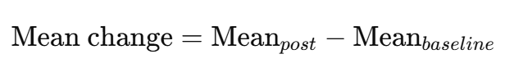  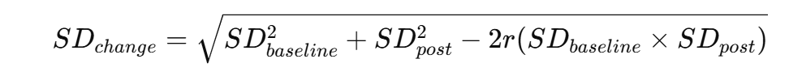  Assume r = 0.5
Multiple intervention arms | Intervention groups were combined into a single intervention effect size following guidance from the Cochrane Handbook. | 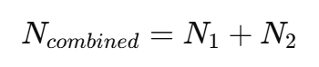  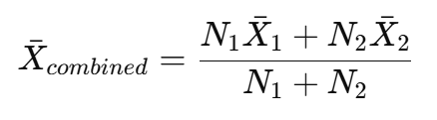  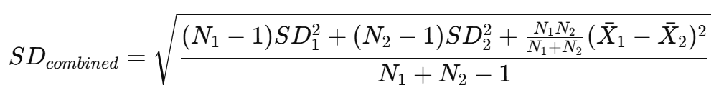
QOL scale reverse | Scales in which higher scores indicated worse outcomes were reversed to ensure a consistent direction of effect before pooling. | 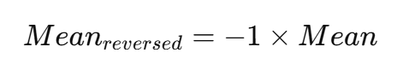
Analysis | Standardized Mean Difference (Hedges’ g) was used to account for the use of different quality-of-life measurement scales across studies | meta esize n_i mean_i sd_i n_c mean_c sd_c, esize(hedgesg) studylabel(studylbl) eslabel("Hedges g")
Bias correction | Small-sample correction was applied (Hedges’ g) | meta esize n_i mean_i sd_i n_c mean_c sd_c, esize(hedgesg) studylabel(studylbl) eslabel("Hedges g")

Supplementary Table 3. Characteristics of included studies
Characteristics | Number of included studies (N)* | Percentage (%)
Publication Year
2019 | 2 | 18.18
2020 | 1 | 9.09
2021 | 3 | 27.27
2022 | 2 | 18.18
2023 | 2 | 18.18
2024 | 1 | 9.09
Country
China | 1 | 9.09
Egypt | 1 | 9.09
Iran | 3 | 27.27
Malawi | 1 | 9.09
Spain | 1 | 9.09
Thailand | 1 | 9.09
Turkey | 1 | 9.09
United Kingdom | 1 | 9.09
United States of America | 1 | 9.09
Study Design
Randomized Control Trial | 6 | 54.54
Quasi-Experimental | 5 | 45.45
Sample Size
1-100 | 6 | 54.54
>100-300 | 4 | 36.36
>300 | 1 | 9.09
Healthcare Providers Involved in Self-Management Intervention
Certified instructors and healthcare workers | 1 | 9.09
Clinical psychologist | 1 | 9.09
Community health volunteer (CHVs) | 1 | 9.09
General Practitioners trained in CBT | 1 | 9.09
Nurse | 3 | 27.27
Physician | 1 | 9.09
Social worker | 1 | 9.09
Specialist kidney physical therapist | 1 | 9.09
Trained primary care nurse | 1 | 9.09
Trained health professional with expertise in diabetes education | 1 | 9.09
Not specified | 2 | 18.18
*One study may report more than one characteristic; the total number of included studies can be > 11.

