Appendix A1. Selection of Person-Wave Observations in Four Aging Cohorts from China, the United States, England, and Europe (2011-2020)
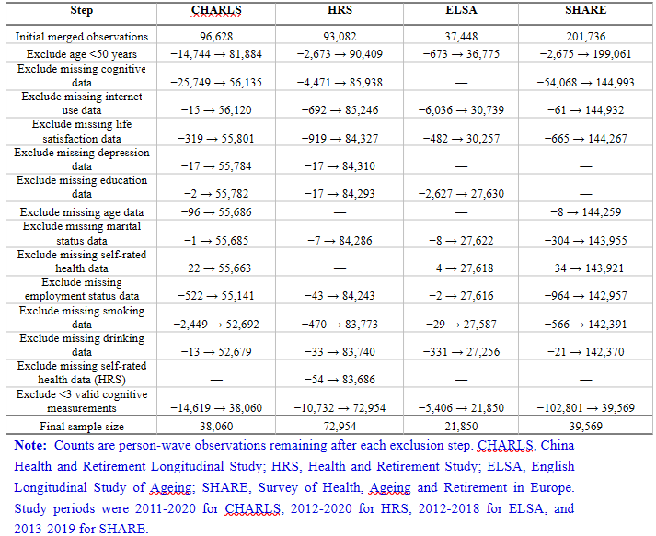

Appendix A2. Baseline Characteristics by Availability of Three or More Cognitive Assessments in the Survey of Health, Ageing and Retirement in Europe Source Cohort
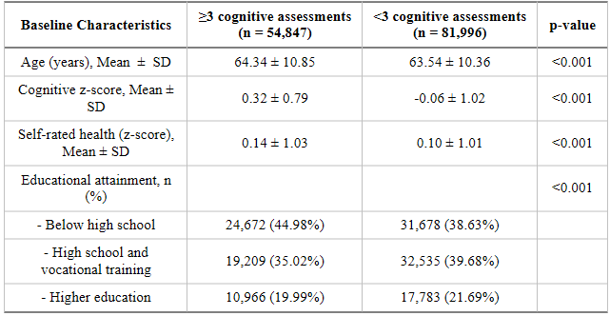

Note: Values are mean ± standard deviation or number (percentage). SHARE, Survey of Health, Ageing and Retirement in Europe; SD, standard deviation. Here, n denotes unique participants (one first-observed record per participant) in the broader SHARE source cohort; these participant counts are not the person-wave denominator reported in Table 2.

Appendix B. Cognitive Domains, Tasks, Scoring, and Harmonization in Four Aging Cohorts from China, the United States, England, and Europe (2011-2020)

Database | Cognitive Dimension | Task Description | Value Range | Scoring Method
CHARLS | Episodic Memory | Respondents listen to a word list containing 10 common words and repeat them immediately (immediate recall), then recall them again after approximately 4 minutes (delayed recall). | 0–20 Points | Immediate recall and delayed recall are each scored 0–10 points, with 1 point for each correctly recalled word, totaling 0–20 points.
CHARLS | Orientation | Respondents are required to correctly state the "year, month, day, day of the week, and season" of the interview date to assess time orientation ability. | 0–5 Point | 1 point for each correct answer, with a maximum of 5 points for all correct answers.
CHARLS | Serial 7’s | Respondents are asked to subtract 7 consecutively from 100 (i.e., 93, 86, 79, 72, 65) to assess attention and calculation ability. | 0–5 Point | 1 point for each correct calculation, with a maximum of 5 points.
CHARLS | Figure Drawing | Respondents are required to copy a figure of two intersecting pentagons to assess visuospatial ability. | 0–1 Point | 1 point for correct drawing, 0 points otherwise.
HRS | Episodic Memory | Respondents listen to a word list containing 10 common nouns and recall them immediately (immediate recall), then recall them again after approximately 5 minutes (delayed recall). This task aims to assess short-term and long-term memory ability. | 0–20 Point | Immediate recall and delayed recall are each scored 0–10 points, with 1 point for each correctly recalled word, totaling 0–20 points.
HRS | Serial 7’s | Subtract 7 consecutively from 100 five times (93, 86, 79, 72, 65). | 0–5 Point | 1 point for each correct calculation, with a maximum of 5 points.
HRS | Backwards Counting | Count 10 consecutive numbers backward from 20 (20→11). | 0-2Point | 2 points for correct consecutive counting on the first attempt, 1 point for correct counting on the second attempt, 0 points otherwise.
HRS | Orientation | Respondents are required to correctly answer the current "month, day, year, and day of the week" to assess time orientation ability. | 0–4 Point | 1 point for each correct answer, with a maximum of 4 points for all correct answers.
ELSA | Episodic memory | Respondents are asked to memorize and recall a word list containing 10 common English words. The test includes two parts: ① Immediate recall: respondents recall immediately after listening to the word list; ② Delayed recall: recall again after several minutes of distractor tasks. | 0–20 Point | Immediate recall and delayed recall are each scored 0–10 points, with 1 point for each correctly recalled word, totaling 0–20 points. This task is used to assess language learning and episodic memory ability.
ELSA | Orientation | Respondents are required to correctly report the date of the interview, including day, day of the week, month, and year, to measure time orientation ability. | 0–4 Point | 1 point for each correct answer, with a maximum of 4 points for all correct answers.
ELSA | Serial 7’s | Respondents are asked to subtract 7 consecutively from 100 (i.e., 93, 86, 79, 72, 65). | 0–5 Point | 1 point for each correct calculation, with a maximum of 5 points for all correct answers.
ELSA | Verbal fluency | Respondents are required to say as many words belonging to the same category (e.g., animals) as possible within one minute to assess vocabulary retrieval and language fluency. | No fixed upper limit (generally between 0–50) | The number of correct words spoken is recorded, and the score is the number of correct items.
ELSA | Visuospatial ability | Respondents are required to correctly copy two intersecting pentagons to measure visuospatial construction ability. | 0–1 Point | 1 point for correct copying, 0 points otherwise (variable).
SHARE | Episodic Memory | During the interview, respondents are asked to memorize and repeat a word list containing 10 common nouns. First, immediate recall is performed, followed by delayed recall after several minutes of distractor tasks. The total score of episodic memory is the sum of the scores of the two recalls. | 0 – 20 Point | 1 point for each correctly recalled word, with immediate and delayed recall each scored 0–10 points, totaling 0–20 points.
SHARE | Orientation | Respondents are required to correctly state the year, month, date, and day of the week of the interview date to assess time orientation ability. | 0 – 4Point | 1 point for each correct answer, with a maximum of 4 points for all correct answers.
SHARE | Serial 7’s | Respondents are asked to subtract 7 consecutively from 100 (i.e., 93, 86, 79, 72, 65). | 0–5 Point | 1 point for each correct calculation, with a maximum of 5 points for all correct answers.
SHARE | Verbal Fluency | Respondents are required to say as many animal names as possible within 1 minute to measure semantic memory and language fluency. | 0 – 100 Point | 1 point for each different animal correctly stated, with repetitions not counted.

Note: Domain scores were standardized within each cohort against its baseline distribution and then combined. The resulting z-score is a relative within-cohort measure and does not imply exact cross-country psychometric equivalence. CHARLS, China Health and Retirement Longitudinal Study; HRS, Health and Retirement Study; ELSA, English Longitudinal Study of Ageing; SHARE, Survey of Health, Ageing and Retirement in Europe. Study periods were 2011-2020 for CHARLS, 2012-2020 for HRS, 2012-2018 for ELSA, and 2013-2019 for SHARE.

To ensure the comparability of cognitive measurements between different countries and survey systems, this study adopted a "two-step standardization" method widely recognized in international cognitive aging research to uniformly process the cognitive data of the four longitudinal cohorts. In the first step, within each cohort, the baseline mean and standard deviation of each cognitive dimension (including episodic memory, orientation, attention and calculation ability [e.g., serial 7’s], verbal fluency, and visuospatial construction, etc.) were calculated with reference to the baseline distribution, and the dimension scores of all waves were converted into standardized z-scores using this distribution, thereby eliminating the dimensional differences caused by differences in test ranges, scoring methods, and survey years within the cohort. In the second step, the z-scores of all available cognitive dimensions in each wave were equally weighted to form an initial comprehensive cognitive index; to ensure the comparability between different waves in the longitudinal trajectory analysis, the comprehensive score was standardized again with reference to the baseline distribution, and finally, a comprehensive cognitive z-score comparable across waves and cohorts was obtained. This method has been adopted by a large number of cross-national aging studies, which can effectively reduce the structural differences in

test content, score upper limits, and measurement environments between different survey projects, enabling the obtained comprehensive cognitive indicators to faithfully reflect the changes in cognitive function within the cohort and have comparability and robustness for cross-national comparison and longitudinal trajectory modeling. For specific formulas, refer to the appendix of Wang et al. [18].

Appendix C. Definitions and Harmonization of Covariates in Four Aging Cohorts from China, the United States, England, and Europe (2011-2020)

Covariate | Name | Coding and Assignment | Explanation
Educational attainment | Education Level | Below high school=1; High school or vocational training=2; Higher education and above=3 | In SHARE, the education variable is uniformly processed according to the International Standard Classification of Education (ISCED-97). The original education variable includes 7 levels (0=No education, 1=Primary education, 2=Lower secondary education, 3=Upper secondary education, 4=Post-secondary non-tertiary education, 5=Tertiary education - first stage, 6=Tertiary education - second stage). The unified education variable integrates it into three categories: Below high school (ISCED 0–2), High school or vocational training (ISCED 3–4), and Higher education (ISCED 5–6) to ensure cross-national comparability; In CHARLS, it is defined based on the comprehensive of years of education and the highest educational qualification. If the years of education are less than 6 years or the educational qualification is primary school or below, it is assigned 1; 7–12 years or high school/technical secondary school is assigned 2; more than 13 years or college or above is assigned 3; In ELSA, according to the highest educational qualification variable, no qualification or below secondary school = 1; High school or vocational certificate (A-level, NVQ level 2–3) = 2; University and above education = 3; In HRS, according to the years of education, less than 12 years (below high school) is assigned 1, 13–15 years (partial college or associate degree) is assigned 2; more than 16 years (bachelor's degree and above) is assigned 3. This stratification is consistent with the three-level division standard of the US education system.
Age（years） | AGE | Survey year - year of birth | Unified approach across the four databases
Sex | sex | Male=1, Female=0 | Unified approach across the four databases
Marital status | Marital Status | Married/cohabiting=1, Others=0; | In CHARLS: Married=1, Married but not cohabiting=2, Cohabiting=3, Separated=4, Divorced=5, Widowed=7, Never married=8; In HRS: Married=1, Married but spouse absent=2, Separated=3, Divorced=4, Separated/divorced=5, Widowed=6, Never married=7, Unknown=8; In ELSA: Married or partner=1, Separated=4, Divorced=5, Widowed=7, Never married=8; In SHARE: Married=1, Registered partnership=3, Separated=4, Divorced=5, Widowed=7, Never married=8
Self-rated health status | Self-rated Health | Poor=1, Fair=2, Good=3, Very good=4, Excellent=5 | In CHARLS: Very poor=1, Poor=2, Fair=3, Good=4, Very good=5; In the other three databases: Poor=1, Fair=2, Good=3, Very good=4, Excellent=5
Depressive symptoms | Depression Score | Shortened depression scale (CES-D or EURO-D), Depression=1, Others=0 | CHARLS uses the CESD-10 scale (with a threshold of 10 points), HRS and ELSA use the CESD-8 scale, and SHARE uses the EURO-D12 scale. Detailed introduction below
Smoking status | Smoking Status | Yes=1, No=0 | Unified question across the four databases: "Do you currently smoke?"
Alcohol consumption | Alcohol Consumption | Yes=1, No=0 | In CHARLS: "Do you currently drink alcohol?"; In HRS: "Do you drink alcohol?"; In ELSA: "Have you drunk alcohol in the past 12 months?"; In SHARE: "Have you ever drunk alcohol?"
Employment status | Employment Status | Yes=1, No=0 | In CHARLS: "Are you currently employed?"; In HRS and ELSA: "Are you in paid employment?"; In SHARE: "Have you done paid work in the past four weeks?"
Activities of Daily Living (ADL) | Daily Living Activities | Fully independent=1, Others=0 | In CHARLS: Dressing, bathing, eating, getting in and out of bed, using the toilet, urinary control; In the other three databases: Bathing, dressing, eating, getting in and out of bed, using the toilet, indoor walking

Note: ADL, activities of daily living; CES-D, Center for Epidemiologic Studies Depression Scale; EURO-D, European Depression Scale; ISCED, International Standard Classification of Education; NVQ, National Vocational Qualification. CHARLS, China Health and Retirement Longitudinal Study; HRS, Health and Retirement Study; ELSA, English Longitudinal Study of Ageing; SHARE, Survey of Health, Ageing and Retirement in Europe. Study periods were 2011-2020 for CHARLS, 2012-2020 for HRS, 2012-2018 for ELSA, and 2013-2019 for SHARE.

Appendix D. Depression Measures and Cutoff Definitions in Four Aging Cohorts from China, the United States, England, and Europe (2011-2020)
The following table shows the detailed measurement of depression in the four databases:

Cohort | Scale | Content of scale | Scoring method | Cut-off for defining depression
CHARLS | CES-D-10 | CESD-10 reflects an individual's depressive symptoms experienced over the previous week and has been demonstrated to be reliable and has good validity to detect depression in Chinese adults [32]. CESD-10 includes 10 items, 3 items addressing depressed affect, 5 items addressing somatic symptoms, and 2 items addressing positive affect. Each question is rated on a scale of 0 (“rarely or none of the time”) to 3 (“all of the time”) but 5 item 8item are sored reverse. | 4-point Likert; the total score has a range of 0-30, a higher score indicates higher depressive symptoms. | 10 scores  [33]
ELSA/HRS | CES-D-8 | CES-D measures participant’s negative affect and somatic complaints experienced in the past week, which includes 8 items, 5 items reflect depressed mood (felt depressed, was happy, felt lonely, enjoyed life, and felt sad) and 3 items reflect somatic complaints (felt depressed, was happy, felt lonely, enjoyed life, and felt sad). | A dichotomous (yes or no) response to each item; the total score has a range of 0 (no symptoms)-8 (all eight symptoms), a higher score indicates higher depressive symptoms. | 4 scores  [34]
SHARE | EURO-D 12-item scale | The EURO-D scale includes 12 questions, covering depressive mood, pessimism, suicidal thoughts, guilt, irritability, tearfulness, fatigue, sleep disturbances, loss of interest, decreased appetite, decreased concentration, and loss of pleasure in the past month, with binary answers (yes/no). | The total score is the sum of the scores of each item, ranging from 0-12 points, with a higher score indicating more severe depressive symptoms. In this study, the case-level definition of depressive symptoms (referred to as "depression" for brevity) adopts the recommended cut-off value of 4 points and above for this scale [35]. | 4 scores  [35]

Note: CES-D, Center for Epidemiologic Studies Depression Scale; EURO-D, European Depression Scale. Cutoffs are cohort-specific and do not establish perfect cross-cohort psychometric equivalence. CHARLS, China Health and Retirement Longitudinal Study; HRS, Health and Retirement Study; ELSA, English Longitudinal Study of Ageing; SHARE, Survey of Health, Ageing and Retirement in Europe. Study periods were 2011-2020 for CHARLS, 2012-2020 for HRS, 2012-2018 for ELSA, and 2013-2019 for SHARE.

Appendix E. Fit and Classification Diagnostics for Candidate Cognitive Trajectory Models in Four Aging Cohorts from China, the United States, England, and Europe (2011-2020)

Cohort | Number of Classes and Polynomial Orders | BIC | Class Proportion (%) | APP (%)
CHARLS | （1 1） | -44598.66 | 31 69 | 92 96
CHARLS | （2 2） | -44553.29 | 31 69 | 92 96
CHARLS | （3 3） | -44538.01 | 31 69 | 92 96
CHARLS | （4 4） | -44532.34 | 31 69 | 92 96
CHARLS | （1 1 1） | -43355.69 | 15 37 48 | 89 84 90
CHARLS | （2 2 2） | -43308.36 | 15 37 48 | 89 84 90
CHARLS | （3 3 3） | -43280.53 | 15 37 48 | 90 84 90
CHARLS | （4 4 4） | -43270.27 | 15 37 48 | 90 84 90
CHARLS | （1 1 1 1） | -43130.21 | 7 19 38 36 | 85 79 78 85
CHARLS | （2 2 2 2） | -43082.97 | 7 19 38 36 | 85 79 77 85
CHARLS | （3 3 3 3） | -43046.04 | 7 19 38 36 | 85 79 78 85
CHARLS | （4 4 4 4） | -43036.67 | 7 19 38 36 | 85 79 78 85
HRS | （1 1） | -95444.21 | 35 65 | 93 96
HRS | （2 2） | -95434.89 | 35 65 | 93 96
HRS | （3 3） | -95444.09 | 35 65 | 93 96
HRS | （4 4） | -95417.48 | 35 65 | 93 96
HRS | （1 1 1） | -91574.71 | 16 45 39 | 92 88 90
HRS | （2 2 2） | -91575.84 | 16 45 39 | 92 88 90
HRS | （3 3 3） | -91589.04 | 16 45 39 | 92 88 90
HRS | （4 4 4） | -91556.77 | 16 45 39 | 92 88 90
HRS | （1 1 1 1） | -90249.59 | 10 27 44 19 | 90 85 85 85
HRS | （2 2 2 2） | -90257.58 | 10 27 44 19 | 90 85 85 85
HRS | （3 3 3 3） | -90273.58 | 10 27 44 19 | 90 85 85 85
HRS | （4 4 4 4） | -90238.1 | 10 27 44 19 | 90 85 85 85
ELSA | （1 1） | -31667.75 | 13 87 | 89 97
ELSA | （2 2） | -31671.94 | 13 87 | 89 97
ELSA | （3 3） | -31672.63 | 13 87 | 89 97
ELSA | （4 4） | -31681.32 | 13 87 | 89 98
ELSA | （1 1 1） | -30675.56 | 3 33 64 | 93 85 91
ELSA | （2 2 2） | -30683.95 | 3 33 64 | 93 85 91
ELSA | （3 3 3） | -30683.08 | 3 33 64 | 93 85 91
ELSA | （4 4 4） | -30696.12 | 3 33 64 | 93 86 91
ELSA | （1 1 1 1） | -30376.03 | 1 6 42 51 | 96 87 83 88
ELSA | （2 2 2 2） | -30387.11 | 1 6 42 51 | 96 87 83 88
ELSA | （3 3 3 3） | -30374.72 | 1 6 42 51 | 95 86 83 88
ELSA | （4 4 4 4） | -30392.1 | 1 6 42 51 | 95 86 83 87
SHARE | （1 1） | -45942.24 | 26 74 | 90 95
SHARE | （2 2） | -45628 | 26 74 | 90 95
SHARE | （3 3） | -45620.69 | 26 74 | 90 95
SHARE | （4 4） | -45630.17 | 26 74 | 90 95
SHARE | （1 1 1） | -43625.39 | 9 47 44 | 92 88 90
SHARE | （2 2 2） | -43218.93 | 9 47 44 | 92 88 90
SHARE | （3 3 3） | -43179.88 | 9 47 44 | 92 88 90
SHARE | （4 4 4） | -43194.11 | 9 47 44 | 92 88 90
SHARE | （1 1 1 1） | -42840.9 | 4 19 49 28 | 90 85 85 86
SHARE | （2 2 2 2） | -42361.33 | 4 19 49 28 | 91 85 85 86
SHARE | （3 3 3 3） | -42305.73 | 4 19 49 28 | 91 85 85 86

Appendix F. Sensitivity Analysis Using Independently Estimated Four-Class Cubic Cognitive Trajectory Models in Four Aging Cohorts from China, the United States, England, and Europe (2011-2020)
To assess whether the main trajectory-stratified findings depended on the harmonized three-class structure, four-class cubic trajectory models were estimated separately within each cohort, without imposing cross-cohort class equivalence. The same covariate-adjusted generalized estimating equation and internet use × time specifications were then re-estimated within the alternative classes. Detailed candidate-model fit statistics are reported in Appendix E.

Appendix Table F1. Classification Diagnostics and Associations of Internet Use with Cognitive Level and Rate of Change Under Alternative Four-Class Cognitive Trajectory Models in Four Aging Cohorts from China, the United States, England, and Europe (2011-2020)

Cohort | Four-class trajectory | Participants, n (%) | APP | Internet use β (95% CI)
CHARLS | C1 | 679 (6.7%) | 0.853 | -0.015 (-0.215, 0.185)
CHARLS | C2 | 1,928 (19.1%) | 0.789 | 0.103* (0.024, 0.182)
CHARLS | C3 | 3,867 (38.4%) | 0.777 | 0.059*** (0.027, 0.091)
CHARLS | C4 | 3,601 (35.7%) | 0.854 | 0.114*** (0.092, 0.137)
HRS | C1 | 1,674 (9.7%) | 0.897 | 0.144*** (0.094, 0.195)
HRS | C2 | 4,756 (27.5%) | 0.85 | 0.098*** (0.078, 0.118)
HRS | C3 | 7,769 (44.9%) | 0.847 | 0.081*** (0.064, 0.097)
HRS | C4 | 3,099 (17.9%) | 0.852 | 0.034* (0.000, 0.068)
ELSA | C1 | 76 (1.3%) | 0.949 | 1.025** (0.404, 1.646)
ELSA | C2 | 322 (5.4%) | 0.861 | 0.177** (0.053, 0.301)
ELSA | C3 | 2,458 (41.2%) | 0.829 | 0.070*** (0.033, 0.107)
ELSA | C4 | 3,112 (52.1%) | 0.87 | 0.059** (0.021, 0.097)
SHARE | C1 | 527 (4.0%) | 0.913 | 0.317*** (0.183, 0.452)
SHARE | C2 | 2,467 (18.7%) | 0.855 | 0.118*** (0.093, 0.144)
SHARE | C3 | 6,668 (50.6%) | 0.851 | 0.104*** (0.089, 0.119)
SHARE | C4 | 3,517 (26.7%) | 0.86 | 0.058*** (0.030, 0.087)

Note: Classes are ordered from the lowest (C1) to the highest (C4) fitted mean cognitive level. Participants are unique individuals assigned to each class. APP, average posterior probability; CI, confidence interval; GEE, generalized estimating equations. Coefficients are from cohort-specific models adjusted for age, age squared, self-rated health, education, smoking, alcohol consumption, sex, marital status, employment, and wave fixed effects. The internet use × time coefficient represents the difference in cognitive slope between internet users and non-users. * p<0.05; ** p<0.01; *** p<0.001. CHARLS, China Health and Retirement Longitudinal Study; HRS, Health and Retirement Study; ELSA, English Longitudinal Study of Ageing; SHARE, Survey of Health, Ageing and Retirement in Europe. Study periods were 2011-2020 for CHARLS, 2012-2020 for HRS, 2012-2018 for ELSA, and 2013-2019 for SHARE.

Person-level cross-tabulation with the original three-class assignments showed only adjacent refinement in every cohort: original C1 split into four-class C1/C2, original C2 split into C2/C3, and original C3 split into C3/C4. No lowest original class was reassigned directly to the highest four-class group. The four-class solution therefore refined the broad ordering of the original trajectories rather than generating a qualitatively different class hierarchy.

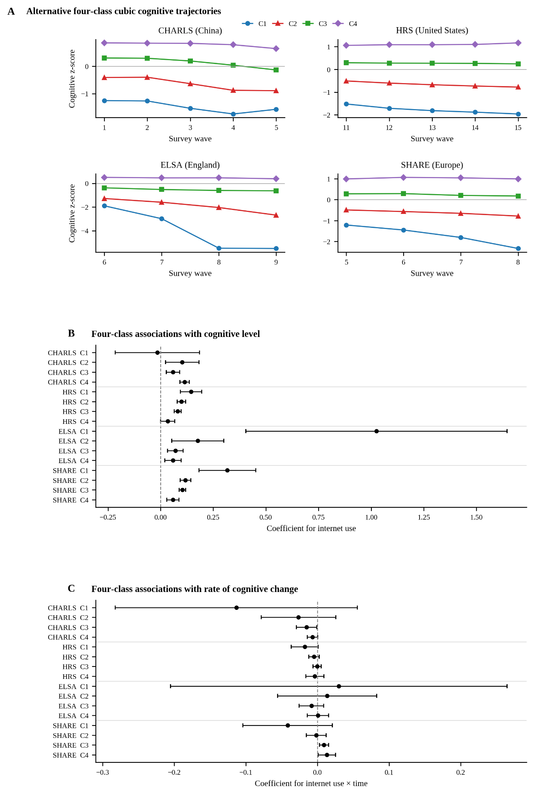

Appendix Figure F1. Four-Class Cognitive Trajectories and Internet-Use Associations in Four Aging Cohorts from China, the United States, England, and Europe (2011-2020)
Note: Panel A shows model-estimated four-class cognitive trajectories. Panel B shows class-specific GEE coefficients for internet use; Panel C shows internet use × time coefficients. Horizontal lines are 95% confidence intervals; the vertical dashed line denotes zero. C1-C4 are ordered from lowest to highest fitted mean cognitive level. CHARLS=China Health and Retirement Longitudinal Study; HRS=Health and Retirement Study; ELSA=English Longitudinal Study of Ageing; SHARE=Survey of Health, Ageing and Retirement in Europe; GEE=generalized estimating equations. Periods: CHARLS 2011-2020; HRS 2012-2020; ELSA 2012-2018; SHARE 2013-2019.

Appendix G. Inverse-Probability-Weighted Population-Averaged Associations Between Internet Use and Cognition Across Harmonized Trajectory Groups in Four Aging Cohorts from China, the United States, England, and Europe (2011-2020)

Cohort | Full-sample | Low and declining trajectory | Moderate-stable trajectory | High-stable trajectory
SHARE (Europe)
Internet Use (95% CI) | 0.291* (0.270, 0.313) | 0.237* (0.155, 0.318) | 0.126* (0.107, 0.144) | 0.081* (0.059, 0.104)
CHARLS (China)
Internet Use (95% CI) | 0.221* (0.171, 0.271) | 0.410 (-0.138, 0.957) | 0.161* (0.039, 0.283) | 0.134* (0.092, 0.176)
HRS (USA)
Internet Use (95% CI) | 0.245* (0.226, 0.263) | 0.142* (0.104, 0.180) | 0.113* (0.096, 0.130) | 0.064* (0.041, 0.087)
ELSA (UK)
Internet Use (95% CI) | 0.147* (0.122, 0.173) | 0.439* (0.261, 0.616) | 0.056* (0.032, 0.081) | 0.033* (0.015, 0.051)

Note: Values are association coefficients (95% confidence intervals) from inverse-probability-weighted generalized estimating equation models. IPW, inverse probability weighting; GEE, generalized estimating equations; CI, confidence interval. Models adjusted for age, age squared, sex, education, self-rated health, smoking, alcohol consumption, marital status, employment, and wave. An asterisk denotes p < 0.001. CHARLS, China Health and Retirement Longitudinal Study; HRS, Health and Retirement Study; ELSA, English Longitudinal Study of Ageing; SHARE, Survey of Health, Ageing and Retirement in Europe. Study periods were 2011-2020 for CHARLS, 2012-2020 for HRS, 2012-2018 for ELSA, and 2013-2019 for SHARE.

Appendix H. Sensitivity Analysis Using a Common-Domain Cognitive Score in Four Aging Cohorts from China, the United States, England, and Europe (2011-2020)

Cohorts / Trajectory Groups | Full Sample | Low and declining trajectory | Moderate-stable trajectory | High-stable trajectory
Panel A: CHARLS
Internet use | 0.260*** | 0.184 | 0.239*** | 0.115***
95% CI | (0.191, 0.329) | (-0.630, 0.997) | (0.0619, 0.416) | (0.0485, 0.181)
Observations | 12,495 | 1,158 | 4,125 | 7,212
Panel B: HRS
Internet use | 0.299*** | 0.277*** | 0.0861*** | 0.0722***
95% CI | (0.267, 0.332) | (0.177, 0.377) | (0.0546, 0.118) | (0.0295, 0.115)
Observations | 25,757 | 5,330 | 12,469 | 7,958
Panel C: ELSA
Internet use | 0.294*** | 0.986*** | 0.104*** | 0.0618***
95% CI | (0.242, 0.345) | (0.593, 1.380) | (0.0550, 0.153) | (0.0273, 0.0964)
Observations | 21,623 | 531 | 6,928 | 14,164
Panel D: SHARE
Internet use | 0.318*** | 0.312*** | 0.0893*** | 0.131***
95% CI | (0.290, 0.345) | (0.173, 0.450) | (0.0613, 0.117) | (0.0958, 0.165)
Observations | 39,569 | 3,488 | 18,531 | 17,550

Note: Values are association coefficients with 95% confidence intervals. Standard errors were clustered at the individual level. Models adjusted for age, age squared, sex, education, marital status, employment, smoking, alcohol consumption, self-rated health, and wave fixed effects. *** p < 0.01; ** p < 0.05; * p < 0.10. CHARLS, China Health and Retirement Longitudinal Study; HRS, Health and Retirement Study; ELSA, English Longitudinal Study of Ageing; SHARE, Survey of Health, Ageing and Retirement in Europe. Study periods were 2011-2020 for CHARLS, 2012-2020 for HRS, 2012-2018 for ELSA, and 2013-2019 for SHARE.

Appendix I. Linear Mixed-Effects Estimates of Associations Between Internet Use and Cognitive Level and Change in Four Aging Cohorts from China, the United States, England, and Europe (2011-2020)

Variable | (1) CHARLS | (2) HRS | (3) ELSA | (4) SHARE
Internet use | 0.187*** | 0.212*** | 0.0764*** | 0.184***
 | (0.108, 0.266) | (0.189, 0.235) | (0.0393, 0.114) | (0.149, 0.219)
Time (Years) | -0.0351*** | -0.00129 | -0.0245*** | -0.0212***
 | (-0.0402, -0.0300) | (-0.00450, 0.00191) | (-0.0315, -0.0175) | (-0.0264, -0.0160)
Internet × Time | -0.000198 | 0.00634*** | 0.0150*** | 0.0206***
 | (-0.0148, 0.0144) | (0.00242, 0.0103) | (0.00750, 0.0226) | (0.0148, 0.0264)
Age-squared | -0.000920*** | -0.00103*** | -0.000714*** | -0.000757***
 | (-0.00116, -0.000681) | (-0.00110, -0.000956) | (-0.000832, -0.000595) | (-0.000859, -0.000654)
Age | 0.108*** | 0.126*** | 0.0860*** | 0.0858***
 | (0.0769, 0.139) | (0.115, 0.136) | (0.0700, 0.102) | (0.0718, 0.0998)
Self-rated health | 0.0535*** | 0.0690*** | 0.0436*** | 0.0740***
 | (0.0397, 0.0673) | (0.0609, 0.0772) | (0.0348, 0.0525) | (0.0651, 0.0829)
Education (Level 2) | 0.465*** | 0.628*** | 0.143*** | 0.374***
 | (0.421, 0.509) | (0.595, 0.662) | (0.116, 0.171) | (0.347, 0.400)
Education (Level 3) | 0.652*** | 1.011*** | 0.269*** | 0.581***
 | (0.572, 0.733) | (0.973, 1.048) | (0.237, 0.302) | (0.551, 0.610)
Smoking | -0.0892*** | -0.0805*** | -0.0333** | 0.00271
 | (-0.128, -0.0500) | (-0.106, -0.0546) | (-0.0639, -0.00275) | (-0.0154, 0.0208)
Drinking | 0.00629 | 0.0958*** | 0.0889*** | 0.0684***
 | (-0.0265, 0.0390) | (0.0794, 0.112) | (0.0592, 0.119) | (0.0525, 0.0843)
Sex | 0.163*** | -0.174*** | -0.179*** | -0.105***
 | (0.115, 0.211) | (-0.195, -0.153) | (-0.199, -0.159) | (-0.126, -0.0832)
Marital Status | 0.132*** | 0.110*** | -0.00659 | 0.00653
 | (0.0734, 0.190) | (0.0919, 0.128) | (-0.0270, 0.0138) | (-0.0159, 0.0290)
Employment | -0.0926*** | 0.0888*** | 0.0403*** | 0.0786***

