Supplementary information for
Nitrogen addition mediates the response of foliar stoichiometry to phosphorus addition: a meta-analysis
Chengming You^{1,2}, Changhui Peng^{2,3}, Zhenfeng Xu¹, Yang Liu¹, Li Zhang¹, Rui Yin⁴, Lin Liu⁵, Han Li¹, Lixia Wang¹, Sining Liu¹, Bo Tan^{1*}, Paul Kardol⁶

1 Forestry Ecological Engineering in the Upper Reaches of the Yangtze River Key Laboratory of Sichuan Province & National Forestry and Grassland Administration Key Laboratory of Forest Resources Conservation and Ecological Safety on the Upper Reaches of the Yangtze River & Rainy Area of West China Plantation Ecosystem Permanent Scientific Research Base, Institute of Ecology & Forestry, Sichuan Agricultural University, Chengdu, Sichuan 611130, China
2 Department of Biological Science, Institute of Environment Sciences, University of Quebec at Montreal, Case Postale 8888, succursale Centre-Ville, Montreal, Quebec H3C 3P8, Canada;
3 Laboratory for Ecological Forecasting and Global Change, College of Forestry, Northwest A & F University, No. 3 Taicheng Road, Yangling 712100, China;
4 Helmholtz-Centre for Environmental Research-UFZ, Department of Community Ecology, Theodor-Lieser-Strasse 4, 06110, Halle, Saale, Germany;
5 College of Animal Science and Technology, Sichuan Agricultural University, Chengdu 611130, China;
6 Department of Forest Ecology and Management, Swedish University of Agricultural Science, 90183, Umeå, Sweden.

Supplementary information

Fig. S1 Global distribution of the study sites included in the meta-analysis
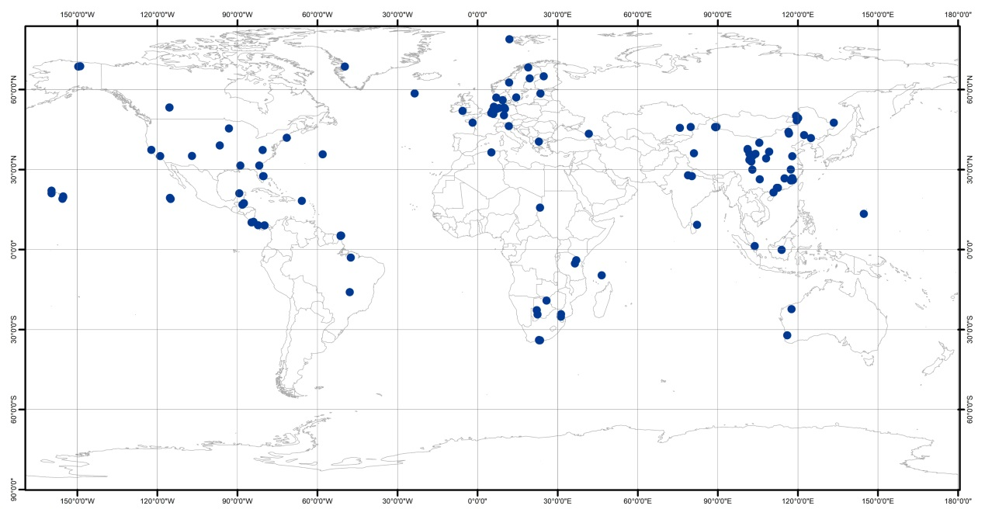

Fig. S2 Repeat analysis of the effects of phosphorus (P) addition on foliar nitrogen (N) concentrations (a), foliar P concentrations (b), and foliar N to P ratios (c) for different sample sizes.

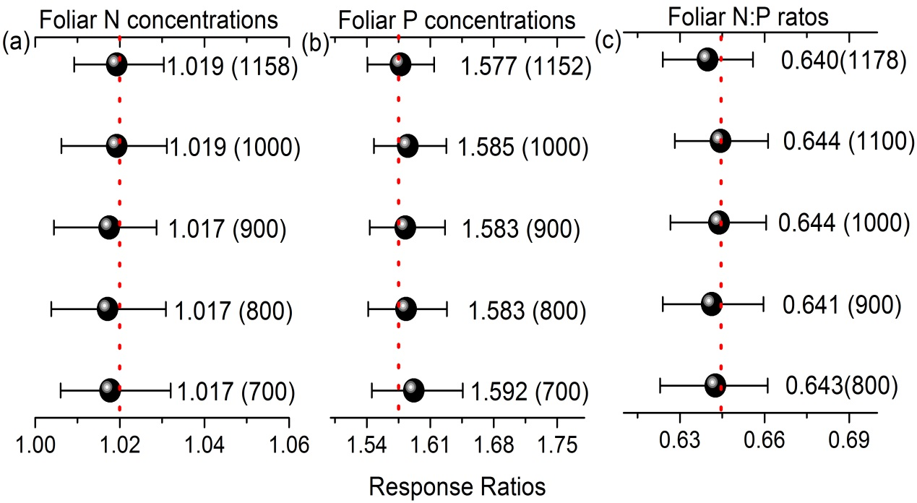

Fig. S3 Frequency distribution of the response ratio (RR) of phosphorus (P) addition on the foliar nitrogen (N) concentrations (a), foliar P concentrations (b), and foliar N to P ratios (c). The curves were fitted by a Gaussian function.
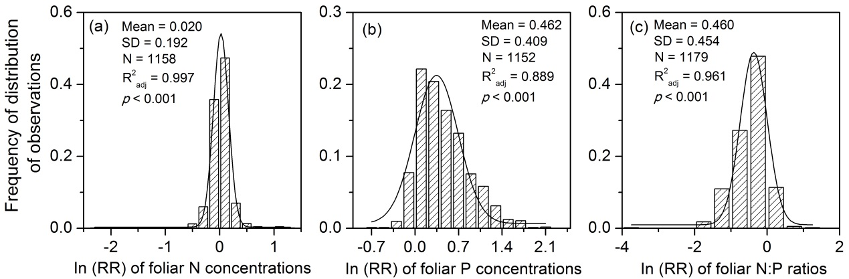

Fig S4. Response ratios of foliar nitrogen (N): phosphorus (P) ratios to the P addition rates (a) without N addition and (b) with N addition. Different letters indicate significant differences between the P addition rates at the 0.05 level.

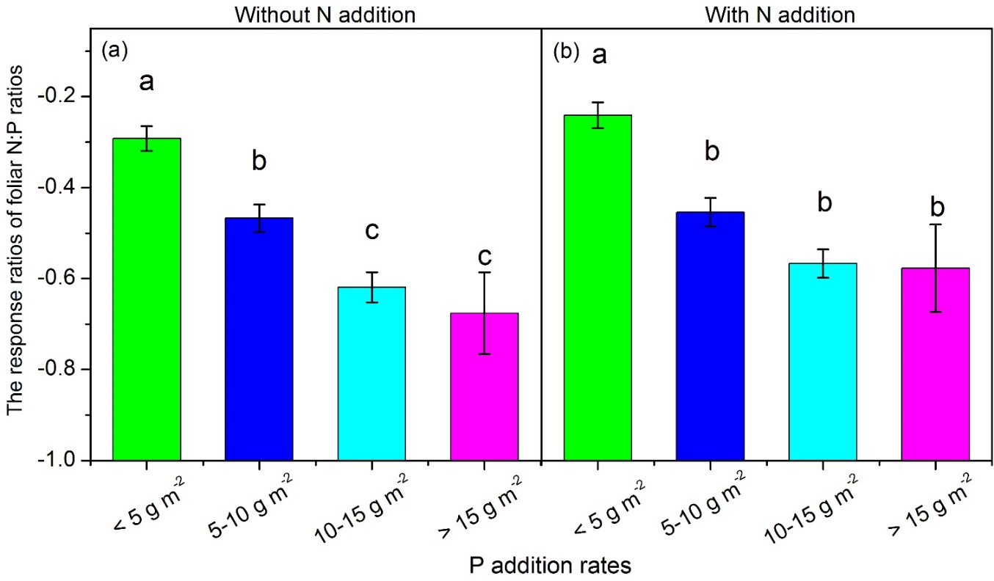

Table S1. Comparison of the effects of phosphorus (P) addition with or without N addition on the foliar nitrogen (N) concentrations (foliar N), foliar P concentrations (foliar P), foliar N to P ratios (foliar N:P), N resorption efficiency (NRE), P resorption efficiency (PRE), soil N availability (soil N) and soil P availability (soil P). The effect sizes indicate the mean of the effect of P addition on the variables, and the 95% CI represents the 95% confidence interval. The heterogeneity between subgroups (Qb, QB) was significant at p <0.05; Qb represents the difference between each grouping variable (including the P addition rates, the experimental durations, the community and species levels and the plant growth types), and QB indicates that the effects of P addition with N addition on the target variables were different from those without N addition.

Variables | Treatments |  | Without N addition |  |  |  |  | With N addition
Variables | Treatments |  | effect sizes | 95% CI |  | Qb | QB | effect sizes | 95% CI |  | Qb
Foliar N | Mean |  | 1.025 | 1.009 | 1.041 |  | 0.065 | 1.012 | 0.997 | 1.025
Foliar P | Mean |  | 1.607 | 1.557 | 1.663 |  | 0.028 | 1.539 | 1.488 | 1.593
Foliar N:P | Mean |  | 0.614 | 0.609 | 0.654 |  | 0.167 | 0.65 | 0.628 | 0.674
NRE | Mean |  | 1.062 | 1.001 | 1.141 |  | 0.52 | 1.038 | 0.971 | 1.106
PRE | Mean |  | 0.896 | 0.843 | 0.949 |  | 0.193 | 0.933 | 0.877 | 0.992
Soil N | Mean |  | 0.97 | 0.907 | 1.032 |  | 0.807 | 0.989 | 0.882 | 1.117
Soil P | Mean |  | 3.034 | 2.517 | 3.759 |  | 0.009 | 4.309 | 3.212 | 6.012
 |  |  | effect sizes | 95% CI |  | Qb | QB | effect sizes | 95% CI |  | Qb
Foliar N | <5 |  | 1.034 | 1.016 | 1.05 | 0.612 | 0.629 | 1.039 | 1.012 | 1.069 | 0.001
Foliar N | 5 to 10 |  | 1.023 | 0.998 | 1.05 |  | 0.003 | 0.982 | 0.958 | 1.006
Foliar N | 10 to 15 |  | 1.021 | 0.994 | 1.047 |  | 0.404 | 1.011 | 0.989 | 1.034
Foliar N | > 15 |  | 1.012 | 0.89 | 1.136 |  | 0.688 | 1.028 | 0.993 | 1.063
Foliar N | ≤ 3 years |  | 1.037 | 1.02 | 1.055 | 0.02 | 0.063 | 1.022 | 1.006 | 1.037 | 0.001
Foliar N | > 3 years |  | 1.008 | 0.981 | 1.036 |  | 0.053 | 0.977 | 0.946 | 1.012
Foliar N | Community |  | 1.039 | 1.01 | 1.072 | 0.432 | 0.05 | 0.994 | 0.962 | 1.031 | 0.374
Foliar N | Species |  | 1.024 | 1.008 | 1.04 |  | 0.137 | 1.013 | 0.998 | 1.028
Foliar N | Evergreen plants |  | 1.088 | 1.044 | 1.144 | 0.001 | 0.002 | 1.032 | 1.007 | 1.059 | 0.044
Foliar N | Deciduous plants |  | 1.002 | 0.962 | 1.041 |  | 0.518 | 0.985 | 0.933 | 1.034
Foliar N | Coniferous plants |  | 0.962 | 0.911 | 1.007 |  | 0.111 | 1.048 | 0.986 | 1.034
Foliar N | Graminoids |  | 0.992 | 0.955 | 1.02 |  | 0.137 | 1.013 | 0.989 | 1.036
Foliar N | Forbs |  | 1.014 | 0.998 | 1.032 |  | 0.272 | 1.002 | 0.979 | 1.029
 |  |  | effect sizes | 95% CI |  | Qb | QB | effect sizes | 95% CI |  | Qb
Foliar P | <5 |  | 1.378 | 1.324 | 1.437 | 0.001 | 0.099 | 1.321 | 1.259 | 1.38 | 0.001
Foliar P | 5 to 10 |  | 1.623 | 1.537 | 1.711 |  | 0.18 | 1.548 | 1.459 | 1.633
Foliar P | 10 to 15 |  | 1.789 | 1.67 | 1.906 |  | 0.423 | 1.738 | 1.625 | 1.851
Foliar P | > 15 |  | 1.976 | 1.718 | 2.295 |  | 0.293 | 1.769 | 1.513 | 2.099
Foliar P | ≤ 3 years |  | 1.576 | 1.519 | 1.632 | 0.914 | 0.01 | 1.482 | 1.429 | 1.544 | 0.045
Foliar P | > 3 years |  | 1.571 | 1.472 | 1.673 |  | 0.71 | 1.591 | 1.478 | 1.706
Foliar P | Community |  | 1.718 | 1.526 | 1.917 | 0.126 | 0.392 | 1.601 | 1.373 | 1.864 | 0.545
Foliar P | Species |  | 1.598 | 1.544 | 1.652 |  | 0.047 | 1.536 | 1.483 | 1.594
Foliar P | Evergreen plants |  | 1.594 | 1.489 | 1.713 | 0.001 | 0.001 | 1.389 | 1.307 | 1.473 | 0.001
Foliar P | Deciduous plants |  | 1.358 | 1.243 | 1.495 |  | 0.551 | 1.301 | 1.168 | 1.445
Foliar P | Coniferous plants |  | 1.457 | 1.32 | 1.616 |  | 0.221 | 1.578 | 1.404 | 1.8
Foliar P | Graminoids |  | 1.59 | 1.497 | 1.68 |  | 0.585 | 1.558 | 1.464 | 1.653
Foliar P | Forbs |  | 1.648 | 1.565 | 1.743 |  | 0.589 | 1.684 | 1.59 | 1.793
 |  |  | effect sizes | 95% CI |  | Qb | QB | effect sizes | 95% CI |  | Qb
Foliar N:P | <5 |  | 0.757 | 0.718 | 0.796 | 0.001 | 0.268 | 0.786 | 0.746 | 0.829 | 0.001
Foliar N:P | 5 to 10 |  | 0.638 | 0.602 | 0.679 |  | 0.826 | 0.643 | 0.609 | 0.681
Foliar N:P | 10 to 15 |  | 0.547 | 0.512 | 0.581 |  | 0.347 | 0.567 | 0.534 | 0.604
Foliar N:P | > 15 |  | 0.535 | 0.458 | 0.609 |  | 0.495 | 0.568 | 0.466 | 0.678
Foliar N:P | ≤ 3 years |  | 0.643 | 0.617 | 0.67 | 0.839 | 0.095 | 0.673 | 0.646 | 0.701 | 0.03
Foliar N:P | > 3 years |  | 0.648 | 0.605 | 0.691 |  | 0.097 | 0.611 | 0.566 | 0.657
Foliar N:P | Community |  | 0.604 | 0.52 | 0.692 | 0.43 | 0.664 | 0.628 | 0.534 | 0.725 | 0.635
Foliar N:P | Species |  | 0.633 | 0.61 | 0.655 |  | 0.234 | 0.65 | 0.628 | 0.675
Foliar N:P | Evergreen plants |  | 0.649 | 0.603 | 0.695 | 0.03 | 0.001 | 0.729 | 0.693 | 0.77 | 0.001
Foliar N:P | Deciduous plants |  | 0.746 | 0.669 | 0.822 |  | 0.819 | 0.765 | 0.682 | 0.847
Foliar N:P | Coniferous plants |  | 0.658 | 0.579 | 0.737 |  | 0.86 | 0.669 | 0.588 | 0.75
Foliar N:P | Graminoids |  | 0.625 | 0.583 | 0.667 |  | 0.49 | 0.646 | 0.605 | 0.692
Foliar N:P | Forbs |  | 0.61 | 0.574 | 0.647 |  | 0.339 | 0.583 | 0.544 | 0.622
The bold text indicates significant differences at p < 0.05

Table S2 Correlation analysis of the relationship between the response ratio (RR) of the foliar nitrogen concentration (N), phosphorus (P), N to P ratio (N:P) and N and P resorption efficiencies (NRE and PRE, respectively) and soil N and P availabilities (soil N and soil P, respectively). The numbers in black in the upper right refer to P addition without N addition, and the numbers in blue in the lower left refer to P addition with N addition. The numbers inside and outside the parentheses represent the sample sizes and correlation coefficients, respectively. * and ** indicate that the relationship is significant at the p < 0.05 and p < 0.01 level, respectively.
 | NRE | PRE | Soil N | Soil P | RRN | RR P | RR N:P
NRE |  | 0.327(102)** | 0.036(31) | 0.14(31) | -0.171(99) | 0.081(99) | -0.145(99)
PRE | 0.386(82)** |  | 0.2(31) | -0.353(33)* | -0.024(99) | 0.117(101) | -0.12(99)
Soil N | -0.126(19) | -0.150(19) |  | -0.101(138) | 0.003(137) | 0.046(131) | -0.02(131)
Soil P | -0.507(19)* | -0.474(19)* | 0.269(108)** |  | -0.159(168)* | 0.421(164)** | -0.45(162)**
RRN | 0.067(74) | 0.148(74) | 0.006(109) | 0.089(135) |  | 0.087(636)* | 0.369(636)**
RRP | 0.166(74) | 0.275(74)* | 0.184(103) | 0.353(129)** | 0.104(494)* |  | -0.867(636)**
RRN:P | -0.142(74) | -0.251(74)* | -0.185(103) | -0.384(129)** | 0.316(494)** | -0.871(494)**

Table S3 F-values from the regression analysis of the relationship between the response ratios (RRs) of foliar nitrogen (N) concentrations (foliar N), foliar phosphorus (P) concentrations (foliar P), foliar N to P ratios (foliar N:P ratios), N and P resorption efficiencies (NRE and PRE, respectively) and soil N and P availabilities (soil N and soil P, respectively) to P addition with and without N addition and geographical (including latitude (°), longitude (°) and altitude (m)) and climatic factors (i.e., mean annual precipitation (MAP, mm) and the mean annual temperature (MAT, °C)).
Without N addition
variables | Latitude | Longitude | Altitude | MAP | MAT
Foliar N | 0.879(568) | (+)5.313(560)** | (-)4.871(366)* | 0.962(435) | (+)4.239(388)*
Foliar P | (+)4.460(568)* | (-)3.371(564)* | (+)20.910(379)*** | (+)12.065(453)*** | 1.195(402)
Foliar N:P ratios | (-)18.304(582)*** | (+)3.704(574)* | (-)18.971(386)*** | (-)7.108(444)** | 2.285(398)
NRE | 0.087(107) | 0.282(107) | 1.541(67) | 0.578(82) | (-)4.184(85)*
PRE | 0.023(104) | 0.361(104) | 0.328(64) | 1.346(79) | 0.872(82)
Soil N | (-)4.611(52)* | 0.008(50) | (+)3.115(44)* | 0.695(50) | 0.973(49)
SoilP | 0.004(62) | (+)4.388(59)* | (+)4.541(50)* | 0.022(56) | (+)3.27(53)*
With N addition
 | Latitude | Longitude | Altitude | MAP | MAT
Foliar N | 0.649(444) | (+)5.715(438)** | 0.637(311) | (+)5.234(359)* | 1.308(318)
Foliar P | (+)8.386(432)** | (-)5.100(426)* | (+)31.703(305)*** | 0.237(361) | (-)21.729(321)***
Foliar N:P ratios | (-)17.244(455)*** | (+)3.242(449)* | (-)43.818(324)*** | 2.716(365) | (+)30.649(325)***
NRE | (+)3.448(93)* | 0.002(93) | 0.337(66) | 0.084(84) | 0.018(84)
PRE | 0.163(87) | 0.550(87) | (-)3.761(60)* | 2.534(78) | (+)8.940(78)***
Soil N | (+)3.617(40)* | 0.014(39) | 0.518(30) | 0.732(39) | 0.202(37)
SoilP | 1.415(44) | (+)7.969(43)** | 2.341(34) | 0.119(41) | (+)7.353(37)*
The numbers inside the parentheses indicate the sample sizes, and (+) and (-) represent that the relationship is significantly positive and negative, respectively. *, **, and *** indicate that the relationship is significant at the p < 0.05, p < 0.01 and p < 0.001 levels, respectively.

Appendix S1. List of 168 articles from which data were extracted for the meta-analysis
1.Fei L, Zhong Q L, Cheng D L, Xu C B, Zhang Z R & Zhang L L (2015) Effect of nitrogen and phosphorus spraying on leaf nutrient resorption efficiency of Machilus pauhoi. Chin J Appl Environ Biol, 21(02), 295-300.
2. Fei L (2015) The effect of nitrogen and phosphorus spraying to the main leaf traits and nutrient resorption efficiency of Machilus pauhoi. Fujian Normal University.
3. Zhang J R (2016) Effects of fertilization on leaf N and P resorption in an alpine meadow of the Tibetan Plateau. Lanzhou University.
4.Wang M, Murphy M T, Moore T R (2014) Nutrient resorption of two evergreen shrubs in response to long‑term fertilization in a bog. Oecologia, 174, 365-377.
5. Mao R, Zeng D H, Zhang X H & Song C C (2015) Responses of plant nutrient resorption to phosphorus addition in freshwater marsh of northeast china. Scientific Reports, 5, 8097.
6. Kozovits A R, Bustamante M M C, Garofalo C R, Bucci S, Franco A C, Goldstein G & Meinzer F C (2007) Nutrient resorption and patterns of litter production and decomposition in a neotropical savanna. Functional Ecology, 21(6), 1034-1043.
7. Lü X T, Reed S C, Yu Q, Hua X G (2016). Nutrient resorption helps drive intra-specific coupling of foliar nitrogen and phosphorus under nutrient-enriched conditions. Plant and Soil, 398(1-2), 111-120.
8. Li, L. J. , Zeng, D. H. , Mao, R. , & Yu, Z. Y. . (2012). Nitrogen and phosphorus resorption of Artemisia scoparia, Chenopodium acuminatum, Cannabis sativa, and Phragmites communis under nitrogen and phosphorus additionsin a semiarid grassland, china. Plant Soil & Environment, 58(10), 446-451.
9. Niinemets Ü, Kull K. (2005). Co-limitation of plant primary productivity by nitrogen and phosphorus in a species-rich wooded meadow on calcareous soils. Acta Oecologica, 28, 345–356.
10. Aerts, R. , Bo Wallén, Malmer, N. , & Caluwe, H. D. . (2001). Nutritional constraints on sphagnum‐growth and potential decay in northern peatlands. Journal of Ecology, 89, 292-299.
11. Aerts, R., de Caluwe, H. and Beltman, B. (2003). Is the relation between nutrient supply and biodiversity co-determined by the type of nutrient limitation?, Oikos 101, 489–498.
12. Bai X F (2016) Effcets of fertilization on nutrient content and ecoological stoichiometry characteristics in Larix principis-rupprechtii Mayr plantation. University of Chinese Academy of Science.
13. Chen F S, Hu X F & Ge G (2007) Leaf N:P stoichiometry and nutrient resorption efficiency of Ophiopogon japonicus in Nanchang City. Acta Prataculturae Sinica, 16, 47-54.
14. Cordell, S. , Goldstein, G. , Meinzer, F. C. , & Vitousek, P. M. . (2001). Morphological and physiological adjustment to n and p fertilization in nutrient-limited metrosideros polymorpha canopy trees in hawaii. Tree Physiology, 21(1), 43-50.
15. Campo, J. , Enrique Solís, & María G. Valencia. (2007). Litter n and p dynamics in two secondary tropical dry forests after relaxation of nutrient availability constraints. Forest Ecology and Management, 252(1-3), 0-40.
16. Joseph M, Craine, Carl Morrow, William D. Stock (2016) Nutrient concentration ratios and co-limitation in South African grasslands. New phytologist. 179, 829–836.
17. Cordell S, Goldstein G, Meinzer F C & Vitousek P M (2001) Regulation of leaf life-span and nutrient-use efficiency of Metrosideros polymorpha trees at two extremes of a long chronosequence in Hawaii. Oecologia, 127, 198-206.
18. Cambridge M L & Kendrick G A (2009) Contrasting responses of seagrass transplants (posidonia Australis) to nitrogen, phosphorus and iron addition in an estuary and a coastal embayment. Journal of Experimental Marine Biology and Ecology, 371, 34-41.
19. Burslem, D. F. R. P. , & Turner, P. J. G. M. . (1995). Responses to nutrient addition among shade-tolerant tree seedlings of lowland tropical rain forest in singapore. Journal of Ecology, 83(1), 113-122.
20. Bucci S J, Scholz F G, Goldstein G, Meinzer F C, Franco A C, Campanello P I, Villalobosvega R, Bustamante M & Miralleswilhelm F (2006) Nutrient availability constrains the hydraulic architecture and water relations of savannah trees. Plant Cell & Environment, 29, 2153.
21. Bowman W D (1994) Accumulation and use of nitrogen and phosphorus following fertilization in two alpine tundra communities. Oikos, 70(2), 261-270.
22. Boeye, D. , Verhagen, B. , Véronique van Haesebroeck, & Mohssine El‐Kahloun. (1999). Phosphorus fertilization in a phosphorus‐limited fen: effects of timing. Applied Vegetation Science, 2, 71-78.
23. Boeye D, Verhagen B, Vvan H & Verheyen R F (1997) Nutrient limitation in species-rich lowland fens. Journal of Vegetation Science, 8, 415-424.
24. Bobbink R (1991) Effects of nutrient enrichment in dutch chalk grassland. Journal of Applied Ecology, 28, 28-41.
25. Blanes, M. C. , Emmett, B. A. , Benjamín Vi?egla, & José A. Carreira. (2012). Alleviation of p limitation makes tree roots competitive for n against microbes in a n-saturated conifer forest: a test through p fertilization and 15n labelling. Soil Biology & Biochemistry, 48(none), 51-59.
26. Bennett J N, Blevins L L, Barker J E, Blevins D P, & Prescott C E. (2003). Increases in tree growth and nutrient supply still apparent 10 to 13 years following fertilization and vegetation control of salal-dominated cedar– hemlock stands on Vancouver Island. Can J For Res, 33, 1516–1524.
27. Bin Z J (2014) Effects of silicon, nitrogen and phosphorus addition on plant community structure and productivity of alpine meadow on Qinghai-Tibetan Plateau, China. Lanzhou University.
28. Li M, Jin B J, Zhong Q L, Ma Y Z, Lu H D, Guo B Q, Zheng Y & Cheng D L (2016) Effect of nitrogen and phosphorus fertilization on leaf N and P stoichiometric characteristics of Machilus pauhoi seedlings. Chinese journal of Applied and Environmental Biology, 22, 285-291.
29. Liu Y, Zhang J, Chen Y M, Chen L & Liu Q (2013) Effect of nitrogen and phosphorus fertilization on biomass allocation and C:N:P stoichiometric characteristics of Eucalyptus grandis seedlings. Chinese Journal of Plant Ecology, 37, 933-941.
30. Zhang J (2017) Effect of N, P addition on decomposition of soil organic carbon in alpine meadows on the Qinghai-Tibetan Plateau. Lanzhou University.
31. Graciano C, Goya J F, Frangi J L & Guiamet J J (2006) Fertilization with phosphorus increases soil nitrogen absorption in young plants of Eucalyptus grandis. Forest Ecology & Management, 236, 202-210.
32. Gordon C, Wynn J M & Woodin S J (2001) Impacts of increased nitrogen supply on high Arctic heath: the importance of bryophytes and phosphorus availability. New Phytologist, 149, 461-471.
33. Vitousek, H. P. M. . (2000). Nutrient limitation of decomposition in hawaiian forests. Ecology, 81(7), 1867-1877.
34. Haubensak, K. A. , & Carla M. D’Antonio. (2011). The importance of nitrogen-fixation for an invader of a coastal california grassland. Biological Invasions, 13(6), 1275-1282.
35. Güsewell S & Koerselman W (2002) Time-dependent effects of fertilization on plant biomass in floating fens. Journal of Vegetation Science, 13, 705-718.
36. Feller I, Lovelock C & Piou C (2009) Growth and nutrient conservation in Rhizophora mangle in response to fertilization along latitudinal and tidal gradients. Smithsonian Contributions to the Marine Sciences, 38, 345-359.
37. Feller I C, Lovelock C E & Mckee K L (2007) Nutrient addition differentially affects ecological processes of Avicennia germinans in nitrogen versus phosphorus limited mangrove ecosystems. Ecosystems, 10, 347-359.
38. Gerdol R, Petraglia A, Bragazza L, Iacumin P & Brancaleoni L (2007) Nitrogen deposition interacts with climate in affecting production and decomposition rates in Sphagnum mosses. Global Change Biology, 13, 1810-1821.
39. Fetcher N, Haines B L, Cordero R A, Lodge D J, Walker L R, Fernandez D S & Lawrence W T (1996) Responses of tropical plants to nutrients and light on a landslide in puerto rico. Journal of Ecology, 84, 331-341.
40. Feller, I. C. , Whigham, D. F. , O’Neill, John P., & Mckee, K. L. . (1999). Effects of nutrient enrichment on within-stand cycling in a mangrove forest. Ecology, 80(7), 2193-2205.
41. Drenovsky R E & Richards J H (2005) Nitrogen addition increases fecundity in the desert shrub Sarcobatus vermiculatus. Oecologia, 143, 349-356.
42. Denslow J S, Vitousek P M & Schultz J C (1987) Bioassays of nutrient limitation in a tropical rain forest soil. Oecologia, 74, 370-376.
43. D'Antonio C M & Mack M C (2006) Nutrient Limitation in a fire-derived, nitrogen-rich Hawaiian Grassland. Biotropica, 38, 458–467.
44. Cuevas-Reyes P, Oliveira-Ker F T D, Fernandes G W & Bustamante M (2011) Abundance of gall-inducing insect species in sclerophyllous savanna: understanding the importance of soil fertility using an experimental approach. Journal of Tropical Ecology, 27, 631-640.
45. Meredith F & Fourqurean J W (2004) Responses of seagrass communities to fertilization along a gradient of relative availability of nitrogen and phosphorus in a carbonate environment. Limnology & Oceanography, 49, 2082-2094.
46. Kirsten F, Uta F, Goddert V O, Kerstin M, Konrad M, Hartmut M & Werner H (2010) Molinia caerulea responses to N and P fertilisation in a dry heathland ecosystem (NW-Germany). Plant Ecology, 209, 47-56.
47. Feller I C, Whigham D F, Mckee K L & Lovelock C E (2003) Nitrogen limitation of growth and nutrient dynamics in a disturbed mangrove forest, Indian River Lagoon, Florida. Oecologia, 134, 405-414.
48. Güsewell S, Koerselman W & Verhoeven J T A (2003) Biomass N:P ratios as indicators of nutrient limitation for plant populations in wetlands. Ecological Applications, 13, 372-384.
49. Feller I C, Mckee K L, Whigham D F & O'Neill J P (2003) Nitrogen vs. phosphorus limitation across an ecotonal gradient in a mangrove forest. Biogeochemistry, 62, 145-175.
50. Liu Y (2014)Effects of nitrogen and phosphorus additions on twig and leaf nutrients and their resorption efficiencies in Cunninghamia lanceolata plantation, Nanchang University.
51. Mo Q F, Chen Y, Wang F M, Zou B, Li Y W, Yu S Q, Li X B & Li Z A (2015) Nitrogen to phosphorus ratios of two understory plant species in response to nitrogen and phosphorus addition in tropical forest of southern China. Chinese Journal of Applied and Environmental Biology, 21, 919-925.
52. Lin, Z. , Mao, L. I. , Jun, X. U. , Di, T. , Chi, Z. , & Xiao-Niu, X. U. . (2015). Effects of simulated nitrogen precipitation on litterfall and related nutrient returns in a castanopsis eyrei forest. Chinese Journal of Soil Science.46, 648-655.
53. Wang F C (2015) Effects of nitrogen and phosphorus additions on understory plant biodiversity and nutrients dynamic in Chinese fir plantation. Nanchang University.
54. Chen L Y (2010) Effects of N, P addition on N: P stoichiometry of different functional groups in Potenilla fruticosa community in a sub-alpine meadow. Lanzhou University.
55. Mo Q, Zou B, Li Y, Chen Y, Zhang W, Mao R, Ding Y, Wang J, Lu X & Li X (2015) Response of plant nutrient stoichiometry to fertilization varied with plant tissues in a tropical forest. Scientific Reports, 5, 14605.
56. Lovelock C E, Feller I C, Mckee K L, Engelbrecht B M J & Ball M C (2004) The Effect of Nutrient Enrichment on Growth, Photosynthesis and Hydraulic Conductance of Dwarf Mangroves in Panamá. Functional Ecology, 18, 25–33.
57. Gao Z B, Wang H Y, Lv X T & Wang W Z (2017) Effects of nitrogen and phosphorus addition on C: N: P stoichiometry in roots and leaves of four dominant plant species in a meadow steppe of hulunbuir. Chinese Journal of Ecology, 36, 80-88.
58. Bennett L T & Adams M A (2001) Response of a perennial grassland to nitrogen and phosphorus additions in sub-tropical, semi-arid Australia. Journal of Arid Environments, 48, 289-308.
59. Mirmanto, E. , Proctor, J. , Green, J. , Nagy, L. , & Suriantata, . (1999). Effects of nitrogen and phosphorus fertilization in a lowland evergreen rainforest. Philosophical Transactions of the Royal Society B: Biological Sciences, 354(1391), 1825-1829.
60. Chen F S, Niklas K J, Liu Y, Fang X M, Wan S Z & Wang H (2015) Nitrogen and phosphorus additions alter nutrient dynamics but not resorption efficiencies of Chinese fir leaves and twigs differing in age. Tree Physiology, 35, 1106.
61. Zhang Y P (2016) Effects of nutrient additions on plant functional traits in temperate grassland of Inner Mongolia. Inner Mongolia University.
62. Liu H M, Li J, Yu L, Huang F C H & Yang D L (2017) Effects of nutrient addition on leaf traits of six plant species in a Stipa baicalensis grass land in Inner Mongolia, China. Acta Prataculturae Sinica, 26, 81-91.
63. Ma Y J (2015) Effets of fertilization on nutrient absorption characteristica and the law of C, N, P ecological stoichiometry of Cunninghamia lanceolata. Northwest Agriculture and Forestry University.
64. Johansson O, Olofsson J, Giesler R & Palmqvist K (2011) Lichen responses to nitrogen and phosphorus additions can be explained by the different symbiont responses. New Phytologist, 191, 795–805.
65. Klaudisová M, Hejcman M & Pavlu V (2009) Long-term residual effect of short-term fertilizer application on Ca, N and P concentrations in grasses Nardus stricta L. and Avenella flexuosa L. Nutrient Cycling in Agroecosystems, 85, 187-193.
66. Ket W A, Schubauer-Berigan J P & Craft C B (2011) Effects of five years of nitrogen and phosphorus additions on a Zizaniopsis miliacea tidal freshwater marsh. Aquatic Botany, 95, 17-23.
67. Jonsson A M, Ingerslev M & Raulundrasmussen K (2004) Frost sensitivity and nutrient status in a fertilized Norway spruce stand in Denmark. Forest Ecology & Management, 201, 199-209.
68. Iversen C M, Bridgham S D & Kellogg L E (2010) Scaling plant nitrogen use and uptake efﬁciencies in response to nutrient addition in peatlands. Ecological Society of America, 91, 693–707.
69. HyväRinen, M. , Walter, B. , & Koopmann, R. . (2003). Impact of fertilisation on phenol content and growth rate ofcladina stellaris: a test of the carbon-nutrient balance hypothesis. Oecologia, 134(2), 176-181.
70. Mayor, J. R. , Wright, S. J. , & Turner, B. L. . (2014). Species‐specific responses of foliar nutrients to long‐term nitrogen and phosphorus additions in a lowland tropical forest. Journal of Ecology, 102(1), 36-44.
71. Do Foliar, Litter, and Root Nitrogen and Phosphorus Concentrations Reflect Nutrient Limitation in a Lowland Tropical Wet Forest? Plos One, 10, e0123796.
72. Lawrence D (2001a) Nitrogen and phosphorus enhance growth and luxury consumption of four secondary forest tree species in Borneo. Journal of Tropical Ecology, 17, 859-869.
73. Long M, Wu H H, Smith M D, Pierre K J L, Lü X T, Zhang H Y, Han X G & Yu Q (2016) Nitrogen deposition promotes phosphorus uptake of plants in a semi-arid temperate grassland. Plant & Soil, 408, 475-484.
74. Yang G, Zhang Z, Zhang G, Zhang H, Han X & Busso C A (2016) Nitrogen deposition influences the response of Potentilla tanacetifolia to phosphorus addition. ɸYTON, 85, 100-107.
75. Ostertag, R. . (2010). Foliar nitrogen and phosphorus accumulation responses after fertilization: an example from nutrient-limited hawaiian forests. Plant and Soil, 334(1-2), 85-98.
76. Li L, Gao X, Li X, Lin L, Zeng F, Gui D & Lu Y (2016) Nitrogen (N) and phosphorus (P) resorption of two dominant alpine perennial grass species in response to contrasting N and P availability. Environmental & Experimental Botany, 127, 37-44.
77. Soudzilovskaia, N.A., Onipchenko, V.G., Cornelissen, J.H. and Aerts, R. (2007), Effects of fertilisation and irrigation on ‘foliar afterlife’ in alpine tundra. Journal of Vegetation Science, 18, 755-766.
78. Hofmann, K. , Heuck, C. , & Spohn, M. . (2016). Phosphorus resorption by young beech trees and soil phosphatase activity as dependent on phosphorus availability. Oecologia, 181(2), 369-379.
79. Lawrence D (2001) Nitrogen and phosphorus enhance growth and luxury consumption of four secondary forest tree species in Borneo. Journal of Tropical Ecology, 17, 859-869.
80. Lajtha, K. . (1987). Nutrient reabsorption efficiency and the response to phosphorus fertilization in the desert shrub larrea tridentata (dc.) cov. Biogeochemistry, 4(3), 265-276.
81. Liang, H. , & Chang, S. X. . (2004). Response of trembling and hybrid aspens to phosphorus and sulfur fertilization in a gray luvisol: growth and nutrient uptake. Canadian Journal of Forest Research, 34(7), 1391-1399.
82. Waal C V D, Kroon H D, Heitkönig I M A, Skidmore A K, Langevelde F V, Boer W F D, Slotow R, Grant R C, Peel M P S & Kohi E M (2011) Scale of nutrient patchiness mediates resource partitioning between trees and grasses in a semi-rid savanna. Journal of ecology, 99, 1124-1133.
83. Raich J W, Russell A E, Crews T E, Farrington H & Vitousek P M (1996) Both nitrogen and phosphorus limit plant production on young Hawaiian lava flows. Biogeochemistry, 32, 1-14.
84. Vitousek P M & Farrington H (1997) Nutrient limitation and soil development: experimental test of a biogeochemical theory. Biogeochemistry, 37, 63-75.
85. Hoek D V D, Mierlo A J E M & Groenendael J M V (2004) Nutrient limitation and nutrient-driven shifts in plant species composition in a species-rich fen meadow. Journal of Vegetation Science, 15, 389-396.
86. Weg, M. J. , Shaver, G. R. , & Salmon, V. G. . (2013). Contrasting effects of long term versus short-term nitrogen addition on photosynthesis and respiration in the arctic. Plant Ecology, 214(10), 1273-1286.
87. Heskel M A, Greaves H E, Turnbull M H, O'Sullivan O S, Shaver G R, Griffin K L & Atkin O K (2014) Thermal acclimation of shoot respiration in an Arctic woody plant species subjected to 22 years of warming and altered nutrient supply. Global Change Biology, 20, 2618.
88. Vitousek P M (1998) Foliar and Litter Nutrients, Nutrient Resorption, and Decomposition in Hawaiian Met rosideros polymorpha. Ecosystems, 1, 401-407.
89. Oheimb G V, Power S A, Falk K, Friedrich U, Mohamed A, Krug A, Boschatzke N & Härdtle W (2010) N:P Ratio and the Nature of Nutrient Limitation in Calluna - Dominated Heathlands. Ecosystems, 13, 317-327.
90. Menge D (2003) Anthropogenic global environmental changes and phosphorus limitation: interactions and implications.
91. Niinemets Ü & Kull K (2005) Co-limitation of plant primary productivity by nitrogen and phosphorus in a species-rich wooded meadow on calcareous soils. Acta Oecologica, 28, 345-356.
92. O"Halloran, L. R. , Shugart, H. H. , Wang, L. , Caylor, K. K. , Ringrose, S. , & Kgope, B. . (2010). Nutrient limitations on aboveground grass production in four savanna types along the kalahari transect. Journal of Arid Environments, 74(2), 0-290.
93. Loaiza, V. , Jayne, L. , Anthony, J. , & Joern. (2011). Grasshoppers (orthoptera: acrididae) select vegetation patches in local-scale responses to foliar nitrogen but not phosphorus in native grassland. Insect Science, 18(5), 533-540.
94. Ludwig F, Kroon H D & Berendse F (2001) Effects of Nutrients and Shade on Tree-Grass Interactions in an East African Savanna. Journal of Vegetation Science, 12, 579-588.
95. Lovelock C E, Feller I C, Mckee K L, Engelbrecht B M J & Ball M C (2004) The Effect of Nutrient Enrichment on Growth, Photosynthesis and Hydraulic Conductance of Dwarf Mangroves in Panamá. Functional Ecology, 18, 25–33.
96. Shafia Nasir, M. Masroor A. Khan. Critical dose of nitrogen and phosphorus enhanced grouth, yield and alkaloid content in withania somnifera. Journal of Plant Nutrition, 35(11), 1705-1724.
97. Øien D (2010) Nutrient Limitation in Boreal Rich-Fen Vegetation: A Fertilization Experiment. Applied Vegetation Science, 7, 119-132.
98. Litaor M I, Seastedt T R & Sackett L C (2008) Nutrient Status in Alpine Soils of the Colorado Front Range Using the Nitrogen/Phosphorus Ratio Index. Soil Science Society of America Journal, 72, 1628-1636.
99. Pasquini S C & Santiago L S (2012) Nutrients limit photosynthesis in seedlings of a lowland tropical forest tree species. Oecologia, 168, 311-319.
100. Li Y, Lin L, Zhu W Y, Zhang Z H & He J S (2017) Responses of Leaf Traits to Nitrogen and Phosphorus Additions across Common Species in an Alpine Grassland on the Qinghai-Tibetan Plateau. Acta Scientiarum Naturalium Universitatis Pekinensis (Natural science), 53, 535-544.
101. Wienand, K. T. , & Stock, W. D. . (1995). Long-term phosphorus fertilization effects on the litter dynamics of an age sequence of pinus elliottii plantations in the southern cape of south africa. Forest Ecology and Management, 75(1-3), 0-146.
102. Weiss, M. , Hobbie, S. E. , & Gettel, G. M. . (2005). Contrasting responses of nitrogen-fixation in arctic lichens to experimental and ambient nitrogen and phosphorus availability. Arctic Antarctic and Alpine Research, 37(3), 396-401.
103. Warren C R, Mcgrath J F, Adams M A.(2005) Differential effects of N, P and K on photosynthesis and partitioning of N in Pinus pinaster needles. Annals of Forest Science, 62(1), 1-8.
104. Wang, L., D’Odorico, P., O’Halloran, & L., et al. (2010). Combined effects of soil moisture and nitrogen availability variations on grass productivity in african savannas. PLANT AND SOIL. 328, 95–108.
105. Vitousek P M, Walker L R, Whiteaker L D (1993). Nutrient limitations to plant growth during primary succession in Hawaii Volcanoes National Park. Biogeochemistry, 23(3), 197-215.
106. Jta V, Beltman B, Dorland E, Robat S A & Bobbink R (2015) Differential effects of ammonium and nitrate deposition on fen phanerogams and bryophytes. Applied Vegetation Science, 14, 149-157.
107. Agüero, Mariana Laura, Puntieri, J. , Mazzarino, María Julia, Grosfeld, J. , & Barroetave?A, C. . (2014). Seedling response ofnothofagusspecies to n and p: linking plant architecture to n/p ratio and resorption proficiency. Trees, 28(4), 1185-1195.
108. Marler T E & Lawrence J H (2015) Leaf and soil nutrient relations of elaeocarpus joga merr. in oceanic island calcareous soils. Hortscience A Publication of the American Society for Horticultural Science, 50, 1644-1649.
109. Sparrius L B, Kooijman A M & Sevink J (2013) Response of inland dune vegetation to increased nitrogen and phosphorus levels. Applied Vegetation Science, 16, 40–50.
110. Song C C, Liu D Y, Song Y Y, Yang G S, Wan Z M, Li Y C & Xu X F (2011) Effect of exogenous phosphorus addition on soil respiration in Calamagrostis angustifolia freshwater marshes of Northeast China. Atmospheric Environment, 45, 1402-1406.
111. Sardans, J. , Peñuelas, J. , & F. Rodà. (2006). The effects of nutrient availability and removal of competing vegetation on resprouter capacity and nutrient accumulation in the shrub Erica multiflora. Acta Oecologica, 29(2), 221-232.
112. Ries, L. P., & Shugart, H. H. (2008). Nutrient limitations on understory grass productivity and carbon assimilation in an african woodland savanna. Journal of Arid Environments, 72(8), 1423-1430.
113. Rejmánková E & Snyder J M (2008) Emergent macrophytes in phosphorus limited marshes: do phosphorus usage strategies change after nutrient addition? Plant & Soil, 313, 141-153.
114. Zhu F, Lu X & Mo J (2014) Phosphorus limitation on photosynthesis of two dominant understory species in a lowland tropical forest. Journal of Plant Ecology, 7, 526-534.
115. Li Y, Lin L, Zhu W Y, Zhang Z H & He J S (2017) Responses of Leaf Traits to Nitrogen and Phosphorus Additions across Common Species in an Alpine Grassland on the Qinghai-Tibetan Plateau. Acta Scientiarum Naturalium Universitatis Pekinensis (Natural science), 53, 535-544.
116. Ren F, Song W, Chen L, Mi Z, Zhang Z, Zhu W, Zhou H, Cao G & He J S (2016) Phosphorus does not alleviate the negative effect of nitrogen enrichment on legume performance in an alpine grassland. Journal of Plant Ecology,, rtw089.
117. Xu, Z. , Yan, B. , He, Y. , Zhai, J. , Song, C. , & Xu, Z. , et al. (2006). Effect of nitrogen and phosphorus on tissue nutrition and biomass of freshwater wetland plant in sanjiang plain,northeast china. Chinese Geographical Science, 16(3), 270-275.
118. (2011). Foliar n/p ratio and nutrient limitation to vegetation growth on keerqin sandy grassland of north-east china. Grass & Forage Science, 66(2), 237-242.
119. Xinhou, Z. , Wenwen, T. , Jiashuang, Z. , & Changchun, S. . (2018). Effects of phosphorus addition on litter quality of deyeuxia angustifolia and the subsequent aerial decomposition in a meadow in sanjiang plain. Ecology and Environmental Sciences. 32(20), 6289-6299.
120. Xiao-Mei, S. , Jing-Jing, C. , Jin-Xia, L. I. , Liang, L. I. , Guo-Jun, H. , & Nian-Lai, C. . (2018). Hierarchical responses of plant stoichiometry to phosphorus addition in an alpine meadow community. Chinese Journal of Plant Ecology, 42, 78-85.
121. Shaokang, Z. , Wei, L. H. , & Feng, J. . (2018). Responses of grassland communities and soil to nitrogen and phosphorus additions in micro-topography of the hilly loess plateau region. Research of Soil and Water Conservation, 25, 76-83.
122. Haiwei, L. , Shaokang, Z. , & Feng, J. . (2017). Effects of nitrogen and phosphorus addition on community and soil stoichiometric characteristics of abandoned farmlands of different vegetation restoration years. Journal of Soil and Water Conservation, 31, 333-338.
123. Li Y, Lin L, Zhu W Y, Zhang Z H & He J S (2017) Responses of Leaf Traits to Nitrogen and Phosphorus Additions across Common Species in an Alpine Grassland on the Qinghai-Tibetan Plateau. Acta Scientiarum Naturalium Universitatis Pekinensis (Natural science), 53, 535-544.
124. Wen-Lan, L. , Shang-Li, S. , Fu-Ping, T. , Yong-Zhong, L. , & University, G. A. . (2017). Spatial distribution of alfalfa biomass and response of leaf c,n,p ecological stoichiometry to p addition. Acta Agrestia Sinica, 25, 322-329.
125. Zhan, S. , Wang, Y. , Zhu, Z. , Li, W. , & Bai, Y. . (2016). Nitrogen enrichment alters plant n: p stoichiometry and intensifies phosphorus limitation in a steppe ecosystem. Environmental and Experimental Botany, 134, 21-32.
126. Gao, Y. , Cooper, D. J. , & Zeng, X. . (2018). Nitrogen, not phosphorus, enrichment controls biomass production in alpine wetlands on the tibetan plateau, china. Ecological Engineering, 116, 31-34.
127. Gao, Y. , Cooper, D. J. , & Ma, X. . (2016). Phosphorus additions have no impact on plant biomass or soil nitrogen in an alpine meadow on the qinghai-tibetan plateau, china. Applied Soil Ecology, 106, 18-23.
128. Li J Y, Guo Q X, Zhang J X, Korpelainen H & Li C Y (2016) Effects of nitrogen and phosphorus supply on growth and physiological traits of two Larix species. Environmental and Experimental Botany, 130, 206-215.
129. Liu C C, Liu Y G, Guo K, Qiao X G, Zhao H W, Wang S J, Zhang L & Cai X L (2018) Eﬀects of nitrogen, phosphorus and potassium addition on the productivity of a karst grassland: Plant functional group and community perspectives. Ecological Engineering, 117, 84-95.
130. Zhang, J. , Yan, X. , Su, F. , Li, Z. , Wang, Y. , & Wei, Y. , et al. (2018). Long-term n and p additions alter the scaling of plant nitrogen to phosphorus in a tibetan alpine meadow. SCIENCE OF THE TOTAL ENVIRONMENT, 625(6), 440-448.
131. Harrington R A, Fownes J H & Vitousek P M (2001) Production and Resource Use Efﬁciencies in N- and P-Limited Tropical Forests: A Comparison of Responses to Long-term Fertilization. Ecosystems, 4, 646-657.
132. Duren, I. C. V. , Boeye, D. , & Grootjans, A. P. . (1997). Nutrient limitations in an extant and drained poor fen: implications for restoration. Plant Ecology, 133(1), 91-100.
133. Fownes, H. J. H. . (1995). Phosphorus limitation of forest leaf area and net primary production on a highly weathered soil. Biogeochemistry, 29(3), 223-235.
134. Waal C V D, Kroon H D, Heitkönig I M A, Skidmore A K, Langevelde F V, Boer W F D, Slotow R, Grant R C, Peel M P S & Kohi E M (2011) Scale of nutrient patchiness mediates resource partitioning between trees and grasses in a semi-rid savanna. Journal of ecology, 99, 1124-1133.
135. Bai X, Cheng J H, Zheng S X, Zhan S X & Bai Y F (2014) Ecophysiological responses of Leymus chinensis to nitrogen and phosphorus additions in a typical steppe, Chinese Journal of Plant Ecology, 38, 103-115.
136. Boeye D, Verhagen B, Vvan H & Verheyen R F (2010) Nutrient limitation in species-rich lowland fens. Journal of Vegetation Science, 8, 415-424.
137. Corbin, J. D. , Avis, P. G. , & Wilbur, R. B. . (2003). The role of phosphorus availability in the response of soil nitrogen cycling, understory vegetation and arbuscular mycorrhizal inoculum potential to elevated nitrogen inputs. Water Air and Soil Pollution, 147(1-4), 141-162.
138. Güsewell S & Koerselman W (2002) Time-dependent effects of fertilization on plant biomass in floating fens. Journal of Vegetation Science, 13, 705-718.
139. Bowman, W. D. , Theodose, T. A. , & Conant, S. R. T. . (1993). Constraints of nutrient availability on primary production in two alpine tundra communities. Ecology, 74(7), 2085-2097.
140. Mirmanto, E. , Proctor, J. , Green, J. , Nagy, L. , & Suriantata, . (1999). Effects of nitrogen and phosphorus fertilization in a lowland evergreen rainforest. Philosophical Transactions of the Royal Society B: Biological Sciences, 354(1391), 1825-1829.
141. Aerts R, Wallen B, Malmer N & Hde C (2001) Nutritional constraints on Sphagnum-growth and potential decay in northern peatlands. Journal of Ecology, 89, 292–299.
142. Aerts R, Wallén B & Malmer N (1992) Growth-limiting nutrients in Sphagnum-dominated bogs subject to low and high atmospheric nitrogen supply, Journal of Ecology, 80, 131-140.
143. Benner J W & Vitousek P M (2007) Development of a diverse epiphyte community in response to phosphorus fertilization, Ecology Letters, 10, 628-636.
144. Blanes, M. C. , Emmett, B. A. , Benjamín Vi?egla, & José A. Carreira. (2012). Alleviation of p limitation makes tree roots competitive for n against microbes in a n-saturated conifer forest: a test through p fertilization and 15n labelling. Soil Biology & Biochemistry, 48(none), 51-59.
145. Blanke, V. , Bassin, S. , Volk, M. , & Jürg Fuhrer. (2012). Nitrogen deposition effects on subalpine grassland: the role of nutrient limitations and changes in mycorrhizal abundance. Acta Oecologica, 45(none).
146. Boeye, D. , Verhagen, B. , Véronique van Haesebroeck, & Mohssine El‐Kahloun. (1999). Phosphorus fertilization in a phosphorus‐limited fen: effects of timing. Applied Vegetation Science, 2, 71-78.
147. Dirzo, C. R. . (2003). Leaf quality and herbivory responses to soil nutrient addition in secondary tropical dry forests of yucatán, mexico. Journal of Tropical Ecology, 19(5), 525-530.
148. Campo, J. , Enrique Solís, & María G. Valencia. (2007). Litter n and p dynamics in two secondary tropical dry forests after relaxation of nutrient availability constraints. Forest Ecology and Management, 252(1-3), 0-40.
149. (2004). Nitrogen and phosphorus limitation of biomass growth in a tropical secondary forest. Ecological Applications, 14(sp4), 150-163.
150. Dordas, C. . (2009). Dry matter, nitrogen and phosphorus accumulation, partitioning and remobilization as affected by n and p fertilization and source–sink relations. European Journal of Agronomy, 30(2), 129-139.
151. Limpens, J. , Tomassen, H. B. M. , & Berendse, F. . (2003). Expansion of sphagnum fallax in bogs: striking the ballance between n and p availability. Journal of Bryology. 25, 00-00.
152. Warren C R, Mcgrath J F, Adams M A.(2005) Differential effects of N, P and K on photosynthesis and partitioning of N in Pinus pinaster needles. Annals of Forest Science, 62(1), 1-8.
153. Johnson D, Leake J R & Lee J A (1999) The eﬀects of quantity and duration of simulated pollutant nitrogen deposition on root-surface phosphatase activities in calcareous and acid grasslands: a bioassay approach. New Phytol, 141, 433-442.
154. Ket, W. A. , Schubauer-Berigan, J. P. , & Craft, C. B. . (2011). Effects of five years of nitrogen and phosphorus additions on a zizaniopsis miliacea tidal freshwater marsh. Aquatic Botany, 95(1), 0-23.
155. Loaiza, V. , Jayne, L. , Anthony, J. , & Joern. (2011). Grasshoppers (orthoptera: acrididae) select vegetation patches in local-scale responses to foliar nitrogen but not phosphorus in native grassland. Insect Science, 18(5), 533-540.
156. Mendoza, R. , Bailleres, M. , I. García, & Ruiz, O. . (2016). Phosphorus fertilization of a grass-legume mixture: effect on plant growth, nutrients acquisition and symbiotic associations with soil microorganisms. Journal of Plant Nutrition, 39(5), 691-701.
157. Newman, S. , Mccormick, P. V. , Miao, S. L. , Laing, J. A. , Kennedy, W. C. , & O"Dell, M. B. . (2004). The effect of phosphorus enrichment on the nutrient status of a northern everglades slough. Wetlands Ecology and Management, 12(2), 63-79.
158. Pakeman R J & Lee P A. . (1991). The ecology of the strandline annuals cakile maritima and salsola kali. ii. the role of nitrogen in controlling plant performance. Journal of Ecology, 79(1), 155-165.
159. Vitousek P M (1998) Foliar and Litter Nutrients, Nutrient Resorption, and Decomposition in Hawaiian Met rosideros polymorpha. Ecosystems, 1, 401-407.
160. Sarmiento, G. , Silva, M. P. D. , & Pinillos, N. M. . (2006). Nitrogen and phosphorus as limiting factors for growth and primary production in a flooded savanna in the venezuelan llanos. Journal of Tropical Ecology, 22(2), 203-212.
161. Shaver, G. R. , Johnson, L. C. , Cades, D. H. , Murray, G. , Laundre, J. A. , & Rastetter, E. B. , et al. (1998). Biomass and co2flux in wet sedge tundras: responses to nutrients, temperature, and light. Ecological Monographs, 68(1), 75-97.
162. Jta V, Beltman B, Dorland E, Robat S A & Bobbink R (2015) Differential effects of ammonium and nitrate deposition on fen phanerogams and bryophytes. Applied Vegetation Science, 14, 149-157.
163. Wienand, K. T. , & Stock, W. D. . (1995). Long-term phosphorus fertilization effects on the litter dynamics of an age sequence of pinus elliottii plantations in the southern cape of south africa. Forest Ecology and Management, 75(1-3), 0-146.
164. Fei-Fei, Y. , Ling-Qiang, Z. , Zi-Mei, Q. , Min-Guo, L. , & Hui-Min, Y. . (2018). Responses of leaf n and p re-sorption in grasses of three functional groups to fertilization. Chinese Journal of Grassland, 40, 55-61.
165. Yang, & Hao. (2017). Effects of nitrogen and phosphorus addition on leaf nutrient characteristics in a subtropical forest. Trees.
166. Hong-Yi, W. , Zheng-Wen, W. , Rui, D. , Shuang-Li, H. , Guo-Jiao, Y. , & Lü Xiao-Tao, et al. (2018). The impacts of nitrogen deposition on community n:p stoichiometry do not depend on phosphorus availability in a temperate meadow steppe. Environmental Pollution, S026974911831100X-.
167. Frost, J. W. , Schleicher, T. , & Craft, C. . (2009). Effects of nitrogen and phosphorus additions on primary production and invertebrate densities in a georgia (usa) tidal freshwater marsh. Wetlands, 29(1), 196-203.
168. Eli?ka Rejmánková, Macek, P. , & Epps, K. . (2008). Wetland ecosystem changes after three years of phosphorus addition. Wetlands, 28(4), 914-927.

