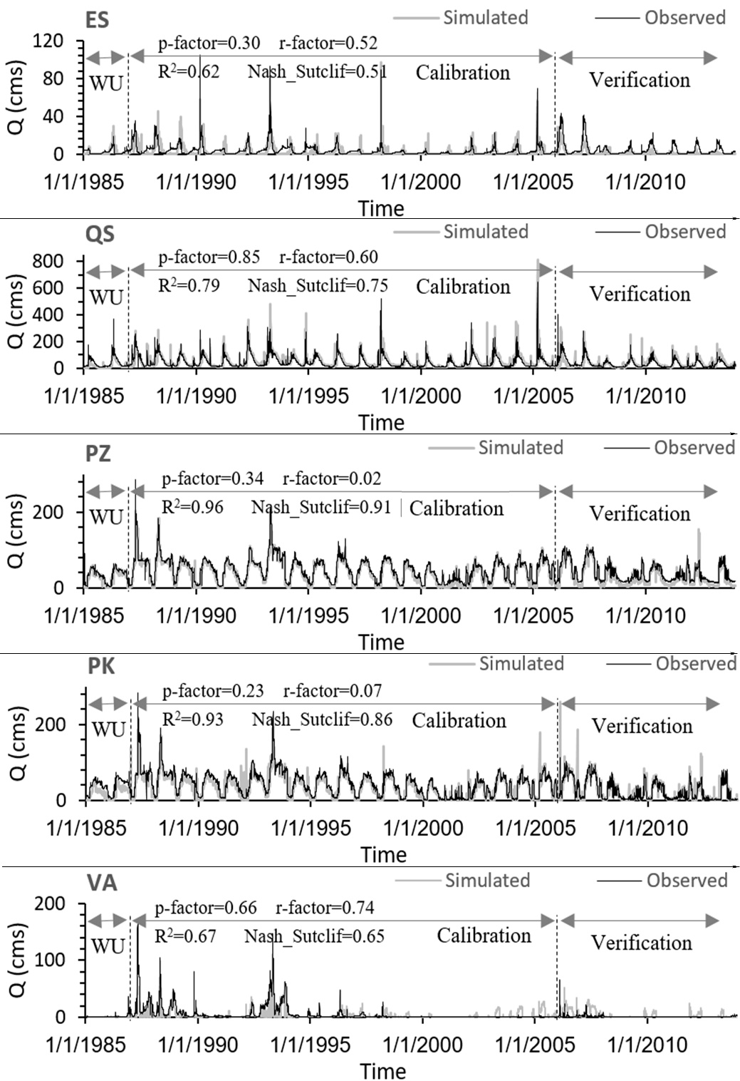
Figure S1. SWAT simulation in warm-up (WU), calibration and verification period along the Zayandeh-Rud river; ES: Eskandari, QS: Qale-Shahrokh, PZ: Pole-Zamankhan, PK: Pole-Kalle, VA: Varzanah.

Table S1. Summary of Indicators of Hydrologic Alteration (IHA) variables (Poff et al. 1997; Richter et al. 1997)
IHA group | IHA parameters | Environmental function
1. Magnitude of monthly water conditions | Mean value for each calendar month | The availability or suitability of habitat
2. Magnitude and duration of annual extreme water conditions | Annual minimum 1-day mean | Whether certain life-cycle requirements are met or can influence the degree of stress or mortality associated with extreme water conditions such as floods or droughts
2. Magnitude and duration of annual extreme water conditions | Annual minimum 3-day means
2. Magnitude and duration of annual extreme water conditions | Annual minimum 7-day means
2. Magnitude and duration of annual extreme water conditions | Annual minimum 30-day means
2. Magnitude and duration of annual extreme water conditions | Annual minimum 90-day means
2. Magnitude and duration of annual extreme water conditions | Annual maximum 1-day mean
2. Magnitude and duration of annual extreme water conditions | Annual maximum 3-day means
2. Magnitude and duration of annual extreme water conditions | Annual maximum 7-day means
2. Magnitude and duration of annual extreme water conditions | Annual maximum 30-day means
2. Magnitude and duration of annual extreme water conditions | Annual maximum 90-day means
2. Magnitude and duration of annual extreme water conditions | Number of zero-flow day
2. Magnitude and duration of annual extreme water conditions | Base flow index
3. Timing of annual extreme water conditions | Julian date of maximum | Reproduction/mortality events for various species (influencing population dynamics)
3. Timing of annual extreme water conditions | Julian date of minimum
4. Frequency and duration | Low pulse count | Whether a particular life-cycle phase can be completed
4. Frequency and duration | Low pulse duration | Whether a particular life-cycle phase can be completed
4. Frequency and duration | High pulse count | Whether a particular life-cycle phase can be completed
4. Frequency and duration | High pulse duration | Whether a particular life-cycle phase can be completed
5. Rate and frequency of water condition change | Rise rate | Stranding of certain organisms along the water’s edge or in ponded depressions
5. Rate and frequency of water condition change | Fall rate
5. Rate and frequency of water condition change | Number of reversals

Table S2. The changes in the natural flow regime due to climate variability in six monitoring stations (MCM/month); ZRD: Zayandeh-Rud dam
Month | Stations |  |  |  |  |  | Inflow into the ZRD
Month | Eskandari | Qale-Shahrokh | Pole-Zamankhan | Pole-Kalle | Musian | Varzanah | Inflow into the ZRD
Jan | 0.0 | -2.6 | -3.0 | -0.1 | 0.0 | 0.0 | -2.6
Feb | 0.0 | -5.6 | -1.1 | 0.0 | 0.0 | 0.0 | -5.6
Mar | -0.1 | -0.9 | -12.6 | -23.9 | -24.5 | -2.1 | -1.0
Apr | -3.4 | -4.9 | -0.5 | -0.1 | -3.6 | -3.5 | -8.3
May | -12.4 | 0.3 | -10.2 | -8.8 | -3.0 | -2.2 | -12.2
Jun | -4.7 | -23.6 | -51.3 | -48.1 | -27.0 | -5.0 | -28.3
July | -0.1 | -22.6 | -21.5 | -13.8 | -11.8 | -8.2 | -22.6
Aug | 0.0 | -3.6 | -3.4 | -0.4 | 0.0 | 0.0 | -3.6
Sep | 0.0 | -3.8 | -0.9 | 0.0 | 0.0 | 0.0 | -3.8
Oct | 0.0 | -2.5 | -0.8 | 0.0 | 0.0 | 0.0 | -2.5
Nov | 0.0 | -13.6 | -15.1 | -10.8 | 0.0 | 0.0 | -13.6
Dec | 0.0 | -2.4 | -2.7 | -3.8 | 0.0 | 0.0 | -2.3
Annual | -21 | -86 | -123 | -110 | -70 | -21 | -106.4

Table S3. The changes in the indicators of hydrologic alteration (group 2) due to climate variability in six monitoring stations
IHA group 2 | Stations
IHA group 2 | Eskandari | Qale-Shahrokh | Pole-Zamankhan | Pole-Kalle | Musian | Varzanah
1-day minimum (M³) | 86 | -174528 | -10109 | 13 | -39 | 43
3-day minimum (M³) | 69 | -181699 | -18101 | 8 | -40 | 43
7-day minimum (M³) | 63 | -192672 | -21050 | -3 | -40 | 41
30-day minimum (M³) | 30 | -184032 | -38051 | -32 | -50 | 39
90-day minimum (M³) | 115 | -174528 | -36893 | -7066 | -152 | 102
1-day maximum (M³) | -277344 | 2298240 | 69120 | 120960 | -380160 | 67392
3-day maximum (M³) | -293760 | -1209600 | -864000 | -578880 | -665280 | 34560
7-day maximum (M³) | -426816 | -2134080 | -1823040 | -1451520 | -1374624 | -76032
30-day maximum (M³) | -416448 | -449280 | 69120 | -25920 | -50112 | -61344
90-day maximum (M³) | -247968 | -60480 | -227232 | -204768 | -266976 | -114912
Number of zero days | 0 | 0 | 0 | 0 | 0 | 0
Base flow index | 0 | -0.03 | -0.01 | 0 | 0 | 0

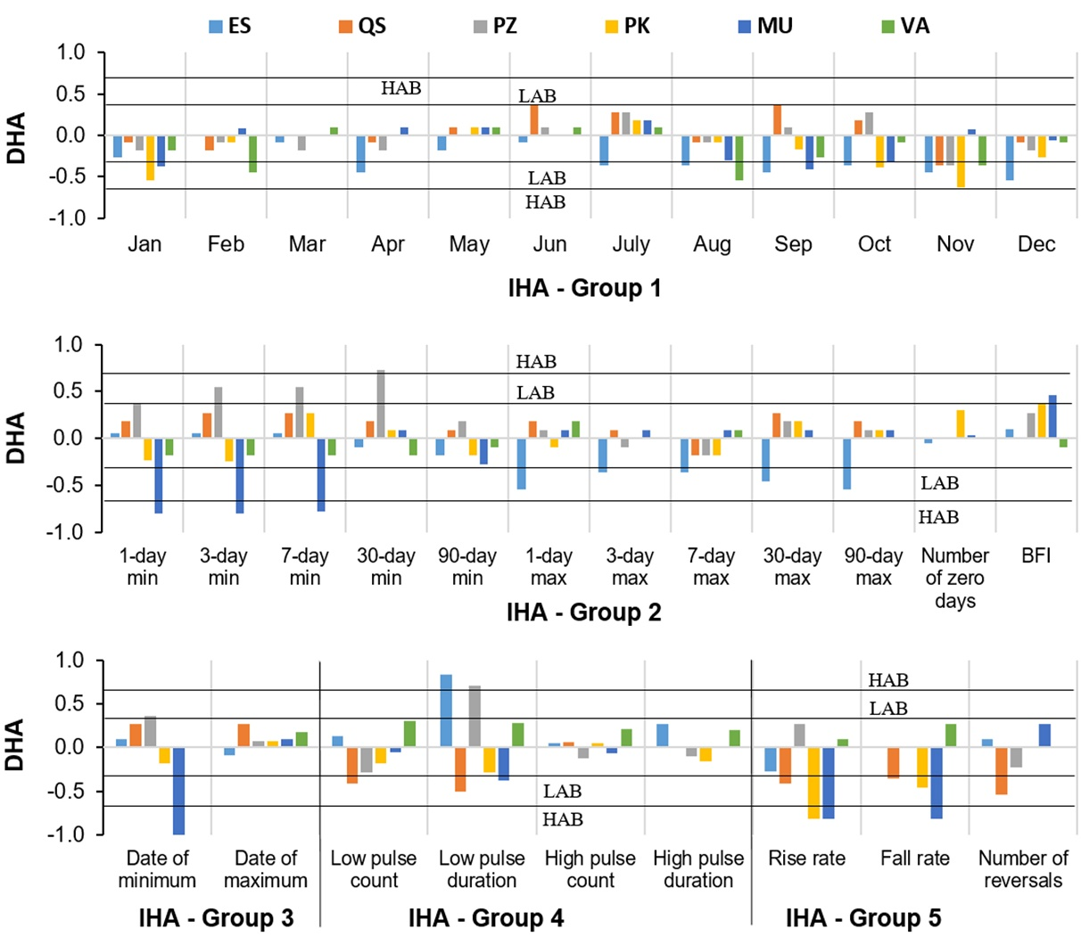
Figure S2. Degree of hydrologic alteration regarding the impact of climate variability on natural flow regime in six sections along the Zayandeh-Rud River basin, HAB: High alteration boundary, LAB: Low alteration boundary, ES: Eskandari, QS: Qale-Shahrokh, PZ: Pole-Zamankhan, PK: Pole-Kalle, MU: Musian, VA: Varzanah.

