Additional file 1 figures to:
Environmental drivers of seasonal shifts in abundance of wild pigs (Sus scrofa) in a tropical island environment
Authors: Derek R. Risch¹, Shaya Honarvar², Melissa R. Price¹

¹ University of Hawaiʻi at Mānoa, Natural Resources and Environmental Department. 1910 East-West Rd. Honolulu, HI 96822
² University of Hawaiʻi at Mānoa, Pacific Cooperative Studies Unit, 3190 Maile Way, Honolulu, HI 96822

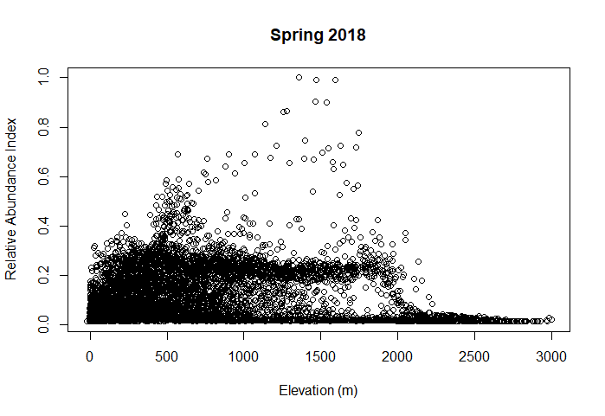
Additional file 1: Figure S1. Abundance estimates across the island of Maui from the best-fit spring model plotted against elevation. All black dots represent a single abundance estimate for each 500 x 500 m cell.

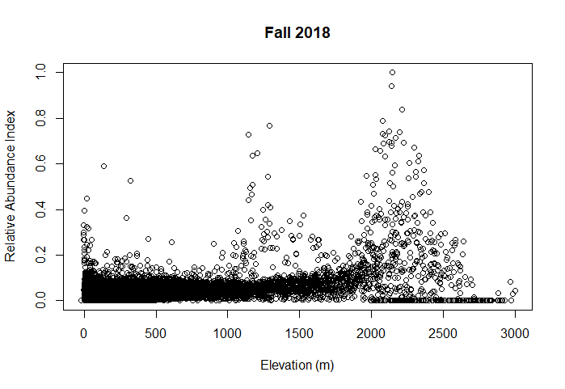
Additional file 1: Figure S1. Abundance estimates across the island of Maui from the best-fit fall model plotted against elevation. All black dots represent a single abundance estimate for each 500 x 500 m cell.

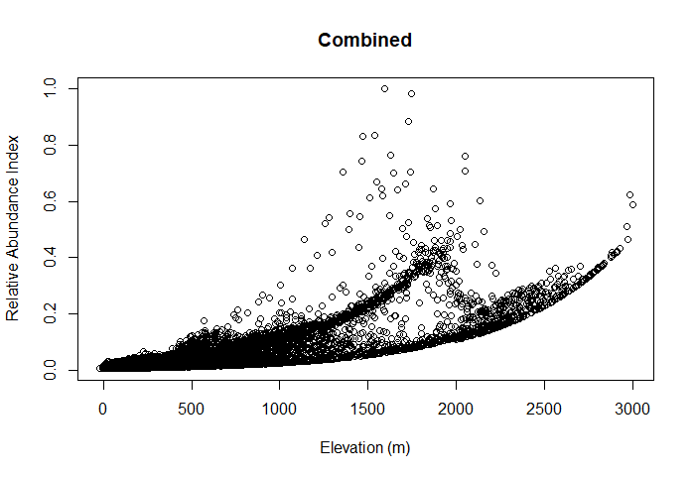
Additional file 1: Figure S1. Abundance estimates across the island of Maui from the best-fit combined model plotted against elevation. All black dots represent a single abundance estimate for each 500 x 500 m cell.

