Additional file 1

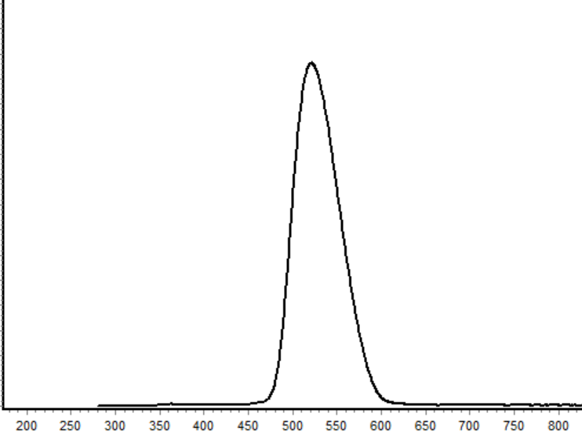  (a) | 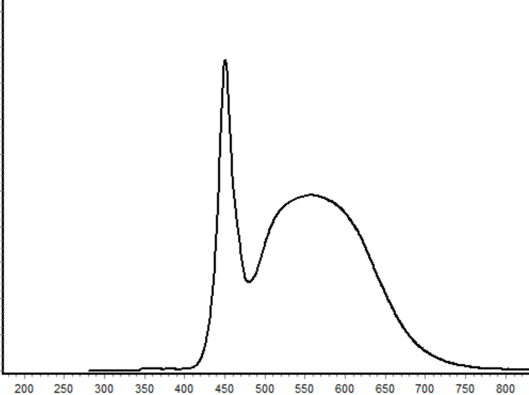  (b)
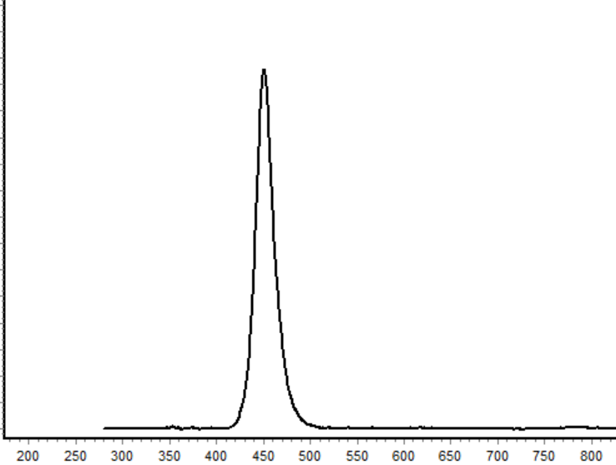  (c) | 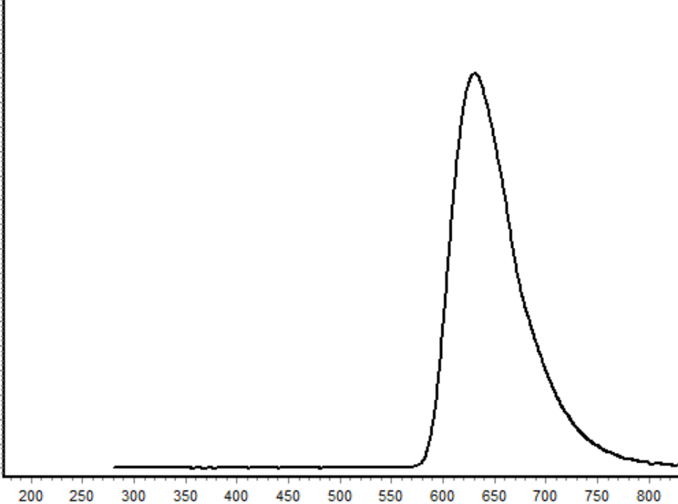  (d)  Wavelength (nm)

Figure. S1 Wave length distributions irradiated by green (a), white (b), blue (c), and red (d) LEDs.
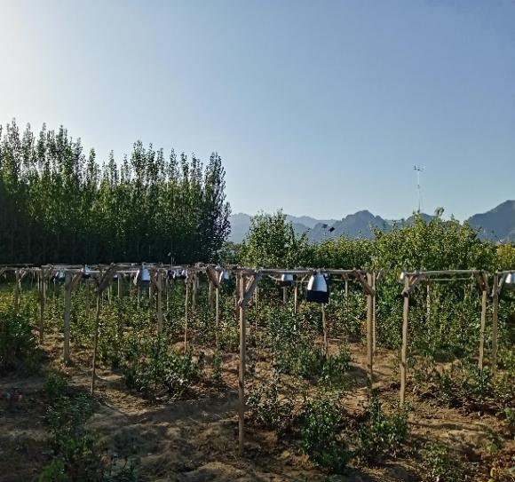  (a) | 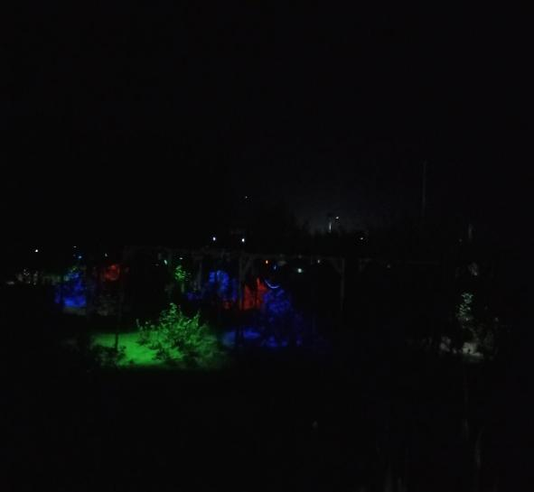  (b)
Figure. S2 Images of the field experiment at dawn (a) and night (b)
(note: the extra pots were used for other experiments, and did not cause cross influence in this study)

