Additional file 1
Table S1: CO₂ data for microcosms. Data represent the means and standard deviations (SD, shaded in light gray) based on triplicate sampling for each treatment, temperature, and time.

 |  | Day 0 |  | Day 4 |  | Day 11 |  | Day 18 |  | Day 25 |  | Day 32 |  | Day 39
Treatment | Temp. (ºC) | CO₂ (µg C / gdw) ± SD |  | CO₂ (µg C / gdw) ± SD |  | CO₂ (µg C / gdw) ± SD |  | CO₂ (µg C / gdw) ± SD |  | CO₂ (µg C / gdw) ± SD |  | CO₂ (µg C / gdw) ± SD |  | CO₂ (µg C / gdw) ± SD
1 | 10 | 1.20 | 0.08 | 21.32 | 5.87 | 11.67 | 2.46 | 17.22 | 14.21 | 18.23 | 6.70 | 10.41 | 7.54 | 5.36 | 2.00
1 | 20 | 1.20 | 0.08 | 15.00 | 4.97 | 13.49 | 2.24 | 2.86 | 3.51 | 6.46 | 5.59 | 11.72 | 13.40 | 13.97 | 14.81
1 | 30 | 1.20 | 0.08 | 24.49 | 1.39 | 16.72 | 1.02 | 39.28 | 26.85 | 75.14 | 22.27 | 38.24 | 17.03 | 25.28 | 21.02
2 | 10 | 20.61 | 0.11 | 4.32 | 0.60 | 3.35 | 0.75 | 10.89 | 6.85 | 9.88 | 6.24 | 8.99 | 4.69 | 9.82 | 3.90
2 | 20 | 20.61 | 0.11 | 12.06 | 2.39 | 8.36 | 2.65 | 27.23 | 11.31 | 21.27 | 15.60 | 20.23 | 7.58 | 16.91 | 12.52
2 | 30 | 20.61 | 0.11 | 19.00 | 1.58 | 13.85 | 1.82 | 47.33 | 9.34 | 45.69 | 3.28 | 37.98 | 1.40 | 24.98 | 8.16
3 | 10 | 20.61 | 0.11 | 10.54 | 1.41 | 7.24 | 1.31 | 21.59 | 4.37 | 19.44 | 4.61 | 18.97 | 5.52 | 48.63 | 58.86
3 | 20 | 20.61 | 0.11 | 17.17 | 2.17 | 8.25 | 1.97 | 33.01 | 7.56 | 28.34 | 6.28 | 22.71 | 4.10 | 18.51 | 6.46
3 | 30 | 20.61 | 0.11 | 22.72 | 2.39 | 12.36 | 1.20 | 60.07 | 14.71 | 53.19 | 10.21 | 40.45 | 3.82 | 38.77 | 2.75
4 | 10 | 20.61 | 0.11 | 8.25 | 0.54 | 8.30 | 0.56 | 23.47 | 0.81 | 21.10 | 1.24 | 13.15 | 6.68 | 17.52 | 4.67
4 | 20 | 20.61 | 0.11 | 26.53 | 1.00 | 17.32 | 1.16 | 48.37 | 1.95 | 42.10 | 3.14 | 37.17 | 4.87 | 42.80 | 5.77
4 | 30 | 20.61 | 0.11 | 33.44 | 3.89 | 17.36 | 3.45 | 65.83 | 16.46 | 62.89 | 15.27 | 59.09 | 13.55 | 54.01 | 14.89
5 | 10 | 20.61 | 0.11 | 3.61 | 0.25 | 3.74 | 0.44 | 13.36 | 1.62 | 12.16 | 0.36 | 10.80 | 1.01 | 11.76 | 0.24
5 | 20 | 20.61 | 0.11 | 11.41 | 3.39 | 9.96 | 3.00 | 25.39 | 19.48 | 29.79 | 7.00 | 19.24 | 14.37 | 19.16 | 13.50
5 | 30 | 20.61 | 0.11 | 15.78 | 1.06 | 11.66 | 0.43 | 50.39 | 4.51 | 42.37 | 7.90 | 37.28 | 3.75 | 28.57 | 16.38

Table S2: Gravimetric moisture data for microcosms. Data represent the means and standard deviations (SD, shaded in light gray) based on triplicate sampling for each treatment, temperature, and time.

 |  | Day 0 |  | Day 4 |  | Day 11 |  | Day 18 |  | Day 25 |  | Day 32 |  | Day 39
Treatment | Temp. (ºC) | Gravimetric moisture ± SD |  | Gravimetric moisture ± SD |  | Gravimetric moisture ± SD |  | Gravimetric moisture ± SD |  | Gravimetric moisture ± SD |  | Gravimetric moisture ± SD |  | Gravimetric moisture ± SD
1 | 10 | 0.14 | 0.00 | 0.15 | 0.03 | 0.14 | 0.01 | 0.15 | 0.02 | 0.13 | 0.01 | 0.14 | 0.01 | 0.18 | 0.02
1 | 20 | 0.14 | 0.00 | 0.15 | 0.01 | 0.14 | 0.00 | 0.15 | 0.00 | 0.15 | 0.00 | 0.15 | 0.00 | 0.18 | 0.01
1 | 30 | 0.14 | 0.00 | 0.17 | 0.00 | 0.17 | 0.01 | 0.16 | 0.01 | 0.17 | 0.02 | 0.16 | 0.01 | 0.17 | 0.01
2 | 10 | 0.15 | 0.00 | 0.17 | 0.02 | 0.16 | 0.01 | 0.17 | 0.02 | 0.17 | 0.02 | 0.16 | 0.02 | 0.20 | 0.03
2 | 20 | 0.15 | 0.00 | 0.17 | 0.01 | 0.17 | 0.02 | 0.17 | 0.01 | 0.16 | 0.01 | 0.16 | 0.01 | 0.18 | 0.02
2 | 30 | 0.15 | 0.00 | 0.16 | 0.01 | 0.18 | 0.01 | 0.17 | 0.02 | 0.16 | 0.01 | 0.16 | 0.01 | 0.18 | 0.01
3 | 10 | 0.15 | 0.00 | 0.17 | 0.01 | 0.17 | 0.01 | 0.17 | 0.02 | 0.17 | 0.01 | 0.16 | 0.01 | 0.21 | 0.03
3 | 20 | 0.15 | 0.00 | 0.17 | 0.02 | 0.16 | 0.01 | 0.17 | 0.01 | 0.16 | 0.02 | 0.16 | 0.01 | 0.19 | 0.02
3 | 30 | 0.15 | 0.00 | 0.17 | 0.02 | 0.15 | 0.01 | 0.16 | 0.01 | 0.16 | 0.01 | 0.16 | 0.01 | 0.18 | 0.00
4 | 10 | 0.15 | 0.00 | 0.17 | 0.01 | 0.15 | 0.00 | 0.16 | 0.01 | 0.15 | 0.00 | 0.15 | 0.01 | 0.20 | 0.01
4 | 20 | 0.15 | 0.00 | 0.17 | 0.01 | 0.18 | 0.02 | 0.17 | 0.01 | 0.17 | 0.01 | 0.18 | 0.01 | 0.22 | 0.01
4 | 30 | 0.15 | 0.00 | 0.17 | 0.01 | 0.18 | 0.03 | 0.17 | 0.01 | 0.17 | 0.02 | 0.17 | 0.01 | 0.18 | 0.00
5 | 10 | 0.15 | 0.00 | 0.16 | 0.00 | 0.16 | 0.01 | 0.16 | 0.01 | 0.15 | 0.00 | 0.16 | 0.01 | 0.19 | 0.01
5 | 20 | 0.15 | 0.00 | 0.19 | 0.02 | 0.17 | 0.01 | 0.18 | 0.01 | 0.17 | 0.02 | 0.18 | 0.01 | 0.19 | 0.01
5 | 30 | 0.15 | 0.00 | 0.15 | 0.00 | 0.15 | 0.01 | 0.15 | 0.00 | 0.15 | 0.01 | 0.15 | 0.01 | 0.17 | 0.00

Table S3: Tests for normality (Shapiro-Wilk) and results of one-way ANOVA testing for significant differences within each treatment and each temperature for CO₂ over time (days 0-39).

Shapiro-Wilk (p-value) | Treatment | Temp. (ºC) | p | F
N.S. | 1 | 10 | 0.035 | 3.176
0.012 | 1 | 20 | 0.272 | 1.428
0.03 | 1 | 30 | 0.003 | 5.8
0.007 | 2 | 10 | 0.005 | 5.36
N.S. | 2 | 20 | 0.287 | 1.386
0.03 | 2 | 30 | <0.0001 | 22.45
<0.0001 | 3 | 10 | 0.432 | 1.058
N.S. | 3 | 20 | 0.0006 | 8.126
N.S. | 3 | 30 | <0.0001 | 18.72
0.006 | 4 | 10 | <0.0001 | 11.75
0.04 | 4 | 20 | <0.0001 | 41.8
N.S. | 4 | 30 | 0.0003 | 9.439
0.01 | 5 | 10 | <0.0001 | 177.3
N.S. | 5 | 20 | 0.342 | 1.246
N.S. | 5 | 30 | <0.0001 | 11.93

Table S4: Cumulative N₂O data for microcosms. Data represent the means and standard deviations (SD, shaded in light gray) based on triplicate sampling for each treatment, temperature, and time.
 |  | Day 0 |  | Day 4 |  | Day 11 |  | Day 18 |  | Day 25 |  | Day 32 |  | Day 39
Treatment | Temp. (ºC) | N₂O (ppm) ± SD |  | N₂O (ppm) ± SD |  | N₂O (ppm) ± SD |  | N₂O (ppm) ± SD |  | N₂O (ppm) ± SD |  | N₂O (ppm) ± SD |  | N₂O (ppm) ± SD
1 | 10 | 0.4 | 0.0 | 0.8 | 0.1 | 1.2 | 0.1 | 1.7 | 0.1 | 2.1 | 0.1 | 2.5 | 0.2 | 3.0 | 0.2
1 | 20 | 0.4 | 0.0 | 2.6 | 2.3 | 6.1 | 3.0 | 12.3 | 7.2 | 21.9 | 14.9 | 36.8 | 35.4 | 46.9 | 48.7
1 | 30 | 0.4 | 0.0 | 24.1 | 4.4 | 38.3 | 5.0 | 70.5 | 20.9 | 97.6 | 23.2 | 113.0 | 34.9 | 119.4 | 39.9
2 | 10 | 0.4 | 0.0 | 1.2 | 0.2 | 1.8 | 0.2 | 2.9 | 0.6 | 3.7 | 0.9 | 4.9 | 1.8 | 5.9 | 2.7
2 | 20 | 0.4 | 0.0 | 12.8 | 3.9 | 15.0 | 4.6 | 22.9 | 11.8 | 28.0 | 17.1 | 31.9 | 21.0 | 34.2 | 23.4
2 | 30 | 0.4 | 0.0 | 18.0 | 7.2 | 22.2 | 8.2 | 36.1 | 18.4 | 42.7 | 21.5 | 49.7 | 22.7 | 52.2 | 23.9
3 | 10 | 0.4 | 0.0 | 5.3 | 2.8 | 6.4 | 3.4 | 9.3 | 3.1 | 12.3 | 2.7 | 15.5 | 1.9 | 22.5 | 8.3
3 | 20 | 0.4 | 0.0 | 19.0 | 6.6 | 22.8 | 7.8 | 29.5 | 9.3 | 32.8 | 10.1 | 36.9 | 13.5 | 39.9 | 16.7
3 | 30 | 0.4 | 0.0 | 59.2 | 8.9 | 69.1 | 13.0 | 86.1 | 17.8 | 99.4 | 24.8 | 110.6 | 33.5 | 117.7 | 41.4
4 | 10 | 0.4 | 0.0 | 2.3 | 0.2 | 3.2 | 0.2 | 5.8 | 0.6 | 7.7 | 0.9 | 9.4 | 2.0 | 13.1 | 6.1
4 | 20 | 0.4 | 0.0 | 15.4 | 10.7 | 28.0 | 12.8 | 97.1 | 48.9 | 127.5 | 62.7 | 155.6 | 66.6 | 305.7 | 33.6
4 | 30 | 0.4 | 0.0 | 54.9 | 22.0 | 79.3 | 27.9 | 174.2 | 51.8 | 261.8 | 53.2 | 555.8 | 71.0 | 879.3 | 114.6
5 | 10 | 0.4 | 0.0 | 1.2 | 0.2 | 1.8 | 0.5 | 3.4 | 1.9 | 5.7 | 4.3 | 8.3 | 5.4 | 13.2 | 7.0
5 | 20 | 0.4 | 0.0 | 2.9 | 1.7 | 4.1 | 1.6 | 6.3 | 1.0 | 8.2 | 1.7 | 9.3 | 1.9 | 10.4 | 2.3
5 | 30 | 0.4 | 0.0 | 15.4 | 2.6 | 21.7 | 2.7 | 49.3 | 21.5 | 58.0 | 25.1 | 60.7 | 24.8 | 62.5 | 24.3

Table S5: Cumulative CH₄ data for microcosms. Data represent the means and standard deviations (SD, shaded in light gray) based on triplicate sampling for each treatment, temperature, and time.

 |  | Day 0 |  | Day 4 |  | Day 11 |  | Day 18 |  | Day 25 |  | Day 32 |  | Day 39
Treatment | Temp. (ºC) | Cumulative CH₄ (ppm) ± SD |  | Cumulative CH₄ (ppm) ± SD |  | Cumulative CH₄ (ppm) ± SD |  | Cumulative CH₄ (ppm) ± SD |  | Cumulative CH₄ (ppm) ± SD |  | Cumulative CH₄ (ppm) ± SD |  | Cumulative CH₄ (ppm) ± SD
1 | 10 | 2.10 | 0.00 | 4.48 | 0.02 | 6.95 | 0.05 | 9.02 | 0.05 | 11.12 | 0.02 | 13.21 | 0.01 | 15.34 | 0.00
1 | 20 | 2.10 | 0.00 | 4.36 | 0.06 | 6.88 | 0.10 | 8.94 | 0.07 | 10.95 | 0.10 | 13.04 | 0.08 | 15.16 | 0.09
1 | 30 | 2.10 | 0.00 | 4.48 | 0.12 | 7.03 | 0.11 | 9.16 | 0.21 | 11.18 | 0.16 | 13.33 | 0.20 | 15.44 | 0.22
2 | 10 | 2.07 | 0.00 | 4.48 | 0.05 | 6.91 | 0.13 | 8.94 | 0.16 | 11.05 | 0.20 | 13.10 | 0.17 | 15.28 | 0.27
2 | 20 | 2.07 | 0.00 | 4.34 | 0.05 | 6.92 | 0.06 | 9.12 | 0.10 | 11.09 | 0.11 | 13.17 | 0.13 | 15.27 | 0.09
2 | 30 | 2.07 | 0.00 | 4.40 | 0.04 | 6.92 | 0.03 | 9.05 | 0.18 | 10.99 | 0.17 | 13.06 | 0.15 | 15.16 | 0.14
3 | 10 | 2.07 | 0.00 | 4.54 | 0.01 | 7.02 | 0.02 | 9.11 | 0.09 | 11.36 | 0.10 | 13.39 | 0.13 | 15.56 | 0.13
3 | 20 | 2.07 | 0.00 | 4.34 | 0.02 | 6.92 | 0.08 | 9.19 | 0.06 | 11.22 | 0.05 | 13.28 | 0.09 | 15.40 | 0.09
3 | 30 | 2.07 | 0.00 | 4.50 | 0.01 | 7.01 | 0.04 | 9.32 | 0.24 | 11.28 | 0.24 | 13.30 | 0.22 | 15.40 | 0.24
4 | 10 | 2.07 | 0.00 | 4.59 | 0.01 | 7.06 | 0.04 | 9.12 | 0.03 | 11.39 | 0.09 | 13.44 | 0.09 | 15.57 | 0.10
4 | 20 | 2.07 | 0.00 | 4.29 | 0.04 | 6.91 | 0.03 | 9.44 | 0.17 | 11.60 | 0.14 | 13.75 | 0.09 | 16.00 | 0.10
4 | 30 | 2.07 | 0.00 | 4.46 | 0.10 | 7.04 | 0.14 | 9.26 | 0.21 | 11.38 | 0.20 | 13.48 | 0.20 | 15.63 | 0.22
5 | 10 | 2.07 | 0.00 | 4.68 | 0.01 | 7.15 | 0.05 | 9.32 | 0.25 | 11.38 | 0.27 | 13.39 | 0.25 | 15.47 | 0.25
5 | 20 | 2.07 | 0.00 | 4.32 | 0.09 | 6.85 | 0.13 | 8.94 | 0.11 | 10.91 | 0.06 | 12.92 | 0.09 | 15.02 | 0.06
5 | 30 | 2.07 | 0.00 | 4.41 | 0.02 | 6.94 | 0.03 | 8.83 | 0.06 | 10.77 | 0.12 | 12.74 | 0.15 | 14.79 | 0.17

Table S6: Tests for normality (Shapiro-Wilk) and results of one-way ANOVA testing for significant differences within each treatment and each temperature for pH over time (days 0-39).

Shapiro-Wilk (p-value) | Treatment | Temp. (ºC) | ANOVA (p-value) | F
0.03 | 1 | 10 | <0.0001 | 26.24
<0.001 | 1 | 20 | <0.0001 | 61.21
0.004 | 1 | 30 | <0.0001 | 16.36
N.S. | 2 | 10 | 0.573 | 0.819
N.S. | 2 | 20 | 0.001 | 7.352
N.S. | 2 | 30 | 0.001 | 7.405
N.S. | 3 | 10 | <0.0001 | 67.41
<0.001 | 3 | 20 | <0.0001 | 152.7
<0.001 | 3 | 30 | 0.0013 | 7.083
<0.001 | 4 | 10 | <0.0001 | 445.3
N.S. | 4 | 20 | <0.0001 | 162.6
0.003 | 4 | 30 | <0.0001 | 22.45
N.S. | 5 | 10 | 0.675 | 0.672
N.S. | 5 | 20 | 0.00011 | 11.4
N.S. | 5 | 30 | 0.685 | 0.656

Table S7: Soil conductivity for each treatment and temperature over time. Values represent means ± standard deviations (SD, shaded in light gray) based on triplicate samples.

 |  | Day 0 |  | Day 4 |  | Day 11 |  | Day 18 |  | Day 25 |  | Day 32 |  | Day 39
Treatment | Temp. (ºC) | Conductivity (µS/cm) ± SD |  | Conductivity (µS/cm) ± SD |  | Conductivity (µS/cm) ± SD |  | Conductivity (µS/cm) ± SD |  | Conductivity (µS/cm) ± SD |  | Conductivity (µS/cm) ± SD |  | Conductivity (µS/cm) ± SD
1 | 10 | 224.5 | 3.0 | 219.6 | 12.3 | 181.4 | 3.3 | 205.2 | 22.3 | 182.5 | 30.5 | 191.0 | 22.7 | 183.3 | 42.2
1 | 20 | 224.5 | 3.0 | 162.9 | 12.1 | 188.4 | 17.6 | 186.6 | 14.3 | 169.4 | 17.7 | 182.6 | 17.0 | 190.0 | 1.2
1 | 30 | 224.5 | 3.0 | 231.6 | 30.5 | 191.6 | 43.0 | 257.9 | 20.4 | 220.1 | 35.3 | 241.6 | 48.5 | 201.8 | 48.4
2 | 10 | 144.7 | 9.6 | 150.6 | 44.1 | 181.7 | 49.9 | 210.8 | 31.4 | 228.7 | 48.9 | 219.3 | 50.8 | 241.6 | 36.6
2 | 20 | 144.7 | 9.6 | 135.1 | 32.9 | 267.8 | 54.5 | 247.9 | 55.9 | 274.8 | 39.0 | 292.9 | 67.0 | 318.5 | 29.4
2 | 30 | 144.7 | 9.6 | 248.1 | 69.0 | 335.2 | 5.2 | 331.0 | 99.7 | 282.3 | 83.2 | 299.2 | 34.6 | 329.4 | 72.4
3 | 10 | 144.7 | 9.6 | 185.8 | 44.7 | 216.5 | 50.4 | 273.3 | 53.5 | 307.4 | 47.6 | 366.3 | 34.0 | 371.2 | 54.6
3 | 20 | 144.7 | 9.6 | 136.4 | 90.5 | 397.5 | 84.5 | 448.1 | 45.3 | 393.2 | 115.9 | 452.5 | 63.2 | 441.2 | 50.8
3 | 30 | 144.7 | 9.6 | 291.1 | 78.3 | 390.5 | 107.2 | 461.3 | 125.1 | 359.1 | 57.3 | 465.9 | 160.5 | 460.6 | 73.3
4 | 10 | 144.7 | 9.6 | 975.0 | 151.0 | 1120.0 | 71.1 | 988.8 | 67.3 | 848.7 | 116.0 | 957.9 | 114.0 | 863.7 | 121.1
4 | 20 | 144.7 | 9.6 | 856.2 | 483.9 | 1182.9 | 347.1 | 1156.6 | 226.7 | 1258.1 | 352.4 | 1346.3 | 227.4 | 1440.7 | 88.5
4 | 30 | 144.7 | 9.6 | 1012.3 | 330.2 | 1342.7 | 237.5 | 1753.7 | 553.0 | 1516.3 | 107.6 | 1510.0 | 247.2 | 1644.3 | 152.3
5 | 10 | 144.7 | 9.6 | 115.0 | 9.8 | 117.0 | 9.7 | 136.6 | 28.0 | 144.9 | 15.5 | 121.1 | 36.8 | 148.2 | 8.6
5 | 20 | 144.7 | 9.6 | 85.2 | 62.0 | 191.7 | 29.7 | 194.0 | 51.8 | 214.5 | 56.6 | 183.7 | 131.6 | 229.9 | 56.1
5 | 30 | 144.7 | 9.6 | 101.0 | 20.8 | 141.2 | 49.0 | 239.9 | 92.8 | 197.5 | 148.4 | 161.4 | 68.3 | 162.7 | 20.7

Table S8: Tests for normality (Shapiro-Wilk) and results of one-way ANOVA testing for significant differences within each treatment and each temperature for conductivity over time (days 0-39).

Shapiro-Wilk (p-value) | Treatment | Temp. (ºC) | p | F
N.S. | 1 | 10 | 0.172 | 1.794
N.S. | 1 | 20 | 0.0021 | 6.391
N.S. | 1 | 30 | 0.374 | 1.174
N.S. | 2 | 10 | 0.0656 | 2.606
N.S. | 2 | 20 | <0.001 | 7.701
N.S. | 2 | 30 | 0.0264 | 3.448
N.S. | 3 | 10 | <0.0001 | 11.7
0.02 | 3 | 20 | <0.001 | 11.22
N.S. | 3 | 30 | 0.0116 | 4.298
<0.001 | 4 | 10 | <0.0001 | 29.33
0.003 | 4 | 20 | 0.0014 | 6.941
0.015 | 4 | 30 | <0.001 | 11.29
N.S. | 5 | 10 | 0.223 | 1.588
N.S. | 5 | 20 | 0.22 | 1.597
0.002 | 5 | 30 | 0.428 | 1.064

 |  | Day 4 |  | Day 11 |  | Day 18 |  | Day 25 |  | Day 32 |  | Day 39
Treatment | Temp. (ºC) | Nitrification potential rate (mg NO₂ gdw/day) ± SD |  | Nitrification potential rate (mg NO₂ gdw/day) ± SD |  | Nitrification potential rate (mg NO₂ gdw/day) ± SD |  | Nitrification potential rate (mg NO₂ gdw/day) ± SD |  | Nitrification potential rate (mg NO₂ gdw/day) ± SD |  | Nitrification potential rate (mg NO₂ gdw/day) ± SD
1 | 10 | 0.00 | 0.00 | 0.00 | 0.00 | 0.00 | 0.00 | 0.00 | 0.00 | 0.00 | 0.00 | 0.00 | 0.00
1 | 20 | 0.00 | 0.00 | 0.00 | 0.00 | 0.00 | 0.00 | 0.00 | 0.00 | 0.00 | 0.00 | 0.00 | 0.00
1 | 30 | 0.00 | 0.00 | 0.00 | 0.00 | 0.00 | 0.00 | 0.00 | 0.00 | 0.00 | 0.00 | 0.00 | 0.00
2 | 10 | 0.01 | 0.00 | 0.01 | 0.00 | 0.01 | 0.00 | 0.01 | 0.00 | 0.01 | 0.00 | 0.00 | 0.00
2 | 20 | 0.05 | 0.00 | 0.03 | 0.00 | 0.03 | 0.00 | 0.03 | 0.00 | 0.04 | 0.00 | 0.04 | 0.00
2 | 30 | 0.04 | 0.01 | 0.09 | 0.00 | 0.06 | 0.01 | 0.05 | 0.01 | 0.07 | 0.01 | 0.05 | 0.00
3 | 10 | 0.01 | 0.00 | 0.01 | 0.00 | 0.01 | 0.00 | 0.01 | 0.00 | 0.02 | 0.00 | 0.01 | 0.00
3 | 20 | 0.06 | 0.01 | 0.03 | 0.00 | 0.04 | 0.01 | 0.04 | 0.01 | 0.04 | 0.01 | 0.04 | 0.01
3 | 30 | 0.04 | 0.01 | 0.09 | 0.02 | 0.06 | 0.01 | 0.06 | 0.01 | 0.07 | 0.01 | 0.06 | 0.01
4 | 10 | 0.01 | 0.00 | 0.01 | 0.00 | 0.01 | 0.00 | 0.00 | 0.00 | 0.01 | 0.00 | 0.00 | 0.00
4 | 20 | 0.02 | 0.01 | 0.03 | 0.01 | 0.04 | 0.01 | 0.03 | 0.01 | 0.03 | 0.01 | 0.01 | 0.00
4 | 30 | 0.04 | 0.02 | 0.07 | 0.01 | 0.03 | 0.01 | 0.01 | 0.01 | 0.00 | 0.00 | -0.02 | 0.01
5 | 10 | 0.01 | 0.00 | 0.01 | 0.00 | 0.00 | 0.00 | 0.00 | 0.00 | 0.01 | 0.00 | 0.00 | 0.00
5 | 20 | 0.04 | 0.00 | 0.02 | 0.00 | 0.02 | 0.00 | 0.03 | 0.00 | 0.03 | 0.00 | 0.03 | 0.01
5 | 30 | 0.04 | 0.00 | 0.07 | 0.00 | 0.05 | 0.00 | 0.04 | 0.00 | 0.05 | 0.00 | 0.04 | 0.00
Table S9: Cumulative nitrification potential rate data for microcosms. Data represent the means and standard deviations (SD, shaded in light gray) based on triplicate sampling for each treatment, temperature, and time.

Shapiro-Wilk (p-value) | Treatment | Temp. (ºC) | p | F
N.S. | 1 | 10 | 0.007 | 5.316
N.S. | 1 | 20 | 0.006 | 5.63
N.S. | 1 | 30 | <0.0001 | 15.14
N.S. | 2 | 10 | 0.003 | 6.40
N.S. | 2 | 20 | 0.003 | 6.83
N.S. | 2 | 30 | 0.004 | 6.23
0.04 | 3 | 10 | 0.0002 | 12.26
N.S. | 3 | 20 | 0.067 | 2.71
N.S. | 3 | 30 | 0.14 | 2.03
N.S. | 4 | 10 | 0.0002 | 12.5
N.S. | 4 | 20 | 0.0009 | 8.68
N.S. | 4 | 30 | 0.044 | 3.121
N.S. | 5 | 10 | <0.0001 | 24.51
N.S. | 5 | 20 | 0.015 | 4.31
N.S. | 5 | 30 | 0.059 | 2.83

Table S10: Tests for normality (Shapiro-Wilk) and results of one-way ANOVA testing for significant differences within each treatment and each temperature for protein over time (days 0-39).

Table S11: Protein content of soils from each treatment and temperature over time. Values represent means ± standard deviations (SD, shaded in light gray) based on triplicate samples.

 |  | Day 0 |  | Day 4 |  | Day 11 |  | Day 18 |  | Day 25 |  | Day 32 |  | Day 39
Treatment | Temp. (ºC) | Protein (mg gdw⁻¹) ± SD |  | Protein (mg gdw⁻¹) ± SD |  | Protein (mg gdw⁻¹) ± SD |  | Protein (mg gdw⁻¹) ± SD |  | Protein (mg gdw⁻¹) ± SD |  | Protein (mg gdw⁻¹) ± SD |  | Protein (mg gdw⁻¹) ± SD
1 | 10 | 0.03 | 0.00 | 0.04 | 0.01 | 0.03 | 0.01 | 0.05 | 0.00 | 0.04 | 0.00 | 0.03 | 0.01 | 0.05 | 0.00
1 | 20 | 0.03 | 0.00 | 0.06 | 0.01 | 0.04 | 0.02 | 0.07 | 0.01 | 0.07 | 0.01 | 0.02 | 0.01 | 0.04 | 0.01
1 | 30 | 0.03 | 0.00 | 0.07 | 0.00 | 0.06 | 0.01 | 0.07 | 0.01 | 0.06 | 0.01 | 0.04 | 0.01 | 0.09 | 0.01
2 | 10 | 0.07 | 0.00 | 0.08 | 0.01 | 0.07 | 0.00 | 0.09 | 0.01 | 0.07 | 0.01 | 0.05 | 0.01 | 0.07 | 0.01
2 | 20 | 0.07 | 0.00 | 0.10 | 0.01 | 0.06 | 0.01 | 0.10 | 0.01 | 0.06 | 0.01 | 0.05 | 0.02 | 0.06 | 0.00
2 | 30 | 0.07 | 0.00 | 0.09 | 0.00 | 0.08 | 0.03 | 0.09 | 0.01 | 0.09 | 0.01 | 0.07 | 0.01 | 0.12 | 0.01
3 | 10 | 0.07 | 0.00 | 0.09 | 0.00 | 0.07 | 0.00 | 0.08 | 0.00 | 0.07 | 0.01 | 0.04 | 0.01 | 0.08 | 0.01
3 | 20 | 0.07 | 0.00 | 0.09 | 0.01 | 0.07 | 0.01 | 0.07 | 0.02 | 0.07 | 0.01 | 0.07 | 0.00 | 0.06 | 0.00
3 | 30 | 0.07 | 0.00 | 0.09 | 0.00 | 0.09 | 0.02 | 0.07 | 0.01 | 0.08 | 0.01 | 0.07 | 0.01 | 0.10 | 0.02
4 | 10 | 0.07 | 0.00 | 0.10 | 0.00 | 0.07 | 0.01 | 0.08 | 0.01 | 0.08 | 0.00 | 0.05 | 0.01 | 0.08 | 0.01
4 | 20 | 0.07 | 0.00 | 0.11 | 0.01 | 0.08 | 0.01 | 0.09 | 0.01 | 0.07 | 0.01 | 0.07 | 0.00 | 0.06 | 0.01
4 | 30 | 0.07 | 0.00 | 0.10 | 0.01 | 0.08 | 0.01 | 0.09 | 0.01 | 0.09 | 0.00 | 0.09 | 0.01 | 0.09 | 0.01
5 | 10 | 0.07 | 0.00 | 0.09 | 0.01 | 0.07 | 0.01 | 0.08 | 0.01 | 0.07 | 0.01 | 0.04 | 0.01 | 0.06 | 0.00
5 | 20 | 0.07 | 0.00 | 0.09 | 0.01 | 0.08 | 0.01 | 0.08 | 0.00 | 0.08 | 0.01 | 0.07 | 0.01 | 0.10 | 0.01
5 | 30 | 0.07 | 0.00 | 0.10 | 0.00 | 0.08 | 0.01 | 0.09 | 0.01 | 0.09 | 0.01 | 0.08 | 0.00 | 0.09 | 0.01

Table S12: Alpha diversity metrics of microbial communities in each library. Values are mean ± standard deviation (SD) of metrics (n = 3).

Day | Incubation Temperature | Treatment | Treatment description | Chao Estimate |  | Inverse Simpson Index
 |  |  |  | Mean | SD | Mean | SD
1 | N/A | C | Initial decomposition fluid | 491 | 23 | 3.13 | 0.07
1 | N/A | S | Initial soil | 5815 | 55 | 159.93 | 34.98
11 | 10°C | 1 | Carcass-only | 381 | 95 | 3.83 | 1.09
11 | 10°C | 2 | Soil-only | 5773 | 41 | 121.17 | 9.34
11 | 10°C | 3 | Carcass + soil | 5535 | 274 | 108.48 | 9.30
11 | 10°C | 4 | Nutrients | 5497 | 124 | 129.24 | 8.48
11 | 20°C | 1 | Carcass-only | 422 | 7 | 14.07 | 2.34
11 | 20°C | 2 | Soil-only | 5586 | 228 | 125.86 | 14.18
11 | 20°C | 3 | Carcass + soil | 5417 | 142 | 130.19 | 11.17
11 | 20°C | 4 | Nutrients | 5037 | 204 | 118.85 | 10.43
11 | 30°C | 1 | Carcass-only | 416 | 20 | 15.87 | 1.18
11 | 30°C | 2 | Soil-only | 5384 | 249 | 139.68 | 2.46
11 | 30°C | 3 | Carcass + soil | 5343 | 86 | 94.43 | 24.75
11 | 30°C | 4 | Nutrients | 4787 | 175 | 95.18 | 33.18
39 | 10°C | 1 | Carcass-only | 336 | 55 | 12.99 | 1.41
39 | 10°C | 2 | Soil-only | 5635 | 196 | 121.76 | 17.71
39 | 10°C | 3 | Carcass + soil | 5584 | 211 | 120.48 | 5.57
39 | 10°C | 4 | Nutrients | 5408 | 180 | 146.02 | 5.23
39 | 20°C | 1 | Carcass-only | 444 | 55 | 9.51 | 3.30
39 | 20°C | 2 | Soil-only | 5337 | 128 | 141.13 | 2.93
39 | 20°C | 3 | Carcass + soil | 5278 | 261 | 105.93 | 4.94
39 | 20°C | 4 | Nutrients | 4909 | 193 | 142.13 | 11.17
39 | 30°C | 1 | Carcass-only | 479 | 61 | 13.50 | 0.39
39 | 30°C | 2 | Soil-only | 5131 | 79 | 118.02 | 4.33
39 | 30°C | 3 | Carcass + soil | 4786 | 166 | 72.60 | 1.06
39 | 30°C | 4 | Nutrients | 4073 | 334 | 63.92 | 16.67

Table S13: Means testing for differences in alpha diversity metrics between treatments. *p < 0.05; **p < 0.01; ***p < 0.001.
Factors |  | Response: Chao | Response: InvSimpson
 | df | F | F
Full model
Day:Treatment:Temperature | 6 | 2.194* | 2.303*
Day 11
Treatment | 3 | 2124*** | 130.8***
Temperature | 2 | 11.33*** | 1.817
Treatment:Temperature | 6 | 2.971* | 3.203*
Day 39
Treatment | 3 | 1539*** | 355.1***
Temperature | 2 | 36.12*** | 62.15***
Treatment:Temperature | 6 | 8.958*** | 20.78***

Table S14: Proportion of the communities derived from the soil and carcass fluid sources, estimated using FEAST (Fast Expectation-Maximization for Microbial Source Tracking). Data are means and standard deviations (SD) of 3 microcosm replicates.

Day | Incubation  Temperature | Treatment | Treatment Description | Soil |  | Carcass |  | Unknown
 |  |  |  | Mean | SD | Mean | SD | Mean | SD
11 | 10°C | 1 | Carcass-only | 0.003 | 0.001 | 0.441 | 0.099 | 0.556 | 0.099
11 | 10°C | 2 | Soil-only | 0.914 | 0.018 | 0.001 | 0.001 | 0.085 | 0.018
11 | 10°C | 3 | Carcass + soil | 0.868 | 0.028 | 0.034 | 0.016 | 0.098 | 0.020
11 | 10°C | 4 | Nutrients | 0.920 | 0.007 | 0.001 | 0.001 | 0.079 | 0.007
11 | 20°C | 1 | Carcass-only | 0.190 | 0.007 | 0.550 | 0.030 | 0.260 | 0.079
11 | 20°C | 2 | Soil-only | 0.945 | 0.050 | 0.001 | 0.001 | 0.054 | 0.009
11 | 20°C | 3 | Carcass + soil | 0.930 | 0.009 | 0.003 | 0.002 | 0.067 | 0.002
11 | 20°C | 4 | Nutrients | 0.917 | 0.003 | 0.001 | 0.001 | 0.083 | 0.012
11 | 30°C | 1 | Carcass-only | 0.264 | 0.012 | 0.511 | 0.019 | 0.225 | 0.066
11 | 30°C | 2 | Soil-only | 0.938 | 0.085 | 0.001 | 0.001 | 0.062 | 0.016
11 | 30°C | 3 | Carcass + soil | 0.907 | 0.017 | 0.001 | 0.001 | 0.092 | 0.027
11 | 30°C | 4 | Nutrients | 0.909 | 0.028 | 0.001 | 0.001 | 0.090 | 0.024
39 | 10°C | 1 | Carcass-only | 0.053 | 0.025 | 0.620 | 0.042 | 0.327 | 0.094
39 | 10°C | 2 | Soil-only | 0.944 | 0.056 | 0.001 | 0.001 | 0.055 | 0.009
39 | 10°C | 3 | Carcass + soil | 0.917 | 0.009 | 0.007 | 0.002 | 0.076 | 0.004
39 | 10°C | 4 | Nutrients | 0.889 | 0.006 | 0.001 | 0.001 | 0.111 | 0.007
39 | 20°C | 1 | Carcass-only | 0.426 | 0.007 | 0.330 | 0.155 | 0.244 | 0.080
39 | 20°C | 2 | Soil-only | 0.932 | 0.100 | 0.001 | 0.001 | 0.067 | 0.022
39 | 20°C | 3 | Carcass + soil | 0.927 | 0.022 | 0.001 | 0.001 | 0.072 | 0.014
39 | 20°C | 4 | Nutrients | 0.907 | 0.014 | 0.001 | 0.001 | 0.092 | 0.030
39 | 30°C | 1 | Carcass-only | 0.589 | 0.030 | 0.204 | 0.112 | 0.207 | 0.049
39 | 30°C | 2 | Soil-only | 0.934 | 0.146 | 0.001 | 0.001 | 0.065 | 0.006
39 | 30°C | 3 | Carcass + soil | 0.882 | 0.043 | 0.001 | 0.001 | 0.117 | 0.043
39 | 30°C | 4 | Nutrients | 0.747 | 0.070 | 0.002 | 0.002 | 0.257 | 0.070

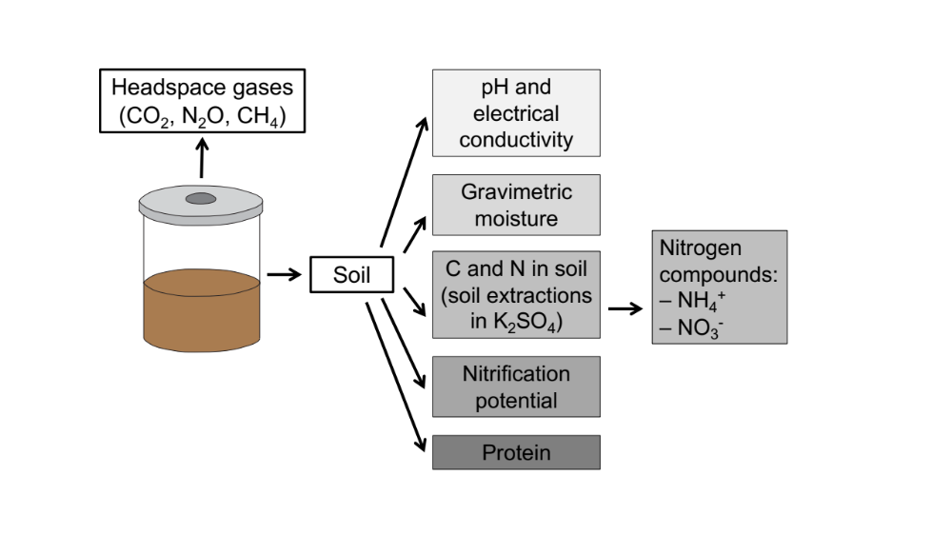
Fig. S1: Schematic diagram of the sampling protocol for each microcosm jar. At each time point, headspace gases were sampled, followed by soil sampling for downstream biogeochemical analyses. Soil for DNA extraction was flash-frozen.

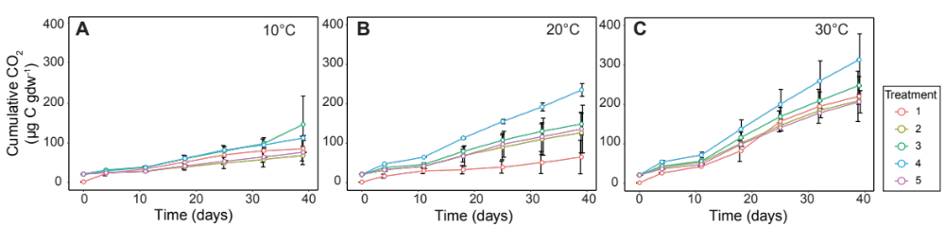

Fig. S2: Cumulative CO₂ release (µg gdw⁻¹) across all treatments, temperatures, and over time. Triplicate treatments were held at (A) 10°C, (B) 20°C, and (C) 30°C. Values are background-subtracted and normalized to soil gram dry weight (gdw). Values represent means and standard deviations (error bars).

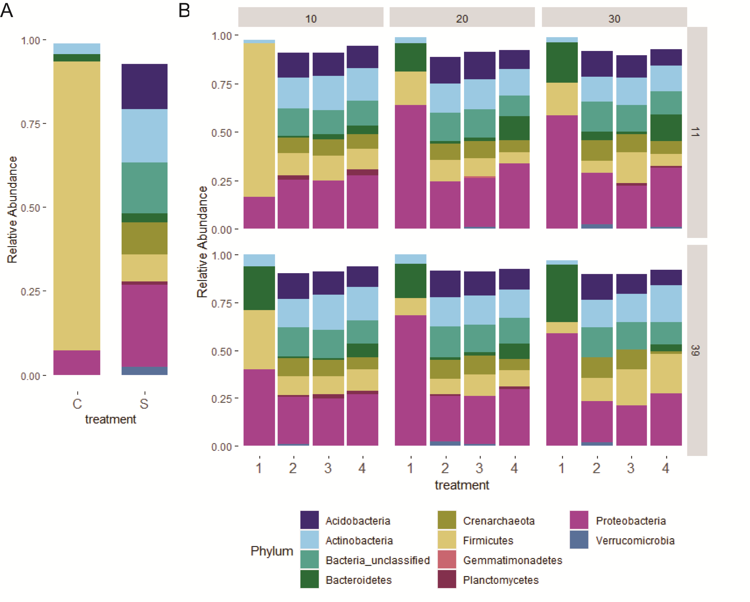
Fig. S3: Stacked bar charts showing mean (n = 3) relative abundance of bacterial phyla with a relative abundance > 1%. A) Initial carcass decomposition fluid (C) and soil (S) communities at the start of the experiment; B) Communities in the four treatments (1—carcass derived; 2—soil derived; 3—mixed; 4—inorganic nutrients) as a function of incubation temperature (10, 20, or 30 °C) on day 11 and day 39.

Fig. S4: Hierarchical clustering of group average Bray Curtis distances, relating Treatments 2 (soil only) and 3 (soil + carcass) to the initial decomposition communities (C). Samples are labelled according to sampling time (day 11 or day 39), Treatment (2—light blue or 3—dark blue), and temperature (10, 20 or 30°C). For example, sample “39230” was from day 39, Treatment 2, and 30°C.

