Additional file 1

Development of a phytoplankton-based index of biotic integrity for ecological health assessment in the Yangtze River

Wenqi Gao^{1, 2}, Fangyuan Xiong¹, Ying Lu¹, Xiao Qu¹, Wei Xin¹ and Yushun Chen^{1, 2,*}
¹ State Key Laboratory of Freshwater Ecology and Biotechnology, Institute of Hydrobiology, Chinese Academy of Sciences, Wuhan, Hubei, 430072, China
² University of Chinese Academy of Sciences, Beijing, 100049, China

* Correspondence: yushunchen@ihb.ac.cn (Y. Chen).
State Key Laboratory of Freshwater Ecology and Biotechnology, Institute of Hydrobiology, Chinese Academy of Sciences, Wuhan, Hubei, 430072, China.

Table S1 Site names, codes, and locations in the middle and lower Yangtze River
Segment name | ID | Longitude (E) | Latitude (N)
Yichang | S1 | 111.4791 | 30.4139
Zhijiang | S2 | 111.7637 | 30.4153
Jinzhou | S3 | 112.0539 | 30.2831
Shishou | S4 | 112.4078 | 30.0172
Jianli | S5 | 112.8605 | 29.7871
Yueyang | S6 | 112.9862 | 29.5008
Luchengzhen | S7 | 113.2668 | 29.5891
Luoshan | S8 | 113.3126 | 29.6413
Honghu | S9 | 113.7112 | 29.9277
Wuhan | S10 | 114.3545 | 30.6395
Tuanfeng | S11 | 114.7871 | 30.6185
Huangshi | S12 | 115.2604 | 30.1607
Wuxue | S13 | 115.6115 | 29.8427
Xinzhou | S14 | 115.7227 | 29.8243
Hukou | S15 | 116.2671 | 29.7879
Pengze | S16 | 116.5350 | 29.9052
Anqing | S17 | 117.0192 | 30.4952
Zongyang | S18 | 117.2361 | 30.6474
Tongling | S19 | 117.7708 | 30.9753
Wuwei | S20 | 118.0731 | 31.2131
Wuhu | S21 | 118.3476 | 31.4785
Maanshan | S22 | 118.4403 | 31.7043
Tongjingzhen | S24 | 118.8733 | 32.1801
Nanjing | S23 | 118.5339 | 31.8385
Zhenjiang | S25 | 119.3736 | 32.2278
Yangzhong | S26 | 119.8541 | 32.2785
Jingjiang | S27 | 120.3608 | 31.9738
Nantong | S28 | 120.9304 | 31.8184
Changshu | S29 | 121.0839 | 31.7387
Taicang | S30 | 121.2678 | 31.6121

Table S2 Monthly average water flow (m³/s) in wet and dry seasons of 2017-2018 and annual runoff (billions m³) during 2017-2018 and historical periods in the middle and lower Yangtze River
Station | Coordinates |  | Water Flow (m³/s) in 2017 |  | Water Flow (m³/s) in 2018 |  | Annual runoff (billion m³)
Station | Longitude (E) | Latitude (N) | Wet season | Dry season | Wet season | Dry season | 2017 | 2018 | Last 10 years average (2008-2018) | Multi-year average (1950-2015)
Yichang | 111.3207 | 30.6874 | 18927 | 8721 | 31206 | 7986 | 4403 | 4738 | 4214 | 4304
Shashi | 112.2342 | 30.3391 | 17923 | 8801 | 26685 | 8218 | 4096 | 4326 | 3879 | 3903
Chenglingji | 113.1572 | 29.4553 | 17013 | 3423 | 9610 | 5475 | / | / | / | /
Hankou | 114.3273 | 30.606 | 35995 | 14623 | 36235 | 15370 | 7373 | 6695 | 6869 | 7040
Jiujiang | 116.0002 | 29.7439 | 37127 | 15489 | 36268 | 15769 | / | / | / | /
Datong | 117.6386 | 30.7768 | 48161 | 18730 | 40845 | 19634 | 9378 | 8028 | 8852 | 8931
Note: “/” indicates missing data. Hydrological station information and monthly average water flow were obtained from the Hydrological Bureau of the Changjiang Water Resources Commission (http://www.cjh.com.cn/) , and annual runoff was obtained from the Changjiang Water Resources Commission of the Ministry of Water Resources (Changjiang Sediment Bulletin, http://www.cjw.gov.cn/).

Table S3 Biological and environmental conditions at reference sites in the middle and lower reaches of the Yangtze River during the wet and dry seasons of 2017-2018
Season | Reference sites | Parameter
Season | Reference sites | DO (mg/L) | COD (mg/L) | NH₃-N (mg/L) | TP (mg/L) | WQI | Habitat score | Shannon-Wiener index
Wet | S6 | 7.04 | 13.83 | 0.03 | 0.09 | 2.59 | 122 | 2.15
Wet | S11 | 6.06 | 7.76 | 0.01 | 0.12 | 2.23 | 133 | 2.25
Dry | S11 | 7.85 | 1.92 | 0.04 | 0.14 | 2.4 | 133 | 2.12
Dry | S19 | 7.99 | 7.49 | 0.10 | 0.05 | 2.33 | 130 | 2.35
Note: The WQI values were calculated according to the class III water quality grades of China’s surface water quality standards (GB3838-2002).

Table S4 Pearson’s correlation coefficients between candidate phytoplankton metrics in the middle and lower reaches of the Yangtze River in the wet season during 2017-2018
Candidate metric | M2 | M11 | M22 | M23 | M26
M2 | 1
M11 | 0.157 | 1
M22 | 0.207* | 0.714** | 1
M23 | -0.04 | 0.740** | 0.775** | 1
M26 | -0.054 | 0.855** | 0.770** | 0.920** | 1
Note: Coefficients with |r| > 0.70 were highlighted in bold.

Table S5 Pearson’s correlation coefficients between candidate phytoplankton metrics in the middle and lower reaches of the Yangtze River during the dry season during 2017-2018
Candidate metric | M1 | M2 | M3 | M5 | M7 | M8 | M9 | M10 | M13 | M17 | M19 | M22 | M24 | M25
M1 | 1
M2 | 0.636** | 1
M3 | 0.900** | 0.445** | 1
M5 | 0.086 | 0.758** | -0.073 | 1
M7 | -0.664** | -0.539** | -0.741** | -0.216 | 1
M8 | 0.740** | 0.570** | 0.697** | 0.162 | -0.422** | 1
M9 | 0.607** | 0.625** | 0.562** | 0.305** | -0.391** | 0.927** | 1
M10 | 0.792** | 0.360** | 0.844** | -0.072 | -0.494** | 0.755** | 0.564** | 1
M13 | 0.259* | 0.596** | 0.195 | 0.567** | -0.364** | 0.392** | 0.628** | 0.087 | 1
M17 | -0.267* | -0.591** | -0.192 | -0.556** | 0.387** | -0.391** | -0.625** | -0.091 | -0.993** | 1
M19 | 0.990** | 0.605** | 0.884** | 0.06 | -0.670** | 0.644** | 0.512** | 0.748** | 0.213 | -0.223 | 1
M22 | 0.561** | 0.228* | 0.508** | -0.117 | -0.303** | 0.581** | 0.300** | 0.627** | -0.177 | 0.162 | 0.513** | 1
M24 | 0.611** | 0.644** | 0.545** | 0.320** | -0.386** | 0.883** | 0.941** | 0.589** | 0.546** | -0.545** | 0.527** | 0.290* | 1
M25 | 0.487** | 0.193 | 0.530** | -0.09 | -0.300** | 0.450** | 0.255* | 0.716** | -0.064 | 0.075 | 0.458** | 0.694** | 0.266* | 1
Note: Coefficients with |r| > 0.70 were highlighted in bold.

Table S6 P-IBI component metrics and score calculation for the wet and dry seasons in the middle and lower reaches of the Yangtze River during 2017-2018
Season | Metric | Response to disturbance | 5th percentile | 95th percentile | Maximum value | Computational formula
Wet | M2 | - | 0 | 6 | 9 | M2/6
Wet | M22 | + | 0.0289 | 0.4398 | 0.6057 | (0.6057-M22)/(0.6057-0.0289)
Dry | M1 | - | 7 | 23 | 37 | M1/23
Dry | M5 | - | 0.0588 | 0.2900 | 0.4000 | M5/0.2900
Dry | M17 | - | 0.1720 | 0.9798 | 1.0000 | M17/0.9798
Dry | M22 | + | 0.0185 | 0.2225 | 0.3911 | (0.3911-M22)/(0.3911-0.0185)

Table S7 P-IBI results in the wet and dry seasons of the middle and lower reaches of the Yangtze River during 2017-2018
Sampling segment | Wet season | Dry season
S1 | 0.82 | /
S2 | 0.67 | 0.91
S3 | 0.80 | 0.81
S4 | 0.65 | 0.84
S5 | 0.95 | 0.82
S6 | 0.96 | 0.95
S7 | 0.62 | 0.94
S8 | 0.91 | 0.91
S9 | 0.63 | 0.90
S10 | 0.85 | 0.87
S11 | 0.99 | 0.85
S12 | 1.08 | 0.94
S13 | 0.95 | 0.97
S14 | 0.68 | 0.97
S15 | 0.94 | 0.87
S16 | 1.01 | /
S17 | 0.96 | 0.89
S18 | 0.27 | 0.98
S19 | 0.95 | 1.00
S20 | 0.56 | 0.89
S21 | 0.64 | /
S22 | 0.63 | 0.99
S23 | 0.97 | 0.93
S24 | 0.91 | 1.06
S25 | 0.77 | /
S26 | 0.90 | 0.87
S27 | 0.74 | 0.91
S28 | 0.96 | 0.86
S29 | 0.86 | /
S30 | 0.93 | 0.86
Average | 0.82 | 0.91
Note: “ / ” indicates that a river segment was not sampled during the dry season.

Table S8 Precipitation (mm) in sites along the middle and lower reaches of the Yangtze River during 2010-2018
Precipitation (mm) |  | 2010 | 2011 | 2012 | 2013 | 2014 | 2015 | 2016 | 2017 | 2018
Jingzhou | Wet season | / | / | 84.3 | 98.3 | 121.7 | 154.7 | 185.3 | 123.6 | 116.9
 | Dry season | / | / | 30.8 | 15.9 | 41.0 | 73.4 | 51.2 | 13.0 | 70.8
 | Annual total | / | / | 1045.1 | 1074.4 | 991 | 1278.5 | 1132.4 | 1144.2 | 988.8
Yueyang | Wet season | 231.5 | 57.5 | 98.0 | 96.8 | 169.1 | 121.1 | 172.2 | 150.8 | 100.8
 | Dry season | 32.0 | 24.0 | 113.5 | 57.4 | 70.7 | 61.3 | 82.1 | 34.7 | 89.1
 | Annual total | 1648.0 | 923.0 | 1587.0 | 1056.7 | 1403.4 | 1725.3 | 1278.3 | 1534 | 1257.5
Wuhan | Wet season | 236.7 | 116.1 | 188.7 | 226.1 | 148.5 | 182.4 | 420.0 | 110.5 | 105.5
 | Dry season | 14.9 | 19.7 | 31.5 | 28.0 | 71.5 | 61.5 | 57.6 | 13.1 | 93.2
 | Annual total | 1137.9 | 985.2 | 1253.6 | 1437.2 | 1995.3 | 1432.7 | 1810.0 | 1091.1 | 1110.4
Anqing | Wet season | 468.1 | 186.9 | 235.4 | 138.0 | 210.3 | 248.1 | 350.6 | 379.3 | 115.2
 | Dry season | 20.7 | 30.2 | 79.4 | 34.3 | 65.1 | 80.3 | 67.0 | 26.0 | 81.9
 | Annual total | 2044.1 | 1117.5 | 1561.6 | 1348.7 | 1471.7 | 1857.5 | 2427.5 | 1731.3 | 1238.1
Nanjing | Wet season | 242.7 | 281.2 | 187.4 | 172.6 | 211.2 | 222.7 | 278.0 | 158.4 | 228.0
 | Dry season | 15.8 | 18.6 | 54.6 | 13.9 | 50.9 | 61.5 | 80.6 | 8.5 | 91.5
 | Annual total | 1298.4 | 1077.0 | 917.2 | 898.4 | 1091.1 | 1765.6 | 1807.7 | 1255.1 | 1267.1
Note: “/” indicates missing data. Wet and dry season precipitation records are monthly averages. Precipitation data were extracted from online yearbooks for the provinces in which the sites are located (Jingzhou and Wuhan: http://tjj.hubei.gov.cn/; Yueyang: http://tjj.hunan.gov.cn/hntj/index.html; Anqing: http://tjj.ah.gov.cn/; Nanjing: http://tjj.nanjing.gov.cn/; Xiong et al., 2022).”

Fig.S1 Box plots of 5 candidate metrics between the reference and impaired sites in the wet season. Note: (a) M2, number of Cyanophyta species; (b) M11, Bacillariophyta density; (c) M22, total biomass; (d) M23, top three dominant species biomass; (e) M26, Bacillariophyta biomass

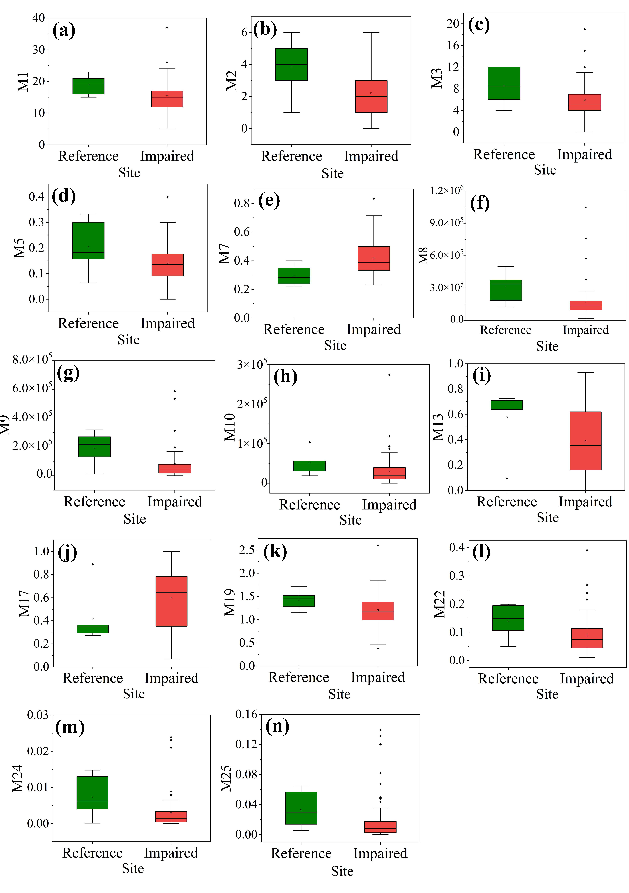
Fig.S2 Box plots of 14 candidate metrics between the reference and impaired sites in the dry season. Note: (a) M1, number of total species; (b) M2, number of Cyanophyta species; (c) M3, number of Chlorophyta species; (d) M5, % Cyanophyta species; (e) M7, % Bacillariophyta species; (f) M8, total density; (g) M9, Cyanophyta density; (h) M10, Chlorophyta density; (i) M13, % Cyanophyta density; (j) M17, % total density composed of Bacillariophyte and Chlorophyta; (k) M19, Margalef index; (l) M22, total biomass; (m) M24, Cyanophyta biomass; (n) M25, Chlorophyta biomass

References
Xiong F, Chen Y, Zhang S, Xu Y, Lu Y, Qu X, Gao W, Wu X, Xin W, Gang D, Lin L (2022) Land use, hydrology, and climate influence water quality of China’s largest river. J Environ Manage 318:115581. https://doi.org/10.1016/j.jenvman.2022.115581

