Supplemental Figures
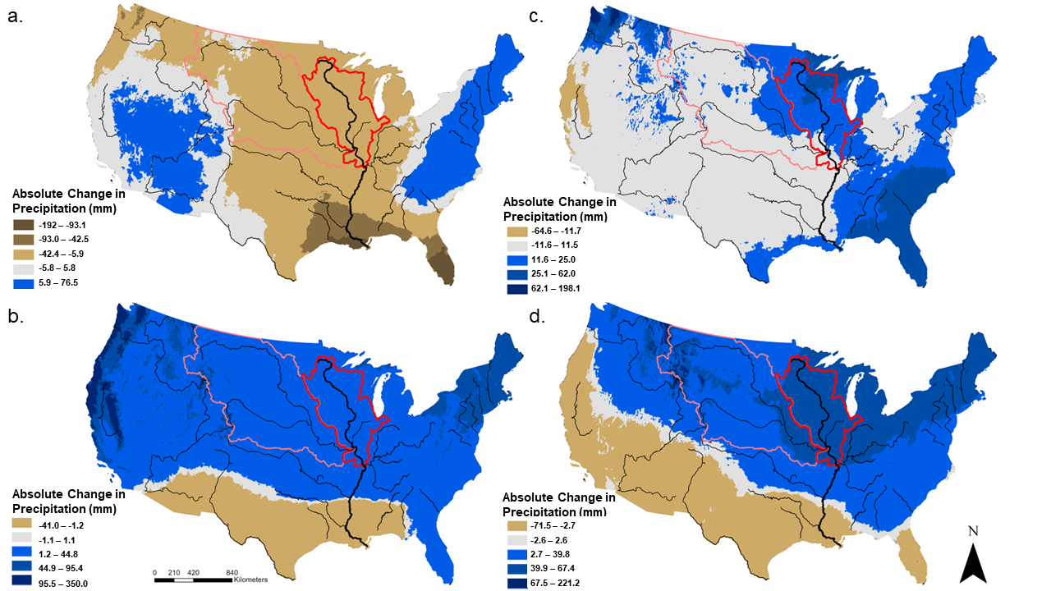
Figure S1. Absolute change in total precipitation from ensemble historical (1971 - 2000) and future (2070 - 2099) model predictions in A) Summer (June, July, August), B) Winter (December, January, February), C) Fall (September, October, November), and D) Spring (March, April, May). RCP 8.5 Climate forcings using from Taylor et al. 2010; Abatzoglou and Brown, 2012. The Missouri River tributary area is outlined in pink and the remaining Upper Mississippi watershed is outlined in red.

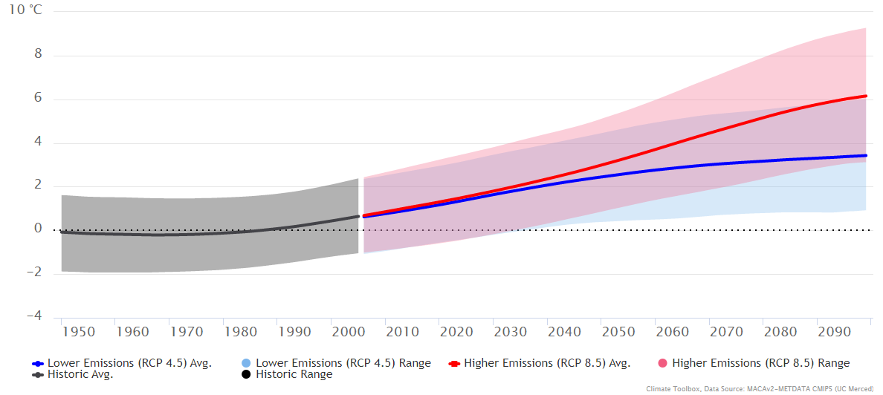
Figure S2. Annual Mean Temperature Anomaly from the 1950 - 2005 average (grey-demarcated period) of 20 CMIP5 climate models and 2 emissions scenarios (RCP 4.5 and 8.5), downscaled to a ~4-km resolution and selected to a rough rectangular area of the Upper Mississippi River mainstem 38.0179N to 45.9814N, 96.2695W to 89.4355W. Figure generated using Hegewisch, K.C., Abatzoglou, J.T., ' Future Time Series' web tool. Climate Toolbox (https://climatetoolbox.org/), accessed on 23 January 2023.
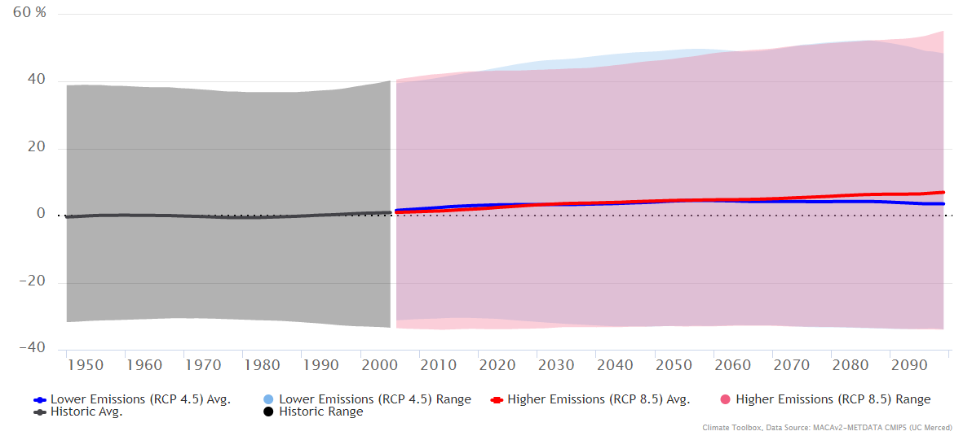
Figure S3. The Annual Total Precipitation as a percent difference from the 1950 - 2005 average (grey-demarcated period) of 20 CMIP5 climate models and 2 scenarios (RCP 4.5 and 8.5), downscaled to a ~4-km resolution and selected to a rough rectangular area of the Upper Mississippi River mainstem 38.02N to 45.98N, 96.27W to 89.44W. Figure generated using Hegewisch, K.C., Abatzoglou, J.T., ' Future Time Series' web tool. Climate Toolbox (https://climatetoolbox.org/), accessed on 23 January 2023.
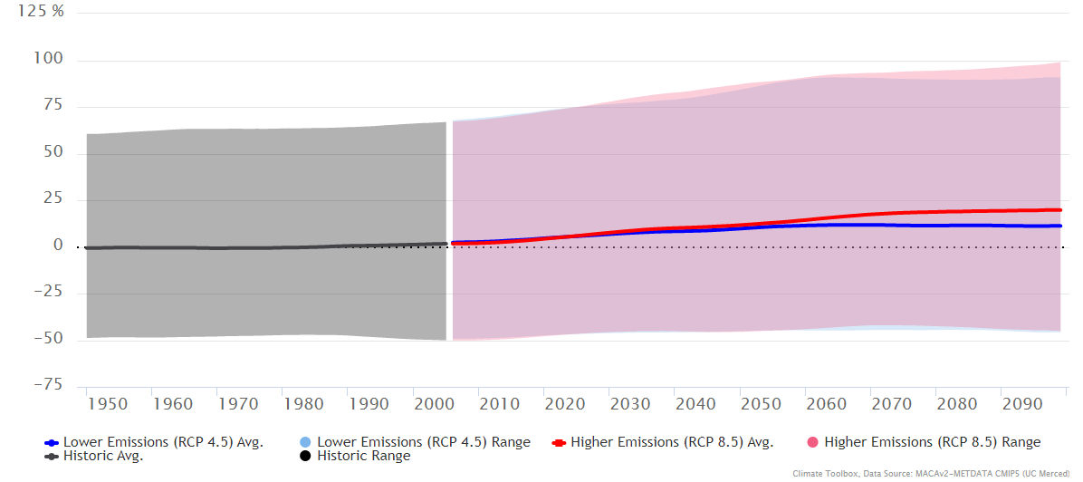
Figure S4. Spring (Mar, Apr, May) Total Precipitation as a percent difference from 1950 - 2005 average (grey-demarcated period) of projections from 20 CMIP5 climate models and 2 emission scenarios (RCP 4.5 and 8.5), downscaled to a ~4-km resolution and selected to a rough rectangular area of the Upper Mississippi River mainstem 38.0179N to 45.9814N, 96.2695W to 89.4355W. Figure generating using Hegewisch, K.C., Abatzoglou, J.T., ' Future Time Series' web tool. Climate Toolbox (https://climatetoolbox.org/), accessed on 23 January 2023.
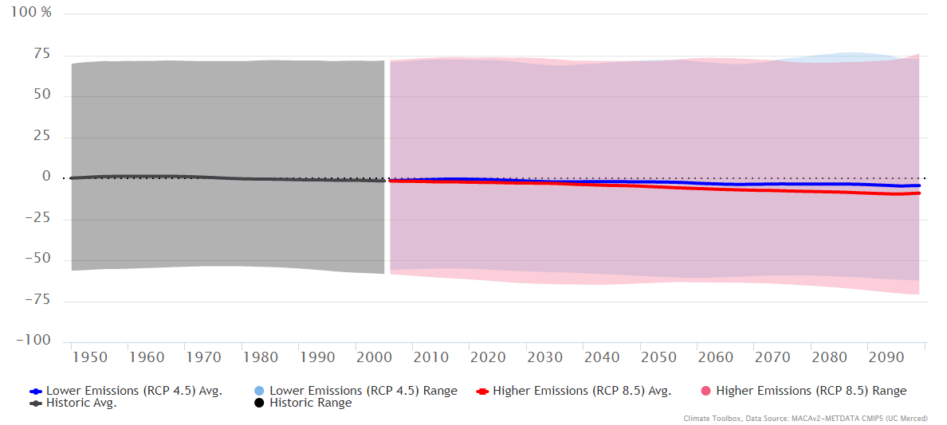
Figure S5. Summer (Jun, Jul, Aug) Total Precipitation as a percent difference from 1950 - 2005 average (grey-demarcated period) of projections from 20 CMIP5 climate models and 2 scenarios (RCP 4.5 and 8.5), downscaled to a ~4-km resolution and selected to a rough estimate rectangular area of the Upper Mississippi River mainstem 38.0179N to 45.9814N, 96.2695W to 89.4355W. Figure generated using Hegewisch, K.C., Abatzoglou, J.T., ' Future Time Series' web tool. Climate Toolbox (https://climatetoolbox.org/), accessed on 23 January 2023.

