Multi-scale habitat influences sprainting and group size of a freshwater-obligate Smooth-coated otter (Lutrogale perspicillata) in Tungabhadra Otter Conservation Reserve, India.

Journal: Ecological Processes
Ankit Moun¹, Ramesh Kumar P², Malathi Priya M³, Ramesh T¹⁴ , Riddhika Kalle^{14*}
¹Sálim Ali Centre for Ornithology and Natural History, Anaikatti, Coimbatore,
Tamil Nadu – 641108
²Deputy Conservator of Forests, Bellary Territorial Forest Division, Near Radio Park, Cowl Bazar, Bellary, Karnataka – 583104
³Deputy Conservator of Forests, Working Plan, and Survey and Research Wing, Bellary Territorial Forest Division, Near Radio Park, Cowl Bazar, Bellary, Karnataka – 583104
⁴Centre for Functional Biodiversity, University of KwaZulu-Natal, South Africa
*Corresponding Author Email: riddhikalle@gmail.com

Supplementary material: Figures
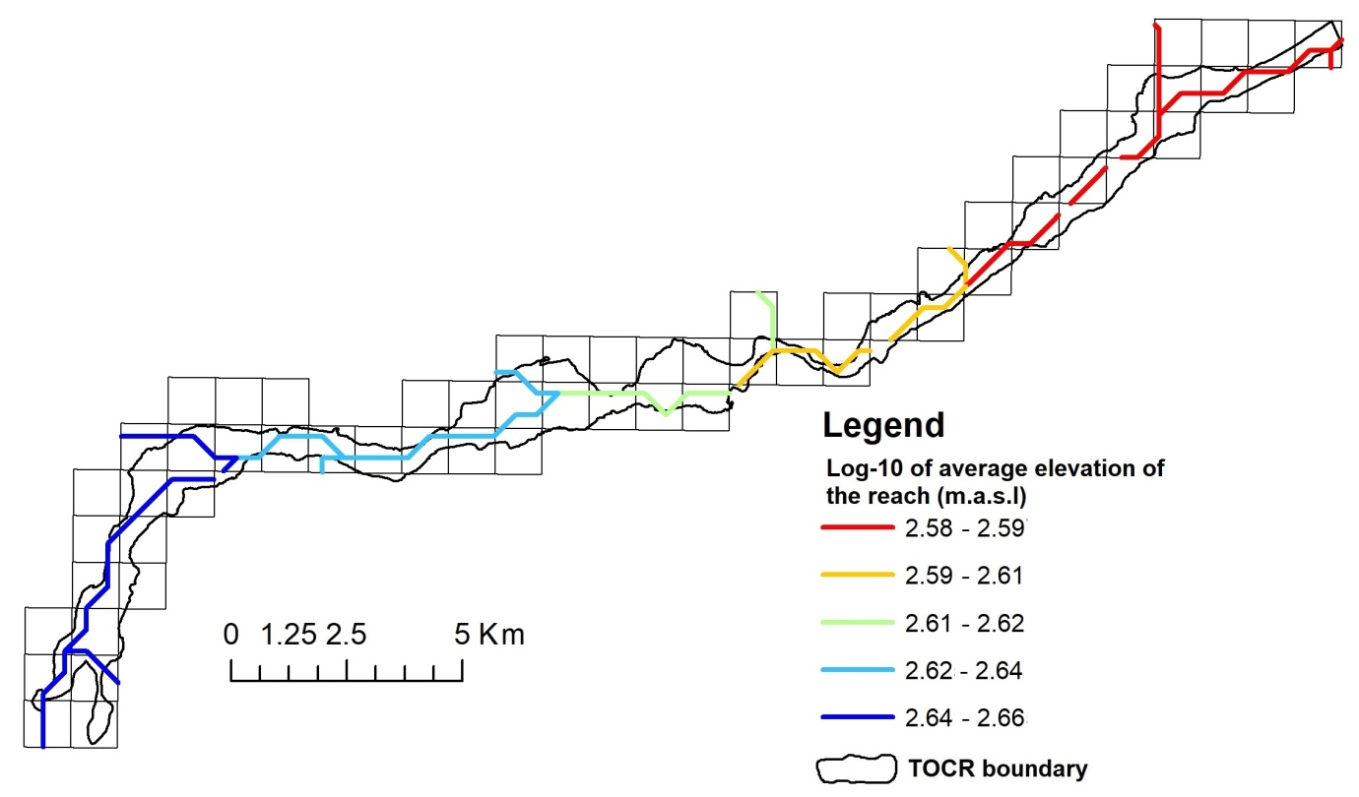
a)
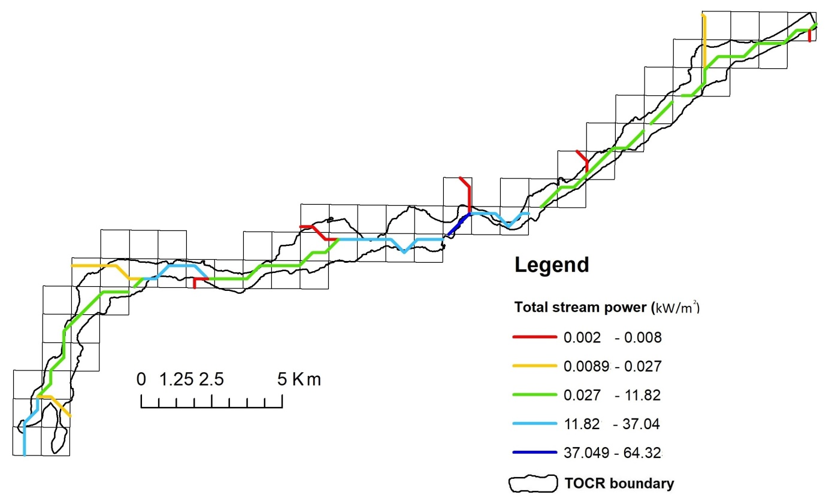
b)
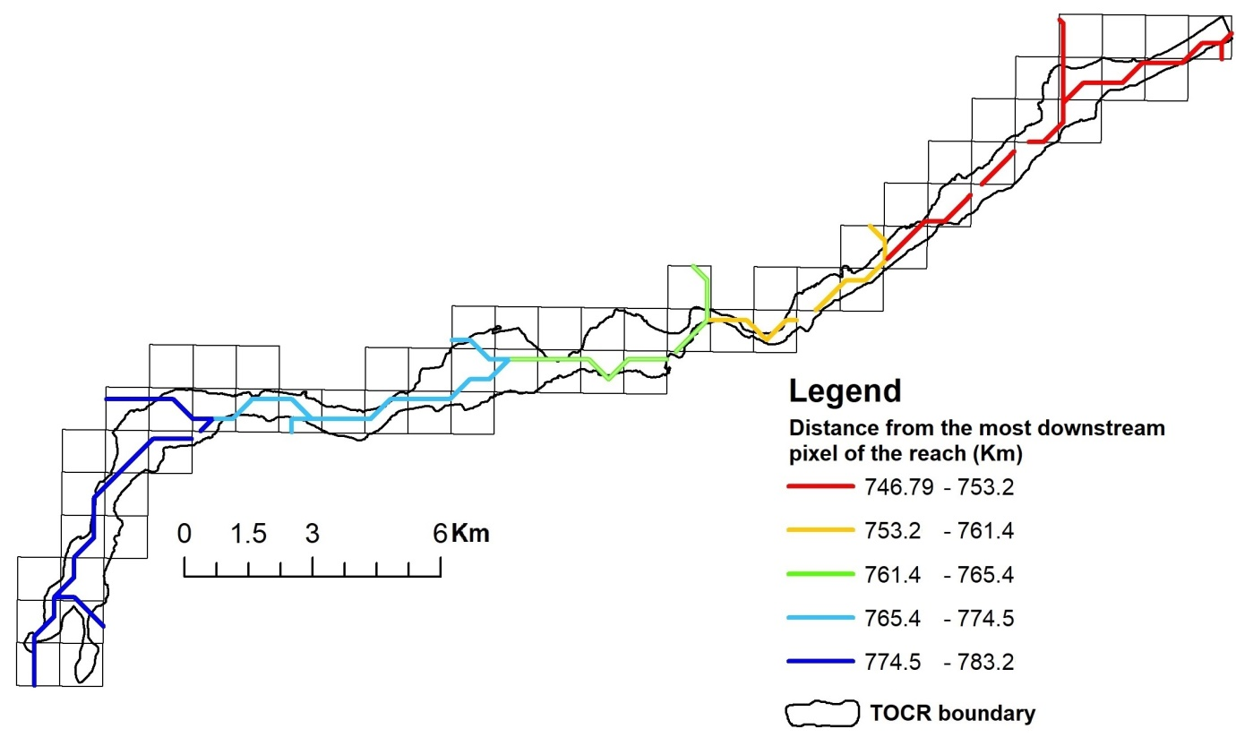
c)
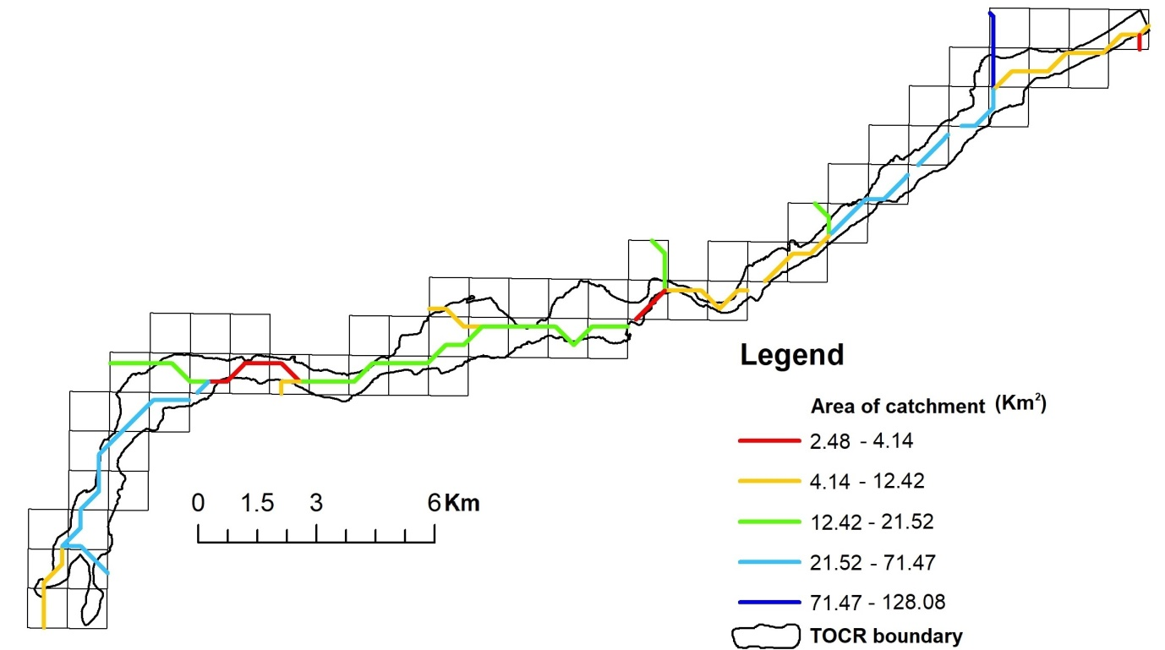
d)
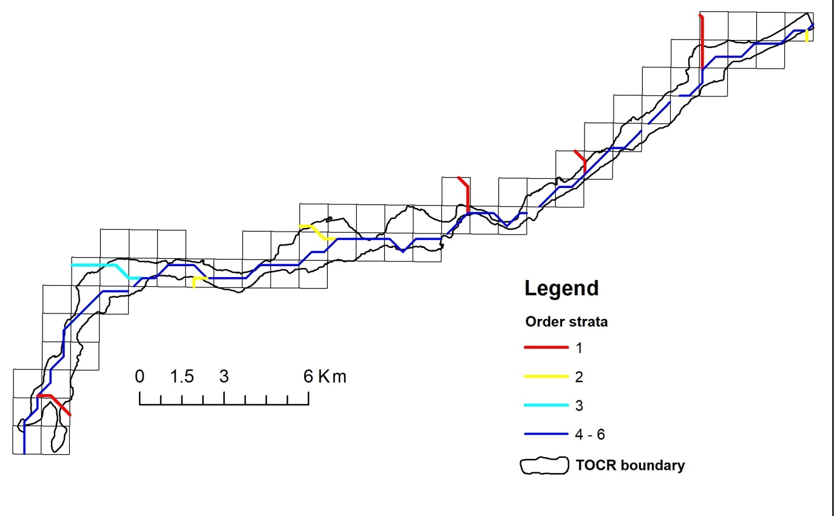
e)
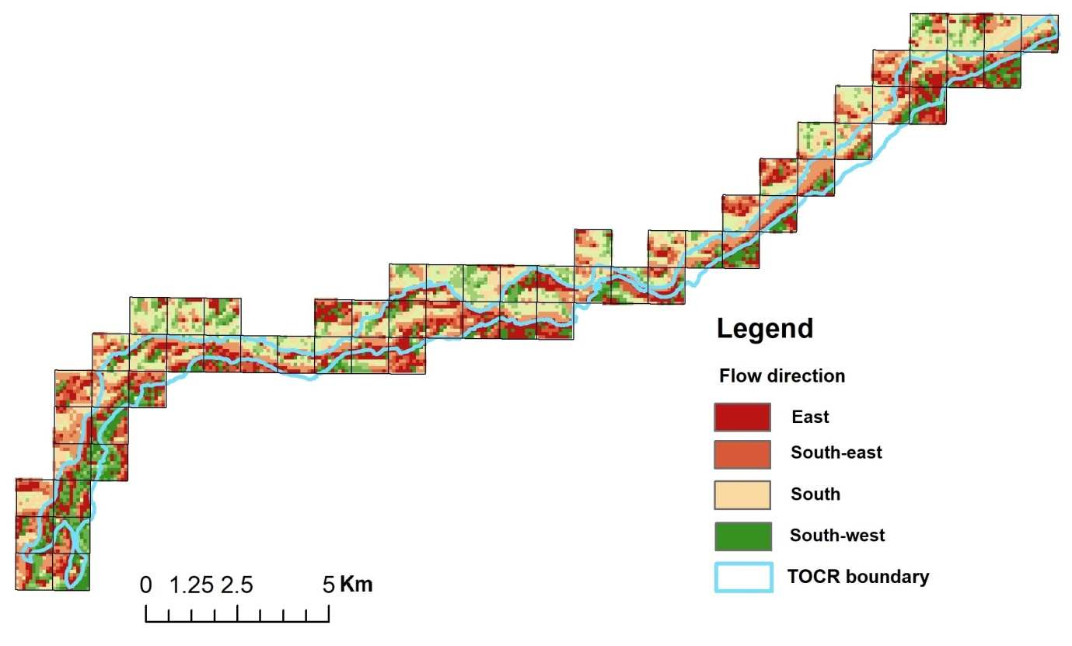
f)

g)
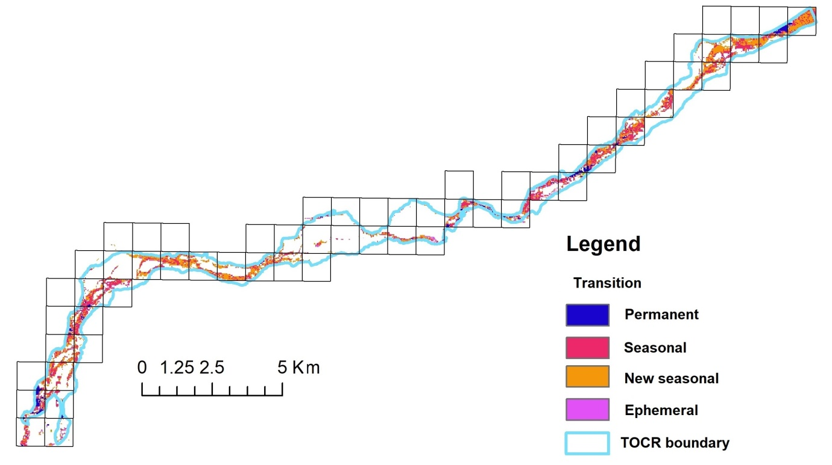
h)
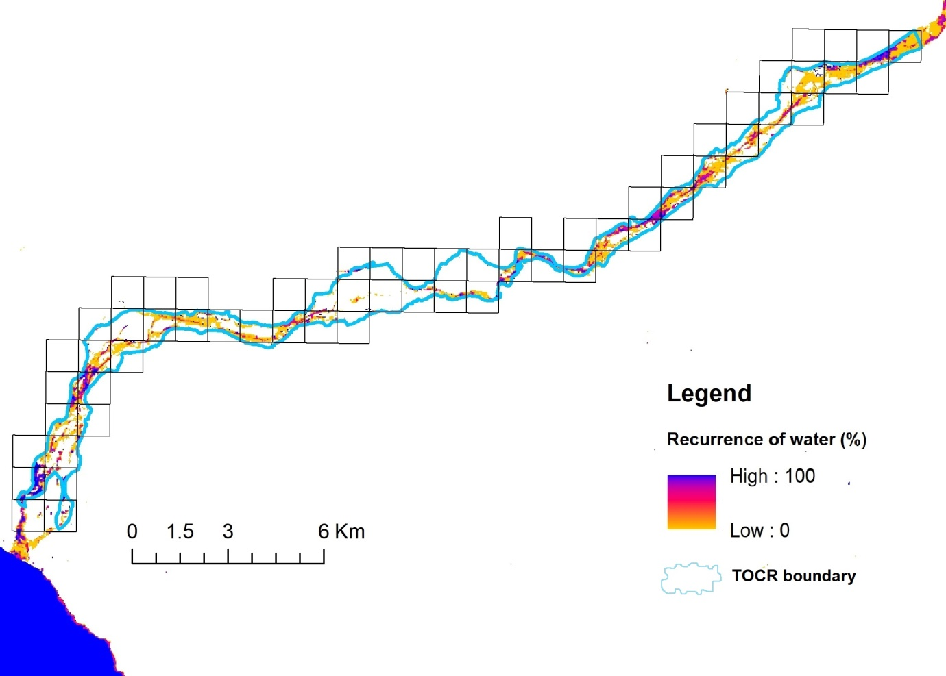
i)
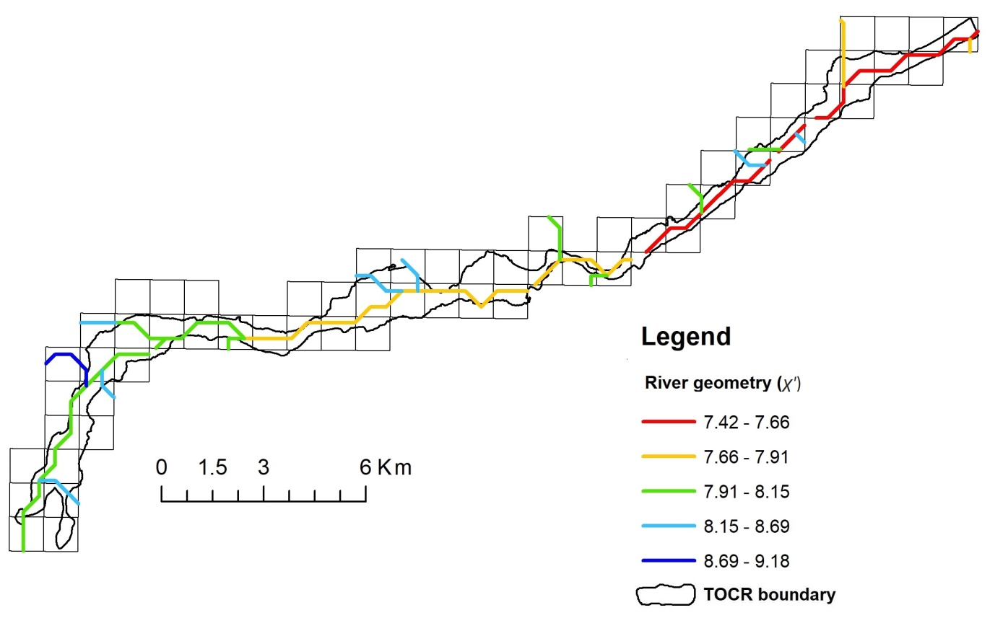
j)
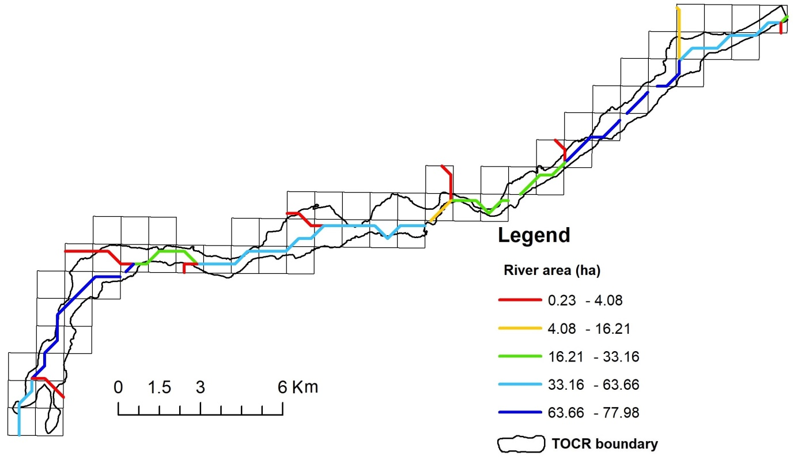
k)
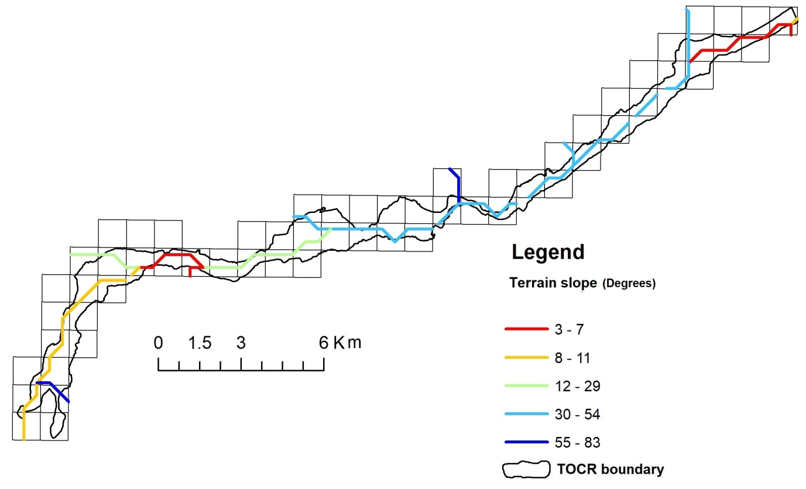
l)
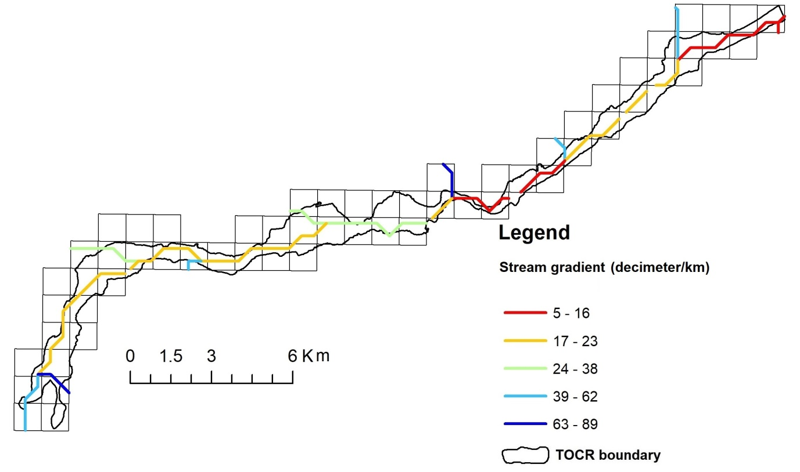
m)
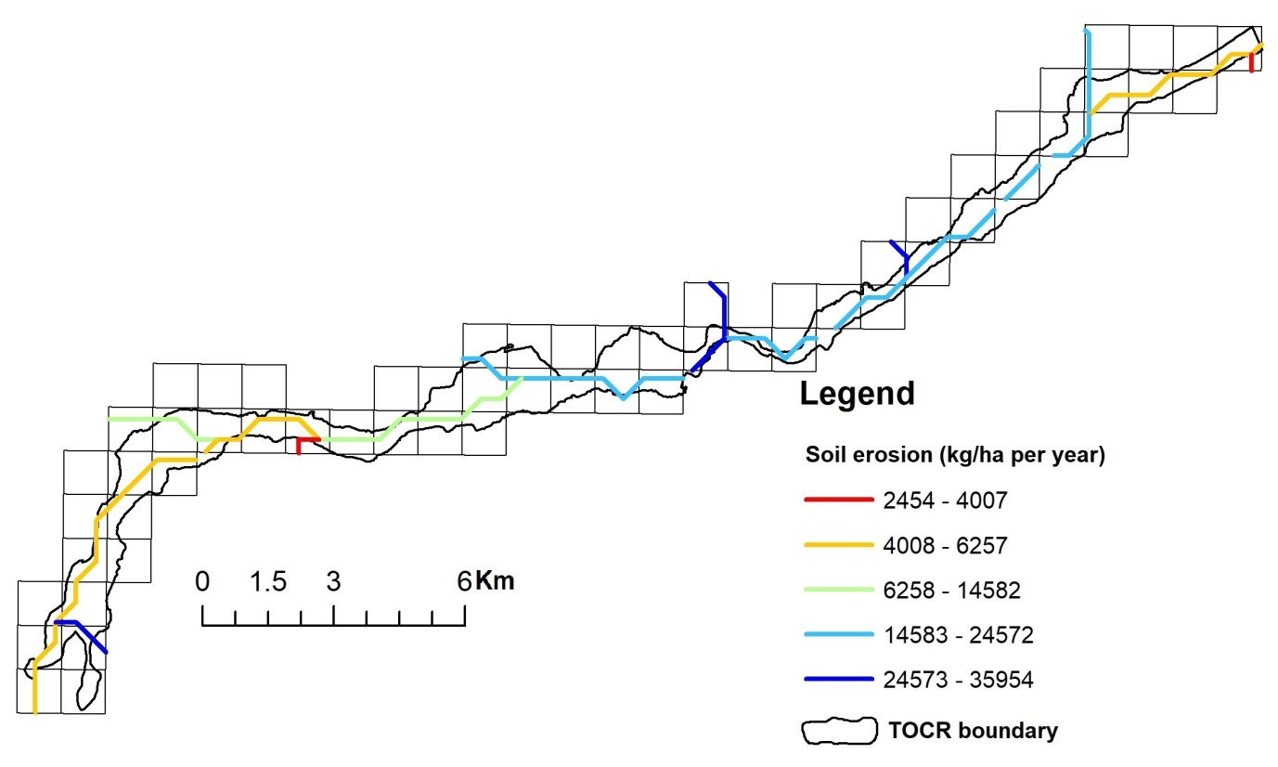
n)
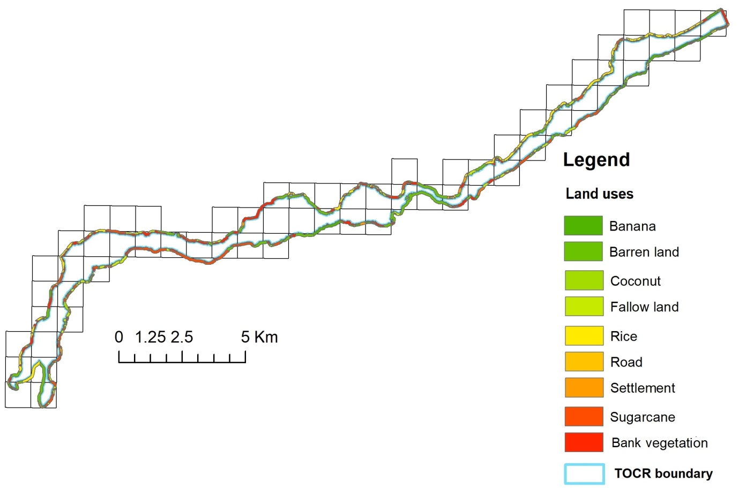
o)

Fig S1(a-o): Hydro-environmental variables from high-resolution remote-sensing data and land uses as landscape scale covariates for modelling smooth-coated otter site use in Tungabhadra Otter Conservation Reserve.

Fig S2: Pearson correlation matrix among local-scale and landscape-scale site covariates for modelling smooth-coated otter site use

a)
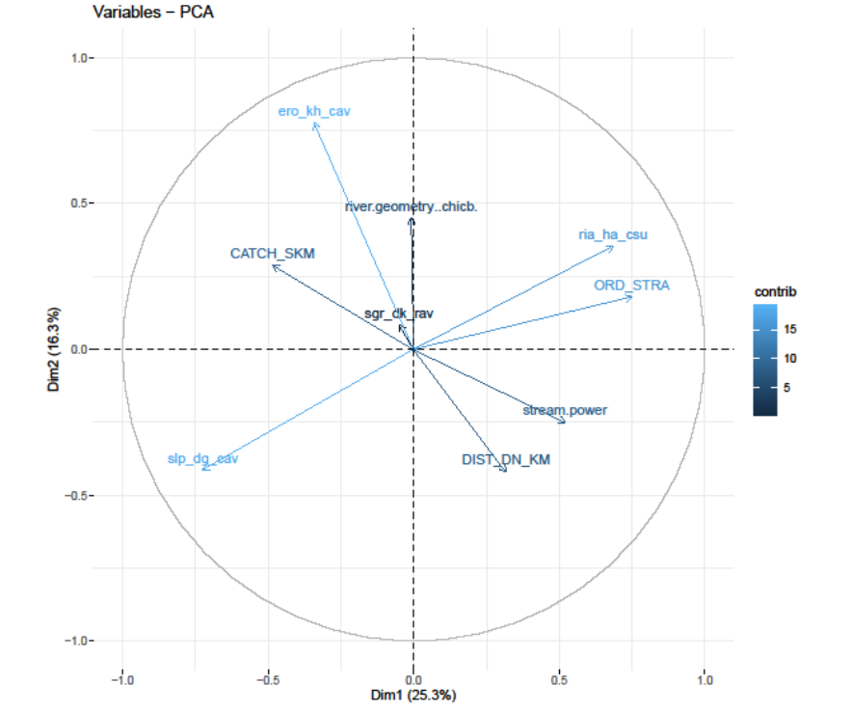

b)
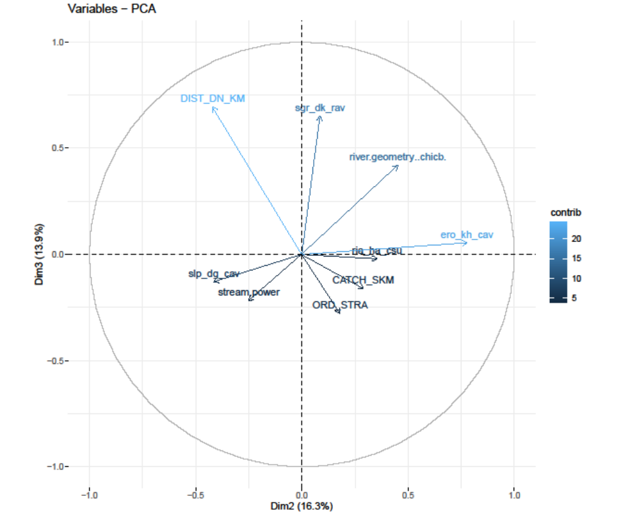

c)
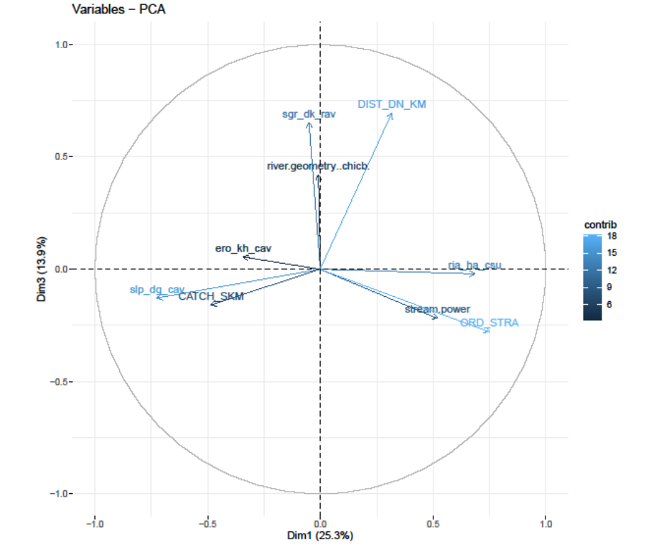

Fig S3(a-c): The varimax rotation from Principal Component Analysis of high resolution hydro-environmental variables along Tungabhadra Otter Conservation Reserve

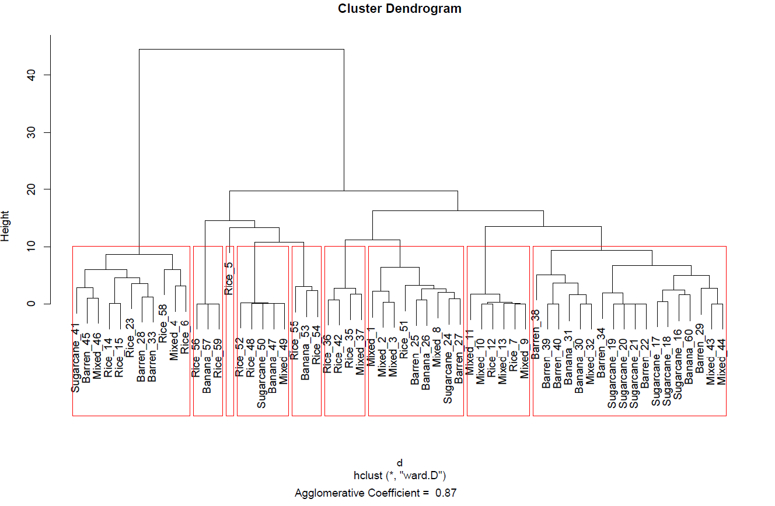
a)

b)
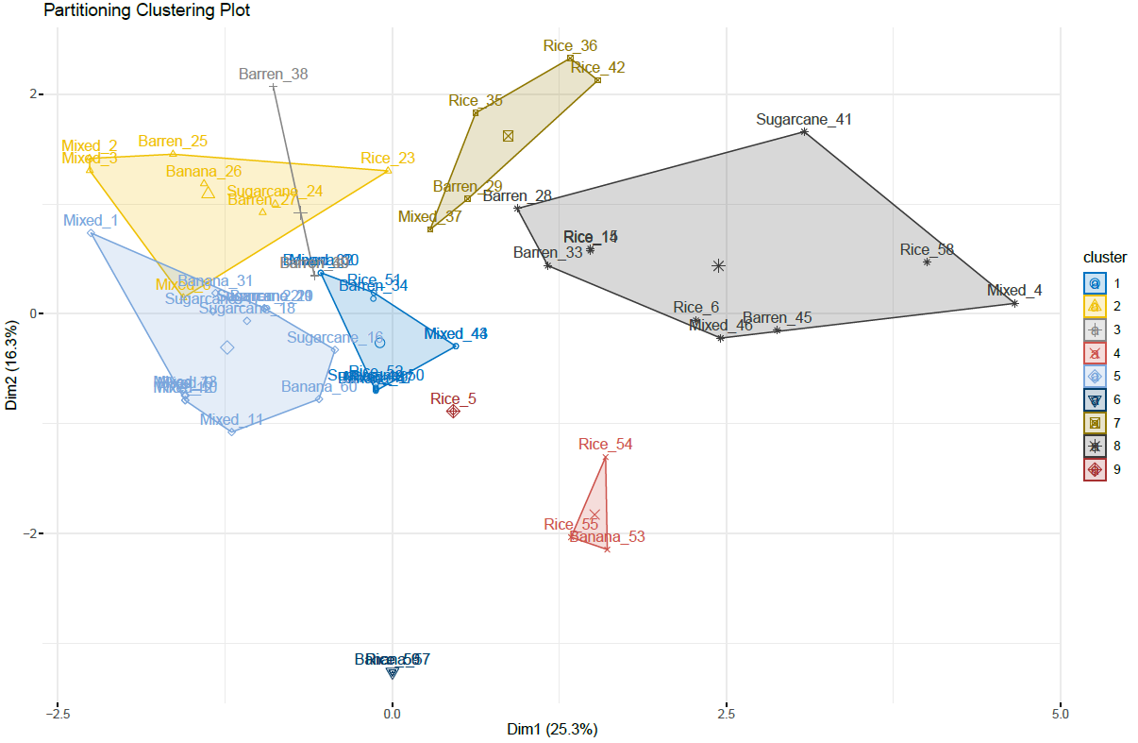

c)
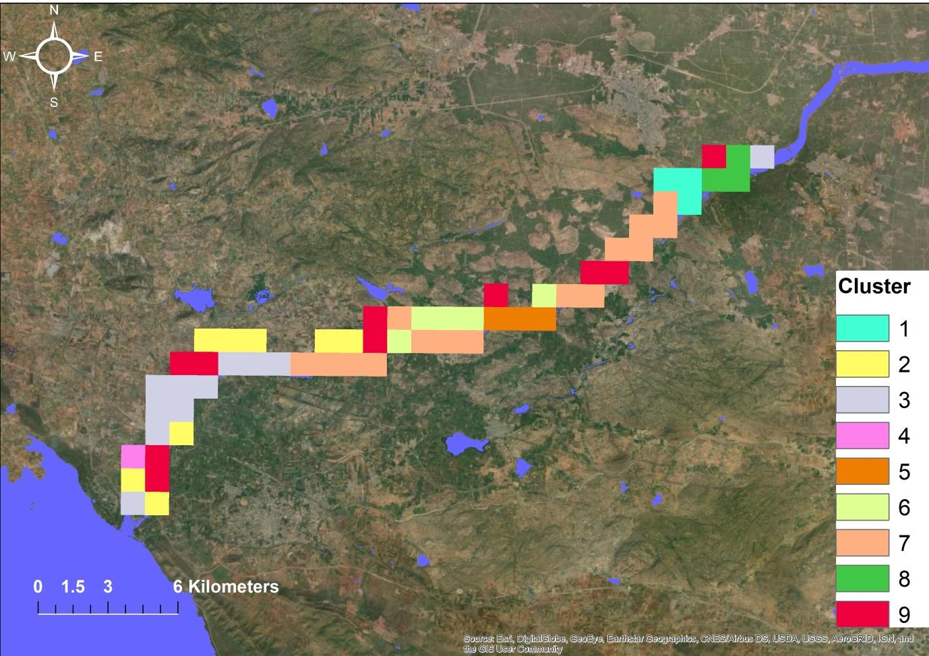
Fig S4a-c: High-resolution hydro-environmental variables in building a dendrogram and factor plot showing the nine clusters along 60 sampled sites from the Hierarchical Agglomerative Clustering method in Tungabhadra Otter Conservation Reserve

