Supplementary Material

Full GLMM formulas for R_{t}, R_{P} and A_{GR} resilience indices:
R_{t} ~ Fixed effects (Sex + pre5TRI + preSPEI + SPEI + Sex*pre5TRI + Sex*preSPEI + Sex*SPEI) + Random effect (Site + Year | ID.Tree)

R_{P} ~ Fixed effects (Sex + pre5TRI + preSPEI + SPEI + postSPEI + Sex*pre5TRI + Sex*preSPEI + Sex*SPEI + Sex*postSPEI2) + Random effect (Site + Year | ID.Tree)

A_{GR} ~ Fixed effects (Sex + pre5TRI + preSPEI + SPEI + postSPEI + Sex*pre5TRI + Sex*preSPEI + Sex*SPEI + Sex*postSPEI2) + Random effect (Site + Year | ID.Tree)

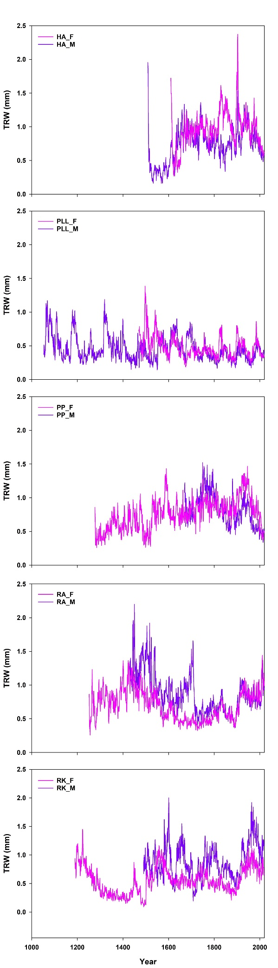
Fig. S1: Site-level SPEI4_D annual trends.
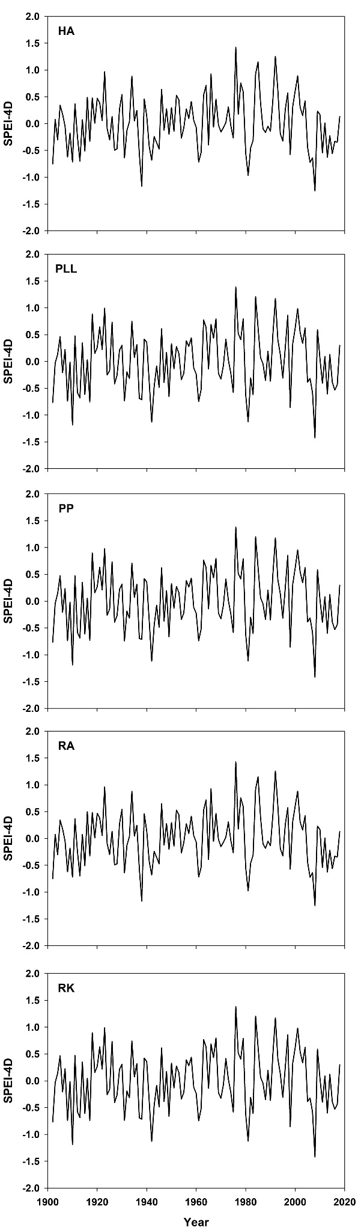
Fig. S2: Site tree-ring width (TRW) chronologies.

