Supplemental Information
Table S1 Initial leaf litter functional traits of Quercus mongolica and Betula platyphylla. Litter carbon (C) content, litter nitrogen (N) content, carbon: nitrogen ratio (C:N), sugar, starch, leaf mass per area (LMA), and lignin. Means values were indicated ± standard error. Different letters indicate significant differences (P<0.05) between litter species.
Species | Total C (%) | Total N (%) | C: N | Sugar (%) | Starch (%) | LMA (g/m²) | Lignin (%)
Quercus mongolica | 46.19±0.36b | 1.19±0.12 | 38.97±3.68 | 2.08±1.01a | 1.44±0.15a | 63.50±0.89a | 16.08±0.74 a
Betula platyphylla | 47.62±0.23a | 1.20±0.079 | 39.64±3.07 | 1.64±0.53b | 1.14±0.06b | 61.57±1.12b | 14.37±1.06 b

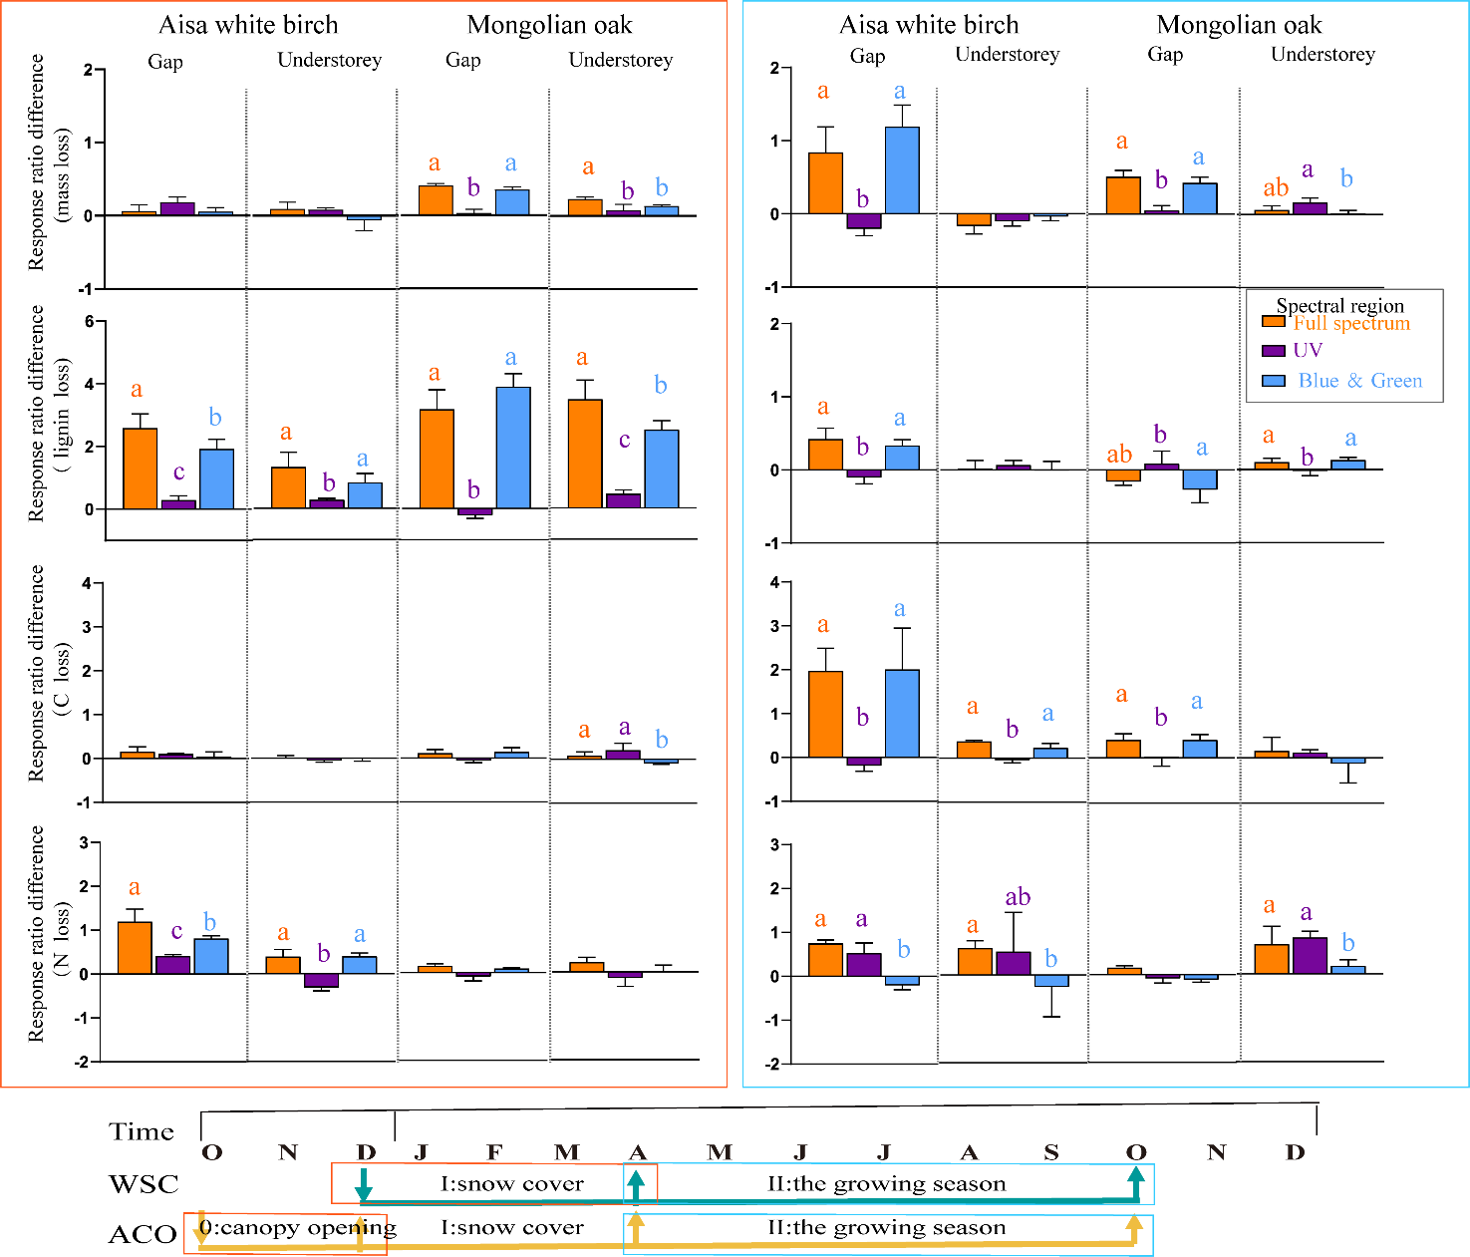
Fig. S1 Difference in response ratios between ACO and WSC litter groups. ACO and WSC represents that litterboxes were placed at the beginning of autumn canopy opening, and at the beginning of winter snow cover, respectively. Different lowercase letters denote significant difference among different spectral regions (P < 0.05). ACO: Phase 0, forest canopy opening; I, snow cover; II, the growing season; Ⅲ, the second decomposition year. WSC: Phase I, snow cover; II, the growing season.

