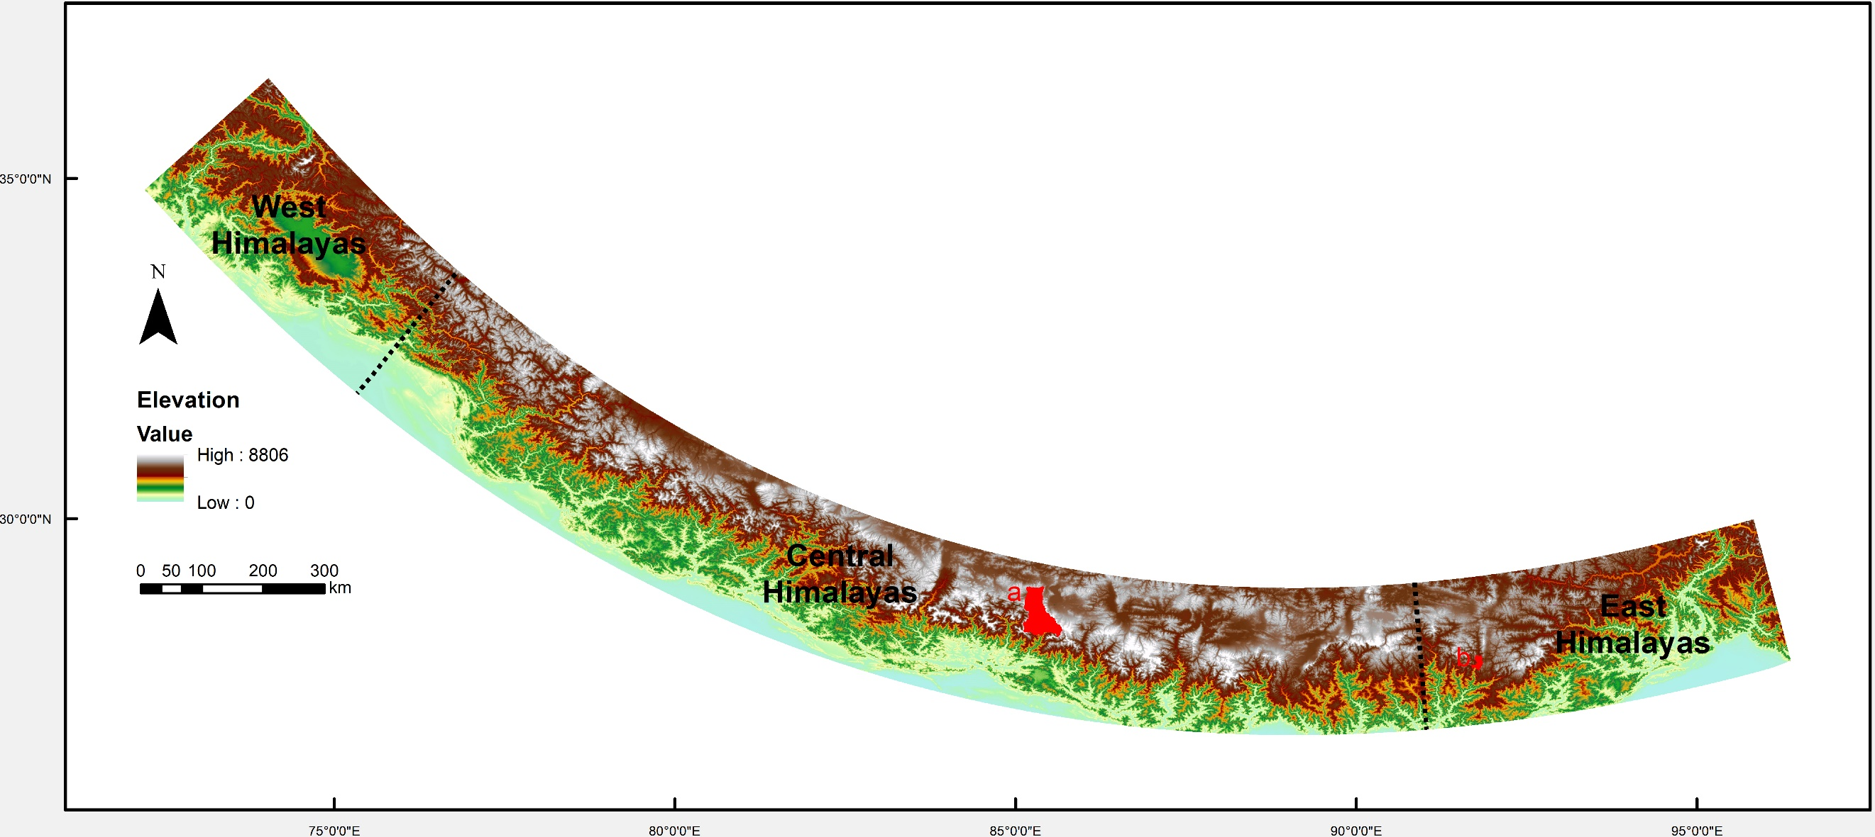
Figure S1 Generalized topographic map of the Himalayas. Black dashed lines represent boundaries between the Western, Central, and Eastern Himalayas. The red shapes represent the study areas: (a) Gyirong Valley and (b) Lebu Valley.

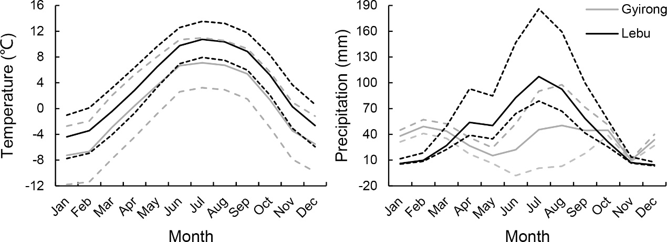
Figure S2 Monthly climate data for (a) mean temperature and (b) precipitation in the study area in the Lebu Valley, East Himalayas (black lines) and Gyirong Valley, Central Himalayas (gray lines) from 1970 to 2000. Climate data are from WorldClim (version 2.1, https://www.worldclim.org/). Dashed lines indicate standard deviation. Mean temperature and precipitation are calculated by averaging all grid cell values within the study area in ArcGIS 10.2. The spatial resolution of the original data is 30 seconds (~1 km²).
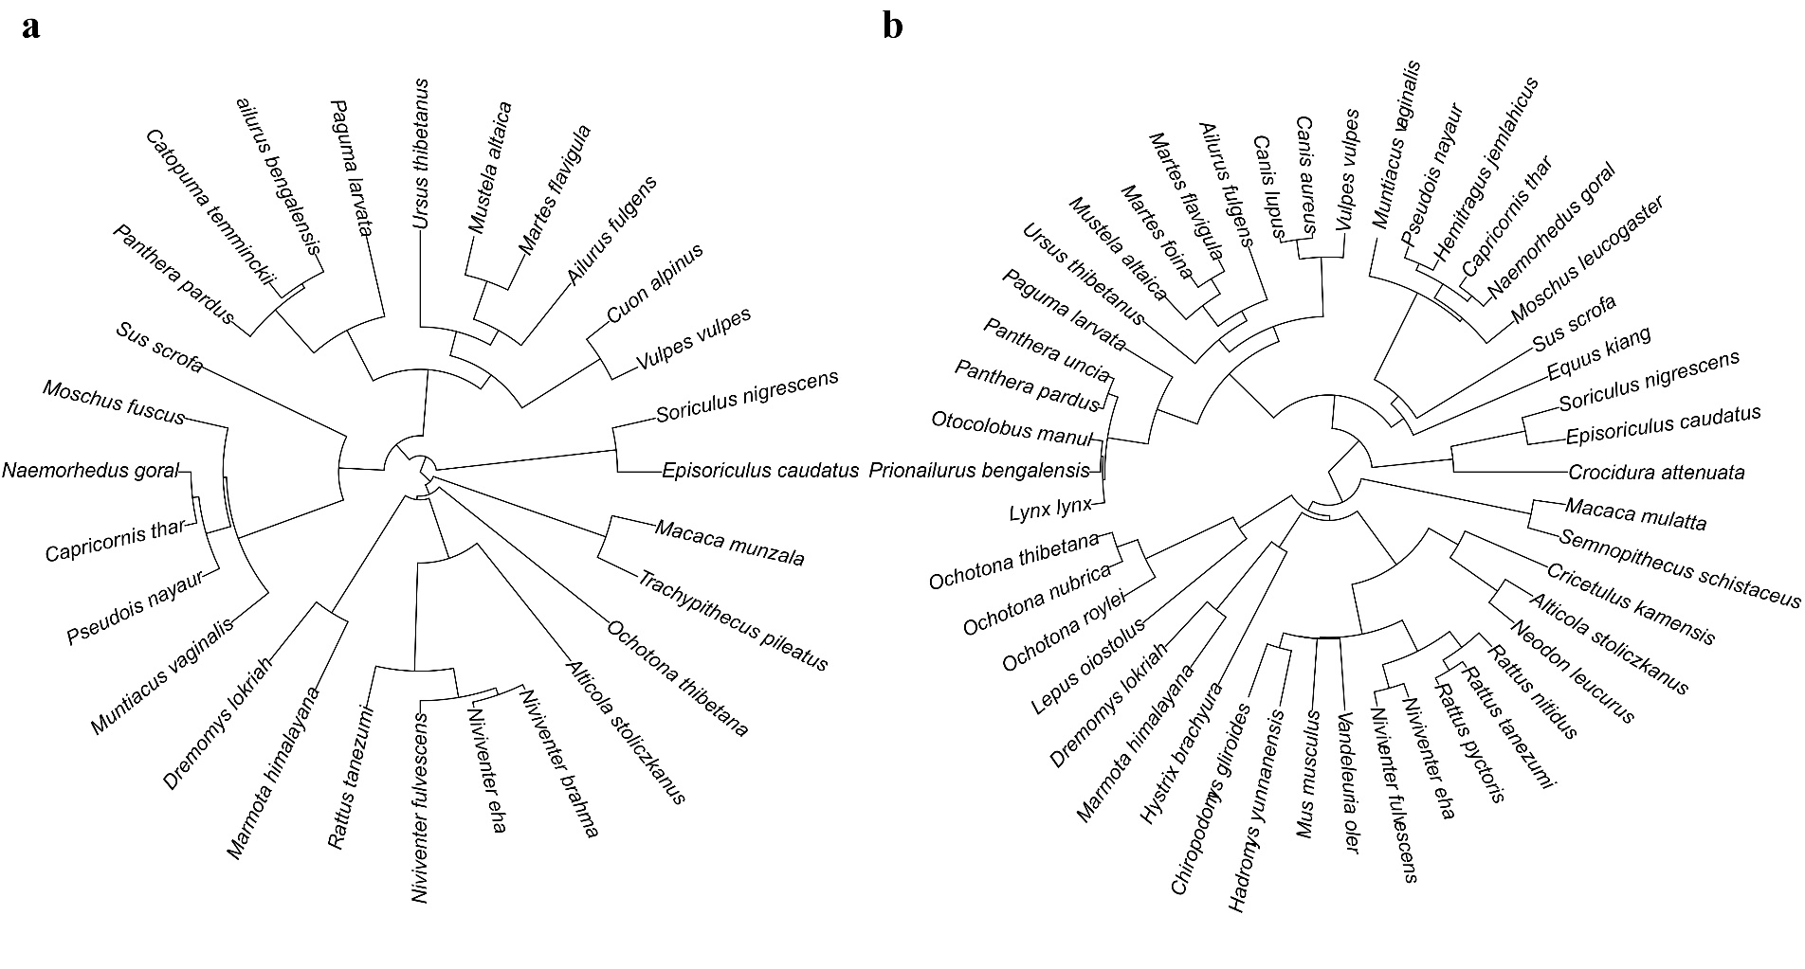
Figure S3 Phylogenetic tree of the mammal species in the (a) Lebu Valley, East Himalayas and (b) Gyirong Valley, Central Himalayas.
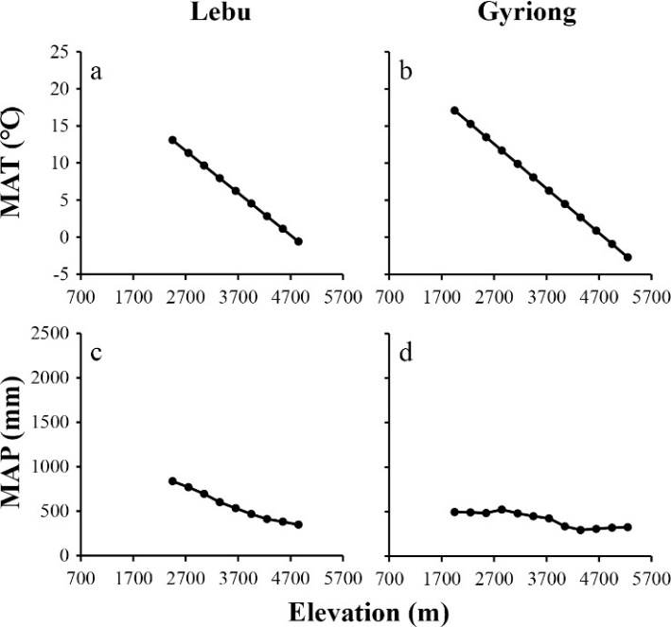
Figure S4 Elevational patterns of (a, b) mean daily temperatures and precipitations in the Lebu Valley, East Himalayas (a, c) and Gyirong Valley, Central Himalayas (b, d). Mean daily temperatures and precipitations were measured and recorded between 2018 and 2019 in the Lebu Valley, and 2015 and 2016 in the Gyirong Valley. Each set of meteorological data loggers included two data loggers (HoBo Pro-RH/Temp and HoBo Pro-Precipitation/Temp) and was surrounded by fences to prevent interference from wild animals. Temperature was recorded every 10 minutes and averaged afterward to 1 hour to minimize the impact of possible outliers for the same period. Mean daily temperatures and accumulate precipitations were extrapolated to all elevational bands by OLS regression and spatial interpolation tool in ArcGIS 10.2, respectively.
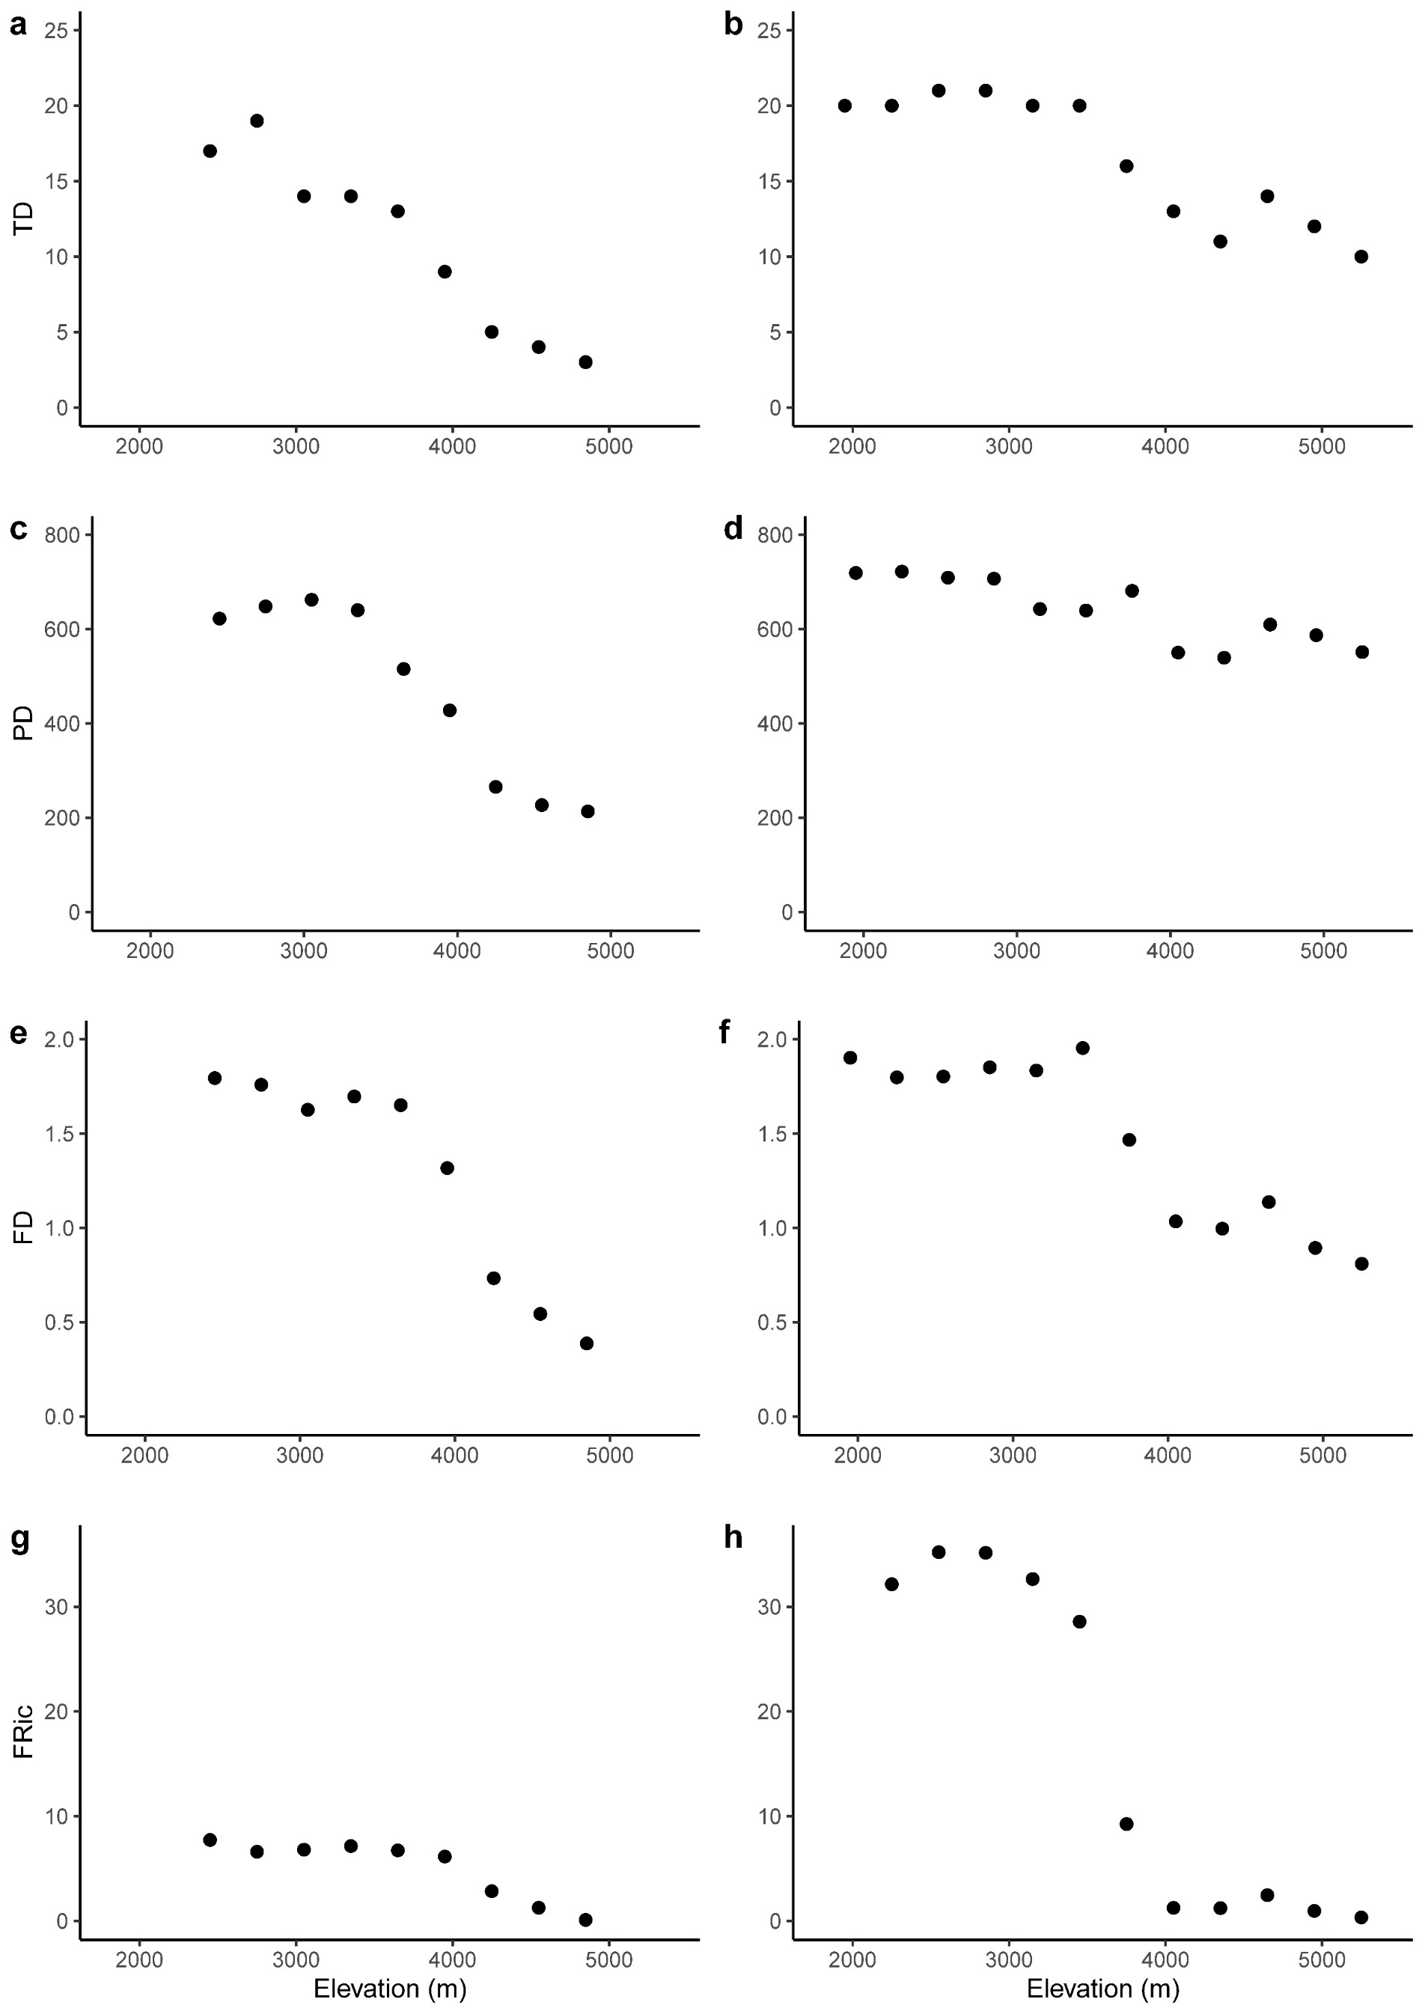
Figure S5 Elevational patterns of taxonomic diversity (TD), phylogenetic diversity (PD) and functional diversity (FD), and functional richness (FRic) in the Lebu Valley, East Himalayas (a, c, e, g) and Gyirong Valley, Central Himalayas (b, d, f, h).
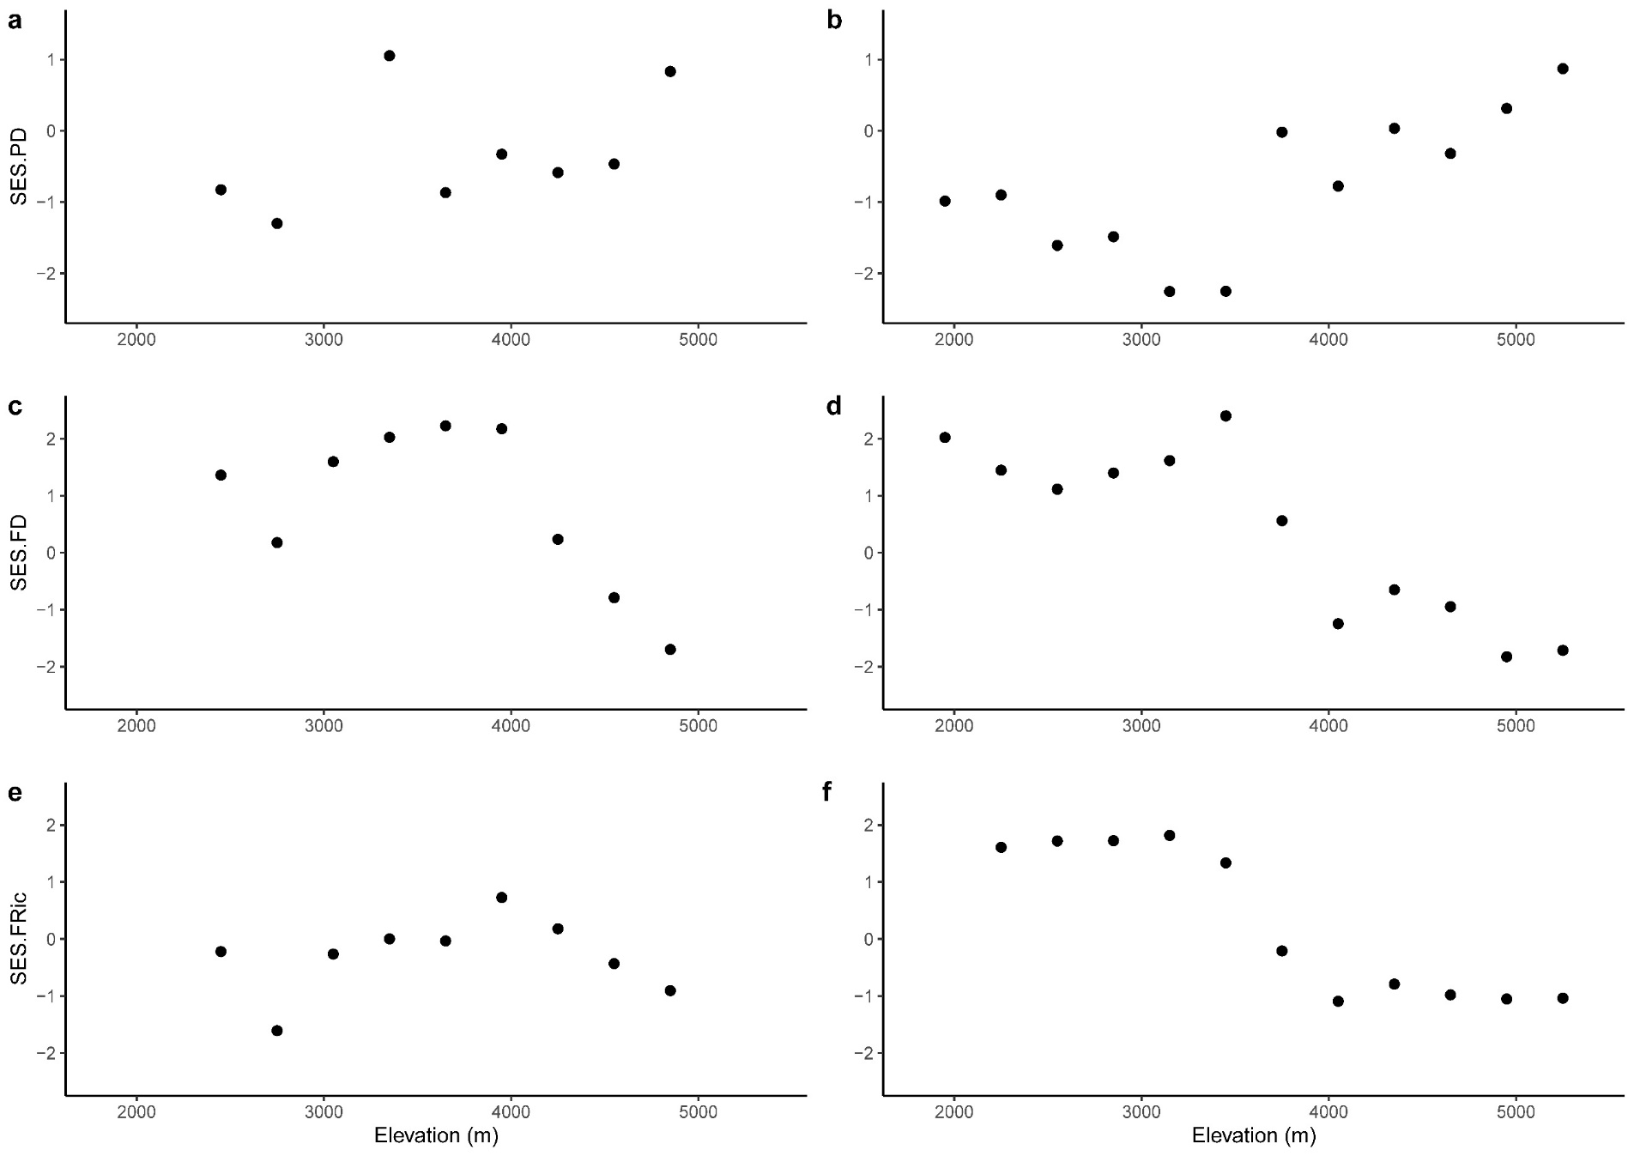
Figure S6 Elevational patterns of standardized effect size of phylogenetic diversity (SES.PD) and functional diversity (SES.FD/FRic) in the Lebu Valley, East Himalayas (a, c, e) and Gyirong Valley, Central Himalayas (b, d, f).

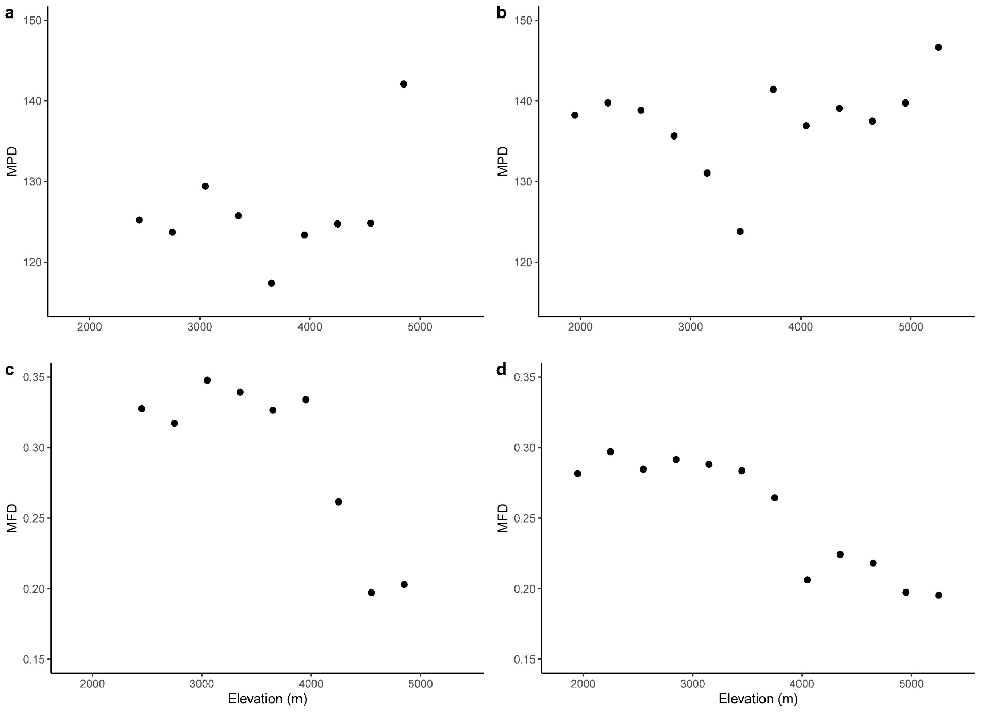
Figure S7 Elevational patterns of mean pairwise phylogenetic/functional distance (MPD/MFD) in the Lebu Valley, East Himalayas (a, c) and Gyirong Valley, Central Himalayas (b, d).

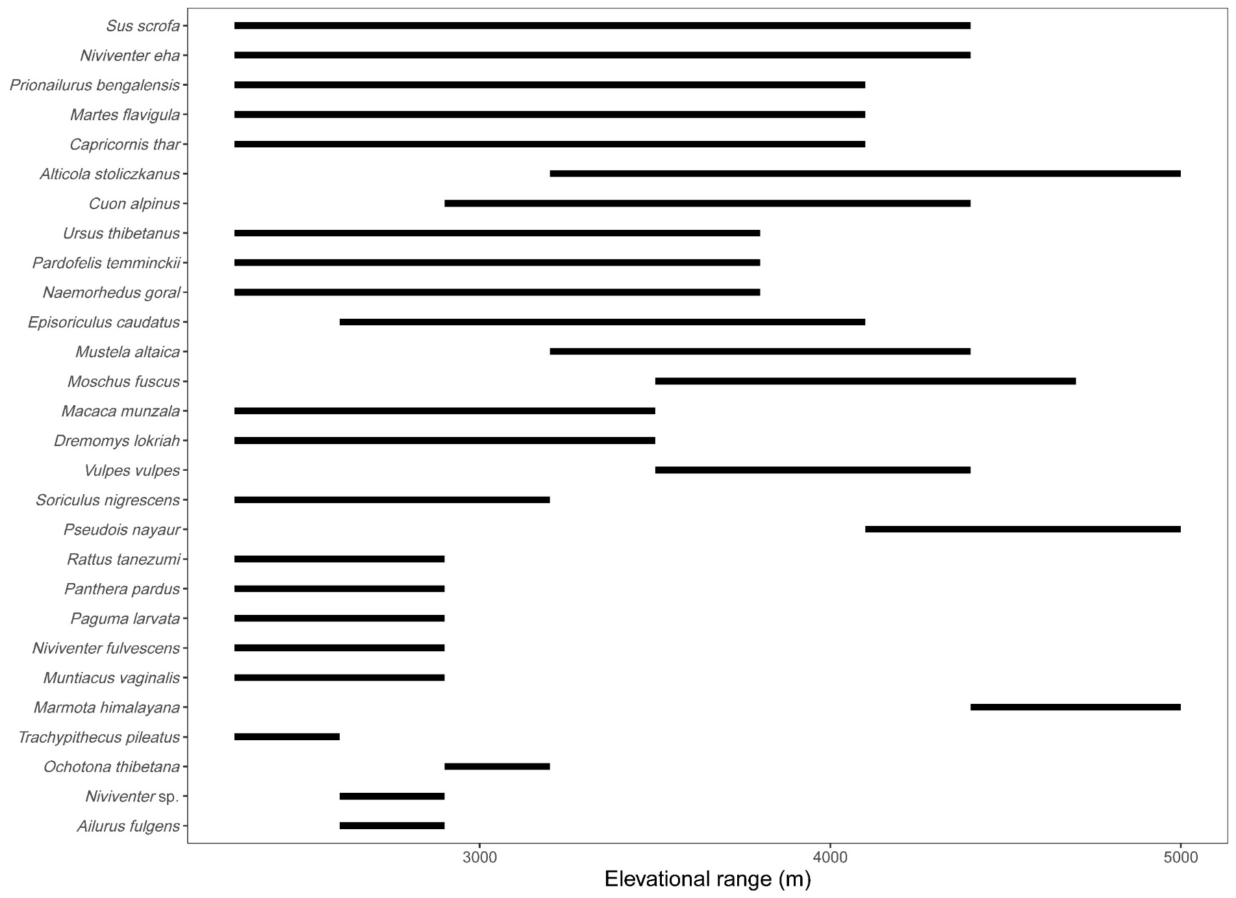Figure S8 Elevational distribution ranges of mammals in the Lebu Valley, East Himalayas.
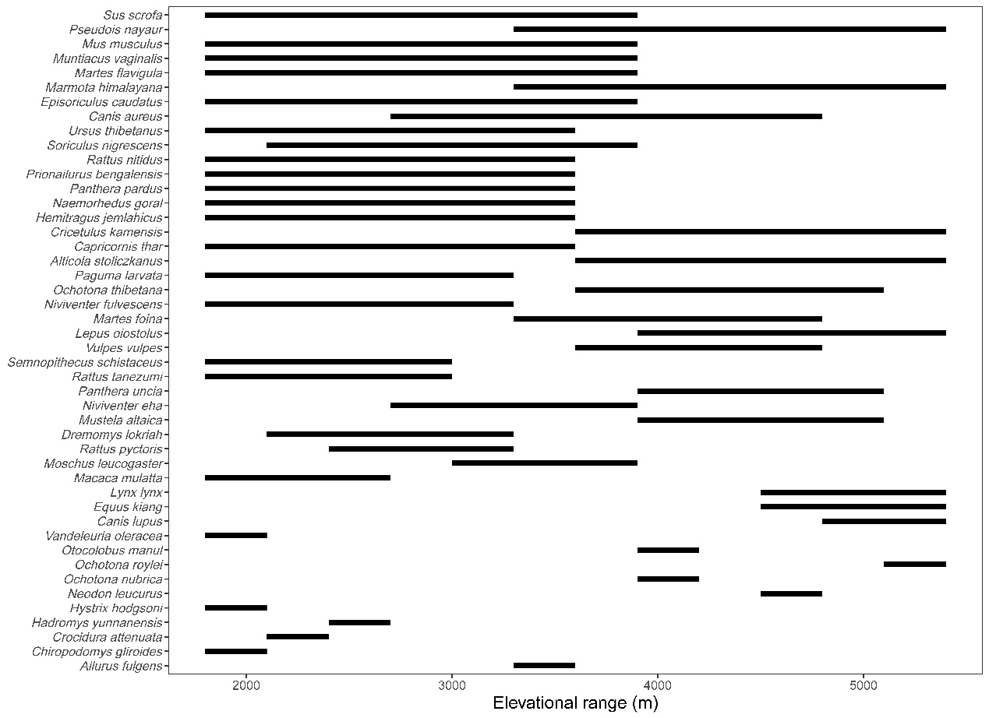Figure S9 Elevational distribution ranges of mammals in Gyirong Valley, Central Himalayas.
Figure S10 Species accumulation curves (gray lines) and sample-based rarefaction curves (black dash lines) for mammal species for each elevational band in Lebu Valley, East Himalayas. Accumulation order of all curves was randomized 100 times. Y axis-accumulation species richness; X axis-sample; 1 unit on the y axis represents 1 sampling day of the snap trap (combining the data from the two surveys in Lebu) and 15 consecutive deployment days of the camera trap.
Figure S11 Species accumulation curves (gray lines) and sample-based rarefaction curves (black dash lines) for mammal species for each elevational band in Gyirong Valley, Central Himalayas. Accumulation order of all curves was randomized 100 times. Y axis-accumulation species richness; X axis-sample; 1 unit on the y axis represents 1 sampling day of the snap trap (combining the data from the two surveys in Gyirong) and 15 consecutive deployment days of the camera trap.

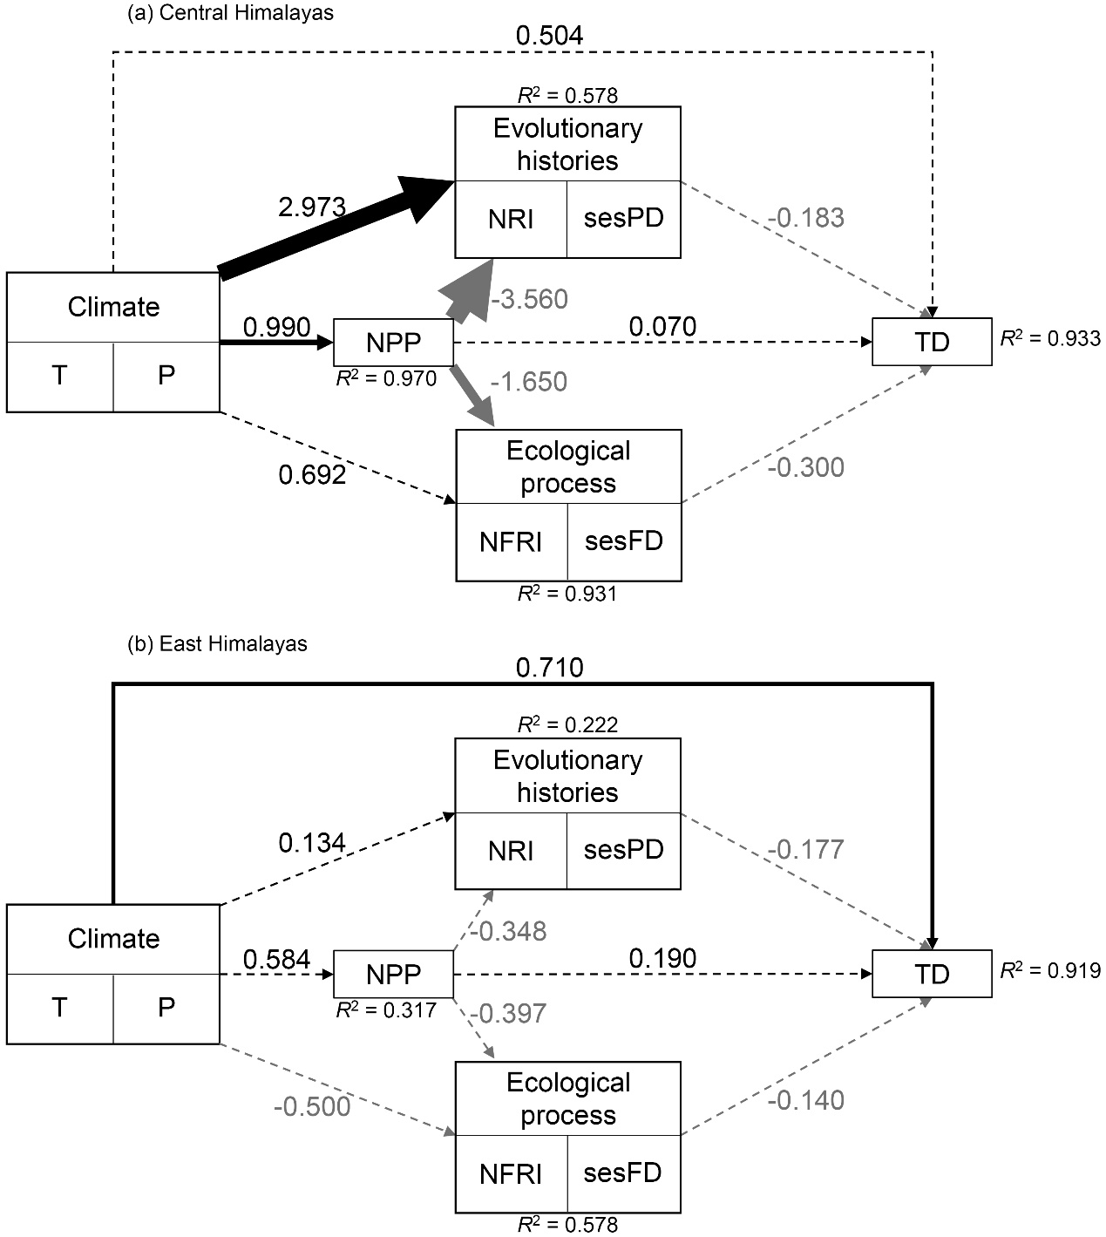
Figure S12 Bayesian structural equation models linking climate (T: temperature; P: precipitation), net primary productivity (NPP), evolutionary histories (sesPD: richness-controlled phylogenetic diversity; NRI: net relatedness index), trait-related ecological processes (sesFD: richness-controlled functional diversity; NFRI: net functional relatedness index), and species richness (TD) in the Central (a) and East (b) Himalayas. Numbers near arrows indicate standardized path coefficients (width represents coefficient strength); Black/grey arrows signify positive/negative relationships; solid lines are significant (95% CI do not overlap with zero), dashed lines are not significant. All Pareto k diagnostic values are below 0.7 for both models.
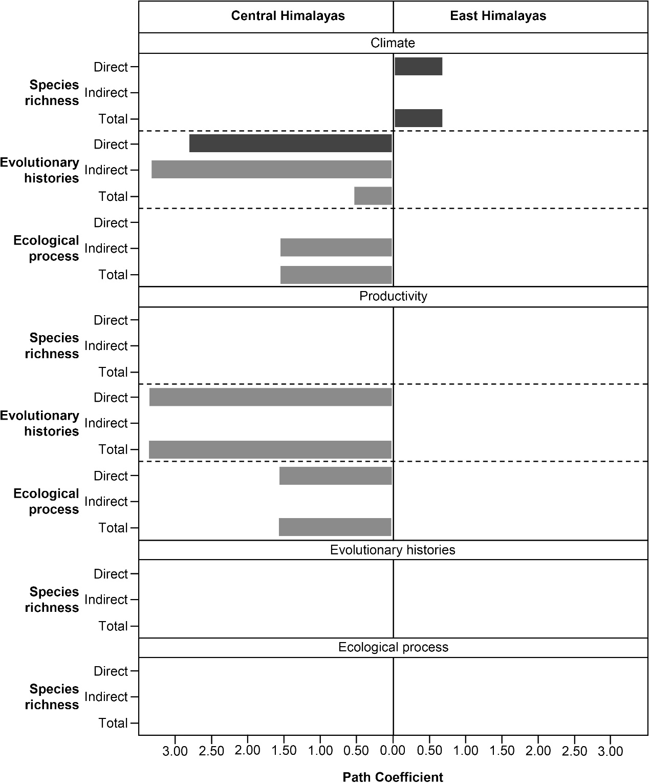
Figure S13 Synthesis of direct, indirect, and total effects of variables over species richness, evolutionary histories, and trait-related ecological process obtained by Bayesian structural equation models in Central and East Himalayas. Path coefficients indicate standardized coefficients of significant paths (black/grey for positive/negative relationships). Direct effects denote path coefficients when two variables solely link through a significant path. Indirect effects resulted from coefficients along significant paths with multiple arrows. The total effect of one variable on another was computed as the sum of its direct and indirect effects, encompassing all significant pathways connecting these variables.
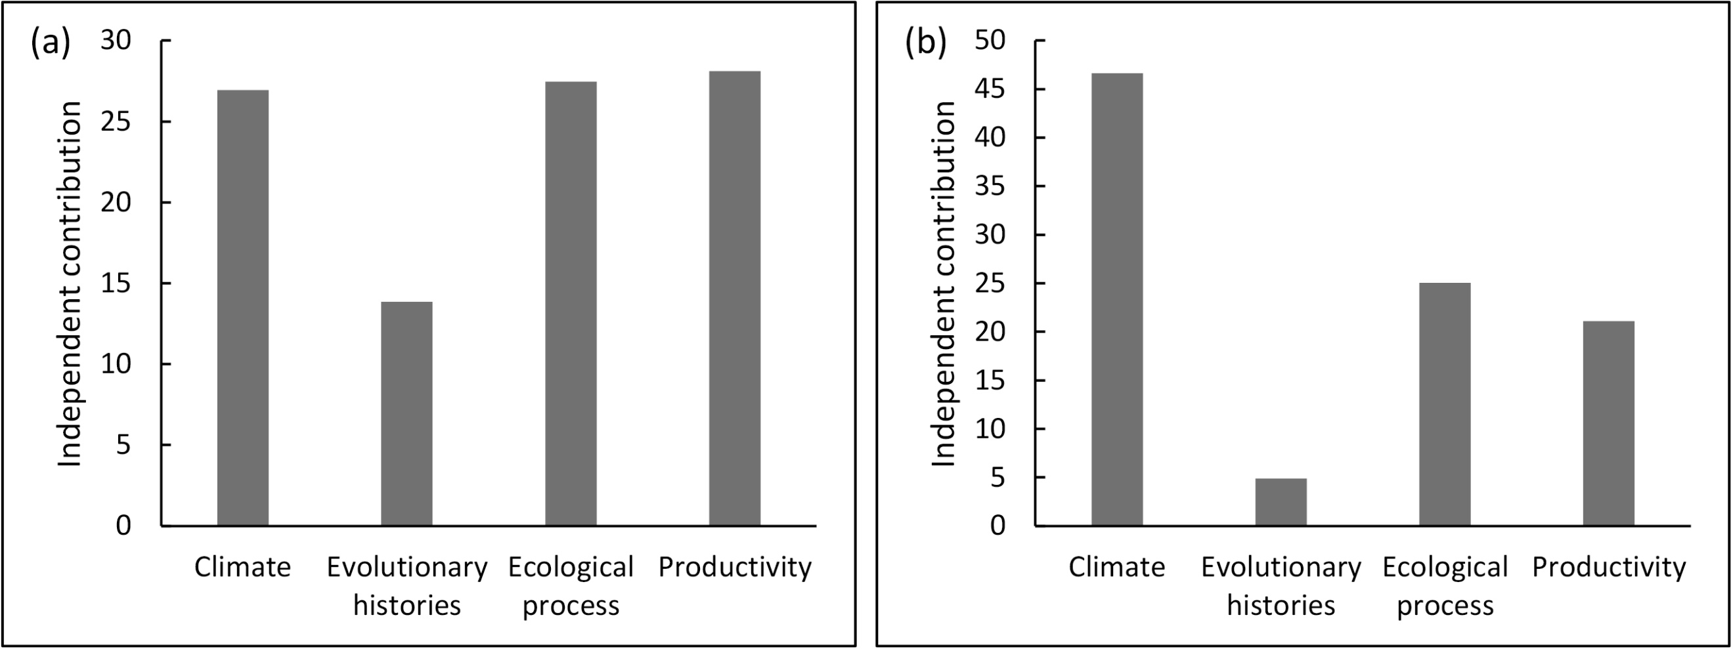
Figure S14 The percentage of independent contribution of each variable derived by hierarchical partitioning on species richness of mammals along elevational gradients in the Central (a) and East (b) Himalayas.
Figure S15 Elevational patterns of species, family and, and order richness for mammals in the (a) Gyirong Valley, Central Himalayas and (b) Lebu Valley, East Himalayas. Dashed lines were predicted by OLS model.
Table S1 GPS locations of the sample sites for snap-trap in the Lebu Valley, East Himalayas. EBF: evergreen broadleaved forest; CBF: coniferous and broad-leaf mixed forest; SCF: subalpine coniferous forest; ASM: alpine shrub and meadows; AM: alpine meadows.
NO. | Elevation | Longitude | Latitude | Vegetation type
1 | 2344 | 91.74774 | 27.80088 | EBF
2 | 2385 | 91.75155 | 27.80474 | EBF
3 | 2406 | 91.75319 | 27.81044 | EBF
4 | 2495 | 91.75278 | 27.81336 | EBF
5 | 2523 | 91.75836 | 27.82174 | EBF
6 | 2555 | 91.76052 | 27.82448 | EBF
7 | 2596 | 91.76275 | 27.82903 | EBF
8 | 2663 | 91.76226 | 27.83245 | EBF
9 | 2779 | 91.76306 | 27.8332 | EBF
10 | 2802 | 91.77229 | 27.8403 | EBF
11 | 2964 | 91.78048 | 27.84685 | EBF
12 | 3095 | 91.7833 | 27.85255 | CBF
13 | 3169 | 91.78308 | 27.85379 | CBF
14 | 3143 | 91.78419 | 27.85448 | CBF
15 | 3164 | 91.79681 | 27.85969 | CBF
16 | 3265 | 91.8057 | 27.89946 | CBF
17 | 3316 | 91.8077 | 27.90338 | CBF
18 | 3421 | 91.80727 | 27.90645 | CBF
19 | 3487 | 91.80831 | 27.90654 | CBF
20 | 3495 | 91.81339 | 27.929 | CBF
21 | 3564 | 91.79311 | 27.90196 | SCF
22 | 3595 | 91.78964 | 27.90592 | SCF
23 | 3676 | 91.79165 | 27.90661 | SCF
24 | 3729 | 91.79323 | 27.91024 | SCF
25 | 3797 | 91.79308 | 27.91133 | SCF
26 | 3850 | 91.79541 | 27.91355 | ASM
27 | 3903 | 91.79513 | 27.91516 | ASM
28 | 3944 | 91.78969 | 27.91628 | ASM
29 | 3946 | 91.77979 | 27.92235 | ASM
30 | 4033 | 91.77901 | 27.92388 | ASM
31 | 4131 | 91.77772 | 27.92599 | ASM
32 | 4138 | 91.77487 | 27.92687 | ASM
33 | 4190 | 91.77742 | 27.93151 | ASM
34 | 4296 | 91.77426 | 27.93139 | ASM
35 | 4353 | 91.77319 | 27.93185 | ASM
36 | 4411 | 91.76903 | 27.9321 | ASM
37 | 4437 | 91.76654 | 27.9306 | ASM
38 | 4485 | 91.76482 | 27.92953 | ASM
39 | 4507 | 91.76576 | 27.93166 | AM
40 | 4564 | 91.76558 | 27.93475 | AM
41 | 4594 | 91.7641 | 27.93634 | AM
42 | 4643 | 91.76061 | 27.93979 | AM
43 | 4689 | 91.76258 | 27.94131 | AM
44 | 4867 | 91.7593 | 27.94143 | AM
45 | 4958 | 91.75544 | 27.94323 | AM

Table S2 GPS locations of the sample sites for snap-trap in the Gyirong Valley, Central Himalayas. EBF: evergreen broadleaved forest; CBF: coniferous and broad-leaf mixed forest; SCF: subalpine coniferous forest; ASM: alpine shrub and meadows; ATS: alpine tundra with sparse herbs.
NO. | Elevation | Longitude | Latitude | Vegetation type
1 | 1853 | 85.38519 | 28.28422 | EBF
2 | 1854 | 85.38312 | 28.28305 | EBF
3 | 1889 | 85.38984 | 28.28706 | EBF
4 | 1898 | 85.38812 | 28.28706 | EBF
5 | 1915 | 85.38674 | 28.28502 | EBF
6 | 2113 | 85.33975 | 28.32397 | EBF
7 | 2196 | 85.33940 | 28.31871 | EBF
8 | 2236 | 85.33756 | 28.32090 | EBF
9 | 2290 | 85.33657 | 28.32159 | EBF
10 | 2338 | 85.33764 | 28.31748 | EBF
11 | 2711 | 85.35620 | 28.37882 | CBF
12 | 2715 | 85.34975 | 28.37918 | CBF
13 | 2717 | 85.34970 | 28.38097 | CBF
14 | 2732 | 85.35462 | 28.37945 | CBF
15 | 2756 | 85.35087 | 28.38435 | CBF
16 | 2877 | 85.32549 | 28.40269 | CBF
17 | 2947 | 85.32737 | 28.40739 | CBF
18 | 2950 | 85.32736 | 28.40812 | CBF
19 | 2952 | 85.32730 | 28.40761 | CBF
20 | 2957 | 85.32832 | 28.40786 | CBF
21 | 2958 | 85.26521 | 28.42892 | CBF
22 | 2982 | 85.25980 | 28.43017 | CBF
23 | 2992 | 85.26218 | 28.42903 | CBF
24 | 3004 | 85.26073 | 28.42919 | CBF
25 | 3046 | 85.26215 | 28.43301 | CBF
26 | 3372 | 85.21653 | 28.51442 | CBF
27 | 3390 | 85.21853 | 28.51923 | CBF
28 | 3391 | 85.21578 | 28.52450 | CBF
29 | 3399 | 85.21603 | 28.52287 | CBF
30 | 3401 | 85.21688 | 28.52804 | SCF
31 | 3637 | 85.24571 | 28.56021 | SCF
32 | 3638 | 85.24313 | 28.55709 | SCF
33 | 3662 | 85.25597 | 28.58184 | SCF
34 | 3673 | 85.25773 | 28.57550 | SCF
35 | 3750 | 85.26225 | 28.60491 | SCF
36 | 3896 | 85.27818 | 28.70071 | SCF
37 | 3921 | 85.28286 | 28.71634 | SCF
38 | 4036 | 85.29130 | 28.82132 | ASM
39 | 4049 | 85.28842 | 28.82890 | ASM
40 | 4069 | 85.29373 | 28.84145 | ASM
41 | 4299 | 85.33331 | 28.89968 | ASM
42 | 4315 | 85.33648 | 28.89837 | ASM
43 | 4347 | 85.34172 | 28.90114 | ASM
44 | 4422 | 85.33793 | 28.92113 | ASM
45 | 4473 | 85.35187 | 28.92407 | ASM
46 | 4541 | 85.35542 | 28.92663 | ASM
47 | 4580 | 85.35605 | 28.92840 | ASM
48 | 4605 | 85.36267 | 28.92841 | ASM
49 | 4680 | 85.36241 | 28.93158 | ASM
50 | 4729 | 85.37161 | 28.93072 | ASM
51 | 4809 | 85.37944 | 28.93500 | ATS
52 | 4832 | 85.38536 | 28.93178 | ATS
53 | 4924 | 85.38474 | 28.93408 | ATS
54 | 4979 | 85.39219 | 28.93286 | ATS
55 | 5033 | 85.39426 | 28.93252 | ATS
56 | 5090 | 85.38623 | 28.93737 | ATS
57 | 5123 | 85.39348 | 28.93520 | ATS
58 | 5130 | 85.40976 | 28.93270 | ATS
59 | 5251 | 85.41121 | 28.93339 | ATS
60 | 5336 | 85.39889 | 28.92969 | ATS

Table S3 GPS locations of the sample sites for camera-trap in the Lebu Valley, East Himalayas. EBF: evergreen broadleaved forest; CBF: coniferous and broad-leaf mixed forest; SCF: subalpine coniferous forest; ASM: alpine shrub and meadows; AM: alpine meadows.
NO. | Elevation | Longitude | Latitude | Vegetation type | 90 consecutive deployment days
1 | 2355 | 91.74637 | 27.80295 | EBF | May to July, 2019
2 | 2372 | 91.74632 | 27.80236 | EBF | May to July, 2019
3 | 2375 | 91.74832 | 27.80413 | EBF | May to July, 2019
4 | 2541 | 91.77134 | 27.84369 | EBF | May to July, 2019
5 | 2558 | 91.76986 | 27.84134 | EBF | May to July, 2019
6 | 2690 | 91.74223 | 27.82152 | EBF | July to September, 2018
7 | 2728 | 91.7944 | 27.86034 | EBF | July to September, 2018
8 | 2730 | 91.73235 | 27.82559 | EBF | July to September, 2018
9 | 2746 | 91.76074 | 27.84355 | EBF | July to September, 2018
10 | 2757 | 91.73244 | 27.82576 | EBF | May to July, 2019
11 | 2760 | 91.79365 | 27.85909 | EBF | July to September, 2018
12 | 2841 | 91.72673 | 27.82495 | EBF | July to September, 2018
13 | 2845 | 91.72688 | 27.82451 | EBF | July to September, 2018
14 | 2993 | 91.80479 | 27.89979 | CBF | July to September, 2018
15 | 3110 | 91.80594 | 27.90728 | CBF | May to July, 2019
16 | 3126 | 91.81065 | 27.87219 | CBF | July to September, 2018
17 | 3170 | 91.81197 | 27.8715 | CBF | July to September, 2018
18 | 3220 | 91.81318 | 27.87175 | CBF | July to September, 2018
19 | 3226 | 91.79591 | 27.90306 | CBF | July to September, 2018
20 | 3231 | 91.7949 | 27.90534 | CBF | July to September, 2018
21 | 3279 | 91.79463 | 27.90314 | CBF | July to September, 2018
22 | 3346 | 91.78944 | 27.90842 | CBF | July to September, 2018
23 | 3386 | 91.78676 | 27.91089 | SCF | July to September, 2018
24 | 3568 | 91.80854 | 27.93858 | SCF | July to September, 2018
25 | 3578 | 91.80862 | 27.94062 | SCF | July to September, 2018
26 | 3596 | 91.80925 | 27.93988 | SCF | July to September, 2018
27 | 3773 | 91.7823 | 27.92243 | SCF | July to September, 2018
28 | 3807 | 91.7795 | 27.92381 | ASM | July to September, 2018
29 | 3823 | 91.79165 | 27.92899 | ASM | May to July, 2019
30 | 3825 | 91.79017 | 27.92801 | ASM | July to September, 2018
31 | 3866 | 91.78638 | 27.92711 | ASM | May to July, 2021
32 | 3929 | 91.77792 | 27.92827 | ASM | July to September, 2020
33 | 3998 | 91.77109 | 27.93179 | ASM | July to September, 2020
34 | 4030 | 91.76841 | 27.93062 | ASM | July to September, 2018
35 | 4120 | 91.77577 | 27.93433 | ASM | July to September, 2018
36 | 4219 | 91.77183 | 27.93611 | ASM | July to September, 2018
37 | 4283 | 91.7676 | 27.93405 | ASM | July to September, 2018
38 | 4357 | 91.76611 | 27.93558 | ASM | July to September, 2018
39 | 4453 | 91.76444 | 27.93601 | AM | July to September, 2018
40 | 4518 | 91.75974 | 27.9412 | AM | July to September, 2018
41 | 4649 | 91.75848 | 27.94458 | AM | July to September, 2018
42 | 4705 | 91.76002 | 27.94608 | AM | July to September, 2018
43 | 4843 | 91.75434 | 27.94633 | AM | July to September, 2018

Table S4 GPS locations of the sample sites for camera-trap in the Gyirong Valley, Central Himalayas. EBF: evergreen broadleaved forest; CBF: coniferous and broad-leaf mixed forest; SCF: subalpine coniferous forest; ASM: alpine shrub and meadows; ATS: alpine tundra with sparse herbs.
NO. | Elevation | Longitude | Latitude | Vegetation type | 90 consecutive deployment days
1 | 1891 | 85.36821 | 28.28653 | EBF | June to August, 2018
2 | 1917 | 85.3753 | 28.28382 | EBF | June to August, 2018
3 | 1943 | 85.34905 | 28.29633 | EBF | June to August, 2018
4 | 2025 | 85.34662 | 28.30853 | EBF | June to August, 2018
5 | 2104 | 85.34564 | 28.31519 | EBF | June to August, 2018
6 | 2184 | 85.34265 | 28.32189 | EBF | June to August, 2018
7 | 2237 | 85.33809 | 28.31939 | EBF | June to August, 2018
8 | 2244 | 85.34799 | 28.33503 | EBF | June to August, 2018
9 | 2365 | 85.3559 | 28.34315 | EBF | June to August, 2018
10 | 2405 | 85.36019 | 28.35432 | EBF | June to August, 2018
11 | 2496 | 85.36227 | 28.36582 | CBF | June to August, 2018
12 | 2515 | 85.36382 | 28.36955 | CBF | June to August, 2018
13 | 2723 | 85.34979 | 28.3766 | CBF | July to September, 2019
14 | 2740 | 85.35986 | 28.37933 | CBF | June to August, 2018
15 | 2786 | 85.35752 | 28.3811 | CBF | June to August, 2018
16 | 2897 | 85.32577 | 28.40421 | CBF | June to August, 2018
17 | 2906 | 85.3435 | 28.38788 | CBF | June to August, 2018
18 | 2926 | 85.31463 | 28.41373 | CBF | June to August, 2018
19 | 2939 | 85.31752 | 28.40845 | CBF | June to August, 2018
20 | 2996 | 85.25632 | 28.43806 | CBF | June to August, 2018
21 | 2999 | 85.26471 | 28.42972 | CBF | June to August, 2018
22 | 3031 | 85.25242 | 28.44531 | CBF | June to August, 2018
23 | 3123 | 85.23853 | 28.4604 | CBF | June to August, 2018
24 | 3140 | 85.22968 | 28.47156 | CBF | July to September, 2020
25 | 3167 | 85.22443 | 28.48273 | CBF | July to September, 2021
26 | 3358 | 85.21576 | 28.5132 | CBF | June to August, 2018
27 | 3484 | 85.22319 | 28.53639 | SCF | June to August, 2018
28 | 3581 | 85.23127 | 28.5446 | SCF | June to August, 2018
29 | 3621 | 85.2337 | 28.54921 | SCF | June to August, 2018
30 | 3657 | 85.24266 | 28.55429 | SCF | June to August, 2018
31 | 3710 | 85.25806 | 28.57443 | SCF | June to August, 2018
32 | 3742 | 85.25953 | 28.59407 | SCF | June to August, 2018
33 | 3760 | 85.25262 | 28.58069 | SCF | June to August, 2018
34 | 3796 | 85.27005 | 28.63127 | SCF | July to September, 2021
35 | 3805 | 85.26453 | 28.60396 | SCF | June to August, 2018
36 | 4055 | 85.29749 | 28.7975 | ASM | June to August, 2018
37 | 4094 | 85.29976 | 28.82626 | ASM | June to August, 2018
38 | 4115 | 85.30062 | 28.83887 | ASM | June to August, 2018
39 | 4156 | 85.31273 | 28.86219 | ASM | June to August, 2018
40 | 4202 | 85.31779 | 28.87262 | ASM | June to August, 2018
41 | 4294 | 85.30132 | 28.89293 | ASM | July to September, 2020
42 | 4371 | 85.34162 | 28.90171 | ASM | July to September, 2020
43 | 4431 | 85.29398 | 28.90505 | ASM | July to September, 2021
44 | 4462 | 85.35038 | 28.90622 | ASM | July to September, 2021
45 | 4474 | 85.34581 | 28.90226 | ASM | July to September, 2021
46 | 4548 | 85.354 | 28.92912 | ASM | July to September, 2020
47 | 4612 | 85.35727 | 28.9071 | ASM | July to September, 2021
48 | 4671 | 85.36117 | 28.93118 | ASM | July to September, 2021
49 | 4710 | 85.35955 | 28.91308 | ASM | July to September, 2019
50 | 4771 | 85.36419 | 28.91224 | ASM | July to September, 2020
51 | 4861 | 85.36376 | 28.90383 | ATS | July to September, 2020
52 | 4871 | 85.36816 | 28.91087 | ATS | July to September, 2020
53 | 4887 | 85.38762 | 28.93068 | ATS | July to September, 2021
54 | 4990 | 85.37196 | 28.90759 | ATS | July to September, 2021
55 | 5029 | 85.39301 | 28.93125 | ATS | July to September, 2021
56 | 5134 | 85.38103 | 28.89783 | ATS | July to September, 2021
57 | 5154 | 85.40139 | 28.92804 | ATS | July to September, 2019
58 | 5163 | 85.38141 | 28.90981 | ATS | July to September, 2019
59 | 5215 | 85.39796 | 28.9278 | ATS | July to September, 2021
60 | 5227 | 85.38564 | 28.90026 | ATS | July to September, 2021

Table S5 Data of functional traits for mammals in the Lebu Valley and Gyirong valley. Diet (percent use of): Inv-invertebrates; Vend-mammals, birds; Vect-reptiles, amphibians; Vunk-vertebrates (general or unknown); Scav-scavenge; PlantO-other plant material. Foraging stratum categories: M-marine; G-ground level, including aquatic foraging; S-scansorial; Ar- arboreal; A-aerial.
Species | Diet (Percent use of) |  |  |  |  |  |  |  |  | Body Mass (g) | Foraging stratum | Foraging time
Species | Inv | Vend | Vect | fish | Vunk | Scav | Fruit | Seed | PlantO | Body Mass (g) | Foraging stratum | Nocturnal | Crepuscular | Diurnal
Ailurus fulgens | 10 | 10 | 0 | 0 | 0 | 0 | 10 | 10 | 60 | 4900.00 | G | 1 | 1 | 1
Alticola stoliczkanus | 0 | 0 | 0 | 0 | 0 | 0 | 0 | 0 | 100 | 27.47 | G | 1 | 1 | 1
Canis aureus | 10 | 50 | 10 | 10 | 10 | 0 | 10 | 0 | 0 | 10345.23 | G | 1 | 1 | 0
Canis lupus | 0 | 100 | 0 | 0 | 0 | 0 | 0 | 0 | 0 | 32183.33 | G | 1 | 1 | 0
Capricornis thar | 0 | 0 | 0 | 0 | 0 | 0 | 0 | 0 | 100 | 69093.52 | G | 0 | 1 | 1
Pardofelis temminckii | 0 | 80 | 20 | 0 | 0 | 0 | 0 | 0 | 0 | 11500 | G | 1 | 0 | 0
Chiropodomys gliroides | 0 | 0 | 0 | 0 | 0 | 0 | 0 | 0 | 100 | 21.50 | Ar | 1 | 0 | 0
Cricetulus kamensis | 0 | 0 | 0 | 0 | 0 | 0 | 0 | 50 | 50 | 37.65 | G | 1 | 1 | 1
Crocidura attenuata | 50 | 0 | 10 | 0 | 0 | 40 | 0 | 0 | 0 | 14.27 | G | 1 | 0 | 0
Cuon alpinus | 0 | 90 | 0 | 0 | 0 | 10 | 0 | 0 | 0 | 14173.33 | G | 0 | 1 | 1
Dremomys lokriah | 20 | 0 | 0 | 0 | 0 | 0 | 30 | 30 | 20 | 227.00 | S | 0 | 0 | 1
Episoriculus caudatus | 70 | 0 | 0 | 0 | 0 | 30 | 0 | 0 | 0 | 6.95 | G | 1 | 0 | 0
Equus kiang | 0 | 0 | 0 | 0 | 0 | 0 | 0 | 0 | 100 | 275000.00 | G | 1 | 1 | 1
Hadromys yunnanensis | 0 | 0 | 0 | 0 | 0 | 0 | 0 | 0 | 100 | 59.00 | G | 1 | 0 | 0
Hemitragus jemlahicus | 0 | 0 | 0 | 0 | 0 | 0 | 0 | 0 | 100 | 35200.00 | G | 1 | 1 | 0
Hystrix hodgsoni | 0 | 0 | 0 | 0 | 0 | 0 | 20 | 0 | 80 | 8450.00 | G | 1 | 0 | 0
Lepus oiostolus | 0 | 0 | 0 | 0 | 0 | 0 | 0 | 0 | 100 | 3000.00 | G | 1 | 0 | 0
Lynx lynx | 0 | 100 | 0 | 0 | 0 | 0 | 0 | 0 | 0 | 17950.00 | G | 1 | 0 | 0
Macaca mulatta | 10 | 0 | 0 | 0 | 0 | 0 | 30 | 20 | 40 | 3713.00 | S | 0 | 0 | 1
Macaca munzala | 10 | 0 | 0 | 0 | 0 | 0 | 30 | 20 | 40 | 3713.00 | S | 0 | 0 | 1
Marmota himalayana | 0 | 0 | 0 | 0 | 0 | 0 | 30 | 30 | 40 | 5000.00 | G | 0 | 0 | 1
Martes flavigula | 10 | 40 | 20 | 0 | 20 | 0 | 10 | 0 | 0 | 1842.50 | Ar | 0 | 0 | 1
Martes foina | 0 | 50 | 0 | 0 | 20 | 0 | 20 | 0 | 10 | 1540.80 | G | 1 | 1 | 0
Moschus fuscus | 0 | 0 | 0 | 0 | 0 | 0 | 0 | 0 | 100 | 8000.00 | G | 1 | 0 | 0
Moschus leucogaster | 0 | 0 | 0 | 0 | 0 | 0 | 0 | 0 | 100 | 2145.93 | G | 1 | 0 | 0
Muntiacus vaginalis | 0 | 0 | 0 | 0 | 0 | 0 | 30 | 0 | 70 | 15925.79 | G | 1 | 1 | 1
Mus musculus | 20 | 0 | 0 | 0 | 0 | 0 | 0 | 20 | 60 | 16.25 | G | 1 | 0 | 0
Mustela altaica | 0 | 100 | 0 | 0 | 0 | 0 | 0 | 0 | 0 | 171.00 | G | 1 | 1 | 0
Naemorhedus goral | 0 | 0 | 0 | 0 | 0 | 0 | 0 | 20 | 80 | 28500.00 | G | 0 | 1 | 1
Neodon leucurus | 0 | 0 | 0 | 0 | 0 | 0 | 0 | 20 | 80 | 41.87 | G | 1 | 1 | 0
Niviventer sp. | 20 | 0 | 0 | 0 | 0 | 0 | 20 | 20 | 40 | 97.30 | S | 1 | 0 | 0
Niviventer eha | 20 | 0 | 0 | 0 | 0 | 0 | 20 | 20 | 40 | 53.60 | S | 1 | 0 | 0
Niviventer fulvescens | 20 | 0 | 0 | 0 | 0 | 0 | 20 | 20 | 40 | 82.55 | S | 1 | 0 | 0
Ochotona nubrica | 0 | 0 | 0 | 0 | 0 | 0 | 0 | 0 | 100 | 116.21 | G | 1 | 1 | 1
Ochotona roylei | 0 | 0 | 0 | 0 | 0 | 0 | 0 | 0 | 100 | 260.00 | G | 1 | 1 | 1
Ochotona thibetana | 0 | 0 | 0 | 0 | 0 | 0 | 0 | 0 | 100 | 83.10 | G | 1 | 1 | 1
Felis manul | 0 | 100 | 0 | 0 | 0 | 0 | 0 | 0 | 0 | 3050.00 | G | 1 | 1 | 1
Paguma larvata | 20 | 60 | 0 | 0 | 0 | 0 | 20 | 0 | 0 | 4300.00 | G | 1 | 0 | 0
Panthera pardus | 0 | 100 | 0 | 0 | 0 | 0 | 0 | 0 | 0 | 52038.22 | G | 1 | 0 | 0
Uncia uncia | 0 | 100 | 0 | 0 | 0 | 0 | 0 | 0 | 0 | 44167.00 | G | 0 | 1 | 1
Prionailurus bengalensis | 0 | 70 | 20 | 10 | 0 | 0 | 0 | 0 | 0 | 3300.00 | S | 1 | 1 | 1
Pseudois nayaur | 0 | 0 | 0 | 0 | 0 | 0 | 0 | 0 | 100 | 45000.00 | G | 1 | 1 | 1
Rattus nitidus | 30 | 0 | 0 | 0 | 0 | 0 | 20 | 40 | 10 | 133.50 | G | 1 | 0 | 0
Rattus pyctoris | 30 | 0 | 0 | 0 | 0 | 0 | 20 | 40 | 10 | 149.96 | G | 1 | 0 | 0
Rattus tanezumi | 30 | 0 | 0 | 0 | 0 | 0 | 20 | 40 | 10 | 134.00 | G | 1 | 0 | 0
Semnopithecus schistaceus | 0 | 0 | 0 | 0 | 0 | 0 | 10 | 10 | 80 | 10752.00 | S | 0 | 1 | 1
Soriculus nigrescens | 70 | 0 | 0 | 0 | 0 | 30 | 0 | 0 | 0 | 14.00 | G | 1 | 0 | 0
Sus scrofa | 10 | 0 | 0 | 0 | 10 | 10 | 0 | 10 | 60 | 96118.09 | G | 1 | 1 | 0
Trachypithecus pileatus | 0 | 0 | 0 | 0 | 0 | 0 | 30 | 0 | 70 | 11450.00 | Ar | 0 | 0 | 1
Ursus thibetanus | 10 | 10 | 0 | 0 | 0 | 10 | 40 | 0 | 30 | 77500.00 | G | 0 | 1 | 1
Vandeleuria oleracea | 0 | 0 | 0 | 0 | 0 | 0 | 40 | 0 | 60 | 10.00 | Ar | 1 | 0 | 0
Vulpes vulpes | 20 | 70 | 0 | 0 | 0 | 0 | 10 | 0 | 0 | 5476.17 | G | 1 | 1 | 0

Table S6 Phylogenetic signals of functional trait for mammals in the Lebu Valley and Gyirong valley. Blomberg’s K = 1 correspond to a Brownian motion process, which implies some degree of phylogenetic signal or conservatism; K = 0 correspond to a random or convergent pattern of evolution; K > 1 indicate strong phylogenetic signal and conservatism of traits. The higher the δ-value the higher the degree of phylogenetic signal between a given tree and a trait. Diet (percent use of): Inv-invertebrates; Vend-mammals, birds; Vect-reptiles, amphibians; Vunk-vertebrates (general or unknown); Scav-scavenge; PlantO-other plant material. Foraging stratum categories: M-marine; G-ground level, including aquatic foraging; S-scansorial; Ar- arboreal; A-aerial. *- P < 0.05; **-P < 0.01.
Trait | Lebu  δ statistic |  | Gyirong  P
Trait | Blomberg’s K | δ statistic | Blomberg’s K | δ statistic
Diet-Inv | 1.27** |  | 1.09**
Diet-Vend | 1.22** |  | 0.67**
Diet-Vect | 0.29 |  | 0.08
Diet-Fish | 0.14 |  | 0.05
Diet-Vunk | 0.33 |  | 0.21
Diet-Scav | 1.41** |  | 2.25**
Diet-Fruit | 0.65** |  | 0.42
Diet-Seed | 0.48** |  | 0.63**
Diet-PlantO | 1.23** |  | 1.37**
Body mass | 0.40* |  | 0.66**
Foraging stratum |  | 1.19* |  | 2.70**
Foraging time -Nocturnal |  | 0.67 |  | 1.19
Foraging time -Crepuscular |  | 1.29** |  | 3.45**
Foraging time -Diurnal |  | 0.66* |  | 0.43

Table S7 OLS regression models of taxonomic diversity (TD), phylogenetic diversity (PD), and functional diversity (FD) against elevation for mammals in the Lebu Valley and Gyirong valley; ** indicates p < 0.05.
 | Gyirong, Central Himalayas |  | Lebu, East Himalayas
 | Standardized coefficient | r² | Standardized coefficient | r²
TD | -0.902** | 0.814 | -0.966** | 0.932
PD | -0.871** | 0.759 | -0.934** | 0.872
FD | -0.900** | 0.810 | -0.922** | 0.851

Table S8 Order, family, and species richness of mammals at different elevational bands in the Lebu Valley and Gyirong valley.
 | Gyirong, Central Himalays |  |  |  | Lebu, East Himalayas
Elevation (m) | Order | Family | Species | Elevation (m) | Order | Family | Species
Total | 8 | 19 | 46 | Total | 6 | 15 | 28
1800-2100 | 6 | 11 | 20 | 2300-2600 | 5 | 11 | 17
2100-2400 | 5 | 11 | 20 | 2600-2900 | 5 | 12 | 19
2400-2700 | 5 | 11 | 21 | 2900-3200 | 6 | 11 | 14
2700-3000 | 5 | 12 | 21 | 3200-3500 | 5 | 11 | 14
3000-3300 | 4 | 12 | 20 | 3500-3800 | 4 | 10 | 14
3300-3600 | 5 | 12 | 20 | 3800-4100 | 4 | 10 | 11
3600-3900 | 6 | 11 | 16 | 4100-4400 | 3 | 7 | 8
3900-4200 | 6 | 8 | 13 | 4400-4700 | 3 | 3 | 4
4200-4500 | 6 | 8 | 11 | 4700-5000 | 3 | 2 | 3
4500-4800 | 7 | 9 | 14
4800-5100 | 7 | 9 | 12
5100-5400 | 7 | 8 | 10

Table S9 Results of spatial lag model for the Gyirong and Lebu Valleys. Spatial weights based on the k=5 nearest neighbors.
Location | Variable | Estimate | SE | Pr >|z|)
Gyirong, Central Himalyas  Log Likelihood: -13.558  Residual Variance: 0.556 | Climate | 1.982 | 1.451 | 0.172
 | NDVI | -3.080 | 10.979 | 0.779
 | Evolutionary histories | -0.738 | 0.350 | 0.035
 | Ecological processes | -0.558 | 0.828 | 0.500
 | Spatial lag term (Rho) | 0.211 | 0.271 | 0.518
Lebu, East Himalayas  Log Likelihood: -0.902  Residual Variance: 0.511 | Climate | 3.928 | 0.874 | <0.001
 | NDVI | 26.830 | 8.545 | <0.002
 | Evolutionary histories | -2.433 | 0.425 | 0.567
 | Ecological processes | 0.057 | 0.551 | 0.917
 | Spatial lag term (Rho) | -0.504 | 0.368 | 0.174

