Supplementary Information
Title: Determinants of Plant Species Richness along Elevational Gradients: Insights with Climate, Energy and Water-Energy Dynamics
Authors: Abhishek Kumar, Meenu Patil, Pardeep Kumar, Anand Narain Singh*
Affiliation: Soil Ecosystem and Restoration Ecology Lab, Department of Botany, Panjab University, Chandigarh 160014, India
*Corresponding author: dranand1212@gmail.com; ansingh@pu.ac.in

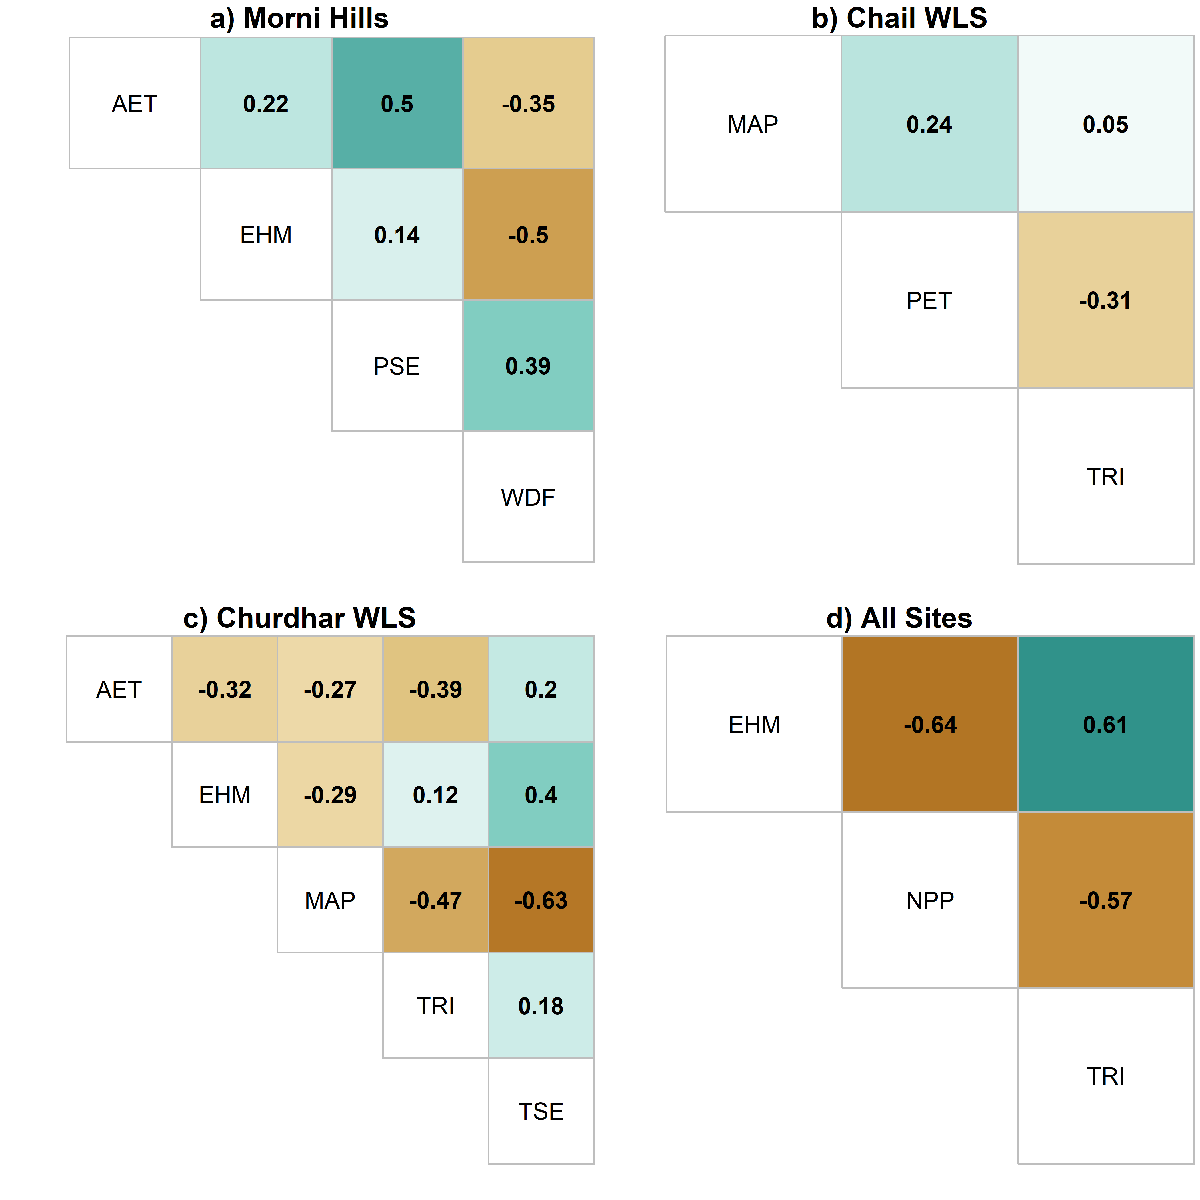
Fig. S1 Final set of uncorrelated explanatory variables for (a) Morni Hills, (b) Chail WLS, (c) Churdhar WLS, and (d) All Sites. The values represent Spearman’s correlation coefficient and the transparency of background is scaled to the magnitude of correlation coefficient

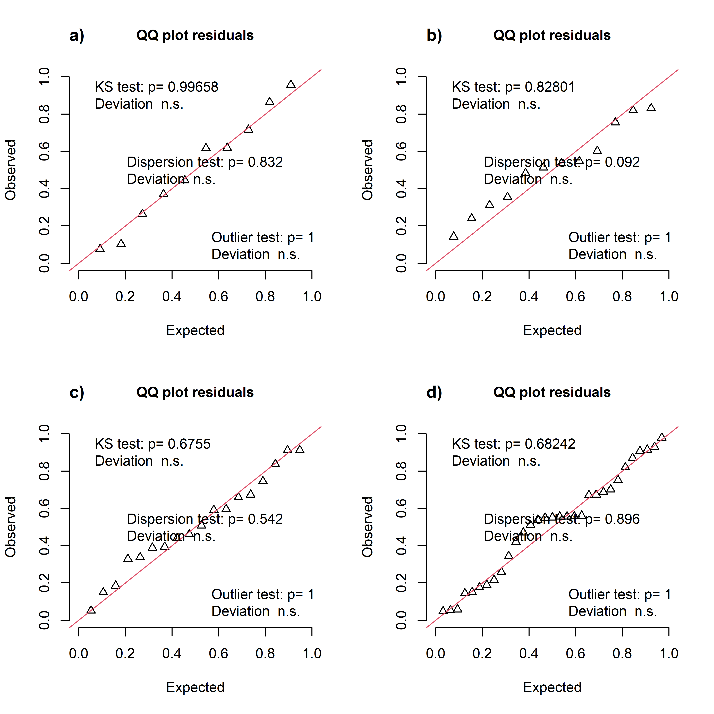
Fig. S2 Quantile-quantile (Q-Q) plot demonstrating model diagnostics for elevational patterns of species richness in (a) Morni Hills, (b) Chail WLS, (c) Churdhar WLS, and (d) All Sites. The plot shows the overall deviations from the simulation-based expected distribution with added tests for correct distribution (KS test), dispersion and outliers. The outliers are defined as values outside the simulation envelope. The plot assesses the goodness-of-fit between observed and expected quantiles, aiding in evaluating model assumptions and performance

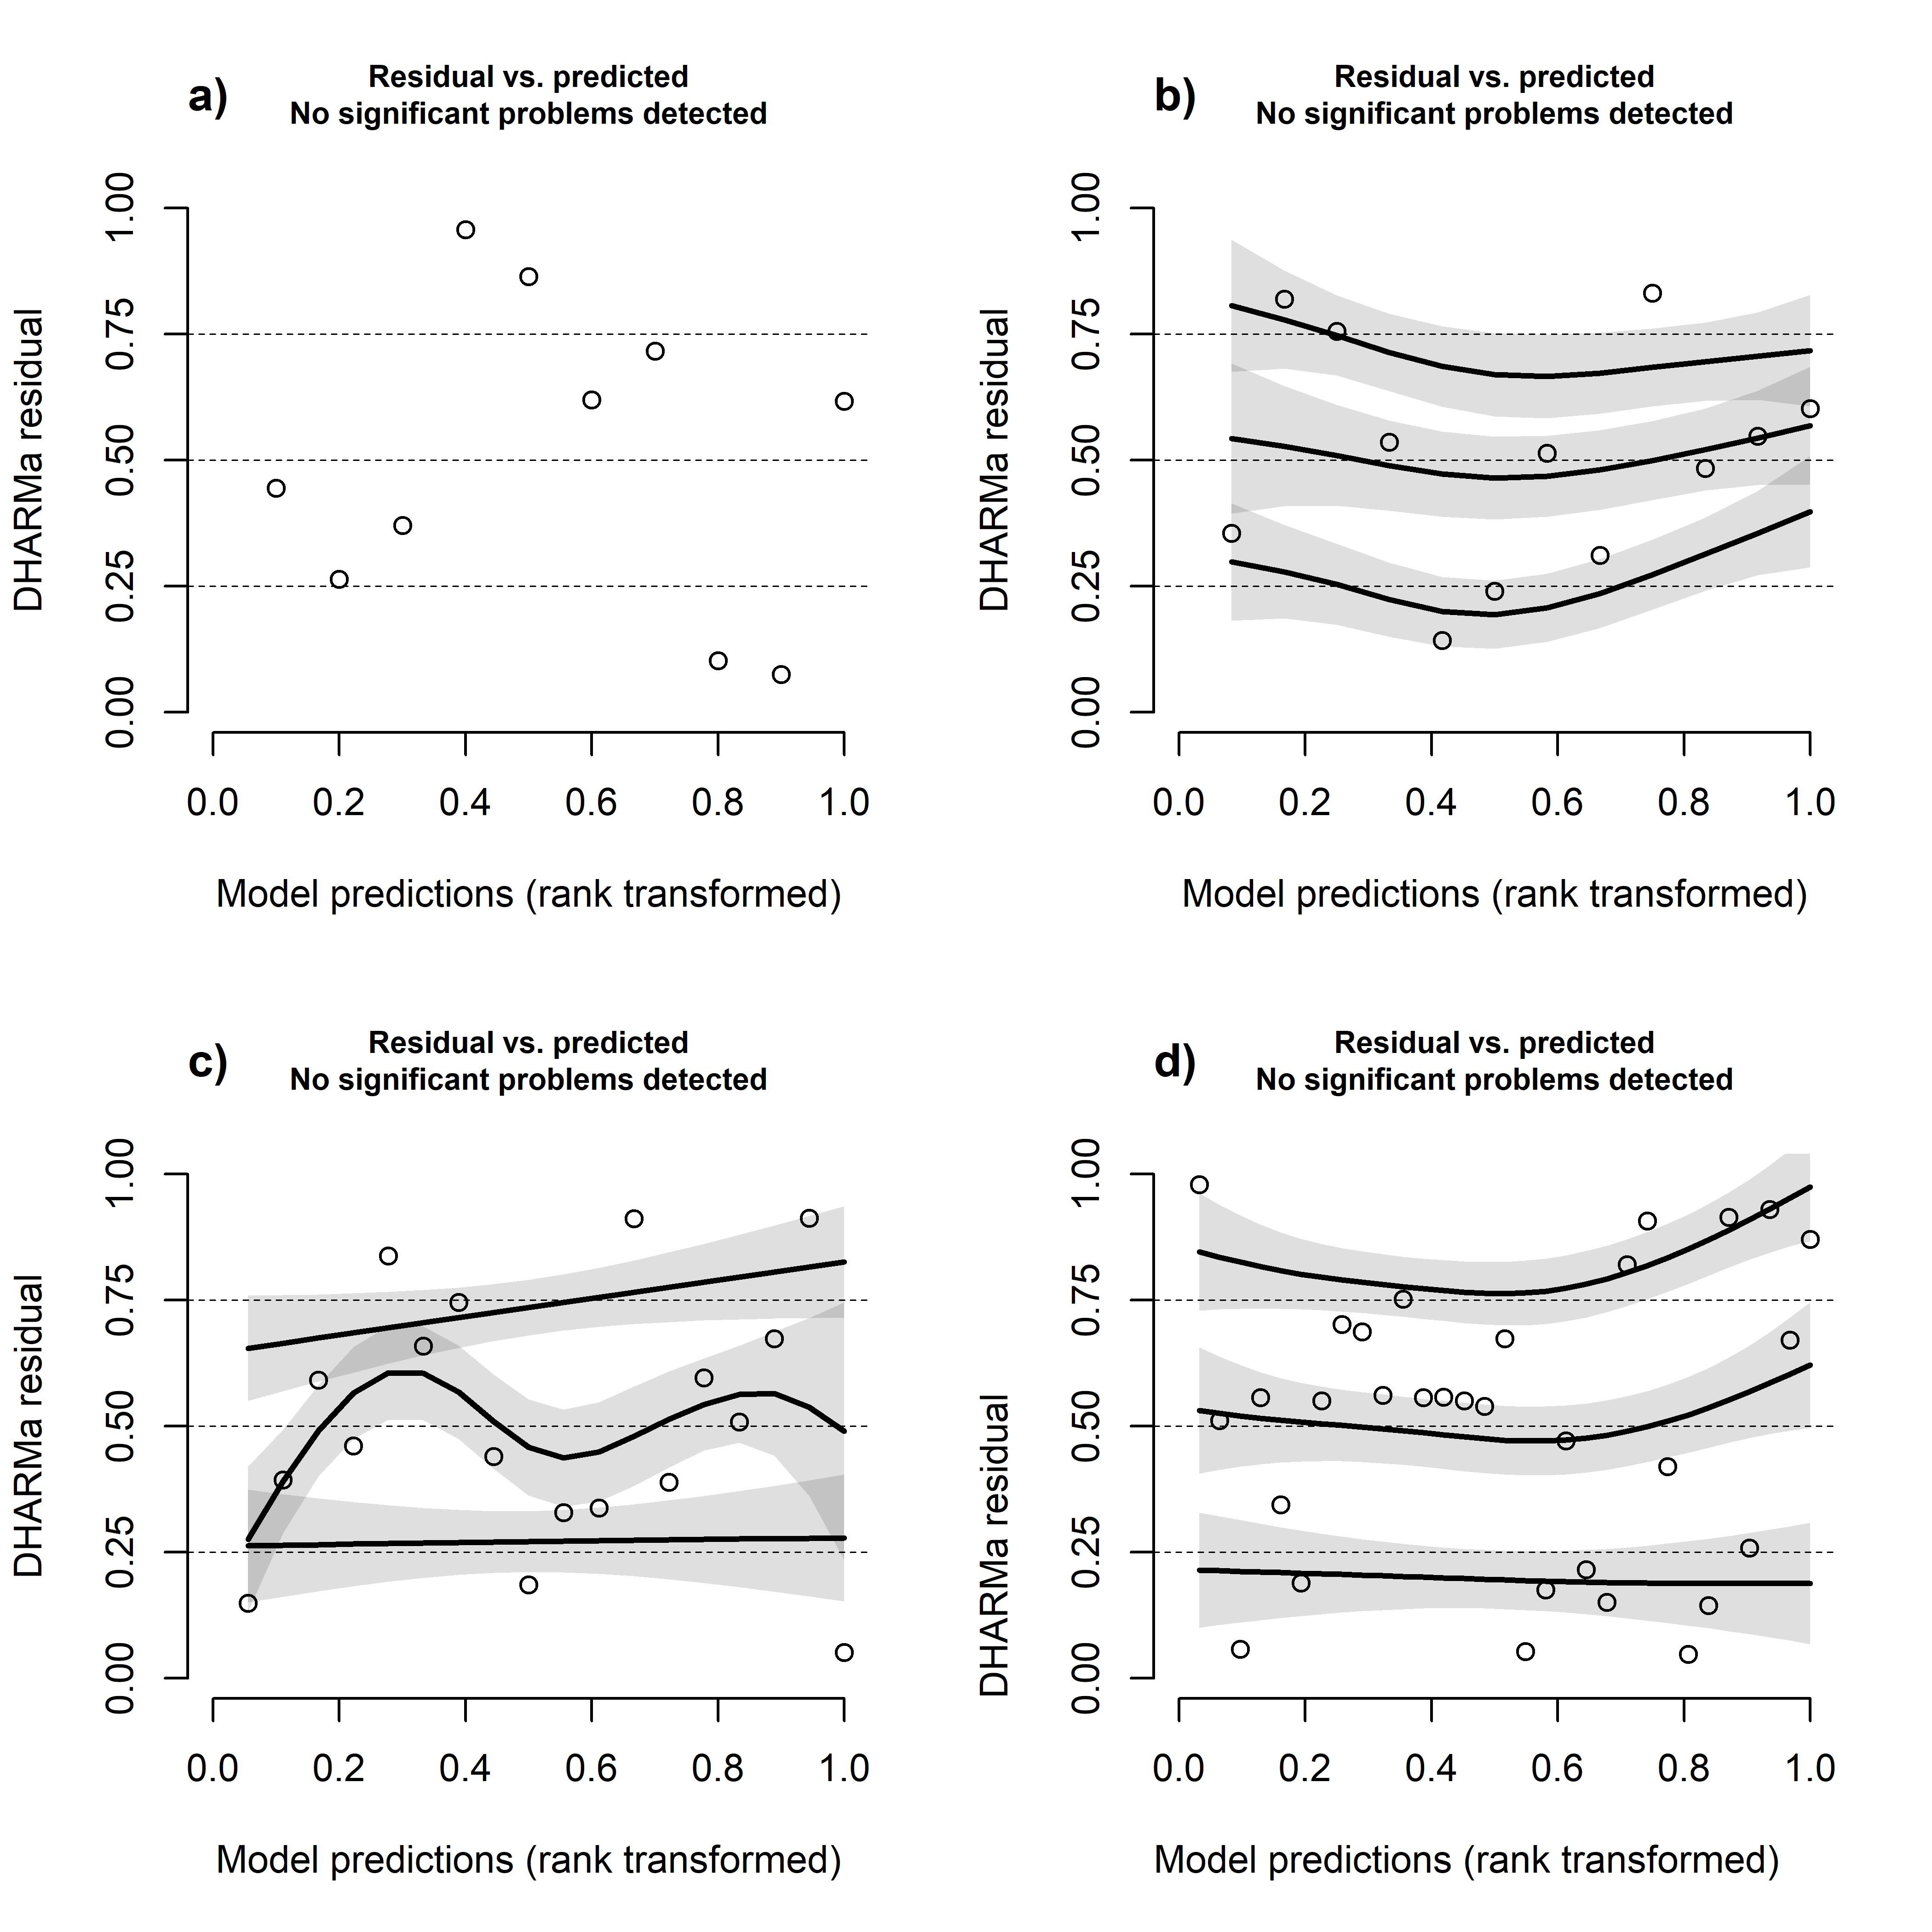
Fig. S3 Residual plots showing the deviations in model residuals against the model predictions for elevational patterns of species richness in (a) Morni Hills, (b) Chail WLS, (c) Churdhar WLS, and (d) All Sites. The deviation from the uniformity (in the y-direction) was estimated by comparing the empirical 0.25, 0.5 and 0.75 quantiles in the y-direction (red solid lines) with the theoretical 0.25, 0.5 and 0.75 quantiles (dashed black line). The simulation-based outliers are highlighted as red stars

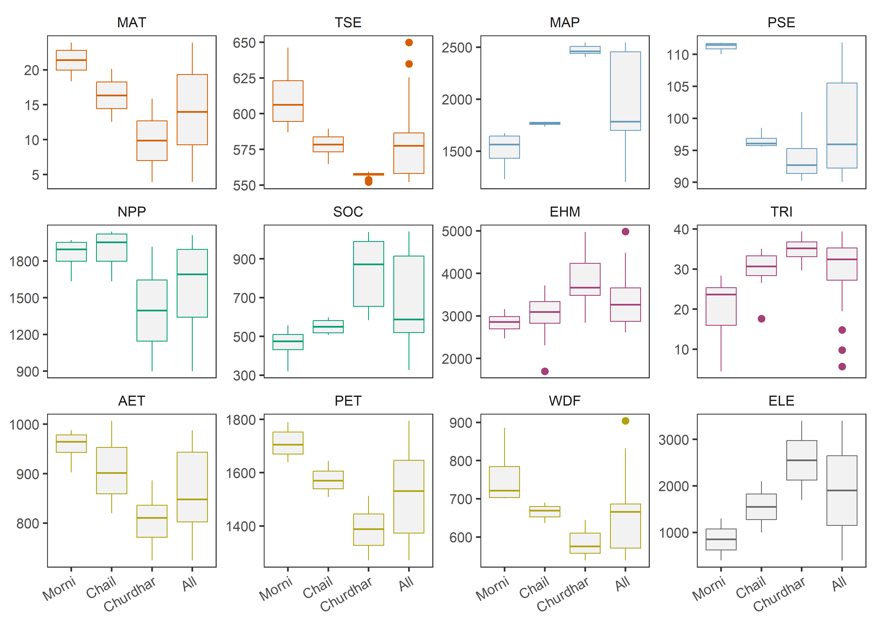
Fig. S4 Boxplots showing the distribution of environmental variables across the study sites. The predictor variables included Mean Annual Temperature (MAT) and Temperature Seasonality (TSE) as temperature variables; Mean Total Annual Precipitation (MAP) and Precipitation Seasonality (PSE) as precipitation variables; Net Primary Productivity (NPP) and Soil Organic Carbon (SOC) as energy variables; Enhanced Vegetation Index Homogeneity Index (EHM) and Terrain Ruggedness Index (TRI) as heterogeneity variables; Actual Evapotranspiration (AET), Potential Evapotranspiration (PET), Water Deficit (WDF) as water availability variables; and elevation (ELE) to represent the elevational gradients

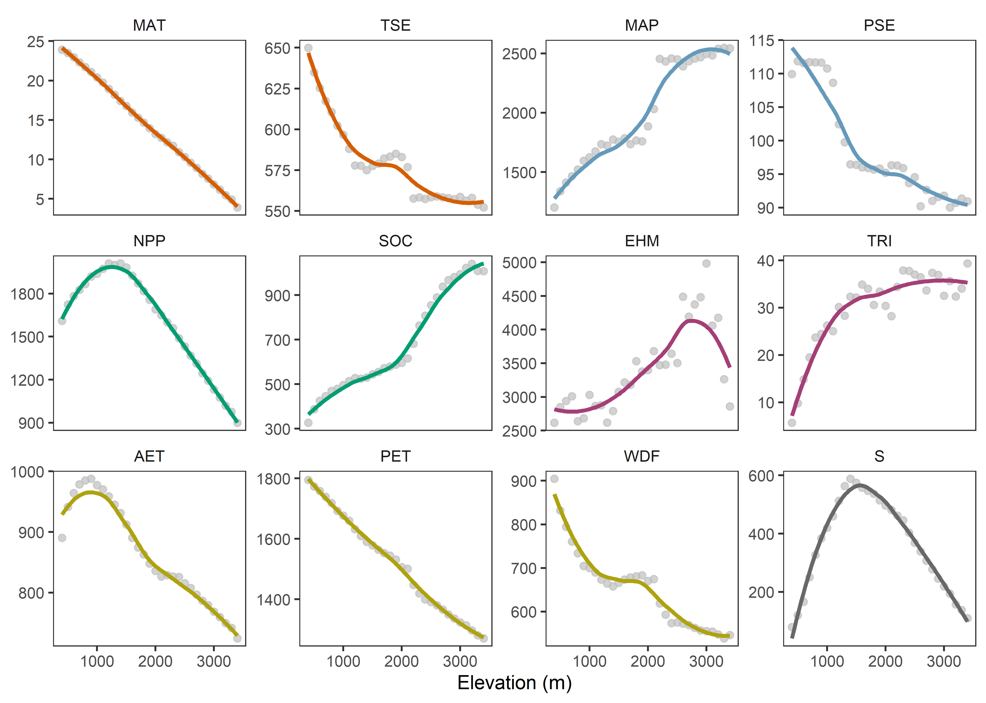
Fig. S5 Distribution of predictors variables and species richness (S) along the entire elevational gradient. The colours represent the category of environmental variables. The predictor variables included Mean Annual Temperature (MAT) and Temperature Seasonality (TSE) as temperature variables; Mean Total Annual Precipitation (MAP) and Precipitation Seasonality (PSE) as precipitation variables; Net Primary Productivity (NPP) and Soil Organic Carbon (SOC) as energy variables; Enhanced Vegetation Index Homogeneity Index (EHM) and Terrain Ruggedness Index (TRI) as heterogeneity variables; Actual Evapotranspiration (AET), Potential Evapotranspiration (PET), and Water Deficit (WDF) as water availability variables

Table S1 Summary of primary variable selection for explaining species richness at lower (Morni), intermediate (Chail), higher (Churdhar) and full (All) elevational gradient
Variable | Morni | Chail | Churdhar | All
AET | 52.06 | 7.35 | 94.59 | 11.06
EHM | 2.94 | 16.69 | 10.77 | 3.76
ELE | 47.79 | 4.19 | 93.55 | 4.19
MAP | 71.43 | 0.97 | 11.17 | 3.34
MAT | 43.81 | 4.42 | 93.27 | 4.05
NPP | 74.06 | 0.85 | 92.74 | 45.85
PET | 53.51 | 6.60 | 92.56 | 2.86
PSE | 0.07 | 33.22 | 69.24 | 0.51
SOC | 61.64 | 0.96 | 82.86 | 11.71
TRI | 80.57 | 79.50 | 14.44 | 10.19
TSE | 66.21 | 7.54 | 19.75 | 2.46
WDF | 88.63 | 8.48 | 81.07 | 0.46

The species richness (S) was regressed against each explanatory variable using Poisson GLM with a log-link function. The values represent the estimated deviance-squared (D²) in percent units and higher values indicate a better model fit. The variables with maximum D² values are highlighted with bold text.
Table S2 Results of model selection for exploring determinants of species richness in selected sites
Site | Model | df | logLik | AICc | delta | weight
Morni | S ~ AET + WDF | 3 | -38.31 | 86.62 | 0.00 | 0.48
Morni | S ~ AET + PSE | 3 | -38.83 | 87.66 | 1.04 | 0.28
Morni | S ~ AET + PSE + WDF | 4 | -36.41 | 88.83 | 2.21 | 0.16
Morni | S ~ AET + EHM + WDF | 4 | -37.09 | 90.19 | 3.57 | 0.08
Chail | S ~ TRI | 2 | -47.93 | 101.19 | 0.00 | 0.59
Chail | S ~ PET + TRI | 3 | -46.77 | 102.55 | 1.36 | 0.30
Chail | S ~ MAP + TRI | 3 | -47.81 | 104.62 | 3.43 | 0.11
Churdhar | S ~ AET + MAP | 3 | -72.50 | 152.72 | 0.00 | 0.54
Churdhar | S ~ AET + MAP + TRI | 4 | -71.74 | 154.56 | 1.84 | 0.22
Churdhar | S ~ AET + MAP + TSE | 4 | -72.15 | 155.37 | 2.65 | 0.14
Churdhar | S ~ AET + EHM + MAP | 4 | -72.50 | 156.07 | 3.35 | 0.10
All | S ~ EHM + NPP + TRI | 4 | -206.65 | 422.83 | 0.00 | 1.00

The table shows the degrees of freedom (df), log-likelihood (logLik), corrected Akaike’s Information Criteria (AICc), the difference in AICc from the top model (delta) and Akaike's model weight (weight) for each model. The species richness (S) was regressed against the predictor variables, including actual evapotranspiration (AET), enhanced vegetation index homogeneity (EHM), mean annual precipitation (MAP), potential evapotranspiration (PET), precipitation seasonality (PSE), temperature seasonality (TSE), terrain ruggedness index (TRI) and water deficit (WDF). Each model represents a generalised linear model (GLM) with Poisson distribution and the log-link function. Only models with a difference of four AICc units from the top model are presented for each site.
Table S3 Explanatory power of species richness models for lower (Morni), intermediate (Chail), higher (Churdhar) and full (All) elevational gradient
Model | Morni | Chail | Churdhar | All | Average
S ~ WDF + PET + I(PET²) | 92.98 | 90.04 | 98.62 | 99.34 | 95.24
S ~ WDF + MAT + WDF:MAT | 95.04 | 85.69 | 97.02 | 98.68 | 94.11
S ~ PET + I(PET²) | 93.97 | 90.04 | 97.88 | 94.32 | 94.05
S ~ MAP + PET + I(PET²) | 93.17 | 88.75 | 97.97 | 94.95 | 93.71
S ~ MAP + I(PET - PET²) + TRI | 95.72 | 82.31 | 77.39 | 97.11 | 88.13
S ~ NPP + EHM + TRI | 69.19 | 77.58 | 94.38 | 91.34 | 83.12
S ~ MAP + I(PET²) | 92.95 | 88.01 | 31.44 | 92.23 | 76.16
S ~ ELE + MAP + PET | 83.09 | 59.02 | 98.16 | 32.57 | 68.21
S ~ ELE + MAP + TSE | 97.26 | 1.93 | 98.22 | 70.05 | 66.86
S ~ MAP + I(PET - PET²) | 91.82 | -4.40 | 78.36 | 92.56 | 64.58
S ~ NPP + I(NPP²) | 85.79 | 16.60 | 98.03 | 40.66 | 60.27
S ~ AET + WDF | 93.96 | -20.12 | 93.54 | 13.06 | 45.11
S ~ NPP | 66.64 | -21.18 | 91.77 | 41.98 | 44.80
S ~ AET + MAP | 92.59 | -27.20 | 98.65 | 6.77 | 42.70
S ~ TRI | 75.01 | 74.94 | 3.03 | 3.77 | 39.19
S ~ WDF | 85.38 | -11.86 | 78.54 | -6.65 | 36.35
S ~ AET | 38.36 | -13.23 | 93.87 | 4.70 | 30.93
S ~ MAT | 27.76 | -16.82 | 92.37 | -2.80 | 25.13
S ~ MAP | 63.27 | -21.04 | -0.67 | -3.56 | 9.50

The explanatory power of each model was evaluated using the adjusted deviance-squared (D²_{adj}) in percent units and higher values indicate better model fit. The last column (Average) represents the mean values of adjusted deviance-squared (D²_{adj}) across the four elevational gradients. The models were arranged according to their average explanatory power across elevational gradients. The species richness (S) was regressed against the predictor variables, including actual evapotranspiration (AET), enhanced vegetation index homogeneity (EHM), elevation (ELE), mean annual precipitation (MAP), mean annual temperature (MAT), potential evapotranspiration (PET), temperature seasonality (TSE), terrain ruggedness index (TRI) and water deficit (WDF). Each model represents a generalised linear model (GLM) with Poisson distribution and the log-link function.
Table S4 Summary of model averaging of competitive models (ΔAICc < 2) for Morni Hills
Parameters | Estimate | SE | SE.adj | Z | p | 2.5% | 97.5% | SW
Intercept | 5.17 | 0.15 | 0.15 | 33.80 | 0.000 | 4.87 | 5.46 | NA
PET | -0.09 | 0.14 | 0.14 | 0.68 | 0.495 | -0.37 | 0.18 | 0.32
PET² | -0.16 | 0.16 | 0.17 | 0.94 | 0.347 | -0.48 | 0.17 | 0.49
AET | 0.04 | 0.06 | 0.06 | 0.64 | 0.521 | -0.08 | 0.17 | 0.32
WDF | -0.11 | 0.16 | 0.16 | 0.68 | 0.497 | -0.43 | 0.21 | 0.32
ELE | -0.38 | 0.78 | 0.79 | 0.48 | 0.635 | -1.93 | 1.18 | 0.19
MAP | -0.45 | 1.12 | 1.16 | 0.39 | 0.695 | -2.72 | 1.82 | 0.36
TSE | -0.95 | 2.00 | 2.03 | 0.46 | 0.642 | -4.93 | 3.04 | 0.19

The table displays the estimated regression coefficients (Estimate), standard errors (SE), adjusted standard errors (SE.adj), z-scores (Z), p-values (p), 95% confidence intervals (2.5% and 97.5%) and the sum of Akaike’s weight (SW) for each independent variable (Parameters) included in the competitive models. The adjusted SE incorporates model selection uncertainty, whereas standard SE considers sampling variance only. The sum of Akaike’s weight (SW) indicates the relative importance of each predictor in the model. The parameter estimates are standardised effect sizes as the predictors have been standardised to have a mean of 0 and SD of 1.
Table S5 Results of model selection to identify the best SEM model for exploring determinants of species richness along elevational gradients
SEM Model | Fisher.C | df | P.Value | AIC | K | AICc
Clim + PET + NPP | 13.59 | 8 | 0.093 | 63.33 | 25 | 78.70
Clim + PET + SOC | 8.10 | 6 | 0.231 | 122.87 | 26 | 139.61
Clim + PET | 3.37 | 2 | 0.186 | 143.11 | 19 | 154.98
Clim + PET + TRI | 14.18 | 10 | 0.165 | 158.37 | 24 | 173.45
Clim + NPP | 11.41 | 4 | 0.022 | 180.97 | 18 | 191.47
Clim + AET | 2.42 | 4 | 0.659 | 212.97 | 18 | 223.47
Clim + PET + EHM | 15.51 | 12 | 0.215 | 212.44 | 23 | 226.88
Clim + WDF | 1.81 | 4 | 0.770 | 220.93 | 18 | 231.70
Clim + SOC | 8.62 | 6 | 0.196 | 243.60 | 17 | 253.00
Clim | 4.85 | 2 | 0.089 | 260.06 | 11 | 265.96
Clim + TRI | 13.44 | 8 | 0.097 | 272.51 | 16 | 281.05
Clim + EHM | 7.24 | 4 | 0.124 | 327.26 | 18 | 337.76

The table shows the Akaike’s Information Criteria (AIC), likelihood degrees of freedom (K), number of observations (n) and corrected Akaike's Information Criteria (AICc) for each model evaluated. The species richness (S) was used as the endogenous variable. The exogenous variables included actual evapotranspiration (AET), enhanced vegetation index homogeneity (EHM), mean annual precipitation (MAP), potential evapotranspiration (PET), precipitation seasonality (PSE), temperature seasonality (TSE), terrain ruggedness index (TRI) and water deficit (WDF).

