Supplementary files

Table S1 Presents a comparison of selection gradients for various functional traits, both with and without covariates. Each row lists a trait along with its selection gradient (S’), standard error (SE), and p-value. Additionally, it includes the corresponding beta coefficient (Beta) and standard error for both analyses. Significance levels are indicated by asterisks: *** for p < 0.001 and NS for non-significant results.
Selection gradient | With cov. |  |  | Without cov.
Selection gradient | S’ | SE | p-value | β | SE | p-value
LA | 1.09 | 0.13 | *** | 2.42 | 0.14 | ***
LDMC | 1.52 | 0.23 | *** | 2.57 | 0.18 | ***
LT | 4.87 | 2.48 | ns | 8.11 | 1.77 | ***
LS | 0.06 | 0.05 | *** | 0.13 | 0.01 | ***
AB | 0.25 | 0.23 | *** | 0.37 | 0.06 | ***
SPAD | 2.87 | 0.13 | *** | 3.378 | 0.10 | ***
FVFM | 0.03 | 0.00 | *** | 0.037 | 0.00 | ***
FLO | 0.92 | 0.02 | *** | 0.99 | 0.02 | ***
FRO | 0.56 | 0.05 | *** | 0.73 | 0.04 | ***
FLD | 0.32 | 0.39 | ns | -0.111 | 0.31 | ns
FRD | 0.35 | 0.34 | ns | -0.09 | 0.28 | ns
DD | 0.22 | 0.24 | ns | -0.07 | 0.198 | ns
RGR | 5.93e-05 | 7.18-05 | ns | -1.84e-05 | 5.79e-05 | ns
Note that TSM and TSN were took as covariate and DO was used as predictor.

Table S2 Presents the Relative Difference in Plasticity Index (RDPI) for various traits of Prosopis across rangelands: DSG, WSG, and WLR. Additionally, an overall mean RDPI value (across) is calculated for each trait, along with the corresponding p-values indicating the significance of differences across the land types.
Trait | Rangeland types |  |  | Across
Trait | DSG | WSG | WLR | Across
TSM | 0.52 | 0.35 | 0.42 | 0.40
TSN | 0.34 | 0.29 | 0.39 | 0.30
LA | 0.60 | 0.61 | 0.56 | 0.61
LDMC | 0.57 | 0.64 | 0.53 | 0.57
LT | 0.71 | 0.73 | 0.35 | 0.60
LS | 0.55 | 0.53 | 0.47 | 0.50
AB | 0.68 | 0.55 | 0.58 | 0.44
SPAD | 0.68 | 0.53 | 0.47 | 0.64
FVFM | 0.54 | 0.52 | 0.49 | 0.54
FLO | 0.62 | 0.63 | 0.47 | 0.62
FRO | 0.57 | 0.64 | 0.45 | 0.63
FLD | 0.53 | 0.59 | 0.52 | 0.46
FRD | 0.66 | 0.59 | 0.45 | 0.43
DO | 0.59 | 0.615 | 0.45 | 0.60
DD | 0.59 | 0.63 | 0.48 | 0.47
RGR | 0.54 | 0.55 | 0.57 | 0.45
To calculate the Relative Difference in Plasticity Index (RDPI) for the specified traits assessing Prosopis plasticity across the three rangelands we used the simplified formula of (Alvarez et al., 2020): RDPI=𝑋−min(𝑋)/ max(𝑋)−min(𝑋). Where: X is the trait value from each rangeland.

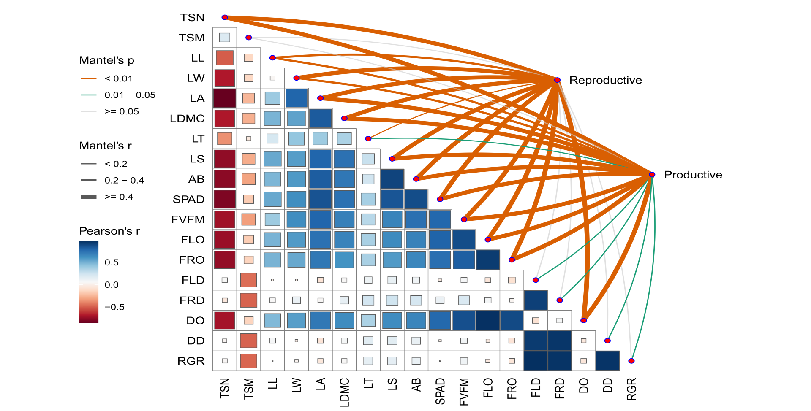
Fig. S1 Illustrates Mantel’s test result among various phenological and functional traits of Prosopis. It combines a Pearson correlation matrix with Mantel's test results. The lower triangular matrix shows Pearson correlation coefficients, where color intensity indicates correlation strength and direction. Lines connecting traits to "Reproductive" and "Productive" nodes represent Mantel's p-values: orange for significant correlations (p < 0.01), green for moderate significance (0.01 ≤ p < 0.05), and gray for non-significant (p ≥ 0.05). Line thickness reflects Mantel's r-values, indicating the strength of the correlations.

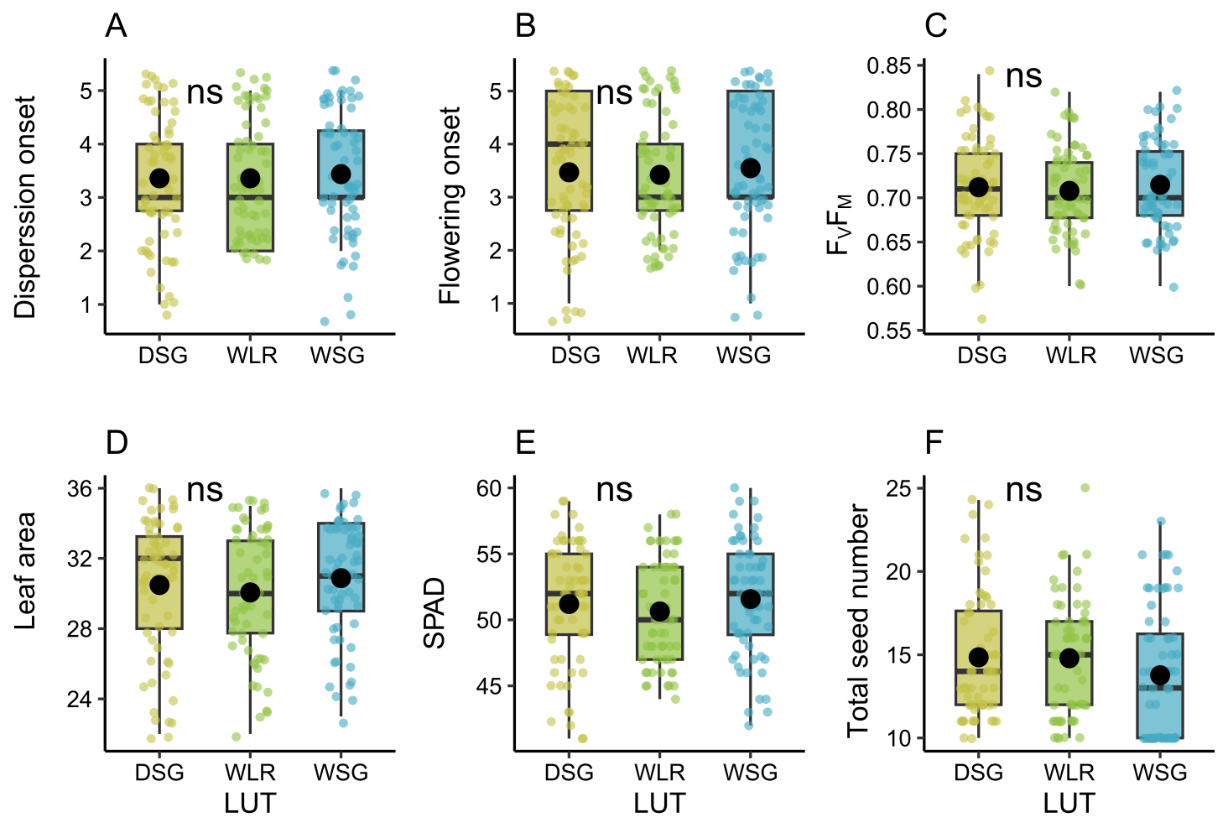Fig. S2 Illustrates the phenotypic and fitness that with no significant variation between rangelands. The Phenotypic means (large dots), average reaction norms (black lines) and groups reaction norms (gray lines) for the traits under selection and total seed mass fitness variable in both species: A) Dispersion onset, B) Flowering onset, C) FvFm, D) Leaf area, E) SPAD, and F) Total seed number.

Functional trait definitions and measurement techniques for Prosopis juliflora
1. Total Seed Number (TSN): The total count of seeds produced by a plant or in a given sample.
- Measurement Technique: Seeds can be counted manually or using automated seed counters that use image analysis systems (TSN= count of seeds). The overall mean number of seeds was 23±4 seeds/pod (Shiferaw et al. 2004).
2. Total Seed Mass (TSM): The total mass of all seeds produced by a plant or in a given sample, typically measured in grams (TSM = sum mass of individual seed). The width and length of seeds ranged between 0.8–1.7 and 8–29 cm, respectively. The mean weight of a seed of Prosopis was 0.0275 g±0.001 (S.E.) while there were 36,000–37,000 seeds/kg (Shiferaw et al. 2004).
- Measurement Technique: Seeds are collected, dried to a constant weight, and weighed using precision balances.
3. Leaf Area (LA): The surface area of leaves, typically measured in square centimeters (cm²)
(LA = sum of leaf areas from all leaves). Leaves bipinnate, glabrous or pubescent, 1-3 pairs of pinnae, rarely 4 pairs; petiole plus rachis (when present) 0.5-7.5 cm long; pinnae 3-11 cm long (Compendium, 2022).
- Measurement Technique: Methods include using a leaf area meter or digital image analysis software to calculate area from photographs of the leaves (Easlon & Bloom 2014).
4. Specific Leaf Area (SLA): The ratio of leaf area to leaf dry mass, expressed in cm²/g.
- Measurement Technique: SLA is calculated by measuring leaf area (via a leaf area meter) and leaf dry mass (after drying leaves to a constant weight, SLA = LA/leaf dry mass (g)) (Ali et al. 2017).
5. Leaf Dry Matter Content (LDMC): The ratio of leaf dry mass to leaf fresh mass, usually expressed as a percentage, LDMC = leaf dry mass/leaf fresh mass*100%.
- Measurement Technique: Fresh leaf samples are weighed, dried in an oven, and reweighed for dry mass measurement (Vaieretti et al. 2007).
6. Leaf Thickness (LT): The average thickness of leaves, LT= thicknesses of leaves/ number of leaves, typically measured in millimeters (mm).
- Measurement Technique: Leaf thickness can be measured using a micrometer or calipers, or non-destructive methods involve imaging techniques paired with image analysis software (Afzal et al. 2017).
7. Total Estimated Leaf Area (TELA): An estimate of the total leaf area of a plant based on its dimensions or other leaf area metrics (TELA~ individual leaf area measurements).
- Measurement Technique: This can be estimated using allometric relationships or based on measurements of individual leaves using leaf area meters (Koyama & Smith 2022).
8. Leaf: Stem Ratio (L.S): The ratio of leaf biomass to stem biomass, providing insight into plant growth strategies ( L.S= leaf biomass/ stem biomass).
- Measurement Technique: Biometric measurements of leaf and stem biomass can be done by harvesting aboveground biomass, separating leaves and stems, and weighing them (Schrader et al. 2021).
9. Aerial Biomass (AB): The total mass of all living plant material above the soil. It is often reported in grams or kilograms per area (e.g., g/m²). Calculated as AB = total mass of aboveground plant material (g).
- Measurement Technique: All aboveground plant material is harvested, dried, and weighed to determine biomass (Robertson et al. 2023).
10. Leaf Chlorophyll Content (SPAD): A relative measure of chlorophyll concentration in leaves, often using a SPAD meter.
Measurement Technique: SPAD meters measure leaf chlorophyll by measuring transmittance of specific wavelengths of light (Süß 2015).
- The chlorophylls (mg g-1) a and b were determined according to the method of Arnon (1949). Fresh leaves (0.5 g) were extracted overnight with 5 mL 80% acetone at 0-4 °C. The extracts were centrifuged at 10,000 x g for 5 min. The absorbance of the supernatant was read at 645 and 663 nm using a spectrophotometer (Hitachi-U2001, Tokyo, Japan).
The chlorophylls a and b were calculated by the following formulae:
Chl a = [12.7 (OD 663) -2.69 (OD 645)] x V/1000 x W
Chl b = [22.9 (OD 645) -4.68 (OD 663)] x V/1000 x W was V = volume of the extract (mL); W = weight of the fresh leaf tissue (g)
11. Photochemical Efficiency (FV/FM): A measure of the maximum efficiency of photosystem II, calculated as the ratio of chlorophyll fluorescence ( FV/FM= F_{v}/F_{M}).
- Measurement Technique: Fluorometers measure chlorophyll fluorescence in response to light pulses, providing F_{V}/F_{M} values (Baker, 2008).
12. Flowering Onset (FLO): The point at which a plant begins to flower.
- Measurement Technique: Phenological observations are made in the field to monitor and record flowering dates across different environmental conditions.
13. Flowering Duration (FLD): The total period during which a plant is in bloom.
- Measurement Technique: This is recorded through phenological studies in the field, noting the beginning and end of flowering. Calculated as FLD =end flowering date - start flowering date.
14. Fruiting Onset (FRO): The point in time when a plant starts to produce fruit.
- Measurement Technique: Similar to flowering onset, monitoring and recording of fruit development stages are done in the field.
15. Fruiting Duration (FRD): The total period during which a plant is producing fruit.
- Measurement Technique: Observations over time track the initiation and cessation of fruit development. Calculated as FRD= end fruiting date- start fruiting date.
16. Dispersion Onset (DO): The time point at which seed dispersion begins. Calculated as DD = end dispersal date- start dispersal date.
- Measurement Technique: Field observations document the start of seed dispersal events.
17. Dispersion Duration (DD): The period during which seeds are dispersed from the plant.
- Measurement Technique: Monitoring seed dispersal events until complete is required.
18. Relative Growth Rate: The increase in biomass relative to the initial biomass over a specific period, usually reported as a percentage. Calculated as RGR = final biomass - initial biomass/initial biomass *100%.
- Measurement Technique: RGR is calculated by measuring initial and final biomass at known time intervals (Lamont et al. 2023).
19. Final Plant Volume (PV_F): The total volume of the plant at the end of a growth period.
- Measurement Technique: Volume can be derived from biomass measurements or directly measured using water displacement methods (Burdett 1979).
20. Initial Plant Volume (PV_I): The total volume of the plant at the beginning of a growth period.
- Measurement Technique: Similar to the final plant volume, measured at the start of the experiment or growth period (Burdett 1979).
21. Maternal Seed Mass (MSM): The mass of seeds produced by the mother plant, which can affect offspring performance. Calculated as MSM = mass of harvested seeds\number of seeds.
Measurement Technique: Seeds are harvested and weighed individually or in batches to determine the average seed mass. Seeds were harvested at maturity (R8) at a moisture content of approximately the number of P. juliflora seeds per kilogram, about 28,400, and screened into different seed size categories (Lima 1986).
Thousand grains were counted from the grain sample of each plot and weighed on an electric balance. Biological yield (ton ha-1) In each plot, the crop was harvested and tied into bundles. Then, it was weighed using an electric balance. Grain yield (ton ha-1) Grain yield from each plot was recorded after threshing the crop.
Abbreviations
TSN: Total seed number; TSM: Total seed mass; LA: leaf area; SLA: specific leaf area; LDMC: leaf dry matter content; LT: leaf thickness; TELA: total estimated leaf area; L.S: leaf: stem ratio; AB: aboveground biomass; SPAD: leaf chlorophyll content; FVFM: photochemical efficiency; FlO: flowering onset; FlD: flowering duration; FrO: fruiting onset; FrD: fruiting duration; DO: dispersion onset; DD: dispersion duration; RGR: relative growth rate; PV_F: final plant volume; PV_I: initial plant volume; MSM: maternal seed mass
References
Afzal A, Duiker S W, Watson JE (2017) Leaf thickness to predict plant water status. Biosystems Engineering, 156, 148-156. https://doi.org/https://doi.org/10.1016/j.biosystemseng.2017.01.011
Ali AM, Darvishzadeh R, Skidmore AK, van Duren I (2017) Specific leaf area estimation from leaf and canopy reflectance through optimization and validation of vegetation indices. Agricultural and Forest Meteorology, 236, 162-174. https://doi.org/https://doi.org/10.1016/j.agrformet.2017.01.015
Alvarez JA, Cortizo SC, Gyenge JE (2020) Yield stability and phenotypic plasticity of Populus spp. clones growing in environmental gradients: I-yield stability under field conditions. Forest Ecology and Management, 463, 117995. https://doi.org/https://doi.org/10.1016/j.foreco.2020.117995
Baker NR (2008) Chlorophyll fluorescence: a probe of photosynthesis in vivo. Annu Rev Plant Biol, 59, 89-113. https://doi.org/10.1146/annurev.arplant.59.032607.092759
Burdett AN (1979) A nondestructive method for measuring the volume of intact plant parts. Canadian Journal of Forest Research, 9(1), 120-122. https://doi.org/10.1139/x79-021
Compendium C (2022). Prosopis juliflora (mesquite). CABI Compendium. https://doi.org/10.1079/cabicompendium.43942
Easlon HM, Bloom AJ (2014) Easy Leaf Area: Automated digital image analysis for rapid and accurate measurement of leaf area. Appl Plant Sci, 2(7). https://doi.org/10.3732/apps.1400033
Koyama K, Smith DD (2022) Scaling the leaf length-times-width equation to predict total leaf area of shoots. Ann Bot, 130(2), 215-230. https://doi.org/10.1093/aob/mcac043
Lamont BB, Williams MR, He T (2023) Relative growth rate (RGR) and other confounded variables: mathematical problems and biological solutions. Ann Bot, 131(4), 555-568. https://doi.org/10.1093/aob/mcad031
Lima PCF (1986) P. juliflora Management at the Brazilian Northeast: (Management of Silvopastoral Resources, Issue.
Robertson SM, Schmid RB, Lundgren JG (2023) Estimating plant biomass in agroecosystems using a drop-plate meter. PeerJ, 11, e15740. https://doi.org/10.7717/peerj.15740
Schrader J, Shi P, Royer DL, Peppe D J, Gallagher RV, Li Y, Wang R, Wright IJ (2021) Leaf size estimation based on leaf length, width and shape. Ann Bot, 128(4), 395-406. https://doi.org/10.1093/aob/mcab078
Shiferaw H, Teketay D, Nemomissa S, Assefa F (2004) Some biological characteristics that foster the invasion of Prosopis juliflora (Sw.) DC. at Middle Awash Rift Valley Area, north-eastern Ethiopia. Journal of Arid Environments, 58(2), 135-154. https://doi.org/https://doi.org/10.1016/j.jaridenv.2003.08.011
Süß A, Danner M, Obster C, Locherer M, Hank T, Richter K (2015) Measuring Leaf Chlorophyll Content with the Konica Minolta SPAD-502Plus –Theory, Measurement, Problems, Interpretation. Field Guides Technical Report
Vaieretti M V, Díaz S, Vile D, Garnier E (2007)Two measurement methods of leaf dry matter content produce similar results in a broad range of species. Ann Bot, 99(5), 955-958. https://doi.org/10.1093/aob/mcm022
Vilà-Guerau de Arellano J, Hartogensis O, Benedict I, de Boer H, Bosman P J M, Botía S, Cecchini M A, Faassen K A P, González-Armas R, van Diepen K, Heusinkveld B G, Janssens M, Lobos-Roco F, Luijkx I T, Machado L A T, Mangan M R, Moene AF, Mol W B, van der Molen M, Moonen R, Ouwersloot H G, Park SW, Pedruzo-Bagazgoitia X, Röckmann T, Adnew GA, Ronda R, Sikma M, Schulte R, van Stratum B J H, Veerman M A, van Zanten M C, van Heerwaarden C C (2023) Advancing understanding of land–atmosphere interactions by breaking discipline and scale barriers. Annals of the New York Academy of Sciences, 1522(1), 74-97. https://doi.org/https://doi.org/10.1111/nyas.14956

