Supplementary Material
Fungi stimulate organic phosphorus fraction transformation in subtropical pine plantation soils after nine years of thinning and understory removal
Zunji Jian ^{a,b,c}, Lixiong Zeng ^{a,b,c}, Lei Lei ^{a,b,c*}, Beat Frey ^{d}, Changfu Liu ^{a,b,c}, Yafei Shen ^{a,b,c},
Jiajia Zhang ^{a,c}, Wenfa Xiao ^{a,b,c}, Mai-He Li ^{d,e,f}
ª Ecology and Nature Conservation Institute, Chinese Academy of Forestry; Key Laboratory of Forest Ecology and Environment of National Forestry and Grassland Administration Beijing, 100091, China
^{b} Co-Innovation Center for Sustainable Forestry in Southern China, Nanjing Forestry University, Nanjing 210037, China
^{c} Hubei Zigui Three Gorges Reservoir National Forest Ecosystem Observation and Research Station, Zigui 443600, China
^{d} Forest Dynamics, Swiss Federal Institute for Forest, Snow and Landscape Research WSL, Zuercherstrasse 111, Birmensdorf CH-8903, Switzerland.
^{e} Key Laboratory of Geographical Processes and Ecological Security in Changbai Mountains, Ministry of Education, School of Geographical Sciences, Northeast Normal University, Changchun 130024, China
^{f} School of Life Science, Hebei University, Baoding 071000, China
Author's E-mail: Zunji Jian (jianzunji2014@163.com);
Lixiong Zeng (zlxcaf@163.com);
Lei Lei (cafleilei@163.com);
Beat Frey (beat.frey@wsl.ch);
Changfu Liu (liucf898@163.com);
Yafei Shen (yafeishen126@126.com);
Jiajian Zhang (zhangjiajia@caf.ac.cn);
Wenfa Xiao (xiaowenf@caf.ac.cn);
Mai-He Li (Maihe.li@wsl.ch).
* Corresponding author: Lei Lei
E-mail address: cafleilei@163.com
Ecology and Nature Conservation, Chinese Academy of Forestry, No. 2 of Dongxiaofu, Xiangshan Road, Haidian District, Beijing, 100091, China.
Tel.: +86 010-62888818
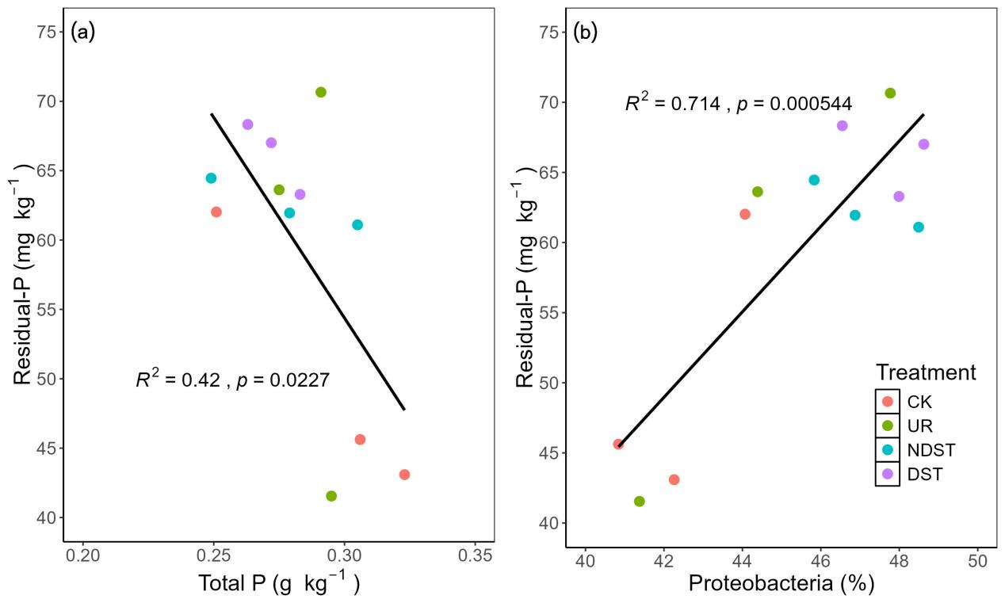
Fig. S1 Relationships between soil residual-P and soil total phosphorus (a) and relative abundance of Proteobacteria (b) after nine years of forest management treatments in a pine plantation of subtropical China. CK, control; UR, understory removal; NDST, non-dominant species thinning; DST, dominant species thinning.
Table S1 Soil physical and chemical properties after nine years of forest management treatments in a pine plantation of subtropical China.
Variable | Management treatment |  |  |  |  | ANOVA test
Variable | CK | UR | NDST | DST |  | F-value | p-value
Bulk density (g cm⁻³) | 1.23±0.07 | 1.17±0.13 | 1.17±0.15 | 1.13±0.23 |  | 0.225 | 0.876
Water content (%) | 22.45±3.28 | 18.56±0.97 | 21.90±1.41 | 19.45±1.70 |  | 2.552 | 0.129
Total porosity (%) | 50.83±2.15 | 50.83±2.39 | 51.83±3.44 | 52.40±5.31 |  | 0.144 | 0.931
pH | 4.93±0.03 | 4.79±0.33 | 4.63±0.16 | 4.78±0.08 |  | 1.273 | 0.347
Organic carbon (g kg⁻¹) | 19.69±0.48 | 20.33±0.27 | 21.02±1.69 | 20.84±1.67 |  | 0.713 | 0.571
Total nitrogen (g kg⁻¹) | 1.84±0.11 | 1.77±0.02 | 1.82±0.12 | 1.86±0.09 |  | 0.430 | 0.737
Total phosphorus (g kg⁻¹) | 0.29±0.04 | 0.29±0.01 | 0.28±0.03 | 0.27±0.01 |  | 0.427 | 0.739
BCD_Fe (g kg⁻¹) | 12.99±0.58 | 13.35±0.61 | 13.04±0.63 | 13.42±0.40 |  | 0.440 | 0.731
Oxa_Fe (g kg⁻¹) | 3.01±0.25 | 3.74±0.66 | 3.10±0.16 | 3.22±0.44 |  | 1.791 | 0.227
TP_Fe (g kg⁻¹) | 0.54±0.03 | 0.52±0.02 | 0.61±0.09 | 0.56±0.04 |  | 1.445 | 0.300
BCD_Al (g kg⁻¹) | 4.32±0.17 | 4.69±0.22 | 4.77±0.32 | 4.46±0.06 |  | 2.931 | 0.099
Oxa_Al (g kg⁻¹) | 1.09±0.08 | 1.14±0.03 | 1.09±0.04 | 1.05±0.00 |  | 1.778 | 0.229
TP_Al (g kg⁻¹) | 0.78±0.03 | 0.89±0.11 | 0.85±0.06 | 0.81±0.01 |  | 1.625 | 0.253
Values are means ± standard deviation (n = 3). CK, control; UR, understory removal; NDST, non-dominant species thinning; DST, dominant species thinning; DCB_Fe, dithionite-citrate-bicarbonate extractable iron; Oxa_Fe, oxalate extractable iron; TP_Fe, tetrasodium-pyrophosphate extractable iron; DCB_Al, dithionite-citrate-bicarbonate extractable aluminum; Oxa_Al, oxalate extractable aluminum; and TP_Al, tetrasodium-pyrophosphate extractable aluminum.

Table S2. Changes in soil P fractions content and its proportion after nine years of forest management treatments in a pine plantation of subtropical China.
Category | Varibale | Management treatment |  |  |  |  | ANOVA test
Category | Varibale | CK | UR | NDST | DST |  | F-value | p-value
Content (mg kg⁻¹) | Labile-P | 17.05±1.09 | 20.12±5.17 | 22.02±1.44 | 17.65±3.03 |  | 1.616 | 0.261
 | Moderately labile-P | 86.74±3.32b | 91.24±4.12ab | 95.79±2.62a | 85.24±2.93b |  | 6.266 | 0.017
 | Occluded-P | 99.16±22.41 | 108.15±17.04 | 109.80±3.25 | 117.85±5.44 |  | 0.848 | 0.506
Percentage (%) | Labile-P | 8.47±1.25 | 9.22±2.71 | 9.67±0.48 | 7.99±1.35 |  | 0.616 | 0.624
 | Moderately labile-P | 43.05±5.31 | 41.65±3.45 | 42.09±0.98 | 38.61±1.27 |  | 1.034 | 0.428
 | Occluded-P | 48.47±6.55 | 49.13±6.11 | 48.24±0.51 | 53.39±2.58 |  | 0.805 | 0.525
Values are shows as the means ± standard deviation (n = 3). Different lowercase letters represent significant differences between forest management treatments (p < 0.05). CK, control; UR, understory removal; NDST, non-dominant species thinning; DST, dominant species thinning.

Table S3. Pearson's correlation coefficient between soil P fractions and soil P-associated microbial and chemical properties.
Variables | Resin-Pi | NaHCO₃-Pi | NaHCO₃-Po | NaOH-Pi | NaOH-Po | HCl-Pi | C.CHl-Pi | C.CHl-Po | Residual-P | Total Pi | Total Po
Bulk density | -0.040 | -0.119 | 0.142 | -0.235 | 0.328 | -0.187 | -0.351 | -0.109 | -0.168 | -0.382 | 0.150
Water content | 0.156 | 0.618* | -0.195 | -0.465 | 0.154 | 0.539 | -0.081 | 0.369 | -0.017 | -0.001 | 0.343
Total porosity | -0.033 | 0.236 | -0.111 | 0.214 | -0.386 | 0.374 | 0.352 | 0.214 | 0.049 | 0.423 | -0.082
pH | 0.152 | -0.229 | -0.704* | -0.527 | -0.311 | -0.035 | -0.219 | 0.349 | 0.168 | -0.360 | -0.136
Organic carbon | 0.233 | 0.204 | 0.046 | 0.348 | -0.096 | 0.296 | 0.479 | -0.214 | 0.135 | 0.551 | -0.228
Total nitrogen | 0.076 | 0.298 | -0.459 | 0.109 | -0.625* | 0.429 | 0.296 | 0.473 | 0.282 | 0.374 | -0.124
Total phosphorus | -0.603* | 0.203 | 0.152 | -0.037 | 0.217 | -0.294 | -0.509 | -0.141 | -0.648* | -0.421 | 0.061
DCB_Fe | 0.265 | -0.779** | -0.277 | -0.053 | -0.193 | -0.472 | 0.110 | -0.087 | 0.332 | -0.134 | -0.293
Oxa_Fe | 0.130 | -0.378 | -0.101 | 0.178 | -0.082 | -0.557 | 0.203 | -0.197 | 0.406 | 0.056 | -0.258
TP_Fe | -0.047 | 0.007 | 0.194 | 0.111 | 0.229 | -0.319 | 0.168 | -0.349 | 0.172 | 0.107 | -0.099
DCB_Al | 0.186 | 0.210 | 0.217 | 0.481 | 0.277 | -0.259 | 0.373 | -0.407 | 0.297 | 0.426 | -0.113
Oxa_Al | -0.036 | 0.196 | 0.023 | -0.066 | 0.324 | -0.154 | -0.126 | -0.158 | -0.129 | -0.104 | 0.062
TP_Al | -0.197 | 0.379 | 0.780** | 0.523 | 0.346 | -0.020 | -0.083 | 0.072 | -0.285 | 0.153 | 0.554
ACP | -0.189 | 0.538 | -0.057 | -0.166 | 0.264 | 0.159 | -0.551 | 0.452 | -0.414 | -0.345 | 0.532
MBP | -0.134 | 0.649* | -0.175 | -0.429 | 0.366 | 0.421 | -0.246 | 0.026 | -0.333 | -0.137 | 0.175
DCB_Fe, dithionite-citrate-bicarbonate extractable iron; Oxa_Fe, oxalate extractable iron; TP_FE, terasodium-pyrophosphate extractable iron; DCB_Al, dithionite-citrate-bicarbonate extractable aluminum; Oxa_Al, oxalate extractable aluminum; TP_Al, terasodium-pyrophosphate extractable aluminum; ACP, acid phosphatase; MBP, microbial biomass phosphorus; Pi, total inorganic phosphorus; and Po, organic phosphorus. *, p < 0.05; and **, p < 0.01.

Table S4. Pearson's correlation coefficient between soil P fractions and soil fungal community.
Variables | Resin-Pi | NaHCO₃-Pi | NaHCO₃-Po | NaOH-Pi | NaOH-Po | HCl-Pi | C.CHl-Pi | C.CHl-Po | Residual-P | Total Pi | Total Po
Basidiomycota | -0.328 | 0.518 | 0.290 | -0.347 | 0.577* | 0.352 | -0.620* | 0.178 | -0.728** | -0.430 | 0.604*
Ascomycota | 0.089 | -0.201 | -0.113 | 0.590* | -0.554 | -0.227 | 0.607* | -0.309 | 0.603* | 0.559 | -0.640*
Mortierellomycota | -0.184 | -0.058 | -0.207 | -0.313 | 0.182 | 0.058 | -0.236 | -0.342 | -0.403 | -0.278 | -0.267
Rozellomycota | 0.335 | 0.091 | 0.387 | 0.584* | 0.094 | 0.454 | 0.390 | -0.367 | 0.235 | 0.565 | -0.124
Glomeromycota | 0.497 | -0.716** | -0.398 | 0.196 | -0.582* | -0.081 | 0.622* | -0.237 | 0.617* | 0.400 | -0.698*
Chytridiomycota | 0.182 | -0.335 | 0.477 | 0.273 | 0.185 | 0.007 | 0.125 | -0.059 | -0.117 | 0.125 | 0.232
Mucoromycota | -0.339 | 0.197 | -0.021 | -0.222 | 0.352 | -0.238 | -0.549 | -0.008 | -0.439 | -0.488 | 0.193
Olpidiomycota | -0.081 | -0.145 | -0.253 | -0.503 | 0.088 | -0.143 | -0.026 | -0.034 | -0.067 | -0.223 | -0.070
Zoopagomycota | 0.409 | -0.600* | -0.315 | -0.076 | -0.105 | -0.355 | 0.444 | -0.289 | 0.447 | 0.160 | -0.431
Entorrhizomycota | 0.557 | 0.177 | 0.125 | 0.118 | 0.390 | 0.733** | 0.335 | -0.457 | 0.099 | 0.452 | -0.124
Others | 0.532 | -0.718** | -0.390 | -0.161 | -0.345 | -0.374 | 0.349 | 0.149 | 0.590* | 0.046 | -0.216
Chao1 | 0.217 | -0.676* | 0.170 | 0.560 | -0.385 | -0.270 | 0.499 | -0.371 | 0.410 | 0.385 | -0.491
Shannon index | 0.047 | -0.616* | 0.239 | 0.521 | -0.312 | -0.481 | 0.402 | -0.340 | 0.340 | 0.272 | -0.395
Pielou index | -0.011 | -0.580* | 0.254 | 0.491 | -0.280 | -0.541 | 0.360 | -0.320 | 0.309 | 0.227 | -0.354
Pi, inorganic phosphorus; and Po, organic phosphorus. *, p < 0.05; and **, p < 0.01.

Table S5. Pearson's correlation coefficient between soil P fractions and soil bacterial community.
Variables | Resin-Pi | NaHCO₃-Pi | NaHCO₃-Po | NaOH-Pi | NaOH-Po | HCl-Pi | C.CHl-Pi | C.CHl-Po | Residual-P | Total Pi | Total Po
Proteobacteria | 0.608* | -0.197 | -0.162 | 0.323 | -0.262 | -0.038 | 0.886** | -0.385 | 0.845** | 0.736** | -0.552
Acidobacteria | -0.191 | 0.275 | 0.814** | 0.470 | 0.431 | -0.295 | -0.118 | -0.120 | -0.167 | 0.050 | 0.448
Actinobacteria | 0.522 | -0.053 | -0.638* | 0.049 | -0.574 | 0.432 | 0.725** | -0.076 | 0.719** | 0.629* | -0.640*
Chloroflexi | -0.291 | -0.147 | -0.156 | -0.415 | -0.021 | -0.070 | -0.762** | 0.547 | -0.462 | -0.736** | 0.411
Verrucomicrobia | -0.368 | 0.045 | -0.017 | -0.161 | 0.301 | 0.079 | -0.544 | -0.157 | -0.688* | -0.445 | 0.034
Bacteroidetes | 0.028 | -0.533 | -0.346 | -0.020 | -0.483 | -0.372 | 0.290 | -0.095 | 0.410 | 0.056 | -0.496
Rokubacteria | -0.359 | 0.270 | -0.420 | -0.172 | -0.373 | 0.069 | -0.401 | 0.547 | -0.074 | -0.305 | 0.105
Planctomycetes | 0.010 | 0.083 | 0.189 | 0.016 | 0.523 | 0.201 | -0.217 | -0.318 | -0.363 | -0.109 | 0.100
Gemmatimonadetes | -0.302 | 0.237 | -0.112 | -0.472 | -0.165 | 0.259 | -0.392 | 0.626* | -0.384 | -0.363 | 0.411
Patescibacteria | -0.242 | 0.267 | 0.243 | -0.390 | 0.261 | 0.140 | -0.474 | 0.504 | -0.500 | -0.409 | 0.686*
Others | -0.479 | 0.066 | -0.043 | -0.490 | -0.034 | -0.004 | -0.649* | 0.577* | -0.537 | -0.636* | 0.470
Chao1 | 0.018 | -0.431 | -0.381 | -0.448 | -0.249 | 0.141 | -0.169 | 0.101 | -0.146 | -0.314 | -0.199
Shannon index | -0.064 | -0.572 | -0.489 | -0.398 | -0.500 | -0.050 | -0.148 | 0.233 | -0.015 | -0.342 | -0.271
Pielou index | -0.120 | -0.562 | -0.489 | -0.360 | -0.536 | -0.146 | -0.166 | 0.266 | 0.015 | -0.359 | -0.264
Pi, inorganic phosphorus; and Po, organic phosphorus. *, p < 0.05; and **, p < 0.01.

