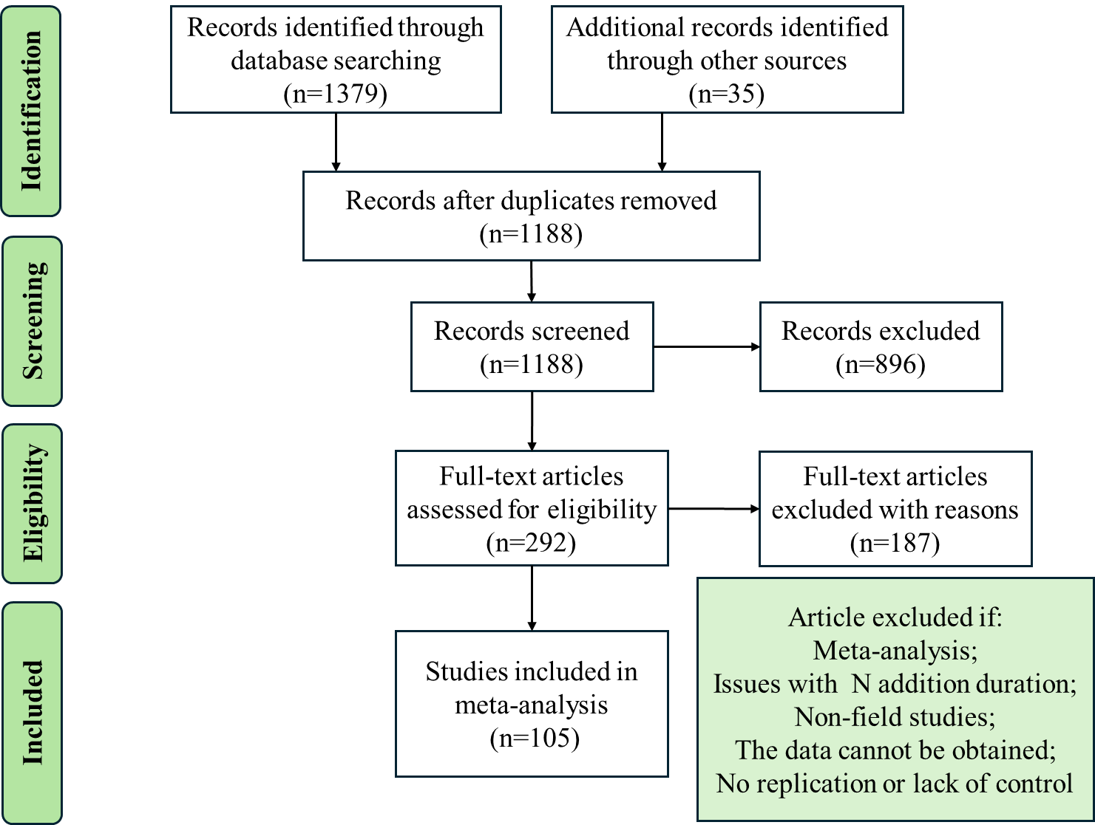
Figure S1 PRISMA flow diagram for publication inclusion in this meta-analysis.

Table S1 Test for publication bias for the response of soil organic carbon to nitrogen addition using Egger’s regression test and Fail-Safe Analysis with Rosenberg method.
Variables | N | Egger，s regression |  | Fail-safe coefficient | 5N+10
Variables | N | z | p | Fail-safe coefficient | 5N+10
SOC | 469 | 1.15 | 0.25 | 7039 | 2355
POC | 459 | 1.22 | 0.22 | 13613 | 2305
MAOC | 333 | -0.46 | 0.64 | 621 | 1675
MAOC:SOC | 296 | -0.25 | 0.80 | 2632 | 1490
POC:SOC | 434 | 4.19 | 0.001 | 8160 | 2180
POC:MAOC | 301 | -0.91 | 0.37 | 1110 | 1515
Note: N is sample size. For Egger's regression test, p values > 0.05 indicates the absence of publication bias. For Fail-Safe Analysis, coefficients > 5N+10 indicate the effect sizes of variables are statistically significant.

Table S2 Mixed linear regression models to test the impact of various variables on predicting SOC component responses to nitrogen addition.
 | Sum Sq | Den DF | F-value | p-value
SOC
Duration | 0.066 | 88.951 | 2.786 | 0.099
N type | 0.005 | 115.324 | 0.212 | 0.646
Ecosystem_type | 0.084 | 89.835 | 1.773 | 0.176
Duration: N type | 0.037 | 89.963 | 1.552 | 0.216
Duration: Ecosystem_type | 0.04 | 87.1 | 0.856 | 0.429
POC
Duration | 1.294 | 129.588 | 4.128 | <0.01
N type | 0 | 64.043 | 0 | 0.993
Ecosystem_type | 2.373 | 74.3 | 11.356 | <0.001
Duration: N type | 0.768 | 88.769 | 2.449 | 0.069
Duration: Ecosystem_type | 3.118 | 81.431 | 4.974 | <0.001
MAOC
Duration | 0.433 | 126.978 | 11.024 | <0.01
N type | 0.440 | 88.8 | 11.204 | <0.001
Ecosystem_type | 0.137 | 84.949 | 1.748 | 0.175
Duration: N type | 0.082 | 123.37 | 2.106 | 0.148
Duration: Ecosystem_type | 0.072 | 111.817 | 0.923 | 0.398

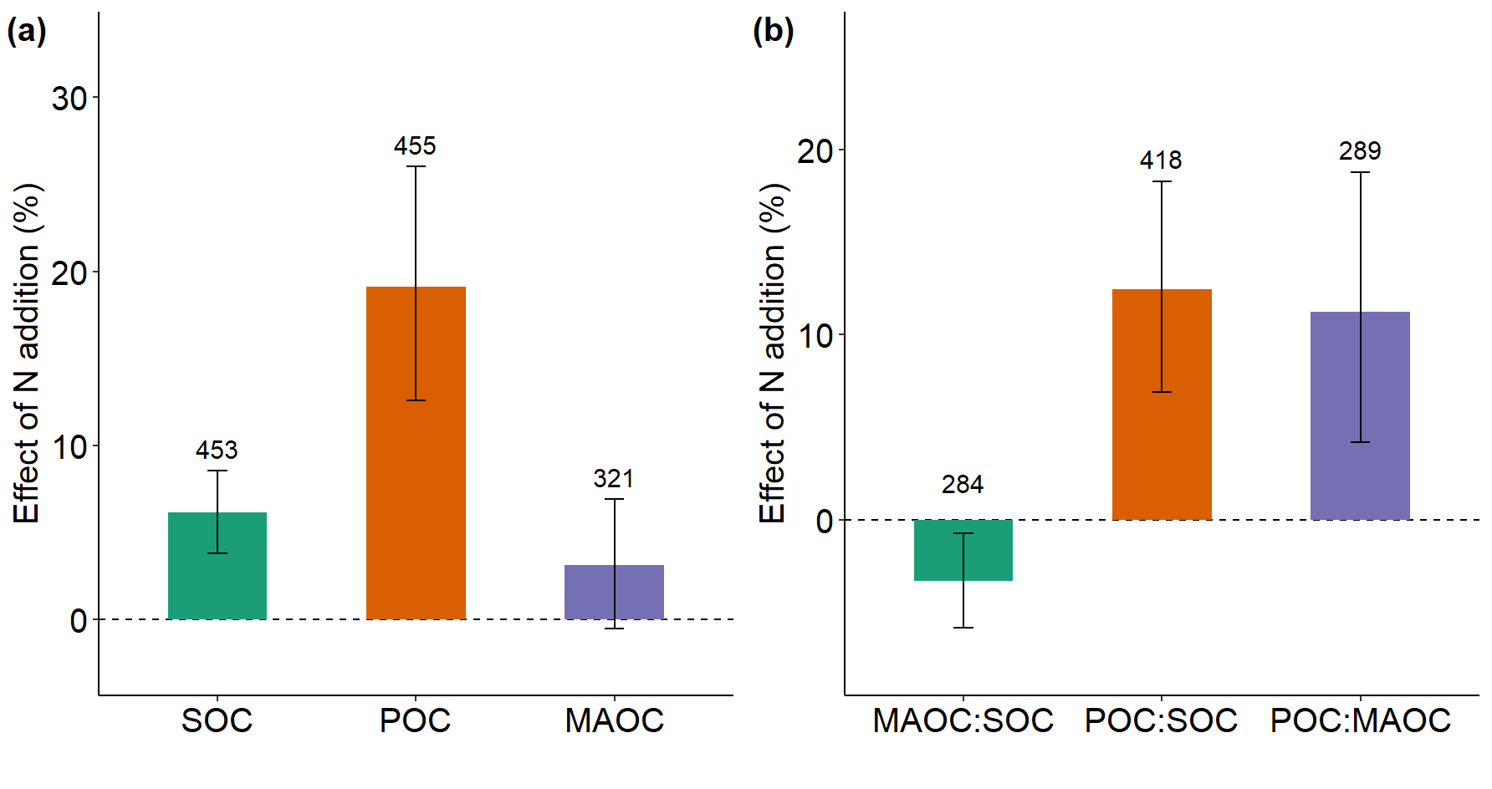
Figure S2 Overall effects of nitrogen addition on soil organic carbon (SOC), particulate organic carbon (POC) and mineral-associated organic carbon (MAOC) (a), and the ratios of MAOC to SOC, POC to SOC, and POC to MAOC (b). Means and 95% confidence intervals (CIs) are given.The numbers above the CIs indicate the sample size.
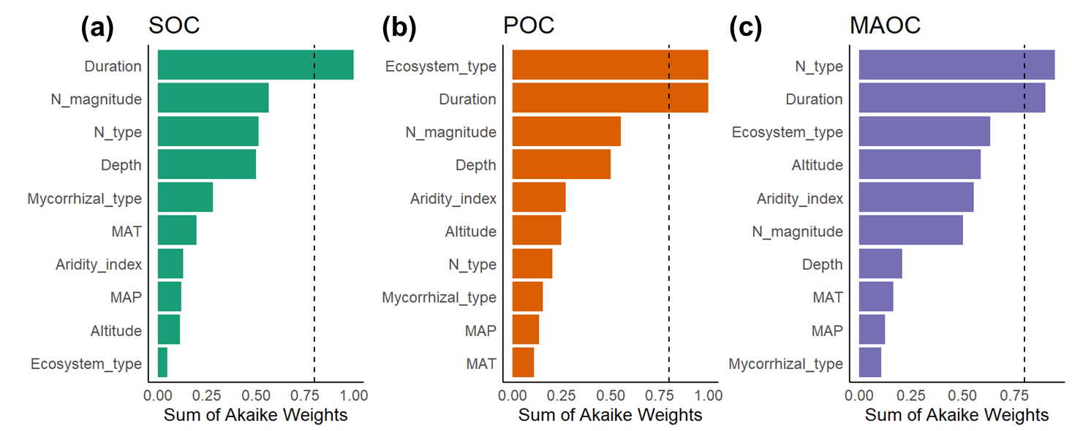
Figure S3 Model-averaged importance of the predictors for the effect of nitrogen addition on soil organic carbon (SOC) (a), particulate organic carbon (POC) (b) and mineral-associated organic carbon (MAOC) (c). Cutoff is set at 0.8 in order to differentiate among the most important predictors.

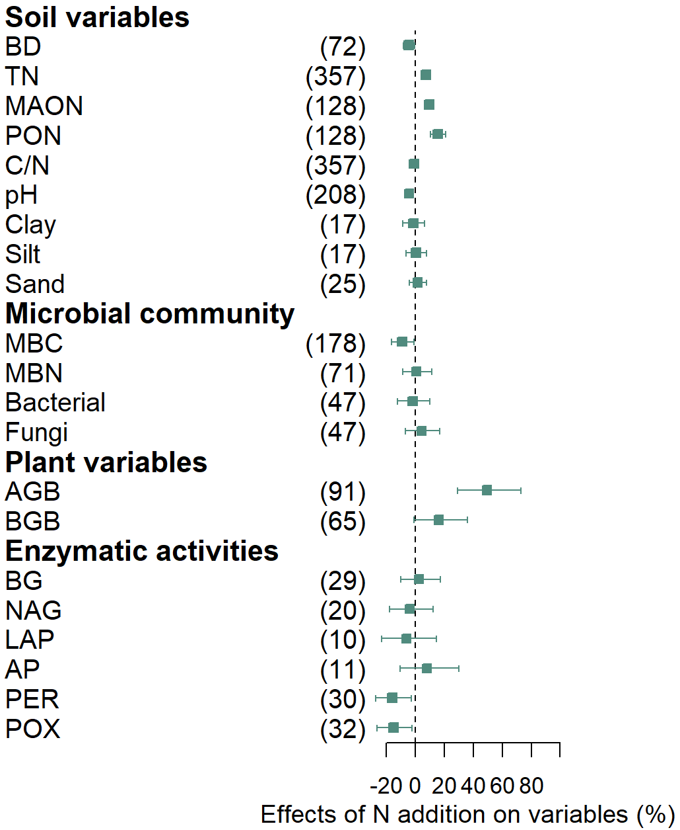
Figure S4 Meta-analysis of the effect of nitrogen addition on the variables. Full bars represent the 95% confidence interval. BD, bulk density; TN, soil total N; MAON, mineral-associated organic nitrogen; PON, particulate organic nitrogen; MBC, microbial biomass C; MBN, microbial biomass N; AGB, aboveground biomass; BGB, belowground biomass; BG, β-glucosidase; NAG, β-1,4,-N-acetyl-glucosaminnidase; LAP, L-aminopeptidase; AP, acid phosphatase; PER, peroxidase; and POX, phenol oxidase.

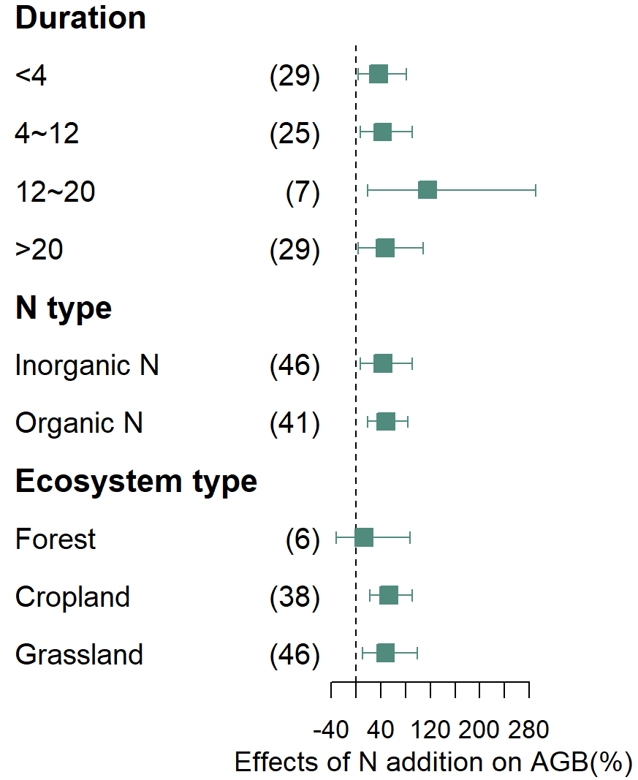
Figure S5 Meta-analysis of the effect of nitrogen addition on aboveground biomass (AGB) with different duration (<4, 4~12, 12~20, and >20 years), N type (organic, inorganic nitrogen) and Ecosystem type (forest, cropland, grassland)

