Supplemental Information for:
Elemental-enzymatic indicators of nutrient limitation in ombrotrophic peatlands across seasonal and spatial gradients

Shuaizhi Guo¹, Danny Turner¹, Deying Wang¹, Donald T. Monteith², Niall P. McNamara², Gary D. Bending¹, Ryan M. Mushinski^{1*}

¹ School of Life Sciences, Gibbet Hill Campus, University of Warwick, Coventry, CV4 7AL, UK
² UK Centre for Ecology & Hydrology, Lancaster Environment Centre, Library Avenue, Bailrigg, Lancaster LA1 4AP, UK

*Corresponding Author: Ryan M. Mushinski (Ryan.Mushinski@warwick.ac.uk)

Supplementary Figures
SI Figure 1. Monthly Total Precipitation recorded in the Moor House Area from 2015 to 2023.............................................................................................Page 3
SI Figure 2. Averaged Peat Depth across Moor House along with Elevation Gradients.......................................................................................................Page 4
SI Figure 3. Spearman Correlation Matrix for Environmental and Microbial Variables..........................................................................................................Page 5
Supplementary Tables
SI Table 1. Monthly Averaged Temperature of the Moor House Area from 2015 to 2023.....................................................................................................Page 6
SI Table 2. Primers and thermocycling parameters for qPCR assay.....................................................................................................................................Page 6
SI Table 3. Physicochemical Properties of Peat Samples.....................................................................................................................................................Page 7
SI Table 4. Proportion of Elemental Content in Peat Samples..............................................................................................................................................Page 8
SI Table 5. Parameters of Enzymatic Activities measured in this Study................................................................................................................................Page 9
SI Table 6. Microbial Abundance across Seasonal and Spatial Gradients..........................................................................................................................Page 10
Supplementary Texts
SI Text 1. Methodological Complications and the Use of Air-Dried Samples in Enzyme Assay..........................................................................................Page 11

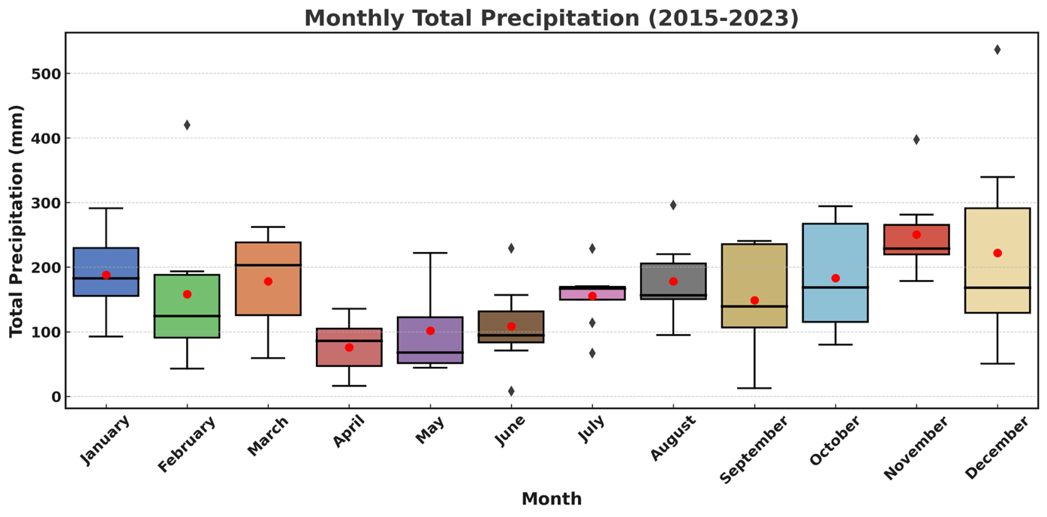
SI Figure 1. Monthly Total Precipitation recorded in the Moor House Area from 2015 to 2023. The amount of Rainfall was collected hourly by a meteorological station located in Moor House. The red dot in each boxplot represents the average precipitation value over the past ten years.

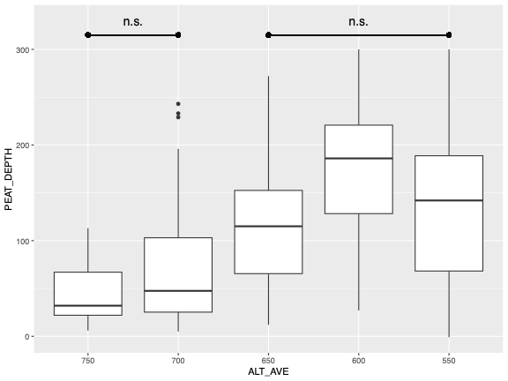
SI Figure 2. Averaged Peat Depth across Moor House along with Elevation Gradients (Rose et al., 2016)

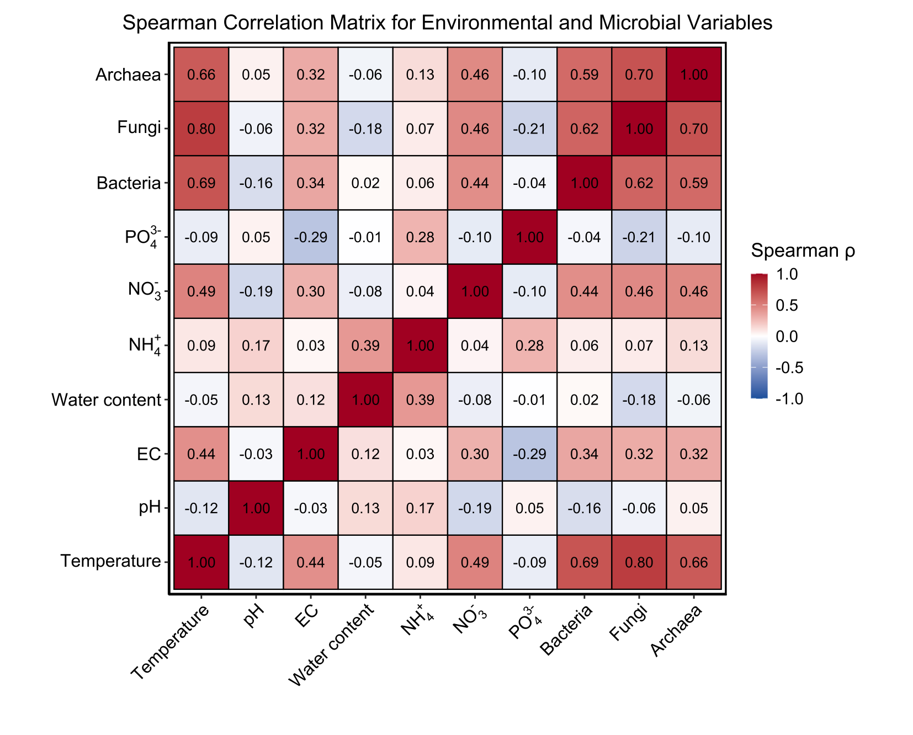
SI Figure 3. Spearman Correlation Matrix for Environmental and Microbial Variables
SI Table 1. Monthly Averaged Temperature of the Moor House Area from 2015 to 2023.
Month | Jan. | Feb. | Mar. | Apr. | May. | Jun. | Jul. | Aug. | Sept. | Oct. | Nov. | Dec.
Avg Temperature (°C) | 1.17 | 1.41 | 2.40 | 4.19 | 7.69 | 10.88 | 12.29 | 11.91 | 10.02 | 7.01 | 3.78 | 2.42

SI Table 2. Primers and thermocycling parameters for qPCR assay
Target Gene | Length (nt²) | Primer Sequence (5’-3’) | qPCR Protocol
Bacterial 16S V4 | 292 | GTGCCAGCMGCCGCGGTAA | 94 °C for 3 min  40 x (94°C for 45 s, 50 °C for 60 s, 72 °C for 90 s)
Bacterial 16S V4 | 292 | GGACTACHVGGGTWTCTAAT
Archaeal 16S V4 | 288 | CAGYMGCCRCGGKAAHACC | 95 °C for 10 min  40 x (95°C for 15 s, 56 °C for 30 s, 72 °C for 30 s)
Archaeal 16S V4 | 288 | GGACTACNSGGGTMTCTAAT
ITS Fungi | 350 | GCATCGATGAAGAACGCAGC | 95 °C for 5 min  40 x (94°C for 30 s, 55 °C for 30 s, 72 °C for 60 s)
ITS Fungi | 350 | TCCTCCGCTTATTGATATGC

SI Table 3. Physicochemical Properties of Peat Samples
Season | Depth (cm) |  | Elevation (m) | Temperature (°C) |  | pH | EC (mS cm⁻¹) |  | Water Content (%) | NH₄⁺ (mg kg⁻¹) | NO₂⁻ + NO₃⁻ (mg kg⁻¹) | PO₄³⁻ (mg kg⁻¹
Winter |  | 0-20 | 550 |  | 6.85 (0.35) | 3.75 (0.05) | 0.11 (0.03) | 91.01 (0.97) |  | 22.02 (3.82) | 5.03 (0.47) | 11.24 (2.02)
Winter |  | 0-20 | 600 |  | 6.73 (0.21) | 3.69 (0.04) | 0.06 (0.01) | 90.87 (0.90) |  | 18.81 (5.27) | 2.95 (1.30) | 11.33 (2.92)
Winter |  | 0-20 | 650 |  | 6.60 (0.23) | 3.67 (0.07) | 0.09 (0.01) | 87.11 (1.07) |  | 11.40 (1.66) | 2.66 (1.39) | 10.07 (3.73)
Winter |  | 0-20 | 700 |  | 6.42 (0.15) | 3.56 (0.03) | 0.11 (0.01) | 87.14 (1.20) |  | 9.39 (2.94) | 8.32 (3.20) | 6.21 (1.60)
Winter |  | 0-20 | 750 |  | 5.25 (0.45) | 3.53 (0.05) | 0.05 (0.01) | 75.57 (5.86) |  | 7.22 (2.20) | 10.35 (2.53) | 7.43 (2.72)
Winter |  | 20-40 | 550 |  | 6.30 (0.14) | 3.60 (0.04) | 0.12 (0.02) | 90.99 (1.03) |  | 15.49 (1.72) | 4.48 (1.23) | 6.41 (1.74)
Winter |  | 20-40 | 600 |  | 6.10 (0.20) | 3.71 (0.06) | 0.10 (0.01) | 90.72 (0.62) |  | 15.70 (2.73) | 5.83 (1.86) | 5.28 (1.89)
Winter |  | 20-40 | 650 |  | 5.68 (0.14) | 3.66 (0.06) | 0.11 (0.01) | 87.40 (0.23) |  | 11.10 (1.54) | 6.70 (0.98) | 9.21 (1.66)
Winter |  | 20-40 | 700 |  | 5.52 (0.09) | 3.57 (0.04) | 0.11 (0.01) | 86.42 (0.68) |  | 11.98 (1.40) | 5.23 (1.61) | 5.23 (0.64)
Winter |  | 20-40 | 750 |  | 4.78 (0.26) | 3.94 (0.12) | 0.08 (0.02) | 70.92 (6.48) |  | 7.71 (1.71) | 3.84 (1.07) | 6.58 (0.71)
Winter |  | 40-60 | 550 |  | 5.80 (0.15) | 3.81 (0.05) | 0.11 (0.02) | 90.39 (0.38) |  | 9.74 (1.99) | 5.54 (1.00) | 1.62 (0.15)
Winter |  | 40-60 | 600 |  | 5.70 (0.18) | 3.81 (0.07) | 0.10 (0.02) | 89.18 (1.01) |  | 6.33 (0.74) | 3.00 (1.07) | 2.05 (0.57)
Winter |  | 40-60 | 650 |  | 5.45 (0.10) | 3.62 (0.06) | 0.11 (0.02) | 87.80 (0.83) |  | 5.10 (1.42) | 4.81 (1.57) | 1.63 (0.27)
Winter |  | 40-60 | 700 |  | 5.20 (0.01) | 3.51 (0.05) | 0.12 (0.01) | 86.12 (0.86) |  | 6.62 (1.19) | 3.82 (0.71) | 1.56 (0.20)
Winter |  | 40-60 | 750 |  | 5.03 (0.05) | 3.85 (0.04) | 0.08 (0.00) | 76.49 (3.43) |  | 6.61 (4.58) | 6.24 (2.18) | 1.01 (0.22)
Summer |  | 0-20 | 550 |  | 10.55 (0.19) | 3.98 (0.16) | 0.12 (0.01) | 87.30 (4.72) |  | 16.15 (3.12) | 13.62 (2.29) | 2.80 (0.50)
Summer |  | 0-20 | 600 |  | 10.02 (0.09) | 3.71 (0.09) | 0.17 (0.00) | 89.13 (2.34) |  | 30.81 (12.08) | 14.59 (3.15) | 4.04 (1.04)
Summer |  | 0-20 | 650 |  | 9.75 (0.18) | 3.97 (0.04) | 0.13 (0.01) | 82.52 (3.11) |  | 10.96 (2.22) | 6.35 (1.25) | 3.21 (0.40)
Summer |  | 0-20 | 700 |  | 11.62 (0.89) | 3.49 (0.10) | 0.15 (0.00) | 83.65 (1.51) |  | 9.80 (4.42) | 14.78 (7.16) | 2.22 (0.43)
Summer |  | 0-20 | 750 |  | 11.12 (0.26) | 3.32 (0.10) | 0.10 (0.02) | 76.25 (1.35) |  | 8.67 (4.01) | 6.02 (1.21) | 3.48 (0.68)
Summer |  | 20-40 | 550 |  | 9.75 (0.15) | 3.75 (0.08) | 0.11 (0.00) | 87.58 (3.53) |  | 19.79 (4.81) | 10.43 (1.21) | 2.60 (0.46)
Summer |  | 20-40 | 600 |  | 9.07 (0.14) | 3.63 (0.12) | 0.15 (0.01) | 87.69 (1.42) |  | 14.85 (4.03) | 20.10 (9.31) | 2.45 (0.20)
Summer |  | 20-40 | 650 |  | 8.88 (0.11) | 3.49 (0.24) | 0.11 (0.01) | 85.83 (1.84) |  | 12.45 (4.75) | 11.02 (2.13) | 3.03 (0.28)
Summer |  | 20-40 | 700 |  | 9.85 (0.48) | 3.51 (0.10) | 0.10 (0.01) | 87.61 (1.15) |  | 11.52 (5.62) | 13.76 (5.27) | 3.00 (0.56)
Summer |  | 20-40 | 750 |  | 9.65 (0.16) | 3.39 (0.13) | 0.11 (0.01) | 77.17 (6.14) |  | 14.42 (2.44) | 11.61 (2.74) | 4.14 (1.66)
Summer |  | 40-60 | 550 |  | 9.22 (0.12) | 3.90 (0.16) | 0.13 (0.01) | 85.08 (3.58) |  | 12.05 (1.67) | 7.77 (1.81) | 1.62 (0.19)
Summer |  | 40-60 | 600 |  | 8.45 (0.12) | 3.51 (0.07) | 0.14 (0.01) | 90.39 (1.07) |  | 7.39 (1.22) | 9.96 (3.90) | 0.79 (0.24)
Summer |  | 40-60 | 650 |  | 8.35 (0.18) | 3.60 (0.09) | 0.15 (0.00) | 85.28 (1.49) |  | 4.26 (1.42) | 8.24 (0.90) | 1.95 (0.20)
Summer |  | 40-60 | 700 |  | 9.38 (0.45) | 3.63 (0.12) | 0.13 (0.01) | 87.13 (0.59) |  | 2.65 (0.06) | 7.45 (1.60) | 2.18 (0.27)
Summer |  | 40-60 | 750 |  | 9.10 (0.11) | 3.29 (0.02) | 0.08 (0.00) | 75.24 (4.34) |  | 2.27 (0.10) | 7.89 (3.17) | 2.73 (0.30)

Units: Temperature (°C); pH (unitless); EC (µS cm⁻¹); Water Content (%); NH₄⁺, NO₂⁻ + NO₃⁻, and PO₄³⁻ (mg kg⁻¹ dry soil).

SI Table 4. Proportion of Elemental Content in Peat Samples
Season | Depth (cm) | Elevation (m) | N (%) | C (%) | P (%)
Winter | 0-20 | 550 | 1.44 (0.08) | 52.70 (2.86) | 0.097 (0.002)
Winter | 0-20 | 600 | 1.36 (0.10) | 48.27 (1.16) | 0.119 (0.029)
Winter | 0-20 | 650 | 1.47 (0.05) | 49.65 (1.02) | 0.157 (0.040)
Winter | 0-20 | 700 | 1.41 (0.13) | 51.67 (1.29) | 0.123 (0.020)
Winter | 0-20 | 750 | 1.63 (0.05) | 34.71 (1.86) | 0.146 (0.019)
Winter | 20-40 | 550 | 1.19 (0.09) | 47.04 (1.29) | 0.131 (0.049)
Winter | 20-40 | 600 | 1.42 (0.07) | 47.98 (0.64) | 0.109 (0.043)
Winter | 20-40 | 650 | 1.41 (0.15) | 50.97 (1.18) | 0.228 (0.114)
Winter | 20-40 | 700 | 1.18 (0.21) | 42.71 (2.68) | 0.092 (0.023)
Winter | 20-40 | 750 | 1.32 (0.07) | 33.78 (1.55) | 0.088 (0.018)
Winter | 40-60 | 550 | 1.25 (0.03) | 48.02 (0.61) | 0.043 (0.002)
Winter | 40-60 | 600 | 1.37 (0.06) | 47.75 (1.09) | 0.051 (0.001)
Winter | 40-60 | 650 | 1.26 (0.04) | 52.33 (2.61) | 0.044 (0.007)
Winter | 40-60 | 700 | 1.35 (0.12) | 52.88 (2.38) | 0.053 (0.005)
Winter | 40-60 | 750 | 1.25 (0.07) | 38.26 (3.61) | 0.053 (0.010)
Summer | 0-20 | 550 | 1.29 (0.03) | 44.31 (1.26) | 0.037 (0.001)
Summer | 0-20 | 600 | 1.25 (0.33) | 50.28 (0.33) | 0.048 (0.014)
Summer | 0-20 | 650 | 1.24 (0.36) | 48.54 (2.15) | 0.054 (0.023)
Summer | 0-20 | 700 | 1.19 (0.24) | 46.45 (2.77) | 0.032 (0.004)
Summer | 0-20 | 750 | 1.73 (0.14) | 36.69 (2.02) | 0.043 (0.005)
Summer | 20-40 | 550 | 1.62 (0.10) | 48.06 (0.18) | 0.042 (0.001)
Summer | 20-40 | 600 | 1.05 (0.29) | 49.29 (1.08) | 0.053 (0.033)
Summer | 20-40 | 650 | 1.58 (0.15) | 53.22 (2.48) | 0.051 (0.008)
Summer | 20-40 | 700 | 1.37 (0.07) | 45.98 (2.14) | 0.018 (0.001)
Summer | 20-40 | 750 | 1.58 (0.16) | 38.37 (5.58) | 0.034 (0.001)
Summer | 40-60 | 550 | 1.38 (0.18) | 34.24 (6.28) | 0.015 (0.002)
Summer | 40-60 | 600 | 1.52 (0.34) | 48.64 (1.31) | 0.021 (0.011)
Summer | 40-60 | 650 | 1.05 (0.29) | 59.63 (0.05) | 0.015 (0.004)
Summer | 40-60 | 700 | 1.65 (0.37) | 48.26 (1.39) | 0.014 (0.004)
Summer | 40-60 | 750 | 1.59 (0.44) | 37.31 (11.74) | 0.023 (0.011)

SI Table 5. Parameters of Enzymatic Activities measured in this Study

Season | Depth | Elevation | FDA (µg fluorescein g⁻¹ h⁻¹) | UA (µg NH₄⁺-N g⁻¹ h⁻¹) | ACP (µg P-nitrophenol g⁻¹ h⁻¹)
Winter | 0-20 | 550 | 0.812 (0.051) | 546.694 (137.017) | 2.038 (0.482)
Winter | 0-20 | 600 | 0.957 (0.064) | 697.229 (72.757) | 2.674 (0.147)
Winter | 0-20 | 650 | 0.842 (0.305) | 707.851 (230.354) | 2.876 (1.707)
Winter | 0-20 | 700 | 0.443 (0.066) | 923.716 (187.900) | 2.520 (0.843)
Winter | 0-20 | 750 | 1.555 (0.221) | 905.233 (68.647) | 2.327 (0.305)
Winter | 20-40 | 550 | 0.562 (0.056) | 269.852 (96.109) | 2.977 (0.330)
Winter | 20-40 | 600 | 0.531 (0.076) | 415.942 (32.425) | 3.541 (1.422)
Winter | 20-40 | 650 | 0.120 (0.014) | 500.921 (42.790) | 2.435 (1.070)
Winter | 20-40 | 700 | 0.320 (0.069) | 377.066 (21.335) | 3.633 (0.698)
Winter | 20-40 | 750 | 0.918 (0.044) | 237.983 (65.386) | 2.240 (0.132)
Winter | 40-60 | 550 | 0.399 (0.100) | 79.752 (40.975) | 6.807 (3.071)
Winter | 40-60 | 600 | 0.127 (0.027) | 149.380 (15.416) | 4.235 (1.098)
Winter | 40-60 | 650 | 0.058 (0.028) | 67.355 (22.632) | 6.133 (1.479)
Winter | 40-60 | 700 | 0.131 (0.013) | 128.323 (34.901) | 6.315 (0.843)
Winter | 40-60 | 750 | 0.161 (0.041) | 152.479 (26.074) | 7.067 (4.332)
Summer | 0-20 | 550 | 1.467 (0.188) | 118.463 (18.632) | 4.495 (0.361)
Summer | 0-20 | 600 | 1.533 (0.234) | 189.183 (16.675) | 3.385 (0.509)
Summer | 0-20 | 650 | 0.667 (0.003) | 191.653 (15.727) | 3.674 (1.001)
Summer | 0-20 | 700 | 0.923 (0.100) | 141.123 (14.075) | 3.020 (0.428)
Summer | 0-20 | 750 | 1.232 (0.076) | 257.203 (45.769) | 4.524 (1.504)
Summer | 20-40 | 550 | 0.317 (0.019) | 111.473 (24.081) | 4.206 (0.137)
Summer | 20-40 | 600 | 0.670 (0.082) | 103.020 (20.645) | 4.113 (0.438)
Summer | 20-40 | 650 | 0.453 (0.038) | 56.400 (14.448) | 4.871 (1.267)
Summer | 20-40 | 700 | 0.323 (0.085) | 74.020 (18.218) | 11.375 (1.483)
Summer | 20-40 | 750 | 0.563 (0.071) | 165.393 (30.321) | 5.226 (0.453)
Summer | 40-60 | 550 | 0.143 (0.037) | 69.277 (15.181) | 13.745 (2.895)
Summer | 40-60 | 600 | 0.083 (0.009) | 39.533 (24.139) | 13.976 (3.143)
Summer | 40-60 | 650 | 0.100 (0.006) | 79.713 (10.502) | 13.210 (4.592)
Summer | 40-60 | 700 | 0.127 (0.033) | 59.290 (5.909) | 17.416 (9.787)
Summer | 40-60 | 750 | 0.080 (0.020) | 134.985 (5.827) | 16.520 (0.977)

SI Table 6. Microbial Abundance across Seasonal and Spatial Gradients
Season | Depth (cm) | Elevation | Bacteria (copies g⁻¹ dry peat) | Fungi (copies g⁻¹ dry peat) | Archaea (copies g⁻¹ dry peat)
Winter | 0-20 | 550 | 1.45e+11 (4.48e+10) | 3.23e+07 (2.16e+07) | 1.65e+08 (8.33e+07)
Winter | 0-20 | 600 | 1.10e+11 (3.13e+10) | 5.56e+07 (1.70e+07) | 4.92e+07 (1.83e+07)
Winter | 0-20 | 650 | 9.16e+10 (3.97e+10) | 3.21e+07 (2.61e+07) | 9.20e+07 (4.16e+07)
Winter | 0-20 | 700 | 9.16e+10 (3.13e+10) | 1.88e+07 (7.27e+06) | 3.04e+08 (5.27e+07)
Winter | 0-20 | 750 | 5.04e+10 (1.02e+10) | 1.11e+08 (7.02e+07) | 1.67e+08 (4.58e+07)
Winter | 20-40 | 550 | 3.38e+10 (5.96e+09) | 1.40e+07 (1.05e+07) | 7.08e+07 (2.81e+07)
Winter | 20-40 | 600 | 1.80e+10 (4.85e+09) | 5.54e+07 (2.46e+07) | 7.90e+07 (1.57e+07)
Winter | 20-40 | 650 | 2.21e+10 (9.06e+09) | 2.23e+07 (2.06e+07) | 5.09e+07 (1.80e+07)
Winter | 20-40 | 700 | 4.15e+10 (2.18e+10) | 5.93e+06 (2.18e+06) | 2.92e+07 (4.39e+06)
Winter | 20-40 | 750 | 2.20e+10 (5.95e+09) | 4.92e+07 (2.04e+07) | 7.30e+07 (3.19e+07)
Winter | 40-60 | 550 | 2.91e+10 (1.08e+10) | 1.95e+07 (1.44e+07) | 1.28e+08 (5.32e+07)
Winter | 40-60 | 600 | 1.60e+10 (3.62e+09) | 9.72e+07 (2.15e+07) | 1.10e+08 (2.74e+07)
Winter | 40-60 | 650 | 7.20e+09 (2.17e+09) | 6.46e+05 (6.94e+04) | 1.45e+07 (6.45e+06)
Winter | 40-60 | 700 | 4.49e+09 (3.84e+09) | 3.71e+06 (2.43e+06) | 3.80e+06 (9.53e+05)
Winter | 40-60 | 750 | 3.29e+10 (9.42e+09) | 1.19e+07 (7.70e+06) | 4.33e+07 (3.50e+06)
Summer | 0-20 | 550 | 3.34e+11 (1.24e+11) | 2.35e+09 (6.90e+08) | 6.23e+09 (1.22e+09)
Summer | 0-20 | 600 | 5.14e+11 (8.71e+10) | 2.19e+09 (1.31e+08) | 1.71e+09 (2.09e+08)
Summer | 0-20 | 650 | 6.75e+10 (6.00e+09) | 2.32e+09 (9.30e+08) | 1.38e+09 (7.85e+08)
Summer | 0-20 | 700 | 2.24e+11 (1.28e+11) | 8.19e+08 (3.17e+08) | 2.67e+08 (5.41e+07)
Summer | 0-20 | 750 | 4.83e+11 (2.34e+11) | 5.09e+09 (6.65e+08) | 1.79e+09 (1.04e+09)
Summer | 20-40 | 550 | 5.59e+11 (1.90e+11) | 2.30e+09 (6.27e+08) | 7.84e+08 (3.02e+08)
Summer | 20-40 | 600 | 4.36e+11 (2.00e+11) | 1.56e+09 (4.10e+08) | 1.08e+09 (3.69e+08)
Summer | 20-40 | 650 | 2.33e+11 (1.12e+11) | 1.89e+09 (5.92e+08) | 2.38e+08 (8.04e+07)
Summer | 20-40 | 700 | 2.90e+11 (4.75e+10) | 6.13e+08 (1.21e+08) | 2.20e+08 (1.25e+08)
Summer | 20-40 | 750 | 8.15e+11 (5.30e+10) | 3.63e+09 (1.85e+08) | 3.53e+08 (7.74e+07)
Summer | 40-60 | 550 | 2.21e+11 (1.29e+11) | 2.12e+09 (1.05e+09) | 3.14e+09 (1.02e+09)
Summer | 40-60 | 600 | 5.64e+11 (1.47e+11) | 2.09e+09 (1.00e+09) | 1.11e+09 (9.73e+08)
Summer | 40-60 | 650 | 8.08e+11 (1.48e+11) | 1.61e+08 (6.78e+07) | 1.09e+08 (1.30e+08)
Summer | 40-60 | 700 | 4.18e+11 (1.82e+11) | 1.76e+08 (3.03e+07) | 1.69e+07 (3.30e+06)
Summer | 40-60 | 750 | 8.04e+10 (2.25e+09) | 6.66e+08 (5.72e+07) | 6.10e+08 (3.75e+08)

Supplementary Text 1: Methodological complications and the use of air-dried samples
The high water content of peat (averaging 85.7 ± 6.8%) creates three main analytical complications for enzyme assays:
- Phase Partitioning: Enzyme activities are partitioned between solid and aqueous phases, with unclear contributions of particle-associated versus dissolved enzymes (Burns et al., 2013).
- Expression Metrics: Standard gravimetric expression (e.g., per gram dry weight) may misrepresent volumetric enzyme concentrations under water-saturated field conditions, where most enzymatic reactions occur.
- Subsampling Variability: Field-moist subsampling introduces high variability due to heterogeneous water distribution within cores. These inherent challenges affect all peatland enzyme studies, regardless of preservation or extraction method (Dunn et al., 2014).
Practical Advantages of Air-Drying While air-drying introduces its own biases, it provides critical advantages for peat analysis:
- Standardisation: It eliminates water as a source of variation in enzyme expression.
- Stability: It reduces microbial growth or enzyme degradation that can occur in field-moist samples stored at 4°C (Wallenius et al., 2010).
- Precision: It enables precise gravimetric subsampling.
Published comparisons demonstrate that air-drying generally reduces absolute activities by 15–60% depending on enzyme type (Dick et al., 1997; Burns et al., 2013; Lopes et al., 2015). However, within each enzyme class, relative differences between samples are preserved when processed identically. Our standardised protocol—applying identical air-drying and incubation conditions to all samples across seasons, depths, and elevations—ensures that any drying-induced changes affect all samples equally. This allows for valid comparisons of enzyme allocation patterns within our dataset, although absolute UA:ACP values and derived thresholds should be regarded as method specific.

