Additional File 1: Seasonal variations in niche partitioning between two sympatric sandgrouse
Additional Text 1: Remote sensing data processing
Sentinel-2 data were sourced from the COPERNICUS/S2_SR_HARMONIZED image collection available on the Google Earth Engine (GEE) cloud platform (Gorelick et al. 2017). This collection provides atmospherically corrected surface reflectance imagery processed using ESA’s Sen2Cor algorithm (Main-Knorn et al. 2017). Additional processing included cloud masking using quality assurance (QA) bands to flag and filter out pixels affected by cloud cover, as well as other anomalies such as saturated pixels, sensor defects, dark pixels, and cloud shadows (see Valerio et al. 2024). For Sentinel-1, imagery was obtained from the COPERNICUS/S1_GRD image collection in GEE, using the Level-1 GRD (Ground Range Detected) Interferometric Wide Swath product at 10 m spatial resolution. The pre-processing workflow for this dataset included five main steps: i) apply orbit file; ii) GRD border noise removal; iii) thermal noise removal; iv) radiometric calibration; and v) terrain correction. These steps were essential for preparing high-quality data (Truckenbrodt et al. 2019).

Additional Text 2: Hyperparameter tuning
The tuning process was conducted with a 10-fold cross-validation scheme repeated three times to smooth out variability in fold assignments. Analyses focused on optimising two key hyperparameters: the number of variables randomly selected at each split (mtry) and the total number of trees in the forest (ntree). To achieve this, a grid search approach was applied using predefined parameter values: mtry values from 1 to 10 and ntree values of 1000, 1500, 2000, and 2500. Model performance was assessed using repeated cross-validation, with 10-fold cross-validation repeated three times to enhance reliability and reduce overfitting. The area under the ROC curve (Receiver Operating Characteristic; Green and Swets 1966) was used as a performance metric, providing a robust measure of classification accuracy across different threshold levels. The best combination of hyperparameters was identified based on its capacity to maximise the ROC, ensuring optimal performance of the ecological niche models (ENMs).

Table A1 Number of captured and tagged individuals by species (Pterocles orientalis – BBS; Pterocles alchata – PTS), sex (male; female), and year (2021-2023). The table also provides details on the deployed tracking devices.
Species | Year | No males | No females | Device type
BBS | 2021 | 5 | 0 | 9 g OT-9-3GX
BBS | 2022 | 5 | 2 | 6 g Druid Mini
BBS | 2023 | 7 | 3 | 6 g Druid Mini
PTS | 2021 | 3 | 0 | 5 g Druid Mini
PTS | 2021 | 1 | 0 | 9 g OT-9-3GX
PTS | 2022 | 11 | 9 | 6 g Druid Mini
PTS | 2023 | 4 | 5 | 6 g Druid Mini

Table A2 Number of presences for each tracked P. orientalis individual, by year (2021 – 2023) and phenological season (Breeding; Non-breeding) used for ecological niche modelling. For each individual, the table also reports sex (M; F), capture date (“Start Date”), and date of the last GPS location (“End Date”). Individuals that continued transmitting data beyond the study period (i.e. after 2023) are marked as “ongoing”.
Bird ID | Sex | Start Date | End Date | Breeding |  |  |  | Non-breeding
 |  |  |  | 2021 | 2022 | 2023 | Total | 2021 | 2022 | 2023 | Total
BBS_2021_1 | M | 16/03/2021 | Ongoing | 202 | 225 | 226 | 653 | 143 | 332 | 188 | 663
BBS_2021_2 | M | 14/03/2021 | 09/06/2021 | 24 | 0 | 0 | 24 | 0 | 0 | 0 | 0
BBS_2021_3 | M | 14/03/2021 | 02/08/2022 | 261 | 149 | 0 | 410 | 44 | 175 | 0 | 219
BBS_2021_8 | M | 15/03/2021 | 19/06/2021 | 3 | 0 | 0 | 3 | 0 | 0 | 0 | 0
BBS_2021_17 | M | 10/04/2021 | 14/07/2022 | 194 | 88 | 0 | 282 | 220 | 208 | 0 | 428
BBS_2022_4 | M | 23/02/2022 | 12/09/2022 | 0 | 273 | 0 | 273 | 0 | 19 | 0 | 19
BBS_2022_7 | M | 23/02/2022 | 18/03/2022 | 0 | 0 | 0 | 0 | 0 | 21 | 0 | 21
BBS_2022_9 | M | 23/02/2022 | 13/07/2022 | 0 | 107 | 0 | 107 | 0 | 20 | 0 | 20
BBS_2022_10 | M | 23/02/2022 | 30/07/2023 | 0 | 268 | 170 | 438 | 0 | 260 | 224 | 484
BBS_2022_12 | M | 01/04/2022 | 01/09/2022 | 0 | 223 | 0 | 223 | 0 | 0 | 0 | 0
BBS_2022_14 | F | 02/04/2022 | Ongoing | 0 | 238 | 214 | 452 | 0 | 161 | 210 | 371
BBS_2022_15 | F | 03/04/2022 | 21/12/2022 | 0 | 153 | 0 | 153 | 0 | 15 | 0 | 15
BBS_2023_1 | M | 21/02/2023 | 21/03/2023 | 0 | 0 | 0 | 0 | 0 | 0 | 25 | 25
BBS_2023_2 | M | 18/02/2023 | Ongoing | 0 | 0 | 238 | 238 | 0 | 0 | 38 | 38
BBS_2023_3 | M | 19/02/2023 | Ongoing | 0 | 0 | 257 | 257 | 0 | 0 | 35 | 35
BBS_2023_4 | F | 18/02/2023 | 15/03/2023 | 0 | 0 | 0 | 0 | 0 | 0 | 32 | 32
BBS_2023_6 | M | 20/02/2023 | Ongoing | 0 | 0 | 264 | 264 | 0 | 0 | 35 | 35
BBS_2023_7 | F | 19/02/2023 | Ongoing | 0 | 0 | 204 | 204 | 0 | 0 | 33 | 33
BBS_2023_8 | M | 19/02/2023 | 05/08/2023 | 0 | 0 | 196 | 196 | 0 | 0 | 30 | 30
BBS_2023_9 | M | 21/02/2023 | Ongoing | 0 | 0 | 224 | 224 | 0 | 0 | 27 | 27
BBS_2023_10 | M | 18/02/2023 | Ongoing | 0 | 0 | 255 | 255 | 0 | 0 | 40 | 40
BBS_2023_12 | F | 18/02/2023 | Ongoing | 0 | 0 | 218 | 218 | 0 | 0 | 34 | 34
Grand Total |  |  |  | 684 | 1724 | 2466 | 4874 | 407 | 1211 | 951 | 2569

Table A3 Number of presences for each tracked P. alchata individual, by year (2021 – 2023) and phenological season (Breeding; Non-breeding) used for ecological niche modelling. For each individual, the table also reports sex (M; F), capture date (“Start Date”), and date of the last GPS location (“End Date”). Individuals that continued transmitting data beyond the study period (i.e. after 2023) are marked as “ongoing”.
Bird ID | Sex | Start Date | End Date | Breeding |  |  |  | Non-breeding
 |  |  |  | 2021 | 2022 | 2023 | Total | 2021 | 2022 | 2023 | Total
Druid_Ganga1 | M | 13/03/2021 | 26/06/2021 | 57 | 0 | 0 | 57 | 0 | 0 | 0 | 0
Druid_Ganga2 | M | 14/05/2021 | 12/04/2022 | 244 | 0 | 0 | 244 | 112 | 220 | 0 | 332
Druid_Ganga3 | M | 16/03/2021 | 13/10/2021 | 237 | 0 | 0 | 237 | 0 | 0 | 0 | 0
Ornit_PTS1 | M | 16/03/2021 | 09/06/2021 | 18 | 0 | 0 | 18 | 0 | 0 | 0 | 0
PTS_2022_2 | M | 22/02/2022 | 21/05/2022 | 0 | 0 | 0 | 0 | 0 | 24 | 0 | 24
PTS_2022_3 | F | 22/02/2022 | 27/02/2022 | 0 | 0 | 0 | 0 | 0 | 9 | 0 | 9
PTS_2022_4 | M | 24/02/2022 | 16/08/2022 | 0 | 156 | 0 | 156 | 0 | 15 | 0 | 15
PTS_2022_5 | F | 31/03/2022 | 31/08/2022 | 0 | 215 | 0 | 215 | 0 | 0 | 0 | 0
PTS_2022_6 | M | 01/04/2022 | 11/03/2023 | 0 | 242 | 0 | 242 | 0 | 229 | 193 | 422
PTS_2022_7 | F | 02/04/2022 | 21/07/2022 | 0 | 132 | 0 | 132 | 0 | 0 | 0 | 0
PTS_2022_8 | F | 24/02/2022 | 18/03/2022 | 0 | 0 | 0 | 0 | 0 | 13 | 0 | 13
PTS_2022_9 | M | 01/04/2022 | 27/06/2022 | 0 | 43 | 0 | 43 | 0 | 0 | 0 | 0
PTS_2022_10 | M | 02/04/2022 | 11/06/2022 | 0 | 30 | 0 | 30 | 0 | 0 | 0 | 0
PTS_2022_11 | M | 02/04/2022 | 10/10/2022 | 0 | 268 | 0 | 268 | 0 | 0 | 0 | 0
PTS_2022_12 | F | 22/02/2022 | 31/05/2023 | 0 | 250 | 0 | 250 | 0 | 225 | 205 | 430
PTS_2022_13 | M | 02/04/2022 | 19/10/2022 | 0 | 239 | 0 | 239 | 0 | 0 | 0 | 0
PTS_2022_14 | F | 03/04/2022 | 02/07/2022 | 0 | 74 | 0 | 74 | 0 | 0 | 0 | 0
PTS_2022_15 | F | 02/04/2022 | 07/09/2022 | 0 | 240 | 0 | 240 | 0 | 0 | 0 | 0
PTS_2022_16 | F | 02/04/2022 | 04/09/2022 | 0 | 217 | 0 | 217 | 0 | 0 | 0 | 0
PTS_2022_17 | M | 02/04/2022 | 25/05/2023 | 0 | 212 | 0 | 212 | 0 | 183 | 196 | 379
PTS_2022_18 | M | 02/04/2022 | 09/11/2022 | 0 | 231 | 0 | 231 | 0 | 0 | 0 | 0
PTS_2022_19 | M | 01/04/2022 | 29/10/2022 | 0 | 250 | 0 | 250 | 0 | 0 | 0 | 0
PTS_2022_20 | F | 02/04/2022 | 01/09/2022 | 0 | 208 | 0 | 208 | 0 | 0 | 0 | 0
PTS_2022_21 | M | 03/04/2022 | 13/06/2022 | 0 | 1 | 0 | 1 | 0 | 0 | 0 | 0
PTS_2023_1 | M | 22/02/2023 | Ongoing | 0 | 0 | 255 | 255 | 0 | 0 | 0 | 0
PTS_2023_2 | F | 19/02/2023 | 25/08/2023 | 0 | 0 | 221 | 221 | 0 | 0 | 33 | 33
PTS_2023_3 | F | 19/02/2023 | 26/07/2023 | 0 | 0 | 139 | 139 | 0 | 0 | 32 | 32
PTS_2023_4 | M | 19/02/2023 | Ongoing | 0 | 0 | 223 | 223 | 0 | 0 | 31 | 31
PTS_2023_5 | M | 21/02/2023 | 11/03/2023 | 0 | 0 | 0 | 0 | 0 | 0 | 22 | 22
PTS_2023_7 | F | 19/02/2023 | 10/05/2023 | 0 | 0 | 119 | 119 | 0 | 0 | 18 | 18
PTS_2023_8 | M | 19/02/2023 | 07/04/2023 | 0 | 0 | 0 | 0 | 0 | 0 | 30 | 30
PTS_2023_9 | F | 19/02/2023 | 06/11/2023 | 0 | 0 | 217 | 217 | 0 | 0 | 10 | 10
PTS_2023_10 | F | 19/02/2023 | 27/02/2023 | 0 | 0 | 0 | 0 | 0 | 0 | 29 | 29
Grand Total |  |  |  | 556 | 3008 | 1174 | 4738 | 112 | 918 | 799 | 1829

Table A4 Nomenclature of the land cover (LC) classes from SIGPAC (Ministerio de Agricultura 2015) and corresponding reclassification.
SIGPAC code | Class description | Reclassified value | New class description
FS | Nut trees | 0 | Other land uses
TH | Vegetable garden | 0 | Other land uses
CI | Citrus trees | 0 | Other land uses
FY | Orchards | 0 | Other land uses
PR | Shrubby pastures | 2 | Shrubby grasslands
OF | Olive groves - Orchards | 0 | Other land uses
IM | Non-productive lands | 0 | Other land uses
AG | Water courses and surfaces | 0 | Other land uses
PS | Pastures | 3 | Pastures
ZU | Urban areas | 0 | Other land uses
IV | Greenhouses and plastic-covered crops | 0 | Other land uses
FL | Nut and olive trees | 0 | Other land uses
OV | Olive groves | 0 | Other land uses
ED | Buildings | 0 | Other land uses
TA | Arable lands | 4 | Arable lands
VI | Vineyards | 0 | Other land uses
CA | Roadways | 0 | Other land uses
VO | Vineyards - Olive groves | 0 | Other land uses
PA | Grassland with trees | 1 | Grasslands with trees
FO | Wooded areas | 0 | Other land uses

Table A5 Potential predictive variables considered in ecological niche models. Biophysical variables were derived from multispectral and SAR (Synthetic Aperture Radar) bands from Sentinel-1 and Sentinel-2. Topographic, Anthropogenic and Land Cover variables were also considered in the models.
Satellite/Sensor | Type | Subtype | Description/Variant | Ecological meaning | Interpretation | Band/Calculation | References
Sentinel-2/A; B | Biophysical | Reflectance Band | Blue; Green; Red; Red-Edge; Near-Infrared (NIR); Short-Wave Infrared (SWIR) | Sensitive to vegetation, including health and soil properties | Towards sparser vegetation cover | BLUE; GREEN; RED; Red-Edge 1 & 2 & 3; NIR1 & 2; SWIR 1 & 2 | (Lillesand et al. 2015; Almalki et al. 2022)
Sentinel-2/A; B | Biophysical | Spectral Index | Normalized Difference Vegetation Index (NDVI)p | Measures vegetation greenness | Towards greater vegetation horizontal contrast | (NIR1 - RED)/ (NIR1 + RED) | (Rouse et al. 1974)
Sentinel-2/A; B | Biophysical | Spectral Index | Plant Senescence Reflectance Index (PSRI) | Detects plant senescence | Towards greater plant senescence | (RED - GREEN)/NIR2 | (Merzlyak et al. 1999)
Sentinel-2/A; B | Biophysical | Spectral Index | Normalized Difference Water Index (NDWI) | Detects water content in vegetation | Towards vegetation with greater moisture content | (NIR1 - SWIR2)/ (NIR1 + SWIR2) | (McFeeters 1996)
Sentinel-2/A; B | Biophysical | Spectral Index | Modified Soil-Adjusted Vegetation Index 2 (MSAVI2) | Improves vegetation detection by minimizing soil interference | Towards denser, healthier, and greener vegetation (where soil is exposed) | (2 * NIR1 + 1 - sqrt (pow ((2 * NIR1 + 1), 2) - 8 * (NIR1 - RED))) / 2 | (Richardson and Wiegand 1977)
Sentinel-2/A; B | Biophysical | Spectral Index | Normalized Difference Infrared Index 45 (NDI45) | Monitors vegetation phenology in sparse vegetation | Towards vegetation with higher chlorophyll content and earlier stress detection (red-edge sensitivity) | (Red_Edge_1 - RED) / (Red_Edge_1 + RED) | (Delegido et al. 2011)
Sentinel-2/A; B | Biophysical | Spectral Index | Normalized Difference Red Edge Index (NDRE1 & 2 & 3) (Red-Edge variants) | Help to assess vegetation health | Towards greater vegetation physiological condition | (NIR2 - Red_Edge_1) / (NIR2 + Red_Edge_1) | (Gitelson and Merzlyak 1994)
Sentinel-2/A; B | Biophysical | Spectral Index | Barren Index (BSI1 & 2) (Near-Infrared variants) | Highlight bare soil areas | Towards greater soil exposure | (SWIR2 + RED) - (NIR1 + BLUE)/ (SWIR2 + RED) + (NIR1 + BLUE) | (Lin et al. 2005)
Sentinel-2/A; B | Biophysical | Spectral Index | Modified Bare Soil Index (MBI) | Detects exposed and degraded soils | Towards greater soil exposure | (SWIR1 - SWIR2 - NIR1)/ (SWIR1 + SWIR2 + NIR1) + 0.5 | (Nguyen et al. 2021)
Sentinel-2/A; B | Biophysical | Spectral Index | Contrast, Variation, Homogeneity, Mean (GLCM-C, GLCM-V, GLCM-H, GLCM-M) | Measure vegetation horizontal structure | Towards horizontal structural aspects of vegetation patterns | Calculated using NDVI with 3 × 3 pixels in 0◦, 45◦, 90◦, and 135◦ directions | (Haralick et al. 1973)
Sentinel-1/A; B | Biophysical | Dual-Polarimetric | Vertical-Vertical polarization (VV) | Useful to capture soil moisture and smoothness | Towards greater ground-level moisture | VV | (Mandal et al. 2020)
Sentinel-1/A; B | Biophysical | Dual-Polarimetric | Vertical-Horizontal polarization (VH) | Measures vegetation vertical structure | Towards greater vegetation vertical complexity | VH | (Mandal et al. 2020)
Topographic |  |  | Elevation | Measures the elevation of the Earth's surface | Towards higher elevations | - | (Conrad et al. 2015; Crippen et al. 2016)
 |  |  | Topographic Wetness Index (TWI) | Quantifies the potential for water accumulation | Towards flatter areas with greater water accumulation | Prepared using the SAGA software | (Conrad et al. 2015; Crippen et al. 2016)
 |  |  | Topographic Ruggedness Index (TRI) | Detects topographic variation | Towards rugged terrains | Prepared using the SAGA software | (Conrad et al. 2015; Crippen et al. 2016)
Anthropogenic |  |  | Distance to Main Paved Roads (Dis_R_P) | Measures the Euclidean distance from major paved roads | Towards greater distances from main paved roads | - | (Geofabrik 2023)
Land Cover |  |  | Land Cover (LC) | Incorporates land cover classes | See Table A2 | - | (Ministerio de Agricultura 2015)

Fig. A1 Relative importance of variables (a), Pearson correlation coefficients between variables (b), and the final set of retained variables for P. orientalis (BBS) during the breeding season (c). In panel (a), the dashed line indicates the mean value.

Fig. A2 Relative importance of variables (a), Pearson correlation coefficients between variables (b), and the final set of retained variables for P. orientalis (BBS) during the non-breeding season (c). In panel (a), the dashed line indicates the mean value.

Fig. A3 Relative importance of variables (a), Pearson correlation coefficients between variables (b), and the final set of retained variables for P. alchata (PTS) during the breeding season (c). In panel (a), the dashed line indicates the mean value.

Fig. A4 Relative importance of variables (a), Pearson correlation coefficients between variables (b), and the final set of retained variables for P. alchata (PTS) during the non-breeding season (c). In panel (a), the dashed line indicates the mean value.

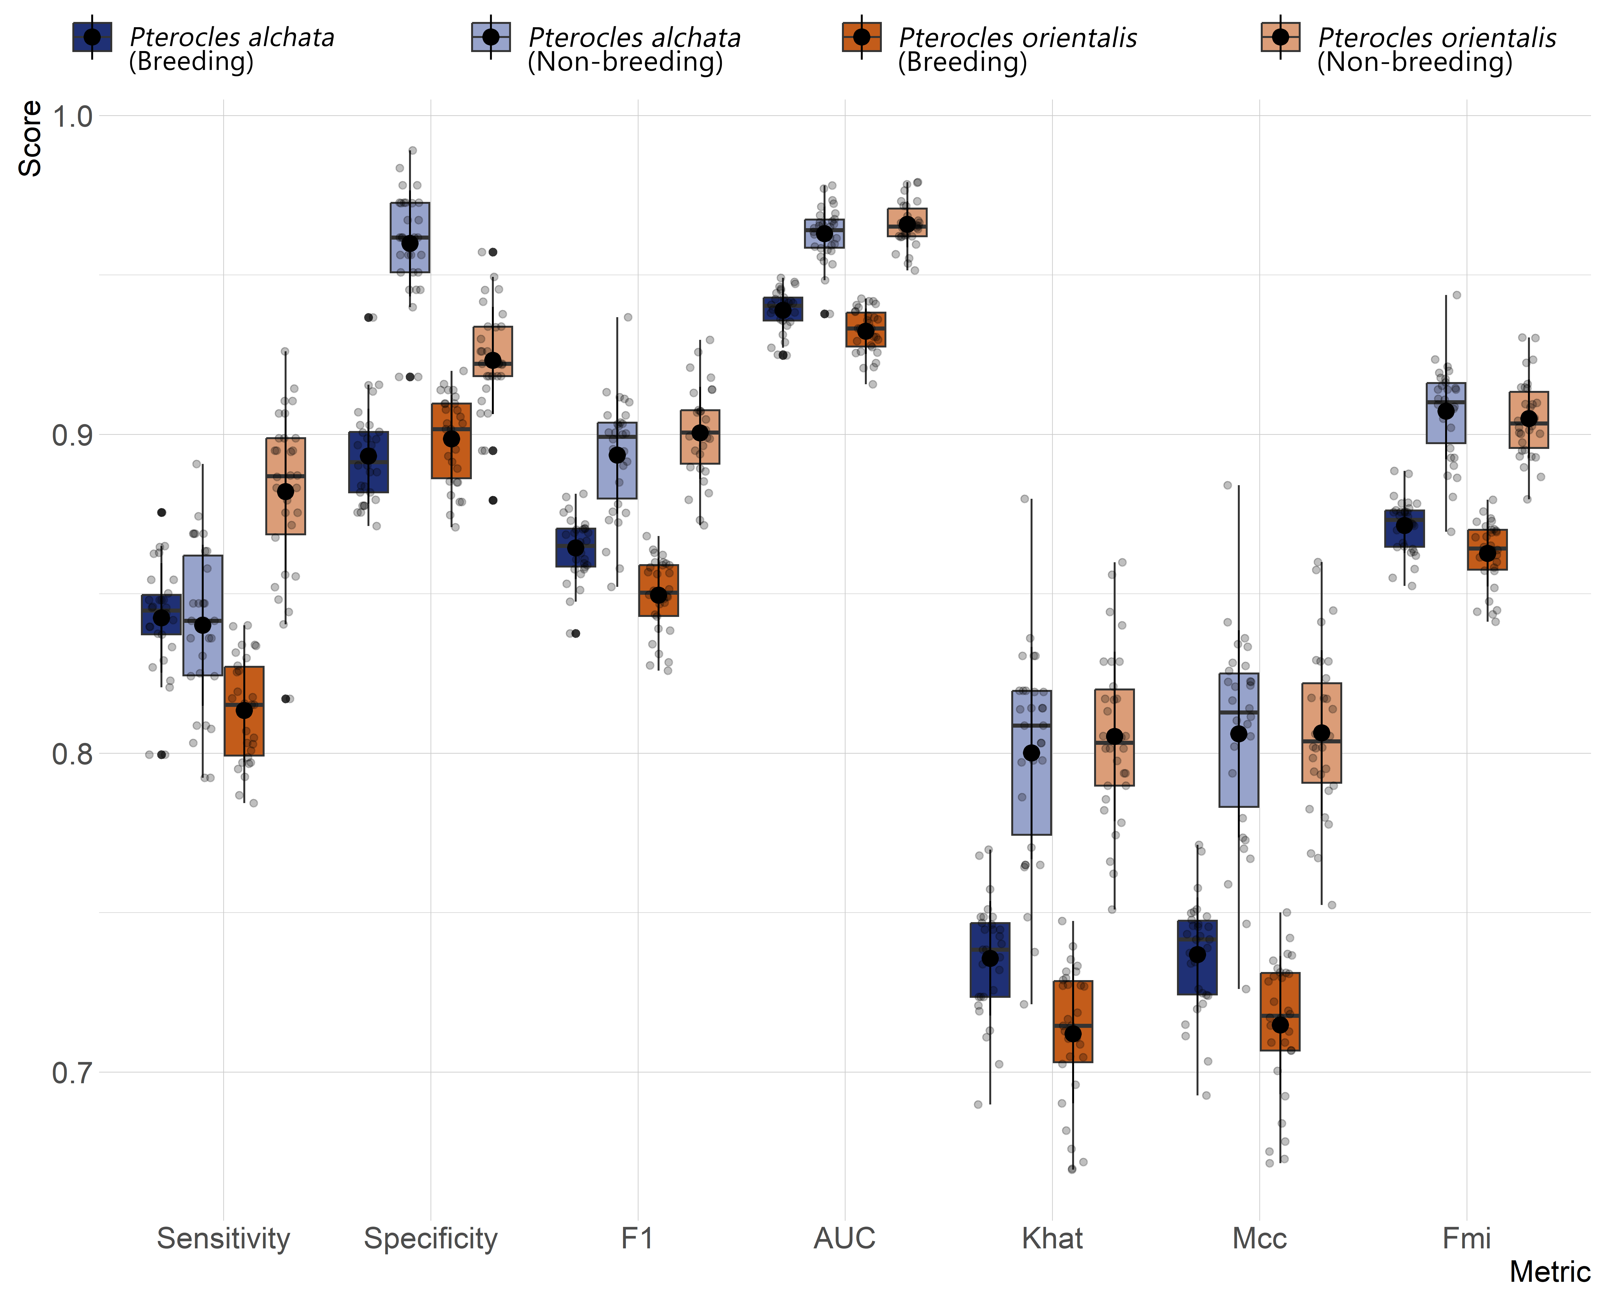
Fig. A5 Boxplots of classification performance from 10-fold cross-validation (three repetitions), showing species-specific (P. alchata - PTS and P. orientalis - BBS) and seasonal (breeding and non-breeding) variation. Metrics shown include Sensitivity, Specificity, F1-score (F1), Area Under the Curve (AUC), Cohen’s Kappa (Khat); Matthews Correlation Coefficient (Mcc) and Fowlkes-Mallows Index (Fmi).

Fig. A6 Fine tuning of the Random Forests models for hyperparameter combinations of the number of trees (ntrees) and the number of random split variables (mtry). The optimal hyperparameter values are indicated by the asterisk (*). Results are shown for P. orientalis (BBS) during the breeding (a) and non-breeding (b) seasons, and for P. alchata (PTS) during the breeding (c) and non-breeding (d) seasons.

Fig. A7 Ecological responses of P. alchata (PTS) and P. orientalis (BBS) to multivariate model variables across seasons. This figure, complementing Fig. 3, offers an alternative intraspecific comparison. The response to the LC variable (only during the non-breeding season), is shown as a histogram due to its categorical nature.

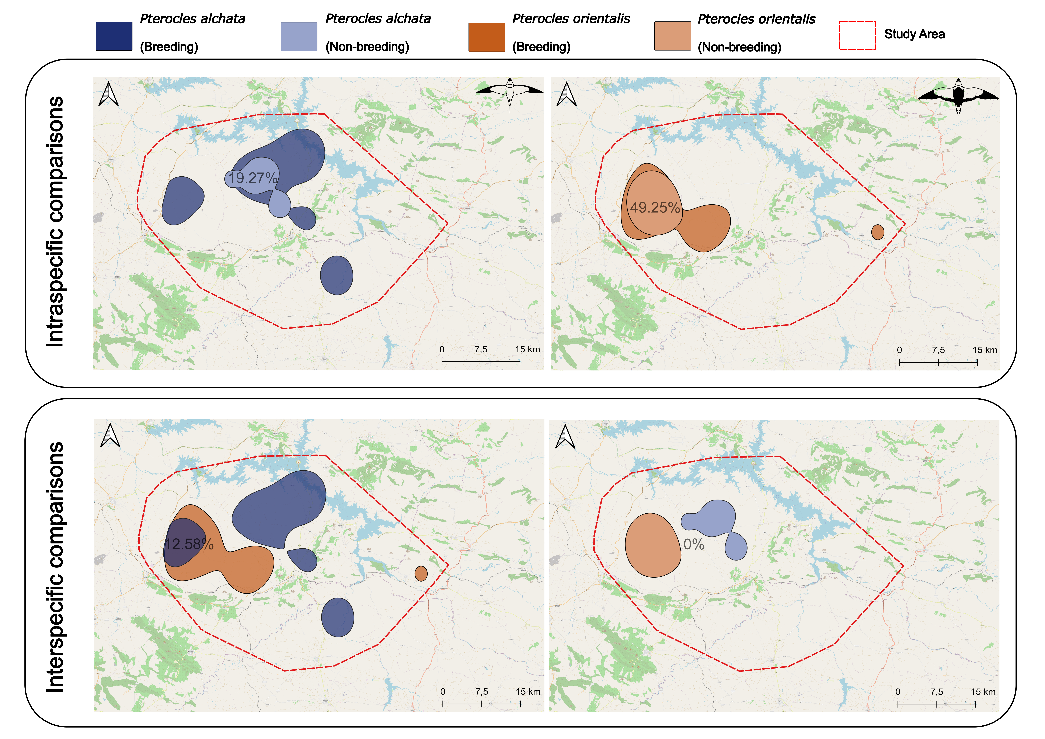
Fig. A8 Intra- and interspecific population-level space use dynamics inferred from Kernel Density Estimations (KDEs) using 50% bandwidths. The upper panel depicts seasonal differences in space use for P. alchata (PTS; upper left panel) and P. orientalis (BBS; upper right panel), while the lower panel illustrates interspecific differences during the breeding (lower left panel) and non-breeding (lower right panel) seasons. Values of space use overlap are presented in each panel. Maps of the 95% KDE isopleths are shown in Fig. 4.

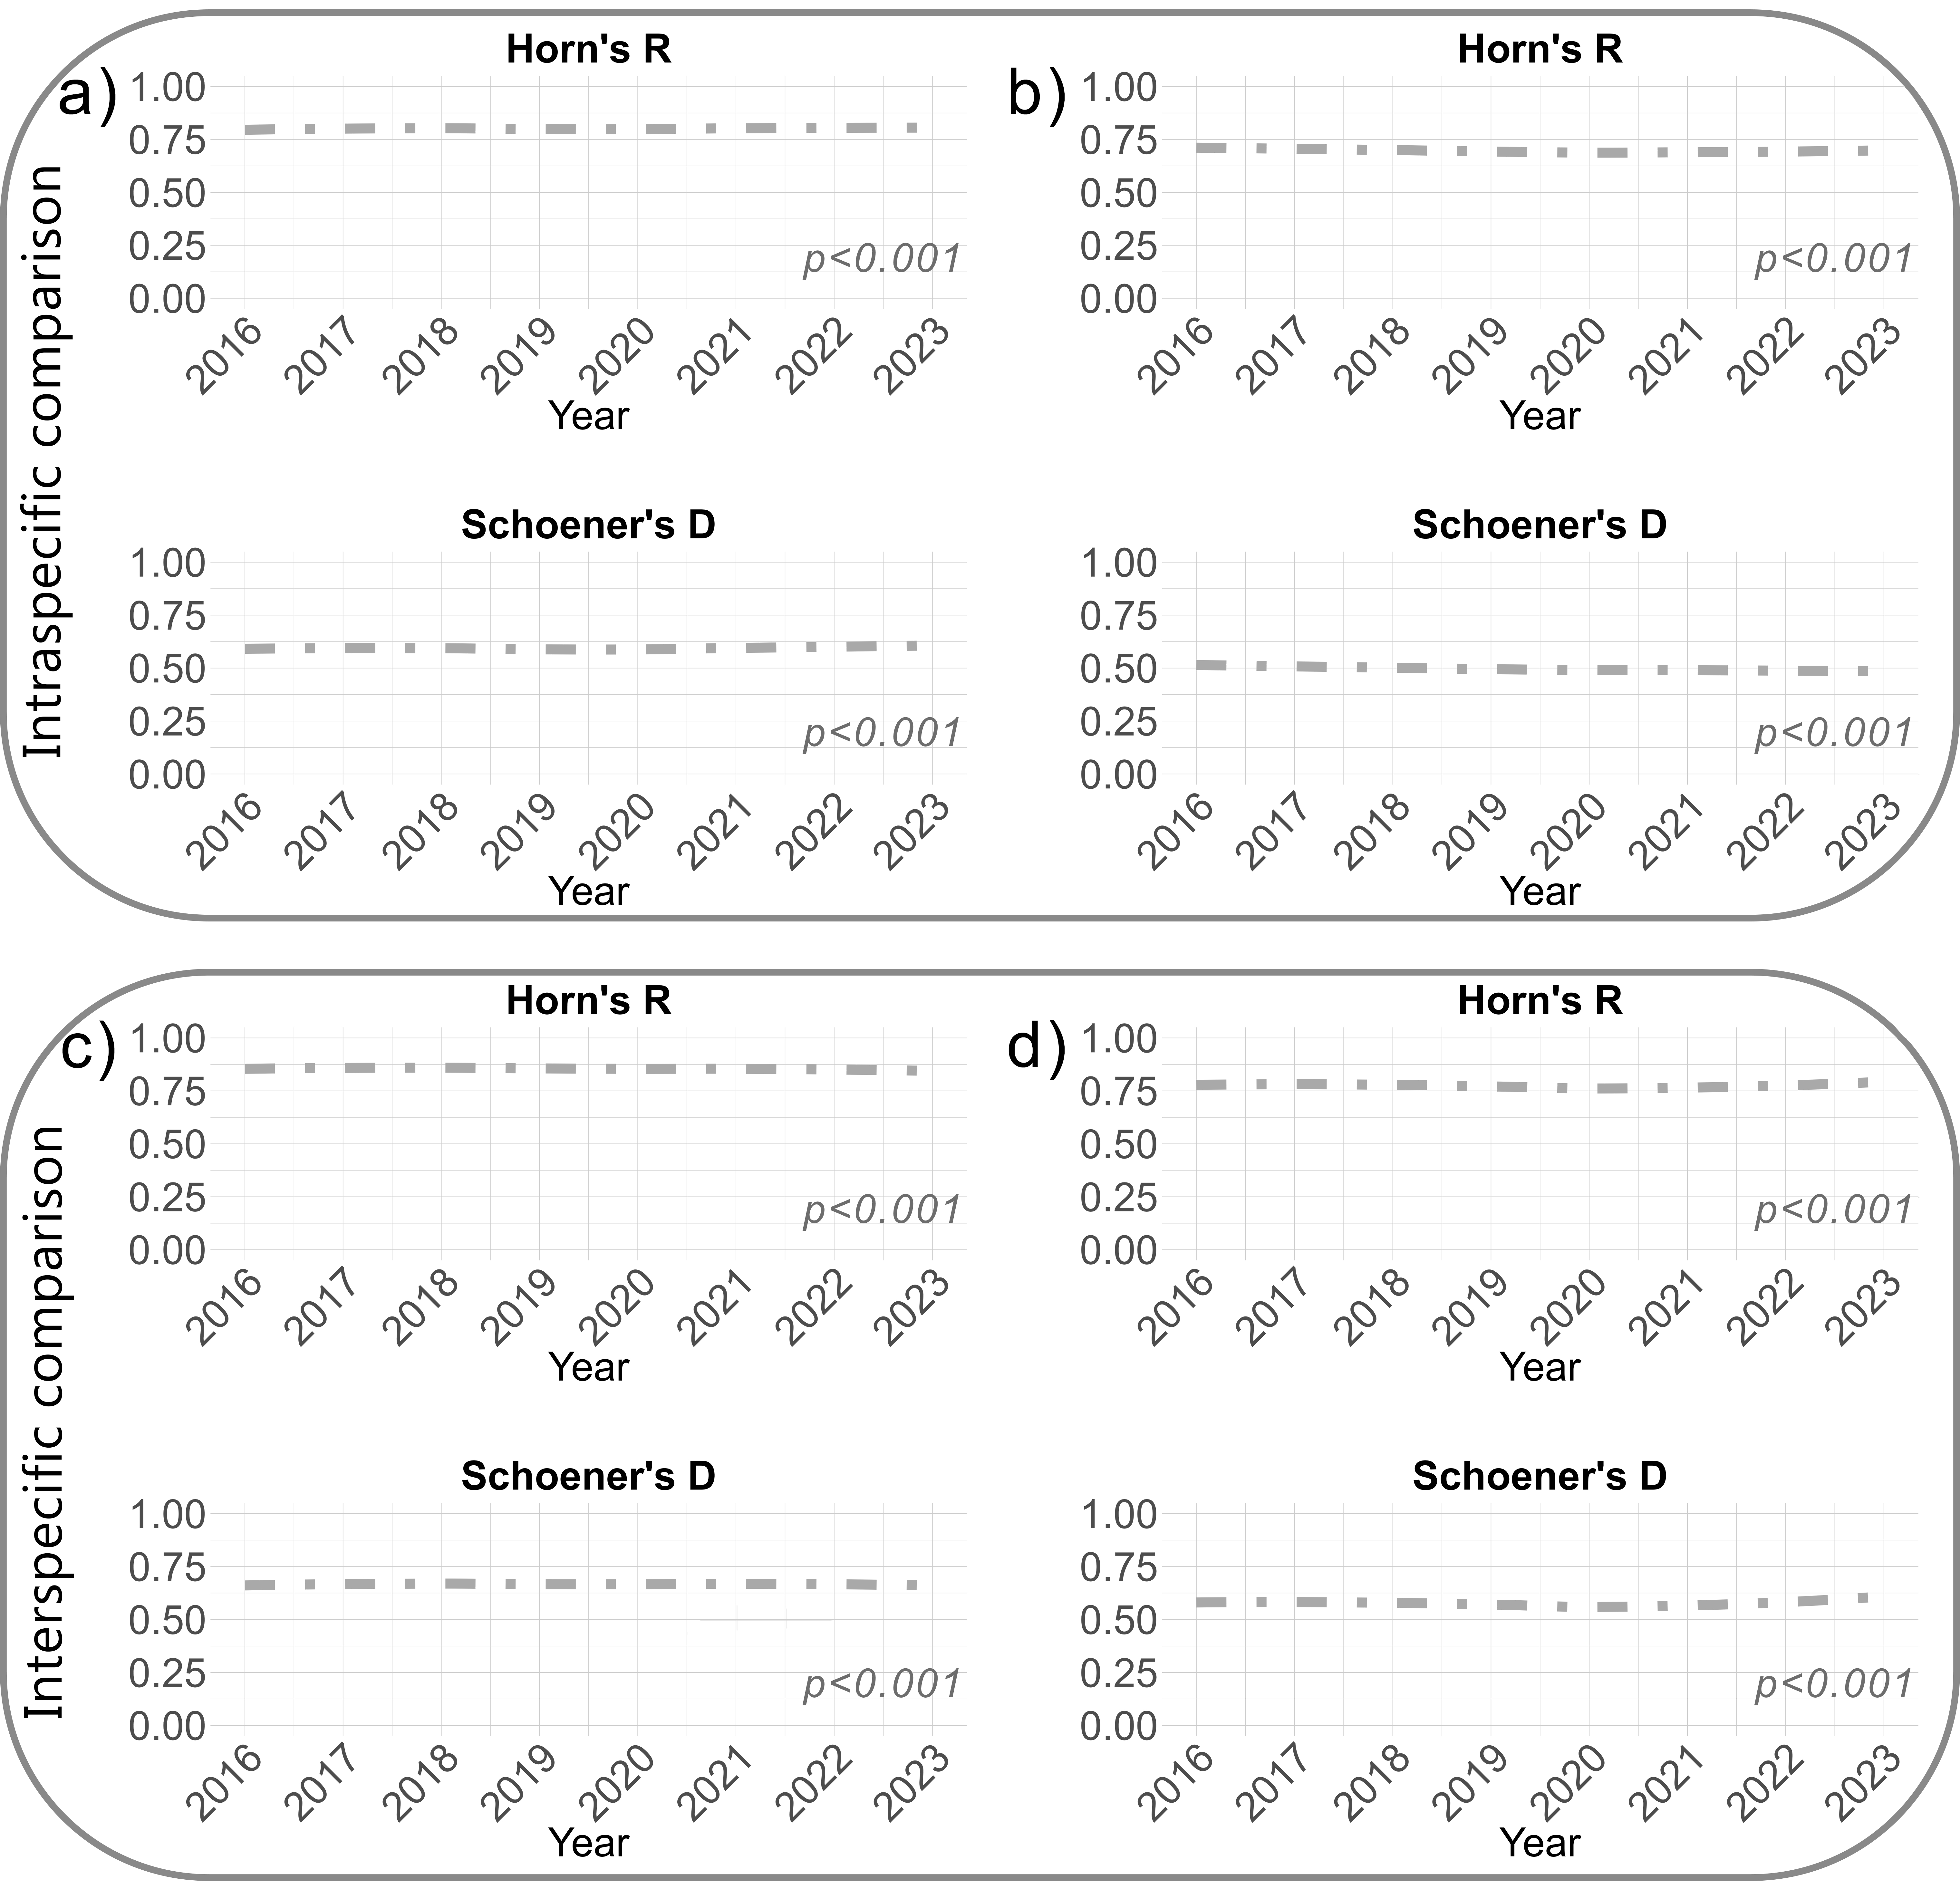
Fig. A9 Niche overlap quantified between species, seasons and years using Schoener’s D and Horn’s R metrics. Statistical results from the 1000 permutation tests are also depicted for each type of comparison. Intraspecific comparisons are shown for P. orientalis (BBS; a) and P. alchata (PTS; b) in the upper panel, while interspecific comparisons are shown for the breeding (c) and non-breeding (d) seasons in the lower panel.

References
Almalki R, Khaki M, Saco PM, Rodriguez JF (2022) Monitoring and mapping vegetation cover changes in arid and semi-arid areas using remote sensing technology: a review. Remote Sens 14:5143. https://doi.org/10.3390/rs14205143
Conrad O, Bechtel B, Bock M et al (2015) System for automated geoscientific analyses (SAGA) v. 2.1.4. Geosci Model Dev 8:1991–2007. https://doi.org/10.5194/gmd-8-1991-2015
Crippen R, Buckley S, Agram P et al (2016) NASADEM global elevation model: Methods and progress. ISPRS Archives 41:125–128. https://doi.org/10.5194/isprs-archives-XLI-B4-125-2016
Delegido J, Verrelst J, Alonso L, Moreno J (2011) Evaluation of sentinel-2 red-edge bands for empirical estimation of green LAI and chlorophyll content. Sensors 11:7063–7081. https://doi.org/10.3390/s110707063
Geofabrik (2023) Geofabrik: Download Server for OpenStreetMap data. Web Based Download Application: Available at: http://download.geofabrik.de/ (Accessed: 20 July 2023).
Gitelson A, Merzlyak MN (1994) Quantitative estimation of chlorophyll-a using reflectance spectra: Experiments with autumn chestnut and maple leaves. J Photochem Photobiol B 22:247–252. https://doi.org/10.1016/1011-1344(93)06963-4
Gorelick N, Hancher M, Dixon M et al (2017) Google Earth Engine: Planetary-scale geospatial analysis for everyone. Remote Sens Environ 202:18–27. https://doi.org/10.1016/j.rse.2017.06.031
Green DM, Swets JA (1966) Signal detection theory and psychophysics. John Wiley & Sons, Inc.
Haralick RM, Shanmugam K, Dinstein IH (1973) Textural features for image classification. IEEE Trans Syst Man Cybern Syst 6:610–621. https://doi.org/10.1109/TSMC.1973.4309314
Lillesand T, Kiefer RW, Chipman J (2015) Remote sensing and image interpretation, 7th edn. John Wiley & Sons, Inc.
Lin H, Wang J, Liu S et al (2005) Studies on urban areas extraction from landsat TM images. In: Proceedings of the 2005 IEEE International Geoscience and Remote Sensing Symposium, vol 6. IEEE, pp 3826–3829. https://doi.org/10.1109/IGARSS.2005.1525743
Main-Knorn M, Pflug B, Louis J et al (2017) Sen2Cor for sentinel-2. In: Image and Signal Processing for Remote Sensing XXIII, vol 10427. SPIE, pp 37–48. https://doi.org/10.1117/12.2278218
Mandal D, Kumar V, Ratha D et al (2020) Dual polarimetric radar vegetation index for crop growth monitoring using sentinel-1 SAR data. Remote Sens Environ 247:111954. https://doi.org/10.1016/j.rse.2020.111954
McFeeters SK (1996) The use of the Normalized Difference Water Index (NDWI) in the delineation of open water features. Int J Remote Sens 17:1425–1432. https://doi.org/10.1080/01431169608948714
Merzlyak MN, Gitelson AA, Chivkunova OB, Rakitin VYU (1999) Non-destructive optical detection of pigment changes during leaf senescence and fruit ripening. Physiol Plant 106:135–141. https://doi.org/10.1034/j.1399-3054.1999.106119.x
Ministerio de Agricultura, Fondo Español de Garantía Agraria (2015) Aplicación SIGPAC. Available at: https://www.fega.es/es/PwfGcp/es/ayudas_dir_desa_rural/aplicacion_sigpac/index.jsp
Nguyen CT, Chidthaisong A, Kieu Diem P, Huo L-Z (2021) A modified bare soil index to identify bare land features during agricultural fallow-period in southeast Asia using Landsat 8. Land 10:231. https://doi.org/10.3390/land10030231
Richardson AJ, Wiegand CL (1977) Distinguishing vegetation from soil background information. Photogramm Eng Remote Sensing 43:1541–1552.
Rouse JW, Haas RH, Schell JA, Deering DW (1974) Monitoring vegetation systems in the Great Plains with ERTS. NASA Special Publications 351:309.
Truckenbrodt J, Freemantle T, Williams C et al (2019) Towards Sentinel-1 SAR analysis-ready data: A best practices assessment on preparing backscatter data for the cube. Data 4:93. https://doi.org/10.3390/data4030093
Valerio F, Godinho S, Marques AT et al (2024) GEE_xtract: High-quality remote sensing data preparation and extraction for multiple spatio-temporal ecological scaling. Ecol Inform 80:102502. https://doi.org/10.1016/j.ecoinf.2024.102502

