Supplementary
Figure
Fig. S1 Sensitivity analysis of WCI and WUI delineation using alternative buffer distances. Annual burned area and percentage of interface area burned are shown for (a, b) WCI buffers of 250, 500, and 1000 m and (c, d) WUI buffers of 1200, 2400, and 4800 m during 1990-2023. Pearson’s correlations compare alternative thresholds with the baseline thresholds of 500 m for WCI and 2400 m for WUI. All correlations were significant at p < 0.001.
Fig. S2 Sensitivity analysis of WUI-WCI overlap effects on burned-area estimates. (a) WUI total burned area and WUI-only burned area, and (b) WCI total burned area and WCI-only burned area. Pearson’s correlations quantify the consistency between total and non-overlapping burned-area series. dashed lines indicate segmented regression trends before and after 2010. The two slope values b separated by a slash correspond to the trends before and after 2010, respectively. Asterisks indicate statistically significant trends at p < 0.05.

Fig. S3. Interannual variation in burned area (1990-2023) across administrative levels in CYP. (a) Prefecture. (b) County. (c) Township.

Fig. S4. Multi-scale spatiotemporal dynamics of fire activity in WCI and WUI (1990-2023). (a–c) Comparative trends of annual burned area (km²) at prefecture, county, and town scales, (d) Interannual variations in burned proportion across three administrative levels for WCI, (e) Interannual variations in burned proportion across three administrative scales for WUI. In (a–c), orange and blue lines represent WCI and WUI, respectively. Solid lines indicate linear regression fits, and shaded areas denote 95% confidence intervals. The vertical dashed line marks the critical turning point of fire activity in 2010.

Fig. S5. Distribution of burned proportions along environmental gradients in the Central Yunnan Plateau. (a-c) Burned proportion (%) for the entire CYP, WCI, and WUI across (a) elevation gradients, (b) slope gradients, and (c) vegetation categories. PEF: planted and economic forests, WCF: warm-temperate coniferous forests.

Fig. S6. Driving mechanisms of fire occurrence and burned-area percentage in the CYP based on Random Forest models. (a) Relative importance of predictor variables for the fire occurrence model; (b) Partial Dependence Plots (PDPs) characterizing the non-linear response of fire probability to key environmental drivers; (c) Relative importance of predictor variables for the fire burned-area percentage model; (d) PDPs illustrating the non-linear effects of dominant factors on fire burned-area percentage. In (a) and (c), the inset pie charts show the aggregated contribution of factor categories, in which different colors represent Climate, Fuel, Human activity, and Topography. The x-axes in (b) and (d) indicate the gradients of predictor variables.

Fig. S7. Temporal variations of temperature and precipitation in the Central Yunnan Plateau from 1990 to 2022. (a) Annual mean temperature; (b) Annual precipitation; (c) Annual relative humidity; (d) Dry season temperature. (e) Dry season precipitation, (f) Dry season relative humidity.

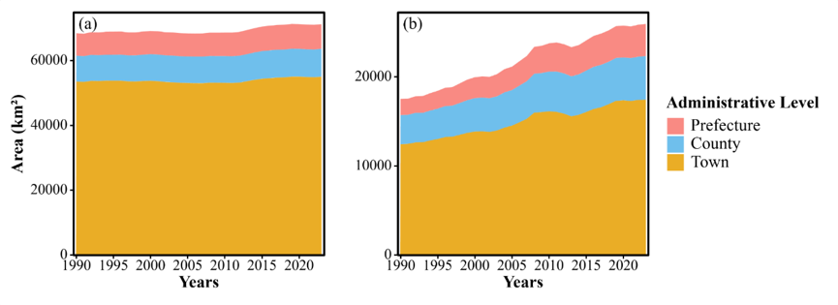
Fig. S8 Interannual changes in interface area (1990–2023) across administrative levels. (a) WCI area. (b) WUI area.

Fig. S9. Temporal changes in the total area of major vegetation types in the Central Yunnan Plateau from 1990 to 2020. WCF: warm-temperate coniferous forests; PEF: planted and economic forests.

Table
Table S1. Performance of random forest models for fire occurrence and burned-area percentage
Model type | Fire context | Training samples | Test samples | AUC | Accuracy | Brier score | Log loss | R² | RMSE | MAE
Occurrence | ALL | 178,353 | 167,189 | 0.791 | 0.894 | 0.104 | 0.362 | - | - | -
Occurrence | WCI | 126,739 | 135,203 | 0.784 | 0.901 | 0.102 | 0.359 | - | - | -
Occurrence | WUI | 37,474 | 56,683 | 0.778 | 0.904 | 0.102 | 0.359 | - | - | -
burned-area percentage | ALL | 53,190 | 13,449 | - | - | - | - | 0.336 | 0.092 | 0.059
burned-area percentage | WCI | 37,957 | 9,478 | - | - | - | - | 0.290 | 0.075 | 0.049
burned-area percentage | WUI | 11,233 | 2,817 | - | - | - | - | 0.281 | 0.083 | 0.053
Note: burned-area percentage models used continuous burned-area proportions and were fitted only to positive fire records with response values greater than 0.01. For occurrence models, sample sizes refer to the training and test records after handling class imbalance; for burned-area percentage models, sample sizes refer to positive fire records only. ALL, WCI, and WUI refer to the full study area, wildland-cropland interface, and wildland-urban interface, respectively.

