Additional file 1: Table S1 – Keywords used for search in databases
PubMed
("narcotics"[Mesh] OR "Narcotic-Related Disorders" [Mesh] OR "narcotics"[tiab] OR "Opiate Overdose" [Mesh] OR "opiate"[tiab] OR "opioid"[tiab] OR "papaverine"[tiab] OR "Papaverine"[Mesh] OR "narcotic-related disorders" [tiab] OR "Analgesics, Opioid"[Mesh]) AND ("COVID-19"[Mesh] OR "coronavirus "[tiab] OR "coronavirus "[Mesh] OR " severe acute respiratory syndrome coronavirus 2"[tiab] OR "SARS-CoV-2 " [tiab] OR "SARS-CoV-2 "[Mesh] OR "novel coronavirus "[tiab] OR " nCoV "[tiab] OR "2019-nCoV "[tiab] OR " COVID-19"[tiab])
Scopus
( ( TITLE-ABS-KEY ( coronavirus ) OR TITLE-ABS-KEY ( "severe acute respiratory syndrome coronavirus 2" ) OR TITLE-ABS-KEY ( "SARS-CoV-2" ) OR TITLE-ABS-KEY ( "novel coronavirus" ) OR TITLE-ABS-KEY ( ncov ) OR TITLE-ABS-KEY ( "2019-nCoV" ) OR TITLE-ABS-KEY ( "COVID-19" ) OR TITLE-ABS-KEY ( covid ) OR TITLE-ABS-KEY ( covid 19 ) ) AND ( TITLE-ABS-KEY ( opioid ) OR TITLE-ABS-KEY ( "opioid overdose" ) OR TITLE-ABS-KEY ( "opiate" ) OR TITLE-ABS-KEY ( "opiate overdose" ) OR TITLE-ABS-KEY ( "papaverine" ) ) OR TITLE-ABS-KEY ( " narcotics" ) )
Web of science
TS= (coronavirus OR "Covid 19" OR COVID-19 OR "severe acute respiratory syndrome coronavirus 2" OR SARS-CoV-2 OR "novel coronavirus" OR nCoV OR 2019-nCoV) AND TS= (Opioid OR Opiate OR Papaverine OR narcotics)
Embase
('coronavirus disease 2019'/exp OR 'coronavirus disease 2019':ti,ab,kw OR 'severe acute respiratory syndrome coronavirus 2'/exp OR 'covid-19':ti,ab,kw OR 'coronavirus':ti,ab,kw OR 'severe acute respiratory syndrome coronavirus 2':ti,ab,kw OR 'sars-cov-2':ti,ab,kw OR 'novel coronavirus':ti,ab,kw OR 'ncov' OR '2019-ncov':ti,ab,kw) AND ('opiate'/exp OR 'opiate':ti,ab,kw OR 'opioid':ti,ab,kw OR 'narcotic agent'/exp OR 'narcotic agent':ti,ab,kw OR 'papaverine'/exp OR 'papaverine':ti,ab,kw)

Additional file 1: Table S2 – Newcastle Ottawa Scale for Quality Assessment

Study | Selection |  |  |  | Comparability | Exposure/Outcome |  |  | Overall  Score
Study | Representation | Control | Exposure | Outcome | Comparability | Outcome | Follow-up | Lost to Follow-up | Overall  Score
Allen et al. | * | * | * | * | ** | * | * | * | 9
Baillargeon et al. | * | * | * | * | - | * | * | - | 7
Jamali et al. | * | * | * | * | - | * | * | * | 7
Qeaden et al. | * | * | * | * | * | * | * | * | 8
Riahi et al. | * | * | * | * | * | * | * | * | 8
Vallecillo et al. | * | * | * | * | * | * | * | - | 7
Velásquez García et al. | - | - | * | * | * | - | * | * | 5
Wang et al. | * | * | * | * | ** | * | * | * | 9

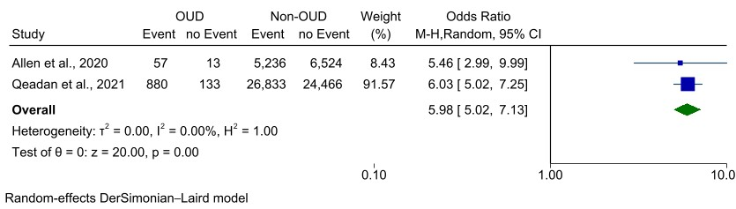
Additional file 1: Figure S1 – Results of COVID-19 hospitalization outcome meta-analysis

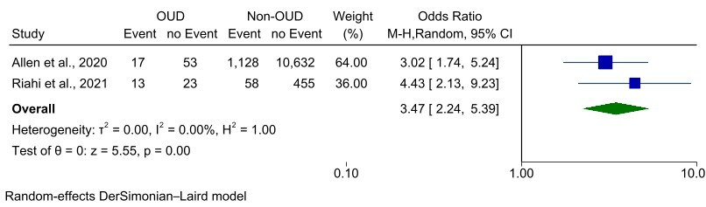
Additional file 1: Figure S2 – Results of COVID-19 ICU admission outcome meta-analysis

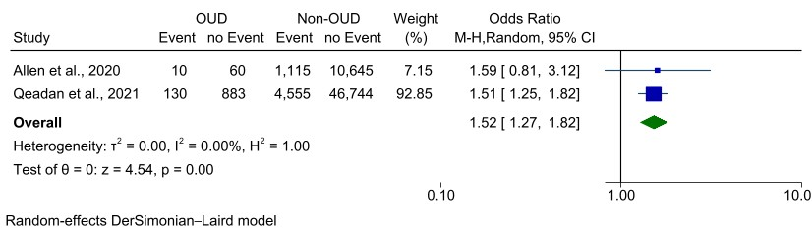
Additional file 1: Figure S3 – Results of COVID-19 mortality outcome meta-analysis

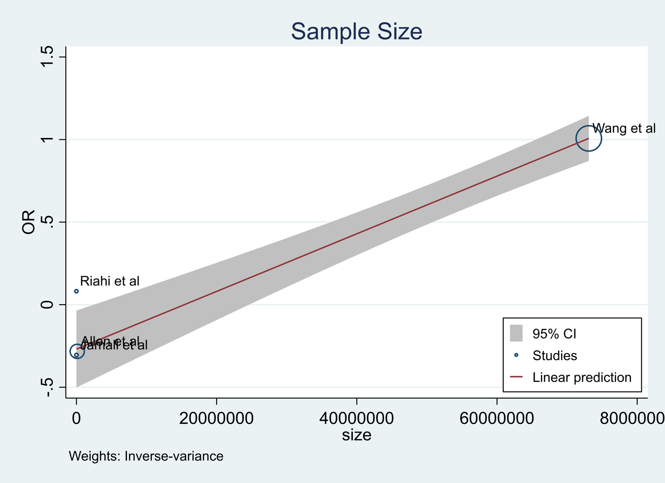
Additional file 1: Figure S4 – Bubble plot of meta-regression of sample size
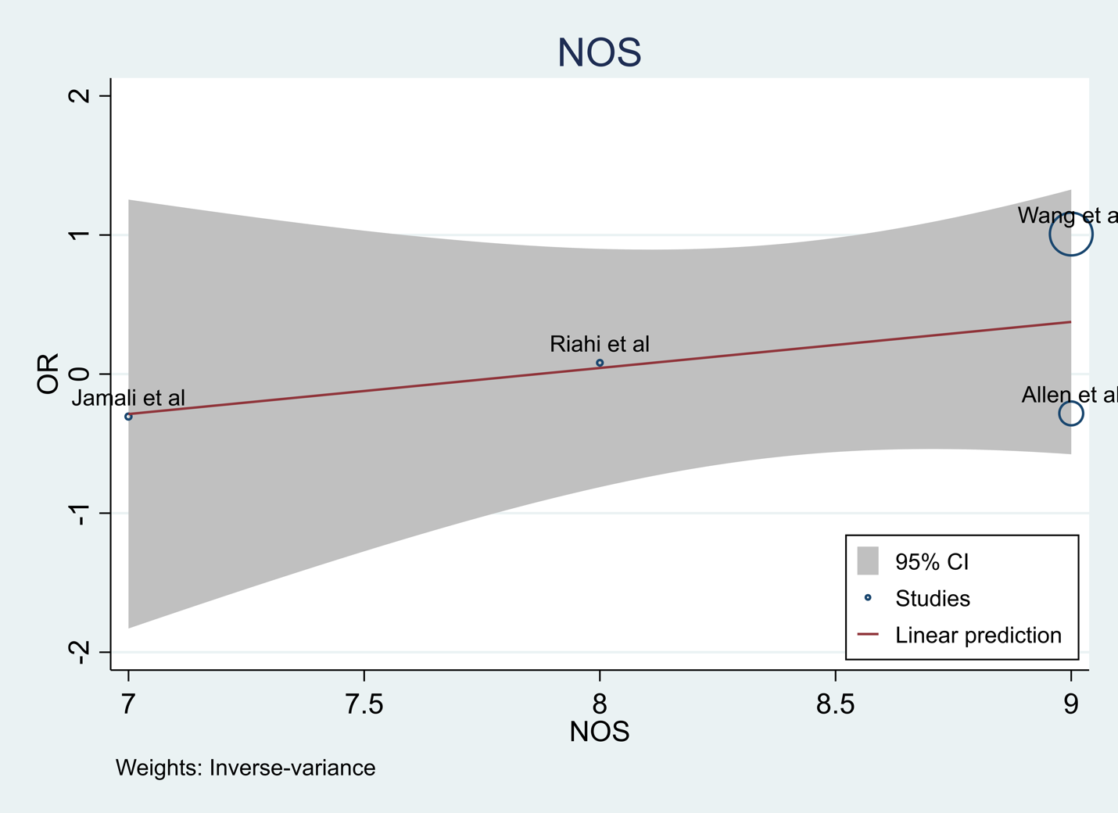
Additional file 1: Figure S5 – Bubble plot of meta-regression of NOS score
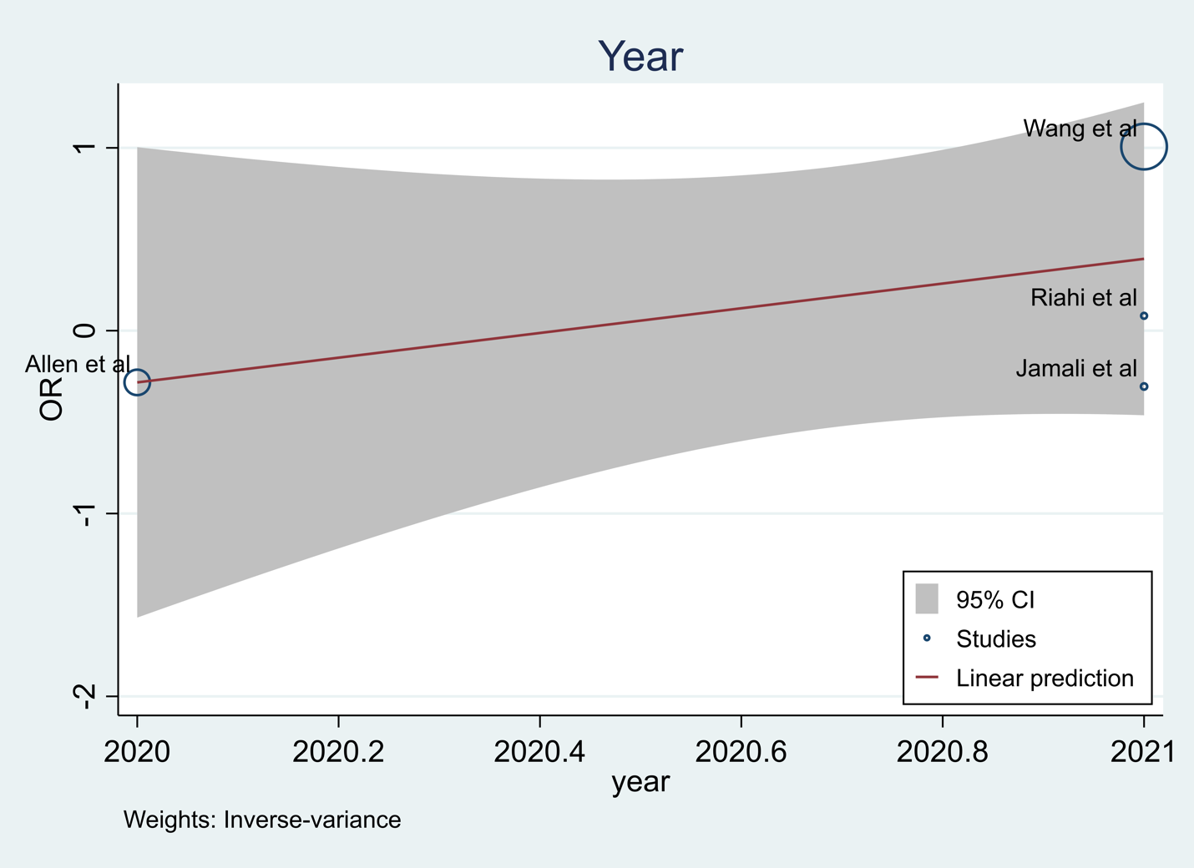
Additional file 1: Figure S6 – Bubble plot of meta-regression of publication year
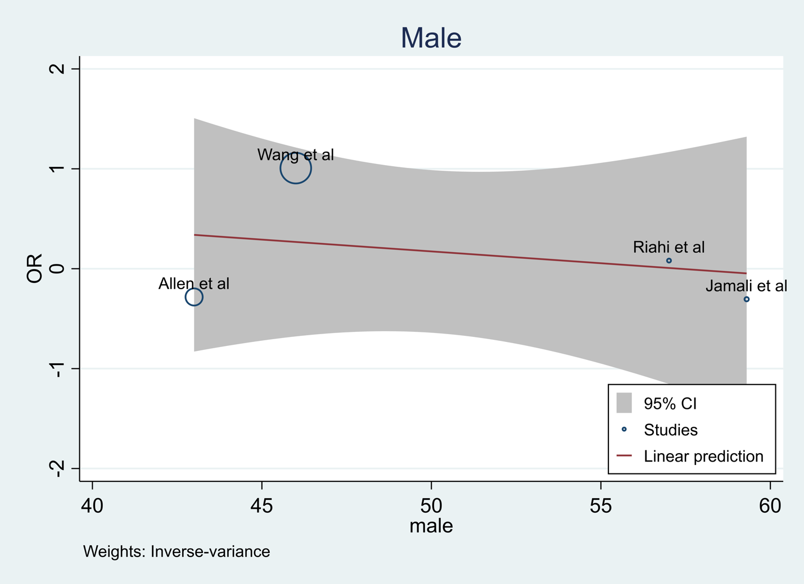
Additional file 1: Figure S7 – Bubble plot of meta-regression of male percentage

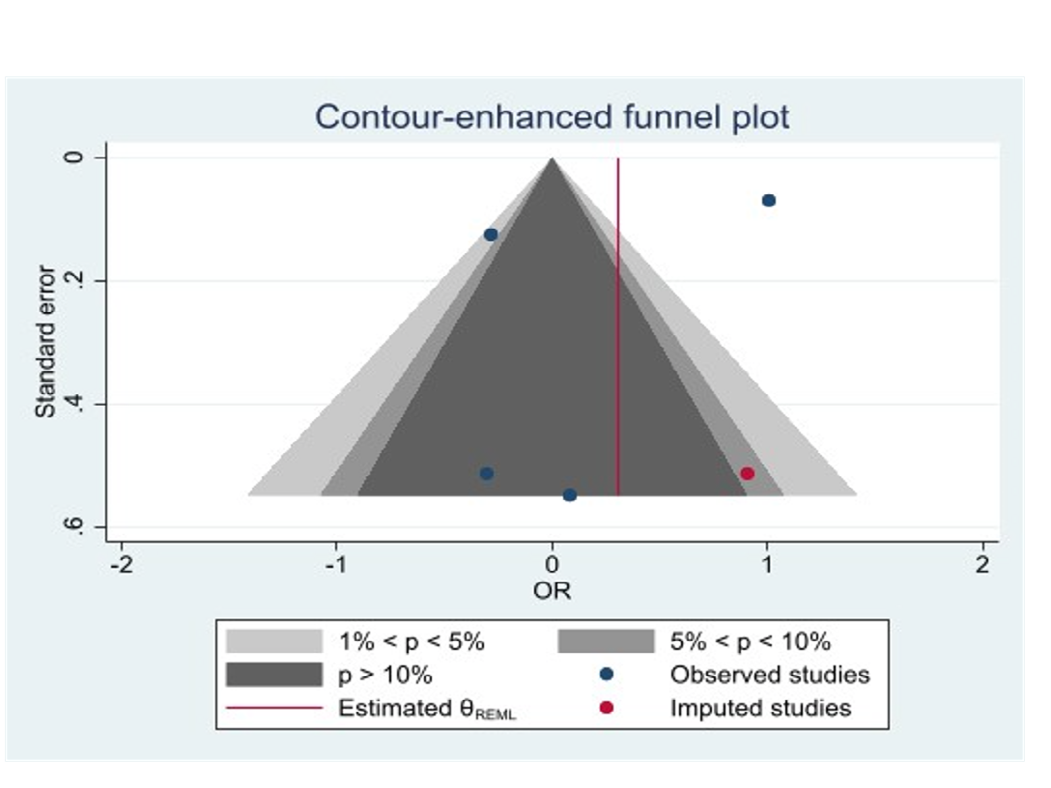

Additional file 1: Figure S8. Funnel plots for COVID-19 infection in patients with OUD

