Figure S1. Exclusions flow diagram to create study population for primary analysis
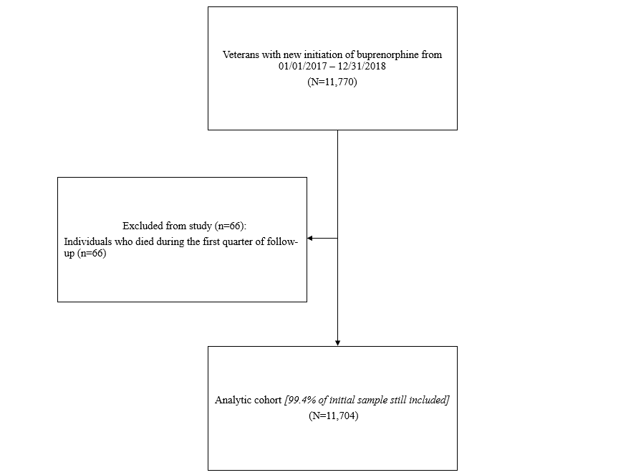

Table S1 Unadjusted associations between service use and buprenorphine discontinuation in primary analysis
Service | N (%) Individuals with service | Discontinuations | PQs | Discontinuation  rate/100 PQs
Social work
None | -- | 3891 | 15028 | 25.9
Any | 8125 (69.4) | 5455 | 14948 | 36.5
Clinical pharmacy
None | -- | 5700 | 19872 | 28.7
Any | 6139 (52.5) | 3646 | 10104 | 36.1
Recreational or occupational therapy
None | -- | 7404 | 26257 | 28.2
Any | 3077 (26.3) | 1942 | 3719 | 52.2
Chaplain
None | -- | 8188 | 27830 | 29.4
Any | 1827 (15.6) | 1158 | 2146 | 54.0
Primary care
None | -- | 2681 | 9185 | 29.2
Any | 9679 (82.7) | 6665 | 20791 | 32.1
Primary care-based mental health
None | -- | 8319 | 27292 | 30.5
Any | 2162 (18.5) | 1027 | 2684 | 38.3
Pain services
None | -- | 8244 | 26554 | 31.0
Any | 1876 (16.0) | 1102 | 3422 | 32.2
Mental health clinic
None | -- | 2260 | 8824 | 25.6
Any | 9742 (83.2) | 7086 | 21152 | 33.5
Substance use disorder psychotherapy
None | -- | 2957 | 8268 | 35.8
Any | 8755 (74.8) | 6389 | 21708 | 29.4
Post-traumatic stress disorder treatment
None | -- | 8495 | 27848 | 30.5
Any | 1447 (12.4) | 851 | 2128 | 40.0
Vocational services
None | -- | 8592 | 28192 | 30.5
Any | 1280 (10.9) | 754 | 1784 | 42.3
Criminal justice outreach
None | -- | 8657 | 28398 | 30.5
Any | 1037 (8.9) | 689 | 1578 | 43.7
Residential treatment
None | -- | 7879 | 27405 | 28.8
Any | 2017 (17.2) | 1467 | 2571 | 57.1
Emergency department
None | -- | 6116 | 22723 | 26.9
Any | 5326 (45.5) | 3230 | 7253 | 44.5
Buprenorphine from multiple facilities
None | -- | 9268 | 29673 | 31.2
Any | 283 (2.4) | 78 | 303 | 25.7
Note. Services were lagged by one quarter so that individuals were considered exposed in each quarter if they were involved in the service in the prior quarter. Individuals with service refers to lagged service receipt for quarters that contributed to analysis only. PQs=person quarters.

Table S2 Associations between service use and buprenorphine discontinuation within 6 months
Service | Fully Adjusted
 | HR (95% CI)
Substance use disorder psychotherapy​ | 0.82​ (0.77, 0.87)
Primary care-based mental health | 0.91​ (0.85, 0.96)
Primary care​ | 0.92 (0.88, 0.96)​
Pain services​ | 0.90​ (0.84, 0.97)​
Mental health clinic​ | 1.04​ (0.98, 1.10)​
Social work​ | 1.08 (1.03, 1.13)​
Clinical pharmacy​ | 1.06​ (1.01, 1.11)​
Post-traumatic stress disorder treatment​ | 1.08​ (1.02, 1.16)​
Criminal justice outreach​ | 1.09 (1.00, 1.19)​
Vocational services​ | 1.09​ (1.00, 1.19)​
Recreational therapy/occupational therapy​ | 1.13​ (1.06, 1.20)​
Chaplain​ | 1.12​ (1.03, 1.21)​
Residential treatment | 1.27​ (1.16, 1.40​)
Note. Fully adjusted model includes all lagged service predictors simultaneously and adjusts for age, gender, race, lagged emergency room visits, and lagged receipt of buprenorphine from multiple facilities. HR= Hazard Ratio. 95 % CI= 95% Confidence Interval.

Table S3 Associations between service use and buprenorphine discontinuation within 18 months using alternative 30-day discontinuation definition
Service | Fully Adjusted
 | HR (95% CI)
Substance use disorder psychotherapy​ | 0.85​ (0.80, 0.90)
Primary care-based mental health | 0.88​ (0.82, 0.95)
Primary care​ | 0.95 (0.91, 0.99)​
Pain services​ | 0.91​ (0.85, 0.98)​
Mental health clinic​ | 1.07​ (1.02,1.13)​
Social work​ | 1.11 (1.06, 1.16)​
Clinical pharmacy​ | 1.06​ (1.01, 1.11)​
Post-traumatic stress disorder treatment​ | 1.06 (0.99, 1.13)​
Criminal justice outreach​ | 1.11 (1.03, 1.19)​
Vocational services​ | 1.08​ (0.99, 1.19)​
Recreational therapy/occupational therapy​ | 1.17​ (1.09, 1.24)​
Chaplain​ | 1.14​ (1.04, 1.24)​
Residential treatment | 1.25​ (1.12, 1.39​)
Note. Fully adjusted model includes all lagged service predictors simultaneously and adjusts for age, gender, race, lagged emergency room visits, and lagged receipt of buprenorphine from multiple facilities. HR= Hazard Ratio. 95 % CI= 95% Confidence Interval.

