Supplementary File 1: Percentage of Non-Hispanic Black and Non-Hispanic White Veterans with OUD who Received Methadone by Month. Monthly cohort sizes are provided in a Supplemental File.
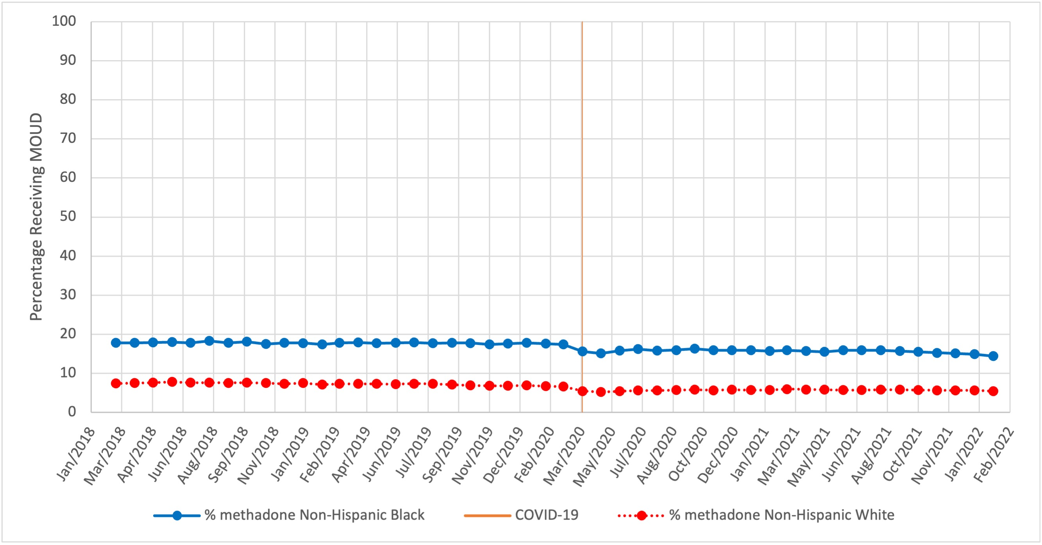
Supplementary File 2: Percentage of Non-Hispanic Black and Non-Hispanic White Veterans with OUD who Received Buprenorphine by Month. Monthly cohort sizes are provided in a Supplemental File. 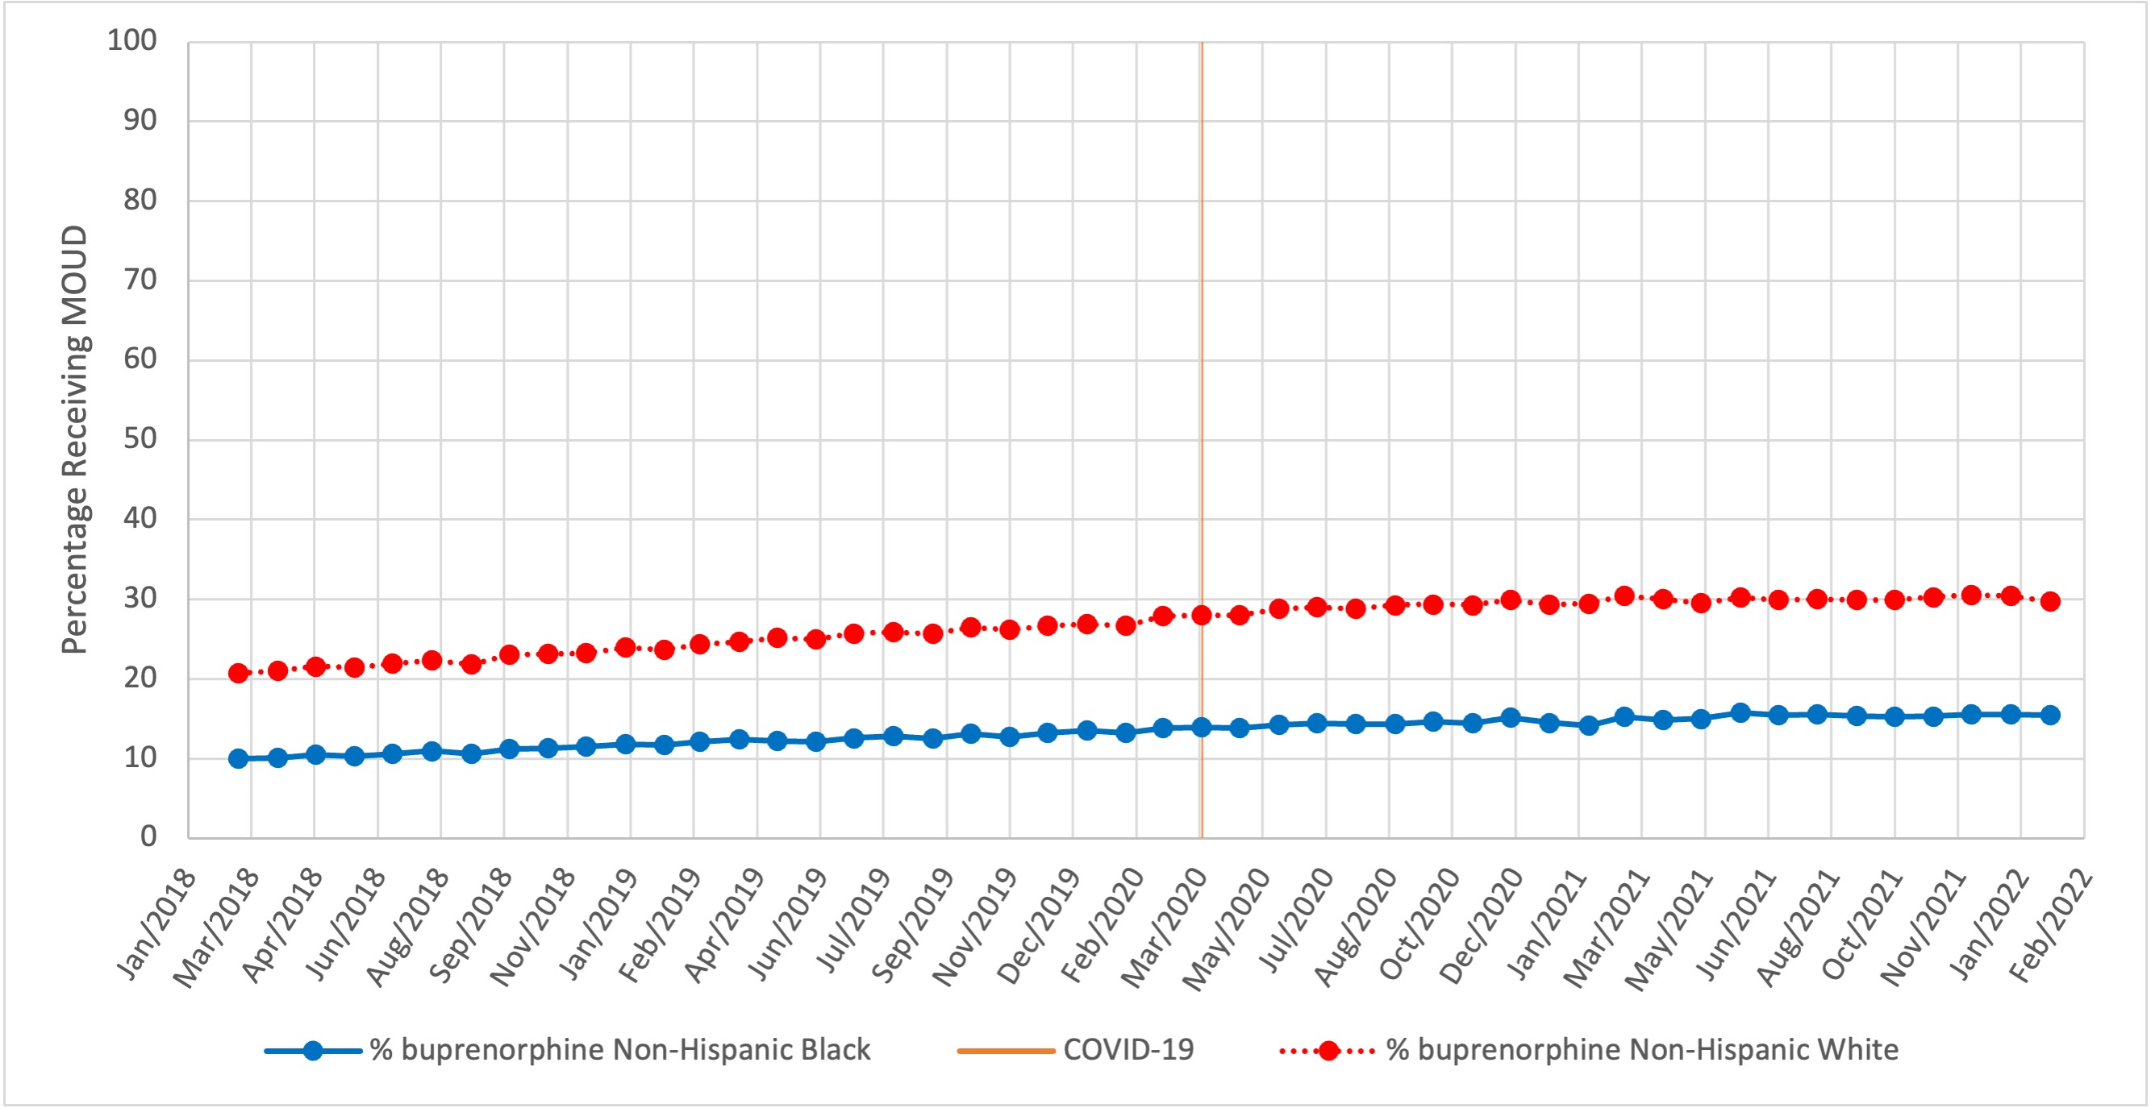

Supplementary File 3: Percentage of Hispanic Black, Hispanic White, Hispanic neither Black nor White, and Non-Hispanic White Veterans with OUD Receiving Methadone by Month. Monthly cohort sizes are provided in a Supplemental File.
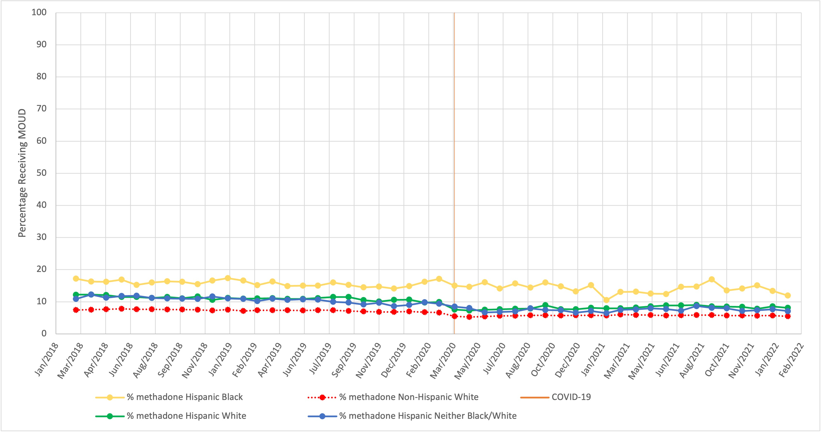
Supplementary File 4: Percentage of Hispanic Black, Hispanic White, Hispanic neither Black nor White, and Non-Hispanic White Veterans with OUD Receiving Buprenorphine by Month. Monthly cohort sizes are provided in a Supplemental File.
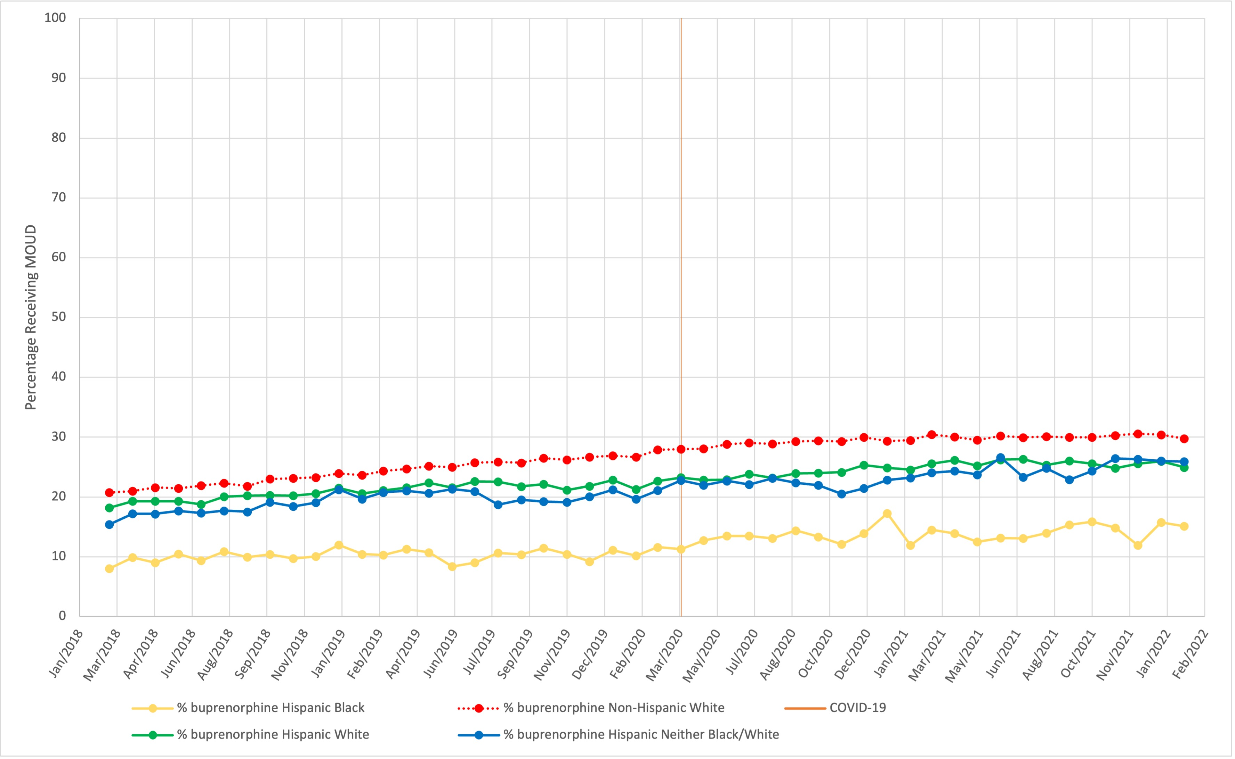

Supplementary File 5: Monthly receipt of Medications for Opioid Use Disorder by medication type (patient-month units)
Month | Buprenorphine | Naltrexone | Methadone | Total
March, 2018 | 11,513 | 1,007 | 5,861 | 16,989
April, 2018 | 11,582 | 983 | 5,836 | 16,955
May, 2018 | 11,903 | 1,082 | 5,941 | 17,422
June, 2018 | 11,833 | 1,030 | 5,967 | 17,303
July, 2018 | 12,019 | 1,028 | 5,889 | 17,390
August, 2018 | 12,357 | 1,071 | 5,954 | 17,928
September, 2018 | 12,031 | 957 | 5,937 | 17,534
October, 2018 | 12,690 | 1,041 | 5,963 | 18,242
November, 2018 | 12,726 | 1,012 | 5,793 | 18,123
December, 2018 | 12,742 | 915 | 5,714 | 18,014
January, 2019 | 13,184 | 971 | 5,925 | 18,671
February, 2019 | 12,964 | 953 | 5,563 | 18,199
March, 2019 | 13,459 | 1,017 | 5,810 | 18,937
April, 2019 | 13,640 | 1,018 | 5,800 | 19,066
May, 2019 | 13,848 | 1,005 | 5,724 | 19,248
June, 2019 | 13,634 | 961 | 5,782 | 19,082
July, 2019 | 14,054 | 969 | 5,884 | 19,528
August, 2019 | 14,142 | 1,000 | 5,920 | 19,680
September, 2019 | 13,950 | 933 | 5,688 | 19,226
October, 2019 | 14,446 | 985 | 5,608 | 19,780
November, 2019 | 14,192 | 862 | 5,377 | 19,215
December, 2019 | 14,398 | 849 | 5,364 | 19,413
January, 2020 | 14,694 | 892 | 5,569 | 19,890
February, 2020 | 14,519 | 883 | 5,330 | 19,559
March, 2020 | 15,096 | 925 | 5,268 | 20,128
April, 2020 | 14,983 | 826 | 4,211 | 19,335
May, 2020 | 14,870 | 736 | 3,942 | 18,999
June, 2020 | 15,152 | 741 | 4,093 | 19,387
July, 2020 | 15,295 | 703 | 4,173 | 19,528
August, 2020 | 15,125 | 728 | 4,118 | 19,328
September, 2020 | 15,259 | 720 | 4,191 | 19,468
October, 2020 | 15,381 | 738 | 4,217 | 19,645
November, 2020 | 15,171 | 640 | 4,086 | 19,232
December, 2020 | 15,589 | 683 | 4,111 | 19,667
January, 2021 | 15,208 | 673 | 3,940 | 19,163
February, 2021 | 15,063 | 652 | 3,907 | 18,983
March, 2021 | 15,753 | 724 | 3,990 | 19,770
April, 2021 | 15,608 | 705 | 3,948 | 19,562
May, 2021 | 15,377 | 703 | 3,958 | 19,300
June, 2021 | 15,909 | 697 | 3,967 | 19,795
July, 2021 | 15,821 | 726 | 3,977 | 19,738
August, 2021 | 15,934 | 681 | 4,107 | 19,882
September, 2021 | 15,874 | 664 | 4,022 | 19,746
October, 2021 | 15,856 | 631 | 3,994 | 19,662
November, 2021 | 16,014 | 626 | 3,967 | 19,779
December, 2021 | 16,209 | 669 | 3,937 | 19,972
January, 2022 | 16,224 | 640 | 3,952 | 19,947
February, 2022 | 15,864 | 632 | 3,861 | 19,522
Note: Monthly counts reflect patient-months rather than unique patients; a single patient may contribute to multiple months.
Supplementary File 6: Distribution of study sample by race/ethnicity and age group, n (%) (N=110,136)
Race/Ethnicity | 18–34 | 35–49 | 50–64 | 65–74 | 75+ | Total
Non-Hispanic White | 11,956 (15.99) | 19,632 (26.25) | 23,657 (31.64) | 15,979 (21.37) | 3,553 (4.75) | 74,777
Non-Hispanic Black | 997 (4.95) | 2,146 (10.65) | 10,177 (50.52) | 6,231 (30.93) | 595 (2.95) | 20,146
Non-Hispanic neither Black nor White | 662 (13.64) | 1,254 (25.85) | 1,557 (32.09) | 1,140 (23.50) | 239 (4.93) | 4,852
Hispanic Black | 60 (17.34) | 64 (18.50) | 139 (40.17) | 75 (21.68) | 8 (2.31) | 346
Hispanic White | 735 (17.03) | 1,092 (25.31) | 1,496 (34.67) | 876 (20.30) | 116 (2.69) | 4,315
Hispanic neither Black nor White | 216 (17.35) | 336 (26.99) | 430 (34.54) | 236 (18.96) | 27 (2.17) | 1,245
Missing Ethnicity/Race | 699 (15.69) | 1,049 (23.55) | 1,516 (34.03) | 983 (22.07) | 208 (4.67) | 4,455

Supplementary File 7: Distribution of MOUD prescriptions by medication type and age group, patient-months (%) by pre- and post-COVID periods
 | Pre-COVID, 2018-2020 (n=88,792) |  |  |  | Post-COVID, 2020-2022 (n=76,627)
 | Bup. (n=14,761) | Met.  (n=7,286) | Nal.  (n=2,465) | Any MOUD (n=22,351) | Bup. (n=16,780) | Met. (n=4,696) | Nal.  (n=1,733) | Any MOUD (n=22,148)
18–34 | 2,854 (21.86) | 863 (6.61) | 593 (4.54) | 3,855 (29.53) | 2,331 (27.22) | 363 (4.24) | 356 (4.16) | 2,886 (33.70)
35–49 | 4,664 (22.61) | 1,405 (6.84) | 790 (3.85) | 6,179 (30.08) | 5,857 (29.08) | 897 (4.45) | 605 (3.00) | 7,040 (34.95)
50–64 | 4,643 (14.48) | 2,843 (8.87) | 831 (2.59) | 7,640 (23.83) | 5,009 (20.14) | 1,607 (6.46) | 556 (2.24) | 6,836 (27.49)
65–74 | 2,424 (12.12) | 2,051 (10.26) | 240 (1.20) | 4,375 (21.88) | 3,208 (16.56) | 1,687 (8.71) | 202 (1.04) | 4,881 (25.20)
75+ | 196 (6.24) | 124 (3.95) | 11 (0.35) | 302 (9.61) | 375 (10.19) | 142 (3.86) | 14 (0.38) | 505 (13.72)
Note: Pre-COVID and post-COVID samples are not mutually exclusive, as patients could contribute visits to both periods; therefore, the sum of the pre-COVID (n=88,792) and post-COVID (n=76,627) samples (N=165,419) exceeds the total number of unique patients across the full study period (N=110,136). The sum of individual MOUD columns (buprenorphine, methadone, and naltrexone) may also exceed the Any MOUD total because patients could be prescribed more than one MOUD type during the study period. Row values reflect patient-months rather than unique patients, so patients who aged into a new age group during the study period may contribute to more than one age group.

