Additional file 1
Supplementary Figure S1. Forest plot for the subgroup analysis based on location of study.
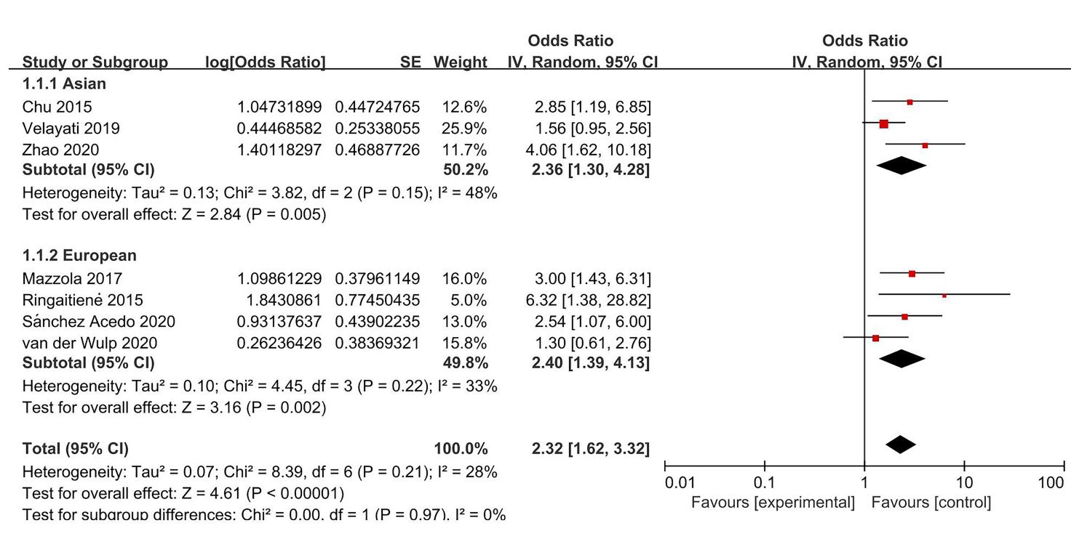
Supplementary Figure S2. Forest plot for the subgroup analysis based on type of surgery.
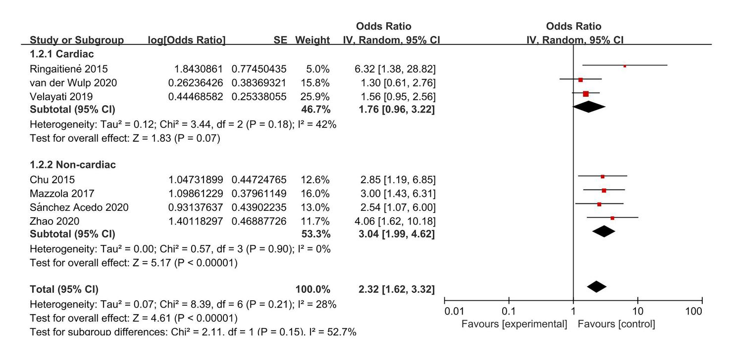

Supplementary Figure S3. Forest plot for the subgroup analysis based on methods for evaluating malnutrition.
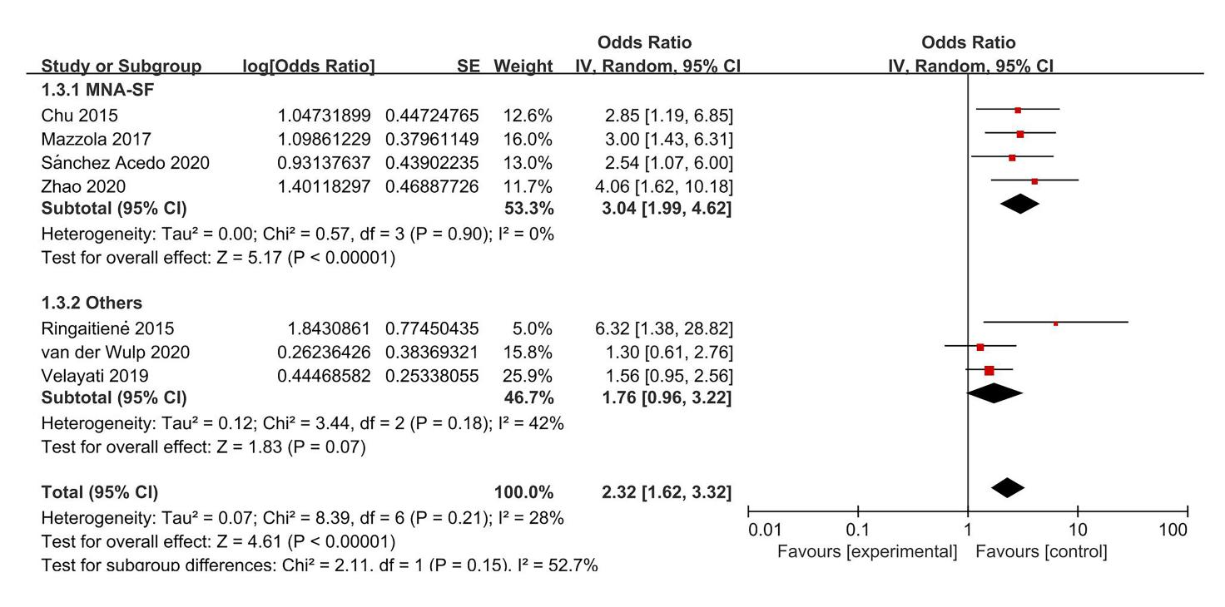
Supplementary Figure S4. Forest plot for the subgroup analysis based on methods for evaluating POD.
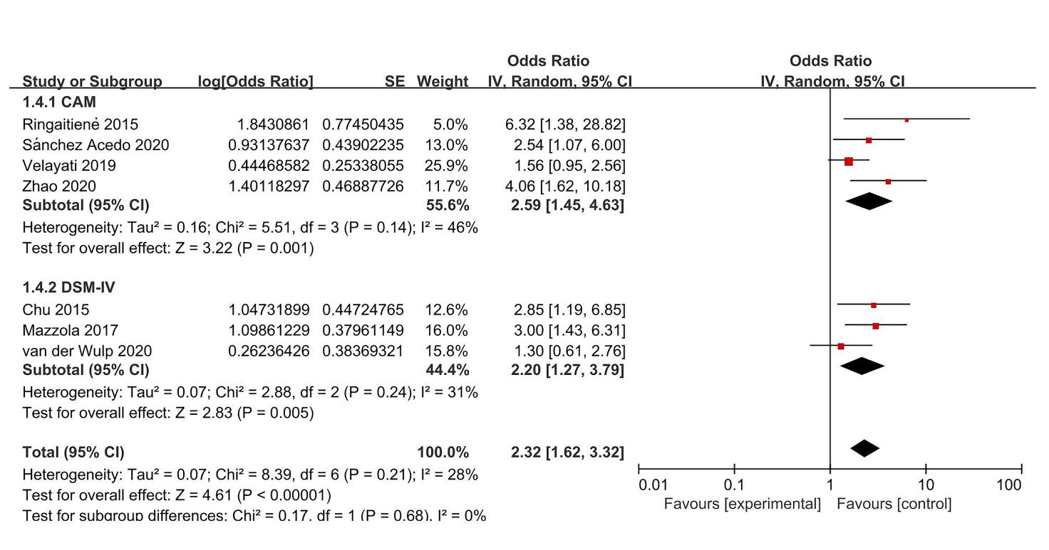

Supplementary Figure S5. Forest plot for the subgroup analysis based on quality of the study.
