Supplementary Materials
Supplementary Method 1 Search strategy
Supplementary Table 1 Risk of bias for included studies
Supplementary Table 2 Network and direct comparison results for transfuse fresh frozen plasma
Note: Comparisons between perioperative fluid therapy should be read from left to right, and the results are all comparisons between treatments defined on the top left and treatments defined on the bottom right. The table is divided into lower left and upper right sections with perioperative fluid therapy as the dividing line. The lower left part represents the network comparison results, and the upper right part represents the direct comparison results. For comparison results, when relative risk (RR) <1, tended to define treatment on the left, when RR >1, treatment tends to be defined to the lower right. Significant results are in bold and underline, and "/" means that the results are not available. HES: hydroxyethyl starch.
Supplementary Table 3 Network and direct comparison results for transfuse platelet
Note: Comparisons between perioperative fluid therapy should be read from left to right, and the results are all comparisons between treatments defined on the top left and treatments defined on the bottom right. The table is divided into lower left and upper right sections with perioperative fluid therapy as the dividing line. The lower left part represents the network comparison results, and the upper right part represents the direct comparison results. For comparison results, when relative risk (RR) <1, tended to define treatment on the left, when RR >1, treatment tends to be defined to the lower right. Significant results are in bold and underline, and "/" means that the results are not available. HES: hydroxyethyl starch.
Supplementary Table 4 Network and direct comparison results for postoperative chest tube output over the first 24h following surgery
Note: Comparisons between perioperative fluid therapy should be read from left to right, and the results are all comparisons between treatments defined on the top left and treatments defined on the bottom right. The table is divided into lower left and upper right sections with perioperative fluid therapy as the dividing line. The lower left part represents the network comparison results, and the upper right part represents the direct comparison results. For comparison results, when mean different (MD) <0, tended to define treatment on the left, when MD >0, treatment tends to be defined to the lower right. Significant results are in bold and underline, and "/" means that the results are not available. HES: hydroxyethyl starch.
Supplementary Table 5 Network and direct comparison results for length of ICU stay
Note: Comparisons between perioperative fluid therapy should be read from left to right, and the results are all comparisons between treatments defined on the top left and treatments defined on the bottom right. The table is divided into lower left and upper right sections with perioperative fluid therapy as the dividing line. The lower left part represents the network comparison results, and the upper right part represents the direct comparison results. For comparison results, when mean different (MD) <0, tended to define treatment on the left, when MD >0, treatment tends to be defined to the lower right. Significant results are in bold and underline, and "/" means that the results are not available. HES: hydroxyethyl starch.
Supplementary Table 6 Network and direct comparison results for length of hospital stay
Note: Comparisons between perioperative fluid therapy should be read from left to right, and the results are all comparisons between treatments defined on the top left and treatments defined on the bottom right. The table is divided into lower left and upper right sections with perioperative fluid therapy as the dividing line. The lower left part represents the network comparison results, and the upper right part represents the direct comparison results. For comparison results, when mean different (MD) <0, tended to define treatment on the left, when MD >0, treatment tends to be defined to the lower right. Significant results are in bold and underline, and "/" means that the results are not available. HES: hydroxyethyl starch.
Supplementary Table 7 Test inconsistency for mortality
Supplementary Table 8 Test inconsistency for transfuse red blood cell
Supplementary Table 9 Test inconsistency for transfuse fresh frozen plasma
Supplementary Table 10 Test inconsistency for transfuse platelet
Supplementary Table 11 Test inconsistency for urinary output at 24h after surgery
Supplementary Table 12 Test inconsistency for postoperative chest tube output over the first 24h following surgery
Supplementary Table 13 Test inconsistency for length of ICU stay
Supplementary Table 14 Test inconsistency for length of hospital stay
Supplementary Figure 1 Funnel plot for mortality
Supplementary Figure 2 Funnel plot for transfuse red blood cell
Supplementary Figure 3 Funnel plot for transfuse fresh frozen plasma
Supplementary Figure 4 Funnel plot for transfuse platelet
Supplementary Figure 5 Funnel plot for urinary output at 24h after surgery
Supplementary Figure 6 Funnel plot for postoperative chest tube output over the first 24h following surgery
Supplementary Figure 7 Funnel plot for length of ICU stay
Supplementary Figure 8 Funnel plot for length of hospital stay

Supplementary Method 1 Search strategy
1. Ovid MEDLINE(R) ALL 1946 to February 15, 2023
- Thoracic Surgery.mp.
- Thoracic Surgical Procedures.mp.
- Cardiac Surgical Procedures.mp.
- exp heart surgery
- Cardiac Surgery.mp.
- Coronary Artery Bypass.mp.
- (heart OR cardiac).ti,ab.
- #1 OR #2 OR #3 OR #4 OR #5 OR #6 OR #7
- Plasma Volume.mp.
- Fluid Therapy.mp.
- Colloids.mp.
- Rehydration Solutions.mp.
- Isotonic Solutions.mp.
- Serum.mp.
- Plasma.mp.
- Plasma Substitutes.mp.
- Albumin.mp.
- Serum Albumin.mp.
- Hydroxyethyl Starch Derivatives.mp.
- Hetastarch.mp.
- HAES-steril.mp.
- Hydroxyethyl Starch.mp.
- Ringer Lactate.mp.
- Hartmanns Solution.mp.
- Priming.mp.
- Prime.mp.
- (colloid* OR hydrocolloid* OR crystalloid* OR albumin* OR albumen* OR plasma OR starch* OR dextran* OR gelofus* OR hemaccel* OR haemaccel* OR serum OR hetastarch OR isotonic OR ringer* OR gelatin* OR gentran* OR pentastarch* OR pentaspan* OR hartman OR sodium OR potassium OR saline OR prime OR priming OR Hetastarch OR Ringer).ti,ab.
- ((Isotonic adj1 saline adj1 solution*) OR (Blood adj1 substitut*) OR (blood adj1 expan*) OR (plasma adj1 volume adj1 expan*) OR (volume adj1 expan*)).ti,ab.
- #9 OR #10 OR #11 OR #12 OR #13 OR #14 OR #15 OR #16 OR #17 OR #18 OR #19 OR #20 OR #21 OR #22 OR #23 OR #24 OR #25 OR #26 OR #27 OR #28
- #8 AND #29
- Limit #30 to (english language and humans and randomized controlled trial)

2. Embase <1974 to February 15, 2023>
- ‘Thoracic Surgery’/exp
- ‘Thoracic Surgical Procedures’/exp
- ‘Cardiac Surgical Procedures’/exp
- ‘Heart surgery’/exp
- ‘Cardiac Surgery’/exp
- ‘Coronary Artery Bypass’/exp
- (heart OR cardiac):ti,ab
- #1 OR #2 OR #3 OR #4 OR #5 OR #6 OR #7
- ‘Plasma Volume’/exp
- ‘Fluid Therapy’/exp
- ‘Colloids’/exp
- ‘Rehydration Solutions’/exp
- ‘Isotonic Solutions’/exp
- ‘Serum’/exp
- ‘Plasma’/exp
- ‘Plasma Substitutes’/exp
- ‘Albumin’/exp
- ‘Serum Albumin’/exp
- ‘Hydroxyethyl Starch Derivatives’/exp
- ‘Hetastarch’/exp
- ‘HAES-steril’/exp
- ‘Hydroxyethyl Starch’/exp
- ‘Ringer Lactate’/exp
- ‘Hartmanns Solution’/exp
- ‘Priming’/exp
- ‘Prime’/exp
- (colloid* OR hydrocolloid* OR crystalloid* OR albumin* OR albumen* OR plasma OR starch* OR dextran* OR gelofus* OR hemaccel* OR haemaccel* OR serum OR hetastarch OR isotonic OR ringer* OR gelatin* OR gentran* OR pentastarch* OR pentaspan* OR hartman OR sodium OR potassium OR saline OR prime OR priming OR Hetastarch OR Ringer):ti,ab
- #9 OR #10 OR #11 OR #12 OR #13 OR #14 OR #15 OR #16 OR #17 OR #18 OR #19 OR #20 OR #21 OR #22 OR #23 OR #24 OR #25 OR #26 OR #27
- #8 AND #28
- #29 AND [randomized controlled trial]/lim AND [english]/lim AND [humans]/lim AND ([embase]/lim OR [embase classic]/lim) AND [article]/lim

3. Cochrane Central Register of Controlled Trials < February 15, 2023>
- MeSH descriptor: [Thoracic Surgery] explode all trees
- MeSH descriptor: [Thoracic Surgical Procedures] explode all trees
- MeSH descriptor: [Thoracic Surgery, Video-Assisted] explode all trees
- MeSH descriptor: [Cardiac Surgical Procedures] explode all trees
- MeSH descriptor: [Thoracic Surgery] explode all trees
- MeSH descriptor: [Coronary Artery Bypass] explode all trees
- (Heart or Cardiac):ti,ab
- #1 or #2 or #3 or #4 or #5 or #6 or #7
- MeSH descriptor: [Plasma Volume] explode all trees
- MeSH descriptor: [Fluid Therapy] explode all trees
- MeSH descriptor: [Colloids] explode all trees
- MeSH descriptor: [Hetastarch] explode all trees
- MeSH descriptor: [Hydroxyethyl Starch] explode all trees
- MeSH descriptor: [Rehydration Solutions] explode all trees
- MeSH descriptor: [Isotonic Solutions] explode all trees
- MeSH descriptor: [Serum] explode all trees
- MeSH descriptor: [Plasma] explode all trees
- MeSH descriptor: [Plasma Substitutes] explode all trees
- MeSH descriptor: [Albumins] explode all trees
- MeSH descriptor: [Serum Albumin] explode all trees
- MeSH descriptor: [Hartmanns Solution] explode all trees
- (colloid* or hydrocolloid* or crystalloid* or albumin* or albumen* or plasma or starch* or dextran* or gelofus* OR hemaccel* or haemaccel* or serum or hetastarch or isotonic or ringer* or gelatin* or gentran* or pentastarch* or pentaspan* or hartman or sodium or potassium or saline or priming or prime):ti,ab
- #9 or #10 or #11 or #12 or #13 or #14 or #15 or #16 or #17 or #18 or #19 or #20 or #22
- #8 and #23 in Trials

Supplementary Table 1 Risk of bias for included studies
Study | Year | Random sequence generation  (Selection bias) | Allocation concealment  (Selection bias) | Blinding of participants and personnel  (Performance bias) | Blinding of outcome assessment  (Detection bias) | Selective reporting (Reporting bias) | Incomplete outcome data (Attrition bias) | Other bias
Alavi | 2012 | Low Risk | Low Risk | Low Risk | Low Risk | Low Risk | High Risk | Low Risk
Belcher | 1983 | Low Risk | Low Risk | Low Risk | Unclear | Low Risk | Low Risk | Unclear
Boom | 2013 | Low Risk | Low Risk | Low Risk | Low Risk | Low Risk | Low Risk | Low Risk
Diehl | 1982 | Low Risk | Low Risk | Low Risk | Unclear | Low Risk | Low Risk | Unclear
Duncan | 2020 | Low Risk | Low Risk | Low Risk | Low Risk | Low Risk | Unclear | Low Risk
Huet | 2000 | Low Risk | Low Risk | Low Risk | Low Risk | Low Risk | Low Risk | Unclear
Kasper | 2003 | Low Risk | Low Risk | Low Risk | Low Risk | Low Risk | Low Risk | Unclear
Kuitunen | 2007 | Low Risk | Low Risk | Low Risk | Low Risk | Low Risk | Low Risk | Unclear
Lee | 2021 | Low Risk | Low Risk | Low Risk | Low Risk | Low Risk | Unclear | Low Risk
Linden | 2005 | Low Risk | Low Risk | Low Risk | Low Risk | Low Risk | Low Risk | Unclear
Mazhar | 1997 | Low Risk | Low Risk | Low Risk | Low Risk | Low Risk | Unclear | Low Risk
Munsch | 1988 | Low Risk | Low Risk | Low Risk | Unclear | Low Risk | Low Risk | Unclear
Niemi | 2008 | Low Risk | Low Risk | Low Risk | Low Risk | Low Risk | Low Risk | Unclear
Niemi | 2006 | Low Risk | Low Risk | Low Risk | Low Risk | Low Risk | Low Risk | Unclear
Öztürk a | 2014 | Low Risk | Low Risk | Low Risk | Low Risk | Unclear | Low Risk | Low Risk
Öztürk b | 2014 | Low Risk | Low Risk | Low Risk | Low Risk | Unclear | Low Risk | Low Risk
Schramko | 2009 | Low Risk | Low Risk | Low Risk | Low Risk | Low Risk | High Risk | Low Risk
Schramko | 2010 | Low Risk | Low Risk | Low Risk | Low Risk | Low Risk | High Risk | Low Risk
Schramko | 2010 | Low Risk | Low Risk | Low Risk | Low Risk | Low Risk | High Risk | Low Risk
Skhirtladze | 2013 | Low Risk | Low Risk | Low Risk | Low Risk | Unclear | Low Risk | Low Risk

Supplementary Table 2 Network and direct comparison results for transfuse fresh frozen plasma
3% Gelatin | / | / | / | 0.34 (0.11, 1.02) | / | /
0.79 (0.03, 18.06) | 4% Albumin | / | / | 0.33 (0.01, 7.58) | 0.33 (0.01, 7.58) | /
0.21 (0.07, 0.69) | 0.27 (0.01, 5.15) | 4% Gelatin | / | 1.00 (0.02, 47.38) | 0.95 (0.72, 1.25) | 1.00 (0.02, 47.38)
0.63 (0.17, 2.43) | 0.81 (0.04, 16.87) | 3.00 (1.22, 7.34) | 5% Albumin | 0.57 (0.26, 1.24) | / | /
0.34 (0.11, 1.02) | 0.44 (0.02, 8.22) | 1.62 (1.04, 2.50) | 0.54 (0.25, 1.18) | 6% HES 130/0.4 | 0.58 (0.41, 0.82) | 1.00 (0.02, 47.38)
0.20 (0.06, 0.63) | 0.26 (0.01, 4.82) | 0.95 (0.72, 1.24) | 0.32 (0.13, 0.74) | 0.59 (0.42, 0.83) | 6% HES 200/0.5 | /
0.27 (0.01, 9.11) | 0.34 (0.00, 29.26) | 1.27 (0.04, 36.19) | 0.42 (0.01, 13.22) | 0.79 (0.03, 22.38) | 1.34 (0.05, 38.19) | Ringer's solution
Note: Comparisons between perioperative fluid therapy should be read from left to right, and the results are all comparisons between treatments defined on the top left and treatments defined on the bottom right. The table is divided into lower left and upper right sections with perioperative fluid therapy as the dividing line. The lower left part represents the network comparison results, and the upper right part represents the direct comparison results. For comparison results, when relative risk (RR) <1, tended to define treatment on the left, when RR >1, treatment tends to be defined to the lower right. Significant results are in bold and underline, and "/" means that the results are not available. HES: hydroxyethyl starch.

Supplementary Table 3 Network and direct comparison results for transfuse platelet
3% Gelatin | / | / | / | 0.35 (0.10, 1.27) | / | /
1.76 (0.07, 44.25) | 4% Albumin | / | / | 0.20 (0.01, 3.85) | 0.20 (0.01, 3.85) | /
0.12 (0.00, 3.45) | 0.07 (0.00, 4.92) | 4% Gelatin | / | 3.00 (0.13, 68.26) | / | /
0.39 (0.09, 1.59) | 0.22 (0.01, 4.47) | 3.30 (0.14, 79.11) | 5% Albumin | 0.92 (0.51, 1.66) | / | /
0.35 (0.10, 1.27) | 0.20 (0.01, 3.84) | 3.00 (0.13, 68.19) | 0.91 (0.51, 1.63) | 6% HES 130/0.4 | 1.00 (0.16, 6.20) | 0.33 (0.04, 3.04)
0.35 (0.05, 2.76) | 0.20 (0.01, 3.84) | 3.00 (0.09, 100.78) | 0.91 (0.16, 5.04) | 1.00 (0.20, 5.00) | 6% HES 200/0.5 | /
0.12 (0.00, 3.45) | 0.07 (0.00, 4.92) | 1.00 (0.12, 8.62) | 0.30 (0.01, 7.28) | 0.33 (0.01, 7.59) | 0.33 (0.01, 11.21) | Ringer's solution
Note: Comparisons between perioperative fluid therapy should be read from left to right, and the results are all comparisons between treatments defined on the top left and treatments defined on the bottom right. The table is divided into lower left and upper right sections with perioperative fluid therapy as the dividing line. The lower left part represents the network comparison results, and the upper right part represents the direct comparison results. For comparison results, when relative risk (RR) <1, tended to define treatment on the left, when RR >1, treatment tends to be defined to the lower right. Significant results are in bold and underline, and "/" means that the results are not available. HES: hydroxyethyl starch.

Supplementary Table 4 Network and direct comparison results for postoperative chest tube output over the first 24h following surgery
4% Albumin | -230  (-451.85, -8.15) | / | / | 108.86  (41.01, 176.71) | -49.26  (-225.17, 126.65) | /
10.58  (-76.29, 97.46) | 4% Gelatin | / | / | 7.88  (-102.87, 118.63) | -67.25  (-129.61, -4.90) | 178  (-21.59, 377.59)
-10.83  (-114.32, 92.67) | -21.41  (-145.88, 103.06) | 5% Albumin | -142.00  (-301.53, 17.53) | 96.07  (-17.38, 209.52) | / | 165  (123.12, 206.88)
-8.89  (-154.33, 136.55) | -19.48  (-176.88, 137.92) | 1.93  (-143.46, 147.33) | 6% HES | / | / | -34  (-158.15, 90.15)
51.45  (-31.22, 134.12) | 40.87  (-51.40, 133.14) | 62.28  (-40.16, 164.71) | 60.34  (-85.86, 206.54) | 6% HES 130/0.4 | 0.00  (-86.11, 86.11) | 30  (-4.88, 64.88)
-8.46  (-101.34, 84.43) | -19.04  (-114.50, 76.41) | 2.37  (-128.31, 133.05) | 0.44  (-161.61, 162.48) | -59.91  (-159.08, 39.27) | 6% HES 200/0.5 | /
83.24  (-28.05, 194.53) | 72.65  (-49.14, 194.45) | 94.06  (-20.37, 208.49) | 92.13  (-47.98, 232.25) | 31.79  (-70.18, 133.75) | 91.70  (-38.11, 221.50) | Ringer's solution
Note: Comparisons between perioperative fluid therapy should be read from left to right, and the results are all comparisons between treatments defined on the top left and treatments defined on the bottom right. The table is divided into lower left and upper right sections with perioperative fluid therapy as the dividing line. The lower left part represents the network comparison results, and the upper right part represents the direct comparison results. For comparison results, when mean different (MD) <0, tended to define treatment on the left, when MD >0, treatment tends to be defined to the lower right. Significant results are in bold and underline, and "/" means that the results are not available. HES: hydroxyethyl starch.

Supplementary Table 5 Network and direct comparison results for length of ICU stay
3% Gelatin | / | / | / | 0.79 (0.59, 0.99) | / | /
0.71 (-1.47, 2.90) | 4% Gelatin | / | 0.08 (0.05, 0.11) | / | / | 0.04 (0.01, 0.07)
0.83 (-1.36, 3.01) | 0.12 (-0.07, 0.31) | 5% Albumin | -0.04 (-0.23, 0.15) | 0.00 (-0.31, 0.31) | / | 0.00 (-0.98, 0.98)
0.79 (-1.39, 2.98) | 0.08 (0.05, 0.11) | -0.04 (-0.22, 0.15) | 6% HES | / | / | -0.04 (-0.07, -0.01)
0.79 (0.59, 0.99) | 0.08 (-2.10, 2.25) | -0.04 (-2.22, 2.14) | -0.00 (-2.18, 2.17) | 6% HES 130/0.4 | 0.10 (-0.16, 0.36) | 0.00 (-2.22, 2.22)
0.89 (0.57, 1.22) | 0.18 (-2.01, 2.37) | 0.06 (-2.13, 2.25) | 0.10 (-2.09, 2.29) | 0.10 (-0.15, 0.36) | 6% HES 200/0.5 | /
0.75 (-1.43, 2.94) | 0.04 (0.01, 0.07) | -0.08 (-0.27, 0.11) | -0.04 (-0.07, -0.01) | -0.04 (-2.21, 2.14) | -0.14 (-2.33, 2.05) | Ringer's solution
Note: Comparisons between perioperative fluid therapy should be read from left to right, and the results are all comparisons between treatments defined on the top left and treatments defined on the bottom right. The table is divided into lower left and upper right sections with perioperative fluid therapy as the dividing line. The lower left part represents the network comparison results, and the upper right part represents the direct comparison results. For comparison results, when mean different (MD) <0, tended to define treatment on the left, when MD >0, treatment tends to be defined to the lower right. Significant results are in bold and underline, and "/" means that the results are not available. HES: hydroxyethyl starch.

Supplementary Table 6 Network and direct comparison results for length of hospital stay
3% Gelatin | / | / | 1.00 (-0.70, 2.70) | / | /
1.00 (-2.82, 4.82) | 5% Albumin | 1.00 (-0.07, 2.07) | 0.00 (-3.42, 3.42) | / | 1.00 (-6.70, 8.70)
2.00 (-1.97, 5.96) | 1.00 (-0.07, 2.07) | 6% HES | / | / | /
1.00 (-0.70, 2.70) | 0.00 (-3.42, 3.42) | -1.00 (-4.58, 2.58) | 6% HES 130/0.4 | -1.00 (-3.46, 1.46) | 1.00 (-6.51, 8.51)
-0.00 (-2.99, 2.99) | -1.00 (-5.21, 3.21) | -2.00 (-6.34, 2.35) | -1.00 (-3.46, 1.46) | 6% HES 200/0.5 | /
2.00 (-5.70, 9.70) | 1.00 (-6.70, 8.70) | 0.00 (-7.77, 7.77) | 1.00 (-6.51, 8.51) | 2.00 (-5.91, 9.91) | Ringer's solution
Note: Comparisons between perioperative fluid therapy should be read from left to right, and the results are all comparisons between treatments defined on the top left and treatments defined on the bottom right. The table is divided into lower left and upper right sections with perioperative fluid therapy as the dividing line. The lower left part represents the network comparison results, and the upper right part represents the direct comparison results. For comparison results, when mean different (MD) <0, tended to define treatment on the left, when MD >0, treatment tends to be defined to the lower right. Significant results are in bold and underline, and "/" means that the results are not available. HES: hydroxyethyl starch.

Supplementary Table 7 Test inconsistency for mortality
Side | Direct |  |  | Indirect |  |  | Difference |  |  | Tau
Side | Coef. | Std. Err. |  | Coef. | Std. Err. |  | Coef. | Std. Err. | P>z | Tau
3% Gelatin vs. 6% HES 130/0.4 | -1.04 | 1.623819 |  | -0.7069666 | 37.80761 |  | -0.3319265 | 37.84246 | 0.993 | 1.00E-08
5% Albumin vs. 6% HES | -0.1941365 | 1.983565 |  | -0.0540295 | 66.70177 |  | -0.140107 | 66.72471 | 0.998 | 6.71E-09
5% Albumin vs. 6% HES 130/0.4 | -1.07 | 0.9535394 |  | -1.145095 | 53.49636 |  | 0.0775041 | 53.50728 | 0.999 | 1.12E-09
6% HES vs. Plasma protein fraction | 1.96E-10 | 1.976047 |  | 0.3296259 | 200.0951 |  | -0.3296259 | 200.0854 | 0.999 | 7.59E-11
6% HES vs. Ringer's solution | 2.43E-10 | 1.987767 |  | 0.3296251 | 200.1149 |  | -0.3296251 | 200.105 | 0.999 | 5.05E-10
6% HES 130/0.4 vs. 6% HES 200/0.5 | 2.48E-02 | 1.405406 |  | 2.102488 | 141.4833 |  | -2.077657 | 141.4763 | 0.988 | 4.77E-09
3% Gelatin vs. 6% HES 130/0.4 | -1.04 | 1.623819 |  | -0.7069666 | 37.80761 |  | -0.3319265 | 37.84246 | 0.993 | 1.00E-08

Supplementary Table 8 Test inconsistency for transfuse red blood cell
Side | Direct |  |  | Indirect |  |  | Difference |  |  | Tau
Side | Coef. | Std. Err. |  | Coef. | Std. Err. |  | Coef. | Std. Err. | P>z | Tau
3% Gelatin vs. 6% HES 130/0.4 | 0.194156 | 0.242806 |  | -0.26912 | 40.82975 |  | 0.463279 | 40.83047 | 0.991 | 1.68E-09
4% Albumin vs. 4% Gelatin | -0.22313 | 0.56273 |  | -0.97013 | 1.348162 |  | 0.747009 | 1.494732 | 0.617 | 5.40E-09
4% Albumin vs. 6% HES 200/0.5 | -0.51081 | 0.632454 |  | 0.236331 | 1.252015 |  | -0.74714 | 1.494732 | 0.617 | 7.09E-09
4% Gelatin vs. 6% HES 130/0.4 | -0.69312 | 0.785275 |  | -0.65024 | 0.452653 |  | -0.04288 | 0.906398 | 0.962 | 1.45E-08
4% Gelatin vs. 6% HES 200/0.5 | 0.018443 | 0.315466 |  | -0.02431 | 0.849705 |  | 0.042757 | 0.906378 | 0.962 | 4.43E-09
4% Gelatin vs. Ringer's solution | -0.28767 | 0.670818 |  | -0.20198 | 1.73286 |  | -0.08568 | 1.812759 | 0.962 | 1.02E-07
5% Albumin vs. 6% HES 130/0.4 | 0.239464 | 0.240618 |  | 0.154125 | 1.796419 |  | 0.085339 | 1.81247 | 0.962 | 2.31E-09
5% Albumin vs. 6% HES 200/0.5 | 0.816667 | 0.386702 |  | 1.183302 | 0.715264 |  | -0.36663 | 0.869333 | 0.673 | 1.58E-07
6% HES 130/0.4 vs. 6% HES 200/0.5 | 0.754202 | 0.388055 |  | 0.486547 | 0.644159 |  | 0.267656 | 0.810728 | 0.741 | 1.67E-08
6% HES 130/0.4 vs. Ringer's solution | 4.05E-01 | 0.83666 |  | 0.319638 | 1.500966 |  | 0.085827 | 1.812797 | 0.962 | 6.79E-08

Supplementary Table 9 Test inconsistency for transfuse fresh frozen plasma
Side | Direct |  |  | Indirect |  |  | Difference |  |  | Tau
Side | Coef. | Std. Err. |  | Coef. | Std. Err. |  | Coef. | Std. Err. | P>z | Tau
3% Gelatin vs. 6% HES 130/0.4 | 1.072226 | 0.5572954 |  | 0.1836902 | 40.8093 |  | 0.8885354 | 40.8131 | 0.983 | 2.67E-07
4% Albumin vs. 6% HES 130/0.4 | 1.098713 | 1.594143 |  | 0.001712 | 2.254714 |  | 1.097001 | 2.227016 | 0.622 | 7.11E-09
4% Albumin vs. 6% HES 200/0.5 | 1.098607 | 1.594143 |  | 2.195672 | 2.254723 |  | -1.097065 | 2.22702 | 0.622 | 1.36E-08
4% Gelatin vs. 6% HES 130/0.4 | 0.0002549 | 1.968407 |  | -0.487109 | 0.224378 |  | 0.4873637 | 1.981156 | 0.806 | 3.42E-07
4% Gelatin vs. 6% HES 200/0.5 | 0.0512946 | 0.1389181 |  | 0.5390808 | 1.975901 |  | -0.487786 | 1.980779 | 0.805 | 1.84E-07
4% Gelatin vs. Ringer's solution | 0.0002076 | 1.968407 |  | -0.974846 | 3.43846 |  | 0.9750535 | 3.961739 | 0.806 | 2.71E-06
5% Albumin vs. 6% HES 130/0.4 | 0.616539 | 0.3994603 |  | 1.52756 | 141.4357 |  | -0.911021 | 141.4374 | 0.995 | 4.37E-07
6% HES 130/0.4 vs. 6% HES 200/0.5 | 0.5384152 | 0.1762032 |  | 0.0503013 | 1.972445 |  | 0.4881139 | 1.980298 | 0.805 | 1.22E-07
6% HES 130/0.4 vs. Ringer's solution | 1.23E-12 | 1.968502 |  | 0.9742083 | 3.43895 |  | -0.974208 | 3.962497 | 0.806 | 1.05E-08

Supplementary Table 10 Test inconsistency for transfuse platelet
Side | Direct |  |  | Indirect |  |  | Difference |  |  | Tau
Side | Coef. | Std. Err. |  | Coef. | Std. Err. |  | Coef. | Std. Err. | P>z | Tau
3% Gelatin vs. 6% HES 130/0.4 | 1.041454 | 0.654219 |  | 0.175052 | 49.99762 |  | 0.866402 | 50.0019 | 0.986 | 1.26E-09
4% Albumin vs. 6% HES 130/0.4 | 1.609438 | 1.50831 |  | 0.473124 | 200.0189 |  | 1.136314 | 200.0359 | 0.995 | 6.08E-10
4% Albumin vs. 6% HES 200/0.5 | 1.609328 | 1.80959 |  | 1.598655 | 7262.511 |  | 0.010673 | 7262.511 | 1.000 | 0.999995
4% Gelatin vs. 6% HES 130/0.4 | -1.09861 | 1.594261 |  | 3.181406 | 200.0139 |  | -4.28002 | 200.0329 | 0.983 | 4.73E-09
5% Albumin vs. 6% HES 130/0.4 | 0.09469 | 0.296989 |  | 1.98809 | 141.3429 |  | -1.8934 | 141.3439 | 0.989 | 7.71E-09
6% HES 130/0.4 vs. 6% HES 200/0.5 | 1.80E-12 | 0.821584 |  | 1.136313 | 199.8268 |  | -1.13631 | 199.8285 | 0.995 | 2.31E-09
6% HES 130/0.4 vs. Ringer's solution | 1.098612 | 1.594261 |  | -3.18141 | 200.0632 |  | 4.280019 | 200.0762 | 0.983 | 2.33E-10

Supplementary Table 11 Test inconsistency for urinary output at 24h after surgery
Side | Direct |  |  | Indirect |  |  | Difference |  |  | Tau
Side | Coef. | Std. Err. |  | Coef. | Std. Err. |  | Coef. | Std. Err. | P>z | Tau
4% Albumin vs. 4% Gelatin | -236.3244 | 485.7059 |  | 70.7211 | 177.0708 |  | -307.0455 | 517.6442 | 0.553 | 413.142
4% Albumin vs. 6% HES 130/0.4 | 944.0253 | 226.0533 |  | -82.96633 | 147.4457 |  | 1026.992 | 268.7722 | 0.000* | 280.7974
4% Albumin vs. 6% HES 200/0.5 | 901.8974 | 223.5678 |  | -16.89571 | 227.713 |  | 918.7931 | 315.8094 | 0.004* | 327.6606
4% Gelatin vs. 6% HES 130/0.4 | -21.42245 | 286.3013 |  | 382.0835 | 298.0613 |  | -403.5059 | 415.1397 | 0.331 | 412.1221
4% Gelatin vs. 6% HES 200/0.5 | 482.3164 | 326.9281 |  | 345.2224 | 310.4206 |  | 137.0939 | 451.0108 | 0.761 | 420.587
4% Gelatin vs. Hypertonic saline solution | 2032.5 | 458.891 |  | 1952.195 | 859.6801 |  | 80.30514 | 939.2841 | 0.932 | 420.5863
4% Gelatin vs. Ringer's solution | -355.625 | 365.423 |  | -179.6263 | 343.9272 |  | -175.9987 | 493.9109 | 0.722 | 417.2055
5% Albumin vs. 6% HES 130/0.4 | 25.40087 | 395.9782 |  | 1100.14 | 679.1108 |  | -1074.74 | 787.7244 | 0.172 | 393.1304
5% Albumin vs. Ringer's solution | 226.6295 | 373.2531 |  | -1414.049 | 717.6803 |  | 1640.678 | 810.3932 | 0.043* | 370.081
6% HES vs. Hyperosmolar sodium lactate | 236.2901 | 441.5961 |  | -79.04658 | 961.7442 |  | 315.3366 | 1040.298 | 0.762 | 419.6873
6% HES vs. Plasma protein fraction | -34.99999 | 420.2483 |  | -350.3366 | 952.131 |  | 315.3366 | 1040.298 | 0.762 | 419.6873
6% HES vs. Ringer's solution | -837.0324 | 450.8215 |  | 27.52544 | 375.791 |  | -864.5578 | 588.8156 | 0.142 | 393.3179
6% HES 130/0.4 vs. 6% HES 200/0.5 | 9.567407 | 263.0266 |  | 639.9582 | 348.7869 |  | -630.3908 | 435.6371 | 0.148 | 400.8304
6% HES 130/0.4 vs. Ringer's solution | -112.6366 | 249.6304 |  | -1179.272 | 392.9105 |  | 1066.636 | 467.7133 | 0.023* | 362.2957
Note: * indicated an inconsistency in this comparison.

Supplementary Table 12 Test inconsistency for postoperative chest tube output over the first 24h following surgery
Side | Direct |  |  | Indirect |  |  | Difference |  |  | Tau
Side | Coef. | Std. Err. |  | Coef. | Std. Err. |  | Coef. | Std. Err. | P>z | Tau
4% Albumin vs. 4% Gelatin | 260.8314 | 119.1226 |  | -52.01498 | 42.02702 |  | 312.8464 | 126.6628 | 0.014* | 55.89644
4% Albumin vs. 6% HES 130/0.4 | -118.6627 | 58.3276 |  | -0.3706845 | 53.10556 |  | -118.292 | 78.11934 | 0.130 | 66.3534
4% Albumin vs. 6% HES 200/0.5 | -11.59502 | 58.4245 |  | 50.47388 | 78.10275 |  | -62.0689 | 96.84139 | 0.522 | 68.96685
4% Gelatin vs. 6% HES 130/0.4 | -21.10284 | 64.57125 |  | -69.84532 | 77.98327 |  | 48.74248 | 103.5699 | 0.638 | 75.25443
4% Gelatin vs. 6% HES 200/0.5 | 81.30602 | 60.47199 |  | -63.55246 | 69.38266 |  | 144.8585 | 91.73364 | 0.114 | 62.39994
4% Gelatin vs. 6% HES 200/0.5 | -149.8374 | 101.3502 |  | -31.1755 | 74.94677 |  | -118.6619 | 123.4484 | 0.336 | 69.63986
5% Albumin vs. 6% HES | 123.3236 | 96.54365 |  | -116.9914 | 87.5065 |  | 240.3149 | 126.9506 | 0.058 | 57.60013
5% Albumin vs. 6% HES 130/0.4 | -94.56001 | 60.75265 |  | 20.981 | 98.4141 |  | -115.541 | 116.622 | 0.322 | 70.64145
5% Albumin vs. Ringer's solution | -163.2404 | 61.98951 |  | 16.38831 | 85.50089 |  | -179.6287 | 105.5564 | 0.089 | 58.23509
6% HES vs. Ringer's solution | 34.08764 | 79.32968 |  | -288.3166 | 101.507 |  | 322.4042 | 132.5177 | 0.015* | 50.20412
6% HES 130/0.4 vs. 6% HES 200/0.5 | -1.29E-11 | 65.15618 |  | 140.1419 | 76.07137 |  | -140.1419 | 100.1608 | 0.162 | 68.15141
6% HES 130/0.4 vs. Ringer's solution | -28.62396 | 62.13476 |  | -43.06058 | 107.4309 |  | 14.43661 | 123.7596 | 0.907 | 74.87098
Note: * indicated an inconsistency in this comparison.

Supplementary Table 13 Test inconsistency for length of ICU stay
Side | Direct |  |  | Indirect |  |  | Difference |  |  | Tau
Side | Coef. | Std. Err. |  | Coef. | Std. Err. |  | Coef. | Std. Err. | P>z | Tau
3% Gelatin vs. 6% HES 130/0.4 | -0.79 | 0.1022401 |  | 0.0034097 | 1.10749 |  | -0.7934097 | 1.112199 | 0.476 | 3.57E-06
4% Gelatin vs. 6% HES | -0.08 | 0.0138977 |  | 0.0800228 | 1.023359 |  | -0.1600228 | 1.023485 | 0.876 | 5.93E-07
4% Gelatin vs. Ringer's solution | -0.0400001 | 0.0143102 |  | -0.2000595 | 1.021678 |  | 0.1600594 | 1.02E+00 | 0.876 | 1.05E-07
5% Albumin vs. 6% HES | 0.0399997 | 0.0968789 |  | -0.0400006 | 0.5016827 |  | 0.0800003 | 5.11E-01 | 0.876 | 7.75E-07
5% Albumin vs. 6% HES 130/0.4 | -0.0002573 | 1.139524 |  | 0.1596019 | 1.35766 |  | -0.1598592 | 1.02E+00 | 0.876 | 0.0000588
5% Albumin vs. Ringer's solution | -0.0000107 | 0.5013348 |  | 0.08 | 0.0980929 |  | -0.0800108 | 5.11E-01 | 0.876 | 6.40E-06
6% HES vs. Ringer's solution | 0.04 | 0.015383 |  | -0.040021 | 0.5106759 |  | 0.0800209 | 0.5109076 | 0.876 | 1.02E-06
6% HES 130/0.4 vs. 6% HES 200/0.5 | -0.1006526 | 0.1303215 |  | 1.479345 | 141.1109 |  | -1.579998 | 1.41E+02 | 0.991 | 8.88E-08
6% HES 130/0.4 vs. Ringer's solution | 0.0002064 | 1.134397 |  | 0.1603625 | 1.359041 |  | -0.160156 | 1.02E+00 | 0.876 | 4.05E-07

Supplementary Table 14 Test inconsistency for length of hospital stay
Side | Direct |  |  | Indirect |  |  | Difference |  |  | Tau
Side | Coef. | Std. Err. |  | Coef. | Std. Err. |  | Coef. | Std. Err. | P>z | Tau
3% Gelatin vs. 6% HES 130/0.4 | -1 | 0.865293 |  | -5.67E-07 | 57.73122 |  | -1 | 57.7377 | 0.986 | 5.98E-06
5% Albumin vs. 6% HES | -0.99999 | 0.547879 |  | 0.9986092 | 199.8512 |  | -1.9986 | 199.8505 | 0.992 | 0.001217
5% Albumin vs. 6% HES 130/0.4 | -4E-05 | 1.745144 |  | -1.199849 | 128.2539 |  | 1.199809 | 128.2759 | 0.993 | 0.000128
5% Albumin vs. Ringer's solution | -1.00013 | 3.926706 |  | -2.998953 | 1293.229 |  | 1.998822 | 1293.229 | 0.999 | 0.000853
6% HES 130/0.4 vs. 6% HES 200/0.5 | 1.000057 | 1.253753 |  | 2.999411 | 200.0708 |  | -1.99935 | 200.0668 | 0.992 | 0.000704
6% HES 130/0.4 vs. Ringer's solution | -0.99995 | 3.833661 |  | 0.9998196 | 1610.041 |  | -1.99977 | 1610.032 | 0.999 | 0.001336

Supplementary Figure 1 Funnel plot for mortality
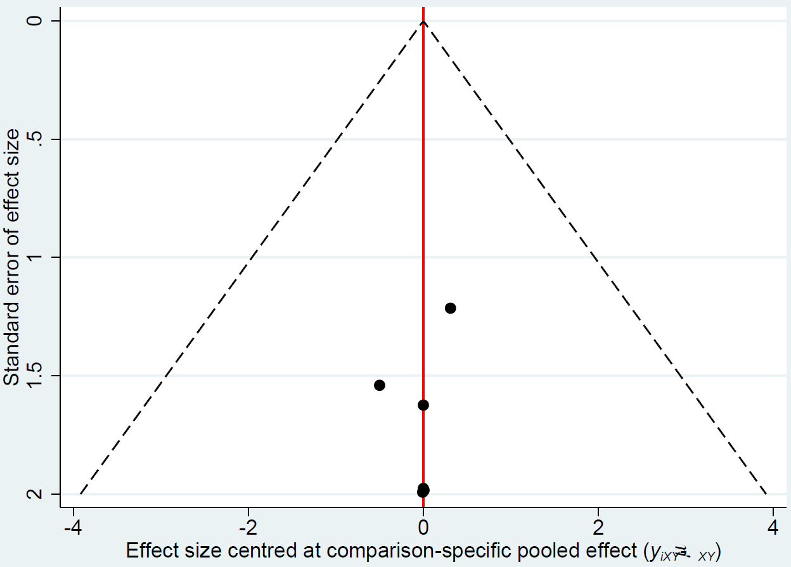

Supplementary Figure 2 Funnel plot for transfuse red blood cell
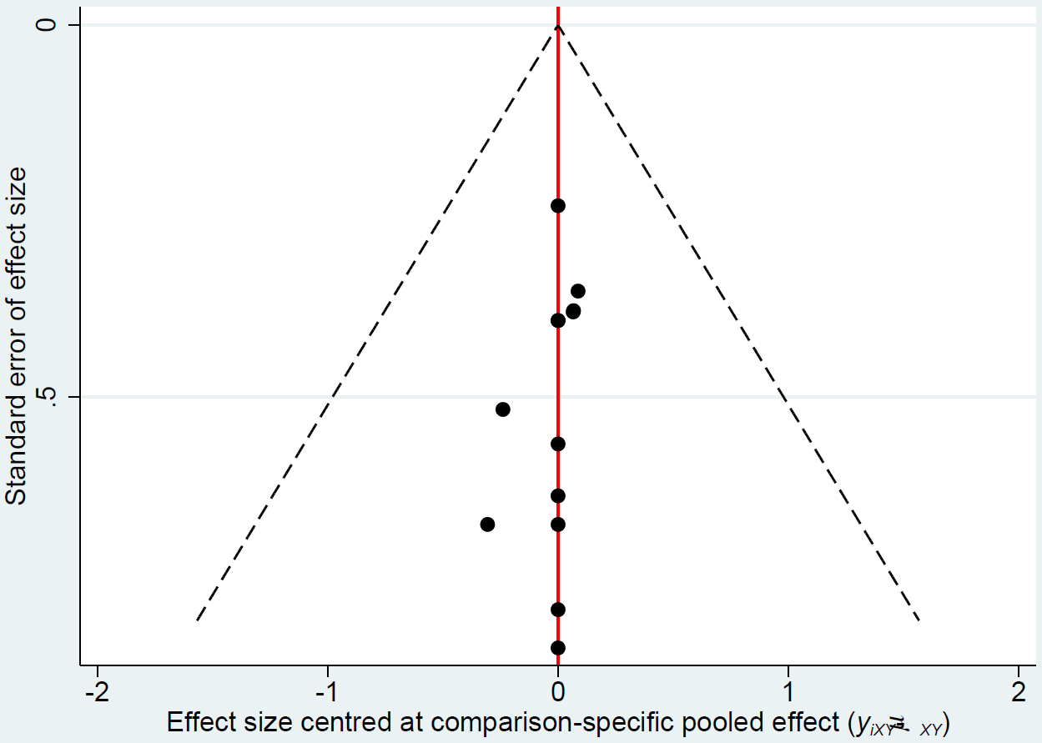

Supplementary Figure 3 Funnel plot for transfuse fresh frozen plasma
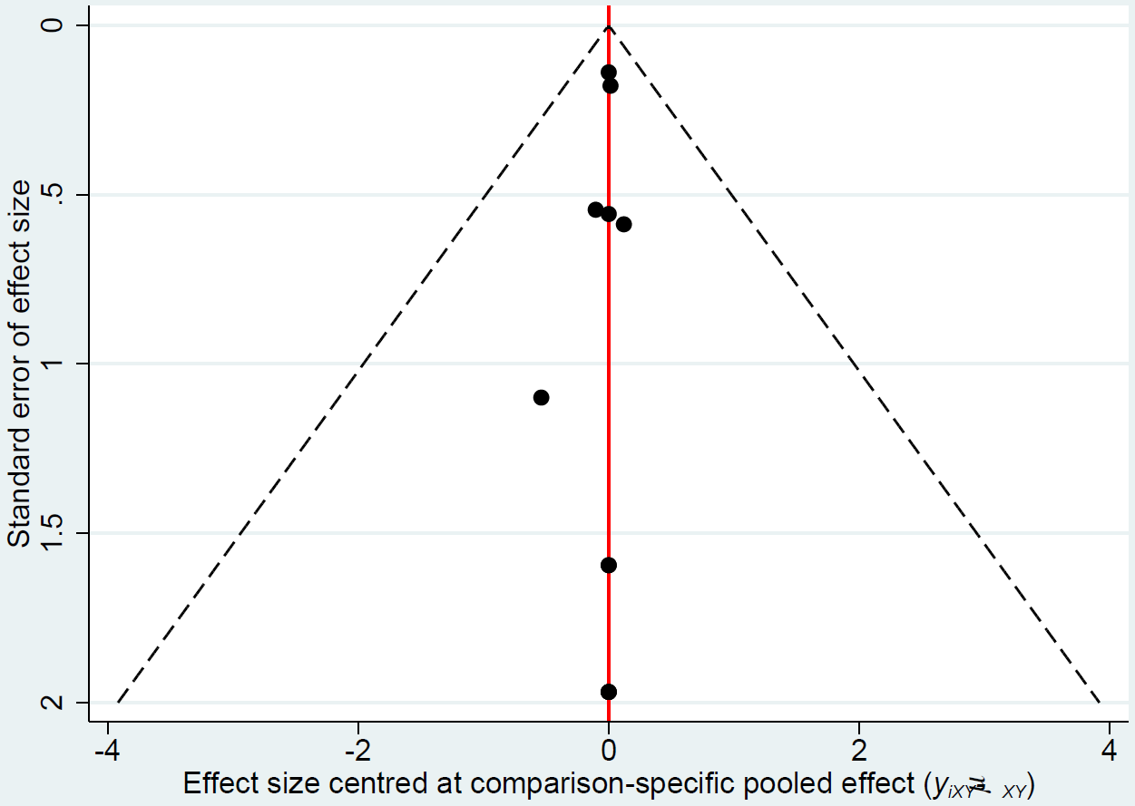

Supplementary Figure 4 Funnel plot for transfuse platelet
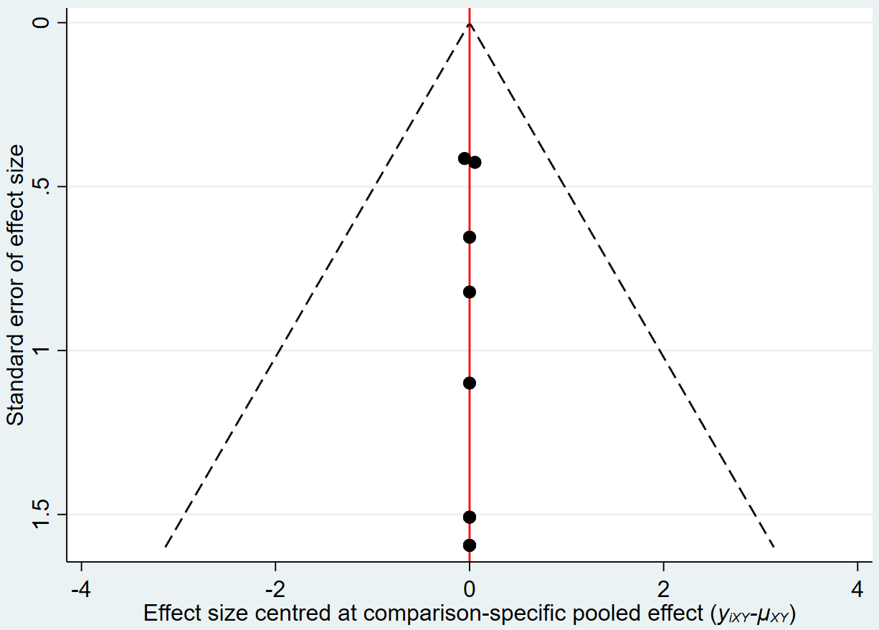

Supplementary Figure 5 Funnel plot for urinary output at 24h after surgery
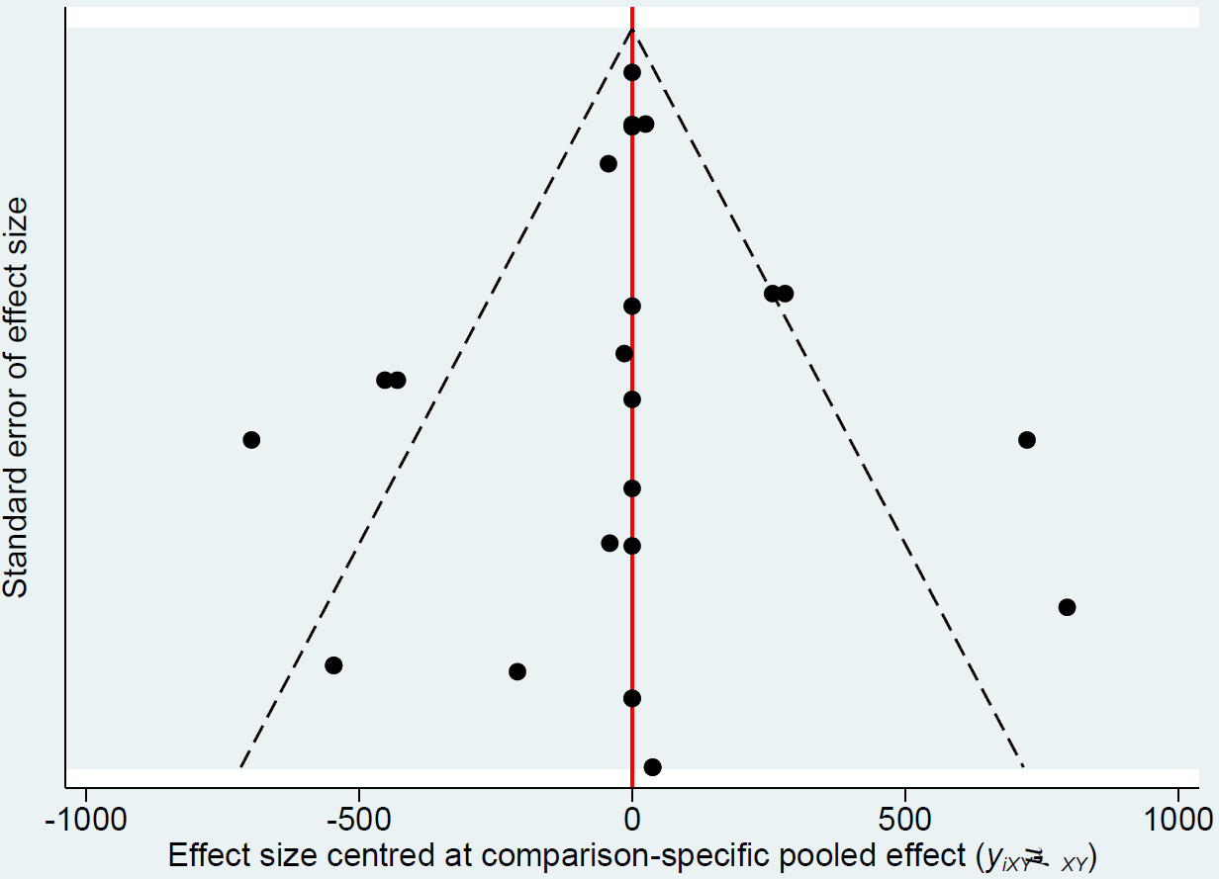

Supplementary Figure 6 Funnel plot for postoperative chest tube output over the first 24h following surgery
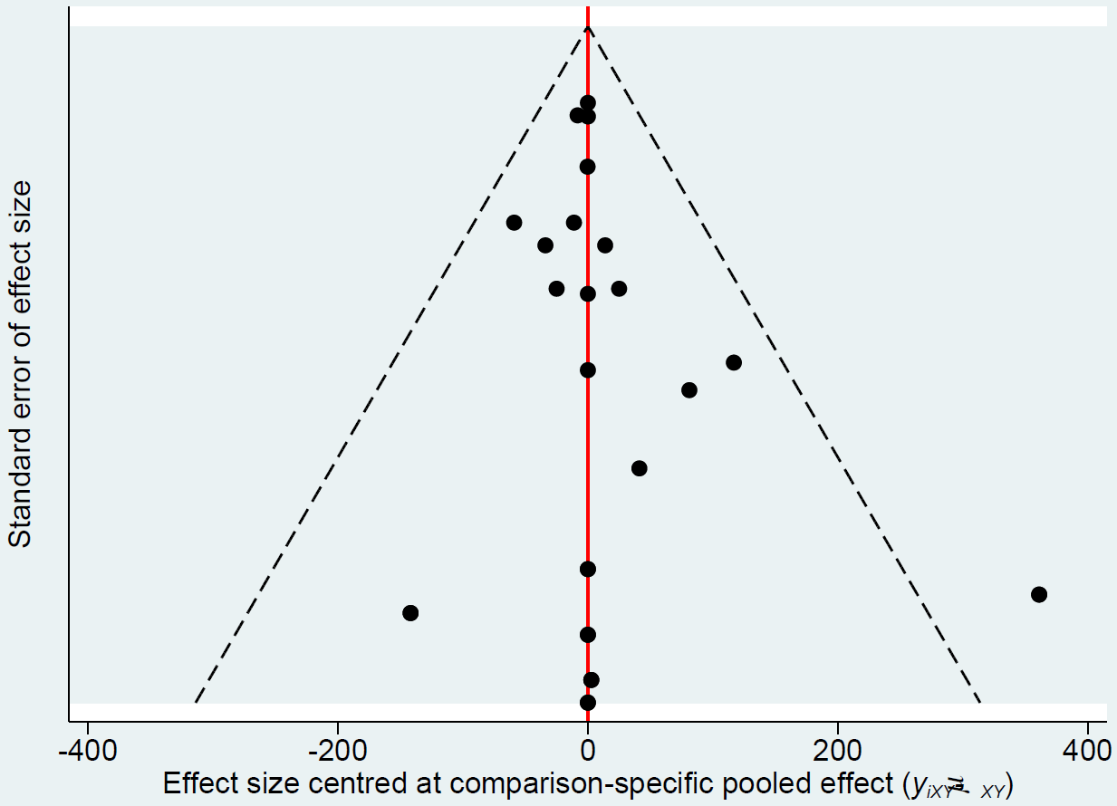

Supplementary Figure 7 Funnel plot for length of ICU stay
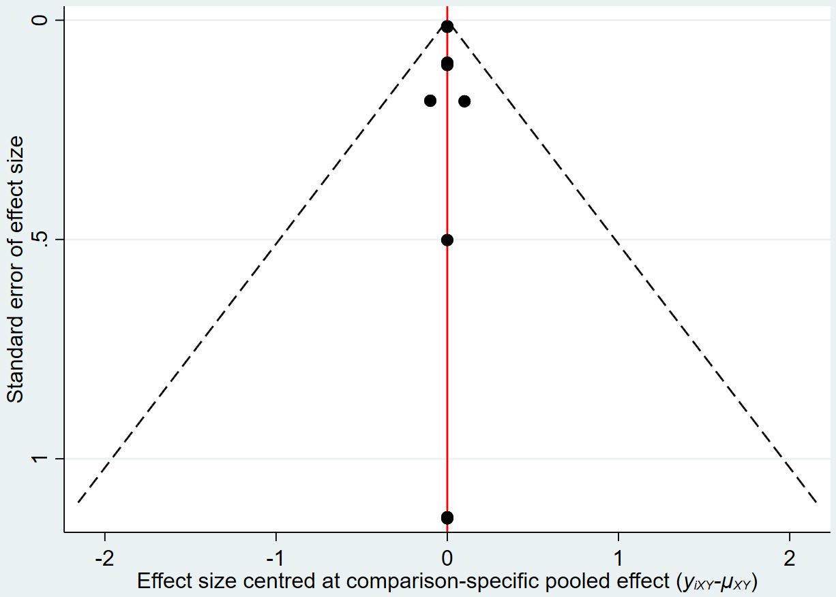

Supplementary Figure 8 Funnel plot for length of hospital stay
