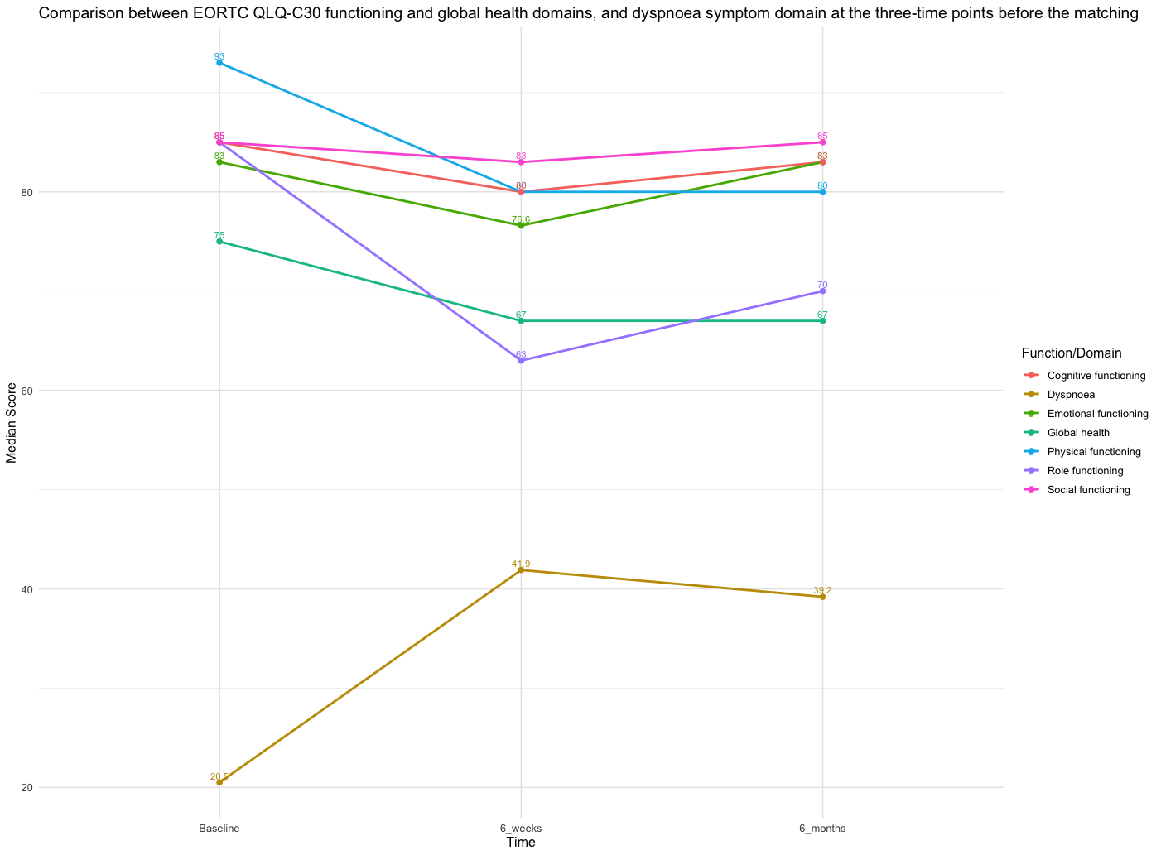
Figure (3): Comparison between EORTC QLQ-C30 functioning and global health domains, and dyspnoea symptom domain

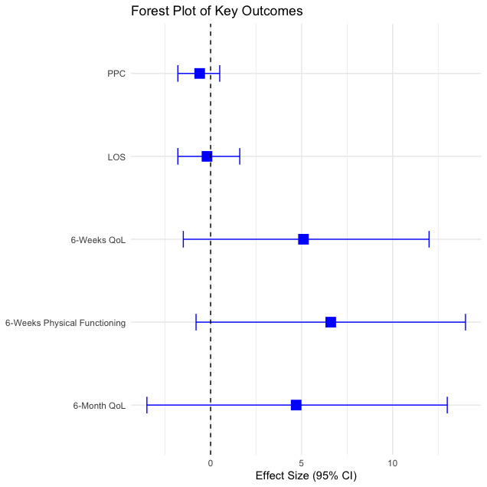
Figure (4): Forest plot of key outcomes

