Appendix 1. Search strategy
Search strategy for PubMed
No. | Search Query | Results
#10 | ((("Head-Down Tilt"[Mesh]) OR ((((Head-Down Tilt[Title/Abstract]) OR (Tilt, Head-Down[Title/Abstract])) OR (Trendelenburg Position[Title/Abstract])) OR (Position, Trendelenburg[Title/Abstract]))) AND (("Ventilators, Mechanical"[Mesh]) OR ((((((((((Ventilators, Mechanical[Title/Abstract]) OR (Ventilator, Mechanical[Title/Abstract])) OR (Respirators[Title/Abstract])) OR (Respirator[Title/Abstract])) OR (Ventilator, Pulmonary[Title/Abstract])) OR (Ventilators, Pulmonary[Title/Abstract])) OR (Pulmonary Ventilator[Title/Abstract])) OR (Pulmonary Ventilators[Title/Abstract])) OR (Mechanical Ventilators[Title/Abstract])) OR (Ventilators[Title/Abstract])))) AND (("Laparoscopy"[Mesh]) OR ((((((((((((((((((Laparoscopy[Title/Abstract]) OR (Laparoscopies[Title/Abstract])) OR (Peritoneoscopy[Title/Abstract])) OR (Peritoneoscopies[Title/Abstract])) OR (Celioscopy[Title/Abstract])) OR (Celioscopies[Title/Abstract])) OR (Surgical Procedures, Laparoscopic[Title/Abstract])) OR (Surgery, Laparoscopic[Title/Abstract])) OR (Laparoscopic Assisted Surgery[Title/Abstract])) OR (Laparoscopic Assisted Surgeries[Title/Abstract])) OR (Surgeries, Laparoscopic Assisted[Title/Abstract])) OR (Laparoscopic Surgical Procedure[Title/Abstract])) OR (Laparoscopic Surgery[Title/Abstract])) OR (Surgeries, Laparoscopic[Title/Abstract])) OR (Procedures, Laparoscopic Surgical[Title/Abstract])) OR (Surgical Procedure, Laparoscopic[Title/Abstract])) OR (Laparoscopic Surgical Procedures[Title/Abstract])) OR (Procedure, Laparoscopic Surgical[Title/Abstract]))) | 36
#9 | ("Laparoscopy"[Mesh]) OR ((((((((((((((((((Laparoscopy[Title/Abstract]) OR (Laparoscopies[Title/Abstract])) OR (Peritoneoscopy[Title/Abstract])) OR (Peritoneoscopies[Title/Abstract])) OR (Celioscopy[Title/Abstract])) OR (Celioscopies[Title/Abstract])) OR (Surgical Procedures, Laparoscopic[Title/Abstract])) OR (Surgery, Laparoscopic[Title/Abstract])) OR (Laparoscopic Assisted Surgery[Title/Abstract])) OR (Laparoscopic Assisted Surgeries[Title/Abstract])) OR (Surgeries, Laparoscopic Assisted[Title/Abstract])) OR (Laparoscopic Surgical Procedure[Title/Abstract])) OR (Laparoscopic Surgery[Title/Abstract])) OR (Surgeries, Laparoscopic[Title/Abstract])) OR (Procedures, Laparoscopic Surgical[Title/Abstract])) OR (Surgical Procedure, Laparoscopic[Title/Abstract])) OR (Laparoscopic Surgical Procedures[Title/Abstract])) OR (Procedure, Laparoscopic Surgical[Title/Abstract])) | 149,612
#8 | (((((((((((((((((Laparoscopy[Title/Abstract]) OR (Laparoscopies[Title/Abstract])) OR (Peritoneoscopy[Title/Abstract])) OR (Peritoneoscopies[Title/Abstract])) OR (Celioscopy[Title/Abstract])) OR (Celioscopies[Title/Abstract])) OR (Surgical Procedures, Laparoscopic[Title/Abstract])) OR (Surgery, Laparoscopic[Title/Abstract])) OR (Laparoscopic Assisted Surgery[Title/Abstract])) OR (Laparoscopic Assisted Surgeries[Title/Abstract])) OR (Surgeries, Laparoscopic Assisted[Title/Abstract])) OR (Laparoscopic Surgical Procedure[Title/Abstract])) OR (Laparoscopic Surgery[Title/Abstract])) OR (Surgeries, Laparoscopic[Title/Abstract])) OR (Procedures, Laparoscopic Surgical[Title/Abstract])) OR (Surgical Procedure, Laparoscopic[Title/Abstract])) OR (Laparoscopic Surgical Procedures[Title/Abstract])) OR (Procedure, Laparoscopic Surgical[Title/Abstract]) | 71,590
#7 | "Laparoscopy"[Mesh] | 123,519
#6 | ("Ventilators, Mechanical"[Mesh]) OR ((((((((((Ventilators, Mechanical[Title/Abstract]) OR (Ventilator, Mechanical[Title/Abstract])) OR (Respirators[Title/Abstract])) OR (Respirator[Title/Abstract])) OR (Ventilator, Pulmonary[Title/Abstract])) OR (Ventilators, Pulmonary[Title/Abstract])) OR (Pulmonary Ventilator[Title/Abstract])) OR (Pulmonary Ventilators[Title/Abstract])) OR (Mechanical Ventilators[Title/Abstract])) OR (Ventilators[Title/Abstract])) | 62,637
#5 | (((((((((Ventilators, Mechanical[Title/Abstract]) OR (Ventilator, Mechanical[Title/Abstract])) OR (Respirators[Title/Abstract])) OR (Respirator[Title/Abstract])) OR (Ventilator, Pulmonary[Title/Abstract])) OR (Ventilators, Pulmonary[Title/Abstract])) OR (Pulmonary Ventilator[Title/Abstract])) OR (Pulmonary Ventilators[Title/Abstract])) OR (Mechanical Ventilators[Title/Abstract])) OR (Ventilators[Title/Abstract]) | 56,383
#4 | "Ventilators, Mechanical"[Mesh] | 10,431
#3 | ("Head-Down Tilt"[Mesh]) OR ((((Head-Down Tilt[Title/Abstract]) OR (Tilt, Head-Down[Title/Abstract])) OR (Trendelenburg Position[Title/Abstract])) OR (Position, Trendelenburg[Title/Abstract])) | 3,569
#2 | (((Head-Down Tilt[Title/Abstract]) OR (Tilt, Head-Down[Title/Abstract])) OR (Trendelenburg Position[Title/Abstract])) OR (Position, Trendelenburg[Title/Abstract]) | 2,665
#1 | "Head-Down Tilt"[Mesh] | 1,929
Search strategy for Embase
No. | Search Query | Results
#10 | #3 AND #6 AND #9 | 17
#9 | #7 OR #8 | 329154
#8 | 'artificial respiration':ab,ti OR 'aartificial respiratory support':ab,ti OR 'artificial ventilatory support':ab,ti OR 'controlled respiration':ab,ti OR 'controlled ventilation':ab,ti OR 'mechanical respiration':ab,ti OR 'mechanical ventilation':ab,ti OR 'respiration, artificial':ab,ti OR 'ventilation, artificial':ab,ti OR 'artificial ventilation':ab,ti | 109681
#7 | 'artificial ventilation'/exp | 314054
#6 | #4 OR #5 | 1701
#5 | 'head-down tilt':ab,ti | 1513
#4 | 'head-down tilt'/exp | 476
#3 | #1 OR #2 | 18416
#2 | 'peritoneal emphysema':ab,ti OR 'peritoneal pneumatosis':ab,ti OR 'pneumatosis peritonei':ab,ti OR 'pneumopelvioperitoneum':ab,ti OR 'pneumoperitoneum':ab,ti | 12648
#1 | 'pneumoperitoneum'/exp | 14776
Search strategy for WOS
No. | Search Query | Results
#1 | Laparoscopy (Topic) OR Laparoscopic Assisted Surgeries (Topic) OR Laparoscopic Surgical Procedures (Topic) OR Procedures, Laparoscopic Surgical (Topic) OR Laparoscopic Assisted Surgery (Topic) OR Surgical Procedures, Laparoscopic (Topic) OR Procedure, Laparoscopic Surgical (Topic) OR Laparoscopic Surgical Procedure (Topic) OR Surgery, Laparoscopic (Topic) OR Laparoscopic Surgeries (Topic) OR Surgery, Laparoscopic Assisted (Topic) OR Surgical Procedure, Laparoscopic (Topic) OR Surgeries, Laparoscopic (Topic) OR Peritoneoscopies (Topic) OR Peritoneoscopy (Topic) OR Celioscopies (Topic) OR Laparoscopies; Celioscopy (Topic) and Preprint Citation Index (Exclude – Database) | 241573
#2 | Ventilators, Mechanical (Topic) OR Mechanical Ventilator (Topic) OR Pulmonary Ventilators (Topic) OR Ventilator, Pulmonary (Topic) OR Ventilator, Mechanical (Topic) OR Ventilators, Pulmonary (Topic) OR Pulmonary Ventilator (Topic) OR Respirator (Topic) OR Respirators (Topic) OR Mechanical Ventilators (Topic) OR Ventilators (Topic) OR Ventilator (Topic) and Preprint Citation Index (Exclude – Database) | 152109
#3 | Head Down Tilt (Topic) OR Trendelenburg Position (Topic) OR Position, Trendelenburg (Topic) OR Tilt, Head-Down (Topic) OR Head Down Tilt (Topic) and Preprint Citation Index (Exclude – Database) | 7446
#4 | #1 AND #2 AND #3 and Preprint Citation Index (Exclude – Database) | 30
Search strategy for Cochrane
No. | Search Query | Results
#1 | MeSH descriptor: [Laparoscopy] explode all trees | 9343
#2 | (Laparoscopic Assisted Surgeries OR Laparoscopic Surgical Procedures OR Procedures, Laparoscopic Surgical OR Laparoscopic Assisted Surgery OR Surgical Procedures, Laparoscopic OR Procedure, Laparoscopic Surgical OR Laparoscopic Surgical Procedure OR Surgery, Laparoscopic OR Laparoscopic Surgeries OR Surgery, Laparoscopic Assisted OR Laparoscopic Surgery OR Surgeries, Laparoscopic Assisted OR Surgical Procedure, Laparoscopic OR Surgeries, Laparoscopic OR Peritoneoscopies; OR Peritoneoscopy OR Celioscopies OR Laparoscopies; Celioscopy):ti,ab,kw (Word variations have been searched) | 21785
#3 | #1 OR #2 | 23681
#4 | MeSH descriptor: [Head-Down Tilt] explode all trees | 303
#5 | (Trendelenburg Position OR Position, Trendelenburg OR Tilt, Head-Down OR Head Down Tilt):ti,ab,kw (Word variations have been searched) | 1192
#6 | #4 OR #5 | 1192
#7 | MeSH descriptor: [Ventilators, Mechanical] explode all trees | 432
#8 | (Mechanical Ventilator OR Pulmonary Ventilators OR Ventilator, Pulmonary OR Ventilator, Mechanical OR Ventilators, Pulmonary OR Pulmonary Ventilator OR Respirator OR Respirators OR Mechanical Ventilators OR Ventilators OR Ventilator):ti,ab,kw (Word variations have been searched) | 54164
#9 | #7 OR #8 | 54164
#10 | #3 AND #6 AND #9 | 168

Appendix 2. The Forest plots

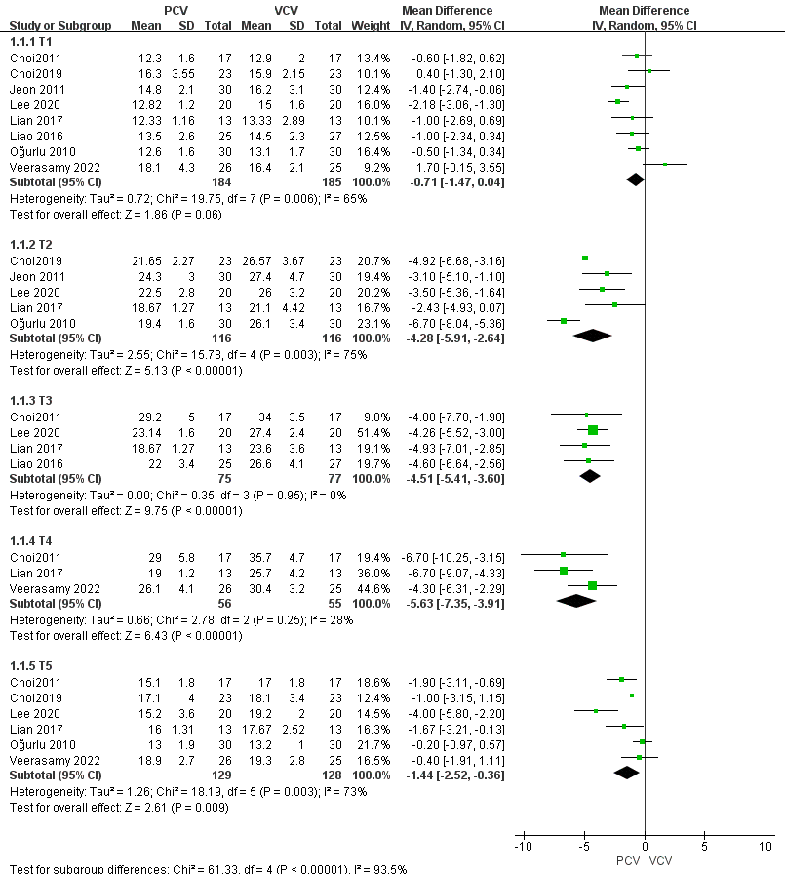

Figure 1. The Forest plots of Ppeak between PCV and VCV

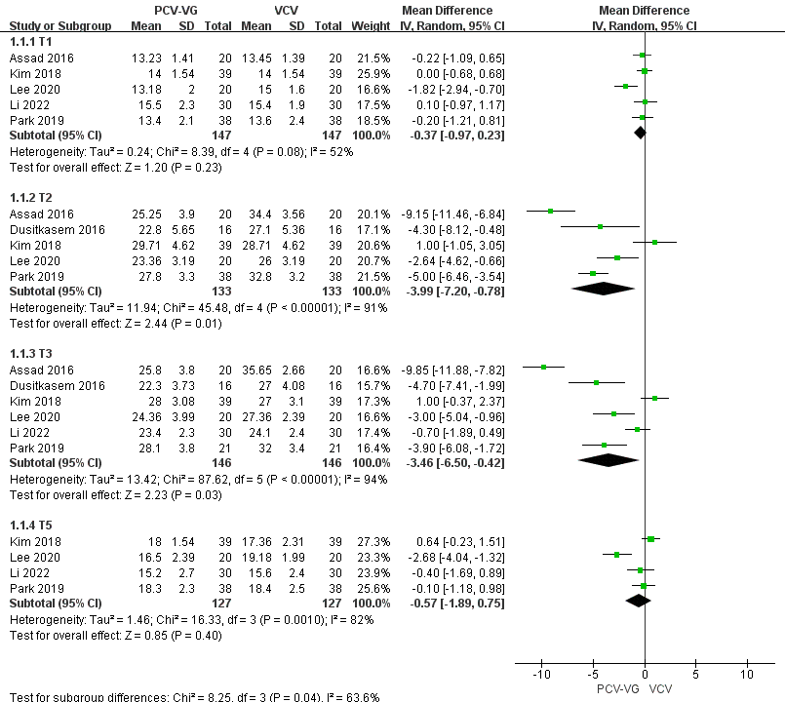

Figure 2. The Forest plots of Ppeak between PCV-VG and VCV

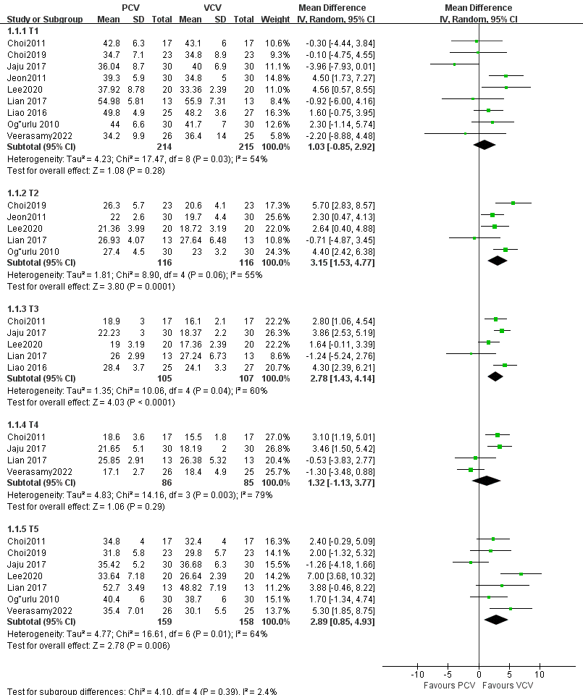

Figure 3. The Forest plots of Cydn between PCV and VCV

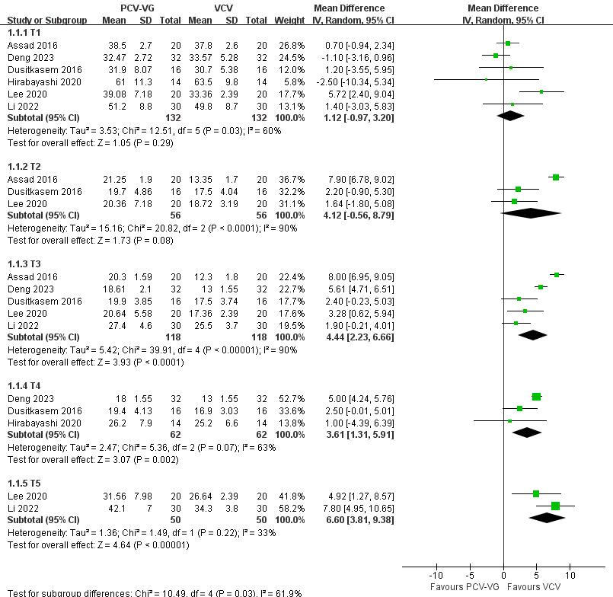

Figure 4. The Forest plots of Cydn between PCV-VG and VCV

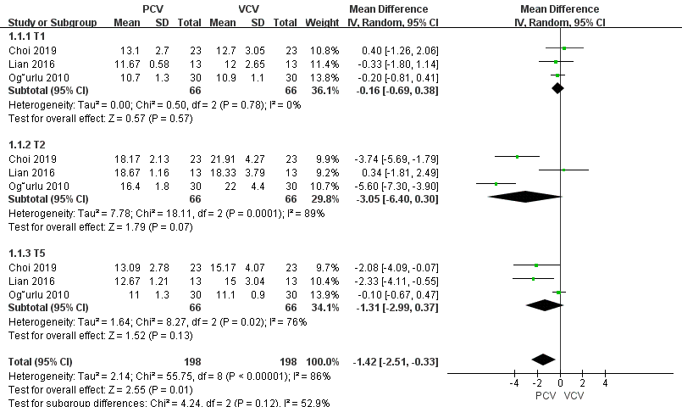

Figure 5. The Forest plots of Pplat between PCV and VCV

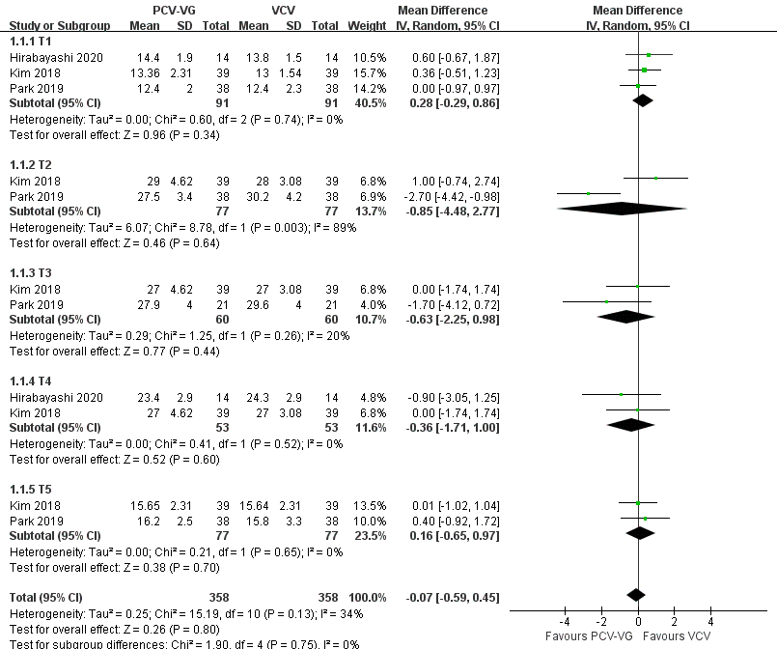

Figure 6. The Forest plots of Pplat between PCV-VG and VCV

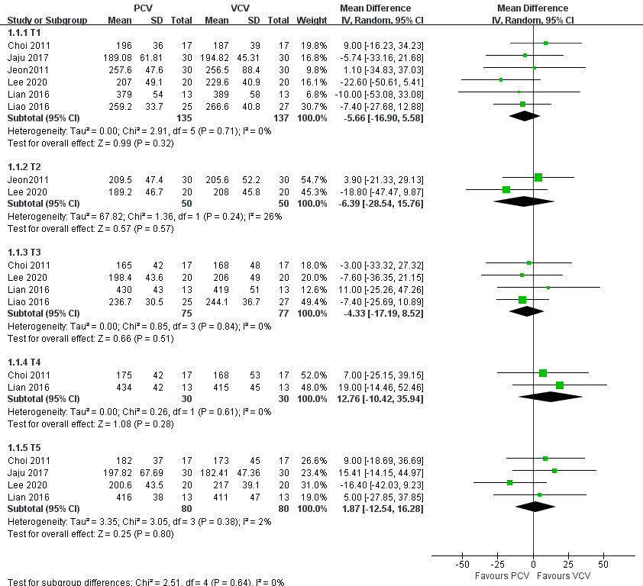

Figure 7. The Forest plots of PO₂ between PCV and VCV

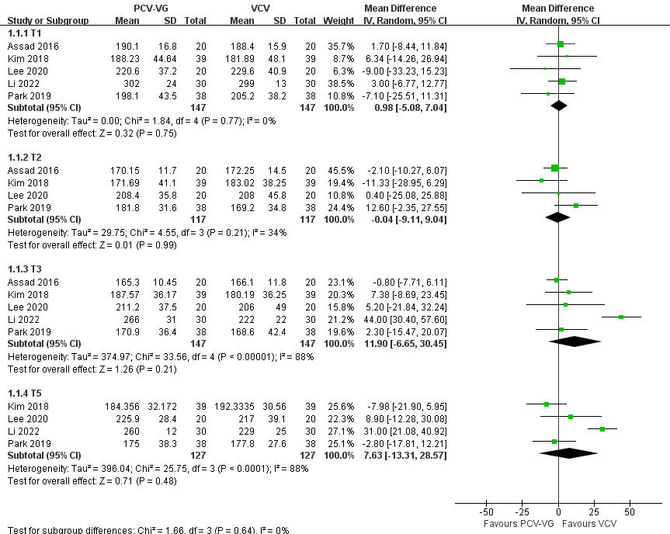

Figure 8. The Forest plots of PO₂ between PCV-VG and VCV

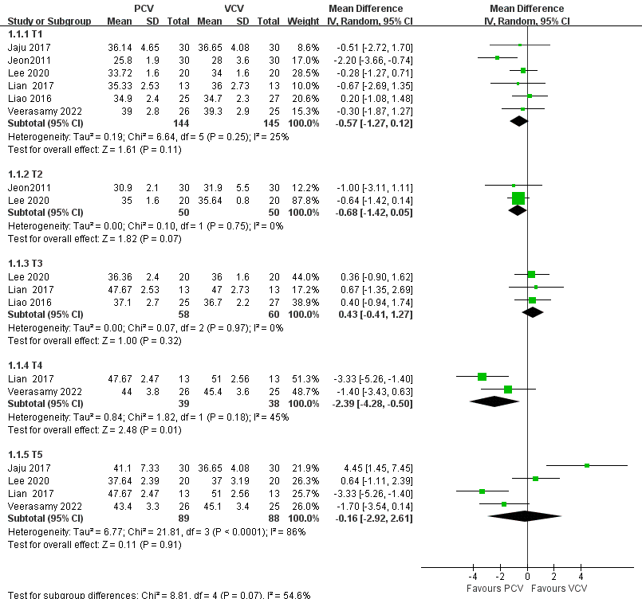

Figure 9. The Forest plots of PCO₂ between PCV and VCV

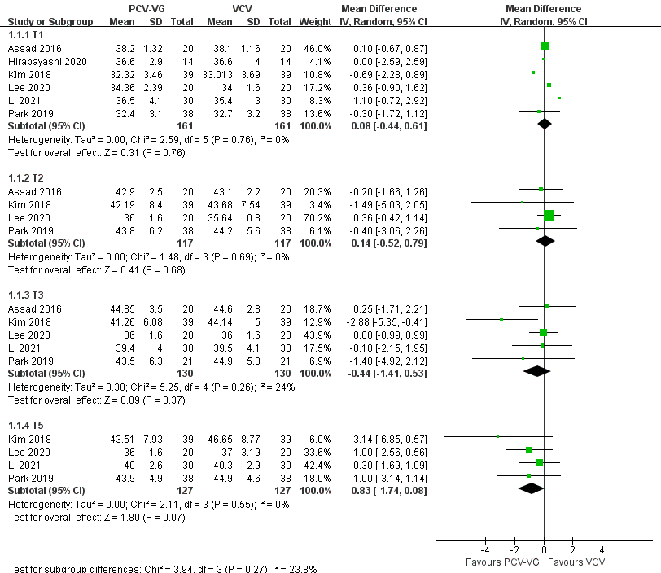

Figure 10. The Forest plots of PCO₂ between PCV-VG and VCV

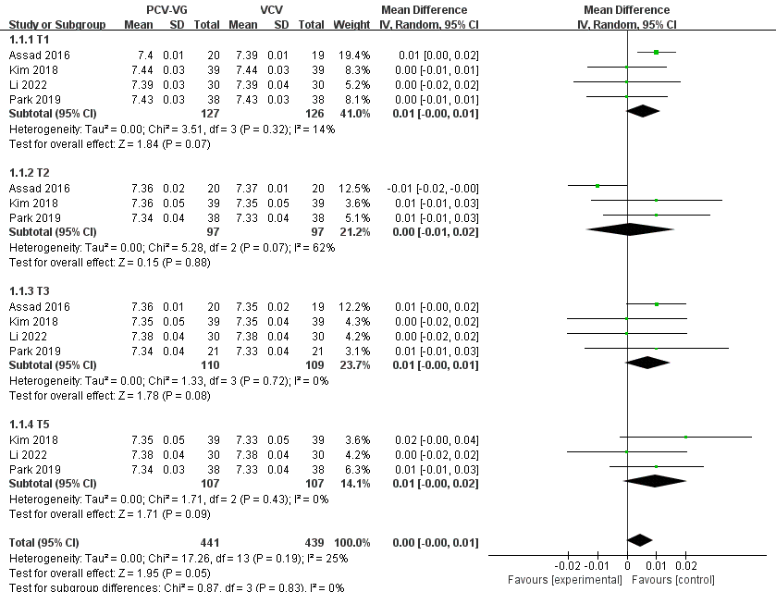

Figure 11. The Forest plots of pH between PCV-VG and VCV

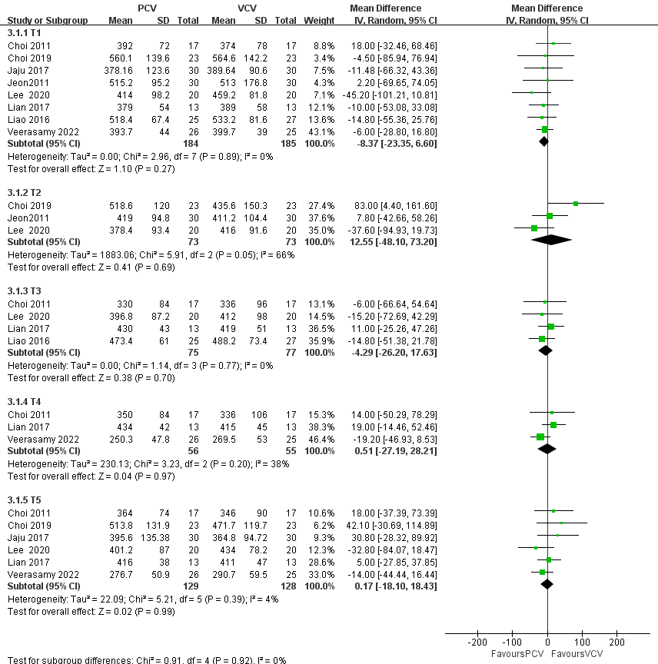

Figure 12. The Forest plots of Oxygenation index between PCV and VCV

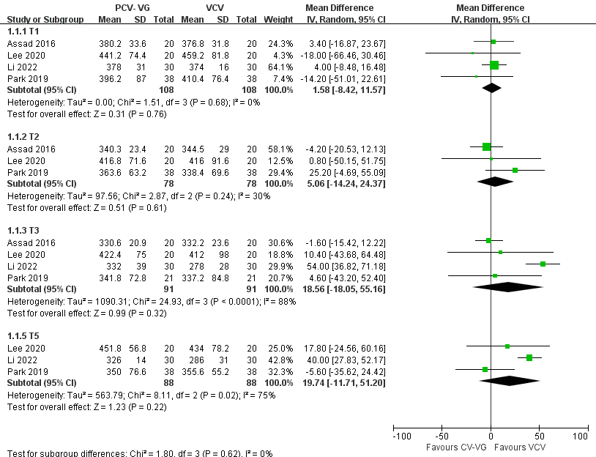

Figure 13. The Forest plots of Oxygenation index between PCV-VG and VCV

Appendix 3. Subgroup analysis

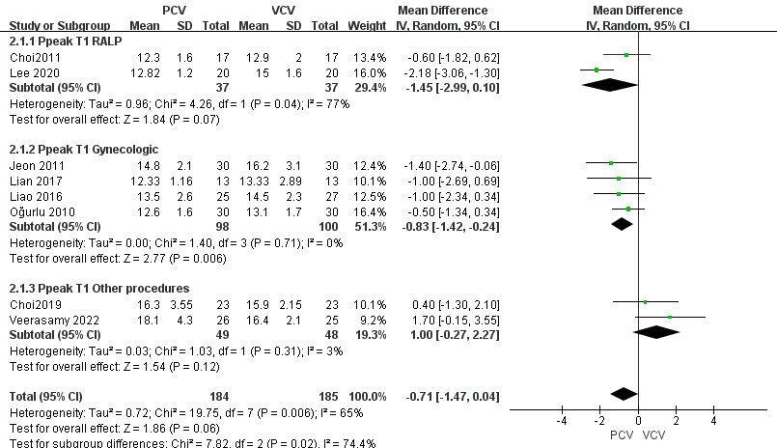

Figure 1. The subgroup analysis of Ppeak between PCV and VCV at T1

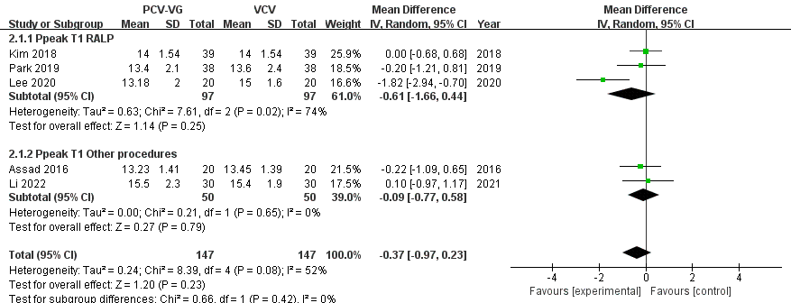

Figure 2. The subgroup analysis of Ppeak between PCV-VG and VCV at T1

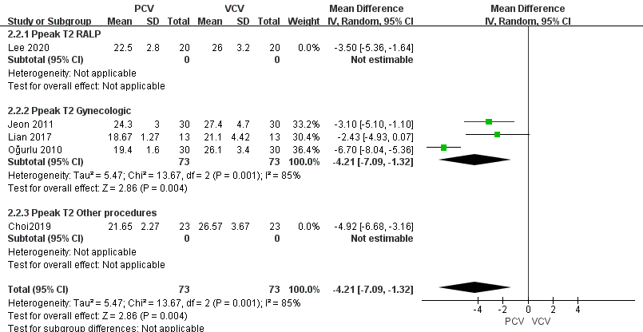

Figure 3. The subgroup analysis of Ppeak between PCV and VCV at T2

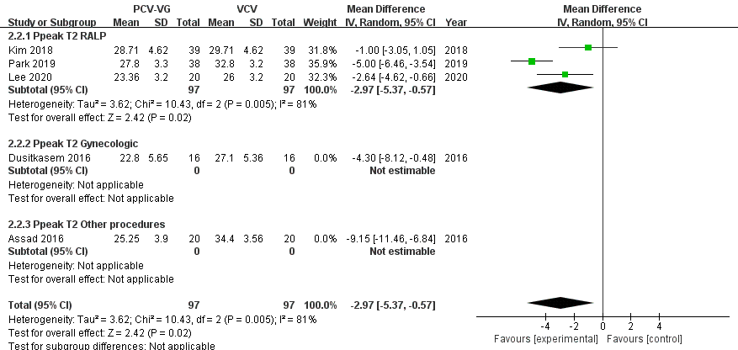

Figure 4. The subgroup analysis of Ppeak between PCV-VG and VCV at T2

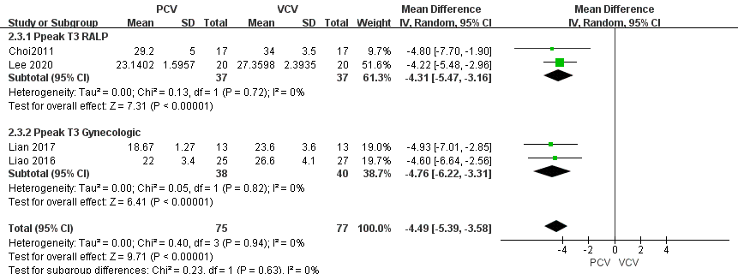

Figure 5. The subgroup analysis of Ppeak between PCV and VCV at T3

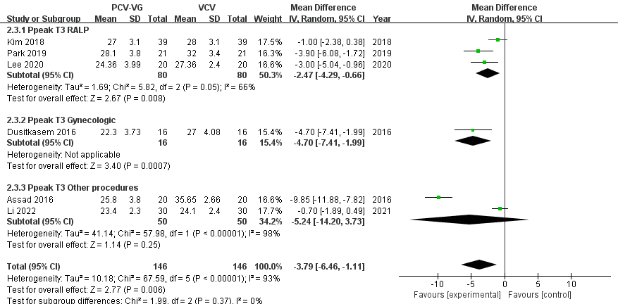

Figure 6. The subgroup analysis of Ppeak between PCV-VG and VCV at T3

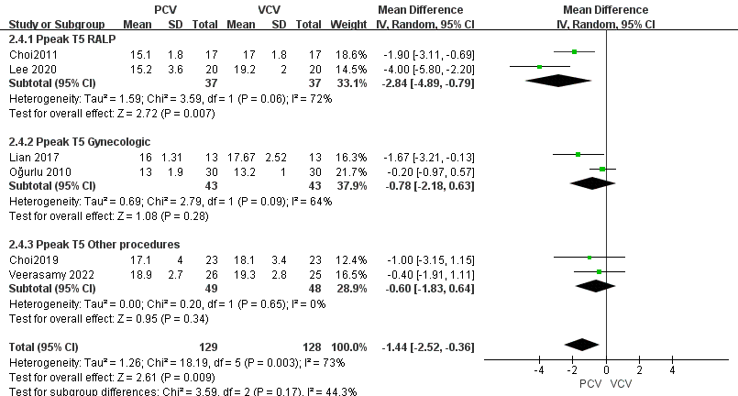

Figure 7. The subgroup analysis of Ppeak between PCV and VCV at T5

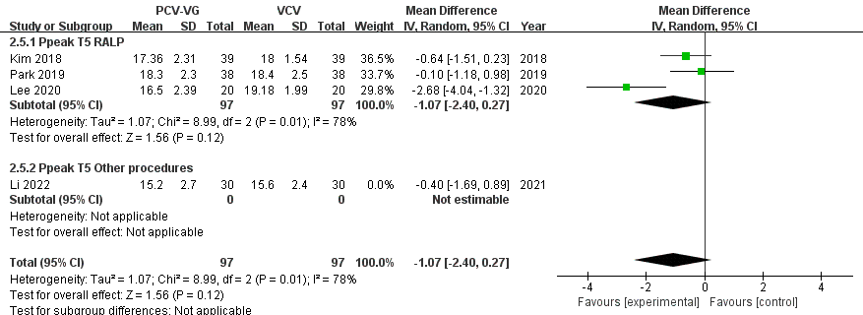

Figure 8.The subgroup analysis of Ppeak between PCV-VG and VCV at T5

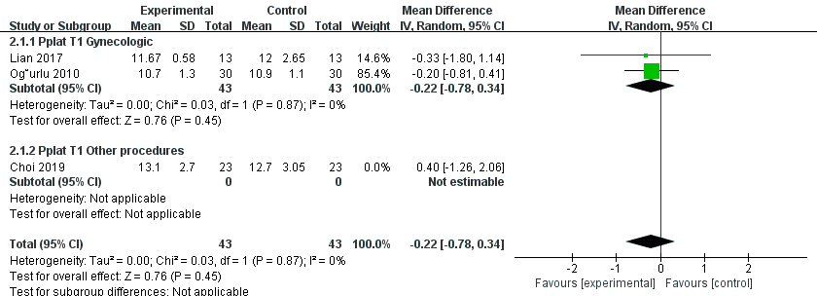

Figure 9. The subgroup analysis of Pplat between PCV and VCV at T1

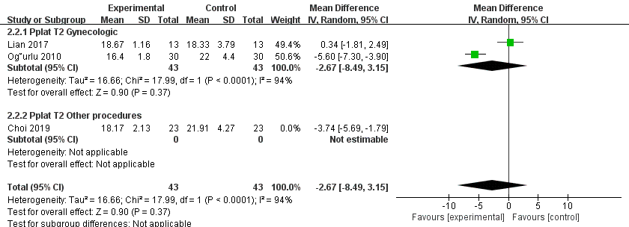

Figure 10. The subgroup analysis of Pplat between PCV and VCV at T2

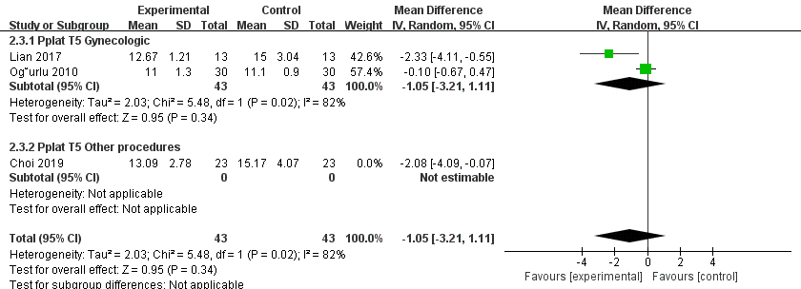

Figure 11. The subgroup analysis of Pplat between PCV and VCV at T5

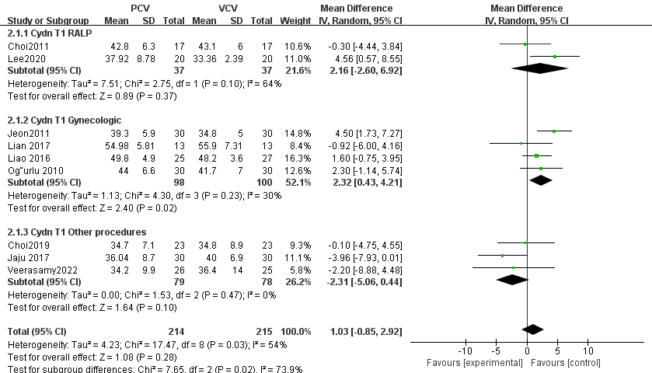

Figure 12. The subgroup analysis of Cydn between PCV and VCV at T1

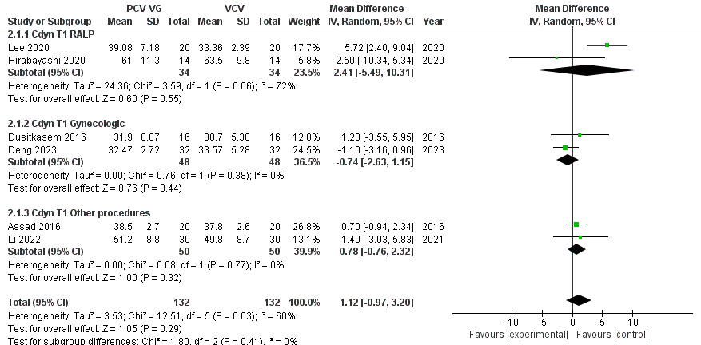

Figure 13. The subgroup analysis of Cydn between PCV-VG and VCV at T1

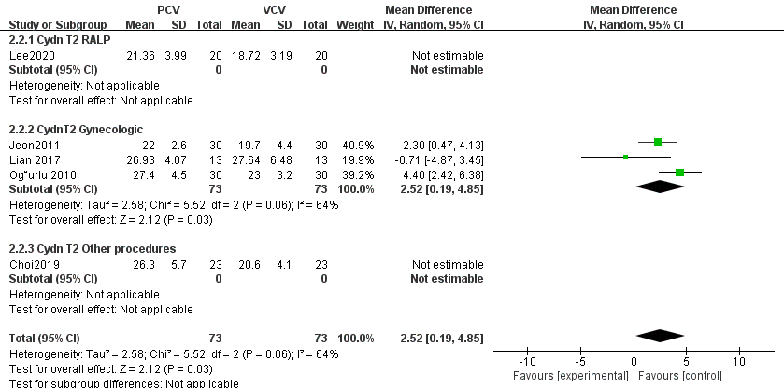

Figure 14. The Subgroup analysis of Cydn between PCV and VCV at T2

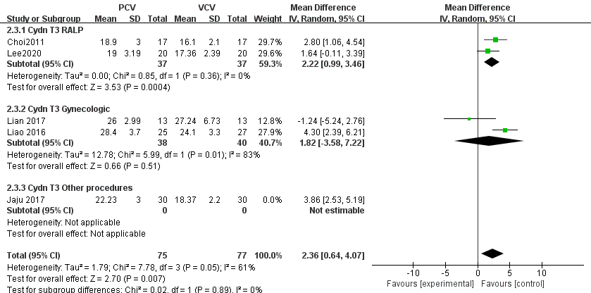

Figure 15. The subgroup analysis of Cydn between PCV and VCV at T3

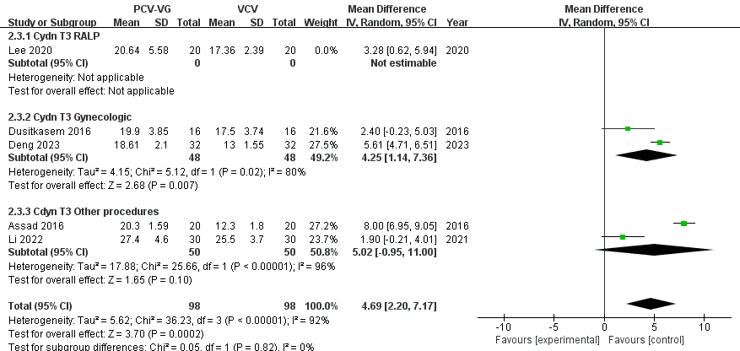

Figure 16. The subgroup analysis of Cydn between PCV-VG and VCV at T3

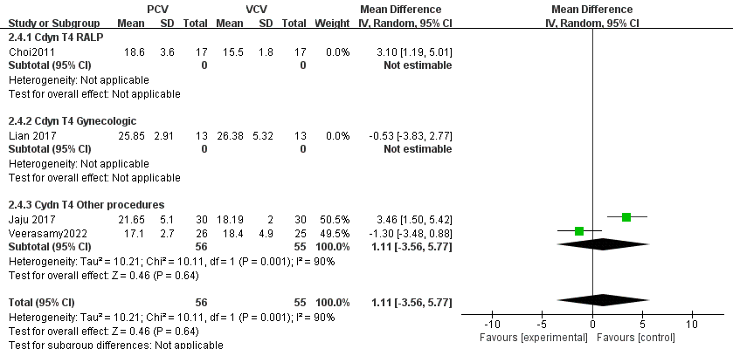

Figure 17. The subgroup analysis of Cydn between PCV and VCV at T4

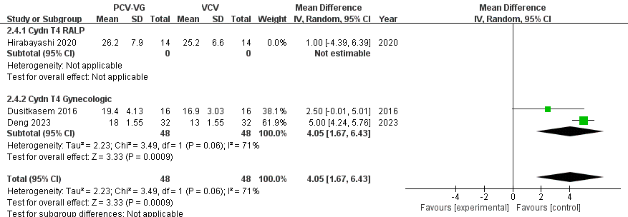

Figure 18. The subgroup analysis of Cydn between PCV-VG and VCV at T4

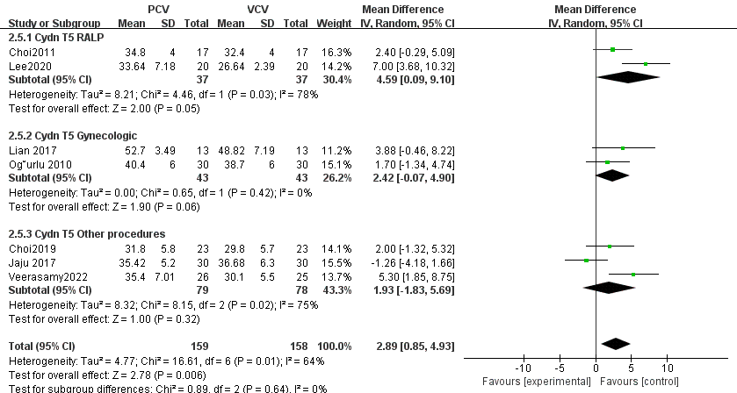

Figure 19. The subgroup analysis of Cydn between PCV and VCV at
Appendix 4. Meta-regression
Tabel 1. Meta-regression of respiratory variables and blood gas analysis between PCV vs
VCV and PCV-VG vs VCV
Outcomes | Coefficient | Std.Err. | t | p> |t|
Ppeak
T₁ | .1305248 | .2936067 | 0.44 | 0.665
T₂ | .2843556 | .5268519 | 0.54 | 0.604
T₃ | .1688158 | .6129858 | 0.28 | 0.790
T₄ | .4245419 | .5567705 | 0.76 | 0.525
T₅ | .4679699 | .3903588 | 1.20 | 0.270
Pplat
T₁ | .192781 | .2290777 | 0.84 | 0.447
T₂ | .6887294 | .7512918 | 0.92 | 0.427
T₃ | -.2094765 | .486558 | -0.43 | 0.741
T₄ | .0422681 | .4382096 | 0.10 | 0.939
T₅ | .5154348 | .2889873 | 1.78 | 0.172
Cydn
T₁ | .0248895 | .2435769 | 0.10 | 0.920
T₂ | .8991734 | .9905203 | 0.91 | 0.399
T₃ | 1.002075 | .8697113 | 1.15 | 0.283
T₄ | .9658645 | .8974955 | 1.08 | 0.331
T₅ | .6129049 | .3851359 | 1.59 | 0.156
PaO₂
T₁ | .1228831 | .1687321 | 0.73 | 0.485
T₂ | .1263287 | .2994694 | 0.42 | 0.695
T₃ | .4479929 | .372034 | 1.20 | 0.268
T₅ | .2999277 | .4539491 | 0.66 | 0.533
PaCO₂
T₁ | .2448198 | .1629619 | 1.50 | 0.164
T₂ | .2944017 | .2405578 | 1.22 | 0.288
T₃ | -.3785358 | .2187217 | -1.73 | 0.134
T₄ | .2994595 | .8245639 | 0.36 | 0.778
T₅ | -.13207 | .4304865 | -0.31 | 0.769
PaO₂/FiO₂
T₁ | .0685012 | .1707575 | 0.40 | 0.697
T₂ | .0086928 | .3266435 | 0.03 | 0.980
T₃ | .4974883 | .4152259 | 1.20 | 0.276
T₅ | .5384308 | .403363 | 1.33 | 0.224

T1: After anaesthesia induction under supine position
T2: 15-40 minutes post-pneumoperitoneum and Trendelenburg position
T3: 60 minutes post-pneumoperitoneum and Trendelenburg position
T4:120 minutes post-pneumoperitoneum and Trendelenburg position
T5: After CO₂ desufflation and resuming the supine position

Appendix 5. Sensitivity analysis
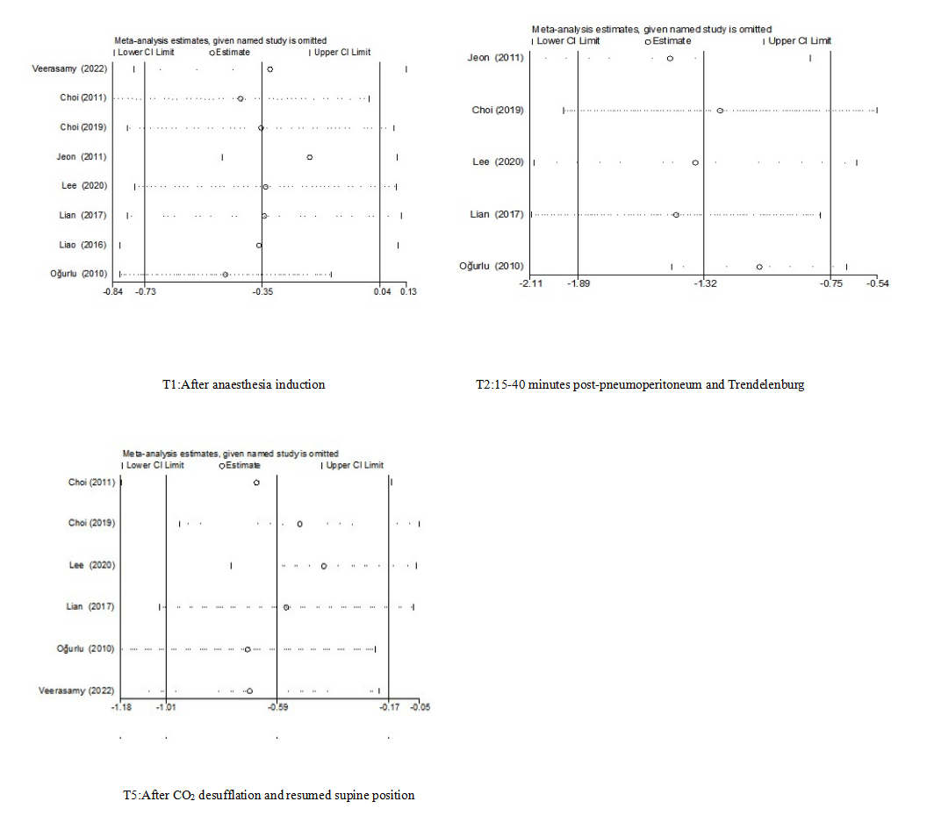
Figure 1. The sensitivity analysis of Ppeak at T1-2 and T5 of Pressure-controlled ventilation and Volume-controlled ventilation

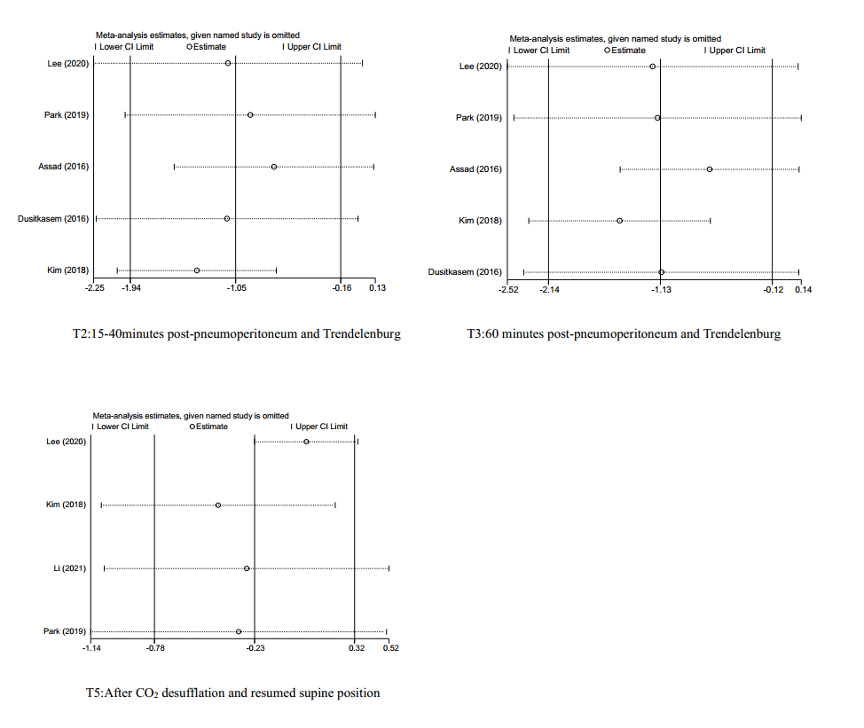
Figure 2. The sensitivity analysis of Ppeak at T2-3 and T5 of Pressure-controlled ventilation volume guaranteed and Volume-controlled ventilation

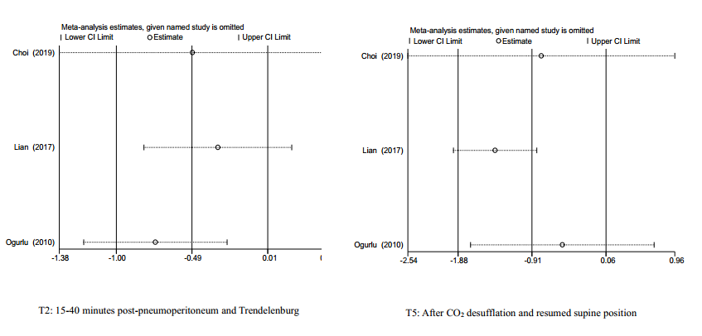

Figure 3. The sensitivity analysis of Pplat at T2 and T5 of Pressure-controlled ventilation and Volume-controlled ventilation
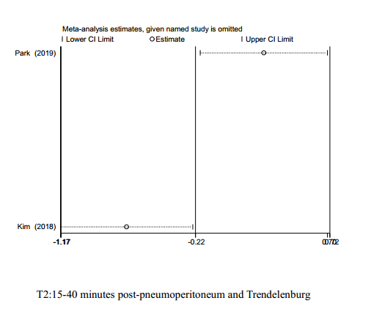
Figure 4. The sensitivity analysis of Pplat at T2 of Pressure-controlled ventilation volume guaranteed and Volume-controlled ventilation

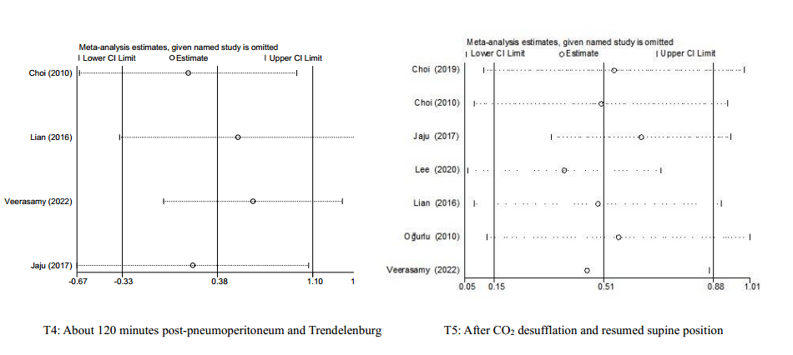
Figure 5. The sensitivity analysis of Cydn at T4 and T5 of Pressure-controlled ventilation and Volume-controlled ventilation

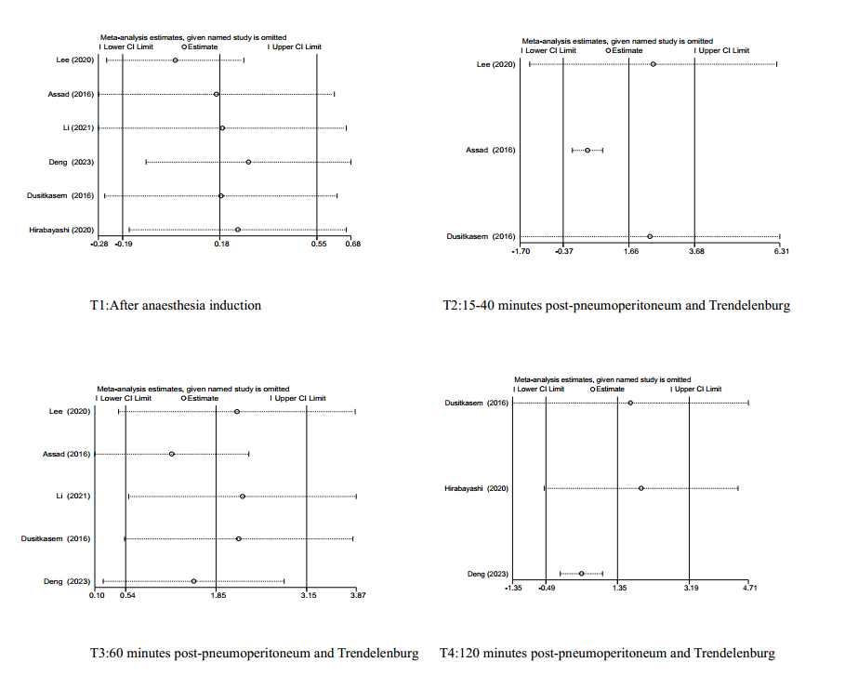
Figure 6. The sensitivity analysis of Cydn at T1-3 and T4 of Pressure-controlled ventilation volume guaranteed and Volume-controlled ventilation
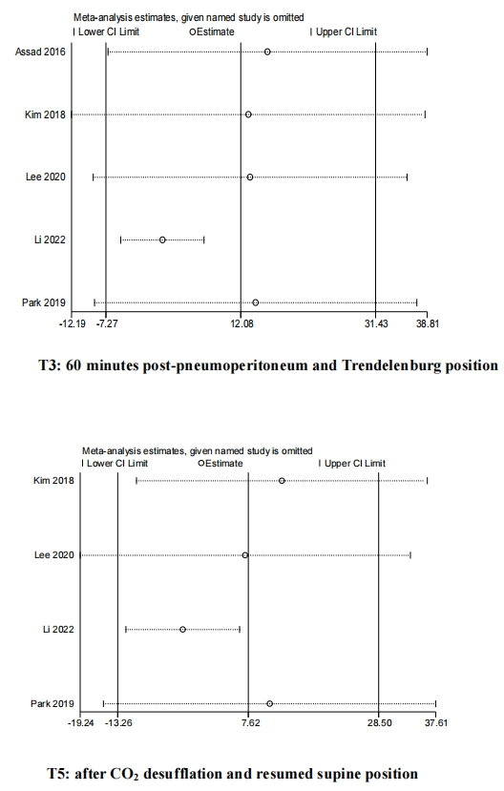
Figure 7. The sensitivity analysis of PO₂ at T3 and T5 of Pressure-controlled ventilation volume guaranteed and Volume-controlled ventilation
Figure 8. The sensitivity analysis of PCO₂ at T5 of Pressure-controlled ventilation and Volume-controlled ventilation
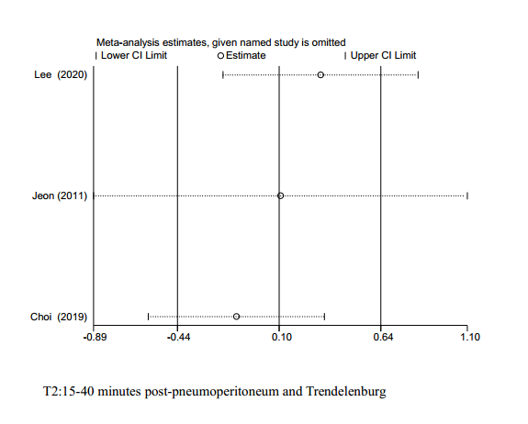
Figure 9. The sensitivity analysis of Oxygenation index at T2 of Pressure-controlled ventilation and Volume-controlled ventilation

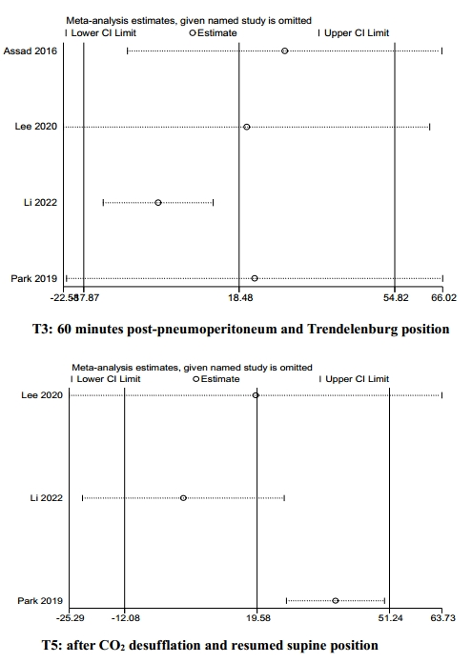
Figure 10. The sensitivity analysis of Oxygenation index at T3 and T5 of Pressure-controlled ventilation volume guaranteed and Volume-controlled ventilation

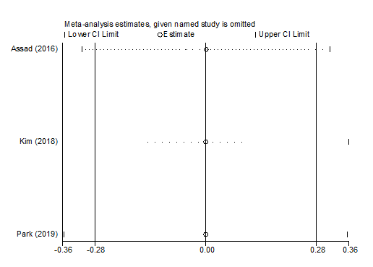
Figure 11. The sensitivity analysis of pH at T2 of Pressure-controlled ventilation volume guaranteed and Volume-controlled ventilation

