Appendix 1 - Supplementary forest & funnel plots for each outcome measure

Change in preoperative anxiety outcome
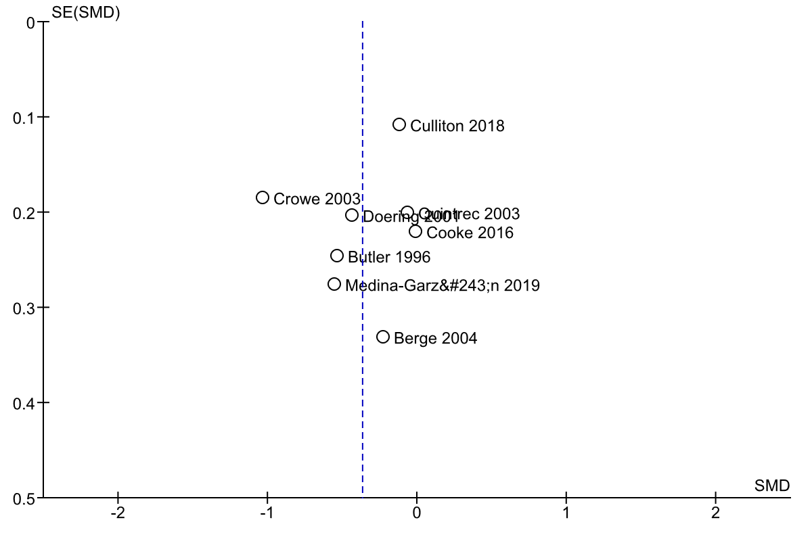
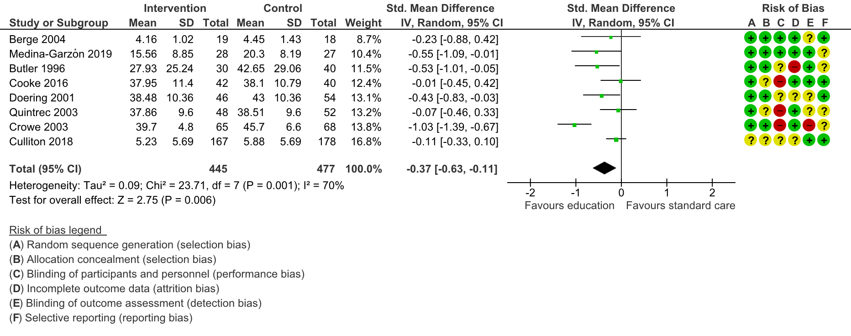
Figure 8 – Anxiety outcome funnel plot
Figure 7 – Overall change in patient reported anxiety following educational intervention intervention
Change in patient knowledge score outcome
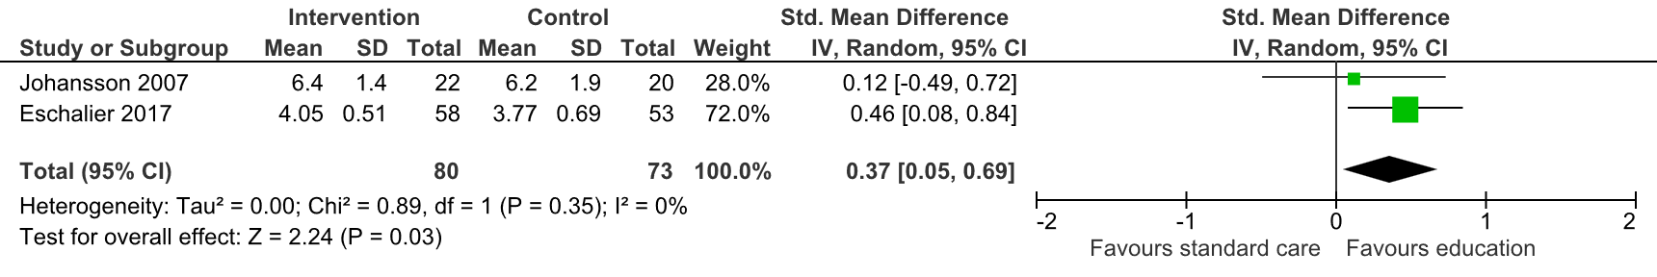
Change in patient knowledge score outcome
Figure 9 – Change in patient knowledge score following educational intervention
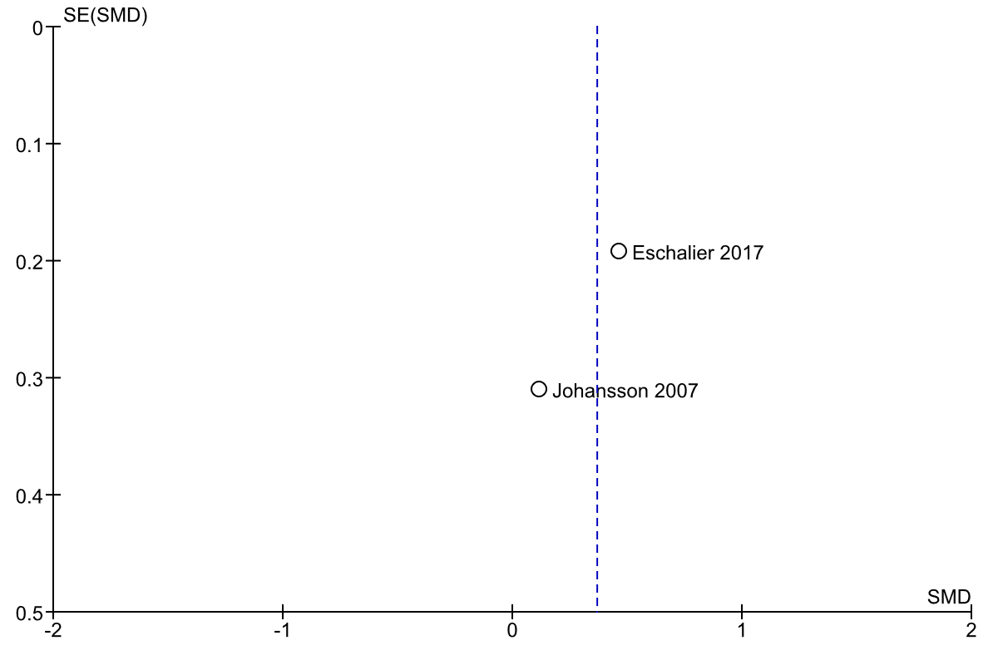
Figure 10 – Knowledge outcome funnel plot

Change in patient reported pain outcome
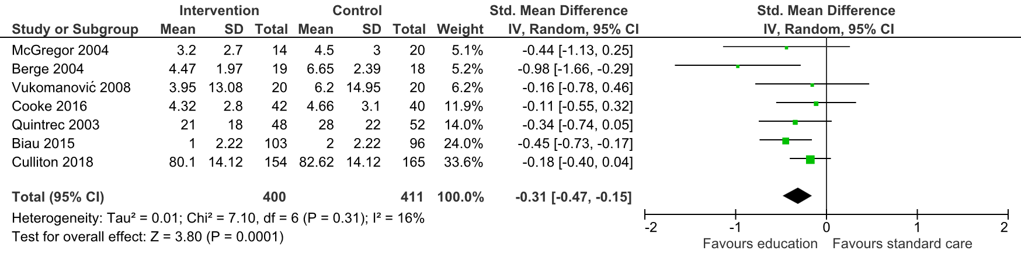
Figure 11 – Change in patient reported pain score following educational intervention

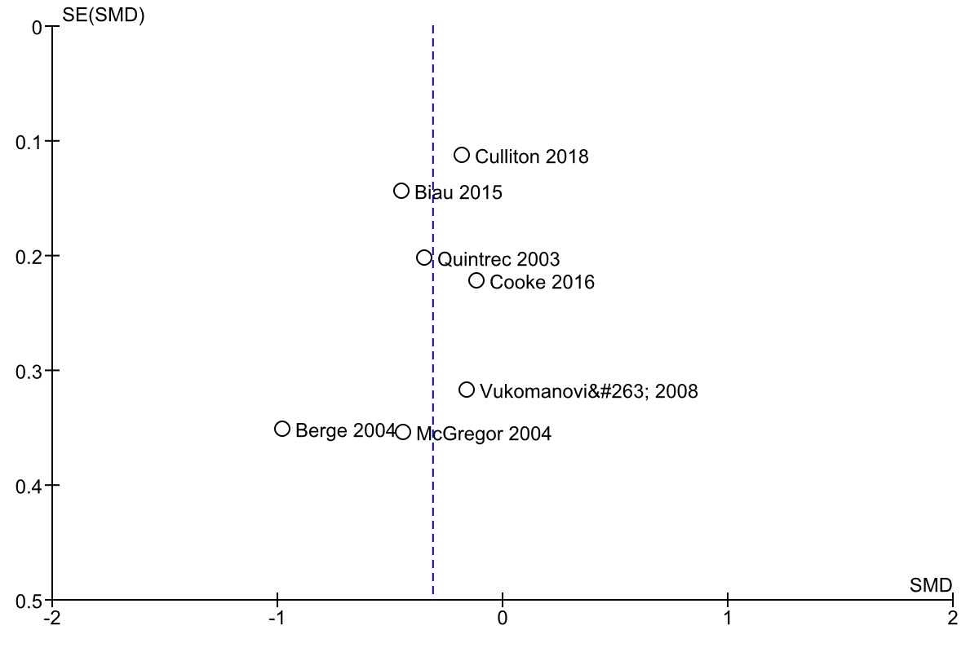
Figure 12 – Pain score outcome funnel plot

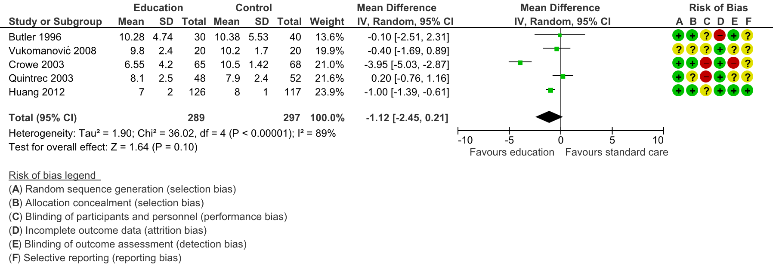
Change in time-to-discharge outcome
Figure 13 – Change in time to discharge following educational intervention

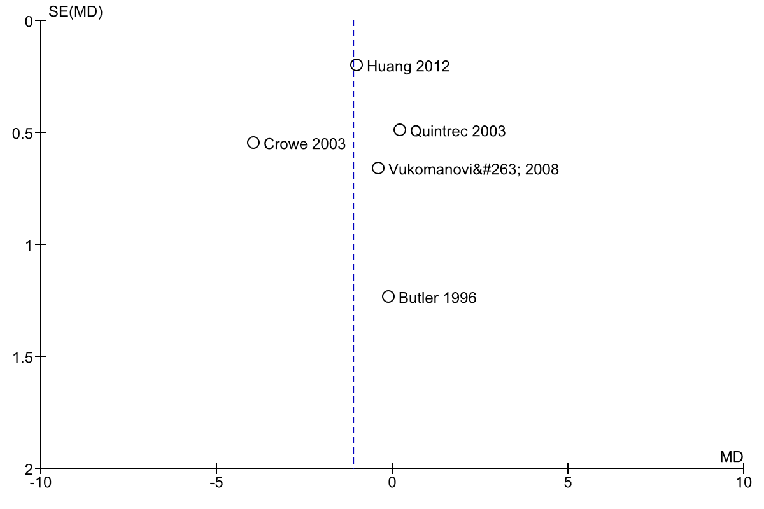
Figure 14 – Time-to-discharge funnel plot

Change in patient reported quality of life score outcome
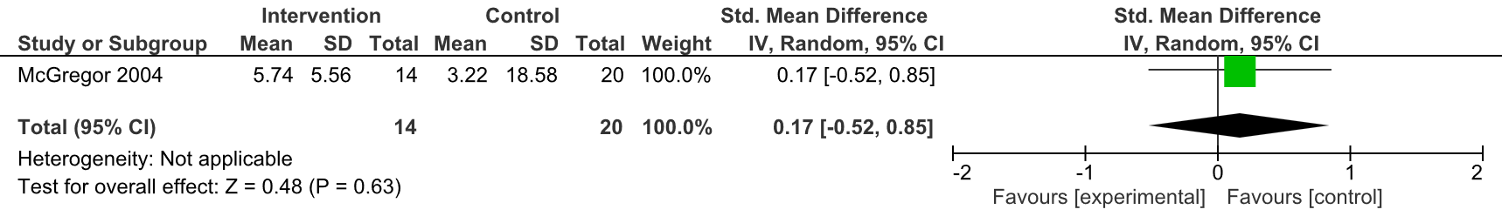
Figure 15 – Change in patient quality of life score following educational intervention

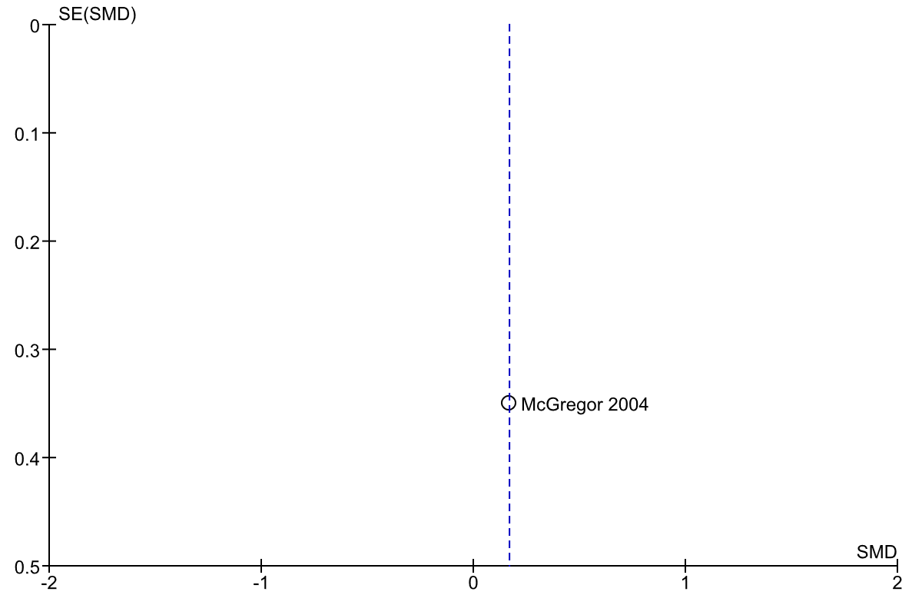
Figure 16 – Quality of life outcome funnel plot

Change in complication rates outcome
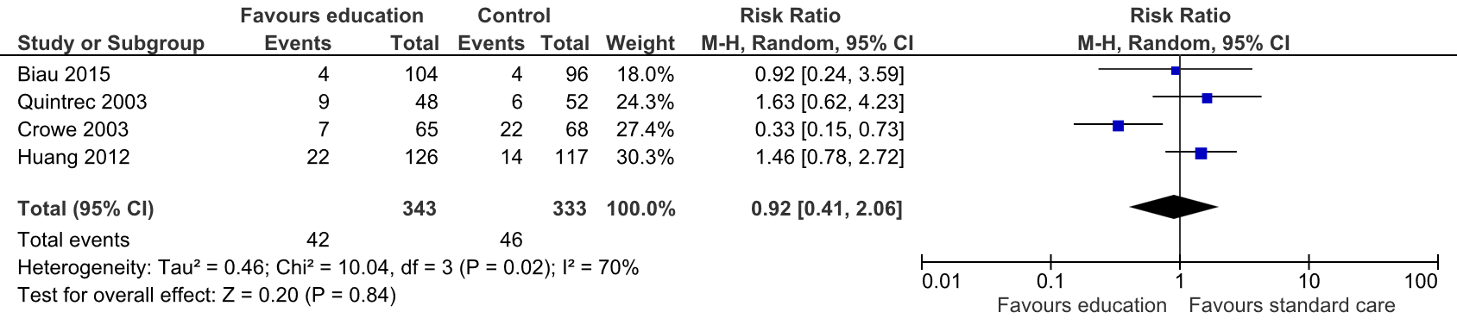
Figure 17 – Change in surgical complication rate following educational intervention

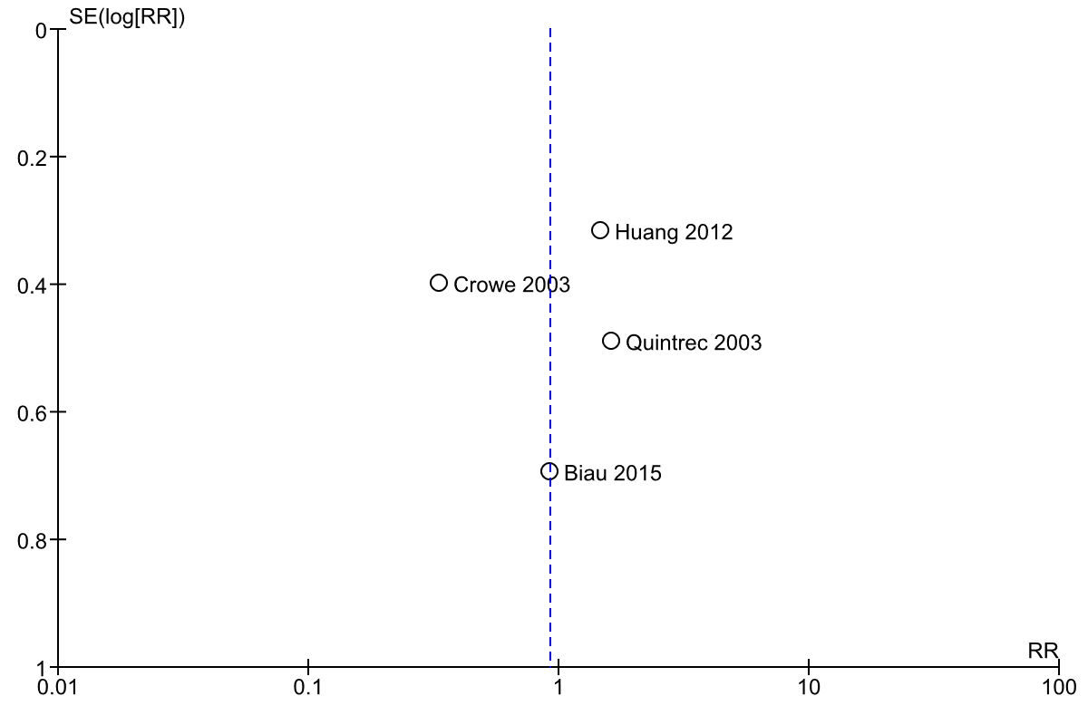
Figure 18 – Complication rate funnel plot

