Appendix IV
Location in Manuscript
Section | Page #
Title | 2
Abstract | 2
Introduction | 4 - 5
Research Aim | 5
Study Design | 5
Methodological Rigour  Authors’ information | 9  29
Study Design | 6
Sampling Strategy | 6
Ethics and Standards | 9
Data Collection | 7
Data Collection  Appendices I / II / III | 7
Participants (Results)  Appendix V | 10-11
Data Analysis | 8
Data Analysis | 8
Methodological Rigour | 9
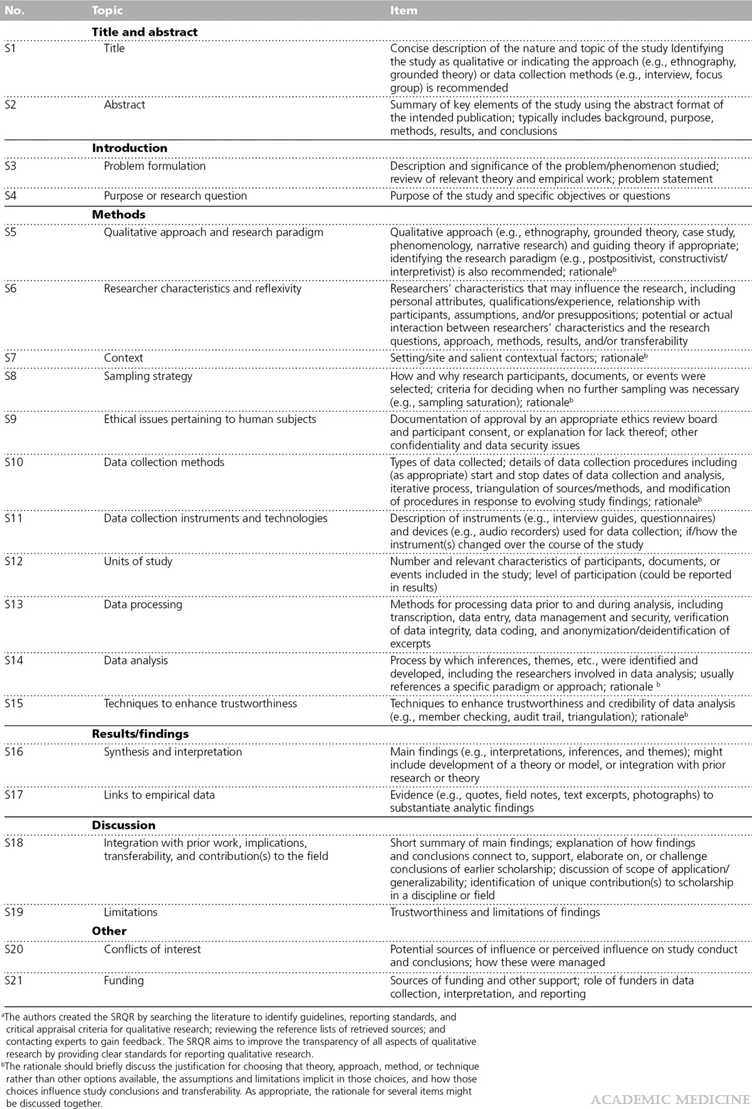

Location in Manuscript
Section | Page
Factors affecting access to, acceptance of, and adherence to cancer prehabilitation (Results) | 12-14
Additional file 1 (Case study table of results from coding of qualitative data)
Discussion | 23-26
Strengths and Limitations | 26-27
Competing interests (Declarations) | 28
Funding (Declarations) | 29

Standards for Reporting Qualitative Research: A Synthesis of Recommendations
O’Brien, Bridget C.; Harris, Ilene B.; Beckman, Thomas J.; Reed, Darcy A.; Cook, David A.
Academic Medicine 89(9):1245-1251, September 2014.
DOI: 10.1097/ACM.0000000000000388

