Appendix Section 2 – Annual boxplots for secondary and supplementary outcomes

Appendix Figure 2.1 – Annual TWA MAP values at < 60 mm Hg and < 55 mm Hg thresholds
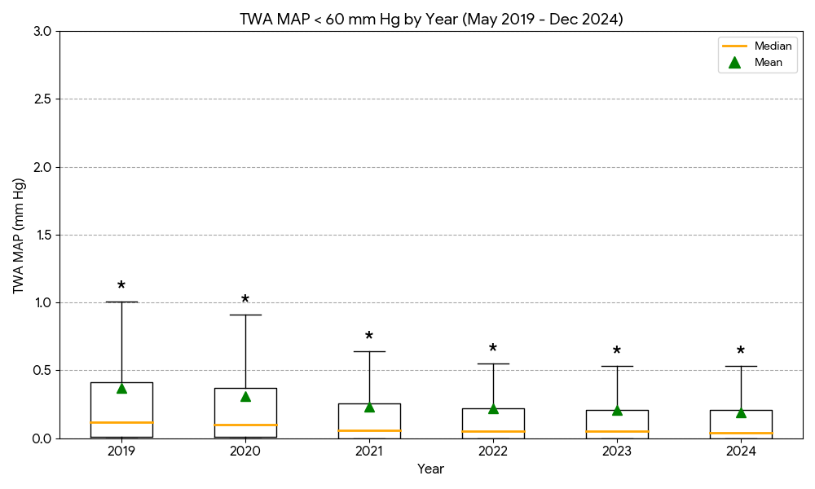
A¹

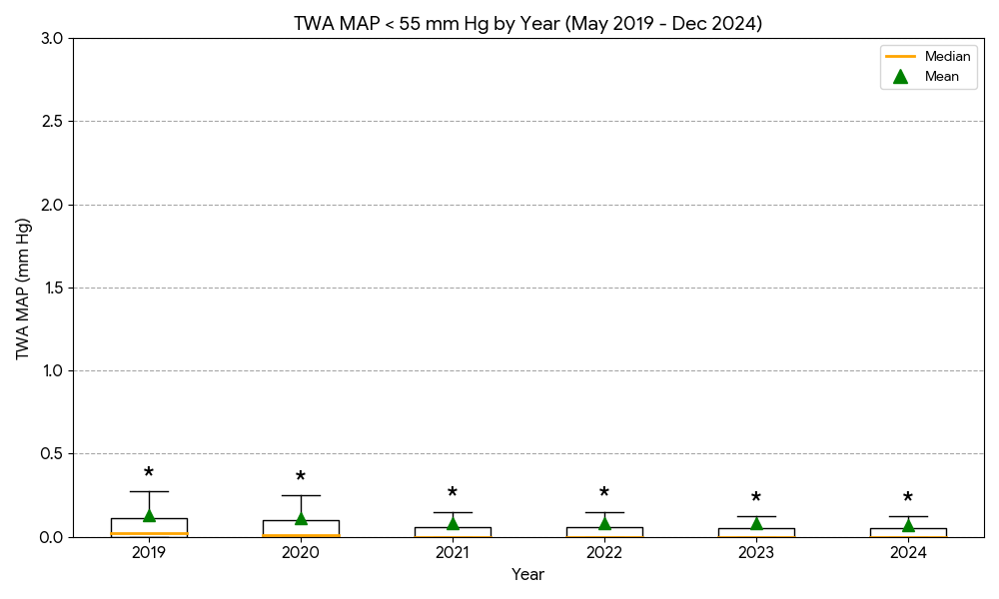

B¹

¹There was a statistically significant difference in the distribution of TWA MAP values between years across all thresholds (Kruskal-Wallis; A: H = 87.2, p < 0.001, B: H = 95.8, p < 0.001).

* indicates that extreme outliers beyond the upper whisker range (3rd quartile plus 1.5 times the interquartile range) and we have detailed the values here;

TWA MAP < 60 mm Hg: 2019 (1.01-7.12, n=61 (9.8%)), 2020 (0.91-6.24, n=65 (9.1%)), 2021 (0.64-8.15, n=97 (9.8%)), 2022 (0.55-9.16, n=133 (11.9%)), 2023 (0.53-6.14, n=123 (10.4%)), and 2024 (0.53-5.76, n=117 (9.3%)).

TWA MAP < 55 mm Hg: 2019 (0.28-4.82, n=81 (13.0%)), 2020 (0.25-3.98, n=84 (11.8%)), 2021 (0.15-3.74, n=140 (14.2%)), 2022 (0.15-5.58, n=152 (13.6%)), 2023 (0.12-4.36, n=162 (13.7%)), and 2024 (0.12-3.7, n=164 (13.0%)).

Appendix Figure 2.2 – Annual frequency of hypotension episodes across all MAP thresholds

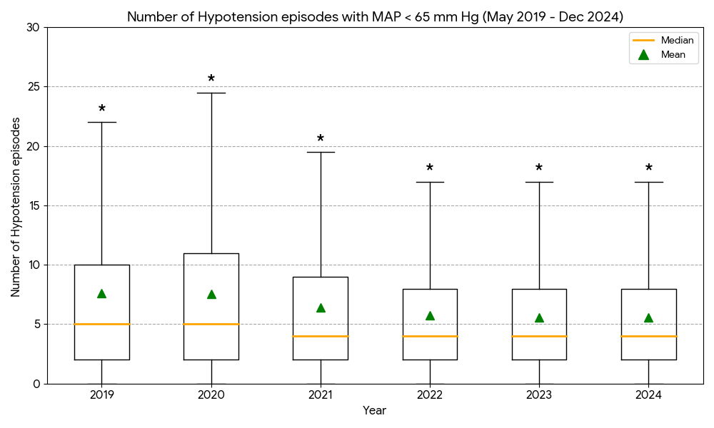

A²

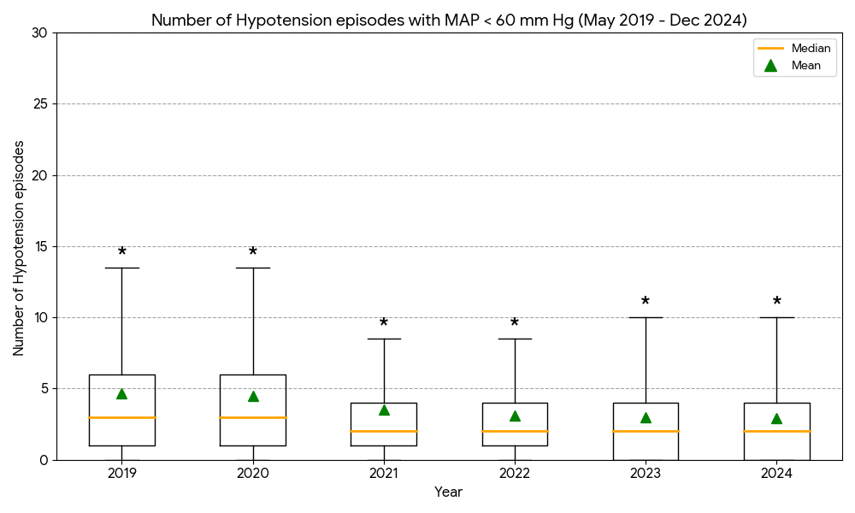

B²

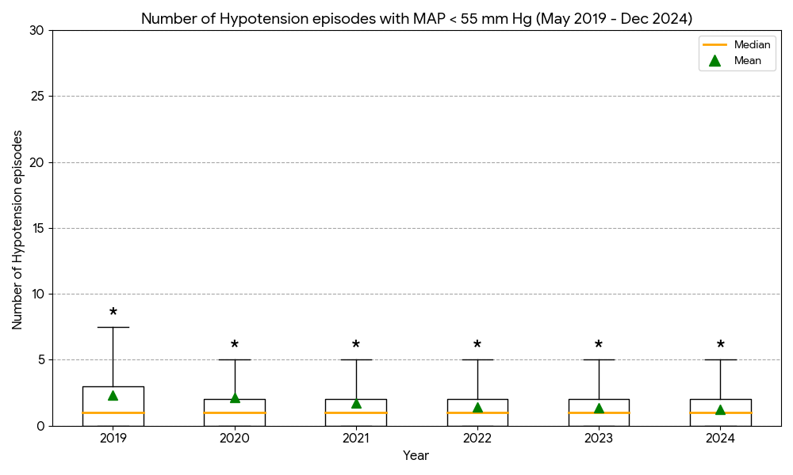

C²

²Annual distributions differed significantly for all thresholds (Kruskal-Wallis, A: H = 72.3, p < 0.001, B: H = 76.0, p < 0.001, C: H = 62.0, p < 0.001)

* indicates that extreme outliers beyond the upper whisker range (3rd quartile plus 1.5 times the interquartile range) and we have detailed the values here;

MAP < 65 mm Hg: 2019 (22-63, n=35 (5.6%)), 2020 (24.5-51, n=31 (4.4%)), 2021 (19.5-52, n=45 (4.6%)), 2022 (17-48, n=59 (5.3%)), 2023 (17-38, n=59 (5.0%)), and 2024 (17-49, n=68 (5.4%)).

MAP < 60 mm Hg: 2019 (13.5-55, n=37 (5.9%)), 2020 (13.5-60, n=43 (6.0%)), 2021 (8.5-45, n=98 (9.9%)), 2022 (8.5-38, n=84 (7.5%)), 2023 (10-29, n=71 (6.0%)), and 2024 (10-35, n=67 (5.3%)).

MAP < 55 mm Hg: 2019 (7.5-39, n=37 (5.9%)), 2020 (5-54, n=89 (12.5%)), 2021 (5-38, n=93 (9.4%)), 2022 (5-32, n=84 (7.5%)), 2023 (5-19, n=80 (6.8%)), and 2024 (5-25, n=70 (5.6%)).

Appendix Figure 2.3 – Annual cumulative duration of hypotension across all MAP thresholds

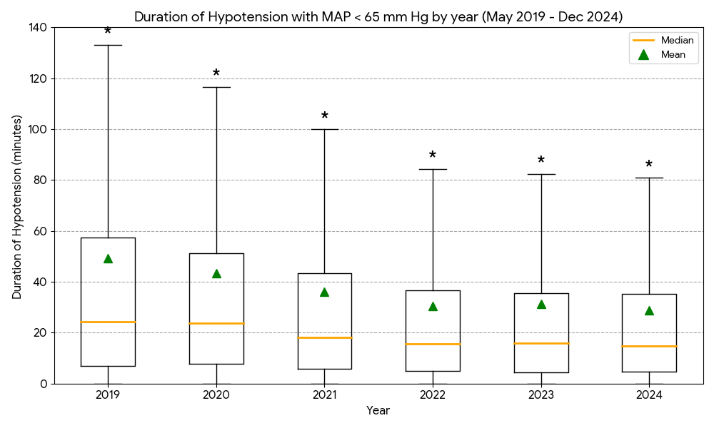
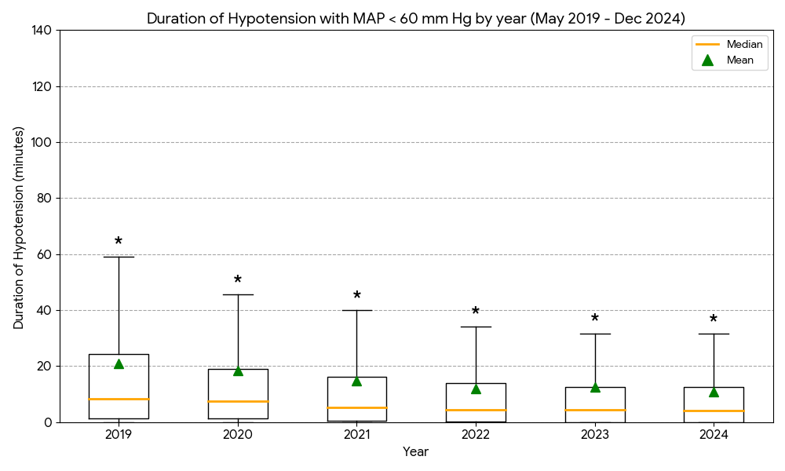
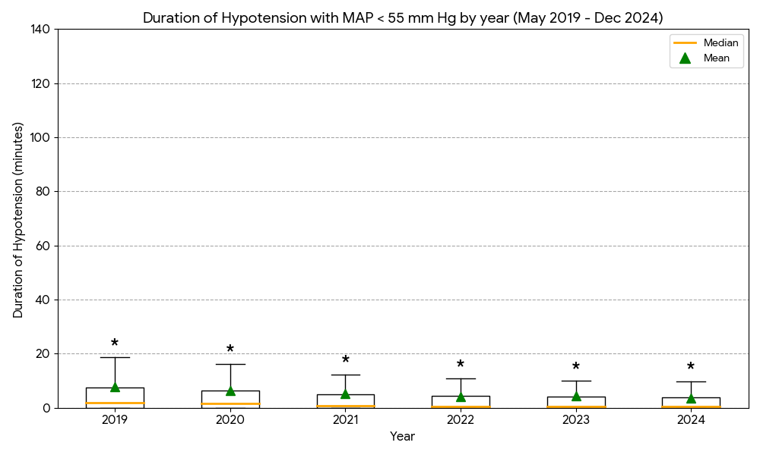
A³
B³
C³

³Significant inter-year variation was observed in the total duration of hypotension (Kruskal-Wallis; A: H = 71.0, p < 0.001, B: H = 87.6, p < 0.001, C: H = 77.9, p < 0.001)

* indicates the extreme outliers beyond the upper whisker range (3rd quartile plus 1.5 times the interquartile range) and we have detailed the values here;

MAP < 65 mm Hg: 2019 (133.11-864.99, n=62 (9.9%)), 2020 (116.56-489.68, n=62 (8.7%)), 2021 (99.98-445.72, n=70 (7.1%)), 2022 (84.34-688.99, n=82 (7.4%)), 2023 (82.44-1360.44, n=95 (8.1%)), and 2024 (80.94-364.43, n=104 (8.3%)).

MAP < 60 mm Hg: 2019 (59.14-310.63, n=62 (9.9%)), 2020 (45.53-303.52, n=78 (11.0%)), 2021 (39.92-296.15, n=89 (9.0%)), 2022 (34.24-334.48, n=90 (8.1%)), 2023 (31.68-1009.39, n=97 (8.2%)), and 2024 (31.48-206.91, n=114 (9.1%)).

MAP < 55 mm Hg: 2019 (18.7-137.89, n=60 (9.6%)), 2020 (16.25-180.67, n=67 (9.4%)), 2021 (12.38-168.44, n=104 (10.6%)), 2022 (10.82-236.62, n=117 (10.5%)), 2023 (10.05-590.25, n=119 (10.1%)), and 2024 (9.83-117.62, n=120 (9.5%)).

Appendix Figure 2.4: Annual incidence of patients experiencing $≥$ 1 hypotensive episode

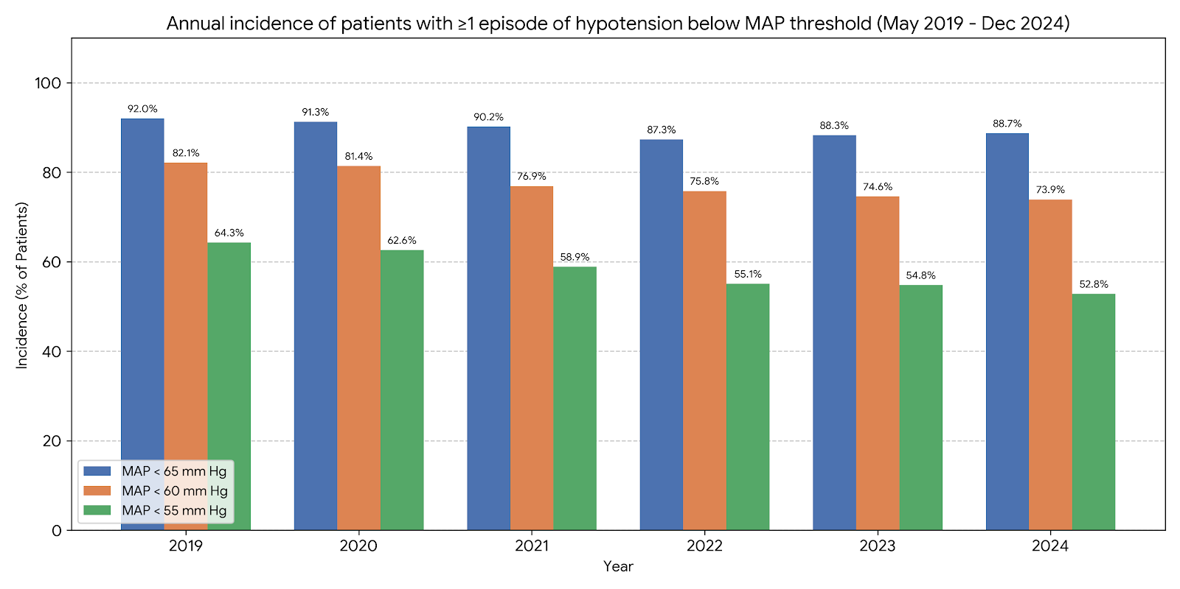

¹

There was a statistically significant association between year and the incidence of hypotension across all thresholds (Pearson’s Chi-squared test, MAP < 65 mm Hg: X² = 14.6, p = 0.012, MAP < 60 mm Hg: X² = 27.8, p < 0.001, MAP < 55 mm Hg: X² = 37.2, p < 0.001).

