Appendix Section 5 – Sensitivity analysis for arterial line data

Characteristic | Total  (n=4845) | 2019  (n=507) | 2020  (n=573) | 2021  (n=787) | 2022  (n=928) | 2023  (n=992) | 2024  (n=1058) | Test statistic | P-value
Age, years | 63.6 (14.5) | 63.6 (14.4) | 64.0 (14.0) | 62.8 (15.3) | 63.9 (14.4) | 63.9 (14.3) | 63.5 (14.4) | 0.76 | 0.58
Male sex | 2395 (49.4%) | 266 (52.5%) | 269 (46.9%) | 396 (50.3%) | 445 (48.0%) | 479 (48.3%) | 540 (51.0%) | 5.96 | 0.31
BMI, kg m⁻² | 28.5 (6.9) | 28.9 (6.8) | 28.3 (6.5) | 28.5 (6.9) | 28.4 (6.9) | 28.3 (7.1) | 28.7 (7.0) | 0.94 | 0.45
ASA physical status |  |  |  |  |  |  |  | 24.23 | 0.06
1 | 30 (0.6%) | 5 (1.0%) | 7 (1.2%) | 6 (0.8%) | 5 (0.5%) | 3 (0.3%) | 4 (0.4%)
2 | 1303 (26.9%) | 139 (27.4%) | 165 (28.8%) | 210 (26.7%) | 264 (28.4%) | 278 (28.0%) | 247 (23.3%)
3 | 3275 (67.6%) | 333 (65.7%) | 374 (65.3%) | 527 (67.0%) | 611 (65.8%) | 677 (68.2%) | 753 (71.2%)
4 | 237 (4.9%) | 30 (5.9%) | 27 (4.7%) | 44 (5.6%) | 48 (5.2%) | 34 (3.4%) | 54 (5.1%)
Diabetes mellitus | 968 (20%) | 118 (23.3%) | 95 (16.6%) | 156 (19.8%) | 173 (18.6%) | 206 (20.8%) | 220 (20.8%) | 9.46 | 0.09
Composite of CVD* | 646 (13.3%) | 80 (15.8%) | 64 (11.2%) | 96 (12.2%) | 123 (13.3%) | 129 (13.0%) | 154 (14.6%) | 7.29 | 0.20
Preoperative Systolic BP, mmHg | 137 (19) | 134 (17) | 140 (19) | 138 (19) | 137 (19) | 136 (19) | 135 (18) | 9.23 | <0.001
Preoperative Creatinine, µmol L⁻¹ | 78 (29) | 79 (30) | 77 (27) | 78 (30) | 76 (27) | 77 (28) | 80 (29) | 23.99 | <0.001
General anaesthesia | 4719 (97.4%) | 500 (98.6%) | 569 (99.3%) | 766 (97.3%) | 894 (96.3%) | 965 (97.3%) | 1025 (96.9%) | 16.53 | 0.006
Elective surgery | 4693 (96.9%) | 483 (95.3%) | 556 (97.0%) | 767 (97.5%) | 903 (97.3%) | 961 (96.9%) | 1023 (96.7%) | 5.93 | 0.31
Duration of Surgery, minutes | 230 (154) | 216 (146) | 230 (187) | 246 (167) | 233 (161) | 222 (145) | 231 (150) | 3.16 | 0.007
Appendix Table 5.1: Baseline characteristics of sensitivity analysis cohort with arterial line data

Data are mean (SD) or n (%), except for Creatinine which is reported as median (interquartile range). Statistical analysis using ANOVA (Age, BMI, Preoperative Systolic BP, Duration of Surgery), Chi-squared test (Male sex, ASA physical status, Diabetes mellitus, Composite of CVD, General anaesthesia and Elective surgery), or Kruskal-Wallis test (Preoperative Creatinine) was conducted. *Composite of CVD = composite of ischaemic heart disease, heart failure or atrial fibrillation.

Appendix Table 5.2 – Types of surgery by year for arterial line data
Characteristic | Total  (n=4845) | 2019  (n=507) | 2020  (n=573) | 2021  (n=787) | 2022  (n=928) | 2023  (n=992) | 2024  (n=1058) | Chi squared test statistic | P-value
Type of Surgery, No. (%) |  |  |  |  |  |  |  | 374.22 | <0.001
Urology | 941 (19.4%) | 119 (23.5%) | 141 (24.6%) | 194 (24.7%) | 163 (17.6%) | 150 (15.1%) | 174 (16.4%)
Thoracic | 857 (17.7%) | 80 (15.8%) | 116 (20.2%) | 136 (17.3%) | 148 (15.9%) | 186 (18.8%) | 191 (18.1%)
Gynaecology | 855 (17.6%) | 86 (17.0%) | 137 (23.9%) | 121 (15.4%) | 156 (16.8%) | 175 (17.6%) | 180 (17.0%)
Colorectal | 721 (14.9%) | 49 (9.7%) | 59 (10.3%) | 109 (13.9%) | 148 (15.9%) | 191 (19.3%) | 165 (15.6%)
Head and Neck | 496 (10.2%) | 56 (11.0%) | 50 (8.7%) | 96 (12.2%) | 116 (12.5%) | 82 (8.3%) | 96 (9.1%)
Orthopaedics | 247 (5.1%) | 15 (3.0%) | 12 (2.1%) | 42 (5.3%) | 57 (6.1%) | 54 (5.4%) | 67 (6.3%)
Upper Gastrointestinal | 412 (8.5%) | 42 (8.3%) | 28 (4.9%) | 40 (5.1%) | 91 (9.8%) | 101 (10.2%) | 110 (10.4%)
General | 170 (3.5%) | 9 (1.8%) | 17 (3.0%) | 22 (2.8%) | 33 (3.6%) | 33 (3.3%) | 56 (5.3%)
Bariatric | 66 (1.4%) | 21 (4.1%) | 6 (1.0%) | 16 (2.0%) | 5 (0.5%) | 8 (0.8%) | 10 (0.9%)
Vascular | 41 (0.8%) | 28 (5.5%) | 3 (0.5%) | 4 (0.5%) | 2 (0.2%) | 1 (0.1%) | 3 (0.3%)
Breast | 23 (0.5%) | 1 (0.2%) | 2 (0.3%) | 7 (0.9%) | 7 (0.8%) | 4 (0.4%) | 2 (0.2%)
Obstetrics | 16 (0.3%) | 1 (0.2%) | 2 (0.3%) | 0 (0.0%) | 2 (0.2%) | 7 (0.7%) | 4 (0.4%)

Appendix Figure 5.3 – Annual TWA MAP boxplots across all thresholds for arterial line data

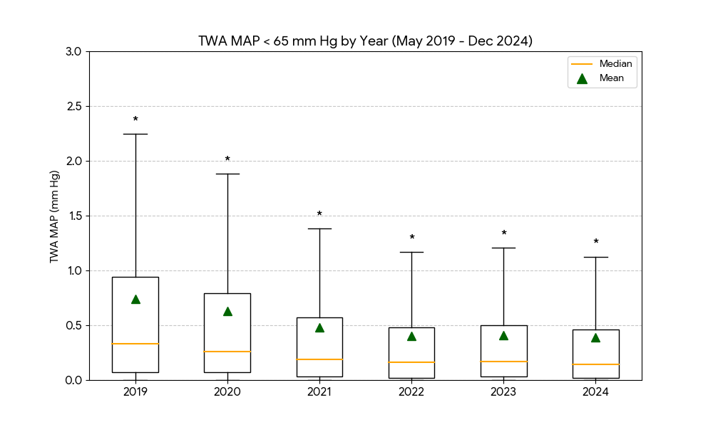
A¹

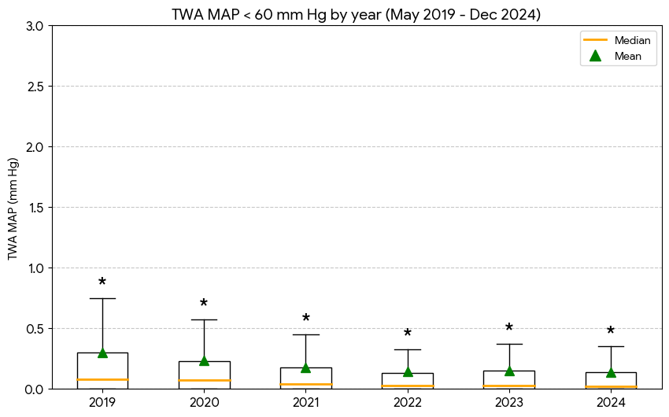

B¹

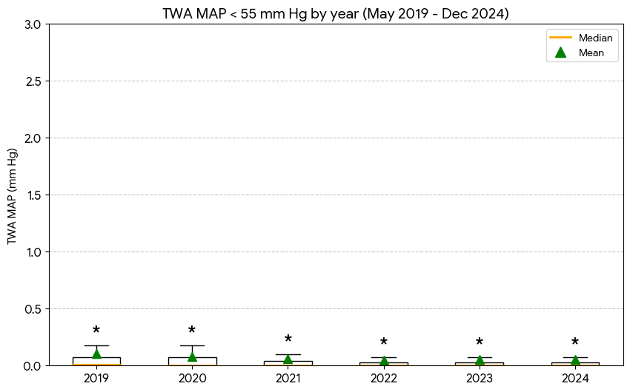

C¹

¹There was a statistically significant difference in the distribution of TWA MAP values between years across all thresholds (Kruskal-Wallis; A: H = 95.3, p < 0.001, B: H = 84.0, p < 0.001, C: H = 74.2, p < 0.001).

* indicates the extreme outliers beyond the upper whisker range (3rd quartile plus 1.5 times the interquartile range) and we have detailed the values here;

TWA MAP < 65 mm Hg: 2019 (2.25-7.79, n=32 (6.3%)), 2020 (1.88-8.04, n=52 (9.1%)), 2021 (1.38-6.96, n=73 (9.3%)), 2022 (1.17-7.72, n=85 (9.2%)), 2023 (1.21-5.79, n=80 (8.1%)), and 2024 (1.13-7.81, n=68 (6.4%)).
TWA MAP < 60 mm Hg: 2019 (0.75-6.07, n=53 (10.5%)), 2020 (0.58-4.78, n=71 (12.4%)), 2021 (0.45-3.52, n=86 (10.9%)), 2022 (0.33-3.96, n=118 (12.7%)), 2023 (0.38-3.26, n=100 (10.1%)), and 2024 (0.35-4.78, n=108 (10.2%)).

TWA MAP < 55 mm Hg: 2019 (0.18-4.38, n=75 (14.8%)), 2020 (0.18-2.47, n=70 (12.2%)), 2021 (0.10-1.63, n=122 (15.5%)), 2022 (0.08-1.84, n=140 (15.1%)), 2023 (0.08-2.16, n=154 (15.5%)), and 2024 (0.08-3.70, n=151 (14.3%)).

Appendix Figure 5.4: Annual frequency of hypotension episodes across all thresholds for arterial line data.

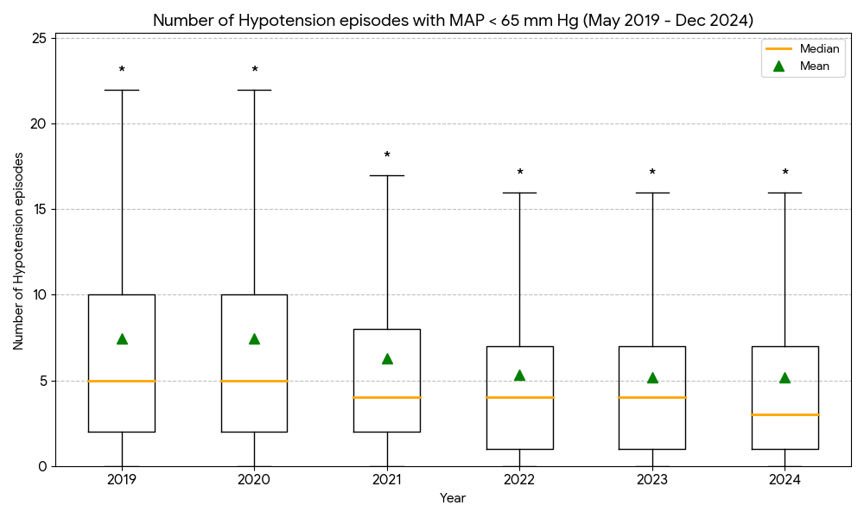
A²

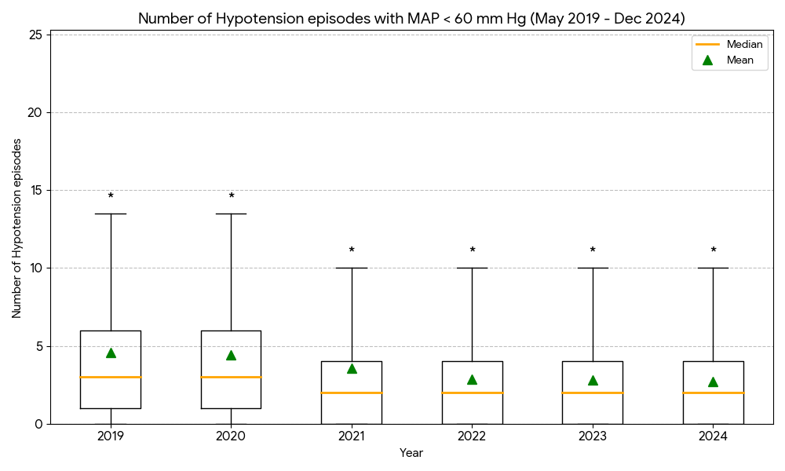

B²

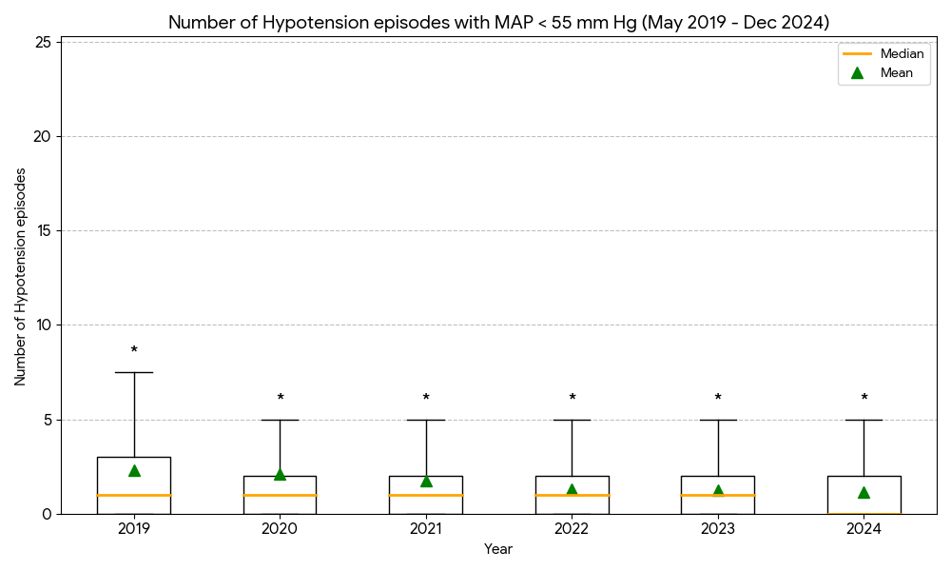

C²

²Annual distributions differed significantly for all thresholds (Kruskal-Wallis, A: H = 83.2, p < 0.001, B: H = 92.3, p < 0.001, C: H = 77.2, p < 0.001)

* indicates the extreme outliers beyond the upper whisker range (3rd quartile plus 1.5 times the interquartile range) and we have detailed the values here;

No of hypotension episodes MAP < 65 mm Hg: 2019 (22.00-53.00, n=22 (4.3%)), 2020 (22.00-49.00, n=2 (5.1%)), 2021 (17.00-50.00, n=3 (5.8%)), 2022 (16.00-45.00, n=2 (4.8%)), 2023 (16.00-35.00, n=1 (4.2%)), and 2024 (16.00-45.00, n=2 (4.2%))

No of hypotension episodes MAP < 60 mm Hg: 2019 (13.50-54.00, n=25 (4.9%)), 2020 (13.50-57.00, n=2 (3.9%)), 2021 (10.00-43.00, n=3 (6.0%)), 2022 (10.00-36.00, n=1 (3.9%)), 2023 (10.00-25.00, n=1 (3.2%)), and 2024 (10.00-35.00, n=2 (4.3%))

No of hypotension episodes MAP < 55 mm Hg: 2019 (7.50-39.00, n=24 (4.7%)), 2020 (5.00-51.00, n=48 (8.4%)), 2021 (5.00-37.00, n=41 (5.2%)), 2022 (5.00-31.00, n=28 (3.0%)), 2023 (5.00-19.00, n=29 (2.9%)), and 2024 (5.00-25.00, n=20 (1.9%))

Appendix Figure 5.5: Annual cumulative duration of hypotension across all thresholds for arterial line data.

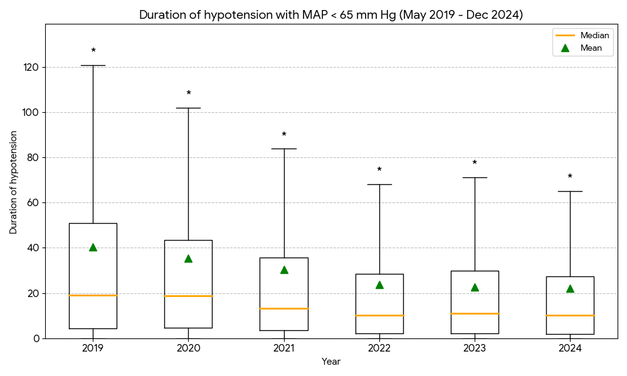
A³

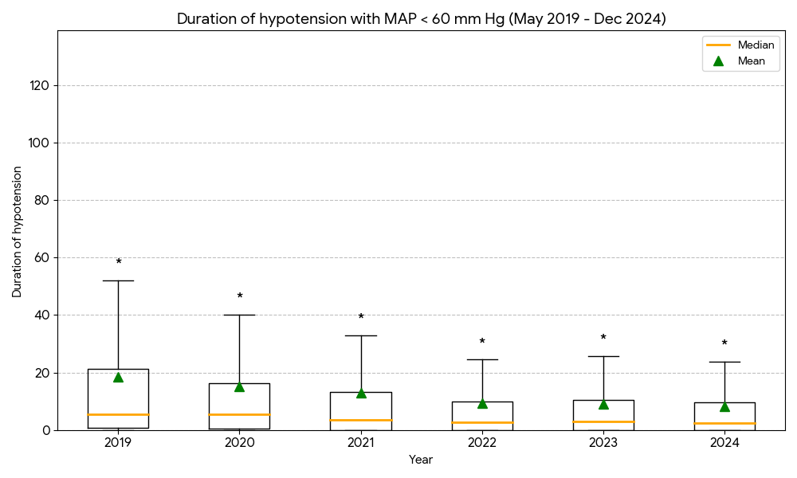

B³

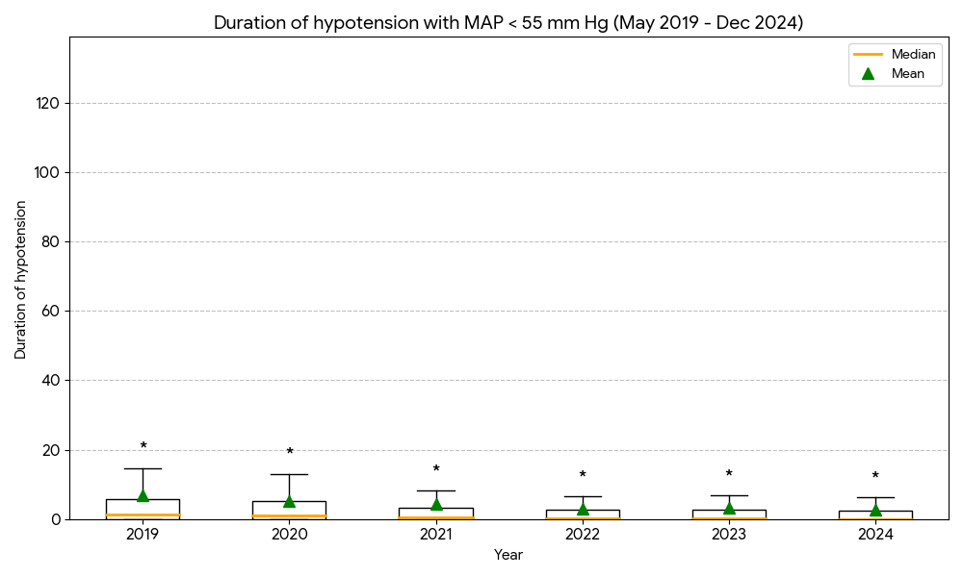

C³

³Significant inter-year variation was observed in the total duration of hypotension (Kruskal-Wallis; A: H = 83.1, p < 0.001, B: H = 84.4, p < 0.001, C: H = 72.5, p < 0.001)

* indicates the extreme outliers beyond the upper whisker range (3rd quartile plus 1.5 times the interquartile range) and we have detailed the values here;
Duration of hypotension with MAP < 65 mm Hg: 2019 (120.85-433.84, n=37 (7.3%)), 2020 (101.92-353.32, n=28 (8.0%)), 2021 (83.85-445.72, n=41 (9.1%)), 2022 (68.19-392.95, n=29 (7.5%)), 2023 (71.27-360.20, n=28 (7.8%)), and 2024 (65.13-288.06, n=24 (8.3%))

Duration of hypotension with MAP < 60 mm Hg: 2019 (52.13-305.92, n=44 (8.7%)), 2020 (40.15-279.38, n=55 (9.6%)), 2021 (33.00-296.15, n=71 (9.0%)), 2022 (24.46-266.98, n=94 (10.1%)), 2023 (25.81-246.09, n=85 (8.6%)), and 2024 (23.84-205.49, n=101 (9.5%))

Duration of hypotension with MAP < 55 mm Hg: 2019 (14.70-137.89, n=54 (10.7%)), 2020 (13.03-175.28, n=63 (11.0%)), 2021 (8.10-137.88, n=110 (14.0%)), 2022 (6.55-110.69, n=128 (13.8%)), 2023 (6.77-131.60, n=128 (12.9%)), and 2024 (6.26-93.52, n=125 (11.8%))

Appendix Figure 5.6: Annual incidences of patients experiencing $≥$ 1 hypotension episode for arterial line data.

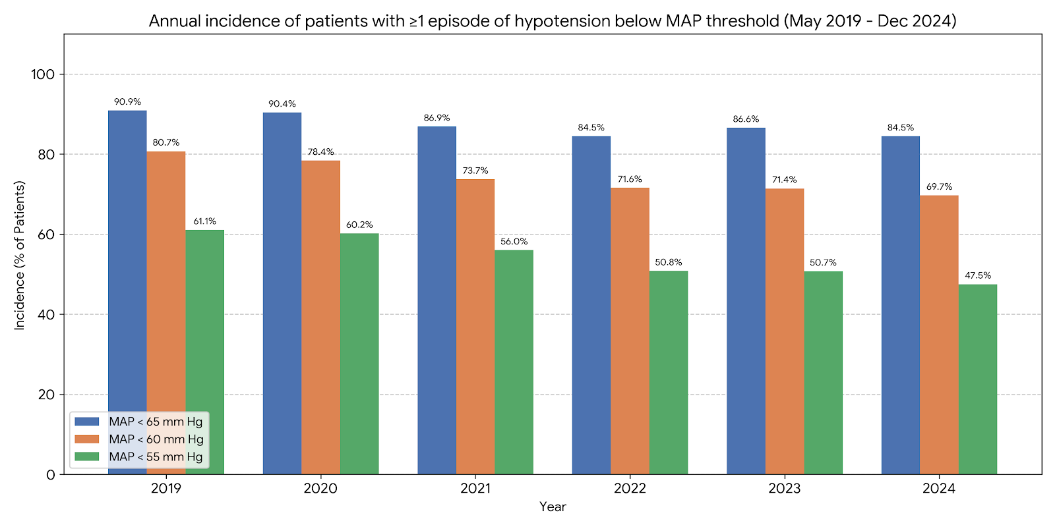

There was a statistically significant association between year and the incidence of hypotension across all thresholds (Pearson’s Chi-squared test, MAP < 65 mm Hg: X² = 23.1, p < 0.001, MAP < 60 mm Hg: X² = 32.0, p < 0.001, MAP < 55 mm Hg: X² = 45.0, p < 0.001)

Appendix Figure 5.7: Monthly mean TWA MAP < 65 mm Hg for arterial line data.

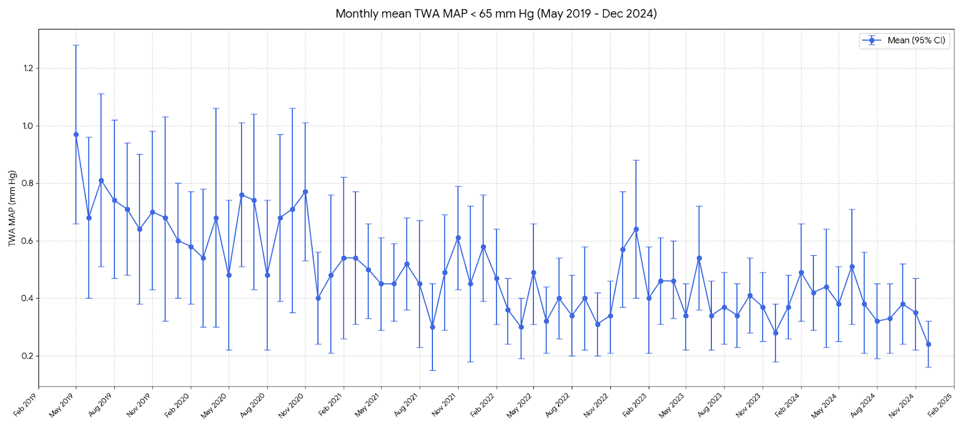

Appendix Figure 5.8: Monthly mean TWA MAP < 60 mm Hg for arterial line data.

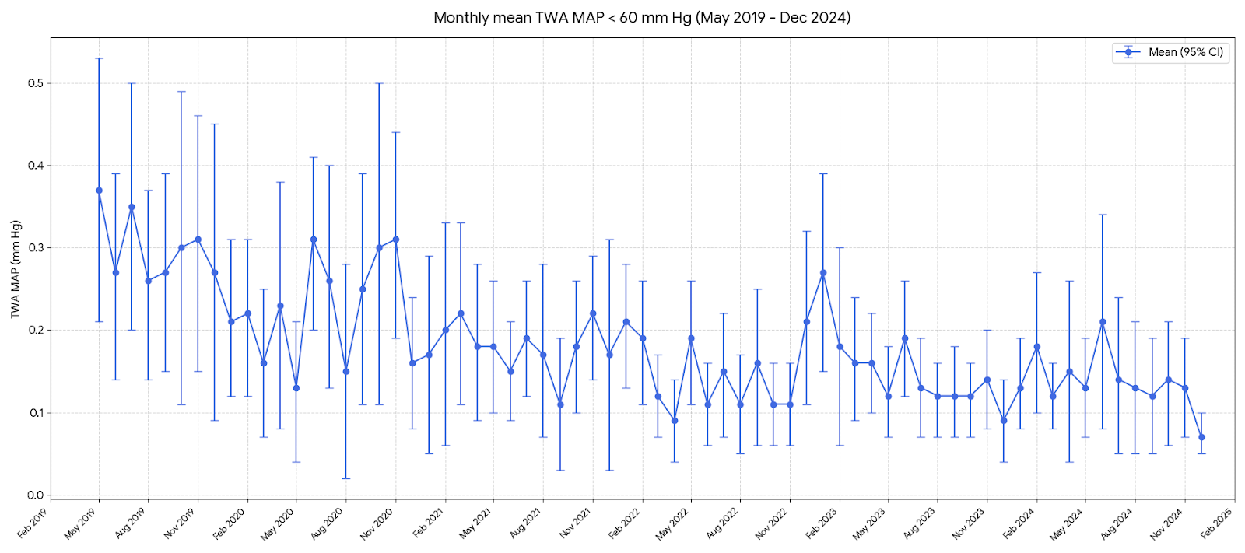

Appendix Figure 5.9: Monthly mean TWA MAP < 55 mm Hg for arterial line data.

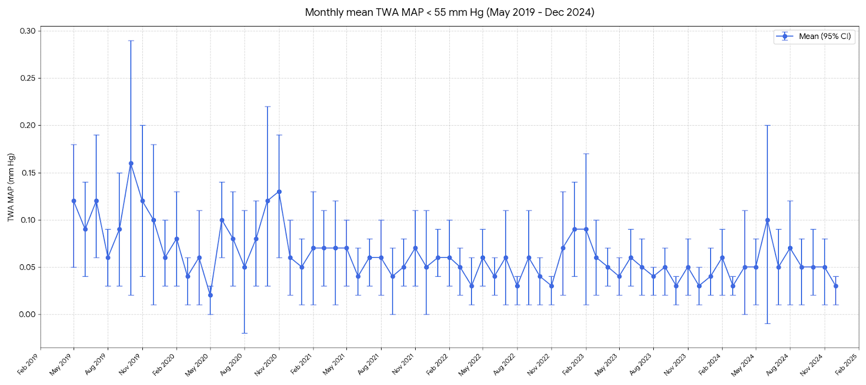

Appendix Figure 5.10: Monthly mean frequency of hypotension episodes MAP < 65 mm Hg for arterial line data.

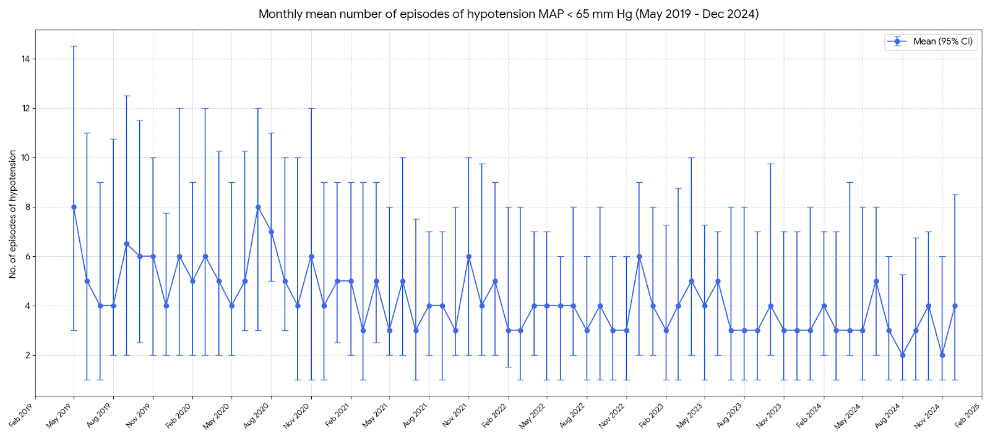

Appendix Figure 5.11: Monthly mean frequency of hypotension episodes MAP < 60 mm Hg for arterial line data.
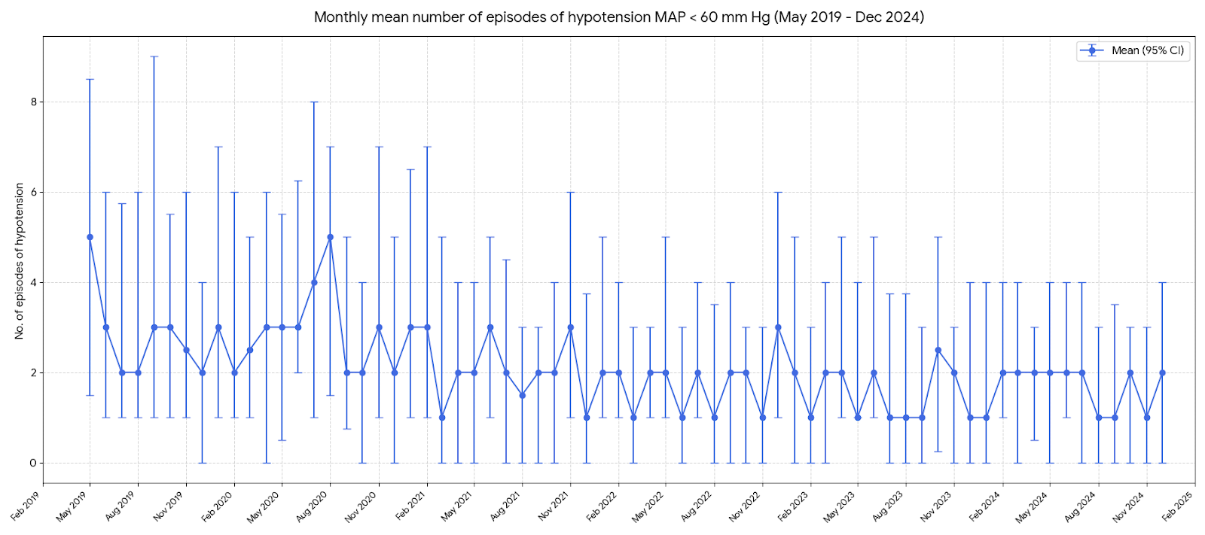

Appendix Figure 5.12: Monthly mean frequency of hypotension episodes MAP < 55 mm Hg for arterial line data.

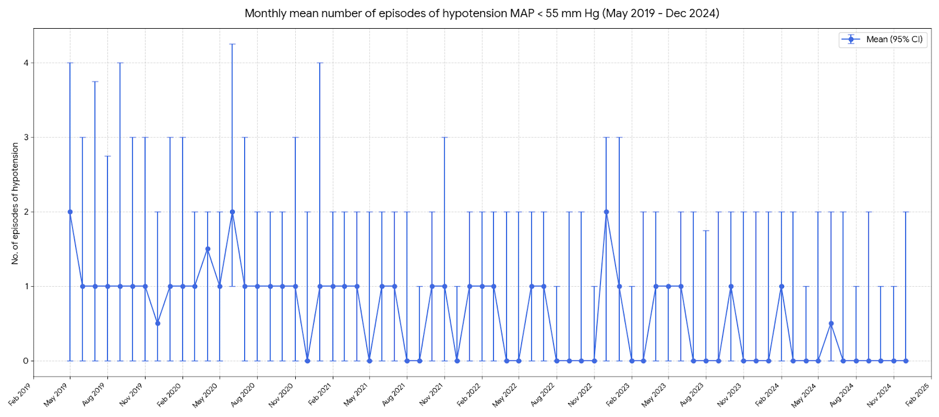

Appendix Figure 5.13: Monthly mean duration of hypotension MAP < 65 mm Hg for arterial line data.

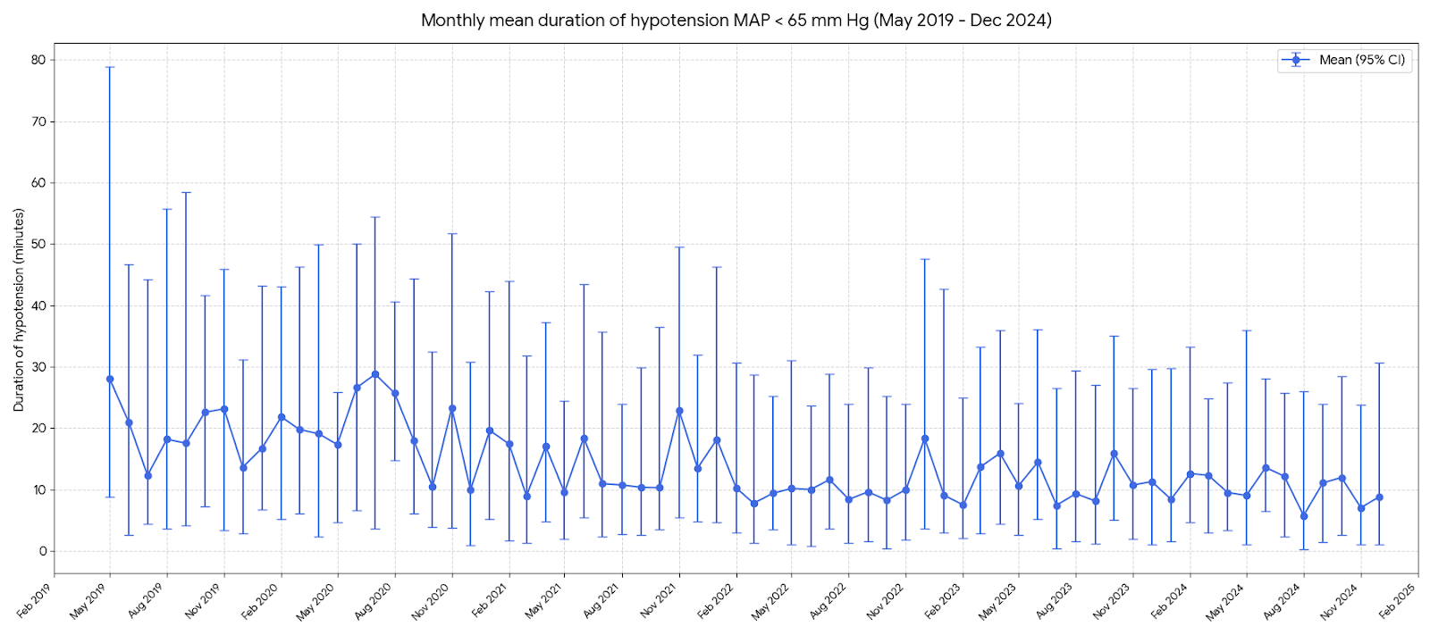

Appendix Figure 5.14: Monthly mean duration of hypotension MAP < 60 mm Hg for arterial line data.

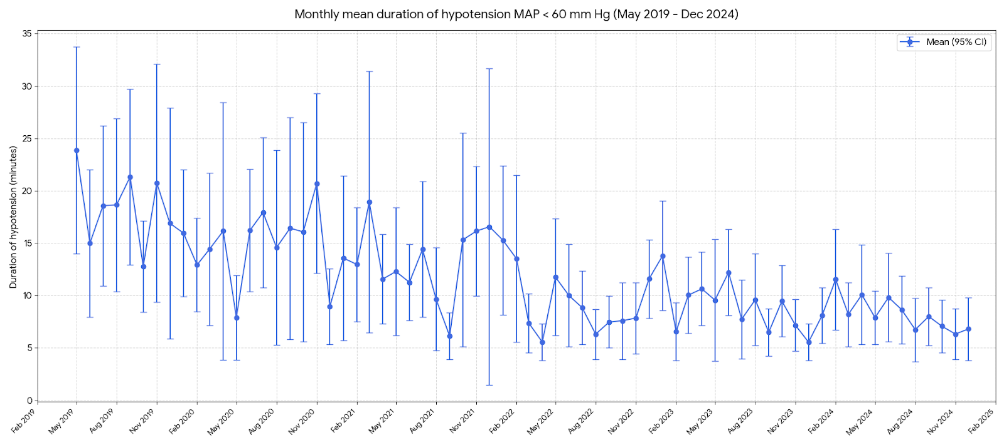

Appendix Figure 5.15: Monthly mean duration of hypotension MAP < 55 mm Hg for arterial line data.

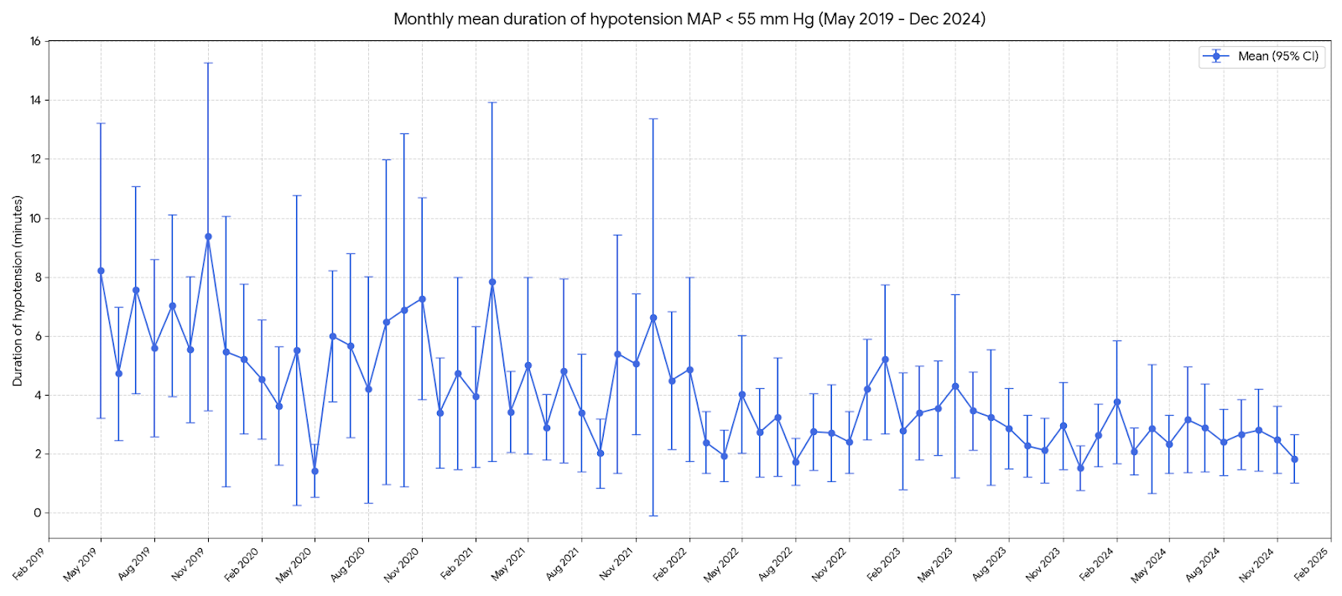

Appendix Figure 5.16: Monthly incidence of $≥$ 1 hypotensive episode MAP < 65 mm Hg for arterial line data.

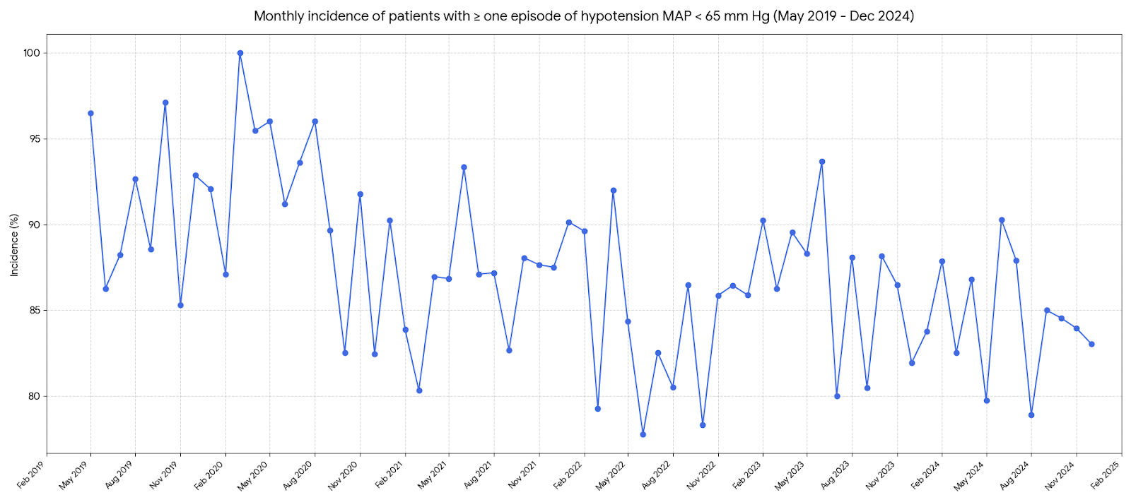

Appendix Figure 5.17: Monthly incidence of $≥$ 1 hypotensive episode MAP < 60 mm Hg for arterial line data.

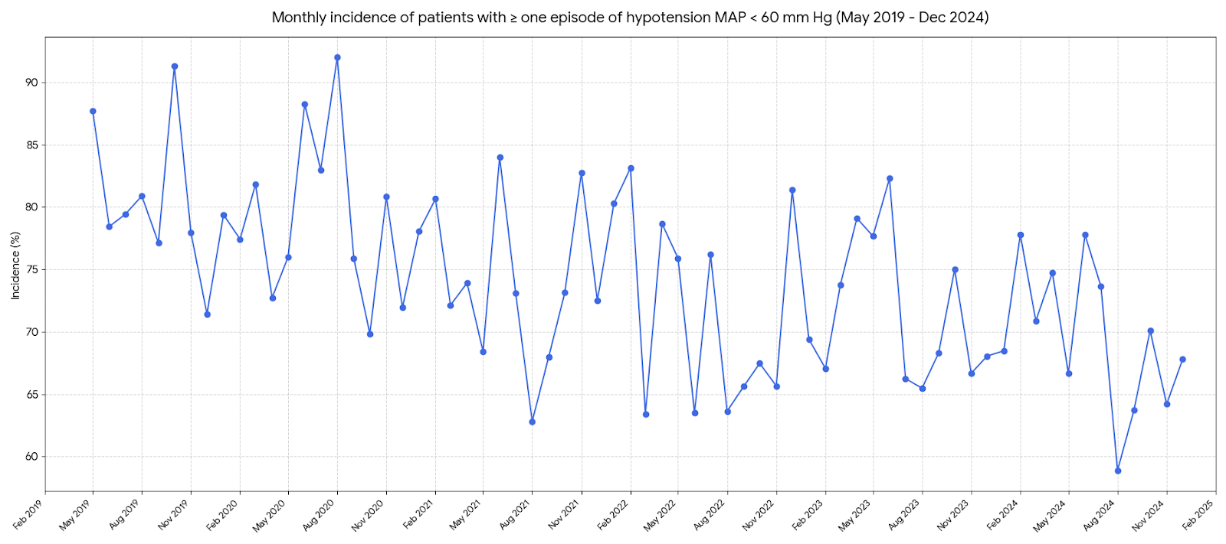

Appendix Figure 5.18: Monthly incidence of $≥$ 1 hypotensive episode MAP < 55 mm Hg for arterial line data.

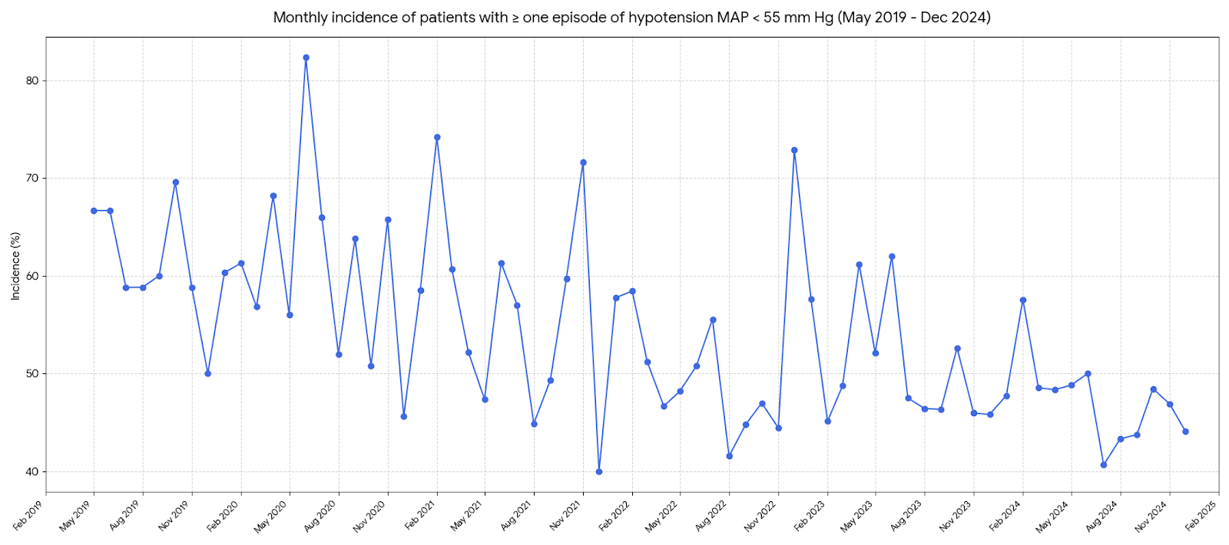

Appendix Table 5.19: Time series analysis of hypotension outcomes using Mann-Kendall testing (arterial line data).

Variable Type | MAP Threshold | Metric (Monthly) | Kendall's Tau (τ) | P-value | Trend
TWA MAP | < 65 mm Hg | Mean | -0.428 | < 0.001 |  | Decreasing
TWA MAP | < 60 mm Hg | Mean | -0.370 | < 0.001 |  | Decreasing
TWA MAP | < 55 mm Hg | Mean | -0.211 | 0.015 |  | Decreasing
TWA MAP | < 65 mm Hg | Median | -0.321 | < 0.001 |  | Decreasing
TWA MAP | < 60 mm Hg | Median | -0.360 | < 0.001 |  | Decreasing
TWA MAP | < 55 mm Hg | Median | -0.210 | 0.026 |  | Decreasing
Number of episodes of hypotension | < 65 mm Hg | Mean | -0.287 | 0.001 |  | Decreasing
 | < 60 mm Hg | Mean | -0.231 | 0.012 |  | Decreasing
 | < 55 mm Hg | Mean | -0.197 | 0.038 |  | Decreasing
 | < 65 mm Hg | Median | -0.407 | < 0.001 |  | Decreasing
 | < 60 mm Hg | Median | -0.370 | < 0.001 |  | Decreasing
 | < 55 mm Hg | Median | -0.260 | 0.006 |  | Decreasing
Duration of hypotension | < 65 mm Hg | Mean | -0.263 | 0.004 |  | Decreasing
Duration of hypotension | < 60 mm Hg | Mean | -0.207 | 0.027 |  | Decreasing
Duration of hypotension | < 55 mm Hg | Mean | -0.098 | 0.301 |  | No significant trend
Duration of hypotension | < 65 mm Hg | Median | -0.472 | < 0.001 |  | Decreasing
Duration of hypotension | < 60 mm Hg | Median | -0.409 | < 0.001 |  | Decreasing
Duration of hypotension | < 55 mm Hg | Median | -0.268 | 0.007 |  | Decreasing
Incidence of patients with $≥$ 1 episode of hypotension | < 65 mm Hg | % Rate | -0.186 | 0.035 |  | Decreasing
Incidence of patients with $≥$ 1 episode of hypotension | < 60 mm Hg | % Rate | -0.198 | 0.026 |  | Decreasing
Incidence of patients with $≥$ 1 episode of hypotension | < 55 mm Hg | % Rate | -0.165 | 0.063 |  | No significant trend
The Mann-Kendall Tau statistic assesses the strength and direction of monotonic trends. A positive tau value denotes an increasing trend, and a negative tau value denotes a decreasing trend. The magnitude of tau reflects the consistency of the trend (closer to ±1 indicates a stronger trend).

Appendix Table 5.20: Mixed effects regression analyses of primary and secondary outcome variables for arterial line data only

Outcome Measure | MAP  Threshold | Unadjusted Ratio (95% CI) | Adjusted Ratio (95% CI) | P-value
TWA MAP below threshold | < 65 mm Hg | 0.88 (0.86 - 0.91) | 0.88 (0.86 - 0.91) | <0.001
 | < 60 mm Hg | 0.87 (0.84 - 0.91) | 0.87 (0.84 - 0.90) | <0.001
 | < 55 mm Hg | 0.89 (0.85 - 0.93) | 0.88 (0.84 - 0.92) | <0.001
Number of Hypotension episodes below MAP threshold | < 65 mm Hg | 0.93 (0.91 - 0.95) | 0.93 (0.91 - 0.95) | <0.001
 | < 60 mm Hg | 0.90 (0.88 - 0.92) | 0.90 (0.88 - 0.92) | <0.001
 | < 55 mm Hg | 0.87 (0.85 - 0.90) | 0.87 (0.84 - 0.90) | <0.001
Duration of hypotension below MAP threshold | < 65 mm Hg | 0.91 (0.88 - 0.93) | 0.91 (0.88 - 0.93) | <0.001
 | < 60 mm Hg | 0.87 (0.84 - 0.90) | 0.87 (0.84 - 0.89) | <0.001
 | < 55 mm Hg | 0.82 (0.78 - 0.85) | 0.85 (0.81 - 0.88) | <0.001
Incidence of $≥$ one episode of hypotension below MAP threshold | < 65 mm Hg | 0.91 (0.86 - 0.95) | 0.90 (0.85 - 0.95) | <0.001
 | < 60 mm Hg | 0.90 (0.86 - 0.94) | 0.90 (0.86 - 0.93) | <0.001
 | < 55 mm Hg | 0.89 (0.86 - 0.93) | 0.89 (0.86 - 0.92) | <0.001

Generalised linear mixed effects models were used for all variables except incidence of $≥$ 1 episode of hypotension below MAP threshold, which required a mixed effects logistic regression model. Ratios < 1.0 indicate a reduction in hypotension burden per year. Models were adjusted for Age, Sex, BMI, ASA physical status, Diabetes, Creatinine, Anaesthesia Type, Surgical Urgency, Cardiovascular Disease, and Preoperative Systolic BP.

Appendix Table 5.21: Mixed effects regression analyses for TWA MAP across all thresholds (arterial line data).

 | TWA MAP below threshold
Covariate | MAP < 65 mm Hg | MAP < 60 mm Hg | MAP < 55 mm Hg
Covariate | Adjusted Mean ratio  (95% CI) | Adjusted Mean ratio  (95% CI) | Adjusted Mean ratio  (95% CI)
Year | 0.88 (0.86 – 0.91)*** | 0.87 (0.84 – 0.90)*** | 0.88 (0.84 – 0.92)***
Age | 1.00 (0.99 – 1.00)** | 1.00 (0.99 – 1.00) | 1.00 (0.99 – 1.01)
Male Sex | 1.08 (0.97 – 1.20) | 1.09 (0.95 – 1.26) | 1.08 (0.91 – 1.29)
BMI | 0.98 (0.98 – 0.99)*** | 0.98 (0.97 – 0.99)*** | 0.99 (0.98 – 1.00)
Diabetes | 1.07 (0.95 – 1.20) | 1.05 (0.90 – 1.22) | 0.97 (0.80 – 1.18)
Preoperative  Creatinine | 1.16 (1.00 – 1.36) | 1.19 (0.97 – 1.46) | 1.16 (0.89 – 1.50)
Preoperative  Systolic Blood Pressure | 1.00 (0.99 – 1.00)* | 1.00 (0.99 – 1.00)* | 1.00 (0.99 – 1.00)*
General Anaesthesia | 1.81 (1.32 – 2.47)*** | 2.03 (1.35 – 3.05)*** | 1.94 (1.16 – 3.26)*
Elective Surgery | 0.93 (0.72 – 1.21) | 0.90 (0.64 – 1.27) | 0.88 (0.56 – 1.36)
Composite of CVD | 0.91 (0.79 – 1.04) | 0.87 (0.72 – 1.06) | 0.89 (0.70 – 1.13)
ASA physical status
(Ref: ASA 1)

ASA 2 | 1.31 (0.74 – 2.33) | 1.57 (0.74 – 3.38) | 1.76 (0.67 - 4.65)
ASA 3 | 1.34 (0.76 – 2.39) | 1.60 (0.75 – 3.42) | 1.70 (0.65 – 4.49)
ASA 4 | 1.34 (0.73 – 2.46) | 1.60 (0.72 – 3.59) | 1.73 (0.62 – 4.83)
*** p < 0.001; ** p < 0.01; * p < 0.05.

Appendix Table 5.22: Mixed effects regression analyses for frequency of hypotension episodes across all thresholds (arterial line data).

 | Number of episodes of hypotension below MAP threshold
Covariate | MAP < 65 mm Hg | MAP < 60 mm Hg | MAP < 55 mm Hg
Covariate | Adjusted Rate Ratio  (95% CI) | Adjusted Rate Ratio  (95% CI) | Adjusted Rate Ratio  (95% CI)
Year | 0.93 (0.91 – 0.94)*** | 0.90 (0.88 – 0.92)*** | 0.87 (0.84 – 0.89)***
Age | 0.99 (0.99 – 1.00)*** | 0.99 (0.99 – 1.00)*** | 0.99 (0.99 – 1.00)*
Male Sex | 1.06 (0.99 – 1.14) | 1.08 (0.99 – 1.17) | 1.16 (1.05 – 1.29)**
BMI | 0.99 (0.98 – 0.99)*** | 0.98 (0.98 – 0.99)*** | 0.98 (0.97 – 0.99)***
Diabetes | 1.01 (0.94 – 1.09) | 1.02 (0.93 – 1.12) | 1.01 (0.90 – 1.13)
Preoperative Creatinine | 0.96 (0.87 – 1.06) | 1.01 (0.90 – 1.14) | 1.06 (0.91 – 1.23)
Preoperative  Systolic Blood Pressure | 1.00 (0.99 – 1.00)*** | 1.00 (0.99 – 1.00)*** | 0.99 (0.99 – 1.00)***
General Anaesthesia | 1.48 (1.16 – 1.87)*** | 2.24 (1.65 – 3.05)*** | 2.91 (1.94 – 4.36)***
Elective Surgery | 0.90 (0.76 – 1.07) | 0.88 (0.72 – 1.07) | 0.83 (0.65 – 1.05)
Composite of CVD | 0.98 (0.89 – 1.07) | 0.91 (0.81 – 1.02) | 0.88 (0.77 – 1.02)
ASA physical status
(Ref: ASA 1)
ASA 2 | 1.05 (0.73 – 1.51) | 1.01 (0.66 – 1.56) | 1.59 (0.90 – 2.80)
ASA 3 | 1.06 (0.74 – 1.53) | 1.03 (0.67 – 1.60) | 1.64 (0.93 – 2.89)
ASA 4 | 0.96 (0.65 – 1.41) | 0.99 (0.62 – 1.57) | 1.56 (0.86 – 2.84)

*** p < 0.001; ** p < 0.01; * p < 0.05.

Appendix table 5.23: Mixed effects regression analyses for duration of hypotension across all thresholds (arterial line data).
Covariate | Duration of hypotension below MAP threshold
Covariate | MAP < 65 mm Hg | MAP < 60 mm Hg | MAP < 55 mm Hg
Covariate | Adjusted Mean Ratio  (95% CI) | Adjusted Mean Ratio  (95% CI) | Adjusted Mean Ratio  (95% CI)
Year | 0.91 (0.88 – 0.93)*** | 0.87 (0.84 – 0.89)*** | 0.85 (0.81 – 0.88)***
Age | 0.99 (0.99 – 0.99)*** | 0.99 (0.99 – 1.00)*** | 0.99 (0.99 – 1.00) **
Male Sex | 1.11 (1.01 – 1.22)** | 1.14 (1.01 – 1.29)* | 1.19 (1.01 – 1.40) *
BMI | 0.98 (0.98 – 0.99)*** | 0.98 (0.97 – 0.99)*** | 0.98 (0.97 - 0.99)***
Diabetes | 1.06 (0.96 – 1.17) | 1.09 (0.95 – 1.24) | 1.07 (0.90 – 1.27)
Preoperative  Creatinine | 1.11 (0.97 – 1.27) | 1.05 (0.88 – 1.25) | 1.10 (0.87 – 1.39)
Preoperative  Systolic Blood Pressure | 1.00 (0.99 – 1.00)** | 1.00 (0.99 – 1.00)** | 0.99 (0.99 – 1.00)***
General Anaesthesia | 2.15 (1.59 – 2.91)*** | 0.00 (0.00 – 0.00)‡ | 0.00 (0.00 – 0.00)‡
Elective Surgery | 0.95 (0.75 – 1.19) | 0.84 (0.62 – 1.12) | 0.75 (0.51 – 1.11)
Composite of CVD | 0.91 (0.81 – 1.03) | 0.89 (0.76 – 1.04) | 0.89 (0.72 – 1.10)
ASA physical status
(Ref: ASA 1)

ASA 2 | 0.90 (0.55 – 1.49) | 1.17 (0.61 – 2.24) | 2.05 (0.87 – 4.85)
ASA 3 | 0.92 (0.56 – 1.51) | 1.19 (0.62 – 2.26) | 2.08 (0.88 – 4.90)
ASA 4 | 0.85 (0.50 – 1.44) | 1.09 (0.55 – 2.17) | 1.90 (0.77 – 4.72)
*** p < 0.001; ** p < 0.01; * p < 0.05.

‡ Coefficients for General Anaesthesia in the MAP < 60 (B=-8.17) and MAP < 55 (B=-5.93) models reflect statistical instability driven by severe sample size imbalance (n=125 vs n=4179). Despite higher mean duration of hypotension in the General Anaesthesia group compared to the reference (11.5 vs 2.44 and 3.97 vs 0.93), the model produced contradictory extreme estimates. Consequently, rate ratios for General Anaesthesia at these thresholds are unreliable; interpretation of this effect should be limited to the stable MAP < 65 mm Hg model.
Appendix Table 5.24: Mixed effects regression analyses for hypotension incidence across all thresholds (arterial line data).

 | Incidence of patients with hypotension below MAP threshold
Covariate | MAP  < 65 mm Hg | MAP  < 60 mm Hg | MAP  < 55 mm Hg
 | Adjusted Odds Ratio  (95% CI) | Adjusted Odds Ratio  (95% CI) | Adjusted Odds Ratio  (95% CI)
Year | 0.90 (0.85 – 0.95)*** | 0.90 (0.86 – 0.93)*** | 0.89 (0.86 – 0.92)***
Age | 1.01 (1.00 – 1.01)* | 1.01 (1.00 – 1.01)* | 1.00 (1.00 – 1.01)
Male Sex | 1.35 (1.11 – 1.65)** | 1.12 (0.96 – 1.31) | 1.27 (1.10 – 1.45)***
BMI | 0.97 (0.96 – 0.98)*** | 0.97 (0.96 – 0.98)*** | 0.98 (0.97 – 0.99)***
Diabetes | 0.95 (0.77 – 1.18) | 0.95 (0.81 – 1.13) | 0.96 (0.82 – 1.11)
Preoperative Creatinine | 0.89 (0.67 – 1.18) | 0.96 (0.77 – 1.20) | 1.03 (0.84 – 1.26)
Preoperative  Systolic Blood Pressure | 0.99 (0.99 – 1.00)*** | 0.99 (0.99 – 1.00)*** | 0.99 (0.99 – 1.00)***
General Anaesthesia | 3.40 (2.11 – 5.47)*** | 3.93 (2.53 – 6.08)*** | 6.17 (3.59 – 10.60)***
Elective Surgery | 1.34 (0.84 – 2.13) | 0.86 (0.57 – 1.28) | 0.76 (0.53 – 1.07)
Composite of CVD | 1.03 (0.79 – 1.33) | 0.96 (0.78 – 1.18) | 0.95 (0.79 – 1.15)
ASA physical status
(Ref: ASA 1)

ASA 2 | 1.37 (0.47 – 4.03) | 1.05 (0.44 – 2.50) | 0.96 (0.46 – 2.03)
ASA 3 | 1.39 (0.47 – 4.06) | 1.07 (0.45 – 2.53) | 0.97 (0.46 – 2.03)
ASA 4 | 0.90 (0.29 – 2.77) | 0.82 (0.33 – 2.04) | 0.84 (0.38 – 1.84)

*** p < 0.001; ** p < 0.01; * p < 0.05.

Appendix Table 5.25 Multivariable regression analysis between surgical specialty and TWA MAP < 65 mm Hg.

Variable | Unadjusted |  | Adjusted†
 | Ratio (95% CI) | P | Ratio (95% CI) | P
Year | — | — | 0.88 (0.86–0.89) | <0.001
Type of Surgery
Urology | Ref | — | Ref | —
Breast Surgery | 0.59 (0.34–1.01) | 0.06 | 0.76 (0.45–1.29) | 0.31
Colorectal | 1.03 (0.92–1.15) | 0.64 | 1.15 (1.03–1.29) | 0.01
General Surgery | 1.10 (0.91–1.32) | 0.32 | 1.28 (1.06–1.54) | 0.01
Gynaecology | 0.84 (0.75–0.94) | 0.002 | 0.99 (0.88–1.12) | 0.88
Head and Neck | 1.28 (1.14–1.45) | <0.001 | 1.30 (1.15–1.47) | <0.001
Obstetrics | 0.99 (0.56–1.76) | 0.98 | 1.22 (0.67–2.20) | 0.52
Orthopaedics | 0.76 (0.64–0.90) | 0.001 | 1.23 (1.00–1.51) | 0.05
Thoracic | 1.12 (1.00–1.24) | 0.04 | 1.26 (1.13–1.40) | <0.001
Upper GI | 0.94 (0.82–1.08) | 0.37 | 1.02 (0.89–1.17) | 0.74
Bariatrics | 0.95 (0.71–1.28) | 0.75 | 1.00 (0.74–1.35) | 1.00
Vascular | 0.84 (0.58–1.22) | 0.36 | 0.79 (0.54–1.15) | 0.21

† Adjusted for Age, Sex, BMI, ASA physical status, Year of surgery, Elective surgery, General Anaesthesia, diabetes, composite of IHD, HF, & AF, preoperative systolic BP and preoperative creatinine. Ratios presented are Geometric Mean Ratio.

