Appendix 6: Sensitivity analysis for major body cavity surgery patients

Appendix Table 6.1: Baseline characteristics of sensitivity analysis cohort for major body cavity surgery patients

Characteristic | Total  (n=4252) | 2019  (n=446) | 2020  (n=561) | 2021  (n=695) | 2022  (n=768) | 2023  (n=890) | 2024  (n=892) | Test statistic | P-value
Age, years | 63.3 (14.0) | 63.2 (14.3) | 64.4 (13.7) | 63.0 (14.0) | 63.2 (14.1) | 63.6 (14.0) | 62.9 (14.3) | 1.03 | 0.40
Male sex | 1994 (46.9%) | 216 (48.4%) | 256 (45.6%) | 338 (48.6%) | 345 (44.9%) | 404 (45.4%) | 435 (48.8%) | 4.89 | 0.43
BMI, kg m⁻² | 28.6 (6.9) | 29.2 (6.9) | 28.6 (6.5) | 28.8 (6.9) | 28.2 (6.9) | 28.3 (7.1) | 28.7 (7.1) | 1.61 | 0.16
ASA physical status |  |  |  |  |  |  |  | 30.5 | 0.01
1 | 25 (0.6%) | 3 (0.7%) | 8 (1.4%) | 4 (0.6%) | 6 (0.8%) | 2 (0.2%) | 2 (0.2%)
2 | 1309 (30.8%) | 145 (32.5%) | 183 (32.6%) | 210 (30.2% | 253 (32.9%) | 275 (30.9%) | 243 (27.2%)
3 | 2747 (64.6%) | 275 (61.7%) | 348 (62.0%) | 453 (65.2%) | 474 (61.7%) | 592 (66.5%) | 605 (67.8%)
4 | 171 (4.0%) | 23 (5.2%) | 22 (3.9%) | 28 (4.0%) | 35 (4.6%) | 21 (2.4%) | 42 (4.7%)
Diabetes mellitus | 812 (19.1%) | 97 (21.7%) | 92 (16.4%) | 134 (19.3%) | 133 (17.3%) | 179 (20.1%) | 177 (19.8%) | 7.18 | 0.21
Composite of CVD* | 508 (11.9%) | 61 (13.7%) | 73 (13.0%) | 75 (10.8%) | 92 (12.0%) | 94 (10.6%) | 113 (12.7%) | 4.82 | 0.44
Preoperative Systolic BP, mm Hg | 137 (19) | 134 (17) | 141 (19) | 138 (19) | 137 (19) | 136 (19) | 134 (19) | 13.6 | <0.001
Preoperative Creatinine, µmol L⁻¹ | 78 (28) | 79 (30) | 77 (26) | 79 (31) | 75 (25) | 77 (27) | 80 (27) | 27.3 | <0.001
General anaesthesia | 4243 (99.8%) | 441 (98.9%) | 558 (99.5%) | 695 (100%) | 768 (100%) | 889 (99.9%) | 892 (100%) | 25.6 | <0.001
Elective surgery | 4143 (97.4%) | 425 (95.3%) | 551 (98.2%) | 683 (98.3%) | 751 (97.8%) | 872 (98.0%) | 861 (96.5%) | 15.9 | 0.007
Duration of Surgery, minutes | 209 (129) | 191 (114) | 195 (123) | 217 (131) | 206 (129) | 208 (128) | 224 (137) | 5.92 | <0.001
Data are mean (SD) or n (%), except for Creatinine which is reported as median (interquartile range). Statistical analysis using ANOVA (Age, BMI, Preoperative Systolic BP, Duration of Surgery), Chi-squared test (Male sex, ASA physical status, Diabetes mellitus, Composite of CVD, General anaesthesia and Elective surgery), or Kruskal-Wallis test (Preoperative Creatinine) was conducted. *Composite of CVD = composite of ischaemic heart disease, heart failure or atrial fibrillation.
Appendix Table 6.2 – Types of surgery by year for major body cavity surgery patients

 | Total  (n=4252) | 2019  (n=446) | 2020  (n=561) | 2021  (n=695) | 2022  (n=768) | 2023  (n=890) | 2024  (n=892) | Chi squared test statistic | P-value
Type of Surgery, No. (%) |  |  |  |  |  |  |  | 169.0 | <0.001
Urology | 890 (20.9%) | 115 (25.8%) | 138 (24.6%) | 205 (29.5%) | 141 (18.4%) | 142 (16.0%) | 149 (16.7%)
Thoracic | 998 (23.5%) | 105 (23.5%) | 150 (26.7%) | 152 (21.9%) | 169 (22.0%) | 211 (23.7%) | 211 (23.7%)
Gynaecology | 924 (21.7%) | 96 (21.5%) | 155 (27.6%) | 129 (18.6%) | 164 (21.4%) | 191 (21.5%) | 189 (21.2%)
Colorectal | 790 (18.6%) | 55 (12.3% | 61 (10.9%) | 123 (17.7%) | 167 (21.7%) | 203 (22.8%) | 181 (20.3%)
Upper Gastrointestinal | 438 (10.3%) | 44 (9.9%) | 36 (6.4%) | 45 (6.5%) | 94 (12.2%) | 106 (11.9%) | 113 (12.7%)
General | 125 (2.9%) | 9 (2.0%) | 14 (2.5%) | 22 (3.2%) | 22 (2.9%) | 24 (2.7%) | 34 (3.8%)
Bariatric | 87 (2.0%) | 22 (4.9%) | 7 (1.2%) | 19 (2.7%) | 11 (1.4%) | 13 (1.5%) | 15 (1.7%)

Appendix Figure 6.3 – Annual TWA MAP boxplots across all thresholds for major body cavity surgery.
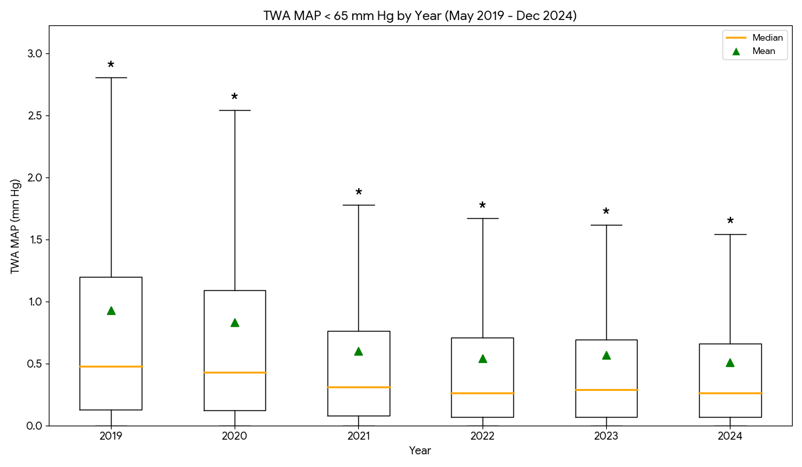

A¹

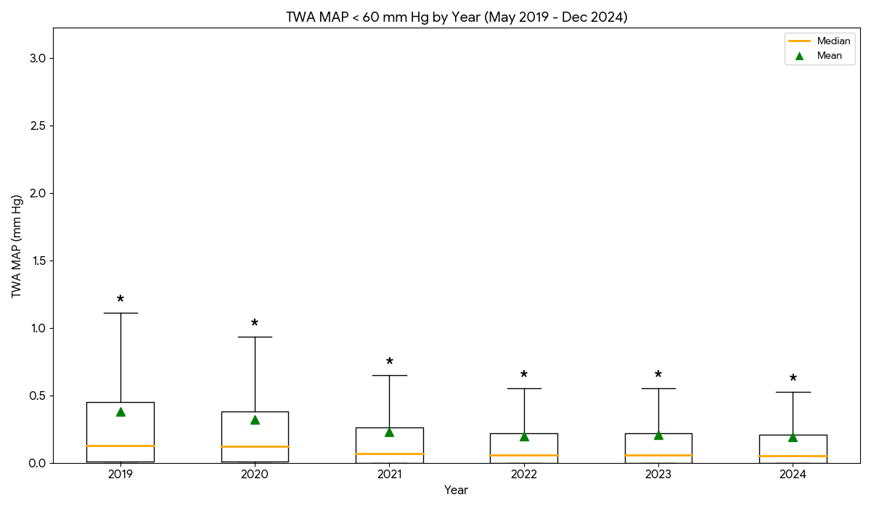

B¹

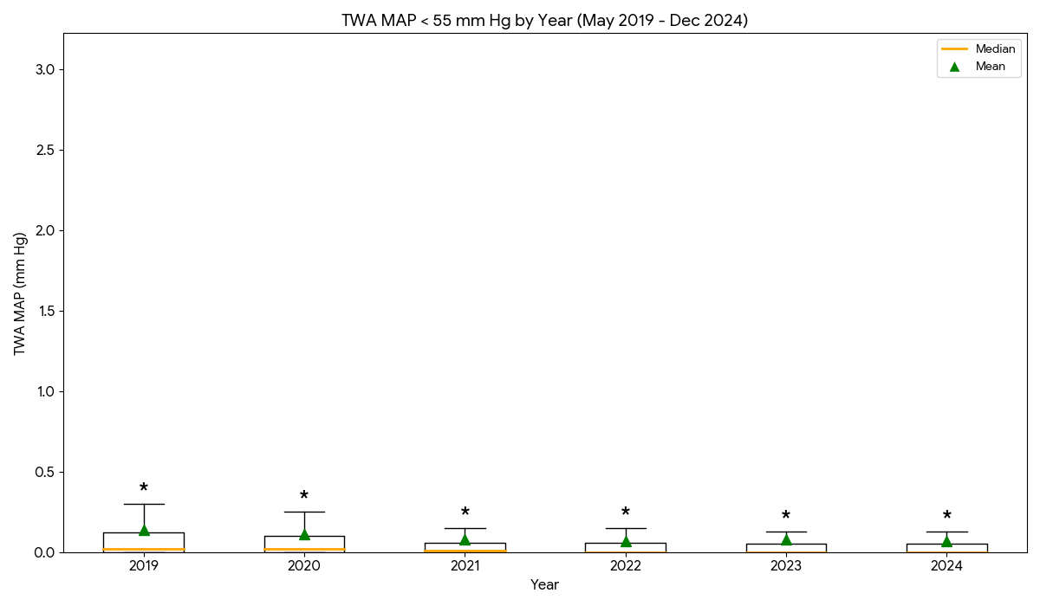

C¹

¹There was a statistically significant difference in the distribution of TWA MAP values between years across all thresholds (Kruskal-Wallis; A: H = 76.1, p < 0.001, B: H = 74.1, p < 0.001, C: H = 64.4, p < 0.001).

* indicates that extreme outliers beyond the upper whisker range (3rd quartile plus 1.5 times the interquartile range) and we have detailed the values here;
TWA MAP < 65 mm Hg: 2019 (2.81-9.65, n=33 (7.4%)), 2020 (2.54-8.88, n=41 (7.3%)), 2021 (1.78-13.55, n=49 (7.1%)), 2022 (1.67-9.79, n=57 (7.4%)), 2023 (1.62-9.14, n=73 (8.2%)), and 2024 (1.55-10.17, n=68 (7.6%)).

TWA MAP < 60 mm Hg: 2019 (1.11-7.12, n=45 (10.1%)), 2020 (0.94-6.24, n=51 (9.1%)), 2021 (0.65-8.15, n=55 (7.9%)), 2022 (0.55-6.80, n=84 (10.9%)), 2023 (0.55-6.14, n=92 (10.3%)), and 2024 (0.53-5.76, n=73 (8.2%)).
TWA MAP < 55 mm Hg: 2019 (0.30-4.82, n=58 (13.0%)), 2020 (0.25-3.98, n=63 (11.2%)), 2021 (0.15-3.74, n=93 (13.4%)), 2022 (0.15-4.59, n=88 (11.5%)), 2023 (0.12-4.36, n=118 (13.3%)), and 2024 (0.12-3.70, n=100 (11.2%)).

Appendix Figure 6.4: Annual frequency of hypotension episodes across all thresholds for major body cavity surgery.

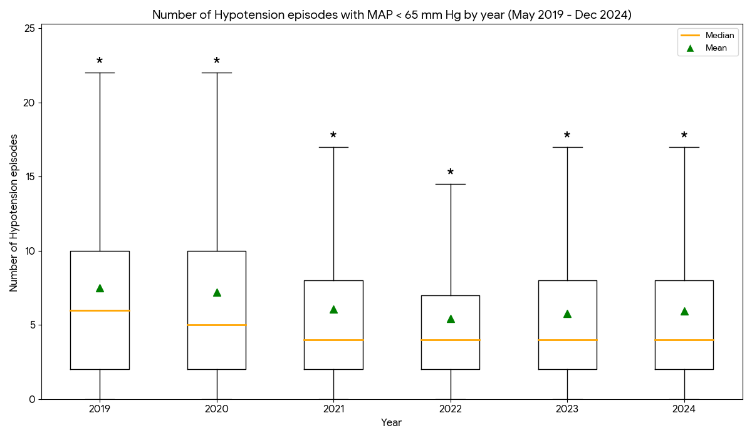
A²

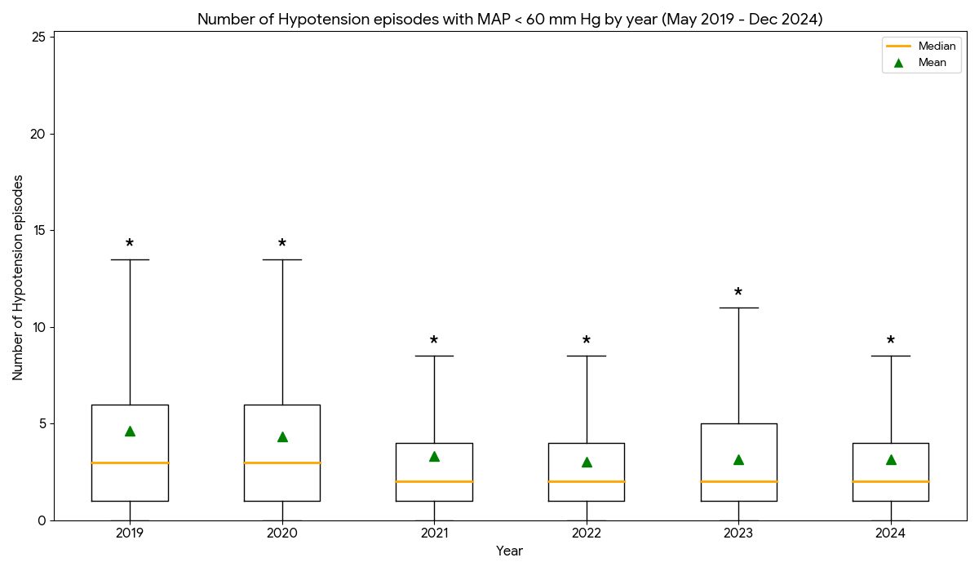

B²

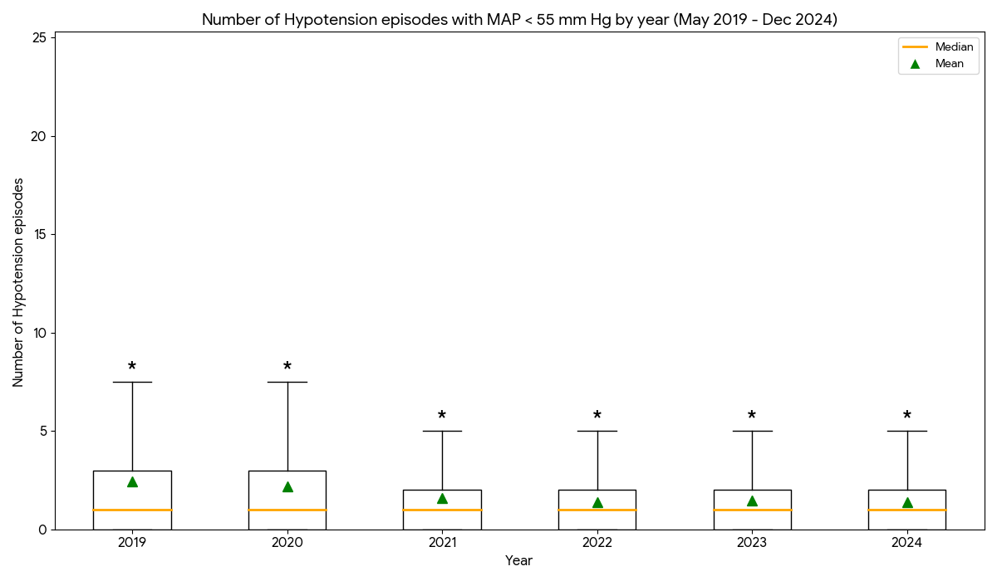

C²

²Annual distributions differed significantly for all thresholds (Kruskal-Wallis, A: H = 39.4, p < 0.001, B: H = 50.5, p < 0.001, C: H = 58.2, p < 0.001)

* indicates that extreme outliers beyond the upper whisker range (3rd quartile plus 1.5 times the interquartile range) and we have detailed the values here;

No of hypotension episodes MAP < 65 mm Hg: 2019 (22.00-38.00, n=16 (3.6%)), 2020 (22.00-47.00, n=21 (3.7%)), 2021 (17.00-40.00, n=28 (4.0%)), 2022 (14.50-31.00, n=33 (4.3%)), 2023 (17.00-38.00, n=37 (4.2%)), and 2024 (17.00-49.00, n=46 (5.2%)).

No of hypotension episodes MAP < 60 mm Hg: 2019 (13.50-40.00, n=20 (4.5%)), 2020 (13.50-42.00, n=26 (4.6%)), 2021 (8.50-27.00, n=45 (6.5%)), 2022 (8.50-23.00, n=33 (4.3%)), 2023 (11.00-29.00, n=31 (3.5%)), and 2024 (8.50-35.00, n=52 (5.8%)).

No of hypotension episodes MAP < 55 mm Hg: 2019 (7.50-35.00, n=21 (4.7%)), 2020 (7.50-29.00, n=28 (5.0%)), 2021 (5.00-20.00, n=35 (5.0%)), 2022 (5.00-15.00, n=28 (3.6%)), 2023 (5.00-19.00, n=39 (4.4%)), and 2024 (5.00-25.00, n=30 (3.4%)).

Appendix Figure 6.5: Annual cumulative duration of hypotension across all thresholds for major body cavity surgery.

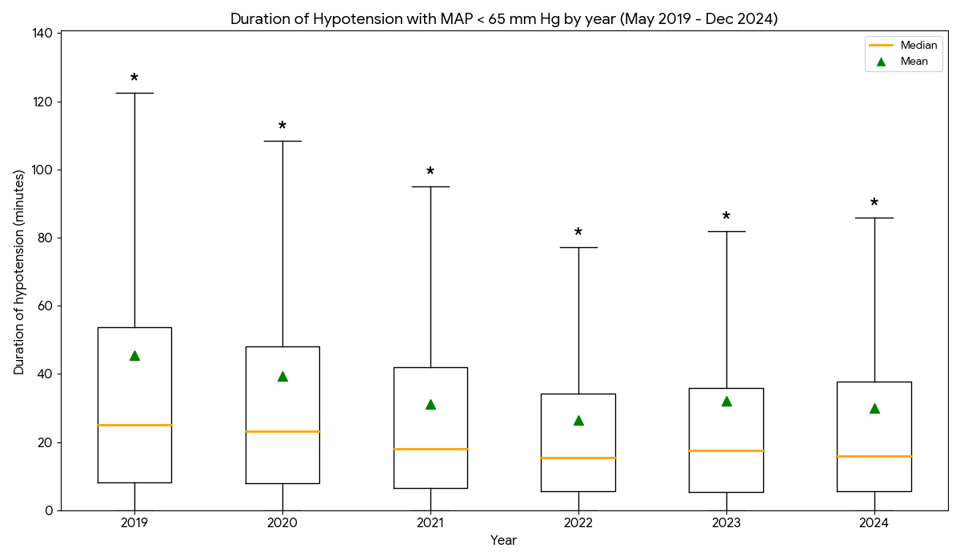
A³

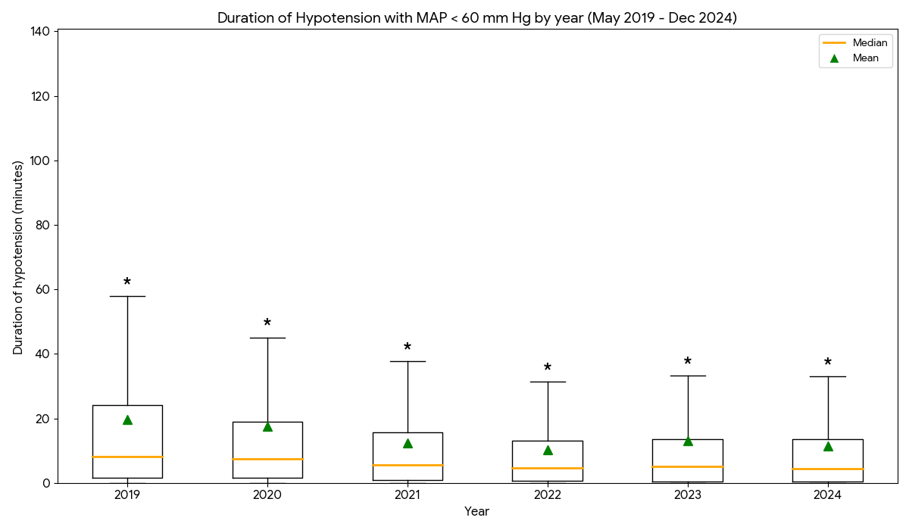

B³

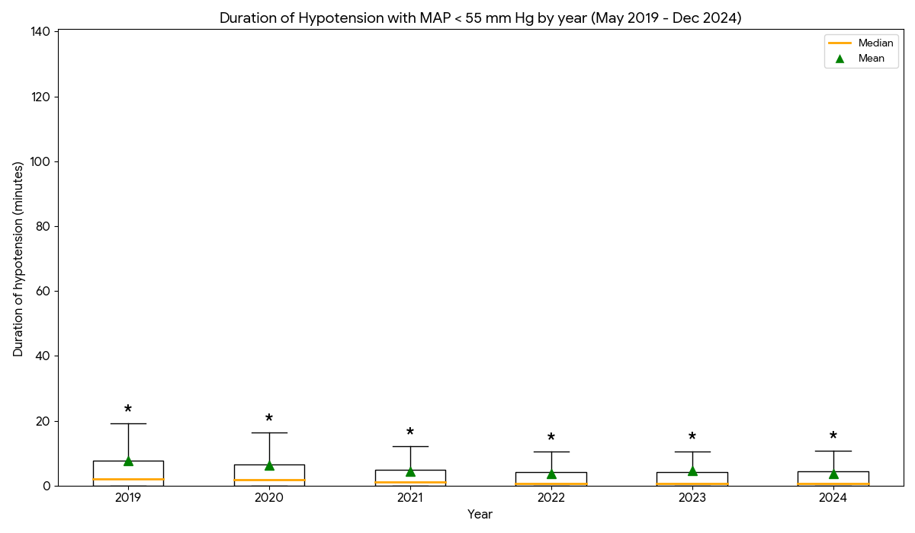

C³

¹Significant inter-year variation was observed in the total duration of hypotension (Kruskal-Wallis; A: H = 48.2, p < 0.001, B: H = 59.6, p < 0.001, C: H = 58.7, p < 0.001)

* indicates the extreme outliers beyond the upper whisker range (3rd quartile plus 1.5 times the interquartile range) and we have detailed the values here;

Duration of hypotension with MAP < 65 mm Hg: 2019 (122.42-864.99, n=37 (8.3%)), 2020 (108.39-489.68, n=50 (8.9%)), 2021 (94.98-420.09, n=42 (6.0%)), 2022 (77.20-688.99, n=52 (6.8%)), 2023 (81.78-1360.44, n=71 (8.0%)), and 2024 (85.84-364.43, n=68 (7.6%)).
Duration of hypotension with MAP < 60 mm Hg: 2019 (57.92-242.75, n=36 (8.1%)), 2020 (45.08-303.52, n=60 (10.7%)), 2021 (37.77-265.69, n=54 (7.8%)), 2022 (31.43-149.48, n=57 (7.4%)), 2023 (33.32-1009.39, n=63 (7.1%)), and 2024 (33.00-204.52, n=77 (8.6%)).

Duration of hypotension with MAP < 55 mm Hg: 2019 (19.20-135.37, n=42 (9.4%)), 2020 (16.27-152.73, n=51 (9.1%)), 2021 (12.07-168.44, n=72 (10.4%)), 2022 (10.43-80.57, n=76 (9.9%)), 2023 (10.60-590.25, n=93 (10.4%)), and 2024 (10.82-117.62, n=80 (9.0%)).

Appendix Figure 6.6: Annual incidences of patients experiencing $≥$ 1 hypotension episode for major body cavity surgery.

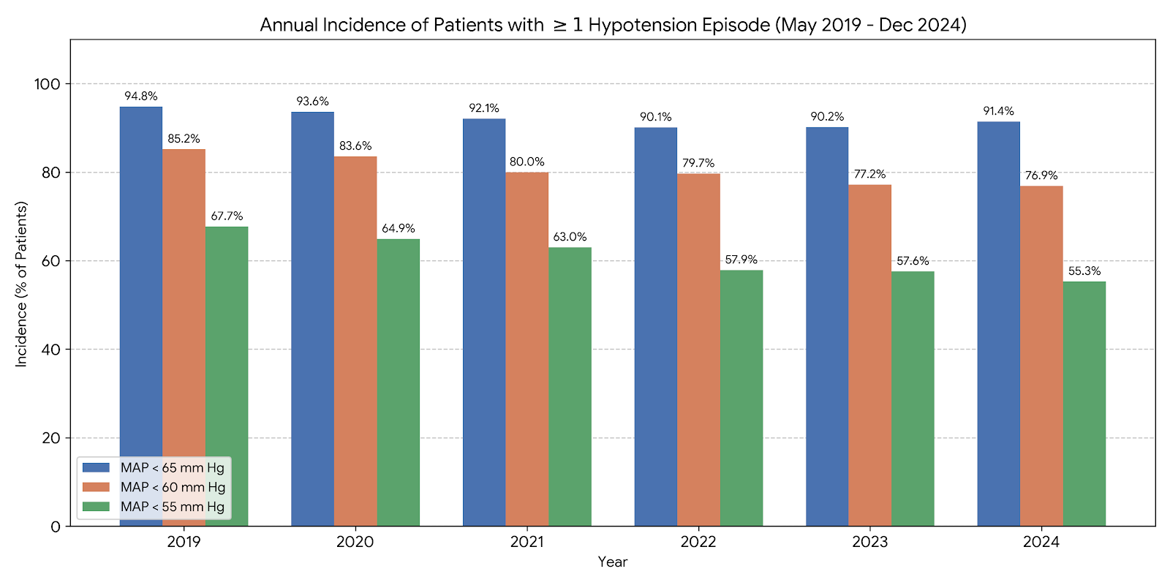

There was a statistically significant association between year and the incidence of hypotension across all thresholds (Pearson’s Chi-squared test, MAP < 65 mm Hg: X² = 13.7, p = 0.017, MAP < 60 mm Hg: X² = 21.4, p < 0.001, MAP < 55 mm Hg: X² = 31.0, p < 0.001).

Appendix Figure 6.7: Monthly mean TWA MAP < 65 mm Hg for major body cavity surgery.

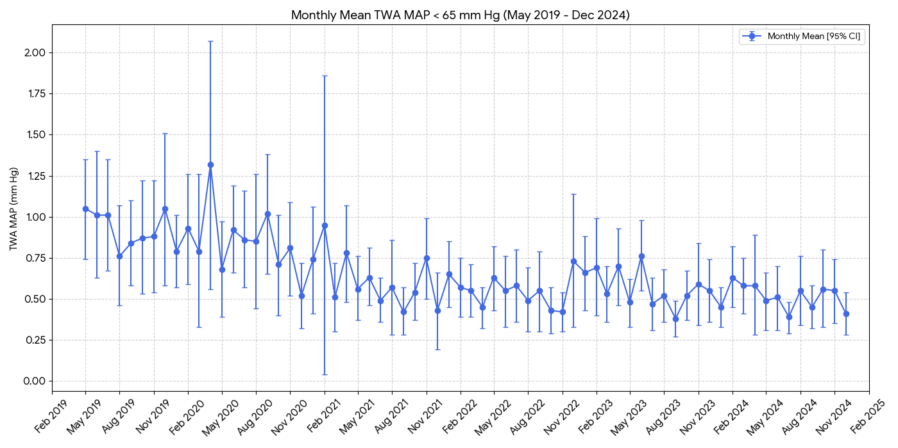

Appendix Figure 6.8: Monthly mean TWA MAP < 60 mm Hg for major body cavity surgery.
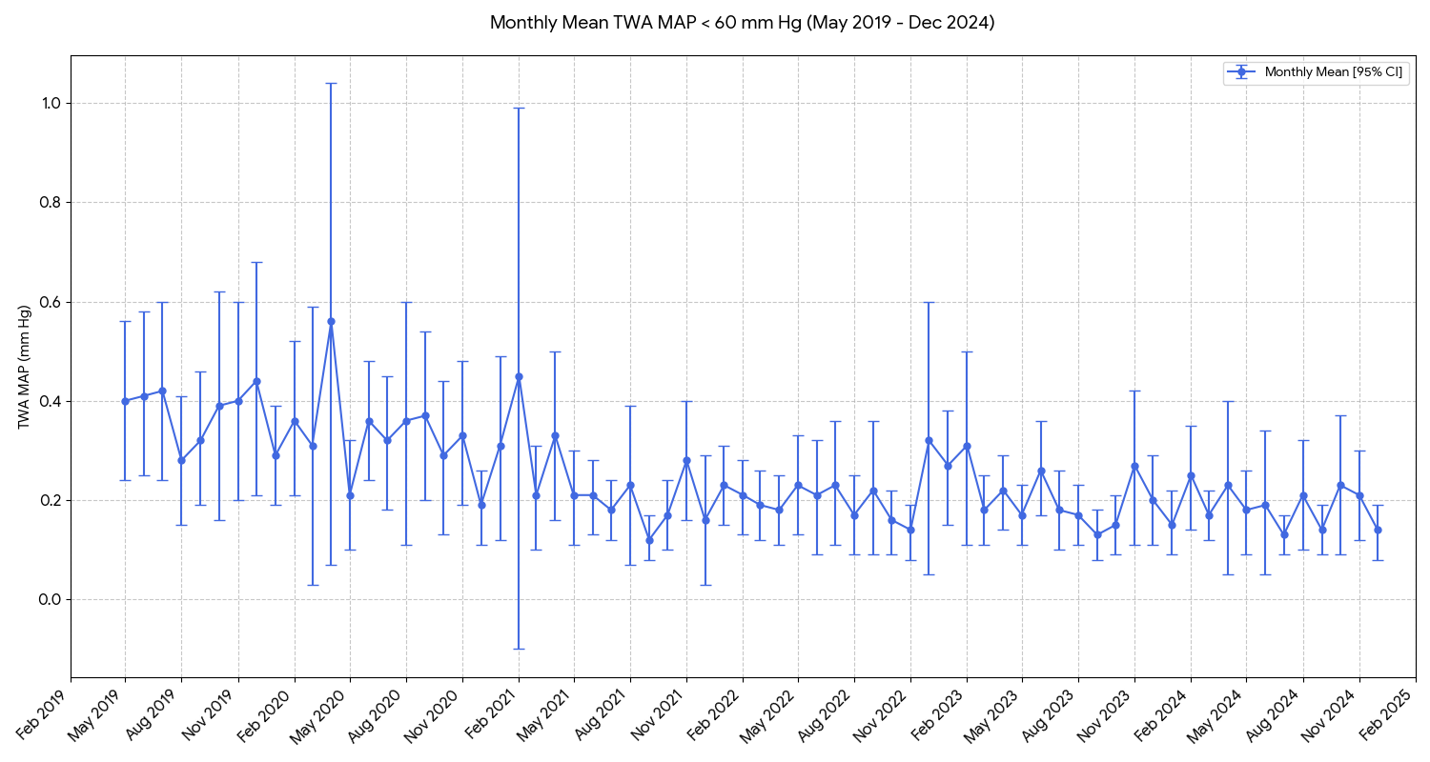

Appendix Figure 6.9: Monthly mean TWA MAP < 55 mm Hg for major body cavity surgery.

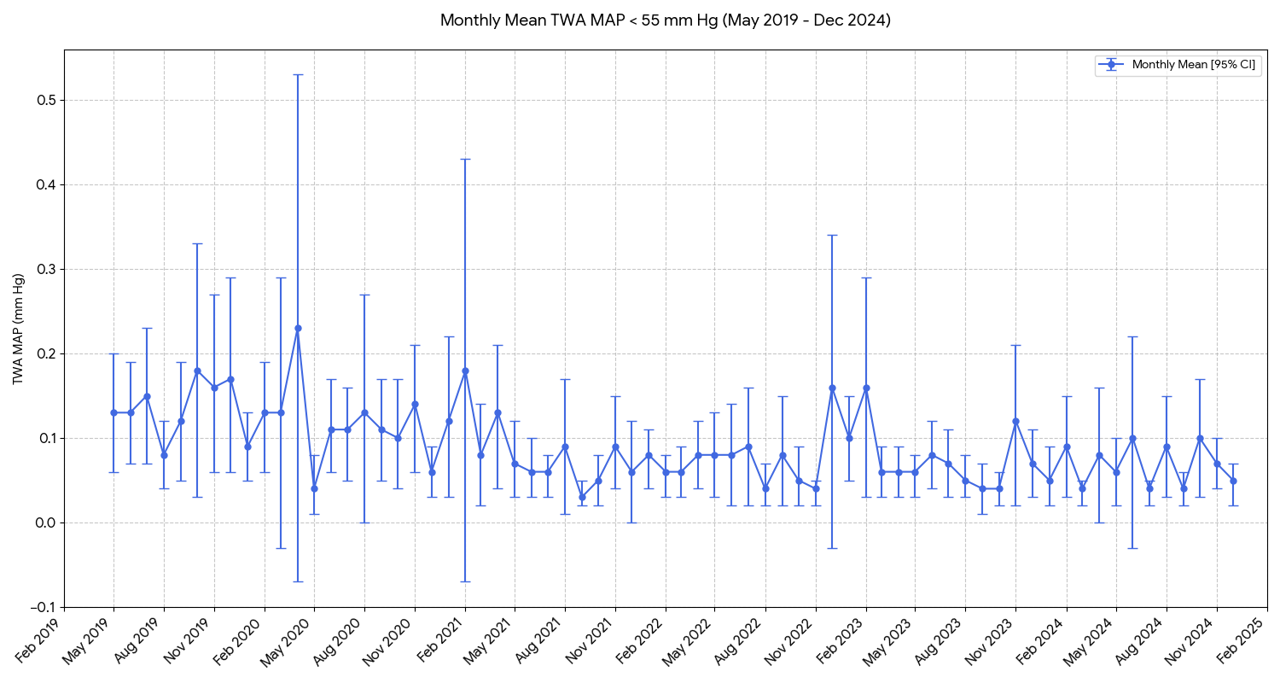

Appendix Figure 6.10: Monthly mean frequency of hypotension episodes MAP < 65 mm Hg for major body cavity surgery.
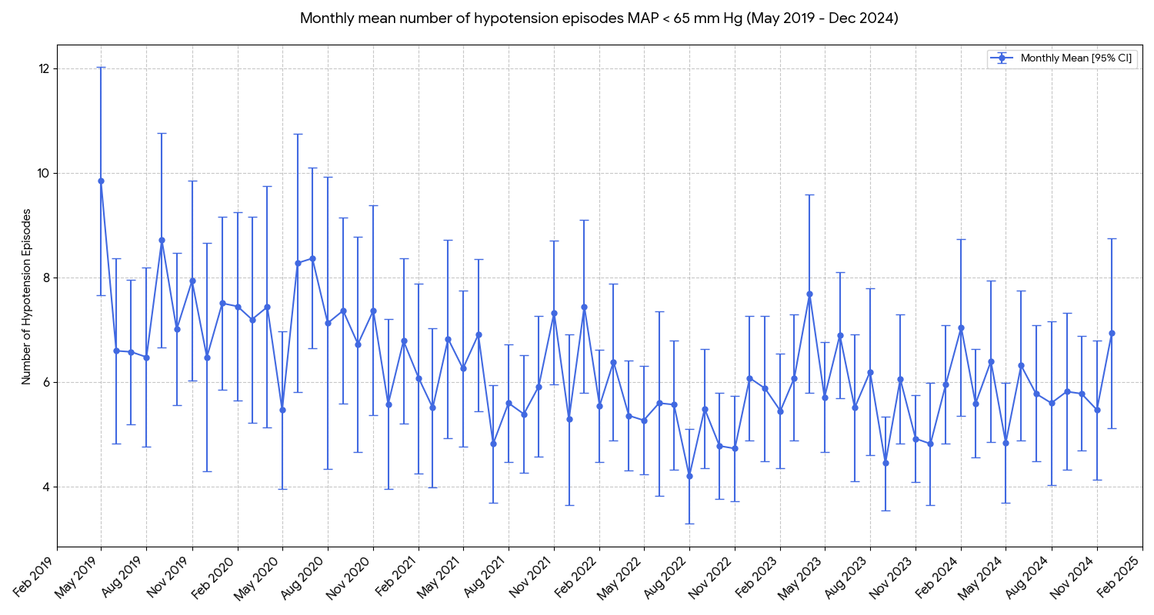

Appendix Figure 6.11: Monthly mean frequency of hypotension episodes MAP < 60 mm Hg for major body cavity surgery.

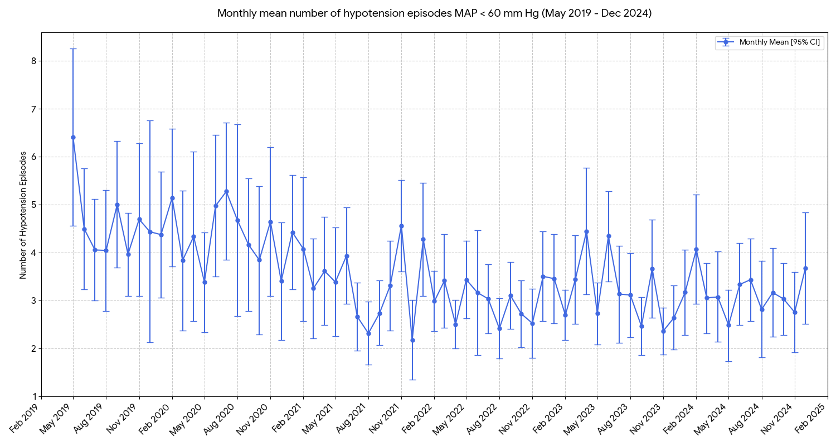

Appendix Figure 6.12: Monthly mean frequency of hypotension episodes MAP < 55 mm Hg for major body cavity surgery.

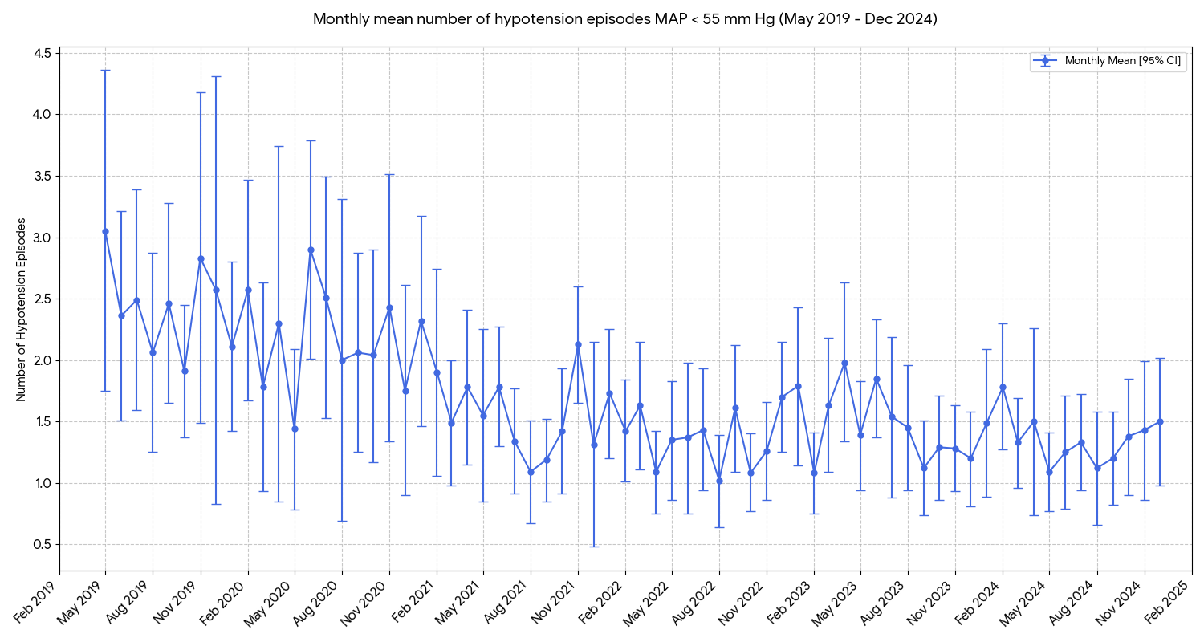

Appendix Figure 6.13: Monthly mean duration of hypotension MAP < 65 mm Hg for major body cavity surgery.

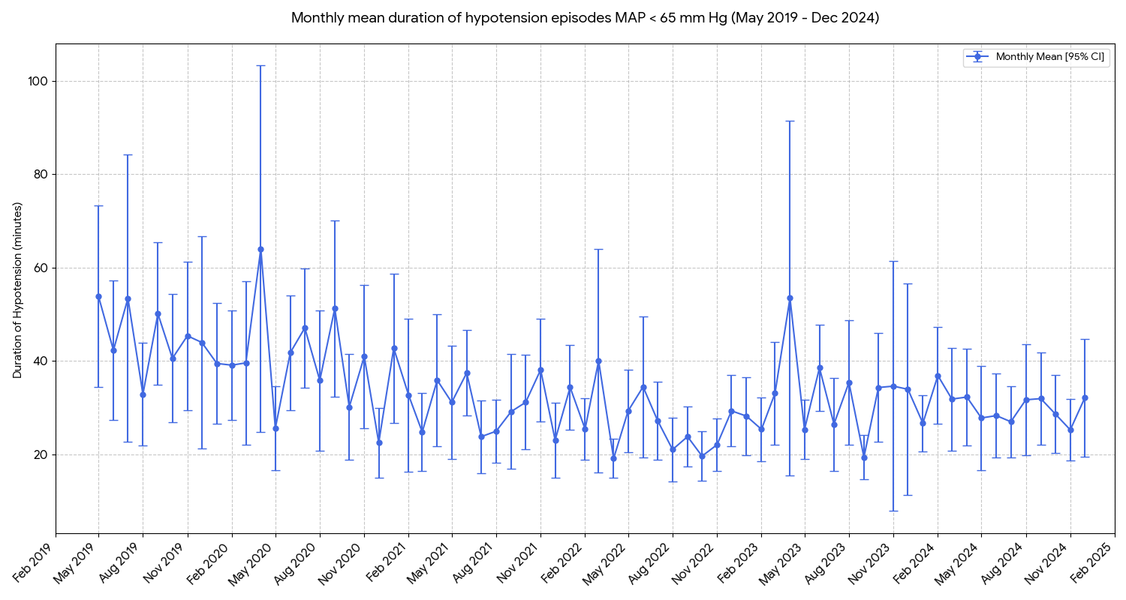

Appendix Figure 6.14: Monthly mean duration of hypotension MAP < 60 mm Hg for major body cavity surgery.

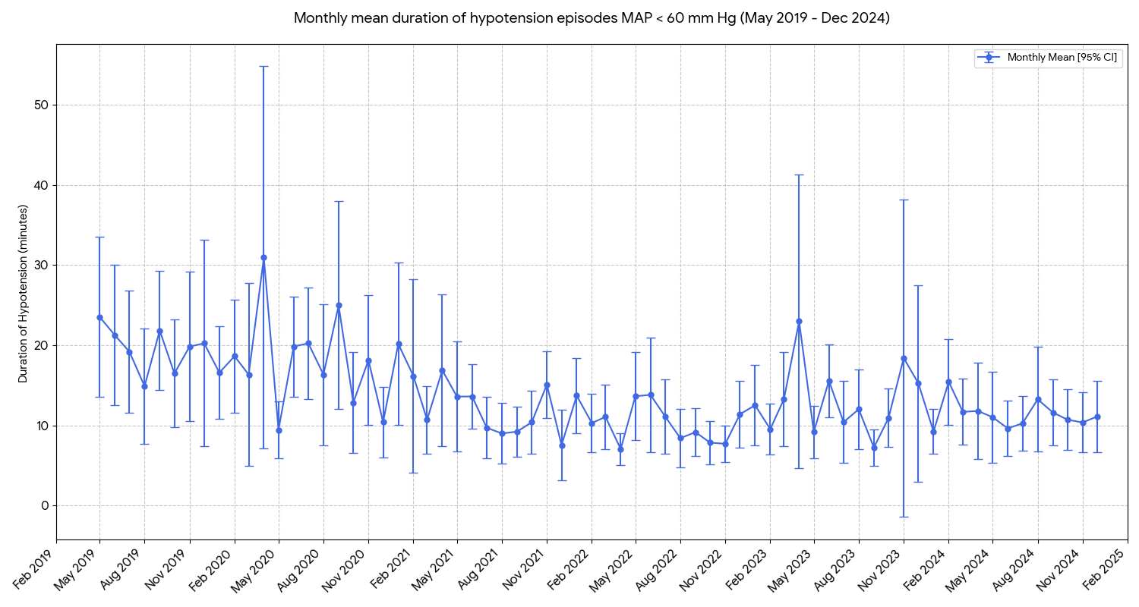

Appendix Figure 6.15: Monthly mean duration of hypotension MAP < 55 mm Hg for major body cavity surgery.

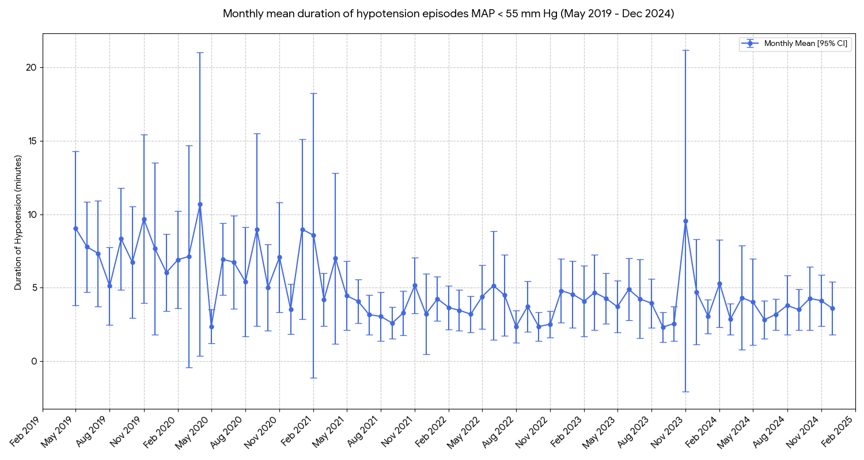

Appendix Figure 6.16: Monthly incidence of $≥$1 hypotensive episode MAP < 65 mm Hg for major body cavity surgery.

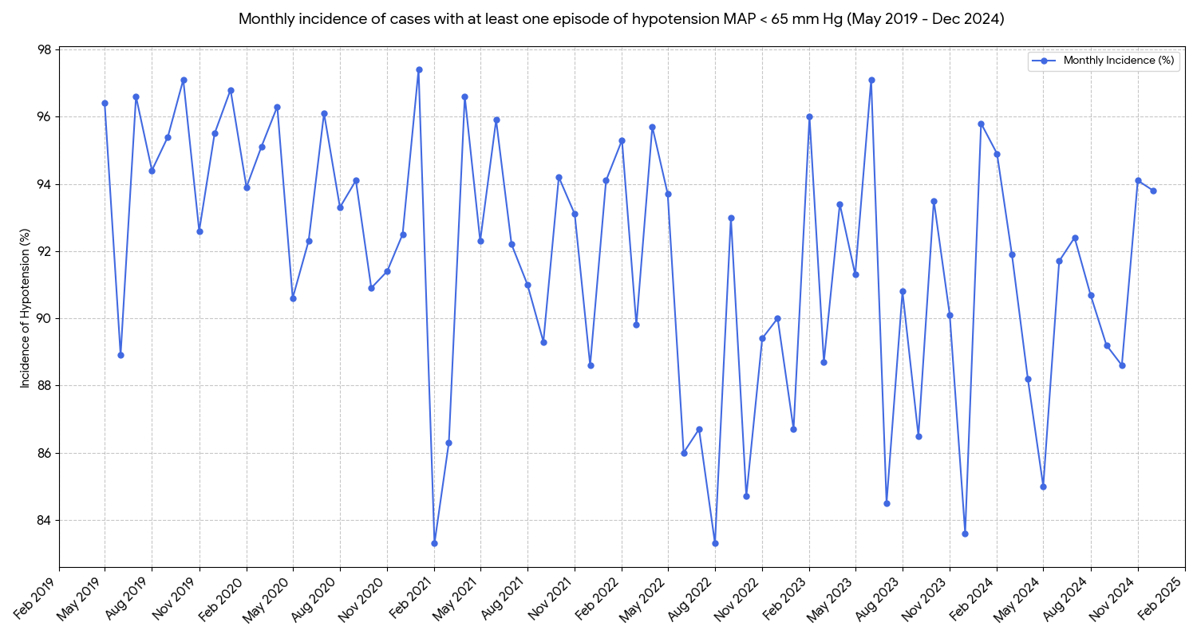

Appendix Figure 6.17: Monthly incidence of $≥$1 hypotensive episode MAP < 60 mm Hg for major body cavity surgery.

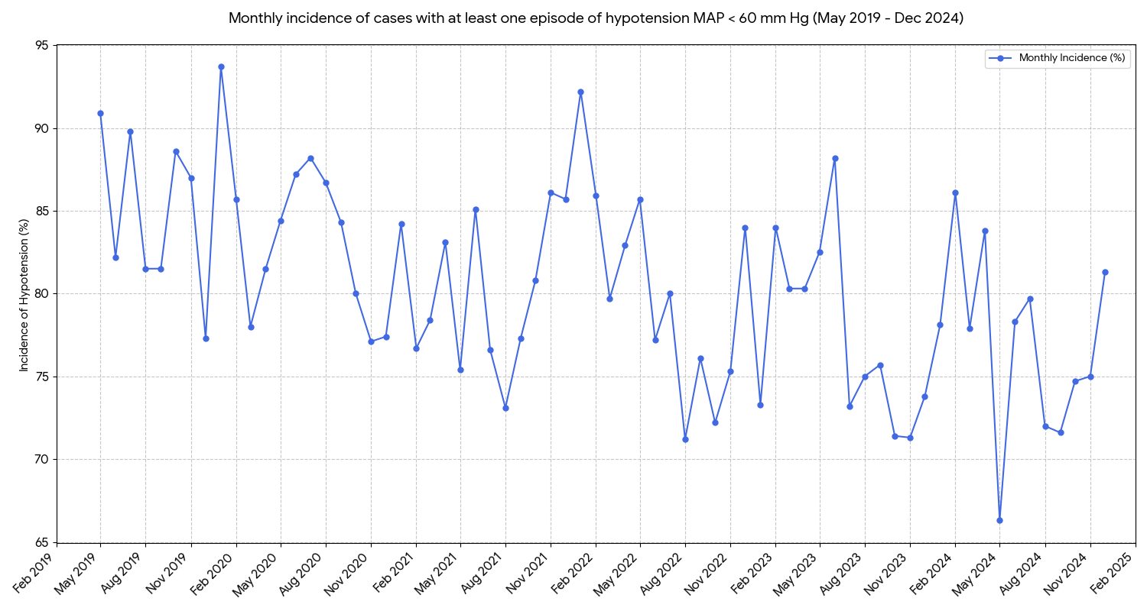

Appendix Figure 6.18: Monthly incidence of $≥$1 hypotensive episode MAP < 55 mm Hg for major body cavity surgery.

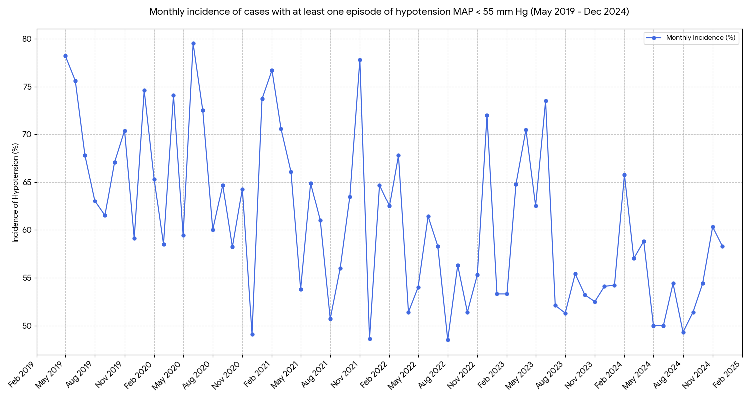

Appendix Table 6.19: Time series analysis of hypotension outcomes using Mann-Kendall testing (major body cavity surgery).

Variable Type | MAP Threshold | Metric (Monthly) | Kendall’s Tau (τ) | p-value | Trend
TWA MAP | < 65 mm Hg | Mean | -0.632 | < 0.001 | Decreasing
TWA MAP | < 65 mm Hg | Median | -0.589 | < 0.001 | Decreasing
TWA MAP | < 60 mm Hg | Mean | -0.565 | < 0.001 | Decreasing
TWA MAP | < 60 mm Hg | Median | -0.552 | < 0.001 | Decreasing
TWA MAP | < 55 mm Hg | Mean | -0.501 | < 0.001 | Decreasing
TWA MAP | < 55 mm Hg | Median | -0.410 | < 0.001 | Decreasing
Number of Hypotension Episodes | < 65 mm Hg | Mean | -0.373 | < 0.001 | Decreasing
Number of Hypotension Episodes | < 65 mm Hg | Median | -0.324 | < 0.001 | Decreasing
Number of Hypotension Episodes | < 60 mm Hg | Mean | -0.395 | < 0.001 | Decreasing
Number of Hypotension Episodes | < 60 mm Hg | Median | -0.288 | 0.002 | Decreasing
Number of Hypotension Episodes | < 55 mm Hg | Mean | -0.380 | < 0.001 | Decreasing
Number of Hypotension Episodes | < 55 mm Hg | Median | -0.245 | 0.012 | Decreasing
Duration of Hypotension | < 65 mm Hg | Mean | -0.402 | < 0.001 | Decreasing
Duration of Hypotension | < 65 mm Hg | Median | -0.365 | < 0.001 | Decreasing
Duration of Hypotension | < 60 mm Hg | Mean | -0.388 | < 0.001 | Decreasing
Duration of Hypotension | < 60 mm Hg | Median | -0.315 | 0.001 | Decreasing
Duration of Hypotension | < 55 mm Hg | Mean | -0.386 | < 0.001 | Decreasing
Duration of Hypotension | < 55 mm Hg | Median | -0.301 | 0.001 | Decreasing
Incidence of patients with $≥$ 1 episode of hypotension | < 65 mm Hg | % Rate | -0.413 | < 0.001 | Decreasing
Incidence of patients with $≥$ 1 episode of hypotension | < 60 mm Hg | % Rate | -0.485 | < 0.001 | Decreasing
Incidence of patients with $≥$ 1 episode of hypotension | < 55 mm Hg | % Rate | -0.467 | < 0.001 | Decreasing
The Mann-Kendall Tau statistic assesses the strength and direction of monotonic trends. A positive tau value denotes an increasing trend, and a negative tau value denotes a decreasing trend. The magnitude of tau reflects the consistency of the trend (closer to ±1 indicates a stronger trend).

Appendix Table 6.20: Mixed effects regression of hypotension outcomes for major body cavity surgery patients.

Outcome Measure | MAP  Threshold | Unadjusted Ratio (95% CI) | Adjusted Ratio (95% CI) | P-value
TWA MAP below threshold | < 65 mm Hg | 0.89 (0.87 – 0.92) | 0.89 (0.87 – 0.91) | < 0.001
 | < 60 mm Hg | 0.88 (0.84 – 0.91) | 0.87 (0.84 – 0.90) | < 0.001
 | < 55 mm Hg | 0.88 (0.84 – 0.92) | 0.87 (0.83 – 0.91) | < 0.001
Number of Hypotension episodes below MAP threshold | < 65 mm Hg | 0.95 (0.93 – 0.97) | 0.95 (0.93 – 0.96) | < 0.001
Number of Hypotension episodes below MAP threshold | < 60 mm Hg | 0.92 (0.90 – 0.94) | 0.92 (0.90 – 0.94) | < 0.001
Number of Hypotension episodes below MAP threshold | < 55 mm Hg | 0.89 (0.87 – 0.91) | 0.89 (0.86 – 0.91) | < 0.001
Duration of hypotension below MAP threshold | < 65 mm Hg | 0.93 (0.91 – 0.96) | 0.93 (0.91 – 0.96) | < 0.001
Duration of hypotension below MAP threshold | < 60 mm Hg | 0.91 (0.87 – 0.95) | 0.91 (0.87 – 0.94) | < 0.001
Duration of hypotension below MAP threshold | < 55 mm Hg | 0.89 (0.84 – 0.94) | 0.87 (0.83 – 0.92) | < 0.001
Incidence of $≥$ one episode of hypotension below MAP threshold | < 65 mm Hg | 0.91 (0.85 – 0.97) | 0.89 (0.83 – 0.95) | < 0.001
 | < 60 mm Hg | 0.90 (0.86 – 0.94) | 0.89 (0.84 – 0.93) | < 0.001
 | < 55 mm Hg | 0.90 (0.86 – 0.93) | 0.89 (0.85 – 0.92) | < 0.001

Generalised linear mixed effects models were used for all variables except incidence of $≥$ 1 episode of hypotension below MAP threshold, which required a mixed effects logistic regression model. Ratios presented are Odds Ratios for Incidence, Geometric Mean Ratios for Duration and TWA-MAP, and Rate Ratios for number of hypotension episodes. Ratios < 1.0 indicate a reduction in hypotension burden per year. Models were adjusted for Age, Sex, BMI, ASA physical status, Diabetes, Creatinine, Anaesthesia Type, Surgical Urgency, Cardiovascular Disease, and Preoperative Systolic BP.

Appendix Table 6.21: Mixed effects regression for TWA MAP across all thresholds for major body cavity surgery.

 | TWA MAP below threshold
Covariate | MAP < 65 mm Hg | MAP < 60 mm Hg | MAP < 55 mm Hg
Covariate | Adjusted Mean Ratio  (95% CI) | Adjusted Mean Ratio  (95% CI) | Adjusted Mean Ratio  (95% CI)
Year | 0.89 (0.87 - 0.91)*** | 0.87 (0.84 - 0.90)*** | 0.87 (0.83 - 0.91)***
Age | 1.00 (0.99 - 1.00) | 1.00 (1.00 - 1.01) | 1.00 (1.00 - 1.01)
Male Sex | 0.93 (0.84 - 1.03) | 0.95 (0.82 - 1.09) | 1.01 (0.84 - 1.22)
BMI | 0.99 (0.98 - 0.99)*** | 0.99 (0.98 - 1.00)* | 1.00 (0.98 - 1.01)
Diabetes | 1.13 (1.01 - 1.27)* | 1.16 (0.99 - 1.35) | 1.14 (0.94 - 1.40)
Preoperative Creatinine | 0.94 (0.81 - 1.10) | 0.92 (0.75 - 1.13) | 0.89 (0.68 - 1.17)
Preoperative  Systolic Blood Pressure | 1.00 (0.99 - 1.00)* | 1.00 (0.99 - 1.00)* | 0.99 (0.99 - 1.00)*
General Anaesthesia | 2.76 (1.07 - 7.09)* | 2.84 (0.81 - 10.01) | 2.70 (0.51 - 14.23)
Elective Surgery | 0.79 (0.60 - 1.05) | 0.76 (0.52 - 1.10) | 0.73 (0.45 - 1.19)
Composite of CVD | 0.97 (0.85 - 1.12) | 0.93 (0.77 - 1.13) | 0.87 (0.68 - 1.12)
ASA Physical Status
(reference: ASA 1)

ASA 2 | 0.98 (0.56 - 1.74) | 1.40 (0.65 - 3.01) | 1.51 (0.55 - 4.11)
ASA 3 | 1.00 (0.57 - 1.77) | 1.47 (0.69 - 3.13) | 1.54 (0.57 - 4.22)
ASA 4 | 0.85 (0.46 - 1.56) | 1.27 (0.56 - 2.87) | 1.46 (0.50 - 4.26)
*** p < 0.001; ** p < 0.01; * p < 0.05.

Appendix Table 6.22: Mixed effects regression for frequency of hypotension episodes across thresholds (major body cavity surgery).

 | No. of Hypotension episodes below MAP threshold
 | MAP < 65 mm Hg | MAP < 60 mm Hg | MAP < 55 mm Hg
Covariate | Adjusted Rate Ratio  (95% CI) | Adjusted Rate Ratio  (95% CI) | Adjusted Rate Ratio  (95% CI)
Year | 0.95 (0.93 - 0.96)*** | 0.92 (0.90 - 0.94)*** | 0.89 (0.86 - 0.91)***
Age | 1.00 (1.00 - 1.00)* | 1.00 (1.00 - 1.00) | 1.00 (1.00 - 1.00)
Male Sex | 0.95 (0.89 - 1.02) | 0.94 (0.87 - 1.02) | 0.94 (0.85 - 1.03)
BMI | 0.99 (0.98 - 0.99)*** | 0.98 (0.98 - 0.99)*** | 0.99 (0.98 - 0.99)***
Diabetes | 1.03 (0.96 - 1.11) | 1.06 (0.97 - 1.16) | 1.08 (0.97 - 1.20)
Preoperative Creatinine | 0.95 (0.86 - 1.05) | 0.96 (0.86 - 1.08) | 1.03 (0.89 - 1.19)
Preoperative  Systolic Blood Pressure | 1.00 (1.00 - 1.00)*** | 1.00 (1.00 - 1.00)** | 1.00 (0.99 - 1.00)***
General Anaesthesia | 5.85 (2.64 - 12.97)*** | 9.48 (2.96 - 30.36)*** | 19.32 (2.41 - 154.62)**
Elective Surgery | 0.83 (0.70 - 0.98)* | 0.77 (0.63 - 0.94)* | 0.73 (0.57 - 0.93)*
Composite of CVD | 0.93 (0.85 - 1.02) | 0.91 (0.82 - 1.02) | 0.85 (0.75 - 0.98)*
ASA Physical Status
(ref: ASA 1)

ASA 2 | 1.11 (0.78 - 1.58) | 1.20 (0.78 - 1.84) | 1.32 (0.77 - 2.28)
ASA 3 | 1.14 (0.80 - 1.63) | 1.26 (0.82 - 1.93) | 1.47 (0.85 - 2.54)
ASA 4 | 1.07 (0.74 - 1.57) | 1.21 (0.76 - 1.91) | 1.35 (0.76 - 2.42)
*** p < 0.001; ** p < 0.01; * p < 0.05.

Appendix table 6.23: Mixed effects regression for cumulative duration of hypotension across thresholds (major body cavity surgery).
*** p < 0.001; ** p < 0.01; * p < 0.05.
Covariate | Duration of Hypotension below MAP threshold
Covariate | MAP < 65 mm Hg | MAP < 60 mm Hg | MAP < 55 mm Hg
Covariate | Adjusted Mean Ratio (95% CI) | Adjusted Mean Ratio (95% CI) | Adjusted Mean Ratio  (95% CI)
Year | 0.93 (0.91 - 0.96)*** | 0.91 (0.87 - 0.94) *** | 0.87 (0.83 - 0.92) ***
Age | 0.99 (0.99 - 1.00) *** | 1.00 (0.99 - 1.00) | 1.00 (0.99 - 1.01)
Male Sex | 0.97 (0.87 - 1.08) | 0.98 (0.84 - 1.13) | 0.97 (0.80 - 1.18)
BMI | 0.98 (0.98 - 0.99) *** | 0.99 (0.98 - 0.99) ** | 0.99 (0.98 - 1.00)
Diabetes | 1.11 (0.99 - 1.25) | 1.23 (1.05 - 1.43) * | 1.35 (1.09 - 1.66) **
Preoperative Creatinine | 0.96 (0.82 - 1.13) | 0.91 (0.74 - 1.13) | 0.93 (0.70 - 1.23)
Preoperative  Systolic Blood Pressure | 1.00 (0.99 - 1.00) ** | 1.00 (0.99 - 1.00) ** | 0.99 (0.99 - 1.00) ***
General Anaesthesia | 4.20 (1.57 - 11.28) ** | 0.00 (0.00 - 0.00)‡ | 10.59 (1.90 - 59.09) **
Elective Surgery | 0.79 (0.59 - 1.06) | 0.74 (0.50 - 1.08) | 0.69 (0.42 - 1.15)
Composite of CVD | 0.98 (0.84 - 1.13) | 1.03 (0.84 - 1.25) | 1.02 (0.79 - 1.32)
ASA Physical Status
(Ref: ASA 1)

ASA 2 | 0.86 (0.48 - 1.57) | 1.36 (0.62 - 2.98) | 1.59 (0.56 - 4.49)
ASA 3 | 0.87 (0.48 - 1.57) | 1.33 (0.60 - 2.91) | 1.66 (0.59 - 4.68)
ASA 4 | 0.74 (0.39 - 1.41) | 1.12 (0.48 - 2.60) | 1.42 (0.47 - 4.32)

‡For the model for duration of hypotension below MAP 60mm Hg, the coefficient for General Anaesthesia (B= -20.354, p < 0.001) reached a mathematical limit due to a sample size imbalance in the reference group (No General Anaesthesia). Because the mean duration in this reference group was near zero (0.09), the model produced an extreme negative coefficient to approximate the baseline, rendering the specific ratio for this variable statistically unstable for this threshold. Interpretations of the effect size for General Anaesthesia should be deferred to the more stable regression models from the other outcome variables.

Appendix Table 6.24: Mixed effects regression for incidence of hypotension across thresholds (major body cavity surgery).

Covariate | Incidence of patients with $≥$ 1 episode of Hypotension below MAP thresholds
Covariate | MAP < 65 mm Hg | MAP < 60 mm Hg | MAP < 55 mm Hg
Covariate | Adjusted Odds Ratio  (95% CI) | Adjusted Odds Ratio  (95% CI) | Adjusted Odds Ratio  (95% CI)
Year | 0.89 (0.83 - 0.95)*** | 0.89 (0.84 - 0.93)*** | 0.89 (0.85 - 0.92)***
Age | 1.02 (1.01 - 1.02)*** | 1.01 (1.01 - 1.02)*** | 1.01 (1.00 - 1.01)***
Sex | 1.07 (0.83 - 1.38) | 0.89 (0.74 - 1.06) | 0.90 (0.78 - 1.05)
BMI | 0.98 (0.96 - 0.99)** | 0.98 (0.97 - 0.99)*** | 0.99 (0.98 - 1.00)**
Diabetes | 0.98 (0.74 - 1.30) | 0.90 (0.74 - 1.10) | 1.02 (0.87 - 1.20)
Preoperative Creatinine | 0.79 (0.55 - 1.15) | 0.85 (0.66 - 1.11) | 1.07 (0.86 - 1.34)
Preoperative  Systolic Blood Pressure | 0.99 (0.98 - 1.00)*** | 0.99 (0.99 - 1.00)*** | 0.99 (0.99 - 1.00)***
General Anaesthesia | 14.07 (3.53 - 56.12)*** | 22.17 (4.47 - 109.84)*** | 18.21 (2.24 - 147.88)**
Elective Surgery | 1.30 (0.68 - 2.50) | 0.81 (0.48 - 1.36) | 0.82 (0.54 - 1.24)
Composite of CVD | 0.78 (0.56 - 1.10) | 0.90 (0.71 - 1.15) | 0.87 (0.71 - 1.06)
ASA Physical Status
(Ref: ASA 1)

ASA 2 | 0.50 (0.07 - 3.76) | 0.87 (0.29 - 2.58) | 0.94 (0.41 - 2.16)
ASA 3 | 0.58 (0.08 - 4.33) | 0.94 (0.32 - 2.80) | 1.04 (0.45 - 2.39)
ASA 4 | 0.37 (0.05 - 2.93) | 0.68 (0.22 - 2.12) | 0.84 (0.35 - 2.04)
*** p < 0.001; ** p < 0.01; * p < 0.05.

Appendix Table 6.25 Multivariable regression between surgical specialty and TWA MAP < 65 mm Hg.

Covariate | Unadjusted Ratio  (95% CI) | P | Adjusted Ratio†  (95% CI) | P
Year | — | — | 0.89 (0.87 – 0.91) | <0.001
Type of Surgery
Urology | Ref | — | Ref | —
Thoracic | 1.36 (1.21 – 1.52) | <0.001 | 1.41 (1.25 – 1.59) | <0.001
General Surgery | 1.16 (0.92 – 1.47) | 0.21 | 1.24 (0.98 – 1.57) | 0.07
Colorectal Surgery | 1.07 (0.95 – 1.20) | 0.29 | 1.12 (0.99 – 1.27) | 0.07
Upper Gastro-intestinal | 1.00 (0.86 – 1.15) | 0.96 | 1.03 (0.89 – 1.19) | 0.72
Bariatrics | 0.97 (0.73 – 1.27) | 0.80 | 1.08 (0.81 – 1.44) | 0.59
Gynaecology | 0.96 (0.85 – 1.07) | 0.44 | 0.96 (0.84 – 1.10) | 0.52

† Adjusted for Age, Sex, BMI, ASA physical status, Year of surgery, Elective surgery, General Anaesthesia, diabetes, composite of CVD, preoperative systolic BP and preoperative creatinine. Ratios presented are Mean Ratios.

