Supplementary Fig. 1 17-mer frequency distribution of ginkgo genome sequencing.

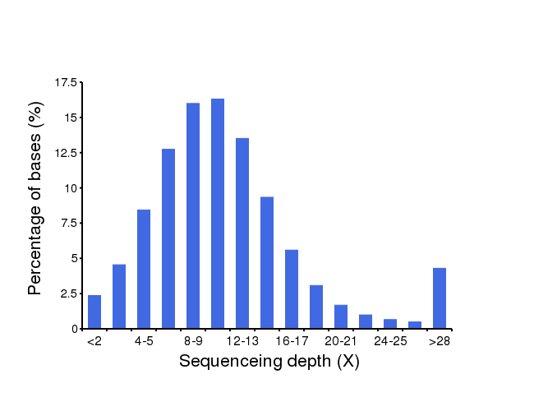
Supplementary Fig. 2 Distribution of sequence depth for the ginkgo genome. The x-axis represents the depth and the y-axis represents the proportion of the corresponding DNA bases. Clean reads were aligned against genic regions and the percentage of bases with different sequencing depth was calculated.
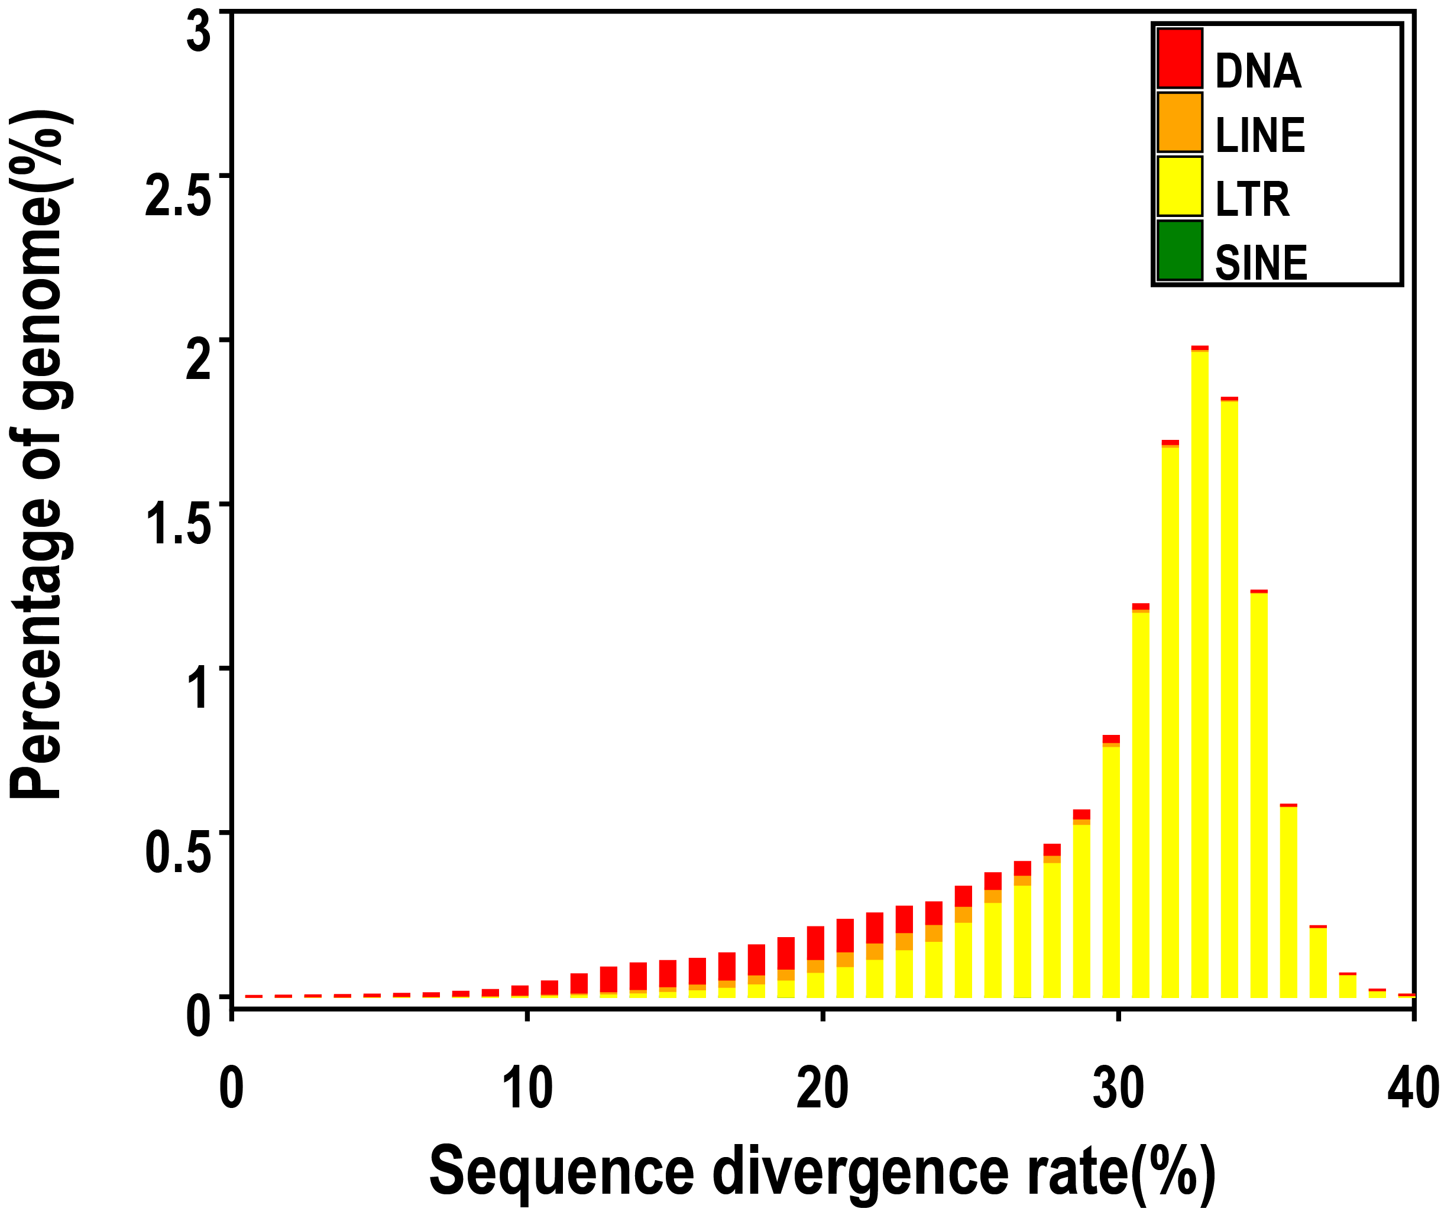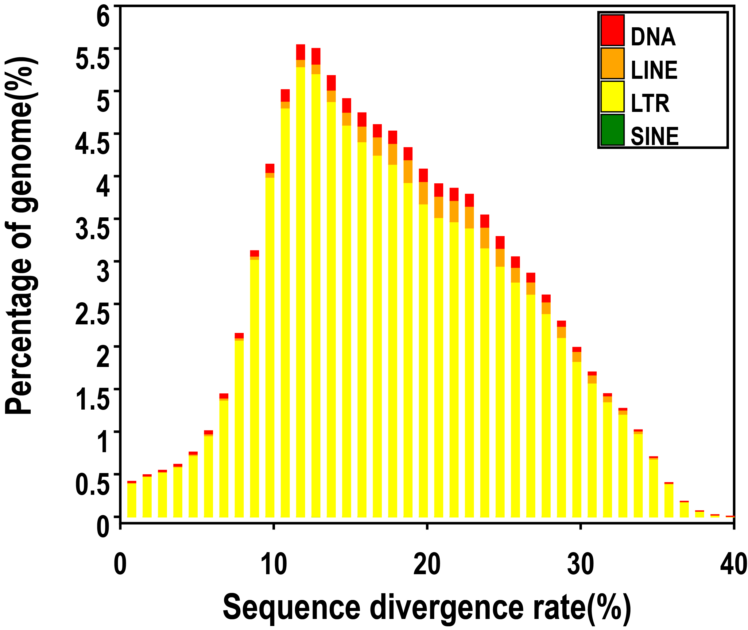
a
b
Supplementary Fig. 3 The distribution of sequence divergence rates of TEs in the ginkgo genome. (a) Based on the Repbase-comparison approach; (b) Based on the de novo approach.
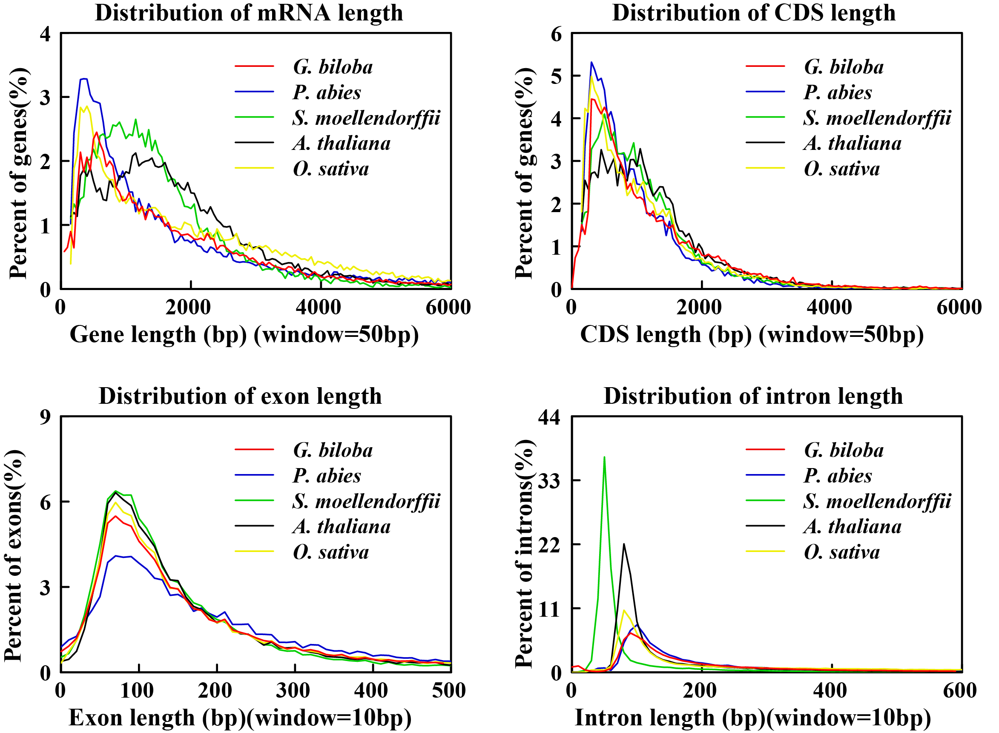
Supplementary Fig. 4Comparison of the length distribution of gene sets in ginkgo and four other land plants.

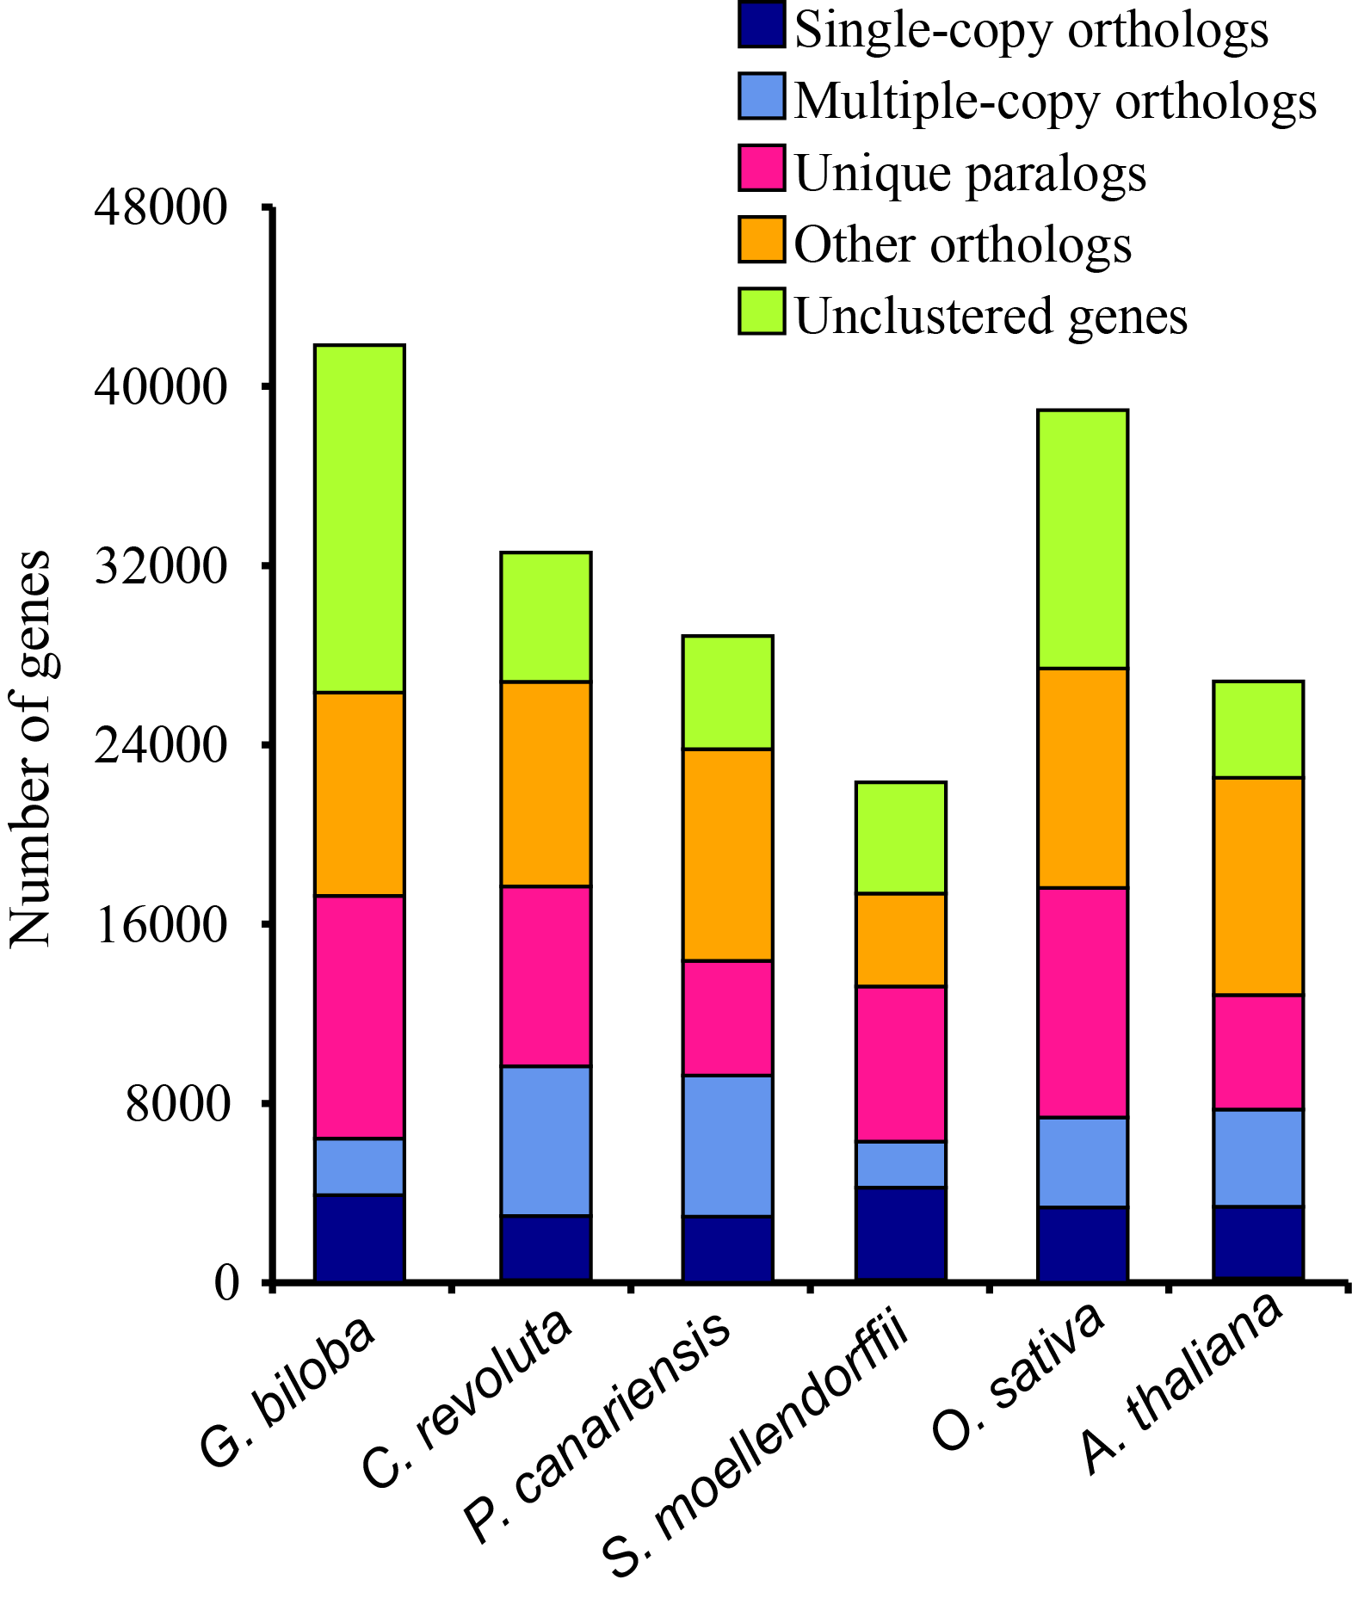
Supplementary Fig. 5 Comparison of orthologous genes in ginkgo and five other land plants.

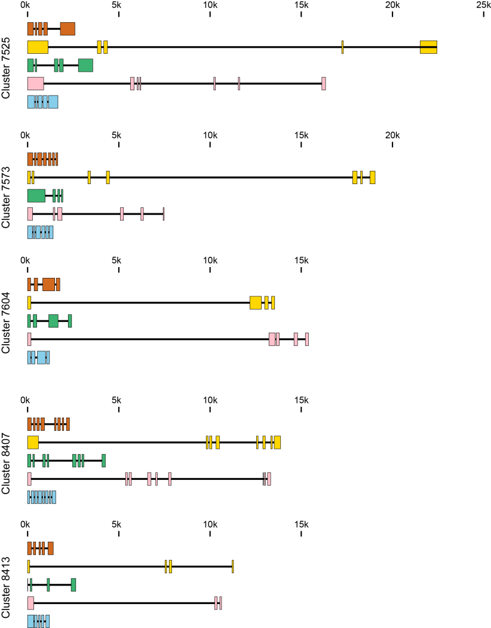
Supplementary Fig. 6 Comparison of gene structure in G. biloba and four other land plants. Five land plants are included in each gene cluster: A. thalina in orange, G. biloba in yellow, O. sativa in green, P. abies in pink and S. moellendorffii in blue.
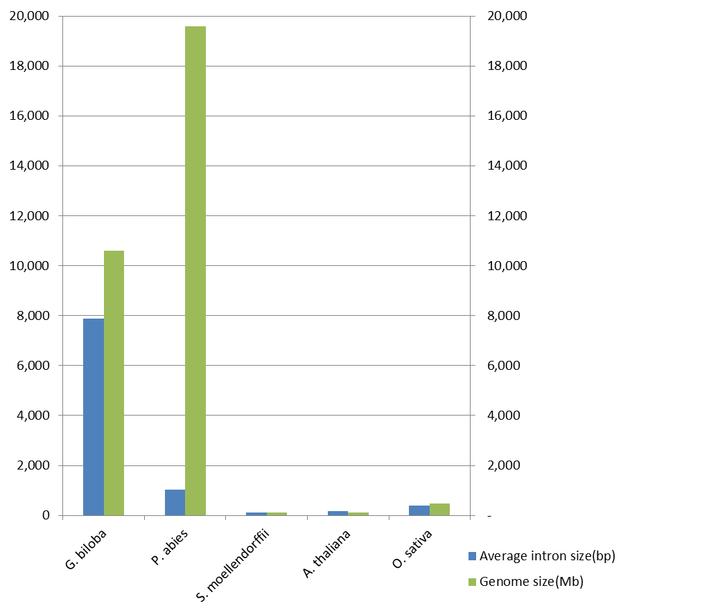
Supplementary Fig. 7 Comparison of genome size and average intron length between ginkgo and four other land plants. Note that the intron size in P. abies might be underestimated due to the assembly quality of its genome.
Supplementary Fig. 8 Comparison of the distribution of repeat elements between intergenic and intron regions in ginkgo.

