Meta-analysis Results

In the following pages we provide the outputs from analyses conducted using the metaphor package within R (see manuscript for citations). For each of 10 sets of meta-analyses we show the results according to the methods. For the data file used in analysis and the R scripts see Additional Files appended to the final report.

- All vascular plant richness
  - Model code
VascRichS<-subset(burn,(Taxon=="Vasc"|Taxon=="NativNNativ"|Taxon=="NativV"|Taxon=="VascHVascW")&(Outcome=="RichS"|Outcome=="RichG/S"))
rmaData<-rma.mv(yi=SMD_g,V=SMD_Vg,data=VascRichS,random=~1|Site_ID)

  - Unmoderated model
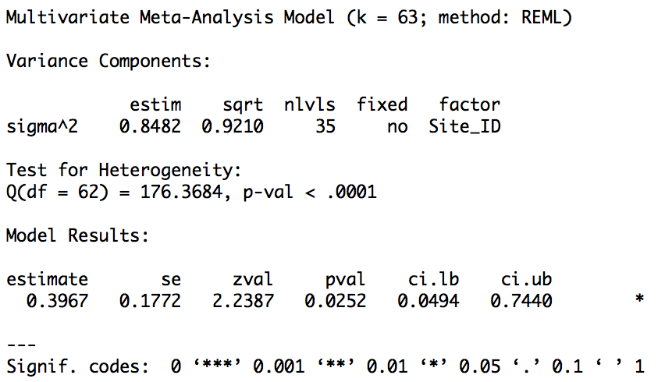

  - Forest plot
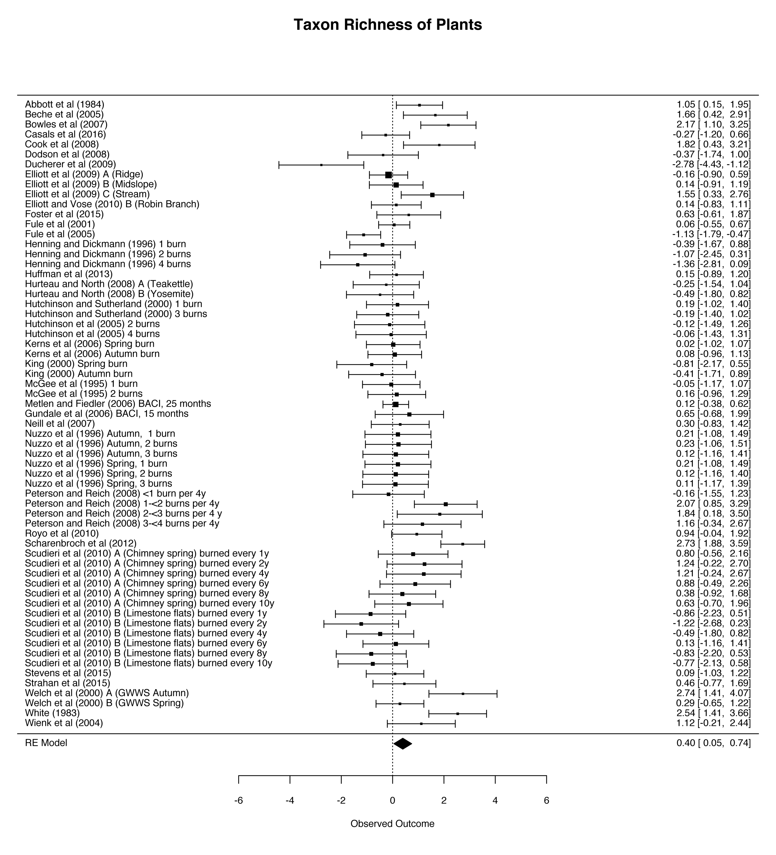

  - Funnel plot

  - Failsafe number
N=331

  - Cook’s Distance plot

  - Sensitivity analysis for critical appraisal

  - Moderated models
    - Forest type
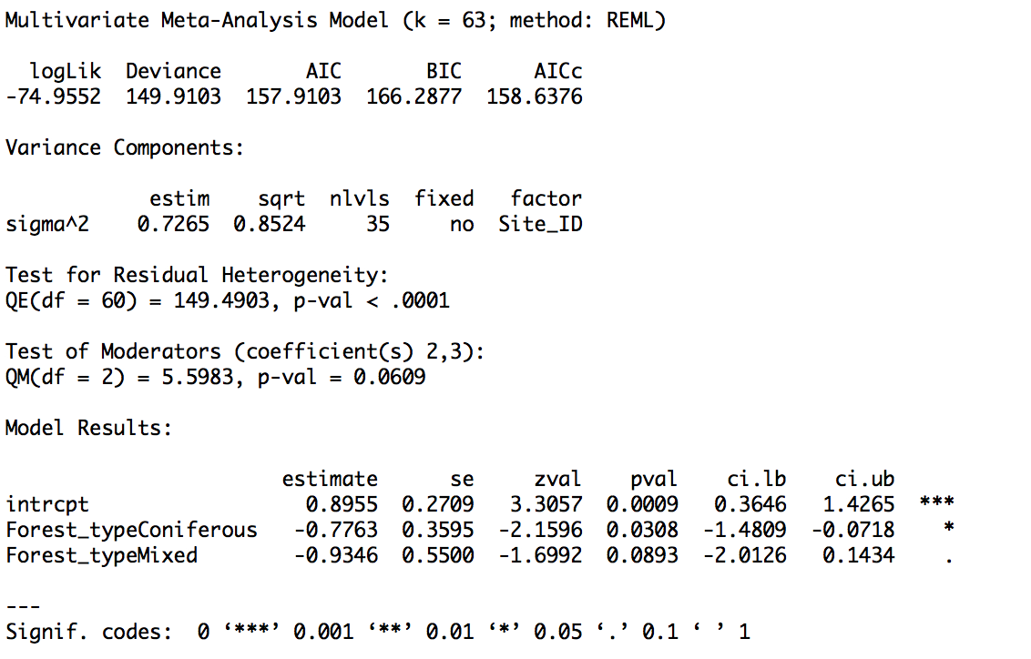

      - Broadleaf

      - Coniferous

      - Mixed

    - Burn frequency
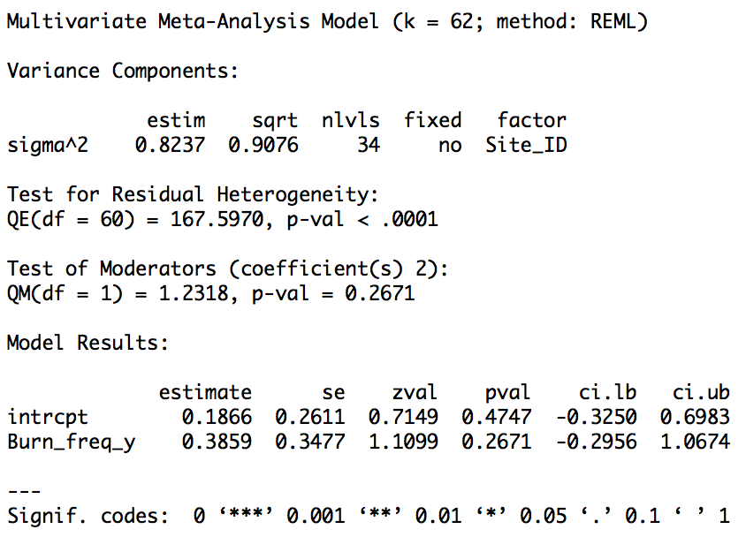

    - Time since burn
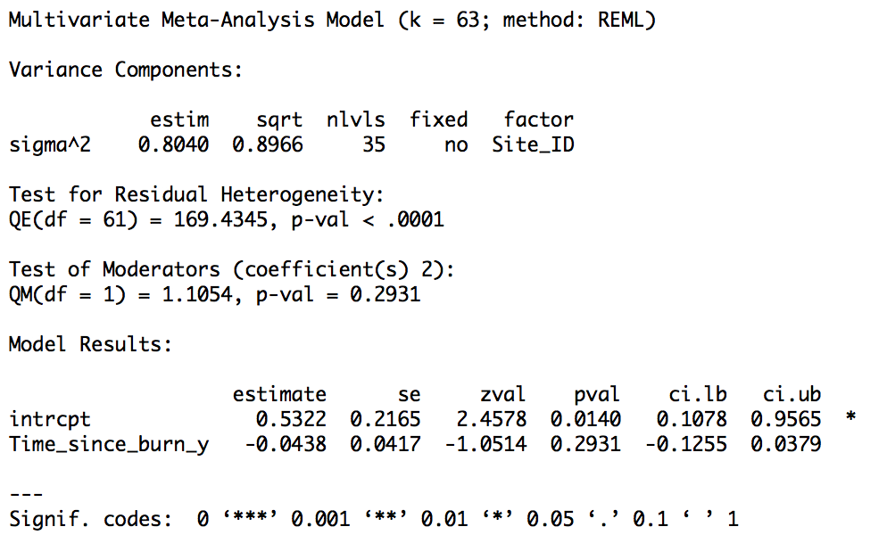

    - Burn season
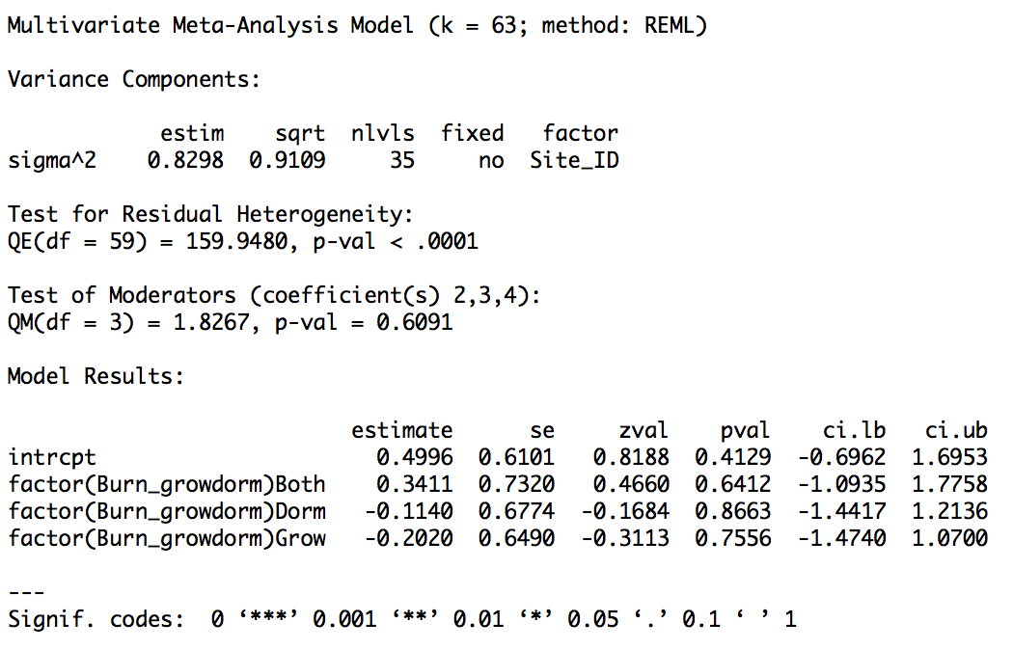

    - Climate zone
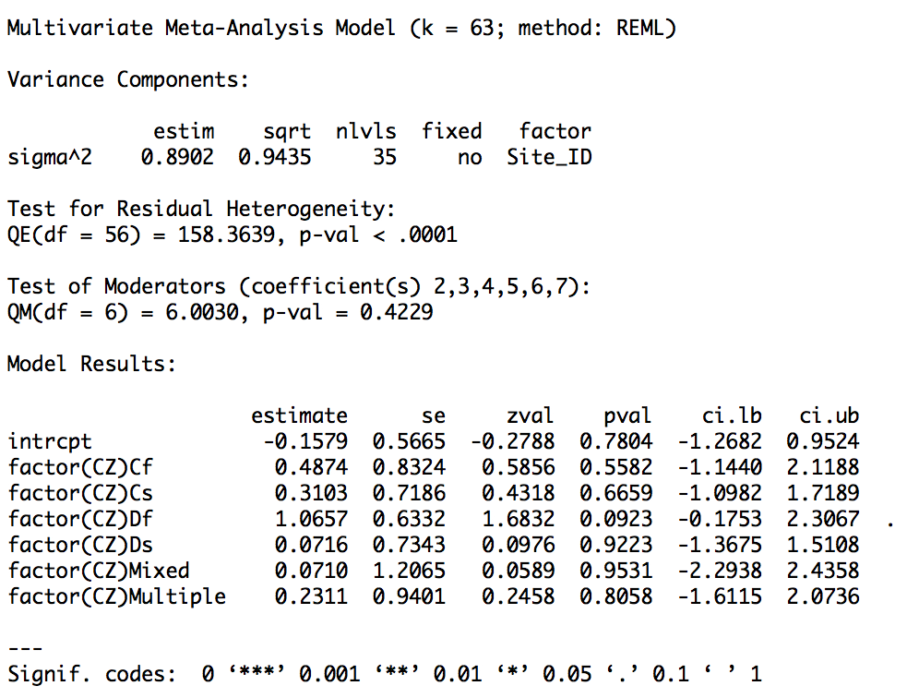
- Non-native vascular plant richness
  - Model code
NNativRichS<-subset(burn,Taxon=="NNativ"&(Outcome=="RichS"|Outcome=="RichG/S"))
rmaData<-rma.mv(yi=SMD_g,V=SMD_Vg,data=NNativRichS,random=~1|Site_ID)

  - Unmoderated model
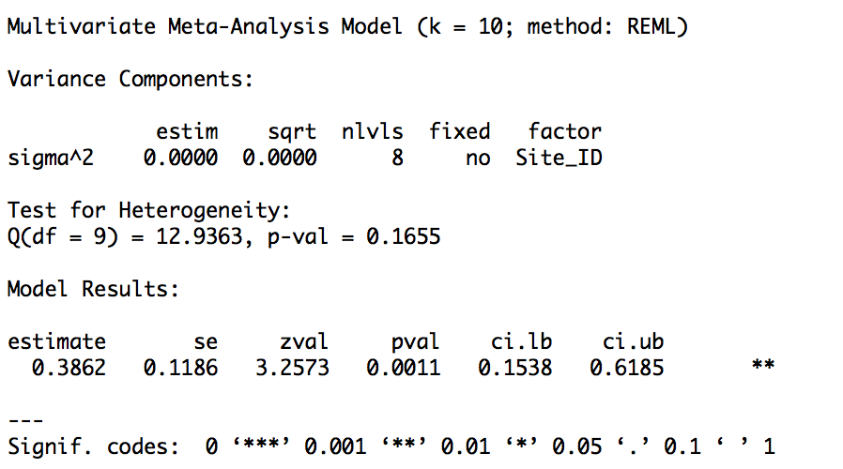

  - Forest plot

  - Funnel plot

  - Failsafe number
N=23

  - Cook’s Distance plot

  - Sensitivity analysis for critical appraisal

  - Moderated models
    - Forest type
      - Broadleaf
n/a – all data are from coniferous forests

      - Coniferous
n/a – all data are from coniferous forests

      - Mixed
n/a – all data are from coniferous forests

    - Burn frequency
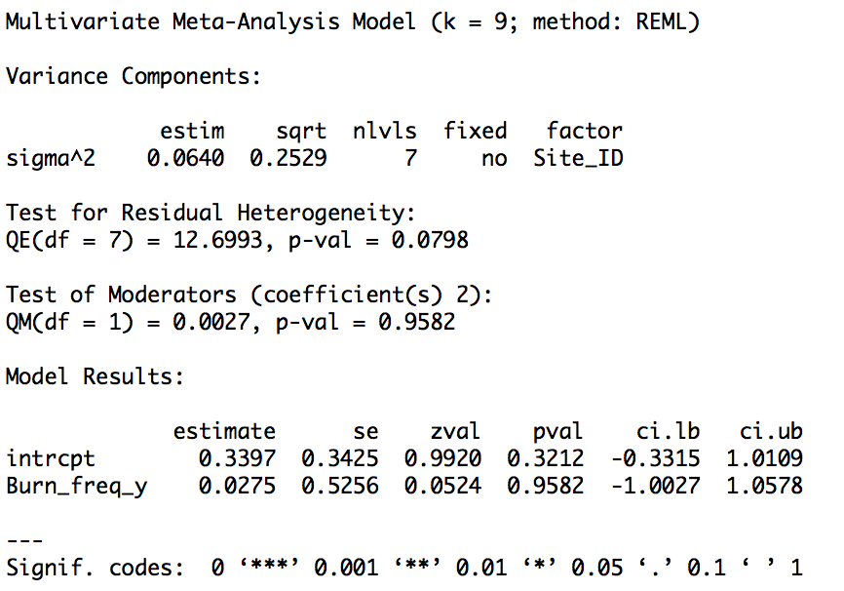

    - Time since burn
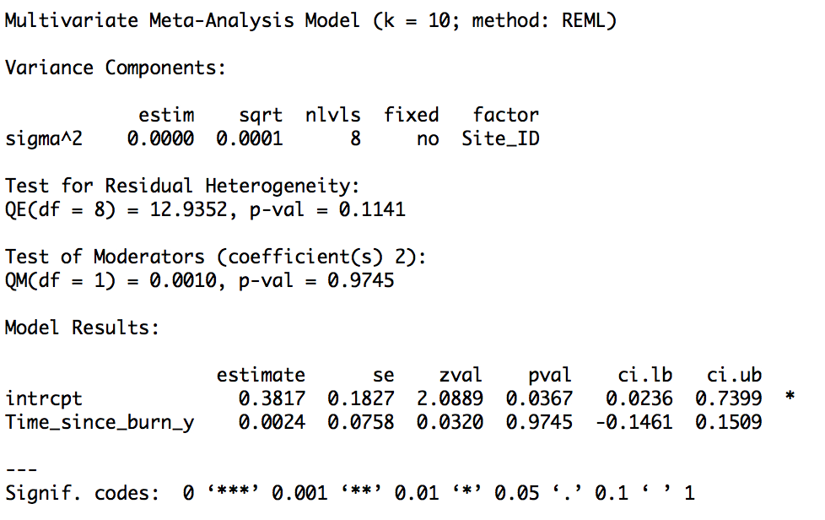

    - Burn season
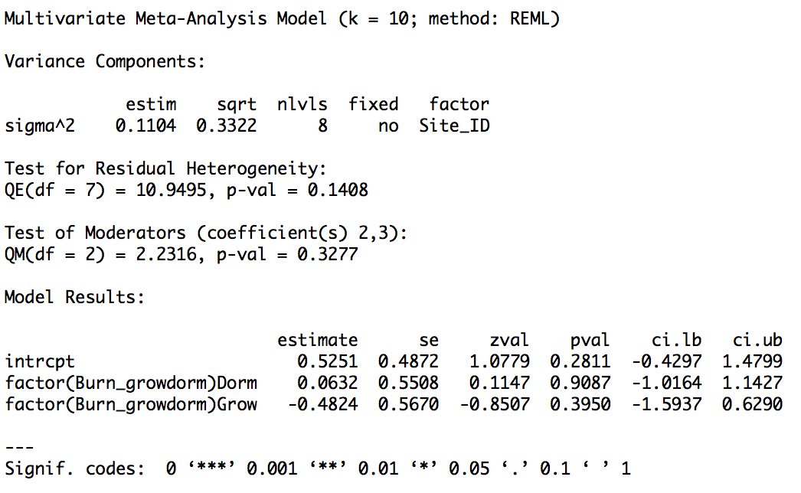

    - Climate zone
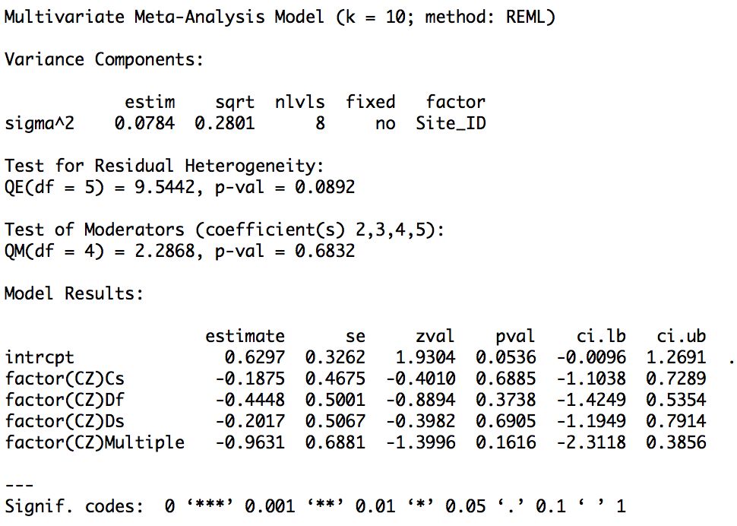

- Herbaceous plant richness
  - Model code
VascHRichS<-subset(burn,Taxon=="VascH"&(Outcome=="RichS"|Outcome=="RichG/S"))
rmaData<-rma.mv(yi=SMD_g,V=SMD_Vg,data=VascHRichS,random=~1|Site_ID)

  - Unmoderated model
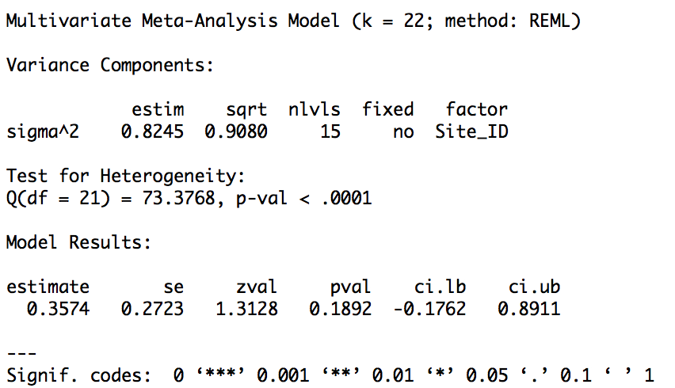

  - Forest plot

  - Funnel plot

  - Failsafe number
N=62

  - Cook’s Distance plot

  - Sensitivity analysis for critical appraisal
Only two studies - cannot run

  - Moderated models
    - Forest type
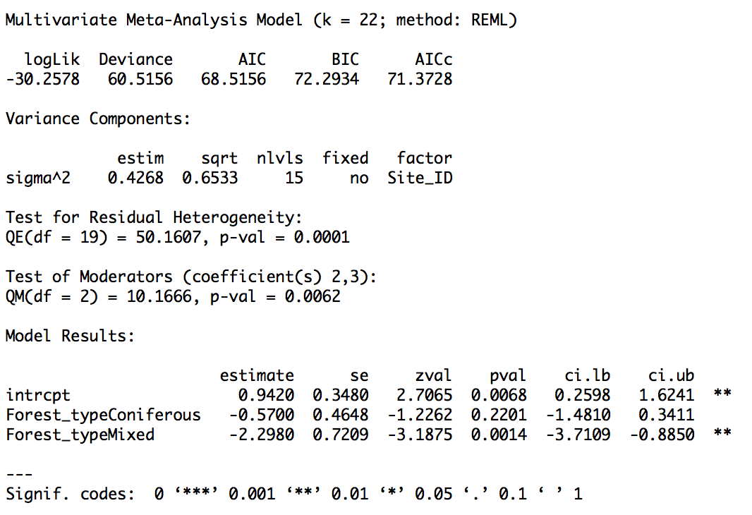

      - Broadleaf

      - Coniferous

      - Mixed

    - Burn frequency
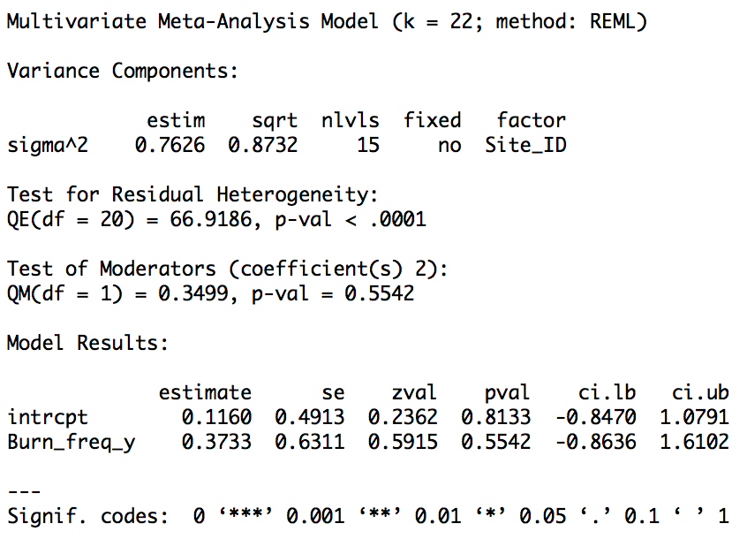

    - Time since burn
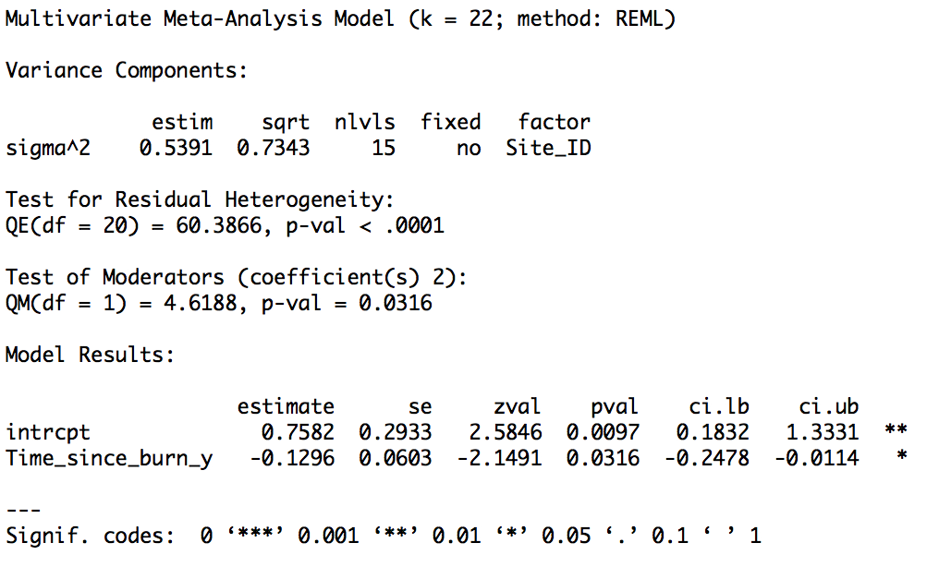

    - Burn season
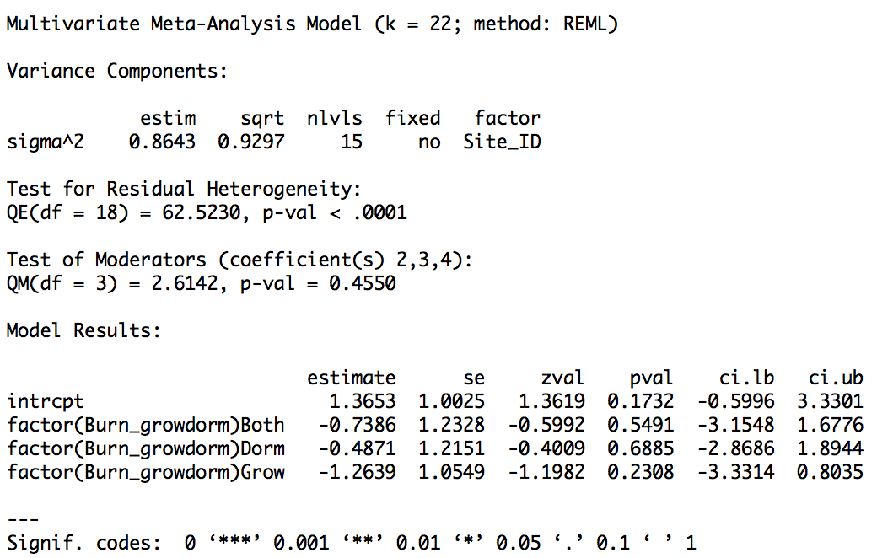

    - Climate zone
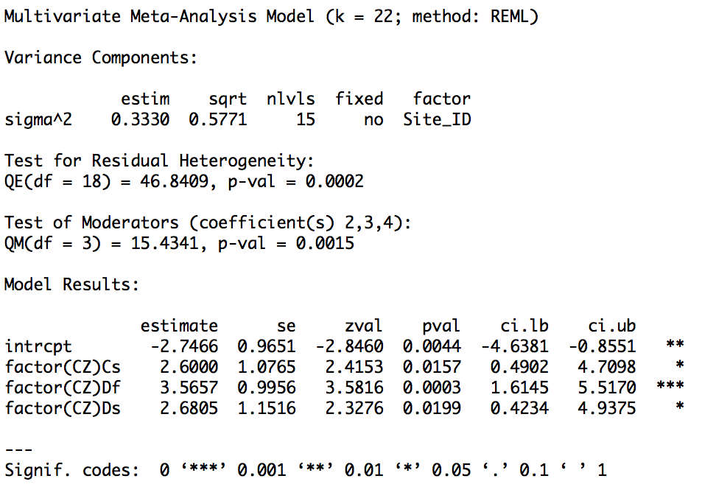
- Woody plant richness
  - Model code
VascWRichS<-subset(burn,Taxon=="VascW"&(Outcome=="RichS"|Outcome=="RichG/S"))
rmaData<-rma.mv(yi=SMD_g,V=SMD_Vg,data=VascWRichS,random=~1|Site_ID)

  - Unmoderated model
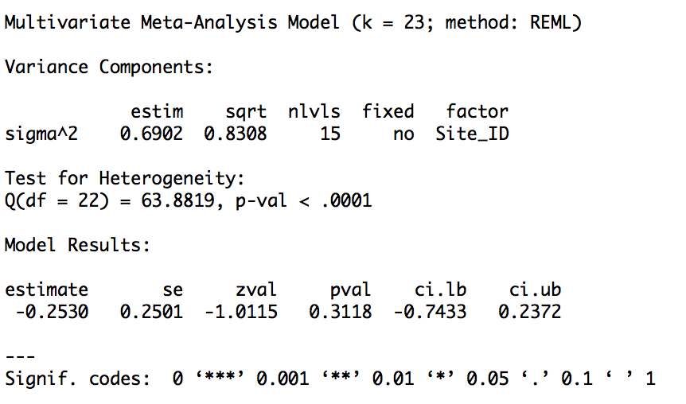

  - Forest plot

  - Funnel plot

  - Failsafe number
N=112

  - Cook’s Distance plot

  - Sensitivity analysis for critical appraisal

  - Moderated models
    - Forest type
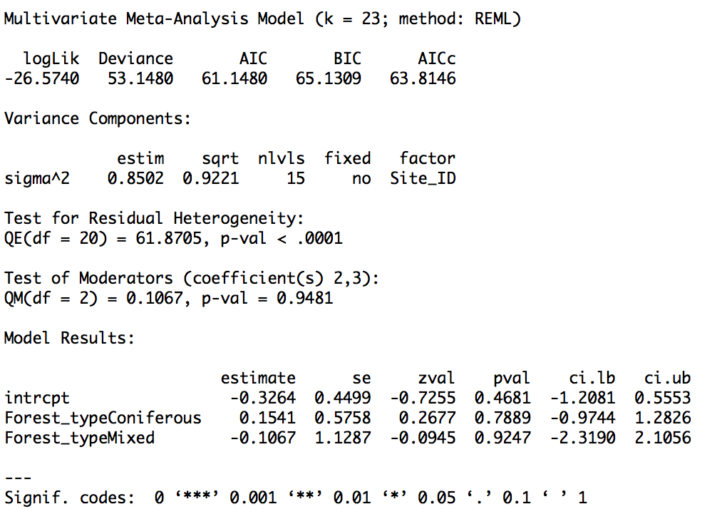

      - Broadleaf

      - Coniferous

      - Mixed

    - Burn frequency
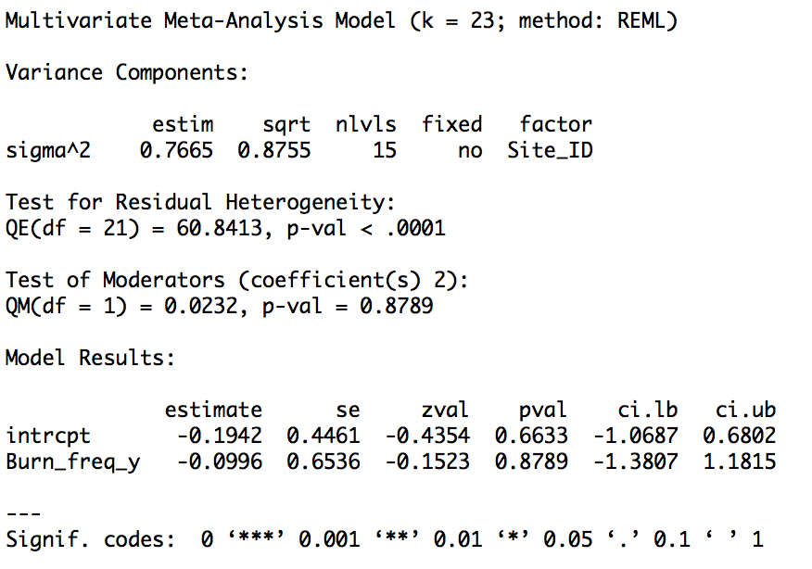

    - Time since burn
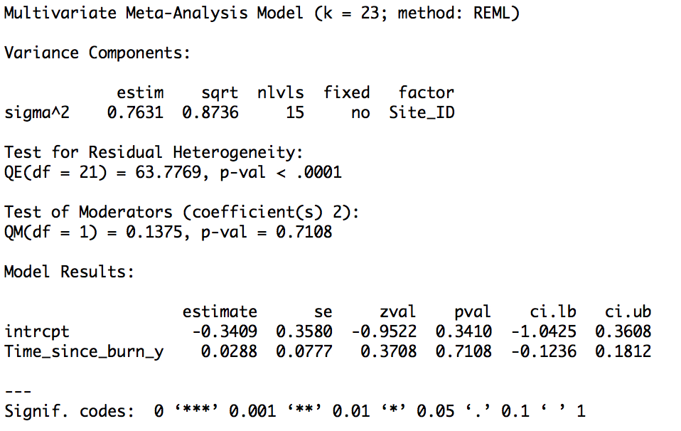

    - Burn season
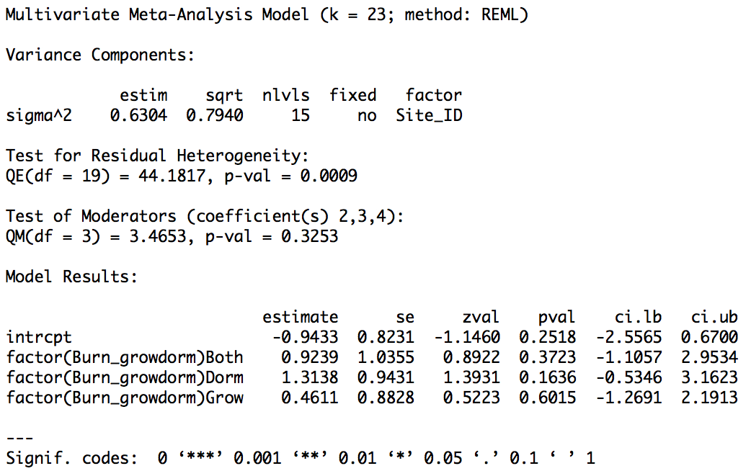

    - Climate zone
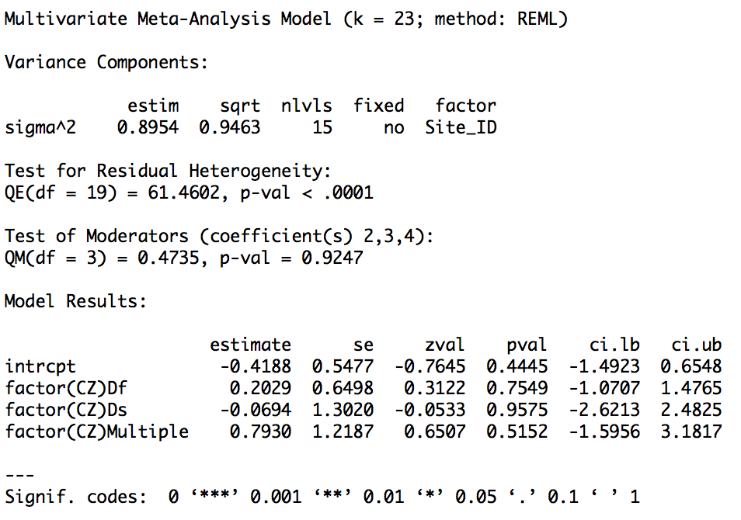

- Tree richness
  - Model code
TreeRichS<-subset(burn,Taxon=="Tree"&Outcome=="RichS")
rmaData<-rma.mv(yi=SMD_g,V=SMD_Vg,data=TreeRichS,random=~1|Site_ID)

  - Unmoderated model
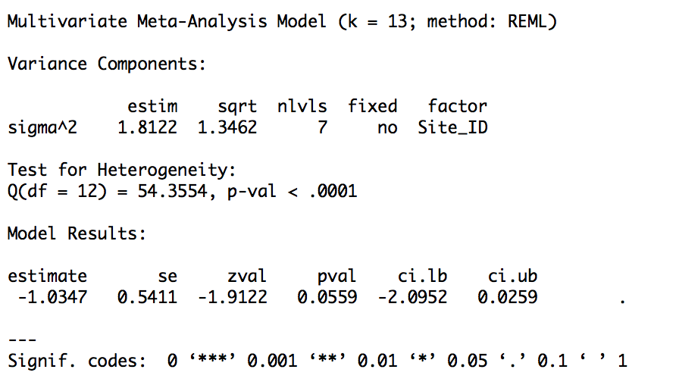

  - Forest plot

  - Funnel plot

  - Failsafe number
N=184

  - Cook’s Distance plot

  - Sensitivity analysis for critical appraisal
n/a – only one study High validity

  - Moderated models
    - Forest type
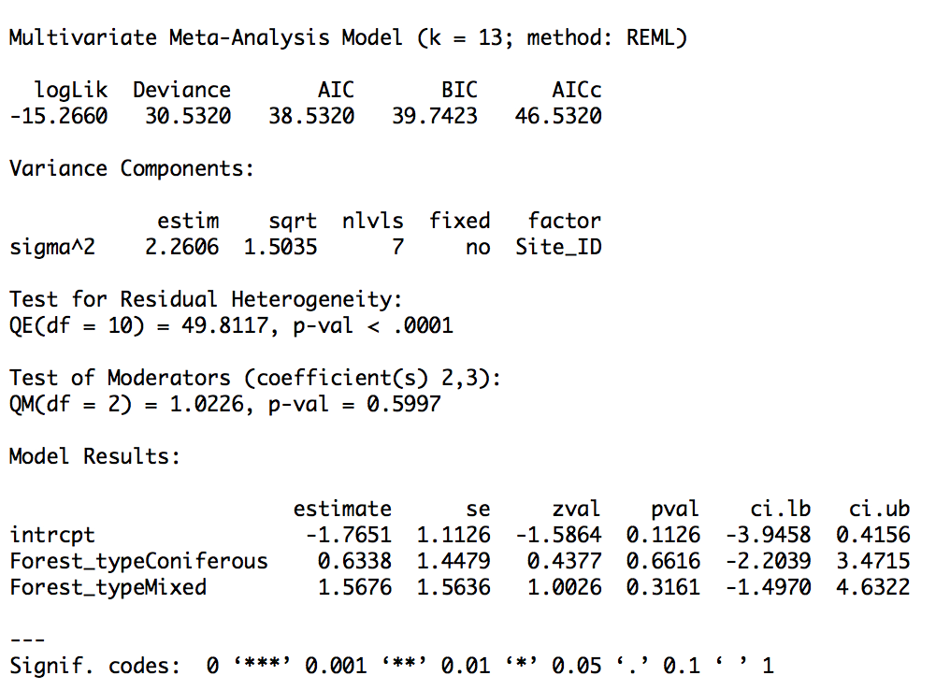

      - Broadleaf

      - Coniferous

      - Mixed

    - Burn frequency
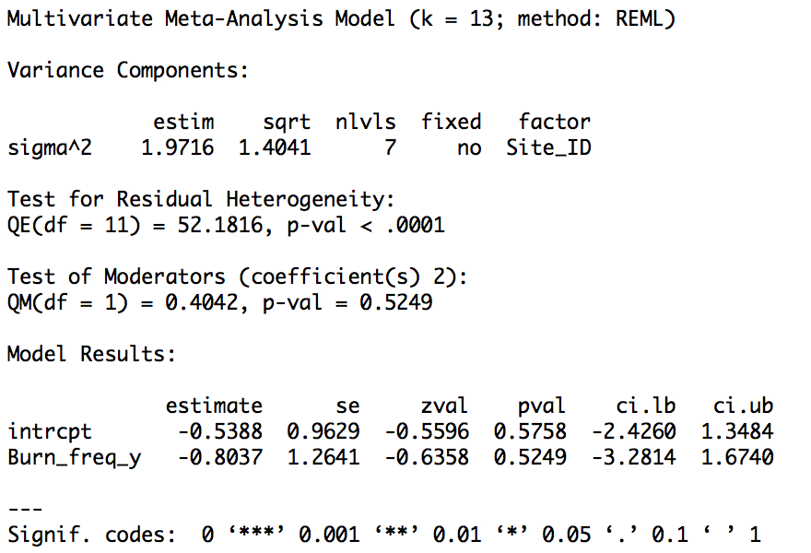

    - Time since burn
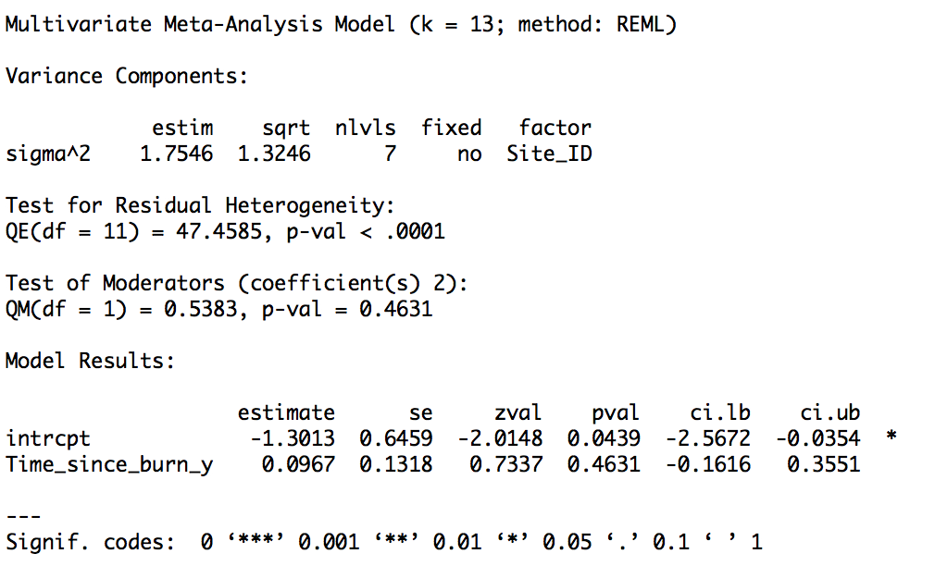

    - Burn season
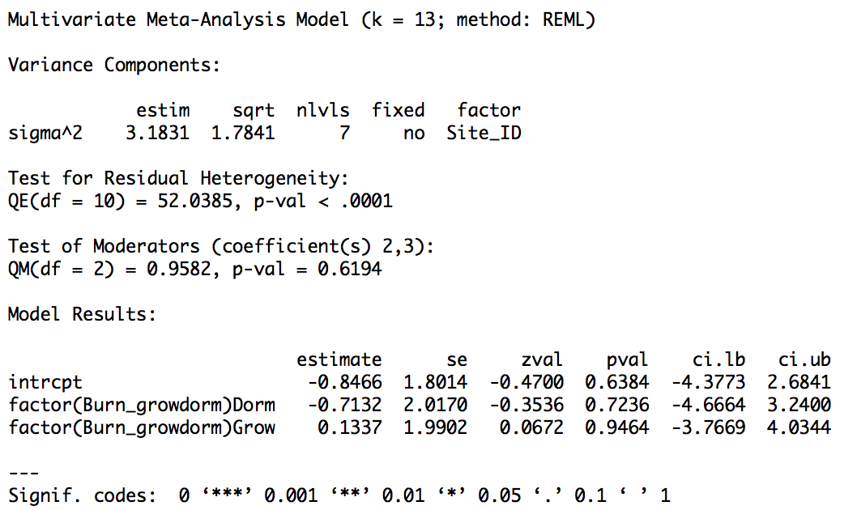

    - Climate zone
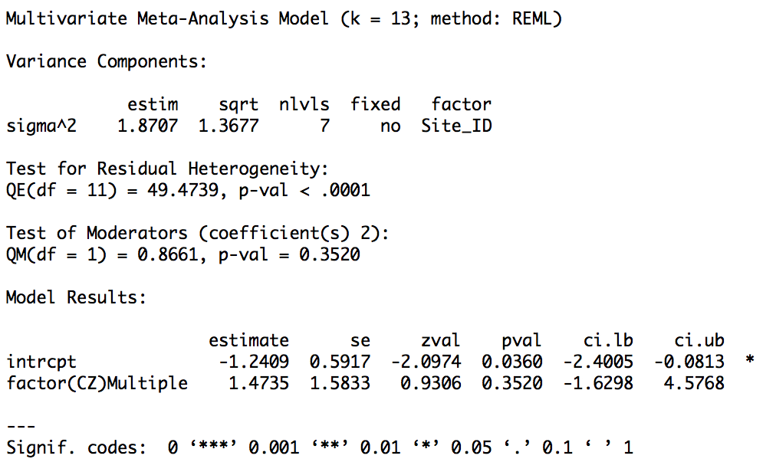

- All vascular plant diversity
  - Model code
VascDivS<-subset(burn,Taxon=="Vasc"&Outcome=="DivS")
rmaData<-rma.mv(yi=SMD_g,V=SMD_Vg,data=VascDivS,random=~1|Site_ID)

  - Unmoderated model
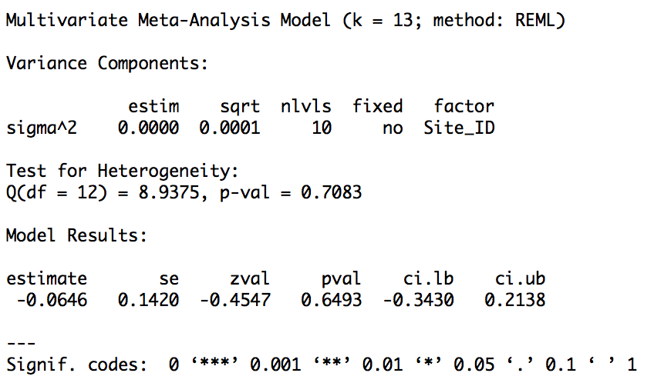

  - Forest plot

  - Funnel plot

  - Failsafe number
N=0

  - Cook’s Distance plot

  - Sensitivity analysis for critical appraisal

  - Moderated models
    - Forest type
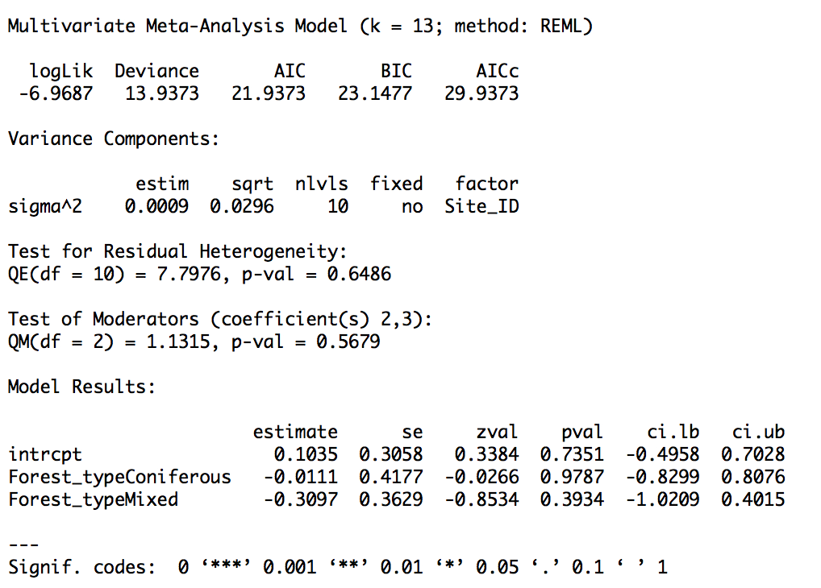

      - Broadleaf

      - Coniferous

      - Mixed

    - Burn frequency
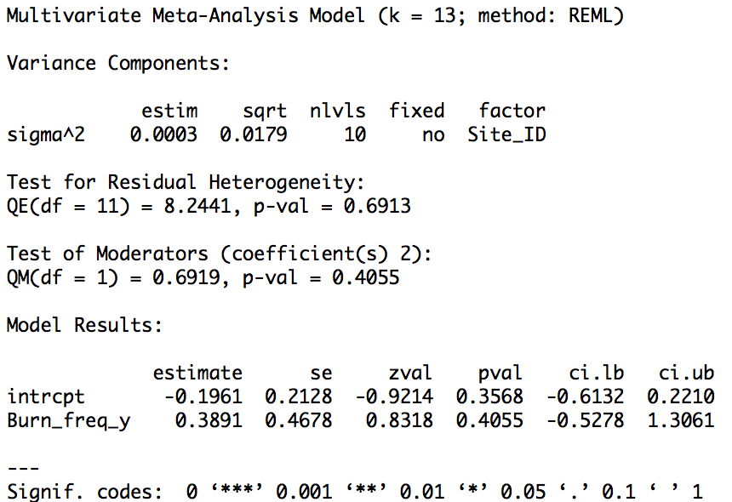

    - Time since burn
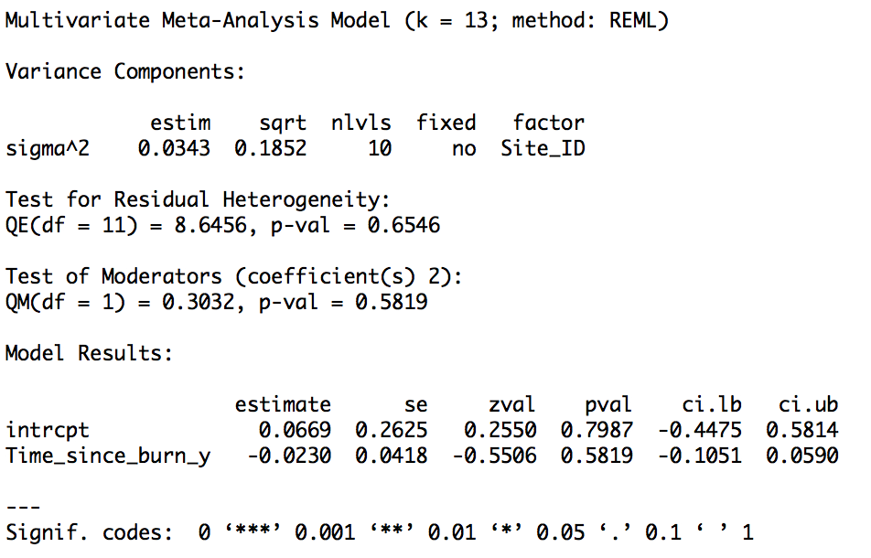

    - Burn season
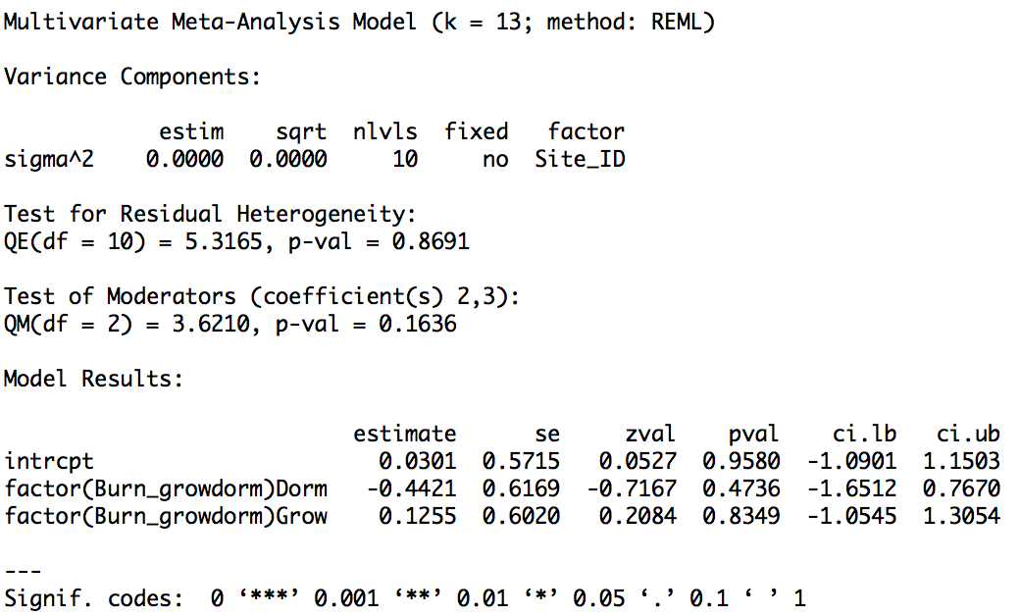

    - Climate zone
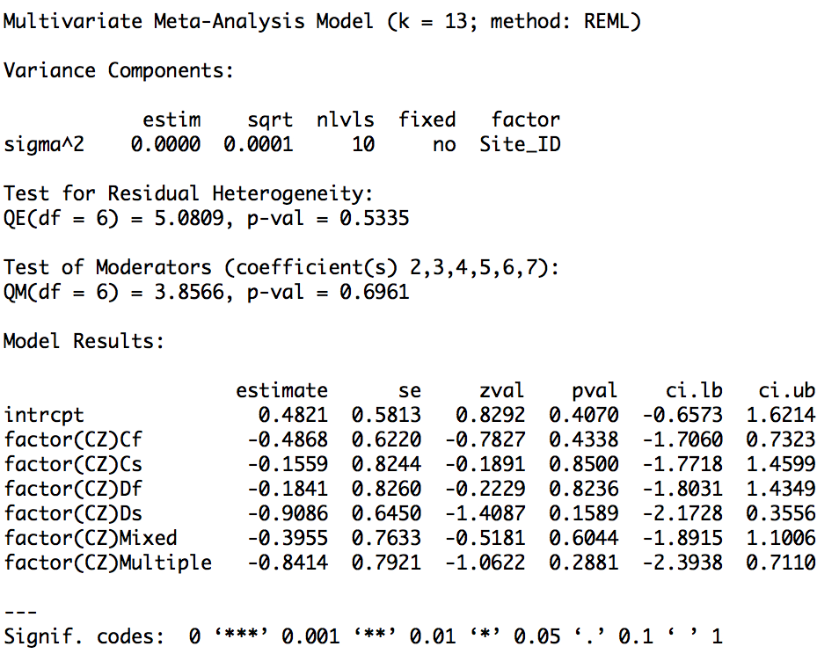

- Fungal richness
  - Model code
FungRichS<-subset(burn,Taxon=="Fung"&(Outcome=="RichS"|Outcome=="RichG/S"))
rmaData<-rma.mv(yi=SMD_g,V=SMD_Vg,data=FungRichS,random=~1|Site_ID)

  - Unmoderated model
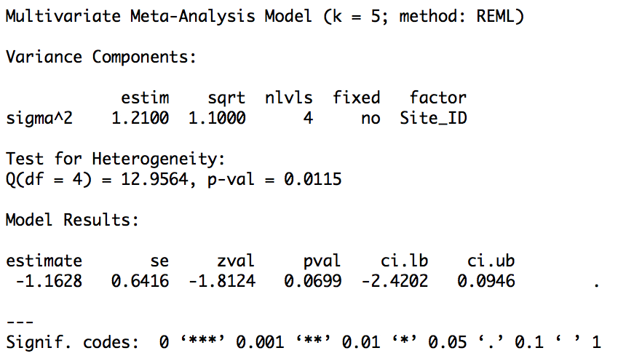

  - Forest plot

  - Funnel plot

  - Failsafe number
N=16

  - Cook’s Distance plot

  - Sensitivity analysis for critical appraisal

  - Moderated models
    - Forest type
      - Broadleaf
n/a – all studies from coniferous forest

      - Coniferous

      - Mixed
n/a – all studies from coniferous forest

    - Burn frequency
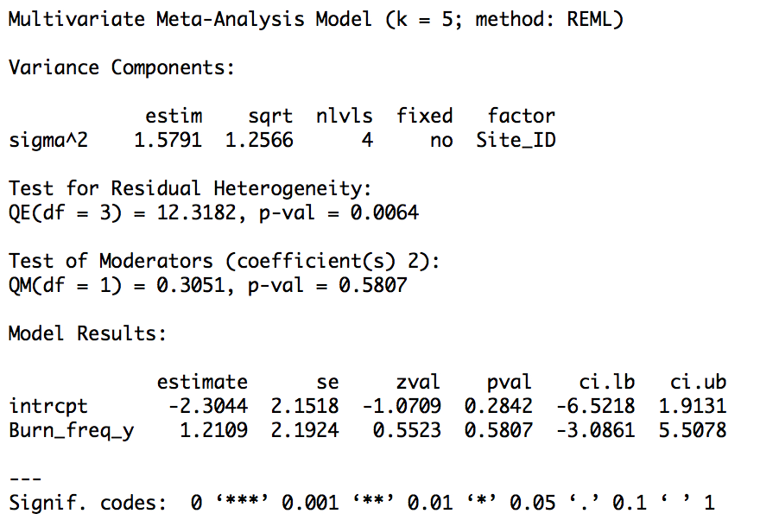

    - Time since burn
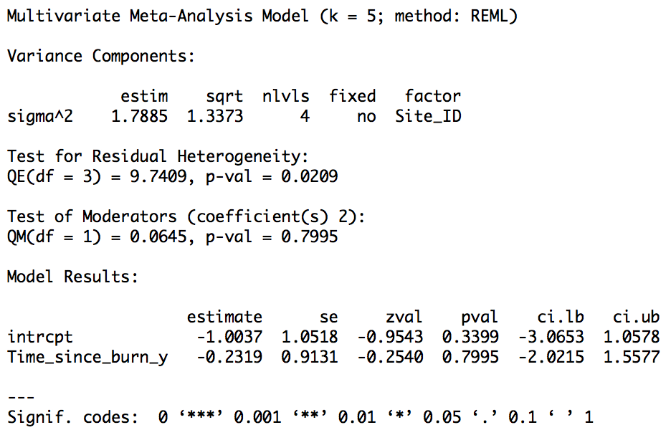

    - Burn season
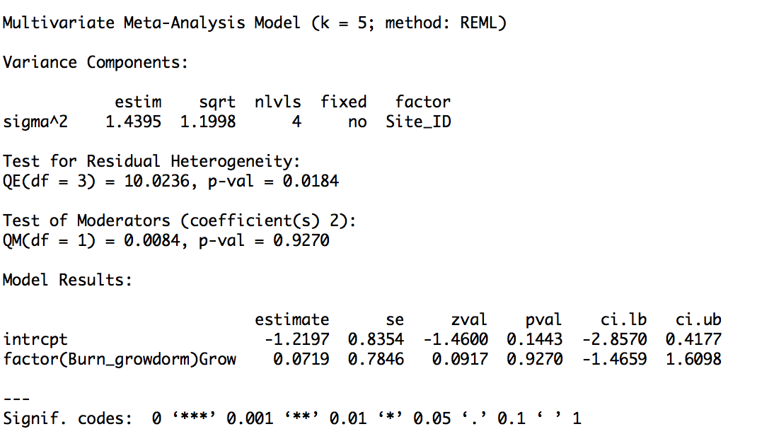

    - Climate zone
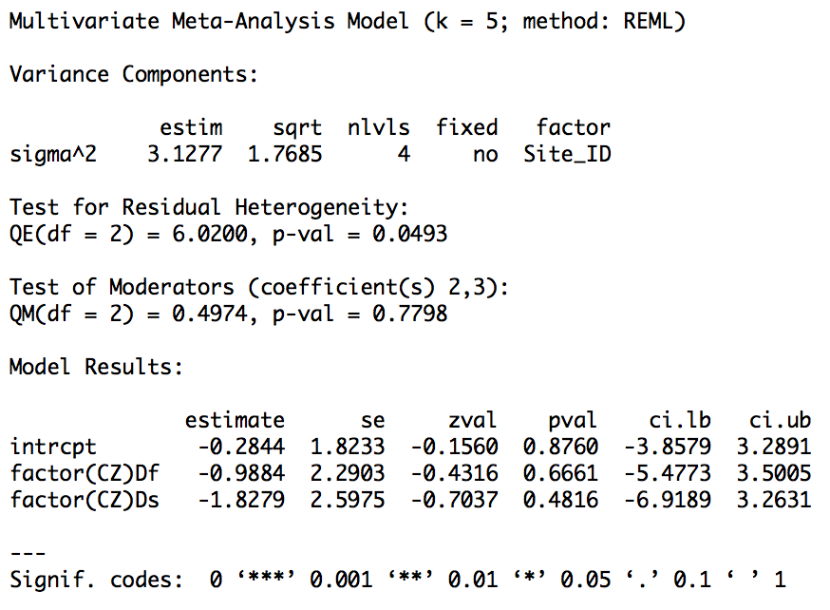

- Bird richness
  - Model code
BirdRichS<-subset(burn,Taxon=="Bird"&Outcome=="RichS")
rmaData<-rma.mv(yi=SMD_g,V=SMD_Vg,data=BirdRichS,random=~1|Site_ID)

  - Unmoderated model
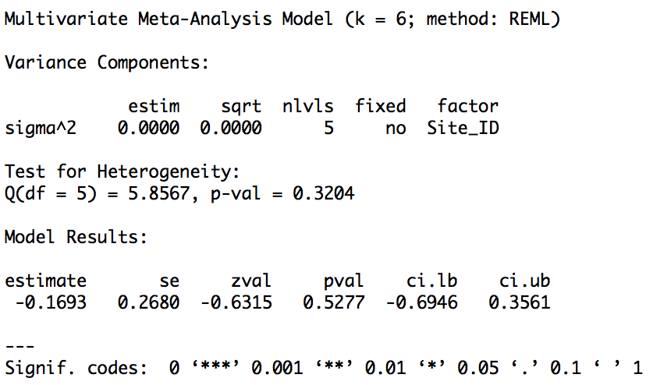

  - Forest plot

  - Funnel plot

  - Failsafe number
N=0

  - Cook’s Distance plot
  - Sensitivity analysis for critical appraisal
n/a – only one study High validity

  - Moderated models
    - Forest type
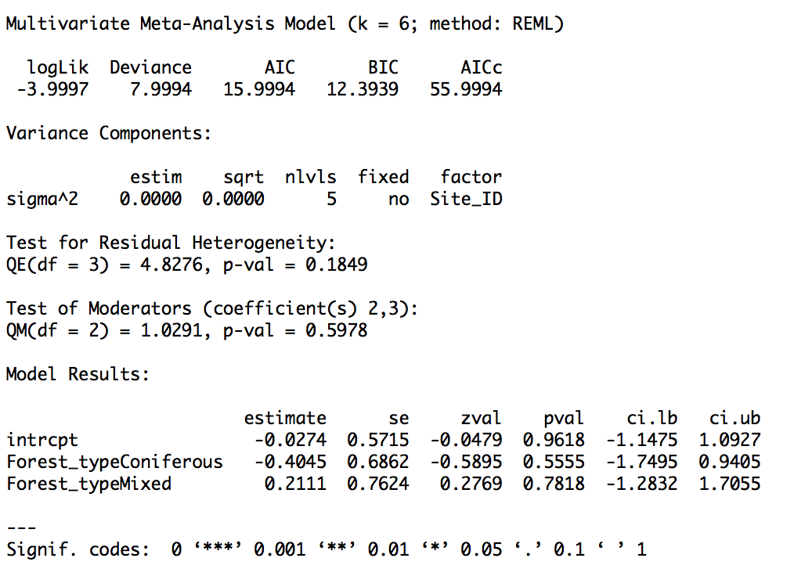
      - Broadleaf
n/a – insufficient studies

      - Coniferous
      - Mixed
    - Burn frequency
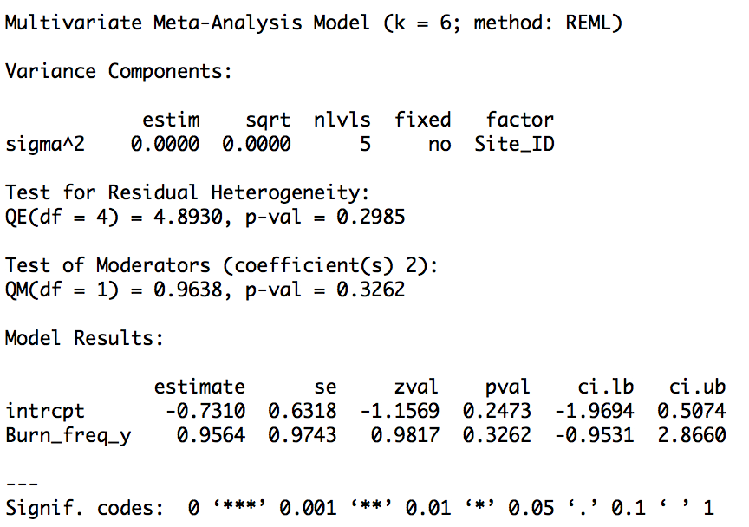
    - Time since burn
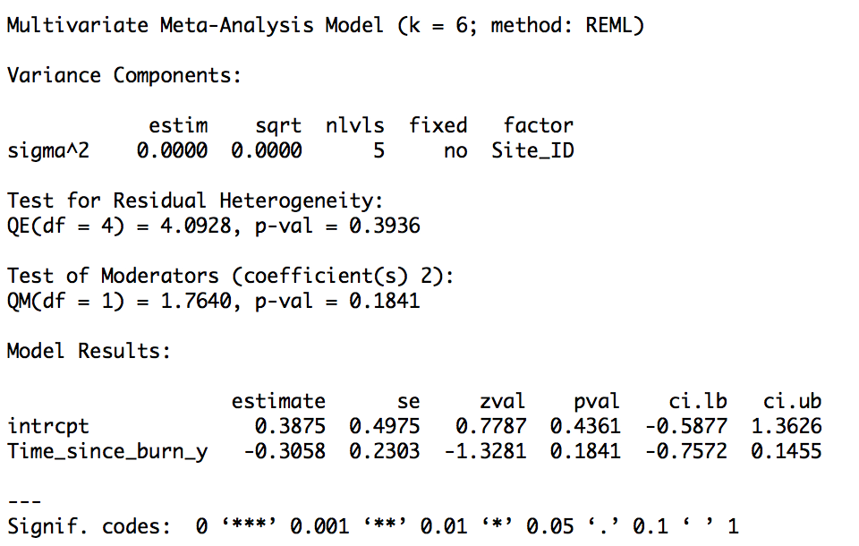
    - Burn season
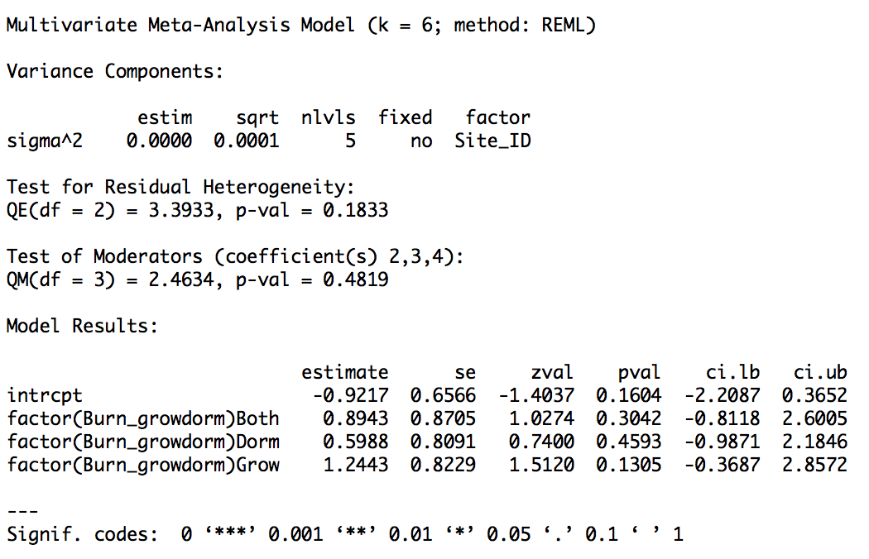
    - Climate zone
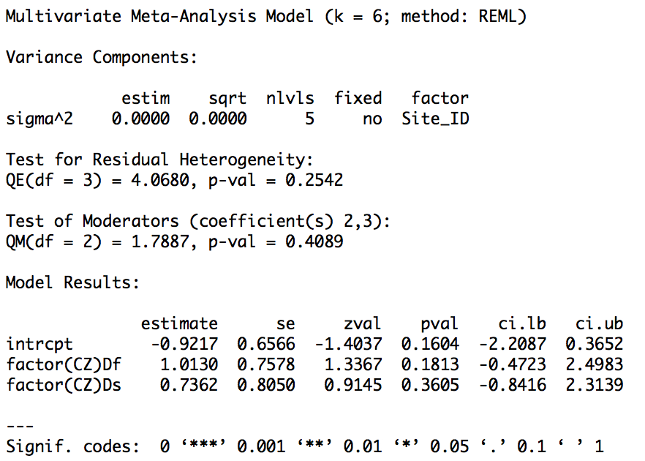

- Beetle richness
  - Model code
BeetRichS<-subset(burn,(Taxon=="BeetA"|Taxon=="BeetC"|Taxon=="BeetG"|Taxon=="BeetO")&Outcome=="RichS")
rmaData<-rma.mv(yi=SMD_g,V=SMD_Vg,data=BeetRichS,random=~1|Site_ID)

  - Unmoderated model
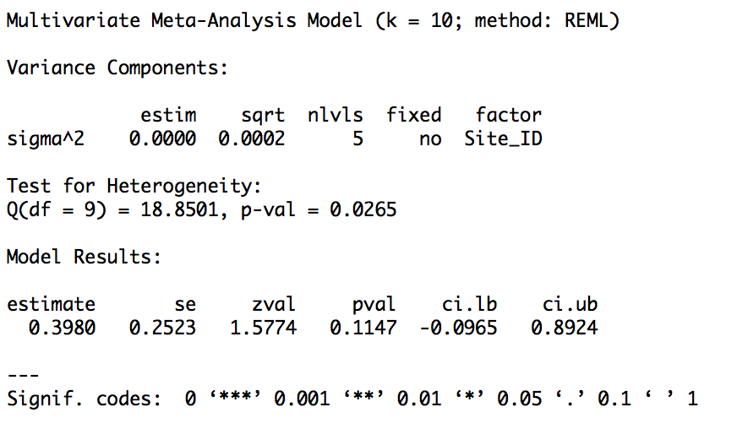

  - Forest plot

  - Funnel plot

  - Failsafe number
N=10

  - Cook’s Distance plot
  - Sensitivity analysis for critical appraisal
n/a – only one High validity study

  - Moderated models
    - Forest type
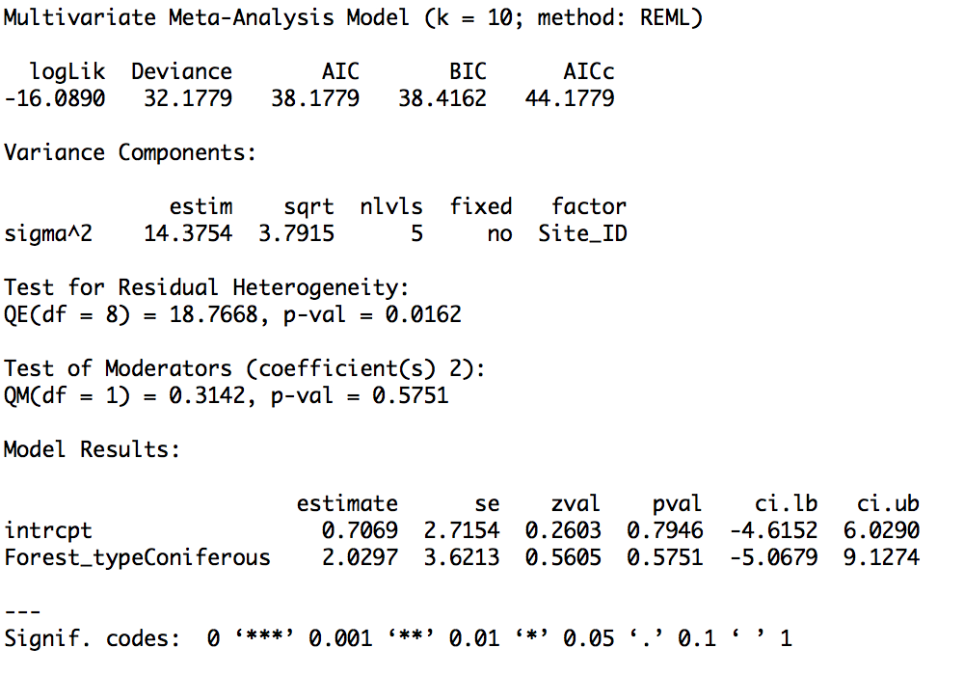

      - Broadleaf

      - Coniferous

      - Mixed
n/a – no studies in this category

    - Burn frequency
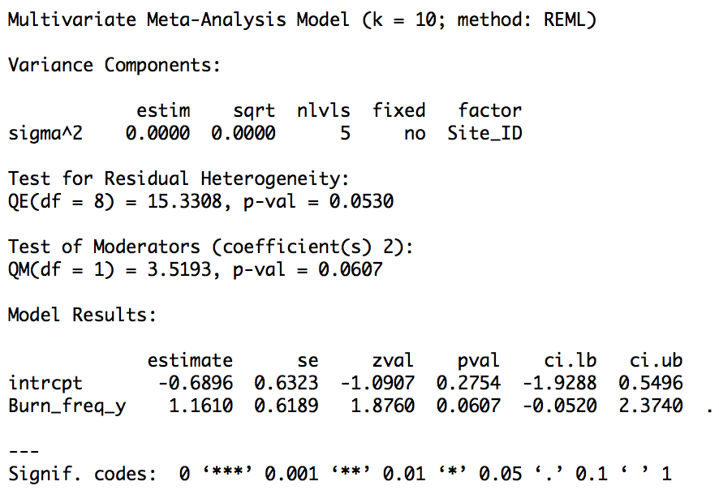

    - Time since burn
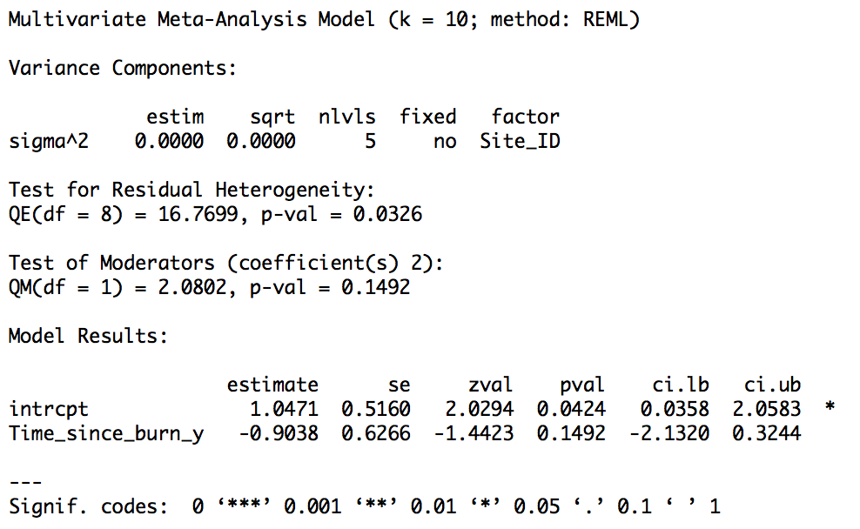

    - Burn season
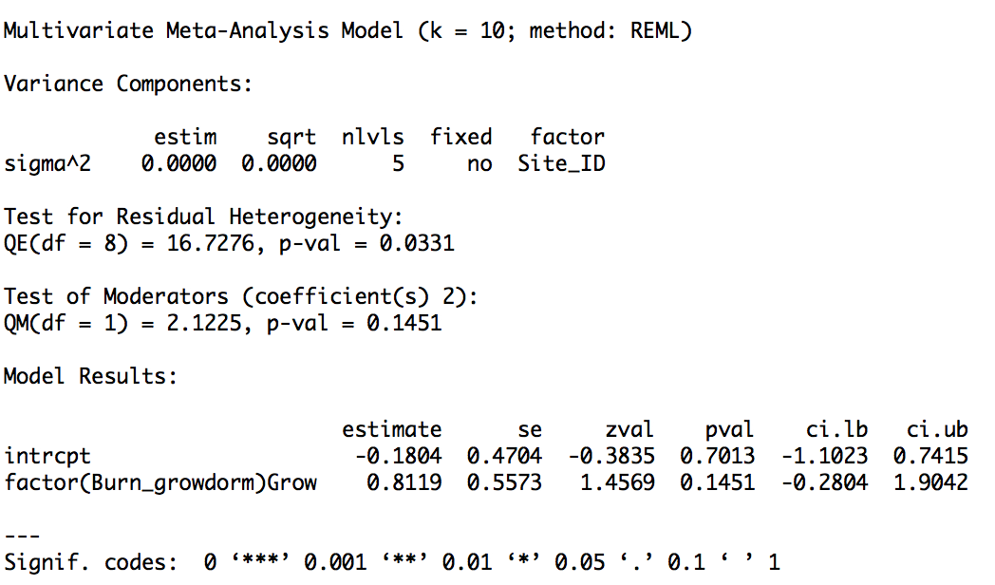

    - Climate zone
