Additional file 7. Results of sensitivity analyses when studies with imputed SDs are excluded from the data sets.

Uneven-aged forest
Species richness
Number of studies with imputed SDs: 2
d = 0.251, p = 0.314, 95% CI: -0.238, 0.739, n = 66
Q = 376.9390, p < 0.0001
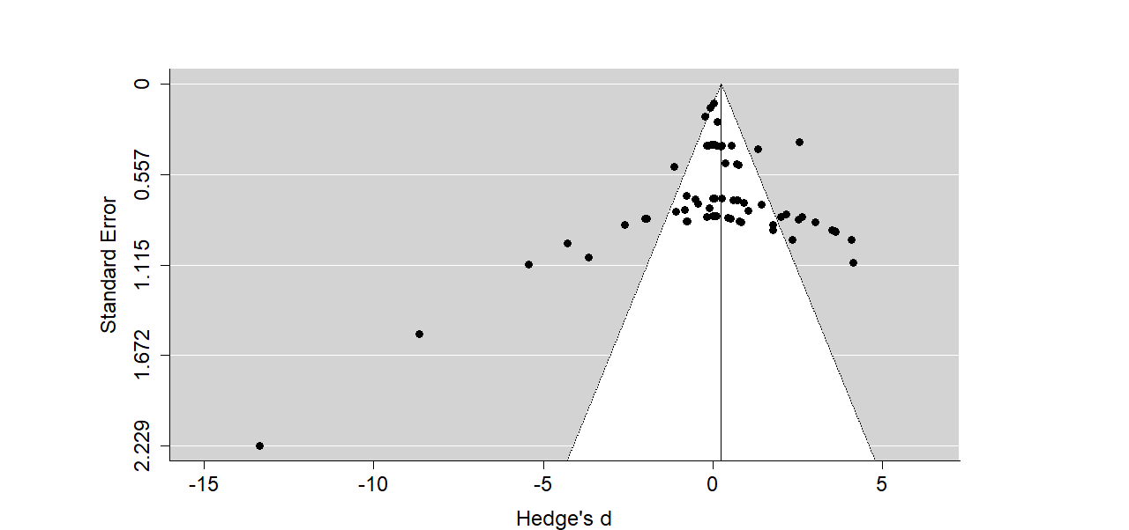

Figure 1. Funnel plot showing effect sizes of species richness when uneven-aged forest is compared to other forest types (young even-aged forest, mature even-aged forest, retention forest and natural forest). Effect sizes in the grey area are significant at p ≤ 0.05. No filled studies were determined to be needed based on the fill and trim -test. No filled studies were determined to be needed based on the fill and trim -test (no white filled circles included in the plot).

Abundance
Number of studies with imputed SDs: 4
d = 0.281, p = 0.069, 95% CI: -0.022, 0.583, n = 126
Q = 1318.211, p < 0.0001

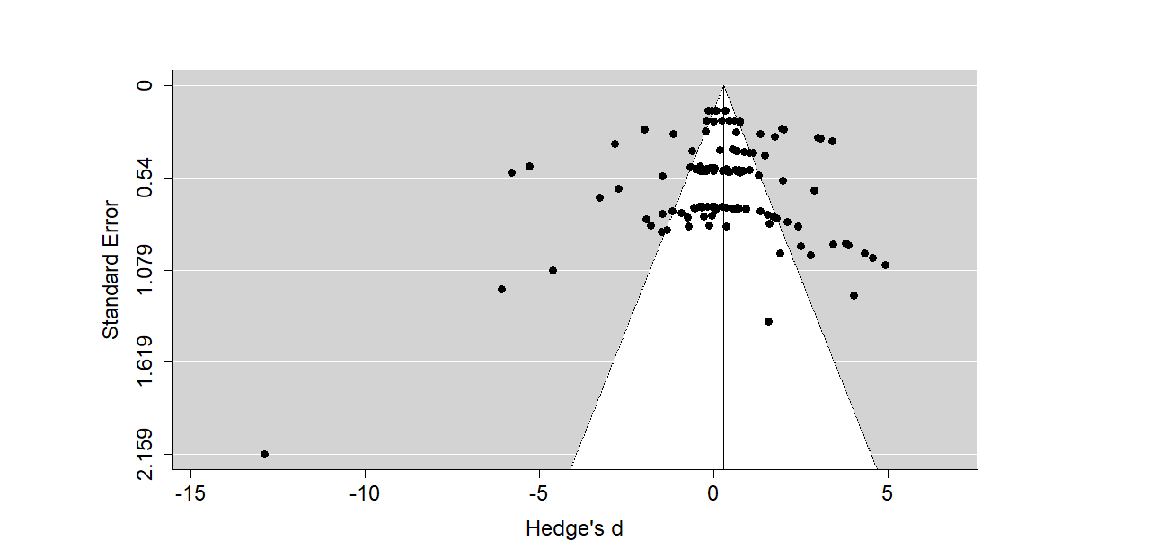

Figure 2. Funnel plot showing effect sizes of individual abundance when uneven-aged forest is compared to other forest types (young even-aged forest, mature even-aged forest, retention forest and natural forest). Effect sizes in the grey area are significant at p ≤ 0.05. No filled studies were determined to be needed based on the fill and trim -test (no white filled circles included in the plot).

Even-aged forest
Species richness
Number of studies with imputed SDs: 14
d = -0.383, p = 0.006, 95% CI: -0.658, -0.108, n = 129
Q = 705.563, p < 0.0001
Number of studies missing based on the trim and fill -test: 4 on left hand size.
Corrected effect size: d = -0.4850, p = 0.001, 95% CI: -0.776, -0.194, n = 133
Q = 755.6757, p < 0.0001
A funnel plot with all the studies is provided for comparison (figure 4)
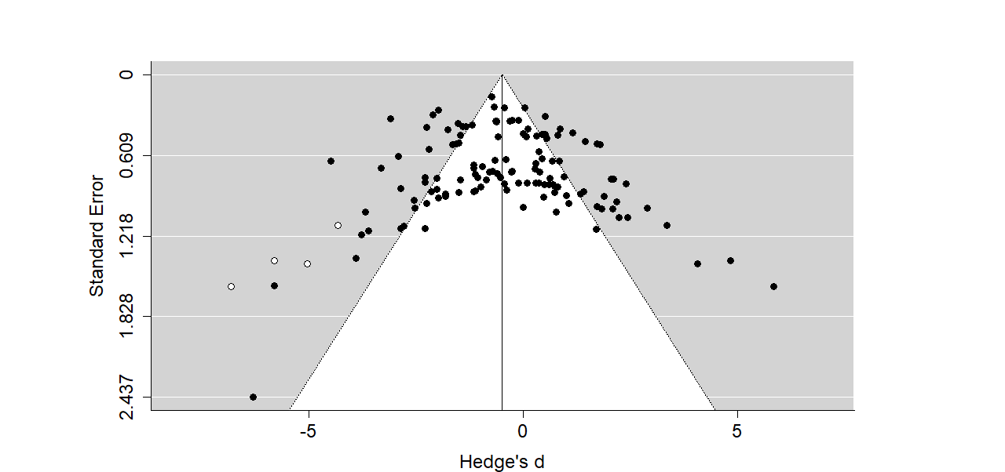
Figure 3. Funnel plot excluding studies with imputed SDs showing effect sizes of species richness when even-aged forest is compared to other forest types (young even-aged forest, mature even-aged forest, retention forest and natural forest). Effect sizes in the grey area are significant at p ≤ 0.05. White filled circles show studies filled in when conducting trim and fill -test.
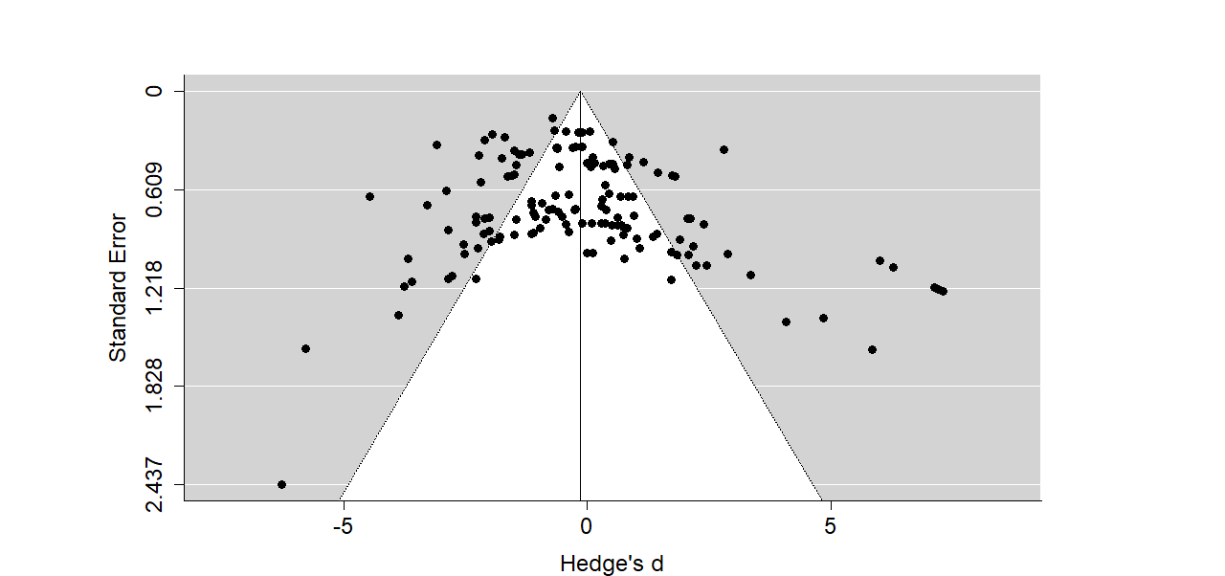
Figure 4. Funnel plot including all studies showing effect sizes of species richness when even-aged forest is compared to other forest types (young even-aged forest, mature even-aged forest, retention forest and natural forest). Effect sizes in the grey area are significant at p ≤ 0.05.
Abundance
Number of studies with imputed SDs: 38
d = -0.215, p = 0.177, 95% CI: -0.527, 0.097
Q = 1617.3104, p < 0.0001

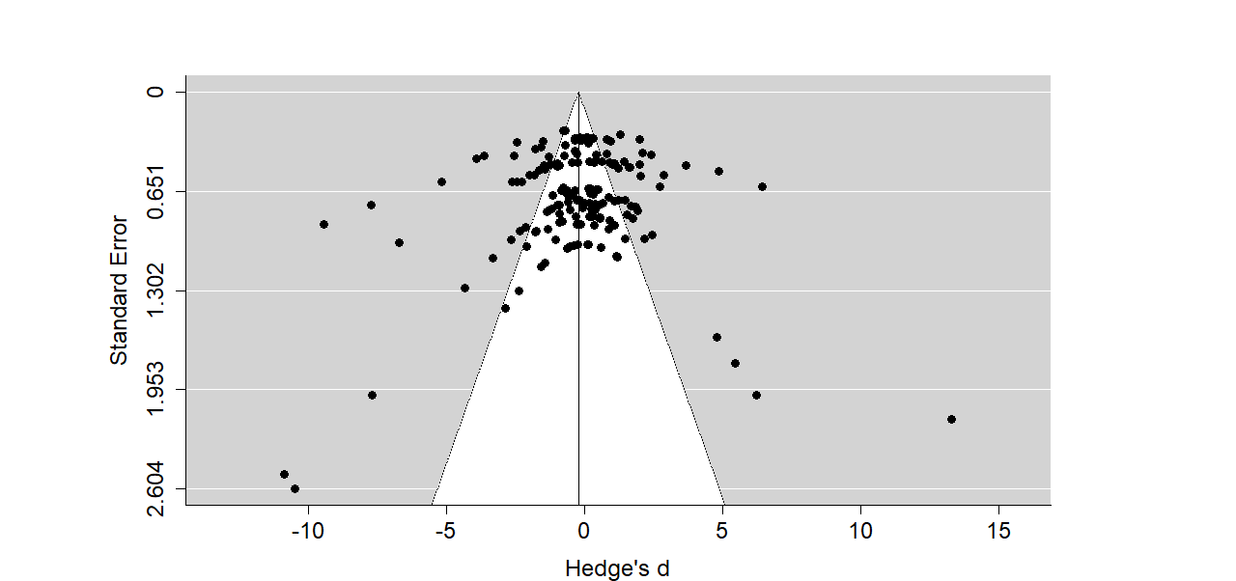
Figure 5. Funnel plot showing effect sizes of individual abundance when even-aged forest is compared to other forest types (young even-aged forest, mature even-aged forest, retention forest and natural forest). Effect sizes in the grey area are significant at p ≤ 0.05. No filled studies were needed based on the fill and trim -test (no white filled circles included in the plot).

