Additional file 9. Comparison of individual abundance between even-aged and natural forest when studies with high risk of bias are removed.
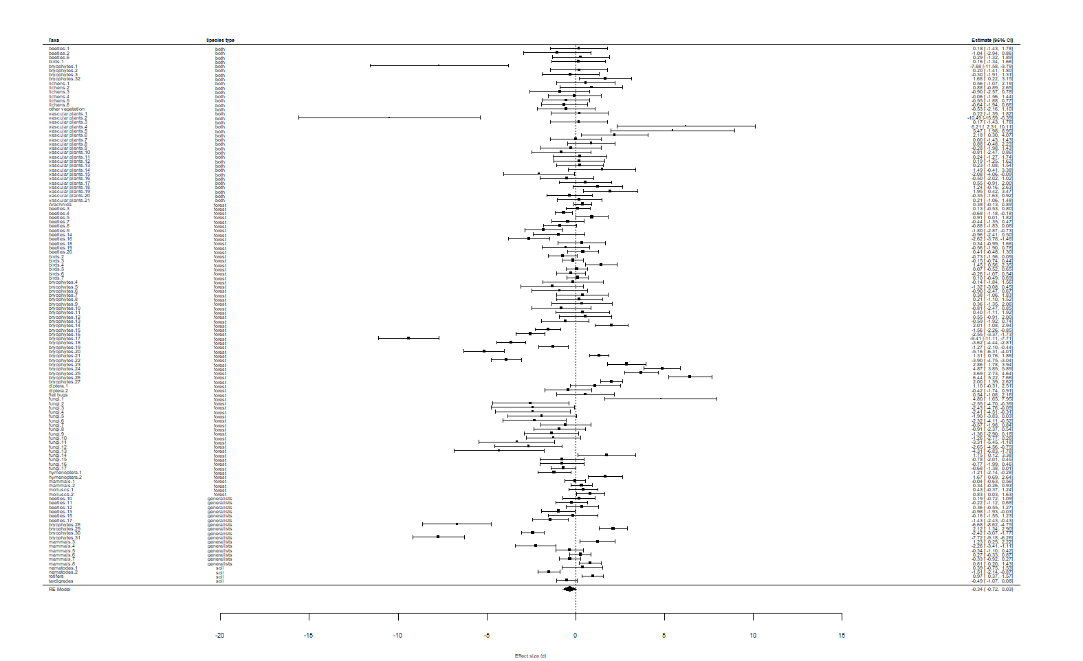
Figure 1. Forest plot of effect sizes of individual abundances when even-aged forest is compared to natural forest. Effect sizes on the right side of zero mean that even-aged forest has more individuals than natural forest.

Results from testing the effect modifiers

Habitat specialism: QM = 3.22, p = 0.359, n = 124
Taxa: QM = 7.344, p = 0.693, n = 119
Years since harvesting: QM = 0.5021, p = 0.479, n = 73
There were no studies with high risk bias that had reported the amount of deadwood.

