Additional file 9. Funnel plots for detecting publication bias.
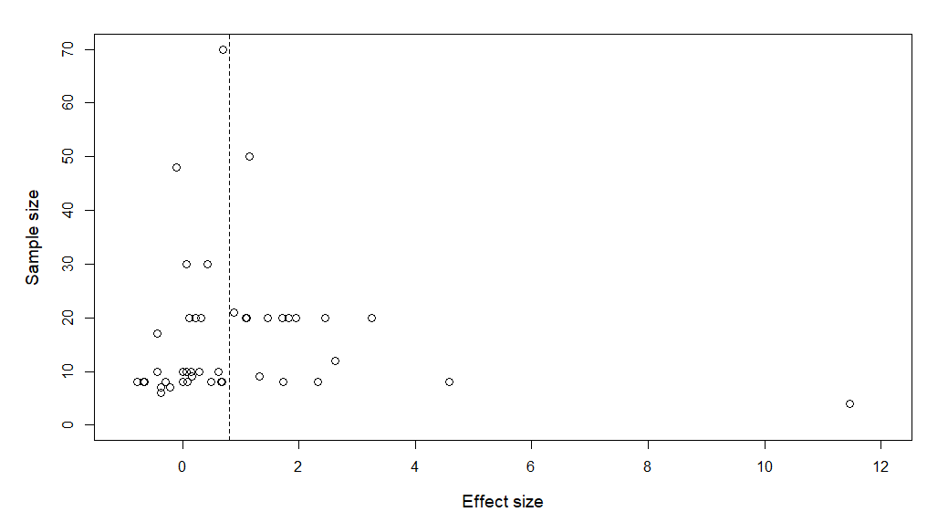
Figure 1. Effect sizes of species richness plotted against sample sizes when SPHP is compared to natural and production forests. The dashed line marks the overall effect size.
Fail-safe number: 2332
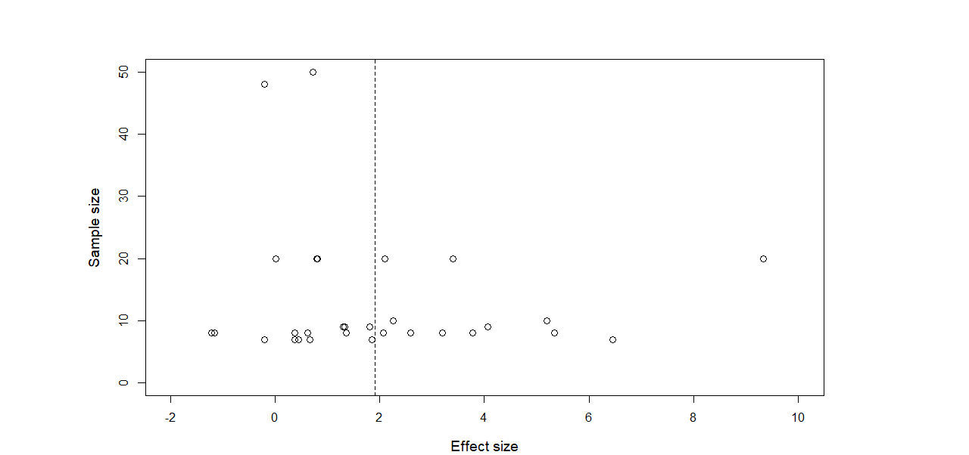
Figure 2. Effect sizes of individual abundance plotted against sample sizes when SPHP is compared to natural and production forests. Effect sizes in the grey area are significant at p ≤ 0.05. The dashed line marks the overall effect size.
Fail-safe number: 2190
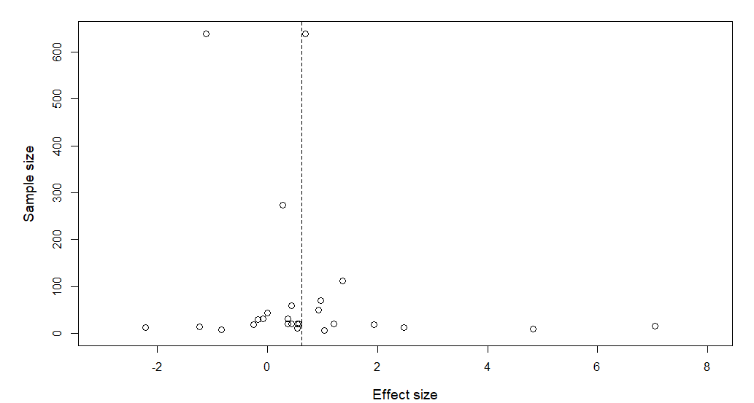
Figure 3. Effect sizes of deadwood volume plotted against sample sizes when SPHP is compared to natural and production forests. The dashed line marks the overall effect size.
Fail-safe number: 716
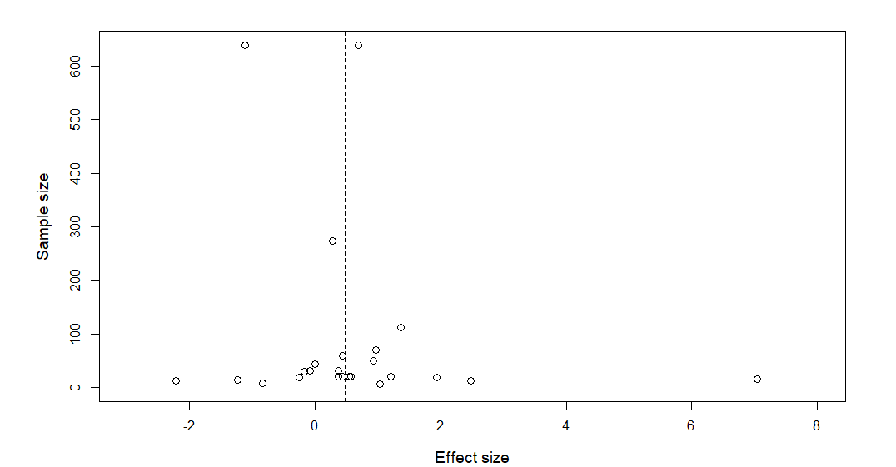
Figure 4. Effect sizes of deadwood volume plotted against sample sizes when SPHP is compared to natural and production forests. Only studies without imputed SDs are included. The dashed line marks the overall effect size.
Fail-safe number: 505

