Supplementary Tables and Figures

Figure S1. Pre-screening process for Web of Science Searches. The macros used for these processes can be found in Additional File 3.

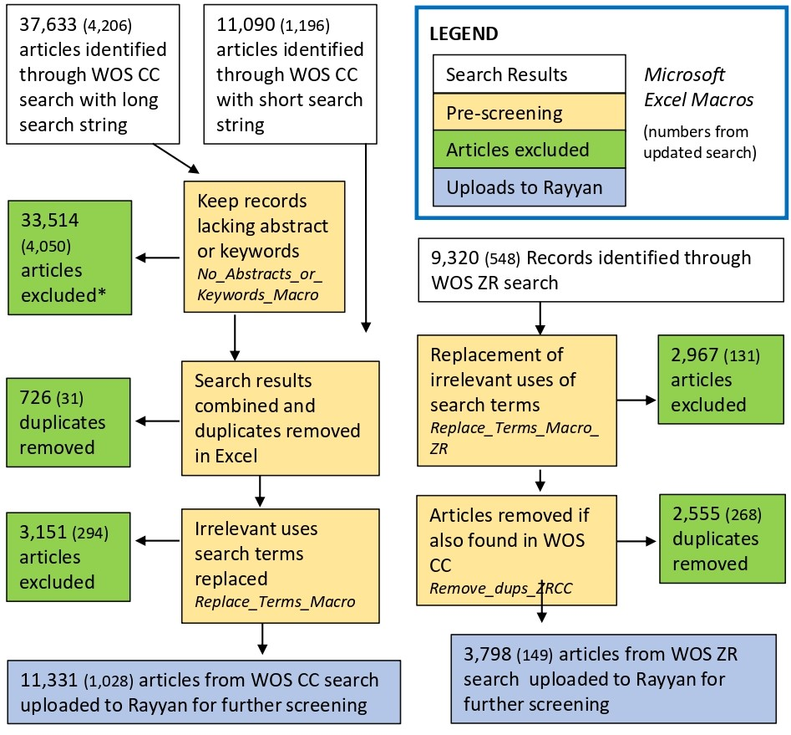
The names of the Microsoft Excel macros used for pre-screening processes are give in italics. The number of articles found or excluded during the updated search are give in parentheses.
*Any article excluded at this stance that had bird, avian, or aves in its abstracft or keywords was found by the search string and included in the WOS CC short search string search results. See Additional File 2 for details.

Table S1. Organizational Website Searches
Organization | Website | Number of Articles Found
Accipiter Radar | https://www.accipiterradar.com | 0
Bird Avert | https://www.birdavert.com | 0
Bird Control Group | https://www.birdcontrolgroup.com | 0
Bird-X | https://bird-x.com | 0
DeTect | https://detect-inc.com | 0
Merlin Environmental | https://merlinenvironmental.co.uk/ | 0
Transport Canada | https://www.tc.gc.ca | 0
USDA/Aphis | https://www.aphis.usda.gov/ | 2
Department for Environment, Food, and rural Affairs (UK) | https://www.gov.uk/government/organisations/department-for-environment-food-rural-affairs | 0
United States Fish and Wildlife Service | https://www.fws.gov/ | 3
Bureau of Ocean Energy Management | https://www.boem.gov/ | 1
Bird Strike Association of Canada | https://canadianbirdstrike.ca | 0
British Trust for Ornithology | https://www.bto.org | 2
Bird-Life International | https://www.birdlife.org | 1
FLAP | https://www.flap.org | 2
International Dark Sky Association | https://www.darksky.org | 2
IUCN SSC Human Wildlife Conflict Task Force | http://www.hwctf.org | 0
Proceedings of the Vertebrate Pest Conference | https://digitalcommons.unl.edu/vpccollection/ | 4
Total |  | 17

Table S2. Number of studies in each hemisphere
 | E | W
N | 129 | 290
S | 53 | 18

Table S3. Number of studies applying treatment at each time of day
Time of Day Treatment Applied | Number of Studies
Day only | 33
Multiple | 58
UA – presumed multiple | 21
Night only | 127
Night and sunset or sunrise only | 44
UA – presumed night | 133
Sunset or dusk only | 10
UA | 64

Table S4. Migration status of study populations
Migration Status | Number of Studies
Yes | 188
Yes (fledgling seabird) | 29
No | 218
Mixed | 22
UA – presumed Mixed | 1

Table S5. Domestication status of study populations.
Domestication Status | Number of Studies
Captive Wild | 81
Domesticated | 32
Wild | 377

Table S6. Orders with no studies in Systematic Map and the number of species in each order.
IOC Orders | Number of Species in Order
Pinafores | 46
Trogoniformes | 43
Otidiformes | 26
Musophagiformes | 23
Coliiformes | 6
Phoenicopteriformes | 6
Casuariiformes | 4
Mesitornithiformes | 3
Phaethontiformes | 3
Eurypygiformes | 2
Cariamiformes | 2
Struthioniformes | 2
Leptosomiformes | 1
Opisthocomiformes | 1

Table S7. Number of studies relevant to each secondary question that were conducted for each study purpose
Blank cells indicate a value of 0.
 | Aggregation/  Mortality | Causes of  Aggregation/Mortality |  | Deterrence | Habitat Selection
 | Aggregation/  Mortality | Attraction | Orientation |  | Habitat Selection
Basic behavioural research |  |  |  | 2 | 5
Capture or count birds for wildlife research | 6 | 3 |  | 34
Deter birds | 10 | 6 |  | 81 | 5
Document and/or reduce bird aggregations or mortality | 168 | 15 |  | 84 | 1
Document birds foraging under artificial light at night | 9 |  |  | 4 | 10
Document occurrence of a rare species | 3 |  |  | 3
Document unusual bird behaviours
Improve welfare or production of captive birds |  |  |  | 7 | 30
Monitor or describe bird migration | 35 | 1 |  | 32
Other | 3 |  |  | 1 | 2
Study effects of AL on bird community |  |  |  |  | 2
Study effects of AL on bird distribution or habitat selection | 5 |  |  | 2 | 35
Study weight loss during nocturnal migration | 2 |  |  | 2
Test ability to orient under artificial light conditions | 1 |  | 38

Table S8. Number of studies documenting each outcome that could demonstrate attraction in flying birds
Outcome | Number of Studies with Control | Number of studies without control
Discrete choice (instantaneous choice among lighting options) | 1 | 0
Modeled flight behaviour based on observations of bird locations or distributions | 2 | 0
Altitude | 1 | 0
Change in flight direction relative to light source | 4 | 1
Altitude | 9 | 9
Capture of birds in flight | 1 | 3
Studies measuring changing in flight direction, altitude, OR capture of birds in flight | 11 | 12

Table S9. Number of studies testing each orientation mechanism
Orientation Mechanism | Number of Studies
Magnetoreception | 30
Horizon glow | 3
Clock-shift (same photoperiod shifted earlier or later) | 3
Photoperiod change | 2
Magnetoreception studies tested how artificial light influenced bird response to changes in the magnetic field. Horizon glow studies tested how the orientation of birds in open-air enclosures changed if horizon glow was present. Clock-shift experiments change the birds’ perceived time-of-day to determine if they used the suns’ position in the sky to orient. Photoperiod change experiments artificially altered day-length to determine if it changed the birds’ preferred migratory direction.

Table S10. Lamp types for white lights used in magnetoreception studies
Study Name | Lamp Type for White Light
Wiltschko et al. 2014b | Fluorescent
Muheim et al. 2016 | Halogen
Migalski 2011 | Halogen
Rappl et al. 2000 | Halogen, Incandescent
Wiltschko et al. 1993 | Halogen, Incandescent
Wiltschko & Wiltschko 1995 | Incandescent
Wiltschko & Wiltschko 1998 | Incandescent
Munro et al. 1997 | Incandescent
Wiltschko et al. 2007b | Incandescent
Wiltschko et al 2004a | Incandescent
Wiltschko et al. 2014a European Robins | UA
Muheim et al. 2002 | Xenon

Table S11. Number of studies testing each wavelength of each deterrent type. Includes all studies that could demonstrate deterrence, regardless of the purpose for which the study was conducted.
Color | Flashing light | Laser | Line markers | Spotlight or beam | UV or near-UV light
White | 30 | 0 | 1 | 22 | 1
UA - presumed white | 5 | 0 | 0 | 59 | 0
Red | 27 | 21 | 0 | 11 | 1
Orange | 1 | 0 | 0 |  | 0
Yellow | 2 | 0 | 0 | 1 | 0
Green | 5 | 10 | 3 | 1 | 1
Blue/green |  | 7 | 0 |  | 0
Blue | 7 | 1 | 0 | 1 | 0
Violet | 1 | 1 | 0 |  | 3
UV | 3 | 0 | 0 |  | 5
UA | 10 | 14 | 0 | 47 | 0

Table S12. Number of studies conducted at different times of day testing each deterrent type. Includes all studies that could demonstrate deterrence, regardless of the purpose for which the study was conducted.
Time of Day  Treatment Applied | Flashing light | Laser | Line markers | Pyrotechnic | Spotlight or beam | UV or near-UV light | All
Day only | 13 | 4 | 0 | 0 | 6 | 3 | 18
Multiple | 4 | 9 | 3 | 0 | 5 | 0 | 23
Night only | 9 | 6 |  | 0 | 55 | 0 | 72
Night and Sunset or Sunrise only | 1 | 7 | 1 | 0 | 1 | 2 | 11
Sunset or Dusk only | 0 | 4 | 0 | 0 | 1 | 0 | 5
UA - presumed multiple | 9 | 0 | 0 | 0 | 3 | 0 | 12
UA - presumed night only | 8 | 0 | 0 | 0 | 55 | 0 | 57
UA | 13 | 16 | 0 | 1 | 1 | 2 | 32

Table S13. Preference tests using light sources typically used as deterrents.
Study ID | Article Citation | Study Name | Control Design
329 | Werner and Clark 2006 | Werner and Clark 2006 | Preference Test - control UA
292 | Kovach 1980 | Kovach 1980 Experiment 1 | Preference Test - no control
293 | Kovach 1980 | Kovach 1980 Experiment 2 | Preference Test - no control
298 | Kovach 1980 | Kovach 1980 Stimulus brightness | Preference Test - no control
299 | Kovach 1980 | Kovach 1980 Stimulus colour | Preference Test - no control
300 | Kovach 1980 | Kovach 1980 colour preferences | Preference Test - no control
128 | Goller et al. 2018 | Goller et al. 2018 | Preference Test - with control
254 | Greenwood et al. 2004 | Greenwood et al. 2004 | Preference Test - with rotation or randomization
288 | Widowski and Duncan 1996 | Widowski and Duncan 1996 | Preference Test - with rotation or randomization
326 | Murdoch et al. 2018 | Murdoch et al. 2018 | Preference Test - with rotation or randomization
354 | Blackwell et al. 2002 | Blackwell et al. 2002 experiment 1 | Preference Test - with rotation or randomization
355 | Blackwell et al. 2002 | Blackwell et al. 2002 experiment 2 | Preference Test - with rotation or randomization
356 | Blackwell et al. 2002 | Blackwell et al. 2002 experiment 3 cowbirds | Preference Test - with rotation or randomization
357 | Blackwell et al. 2002 | Blackwell et al. 2002 experiment 3 starlings | Preference Test - with rotation or randomization
358 | Blackwell et al. 2002 | Blackwell et al. 2002 experiment 4 starlings | Preference Test - with rotation or randomization
359 | Blackwell et al. 2002 | Blackwell et al. 2002 experiment 4 doves | Preference Test - with rotation or randomization
360 | Blackwell et al. 2002 | Blackwell et al. 2002 experiment 5 geese | Preference Test - with rotation or randomization
361 | Blackwell et al. 2002 | Blackwell et al. 2002 experiment 5 mallards | Preference Test - with rotation or randomization

Table S14. Number of studies in the habitat selection evidence base with each control design and habitat selection study design
Control Design | Habitat Selection Study Design | Number of Studies
Preference Test - with rotation or randomization and control | NA | 3 | Total preference tests: 43
Preference Test - with rotation or randomization | NA | 29 | Total preference tests: 43
Preference Test - with control | NA | 1 | Total preference tests: 43
Preference Test - no control | NA | 7 | Total preference tests: 43
Preference Test - control UA | NA | 3 | Total preference tests: 43
Before/After | Relative Abundance | 1 | Total measuring relative abundance: 6
Control/Impact | Relative Abundance | 1 | Total measuring relative abundance: 6
Gradient - spatial | Relative Abundance | 4 | Total measuring relative abundance: 6
Gradient - spatial | Used vs. Available | 1 | Total measuring probability of selection or occupancy: 15
Gradient - spatial | Used vs. Random | 4 | Total measuring probability of selection or occupancy: 15
Before/After | Used vs. Random | 1 | Total measuring probability of selection or occupancy: 15
Gradient - spatial | Used vs. Unused | 7 | Total measuring probability of selection or occupancy: 15
Control/Impact | Used vs. Unused | 2 | Total measuring probability of selection or occupancy: 15
Gradient - spatial | Used vs. Unused; Relative Abundance | 1 | Total meausuring both: 1
Control/Impact | **A control/impact design with distance to light source as the response variable in a regression analysis | 1 | Total using other Control/Impact, Before/After, or Gradient designs: 19
Control/Impact | **Used vs. Available - light logger readings compared to average light level in site | 2
Control/Impact | NA | 8
Before/After | NA | 7
Before/After/Control/Impact - Rotating | NA | 1
Gradient - spatial | NA | 2
Analysis of the influence of species characteristics on the population's response to artificial light | **Analysis of how species traits influence their distributions relative to artificial light | 2
Qualitative observation of bird proximity to light sources | NA | 1
Behavioural Assay - no control | NA | 1

Table S15. Number of studies with and without controls in the Systematic Map and in the evidence base for each secondary question.
 | All | Aggregation/Mortality | Attraction | Orientation | Deterrence | Habitat Selection
With Control | 290 | 96 | 13 | 35 | 114 | 88
Without Control | 200 | 122 | 12 | 3 | 116 | 0

Table S16. Number of studies with each control design
Control Design | Number of Studies
Analysis of the influence of species characteristics on the population's response to artificial light | 2
Before/After | 58
Before/After/Control/Impact | 8
Before/After/Control/Impact - Rotating | 2
Behavioural Assay - no control | 51
Behavioural Assay - with control | 67
Control/Impact | 57
Gradient - spatial | 34
Gradient - temporal | 1
Incidental Report | 3
No Control | 156
Preference Test - control UA | 4
Preference Test - no control | 11
Preference Test - with control | 2
Preference Test - with rotation or randomization | 40
Preference Test - with rotation or randomization and control | 3
Qualitative observation of bird proximity to light sources | 10
UA | 2

