How to use the Systematic Map database
We provide two versions of the database: a version in Microsoft Access and a version in Excel. The Access version has much greater capacity for searching and viewing metadata. Users without Microsoft Access on their computer can download the free version of Microsoft Access runtime from https://www.microsoft.com/en-ca/download/details.aspx?id=50040.
Contents
Instructions for using the Access Version: 1
Navigation Form 1
View Form 2
Search From 3
Exporting Data 3
Identifying Evidence for Each Secondary Question 4
Instructions for the Excel version 4
Searching for studies 4
Identifying Evidence for Each Secondary Question 5

Instructions for the Access and Access Runtime versions:

Opening the Database
If you do not have Microsoft Access installed on your computer, you can download Access Runtime for free from https://www.microsoft.com/en-ca/download/details.aspx?id=50040. The Access version of the database is named AF 13 Adams_et_al_2021_Systematic_Map.accdb. The Access Runtime version of the database is named AF 14 Adams_et_al_Systematic_Map_Runtime.accde. Please not that Access and Access Runtime require Windows operating systems.

Navigation Form
The database will open to the NAVIGATION FORM. You will see buttons called SEARCH FOR STUDIES and VIEW ALL STUDIES. Use these buttons to switch between the View and Search forms
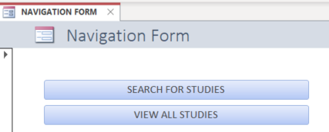Click the VIEW ALL STUDIES button to scroll through all studies, viewing all metadata. Click the SEARCH FOR STUDIES button to search for studies that meet particular criteria.

View Form
The View form allows you to scroll through all studies, as if you are reading a book. All meta-data are displayed for each study.
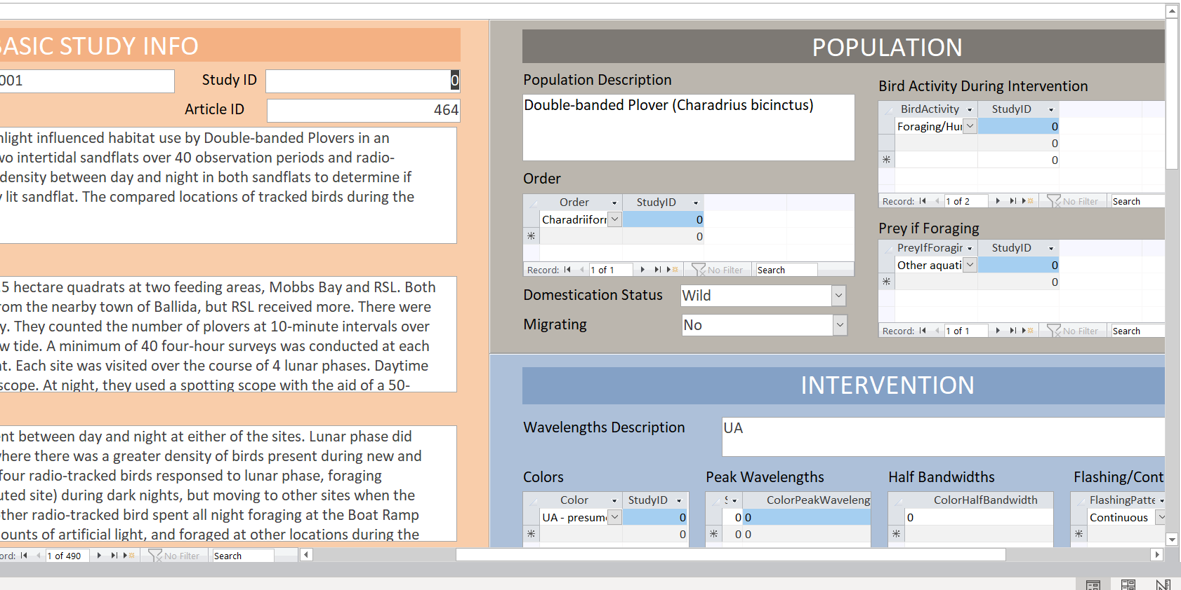
Use the scroll bars to view all of the metadata within each study
You can use the search bar to search for words within the metadata, but it is much more effective to use the Search form
Use the arrows to view the next study or previous study

Search From
The search form allows you to search for studies that meet particular meta-data criteria.
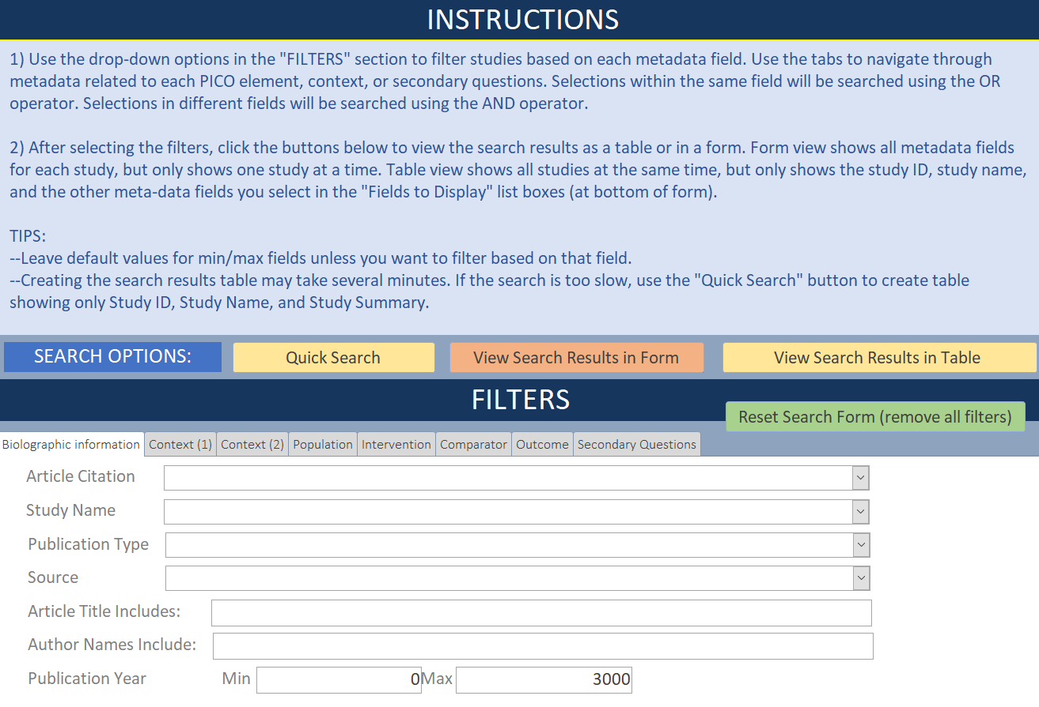
Quick search displays a table with Study ID, Study Name, and Study Summary

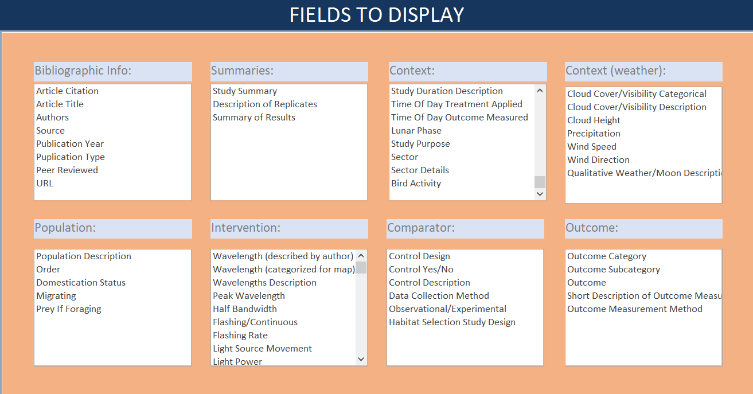
View Search Results in Table displays a table with the metadata files selected in FIELDS TO DISPLAY
View Search Results in Form displays all study metadata in the ‘View’ form. The user can scroll through studies one-by-one

In the FILTERS section, choose the filters you want to apply to the studies in the database.

As explained in the INSTRUCTIONS section of the SEARCH form, selections within each field are separated by the OR operator, and the selections from different fields are connected using the AND operator. For example, the following set of filters would return all studies on wild birds that are in the orders Strigiformes or Falconiformes. It would not return studies of wild birds in other orders, nor would it return studies of domesticated populations of birds in Strigformes or Falconiformes.
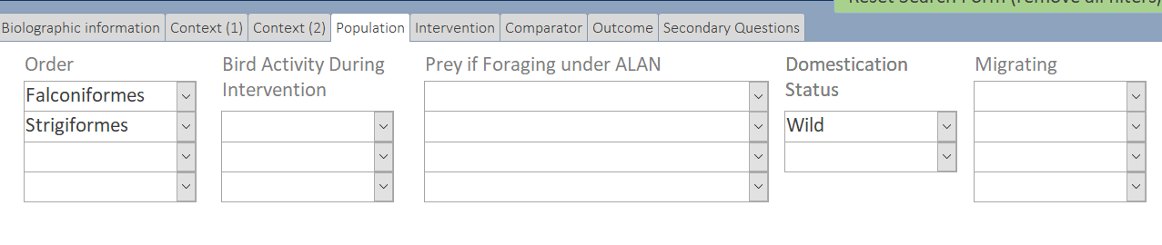
As another example, the following set of filters would return studies of flying birds that were exposed to green lasers or green flashing light
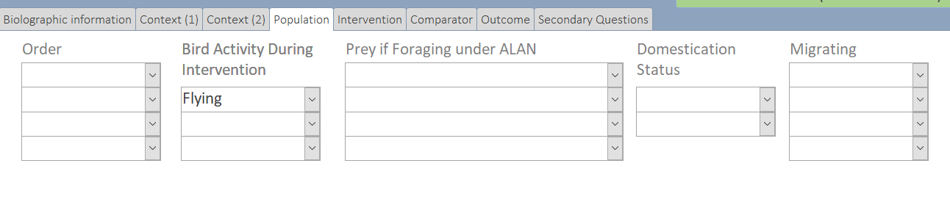
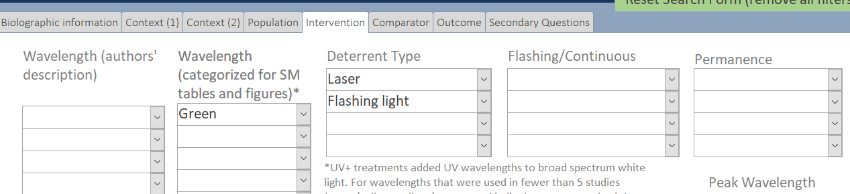

Exporting Data
To export a table as an excel of csv file, go to External Data Excel.
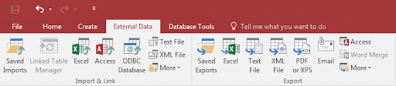

Identifying evidence for each secondary question
To view all of the evidence for each of our secondary questions, use the FILTERS section of the SEARCH form. Go to the Secondary Questions tab and select one or more of the secondary questions from the drop-down menu.
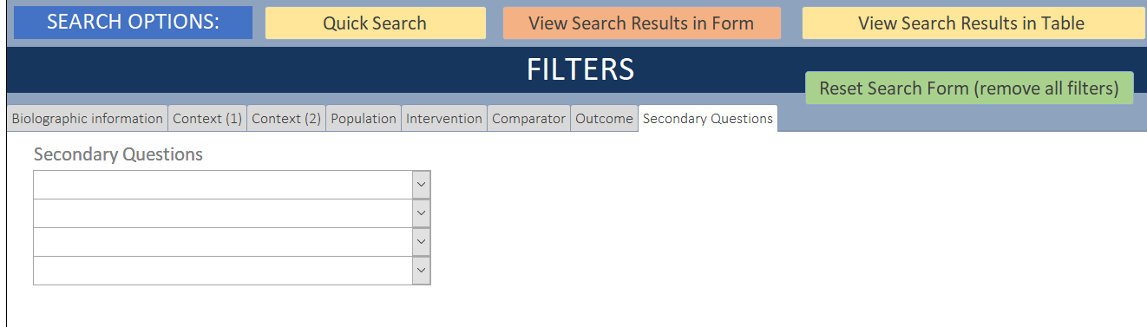

Instructions for the Excel version

Searching for studies
The challenge with using the Filter function in the Excel version is that some studies have multiple codes for each metadata field. For example, light wavelength can be both blue and green for the same study. One way to search for studies that meet particular metadata criteria is to use the Text Filters.
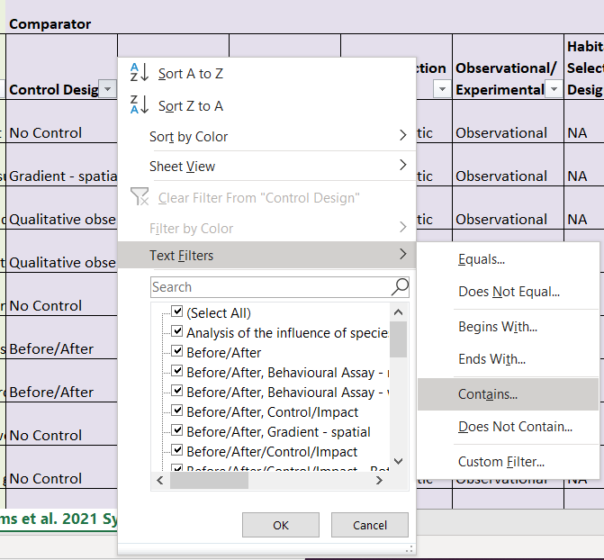

Identifying Evidence for Each Secondary Question
The final column of the spreadsheet shows the secondary questions for which each study is relevant. Use text filters to find all studies relevant to a particular secondary question by searching for studies that contain the code for that secondary question. For example, to search for all studies relevant to our first secondary question, click on “Contains…” and apply the following filter:
