Descriptive statistics

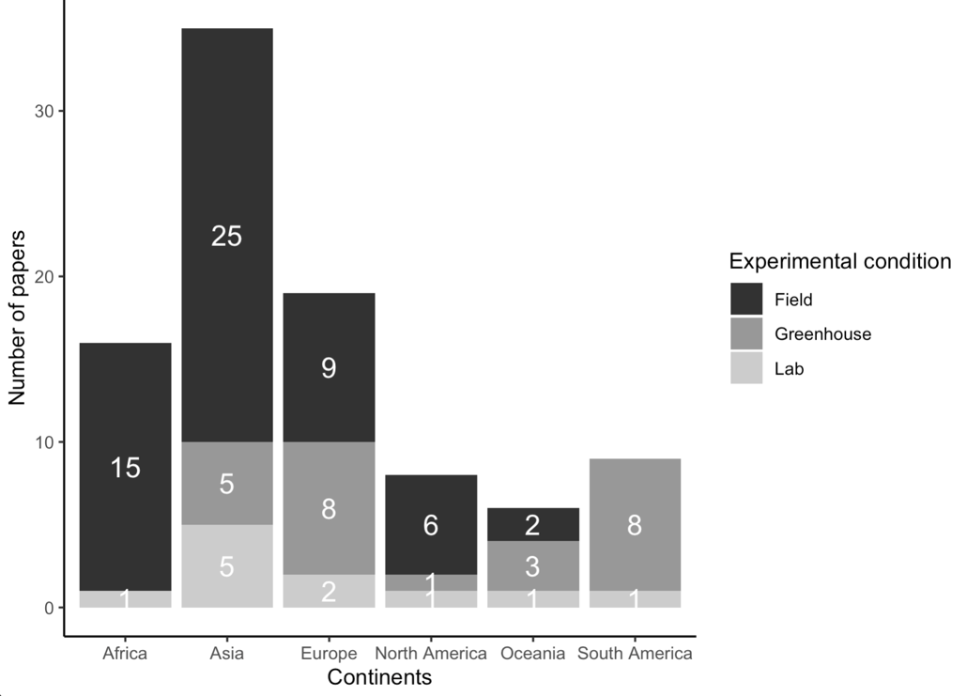

Figure 10.1. Studies with different experimental conditions per continent

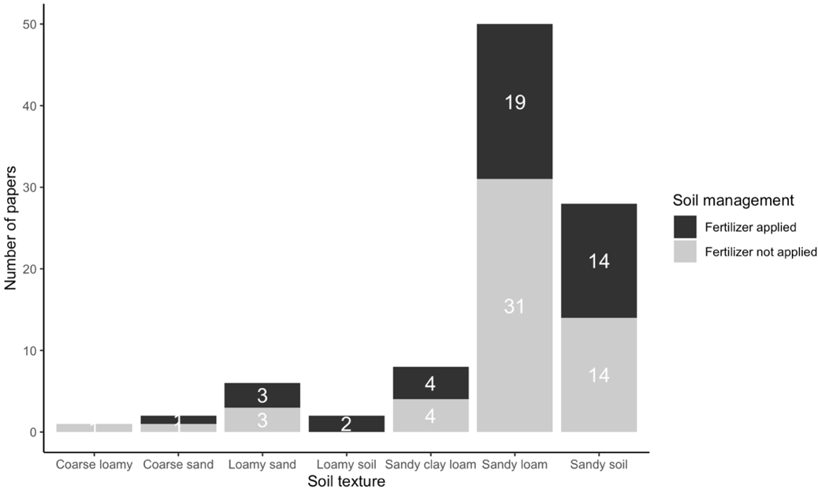
Figure 10.2. Studies with different soil managements per soil type

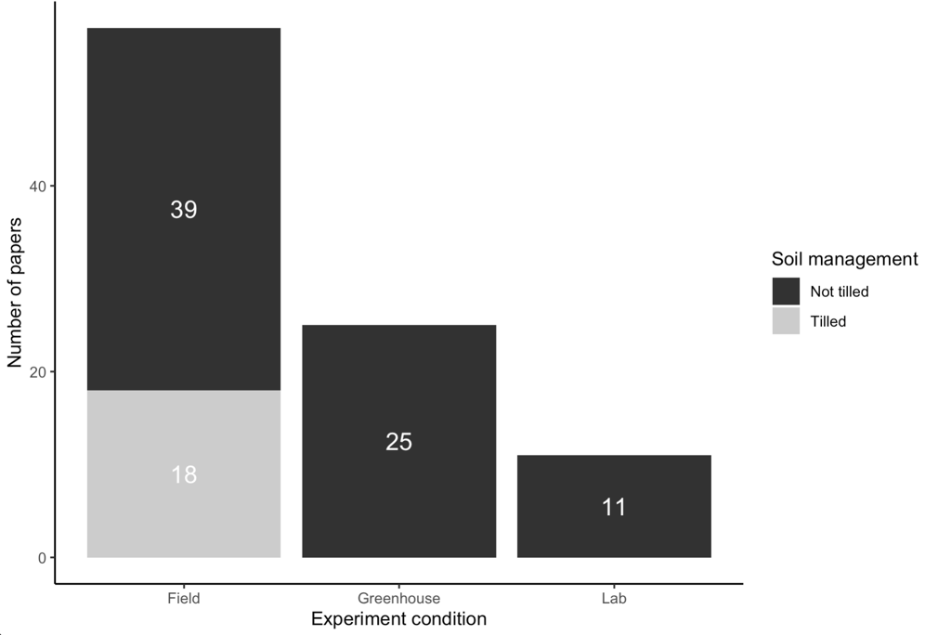
Figure 10.3. Studies with different soil managements per study design

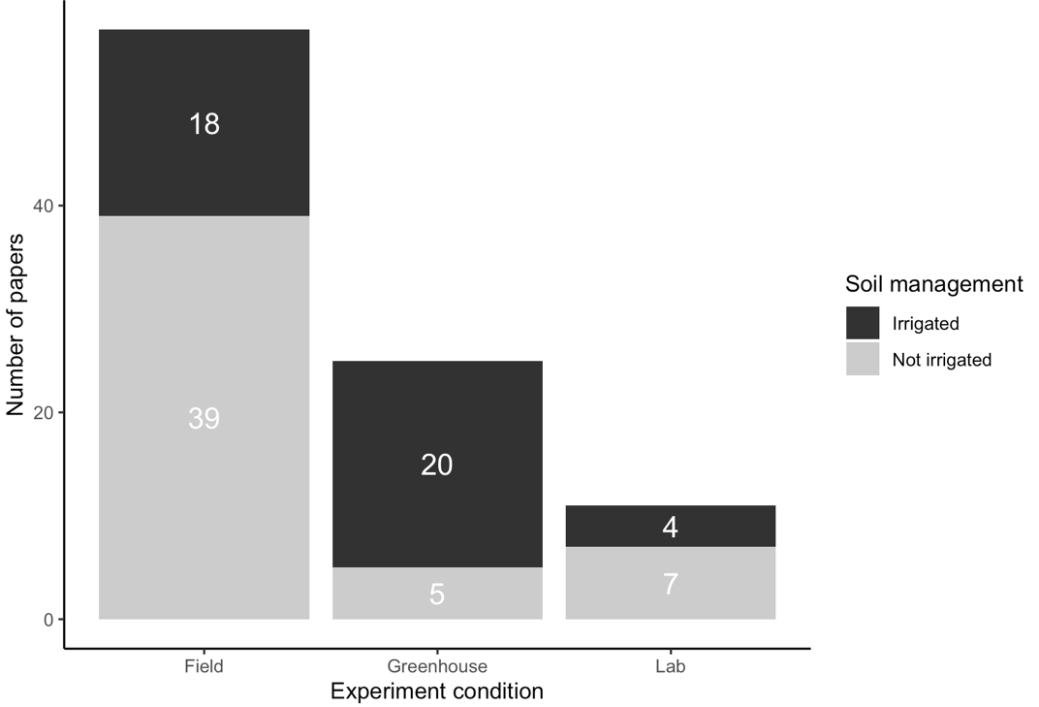
Figure 10.4. Studies with different soil managements per study design

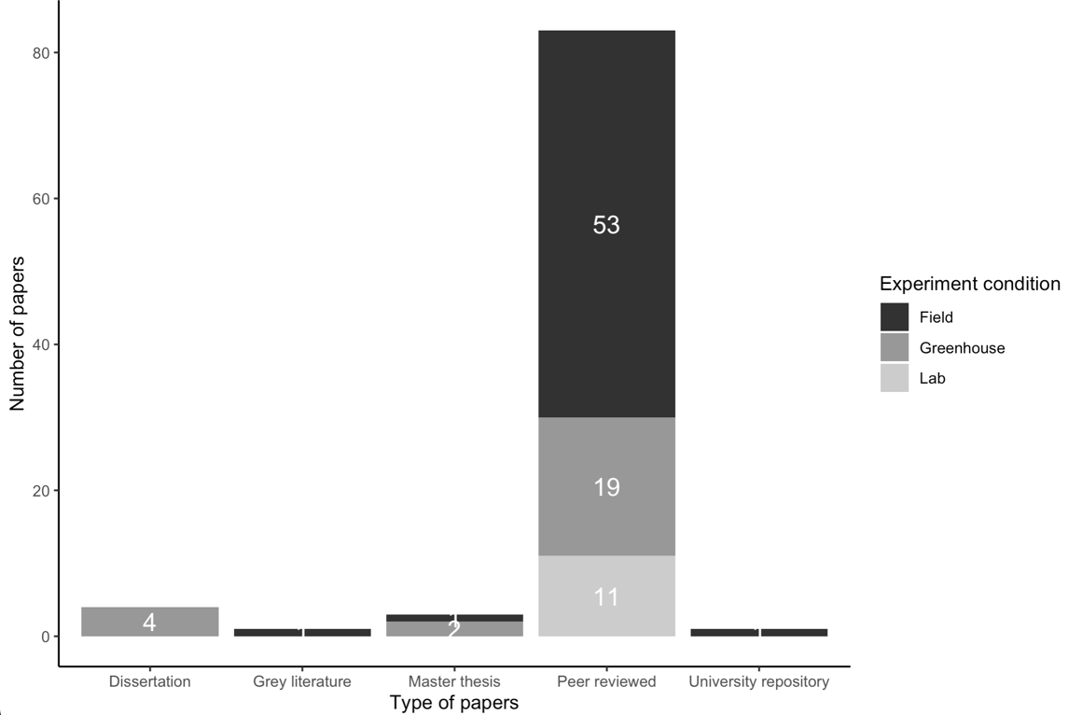
Figure 10.5. Studies with different soil managements per study design

Table 10.1. Number of observations per feedstock type in different pyrolysis groups

Feedstock type | Pyrolysis group | Unique studies | Number of observations
Agricultural residue | High | 7 | 67
Agricultural residue | Low | 22 | 414
Agricultural residue | Medium | 25 | 326
Manure|digestate | High | 3 | 9
Manure|digestate | Low | 4 | 32
Manure|digestate | Medium | 11 | 135
Woody | High | 9 | 97
Woody | Low | 11 | 103
Woody | Medium | 26 | 362

Table 10.2. Number of observations per tillage application in different experimental conditions

Tillage application | Experiment condition | Unique studies | Number of observations
Not tilled | Field | 39 | 551
Not tilled | Greenhouse | 25 | 496
Not tilled | Lab | 11 | 211
Tilled | Field | 18 | 341

Table 10.3. Number of observations per soil management in different sandy-textured soils

NPK before biochar | Soil type | Unique studies | Number of observations
Fertilizer applied | Coarse sand | 1 | 5
Fertilizer applied | Loamy sand | 3 | 75
Fertilizer applied | Loamy soil | 2 | 28
Fertilizer applied | Sandy clay loam | 4 | 43
Fertilizer applied | Sandy loam | 19 | 198
Fertilizer applied | Sandy soil | 14 | 240
Fertilizer not applied | Coarse loamy | 1 | 9
Fertilizer not applied | Coarse sand | 1 | 4
Fertilizer not applied | Loamy sand | 3 | 81
Fertilizer not applied | Sandy clay loam | 4 | 122
Fertilizer not applied | Sandy loam | 31 | 536
Fertilizer not applied | Sandy soil | 14 | 258

Table 10.4. Number of observations per experiment duration in different experimental conditions

Experiment duration | Experiment condition | Unique studies | Number of observations
0-60 | Field | 1 | 4
0-60 | Greenhouse | 9 | 202
0-60 | Lab | 4 | 40
60-160 | Field | 10 | 190
60-160 | Greenhouse | 11 | 232
60-160 | Lab | 7 | 77
160-402 | Field | 17 | 236
160-402 | Greenhouse | 4 | 54
160-402 | Lab | 2 | 94
402-730 | Field | 19 | 310
402-730 | Greenhouse | 1 | 8
730-2200 | Field | 9 | 152

Treatment | Control | Unique studies | Number of observations
Biochar alone | Control no amendment | 79 | 1020
Biochar with compost | Control with compost | 6 | 33
Biochar with manure | Control with manure | 11 | 127
Biochar with fertilizer | Control with fertilizer | 30 | 401
Biochar with fertilizer & compost | Control with fertilizer & compost | 1 | 6
Biochar with fertilizer & manure | Control with fertilizer & manure | 2 | 12
Table 10.5. Number of observations per control and treatment

