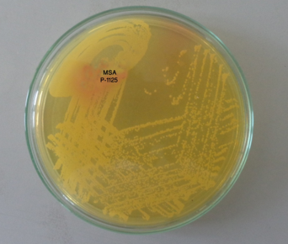
Photograph 1: Golden yellow colonies of Staphylococcus aureus on MSA medium (Sample code: p-146).

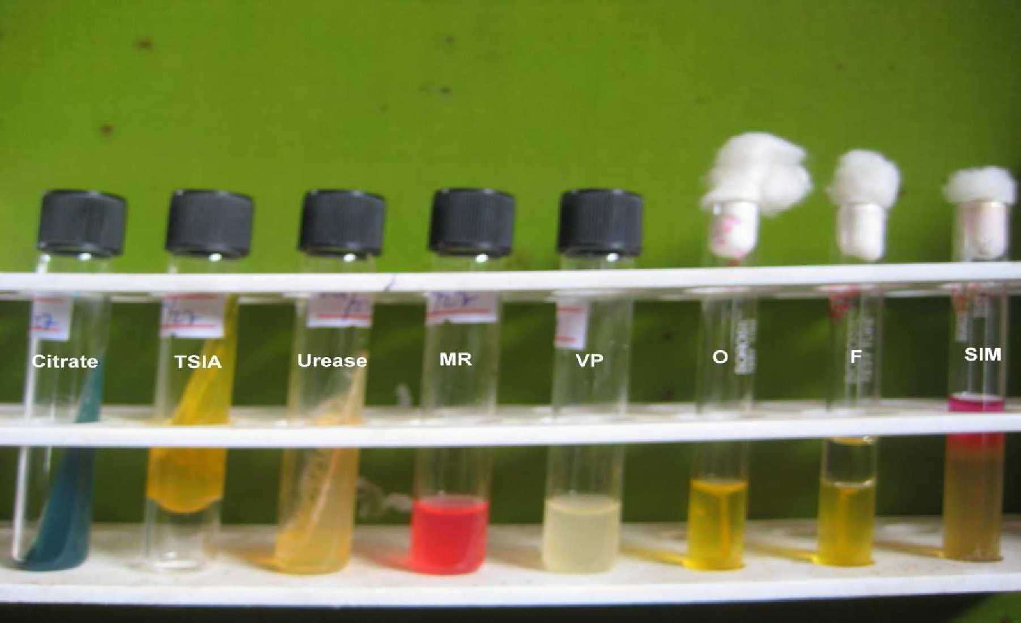
Photograph 2: Biochemical tests of Escherichia coli (Citrate= -ve, TSIA= +ve, Urease= -ve, MR= +ve, VP= -ve, OF= fermentative, H₂S= -ve, Indole= +ve, motile) (Sample code: p-76).

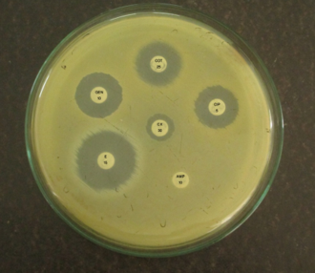
Photograph 3: Antibiotic susceptibility pattern of Staphylococcus aureus where cefoxitin (CX) = resistant, ampicillin (AMP) = resistant, erythromycin (E) = sensitive, gentamicin (G) = Sensitive, ciprofloxacin (CIP) = sensitive and co-trimoxazole (COT) = sensitive (Sample code: p-43).

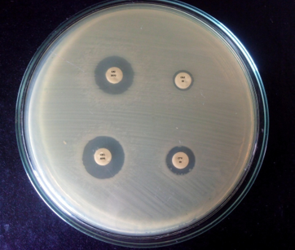
Photograph 4: Positive ESBL confirmation test on Mueller- Hinton Agar (CAZ 30 and CAC 30/10 and CTX 30 and CEC 30/10) (Difference in zone of inhibition of CAC and CAZ >5mm) (Sample code: p-167).

