Annex 2: Results of Judgement and Comprehension testing
Symbol judgement testing
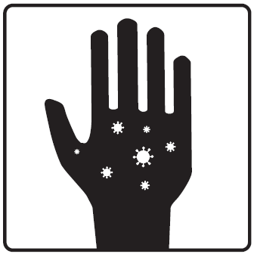
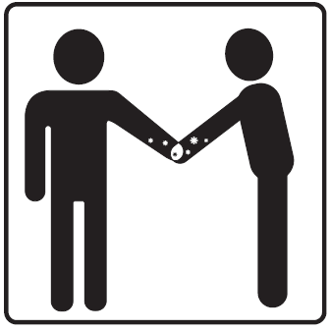
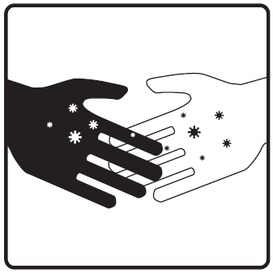
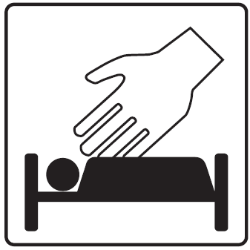
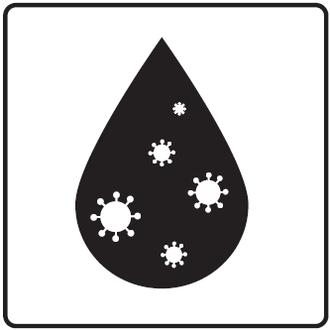
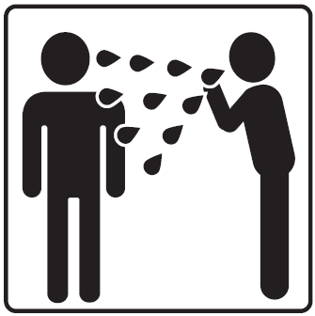
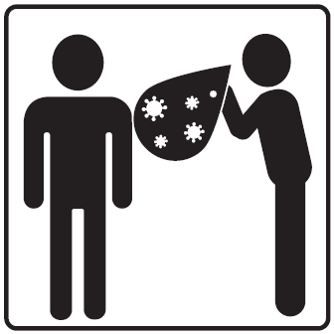
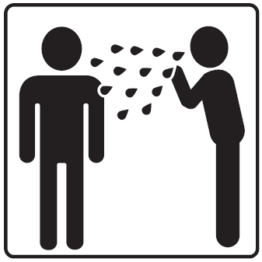
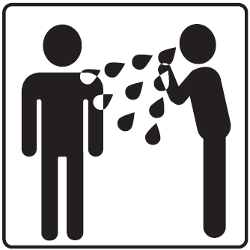
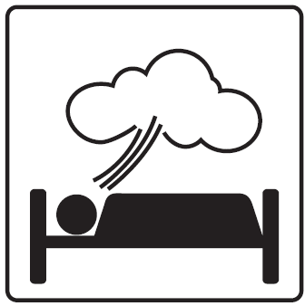
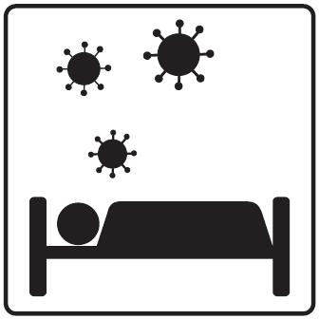
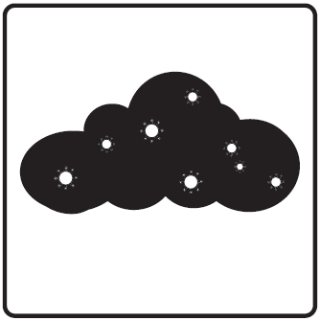
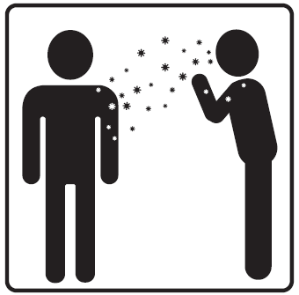
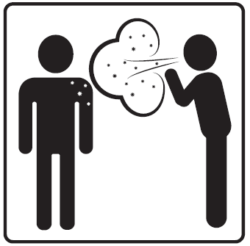
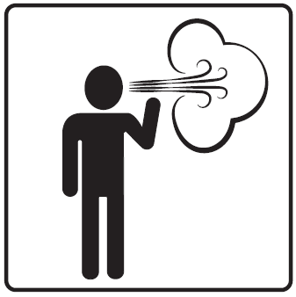
A total of 15 symbols were assessed by 10 respondents during the judgement test. Respondents included male (n=2) and female (n=8) nurses (n=6), physicians (n=2), and lab technicians (n=2), with ages of 31-50 (n=6) and over 50 (n=4). The symbols assessed included variants of three referents: contact isolation (n=4), droplet isolation (n=5), and airborne isolation (n=6), pictured above. Respondents’ judgements of how many of their colleagues would understand the symbols ranged from 17-78%. The highest rated symbols for each category were retained and further examined through a comprehensibility test.

Percentages represent respondents’ judgements of how many healthcare personnel and visitors they expect would understand the given symbols.
Symbol comprehensibility testing

