Supplemental files
The carbapenem resistance gene bla_{OXA-23} is disseminated by a conjugative plasmid containing the novel transposon Tn6681 in Acinetobacter johnsonii M19
Gongli Zong^{1,2,3}, Chuanqing Zhong⁴, Jiafang Fu^{2,3,5}, Yu Zhang⁴, Peipei Zhang^{2,3,5}, Wenchi Zhang⁶, Yan Xu¹, Guangxiao Cao^{2,3*}, Rongzhen Zhang¹

Table S1 General features of the A. johnsonii M19 genome
Features | Genome
Features | Chromosome | plasmid
Total number of base pairs | 3,749,210 | 55,044
G+C content (%) | 41.39 | 35.77
Total genes | 3,774
Number of ncRNA genes | 121
Number of tandem repeats | 147
Number of COG annotation genes | 2,613
Number of GO annotation genes | 2,124
Number of KEGG annotation genes | 2,030
Number of VFDB annotation genes | 197
Number of PHI annotation genes | 228
Number of ARDB annotation genes | 21
Abbreviations: ncRNA, noncoding RNA; COG, Clusters of Orthologous Groups database; GO, Gene Ontology database; KEGG, Kyoto Encyclopedia of Genes and Genomes; VFDB, Virulence Factors of Pathogenic Bacteria database; PHI, Pathogen Host Interactions database; ARDB, Antibiotic Resistance Genes database.

Table S2 Antibiotic resistance genes of the A. johnsonii M19 genome
Resistance mechanism | Class/subgroup | Protein | Number of genes | Location
β-lactamase | Class B | MBL | 6 | Chromosome
β-lactamase | Class C | AmpC | 2 | Chromosome
β-lactamase | Class D | OXA-211 | 1 | Chromosome
β-lactamase | Class D | OXA-23 | 1 | Plasmid
Efflux pumps | MFS | MdtD | 1 | Chromosome
Efflux pumps | MFS | Bcr/CflA | 1 | Chromosome
Efflux pumps | MFS | MdfA | 1 | Chromosome
Efflux pumps | MFS | FsR | 1 | Chromosome
Efflux pumps | RND | MexP | 1 | Chromosome
Efflux pumps | RND | MexQ | 1 | Chromosome
Efflux pumps | RND | OpmE | 1 | Chromosome
Efflux pumps | RND | AdeA | 1 | Chromosome
Efflux pumps | RND | AdeB | 1 | Chromosome
Efflux pumps | RND | AdeC | 1 | Chromosome
Efflux pumps | RND | AdeI | 1 | Chromosome
Efflux pumps | RND | AdeJ | 1 | Chromosome
Efflux pumps | RND | AdeK | 1 | Chromosome
Efflux pumps | RND | AdeT | 2 | Chromosome
Efflux pumps | SMR | QacE | 1 | Chromosome
Efflux pumps | MATE | MdtK/NorM | 2 | Chromosome
Efflux pumps | PACE | AceI | 1 | Chromosome
Efflux pumps | Other efflux pumps | EmrA | 2 | Chromosome
Efflux pumps | Other efflux pumps | EmrB | 2 | Chromosome
Efflux pumps | Other efflux pumps | MacA | 1 | Chromosome
Efflux pumps | Other efflux pumps | MacB | 1 | Chromosome
Efflux pumps | Other efflux pumps | MacC | 1 | Chromosome
Permeability defects | Porin | OmpA | 1 | Chromosome
Aminoglycoside-modifying enzymes | Aminoglycoside phosphotransferase | APH(3") | 1 | Chromosome
Fluoroquinolones | gyrA mutation | GyrA | 1 | Chromosome
Fluoroquinolones | parC mutation | ParC | 1 | Chromosome
MFS, major facilitator superfamily; FsR, Fosmidomycin resistance protein; RND, resistance nodulation division; SMR, small multidrug resistance; MATE, multidrug and toxic compound extrusion; PACE, proteobacterial antimicrobial compound efflux.

Table S3 Predicted genes of plasmid pFM-M19
Gene ID | Start | Stop | Strand | Protein name
E0Z08_18620 | 11 | 3286 | - | ATP-dependent helicase
E0Z08_18630 | 5442 | 5879 | - | hypothetical protein
E0Z08_18635 | 6047 | 6439 | - | hypothetical protein
E0Z08_18640 | 6432 | 8603 | - | DNA topoisomerase III
E0Z08_18645* | 8683 | 10140 | - | P-type conjugative transfer protein TrbI
E0Z08_18650 | 10141 | 10584 | - | hypothetical protein
E0Z08_18655* | 10597 | 11628 | - | P-type conjugative transfer protein TrbG
E0Z08_18660* | 11656 | 12360 | - | conjugal transfer protein TrbF
E0Z08_18665* | 12427 | 13809 | - | P-type conjugative transfer protein TrbL
E0Z08_18670* | 13870 | 14646 | - | conjugal transfer protein TrbJ
E0Z08_18675* | 14687 | 15085 | - | hypothetical protein
E0Z08_18680* | 15057 | 17546 | - | ATPase TrbE
E0Z08_18685* | 17559 | 17846 | - | translocation channel protein TrbD
E0Z08_18690* | 17900 | 18277 | - | conjugal transfer protein TrbC
E0Z08_18695* | 18288 | 19238 | - | P-type conjugative transfer ATPase TrbB
E0Z08_18700 | 19846 | 20340 | + | hypothetical protein
E0Z08_18705 | 20560 | 21015 | + | hypothetical protein
E0Z08_18710 | 21067 | 21402 | + | hypothetical protein
E0Z08_18715 | 21476 | 22246 | + | ParA family protein
E0Z08_18720 | 22264 | 23523 | + | ParB/RepB/Spo0J family partition protein
E0Z08_18725 | 23591 | 23836 | + | hypothetical protein
E0Z08_18730** | 24105 | 25249 | + | IS3-like element ISAba14 family transposase
E0Z08_18735** | 25312 | 25659 | + | hypothetical protein
E0Z08_18740** | 25677 | 26336 | + | ATP-binding protein
E0Z08_18745** | 26441 | 27262 | - | carbapenem-hydrolysing class D beta-lactamase OXA-23
E0Z08_18750** | 27361 | 28079 | + | IS4 family transposase ISAba1
E0Z08_18755** | 28161 | 29305 | + | IS3-like element ISAba14 family transposase
E0Z08_18760 | 29362 | 29736 | + | hypothetical protein
E0Z08_18765 | 29797 | 30282 | - | hypothetical protein
E0Z08_18770* | 30292 | 31017 | - | conjugal transfer protein TraL
E0Z08_18775 | 31033 | 31395 | - | hypothetical protein
E0Z08_18780 | 31723 | 32109 | + | LysR family transcriptional regulator
E0Z08_18785* | 32119 | 34026 | + | relaxase
E0Z08_18790* | 34113 | 36038 | + | conjugal transfer protein TraG/ VirD4
E0Z08_18795 | 36038 | 36625 | + | signal peptidase I
E0Z08_18800 | 36658 | 37302 | + | lytic transglycosylase domain-containing protein
E0Z08_18805 | 37316 | 37504 | + | hypothetical protein
E0Z08_18810 | 37507 | 41289 | + | DUF1738 domain-containing protein
E0Z08_18815 | 41514 | 41966 | - | hypothetical protein
E0Z08_18820 | 41994 | 42647 | - | recombinase family protein
E0Z08_18825 | 42831 | 43775 | + | hypothetical protein
E0Z08_18830 | 43778 | 44257 | + | hypothetical protein
E0Z08_18835 | 44270 | 44542 | + | hypothetical protein
E0Z08_18840 | 44557 | 45537 | + | hypothetical protein
E0Z08_18850 | 46721 | 47497 | + | SprT domain-containing protein
E0Z08_18855 | 47799 | 49145 | + | hypothetical protein
E0Z08_18860 | 49267 | 52470 | - | DEAD/DEAH box helicase
E0Z08_18865 | 52483 | 54357 | - | site-specific DNA-methyltransferase
E0Z08_18870 | 54374 | 55018 | - | DUF4391 domain-containing protein
*, conjugal transfer protein genes; **, genes of Tn6681

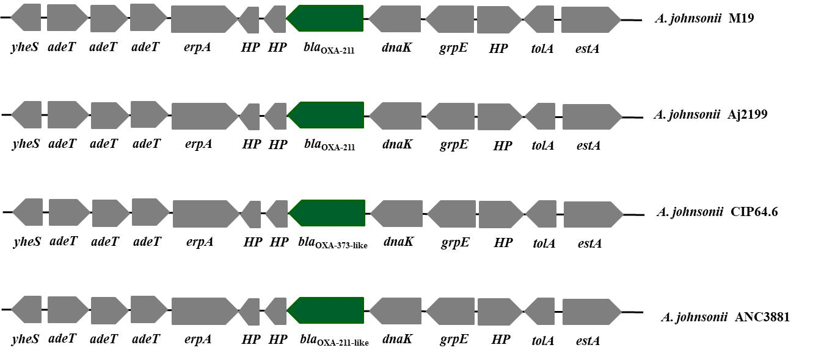
Fig. S1 Comparison of the genetic context of bla_{OXA-211} in M19 and other A. johnsonii strains. bla_{OXA-211} gene, green arrows; downstream and upstream genes, grey arrows. HP, hypothetical protein.

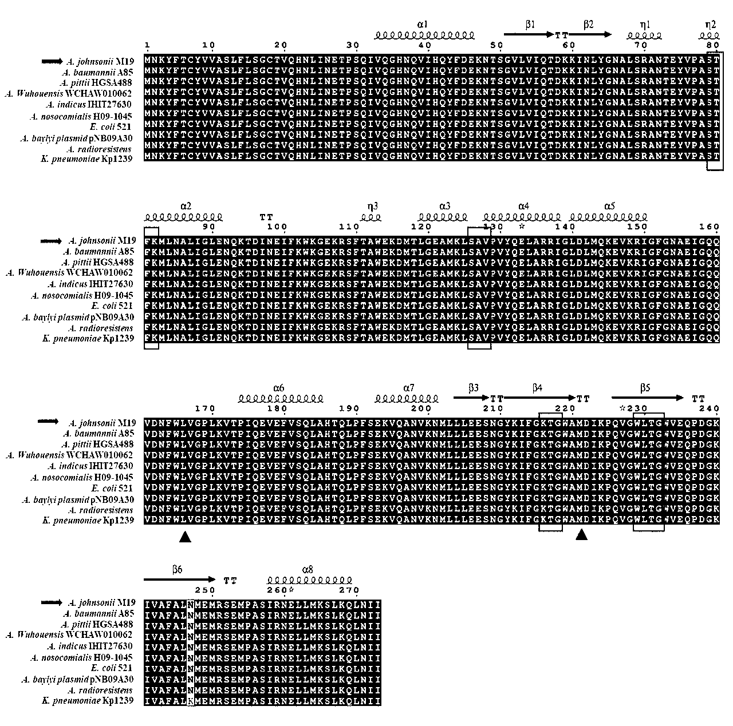
Fig. S2 Multi-sequence comparison of OXA-23 proteins from A. johnsonii M19 and various other bacteria. A. johnsonii M19, QBK71541.1; A. baumannii A85, CAB69042.1; A. pittii HGSA488, AUF80820.1; A. wuhouensis WCHAW010062, AYO52469.1; A. indicus IHIT27630, ANG65640.1; A. nosocomialis H09-1045, AKL90363.1; E. coli 521, AIE13834.1; A. baylyi plasmid pNB09A30, AER61544.1; A. radioresistens, ABX00637.1; K. pneumoniae Kp1239, WP_063864531.1. Residues in boxes are known to play a role in the catalytic mechanism, and residues marked by arrowheads are critical for carbapenemase activity. Protein structural features are indicated at the top of each section.

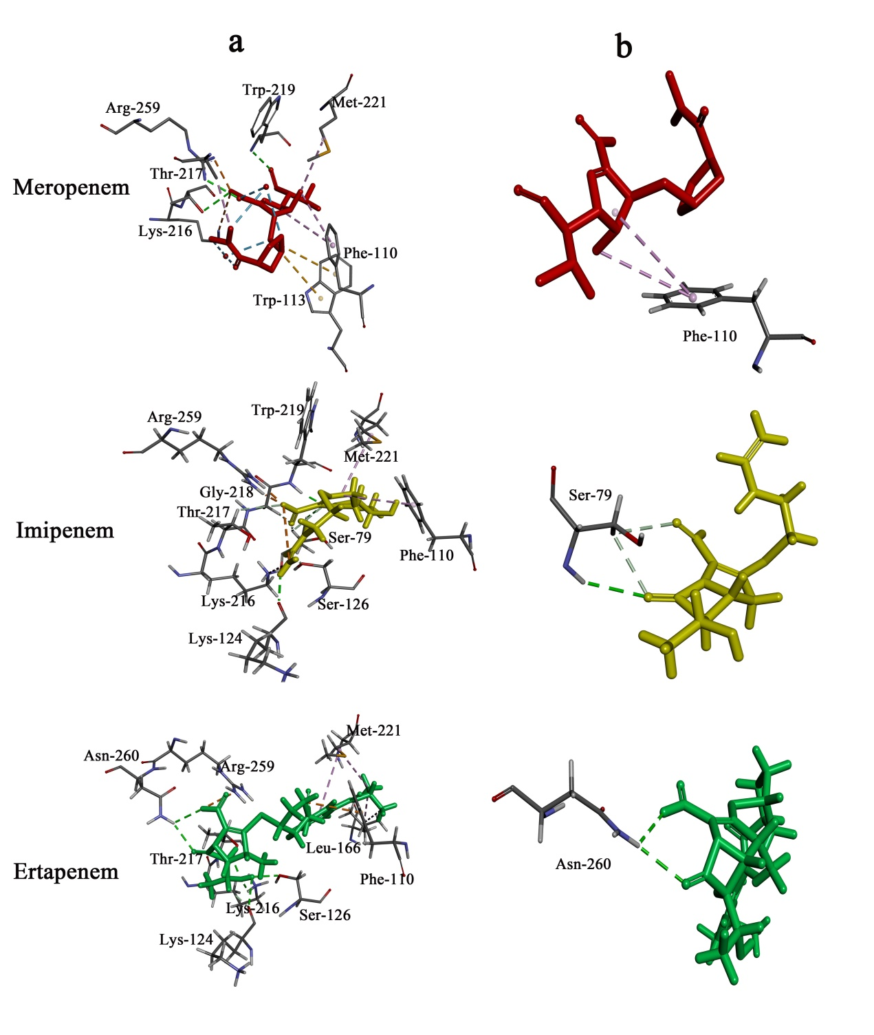
Fig. S3 Stick models of the active sites of OXA-23 during carbapenem binding and the carbapenem β-lactam ring. Meropenem, imipenem and ertapenem are represented, respectively, by red, blue and green stick models. Broken lines represent bonds between OXA-23 and the carbapenems.

Correspondence: rzzhang@jiangnan.edu.cn (Rongzhen Zhang); ¹Key Laboratory of Industrial Biotechnology of Ministry of Education & School of Biotechnology, Jiangnan University, Wuxi 214122, China. caozhong0402@163.com (Guangxiao Cao) ² Department of Epidemiology, the First Affiliated Hospital of Shandong First Medical University, Jinan 250062, China. ³Shandong Medicinal Biotechnology Center, Shandong First Medical University & Shandong Academy of Medical Sciences, Jinan 250062, China.

