Evidence-Based Hand Hygiene: Liquid or Gel Handrub, does it matter?
Constantinos Voniatis^{1,2}, Száva Bánsághi^{3,6}, Dániel Sándor Veres⁴, Péter Szerémy⁶, Angela Jedlovszky-Hajdu², Attila Szijártó¹, Tamás Haidegger^{6,7}
- Department of Surgery, Transplantation and Gastroenterology, Semmelweis University, Budapest, Hungary
- Laboratory of Nanochemistry, Department of Biophysics and Radiation Biology, Semmelweis University, Budapest, Hungary
- Doctoral School of Health Sciences, Semmelweis University, Budapest, Hungary
- Department of Biophysics and Radiation Biology, Semmelweis University, Budapest, Hungary
- University Research and Innovation Centre (EKIK), Óbuda University, Budapest, Hungary
- Austrian Center for Medical Innovation and Technology (ACMIT), Wiener Neustadt, Austria

Corresponding Author: Dr. Tamás Haidegger, haidegger@irob.uni-obuda.hu

Supplementary Material
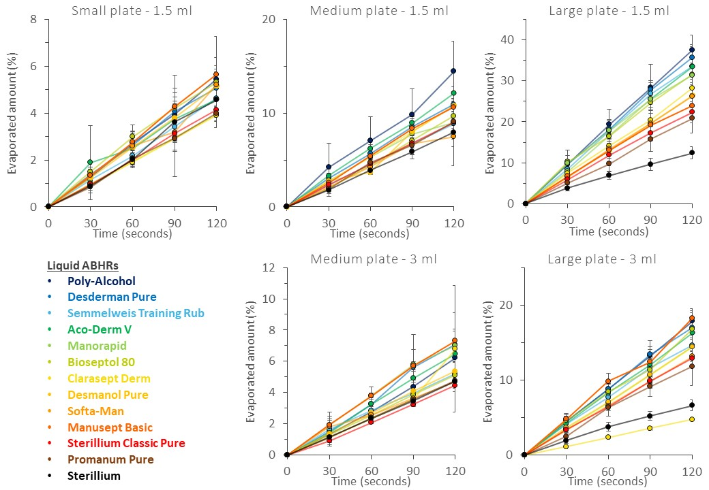
Supporting Figure 1. Liquid ABHR – in vitro evaporation rate examination results

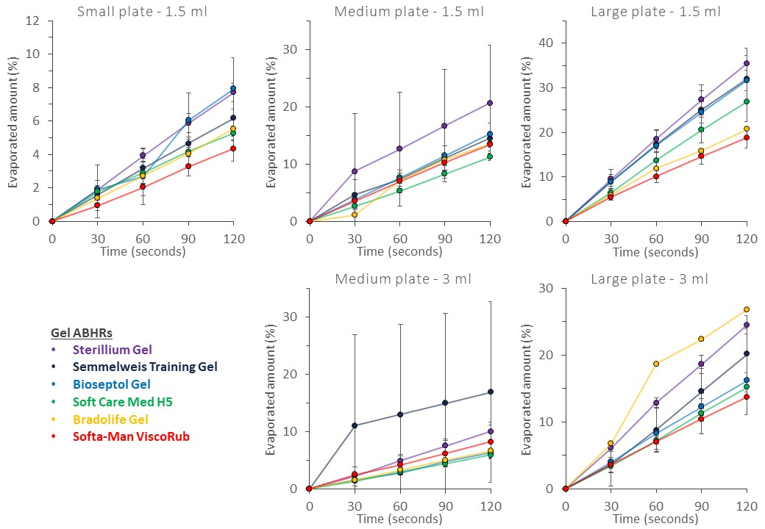
Supporting Figure 2. Gel ABHR – in vitro evaporation rate examination results

