Supplementary material

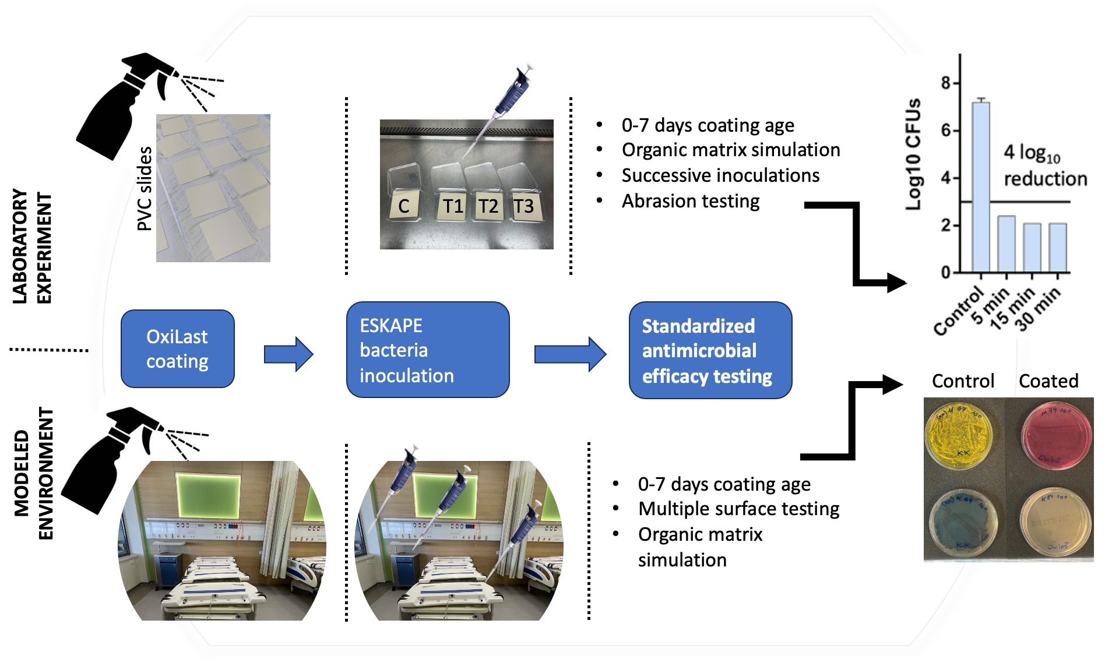
Supplementary Figure 1. Schematic overview of the laboratory phase experiment and the modeled environmental experiment phases aiming at a four log₁₀ reduction of the inoculated bacterial strains onto OxiLast-coated and non-coated control surfaces.

