Additional file 4

Antimicrobial consumption by gender, age group, and ICU care level 2018-2021.
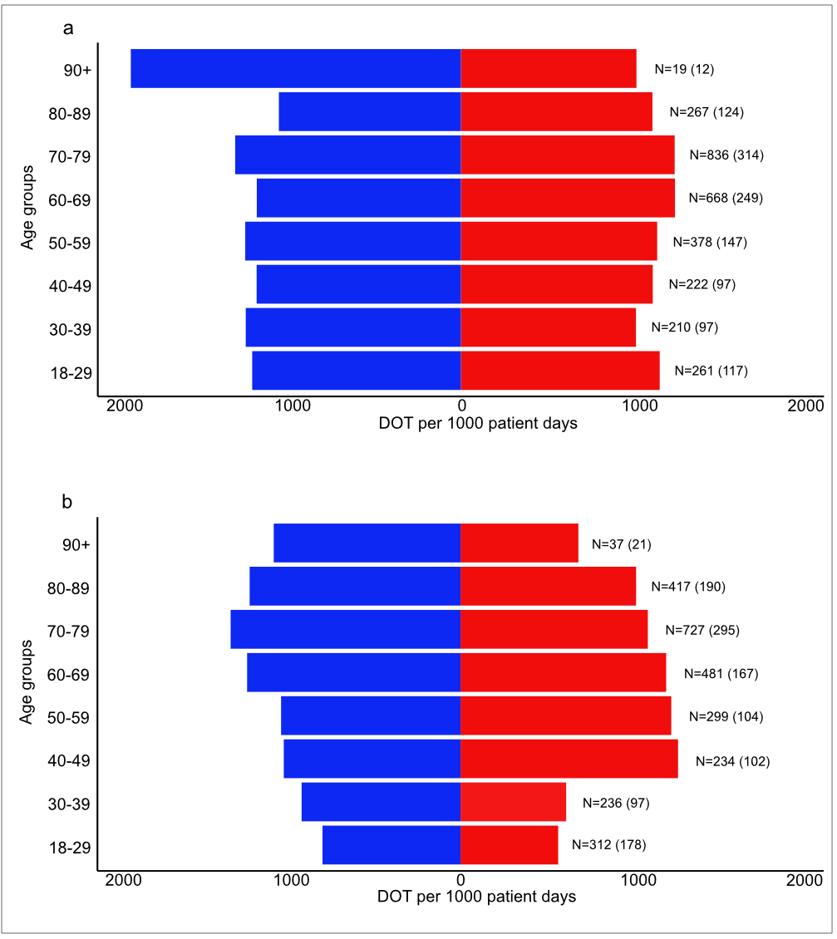

Additional file 4. Antimicrobial consumption in DOT per 1000 patient days by age group and gender. Men are indicated by blue bars and women by red bars. Panel a shows data for the tertiary care ICU. Panel b shows aggregated data for the two secondary care ICUs. The total number of admissions per age group are indicated to the far right. Numbers in parentheses indicate admissions of women.

