Supplementary materials for

Temporal trends of skin and soft tissue infections caused by methicillin-resistant Staphylococcus aureus in Gabon

Authors:
Christiane Sidonie Gouleu¹, Maradona Agbanrin Daouda¹, Sam O’neilla Oye Bingono¹, Matthew Benjamin Bransby McCall², Abraham Sunday Alabi¹, Ayola Akim Adegnika^{1,3}, Frieder Schaumburg^{1,4}, Tobias Grebe⁴

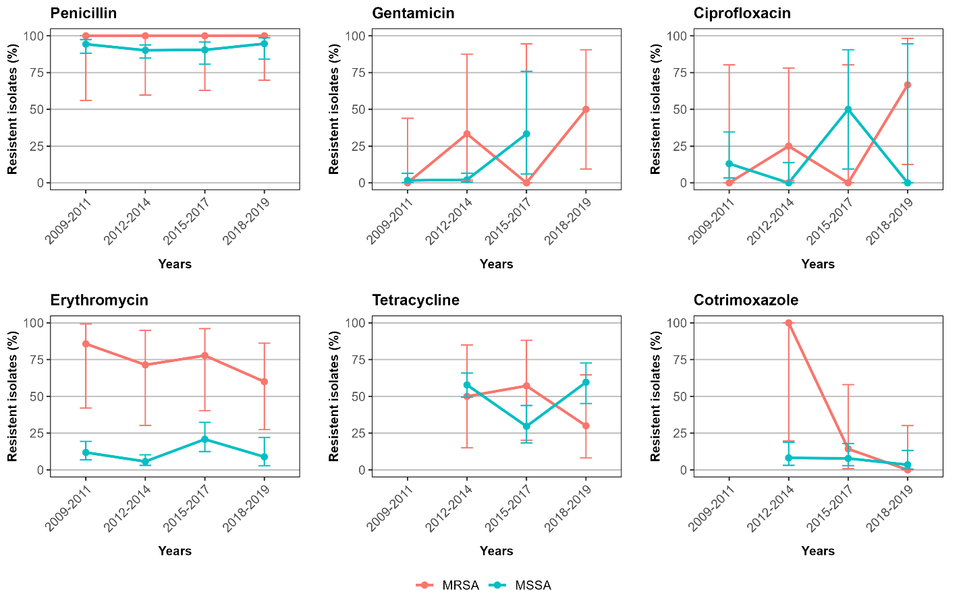

Figure S1. Temporal trends in the antimicrobial resistance profile of MRSA and MSSA. Proportion of methicillin-resistant Staphylococcus aureus (MRSA) and methicillin-susceptible Staphylococcus aureus (MSSA) isolates resistant to each antimicrobial agent during the study period. The time frame of the study was divided into four sections of 2-3 years to account for the low sample number in some individual years. Clindamycin was excluded because there was only one resistant isolate in our study. It should be noted that in some years sample numbers were low for some antibiotics, so proportions should be interpreted with caution (see Table 2). Error bars represent 95% confidence intervals. Prior to 2012, susceptibility testing for tetracycline and cotrimoxazole was not performed.

