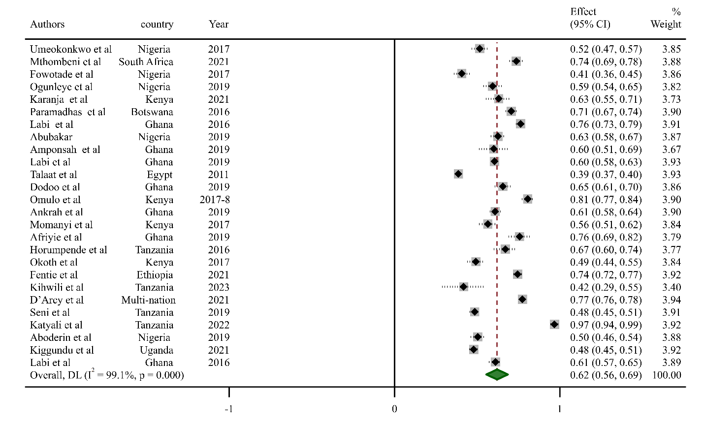
Figure 1 Prevalence of antimicrobial prescription for therapeutics reason in African health facilities
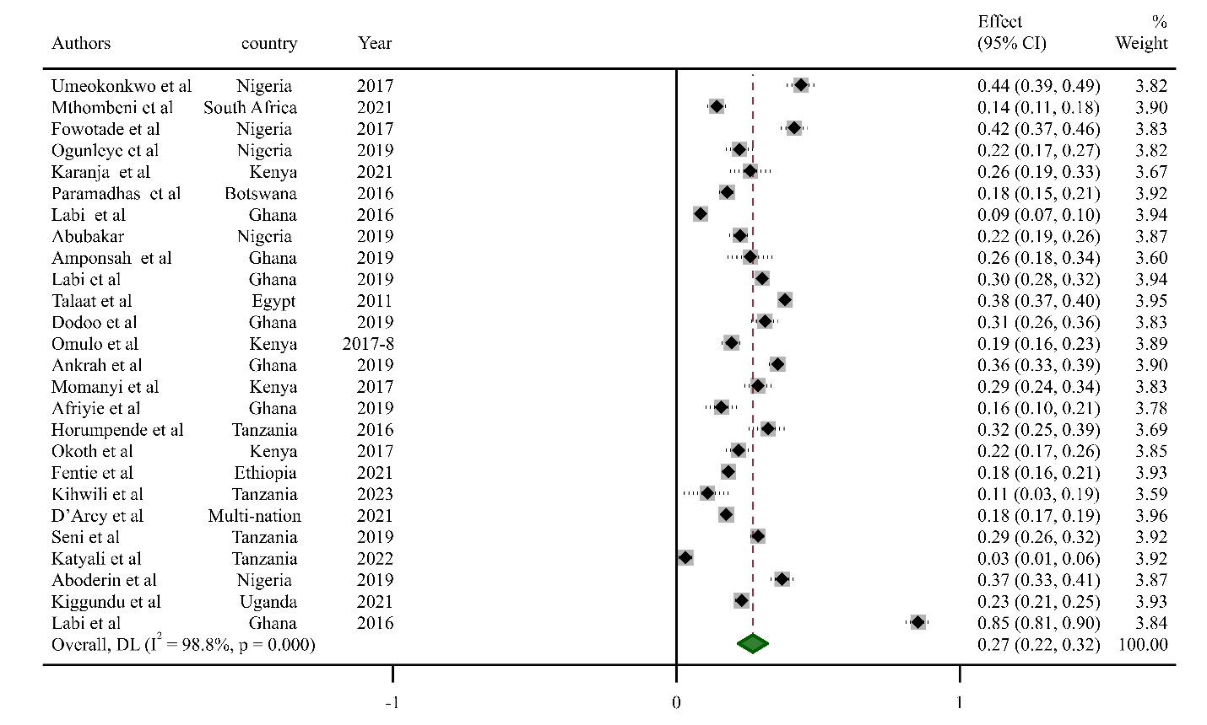
Figure 2 Prevalence of antimicrobial prescription for surgical prophylaxis in African health facilities

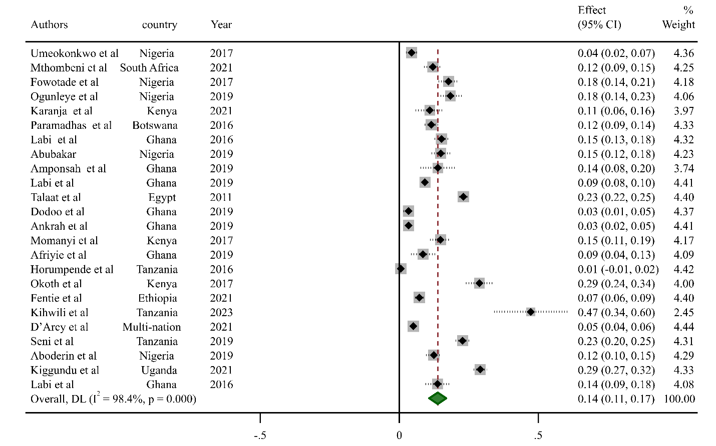
Figure 3 Prevalence of antimicrobial prescription for medical prophylaxis in African health facilities
Table 1 Univariate meta-regression of sample size, year of study number of facilities, and prevalence of antimicrobial prescription
P | Coefficient | Std. err. | t | P>|t| | [95% conf. interval]
Sample Size | -.0000238 | .0000181 | -1.32 | 0.088 | -.0000607 .0000131
year of study | .0081188 | .0116124 | 0.70 | 0.490 | -.0155969 .0318346
Number of facilities | -.0020618 | .0047922 | -0.43 | 0.670 | -.0118487 .0077251

Fig. 4 Galbaith plot of prevalence of antimicrobial prescription in African health facilities
Table 4 Eggers regression test for publication bias analysis
Std_Eff | Coefficient | Std. err. | t | P>|t| | [95% conf. interval]
Slop | .5192506 | .0490436 | 10.59 | 0.000 | .4189452 .619556
Bias | 3.425891 | 3.560406 | 0.96 | 0.344 | -3.855957 10.70774
Test of H0: no small-study effects P = 0.34
Table 5 Trim and fill analysis
Method |  | Pooled Est | 95% ci |  | Asymptotic |  | No. of studies
 |  | Pooled Est | Lower | Upper | z_value | p_value | No. of studies
Before | Fixed | 0.560 | 0.555 | 0.565 | 226.233 | 0.000 | 31
Before | Random | 0.591 | 0.540 | 0.642 | 22.601 | 0.000 | 31
Filled | Fixed | 0.546 | 0.541 | 0.551 | 226.233 | 0.000 | 36
Filled | Random | 0.548 | 0.497 | 0.599 | 21.095 | 0.000 | 36
Test for heterogeneity: Q= 3780.068 on 35 degrees of freedom (p =0.000), Moment-based estimate of between studies variance = 0.023

