Supplementary figure 1.
Standardized grid used for direct observation of the proximal manipulations.

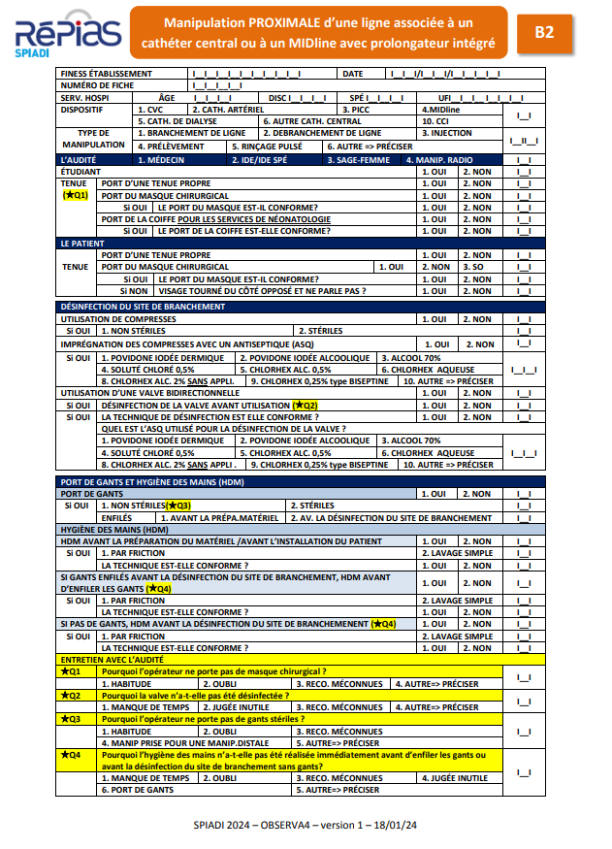
Supplementary figure 2.
Schematic representation of the different steps of proximal manipulation and the timing of microbiological sampling of the hands of the observed HCWs.

Supplementary figure 3.
Regional distribution of the 35 participating centers in the CleanhandPROX study.

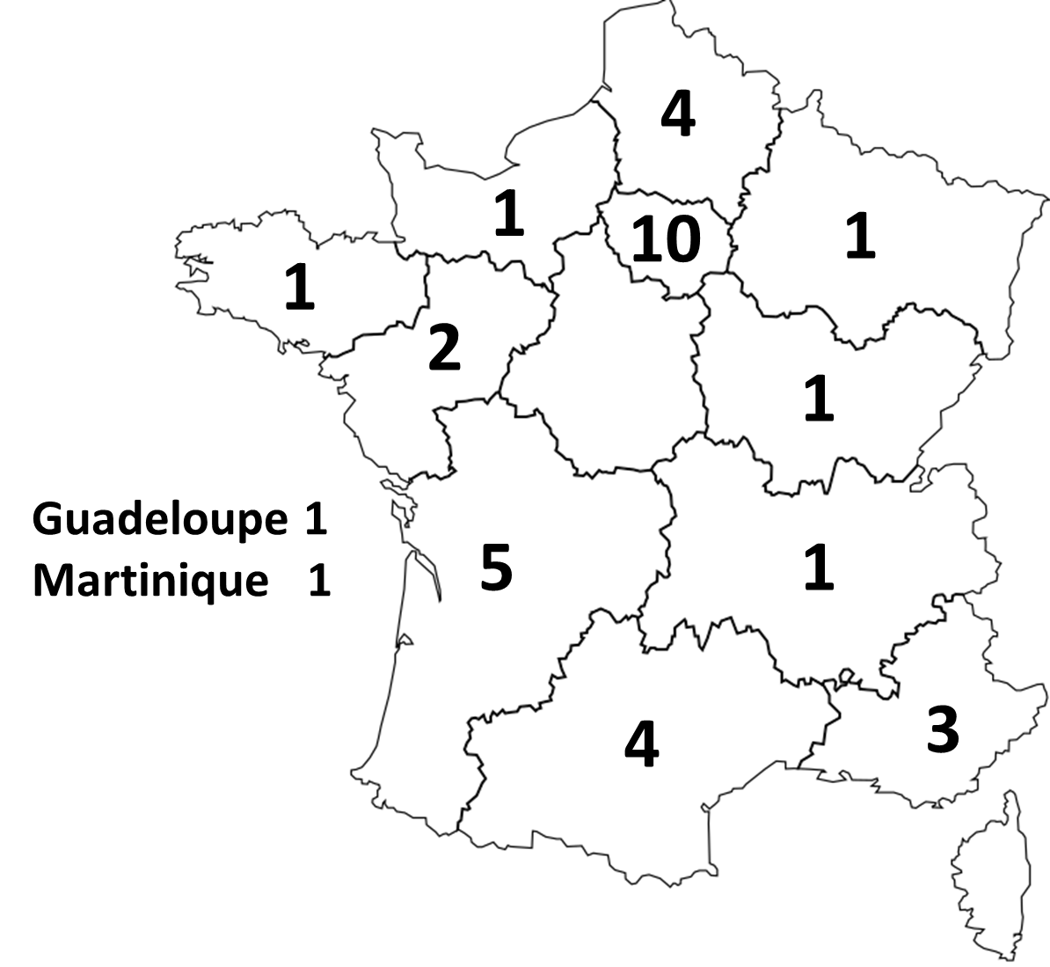
Supplementary figure 4.
Microorganisms involved in 698 CVC-, PICC- and IPC-related late-onset bacteremia cases (Survey campaign 2023; SPIADI national network).

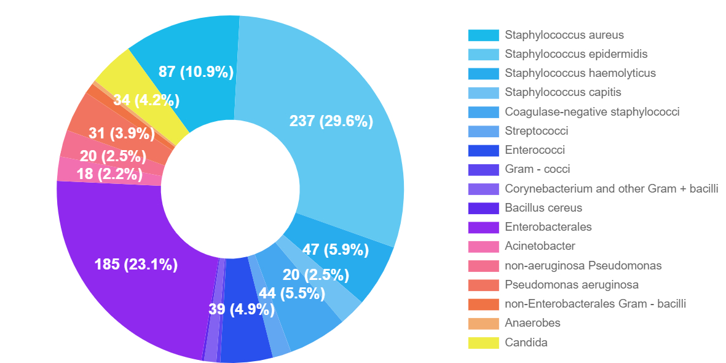

Staphylococcus aureus 87 (10.9%)
Staphylococcus epidermidis 237 (29.6%)
Staphylococcus hemolyticus 47 (5.9%)
Staphylococcus capitis 20 (2.5%)
Coagulase-negative staphylococci 44 (5.5%)
Streptococci 14 (1.7%)
Enterococci 39 (4.9%)
Gram – cocci 3 (0.4%)
Corynebacterium and other Gram + bacilli 9 (1.1%)
Bacillus cereus 2 (0.2%)
Enterobacterales 185 (23.1%)
Acinetobacter 18 (2.2%)
nonaeruginosa Pseudomonas 20 (2.5%)
Pseudomonas aeruginosa 31 (3.9%)
non-Enterobacterales Gram- bacilli 8 (1.0%)
Anaerobes 3 (0.4%)
Candida 34 (4.2%).

Supplementary figure 5.
The CleanhandPROX educational tool.

The poster announcing an educational session in the wards.

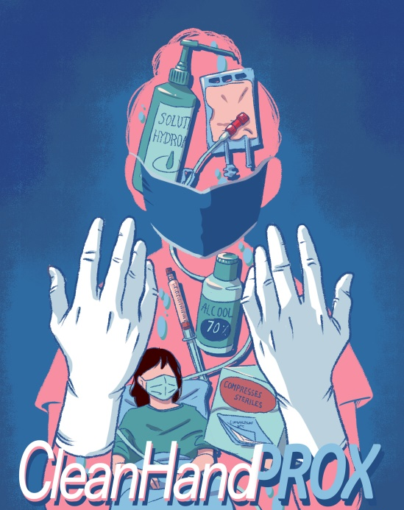

The guide to assist local infection control team in organizing educational sessions.
https://l.spiadi.fr/cleanhandprox-guide

The presentation of microbiological data
https://l.spiadi.fr/cleanhandprox-results

3 videos:
https://video.ploud.fr/w/eyaA9MSg9req6bVKw6sa4t
https://video.ploud.fr/w/myNincm2GxsphaFU7X4KDC
https://video.ploud.fr/w/uffuha177ahcYEoUNmeEFr

