Supplementary File II
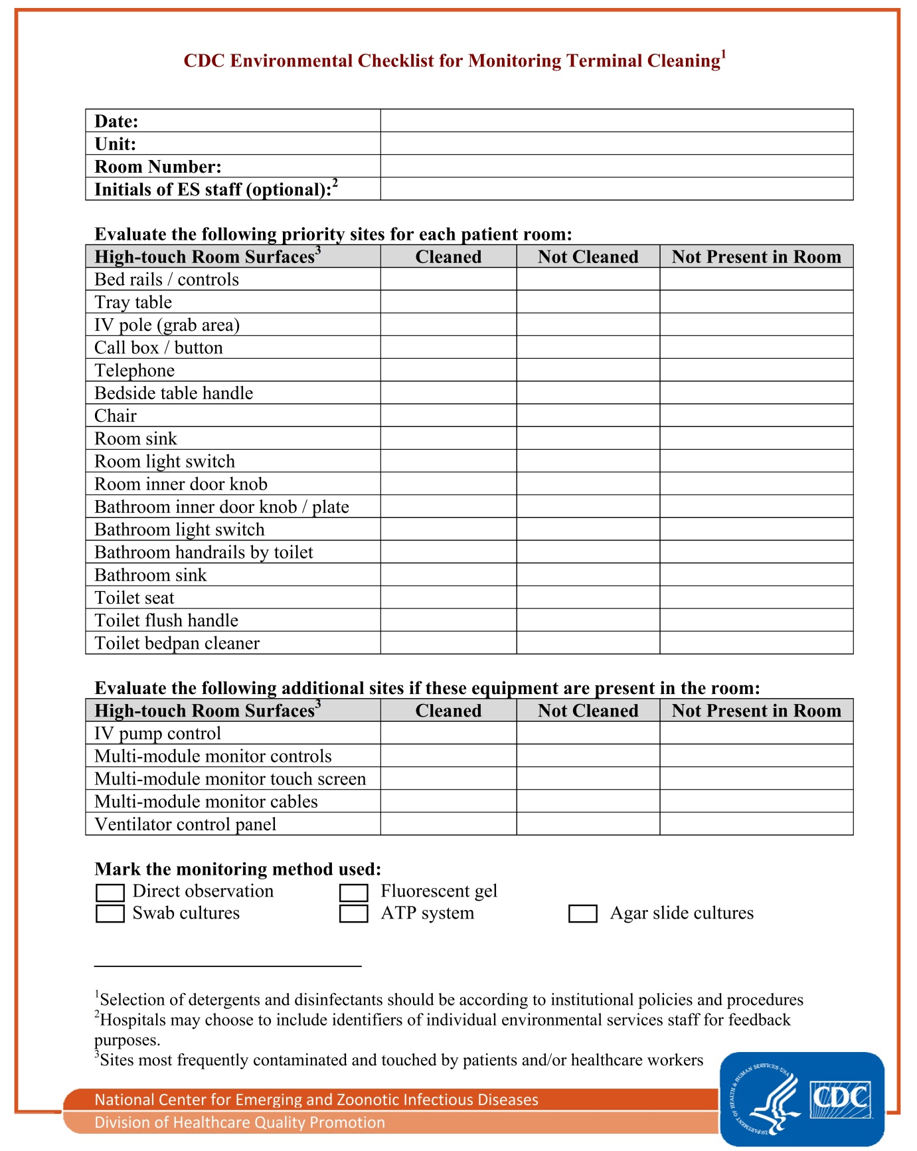

https://www.cdc.gov/hai/pdfs/toolkits/environmental-cleaning-checklist-10-6-2010.pdf

